Adaboost Analysis:
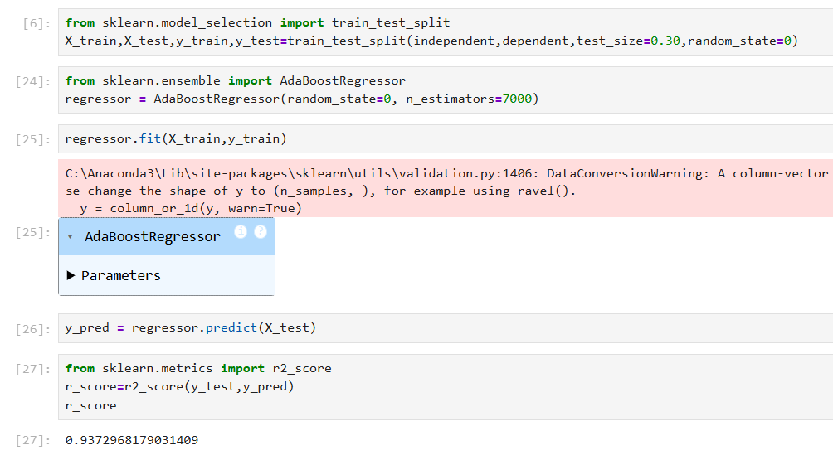
Adjusting the n_estimators till 7000 shows the value of r_score as 0.937
Trying with XG_Boost:
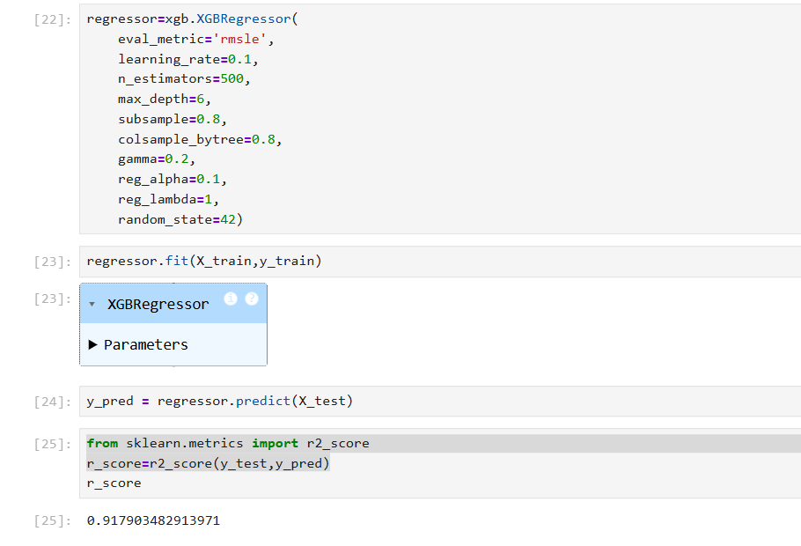

Getting R score value with adjustments made to learning_rate alone could get maximum of 0.917
LG_Boost:
Loss | criterion | n_estimators | R_score
squared_error | friedman_mse | 100 | 0.9226
squared_error | squared_error | 100 | 0.9226
absolute_error | friedman_mse | 100 | 0.8816
absolute_error | squared_error | 100 | 0.8816
huber | friedman_mse | 100 | 0.9220
huber | squared_error | 100 | 0.9220
quantile | friedman_mse | 100 | 0.8238
quantile | squared_error | 100 | 0.8238

Getting r_score value as 0.9226

Conclusion: Comparing all the 3 could see the r_score value of Adaboost is good aquiring r_score as 0.937, So deploying the same.

