

Course: Data Science
Project Title: Student Performance Analysis
Student Name: Aneela Khanum
MIS ID: 38098
Department: CS 7thB(Eve)
Submission Date: 03 January 2026
Instructor: Ms Hina Javed

Abstract
This project focuses on analyzing student academic performance using Python-based data analysis techniques. The datasets includes student demographic information, study habits, attendance records, and subject-wise scores.
The primary objective of this study is to identify performance trends and understand how factors such as study hours, gender, and department affect academic results. Data cleaning, analysis, and visualization techniques were applied to extract meaningful insights.
The results show that students from the Science department performed better overall, and a strong positive relationship exists between study hours and total score. Visualization techniques further helped in presenting these findings in an understandable manner.

2. Introduction
Student performance analysis plays an important role in modern education systems by enabling data-driven decision making. Educational institutions can improve learning outcomes by identifying academic strengths and weaknesses among students.
With the increasing availability of educational data, Python provides powerful libraries such as Pandas, Matplotlib, and Seaborn to analyze and visualize large datasets efficiently. This project applies these tools to analyze student academic performance and present insights that can help educators, students, and administrators.

3. Methodology
This project follows a structured data analysis workflow, starting from data acquisition and ending with visualization.

Data Acquisition
The dataset was collected in CSV format and loaded into Python using the Pandas library. It contains records of 60 students with 15 attributes, including personal details, study habits, attendance, and subject-wise marks.

Data Cleaning
Data cleaning was performed to ensure accuracy and consistency. Missing values in student names and gender were handled appropriately, invalid or inconsistent entries were corrected, and duplicate records were removed. Numerical values were verified, and total scores were recalculated to maintain correctness.

Data Analysis
After cleaning, statistical analysis was conducted to calculate averages, distributions, and correlations. Gender-wise and department-wise comparisons were performed to observe performance trends. The relationship between study hours and academic performance was analyzed using correlation analysis.

Data Visualization
Various graphs were generated to visually represent the analysis results. These include bar charts for grade distribution and department-wise performance, as well as scatter plots to show the relationship between study hours and total scores.

Analysis

Grade Distribution
Most students achieved Grade B (24 students) followed by Grade A (20 students). Grades C and D were obtained by 8 students each, indicating a smaller group of low-performing students.
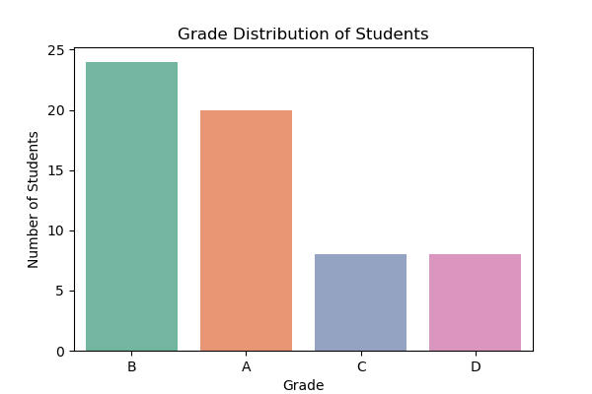
This graph shows the distribution of grades among students. Most students achieved grade B and A, indicating satisfactory overall performance.

Descriptive Statistics
The average scores of students were approximately 77.68 in Mathematics, 77.85 in Science, and 78.83 in English. The mean total score of all students was around 234.37, indicating overall satisfactory academic performance across subjects.
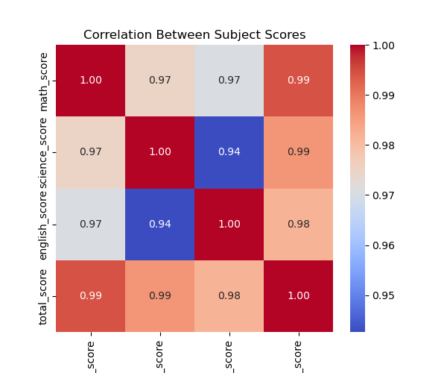

Gender-wise Performance
Female students had an average total score of approximately 234.46, while male students scored around 233.82. The results show no significant performance difference between genders.
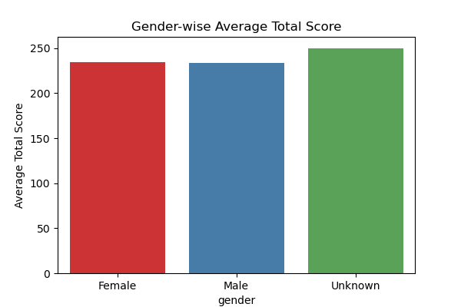
The graph indicates that male and female students have nearly equal academic performance, showing no significant gender bias.

Department-wise Performance
Science students achieved the highest average total score (≈ 264.5), followed by Arts (≈ 214.17) and Commerce (≈ 200.93). This indicates better overall performance of Science students.
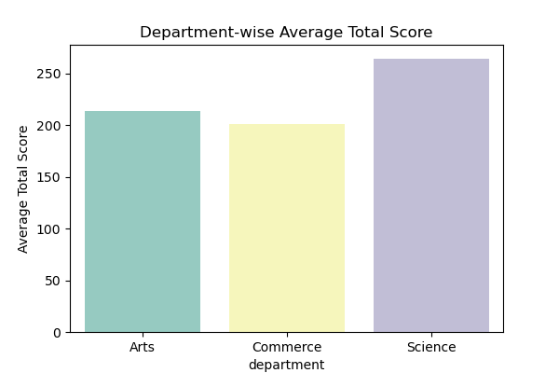
Science department students achieved the highest average scores compared to Arts and Commerce departments.

Correlation Analysis
A strong positive correlation (≈ 0.82) was observed between study hours and total score. This shows that increased study time leads to improved academic performance.
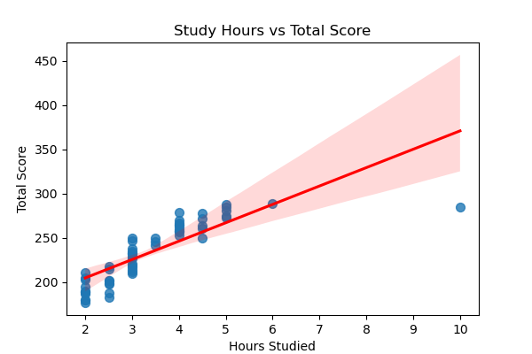
A strong positive correlation is observed between study hours and total score, indicating that increased study time improves academic performance.

5. Comparison
A comparative analysis was conducted among different departments and genders. Science students consistently outperformed students from Arts and Commerce departments. Gender-based comparison shows negligible difference in performance between male and female students.
Additionally, students with higher study hours demonstrated significantly better academic outcomes compared to those with lower study hours. This comparison highlights the importance of consistent study habits.

6. Results
The analysis successfully identified academic performance patterns among students. Key results include improved performance among Science students, minimal gender impact on results, and a strong link between study hours and academic success. The visualizations provided clear and interpretable representations of these trends.

7. Conclusion
This project demonstrates the complete life cycle of a Python-based data analysis project, including data loading, cleaning, analysis, and visualization.
The findings emphasize the importance of study habits in academic success and show how data analysis can support educational decision-making. The methodology used in this project can be applied to other academic datasets for further analysis and improvement strategies.

8. References
Python Software Foundation. Python Documentation.
Matplotlib Development Team. Matplotlib Documentation.
Seaborn Developers. Seaborn Statistical Data Visualization.
GeeksforGeeks – Python Data Analysis Tutorials.
W3Schools – Python and Pandas Tutorials.

9. GitHub Repository
The complete source code and dataset for this project are available on GitHub.
Repository Link:
aneela_repo/student_performance_analysis at main · anuukhan939-debug/aneela_repo
The repository contains the dataset, Python analysis script, and generated visualizations.

