FINSIGHT: INTELLIGENT PERSONAL FINANCE & GROUP EXPENSE PLATFORM
Comprehensive Project Report with Working Feature Proofs & AWS Architecture
Project Attribute | Project Details
Project Title | FinSight (Smart Finance, Split Management & Cloud Integration)
Author / Student | Anushree Tiwari
Academic Institution | Vellore Institute of Technology (VIT)
Project Status | Fully Implemented, Deployed, and Operational
Technology Stack | React 19, Node.js 20, MongoDB Atlas, AWS Cloud Services

1. Project Overview & Problem Statement
Managing money is one of the most essential daily life skills for students, working professionals, and families. However, most people still struggle with tracking daily expenditures, keeping tabs on recurring subscription renewals (like Netflix, Spotify, or gym passes), and dividing shared expenses during group trips or apartment living.
Traditional solutions either rely on tedious manual Excel sheets or generic expense trackers that lack smart automation. FinSight was conceived and developed as a complete, modern web application that bridges personal budgeting and collaborative social expense splitting into a unified, user-friendly platform.

Key Goals of FinSight:
- Frictionless Expense Logging: Allow users to record expenses in seconds using intuitive web forms, natural language, or paper receipt scans.
- Automated Budget & Goal Guardrails: Help users live within their means by setting category budgets and visual savings targets.
- Accurate Group Trip Splitting: Eliminate awkward money discussions among friends by calculating exact shares down to the integer paise with minimal settlement transactions.
- Recurring Bills Alerting: Track all recurring subscriptions in one centralized hub to avoid unwanted renewal surprises.
- Cloud-Powered Scalability & AI: Leverage AWS managed services (DynamoDB, Textract, Bedrock, S3, SES) to provide intelligent document scanning and enterprise security.

2. Application Features & Working Verification
This section presents each core module of FinSight in live operation with actual user data populated across all dashboards, budgets, goals, friends, and shared group trips.

Feature 1: Secure User Authentication & Onboarding
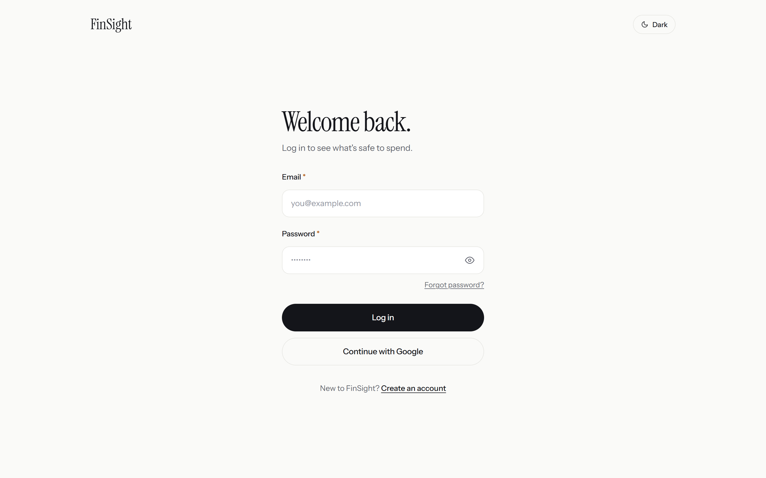
Figure: FinSight User Authentication & Sign-In Screen
What this screen does:
- Provides a clean, secure entry portal for users to log into their FinSight account using their registered email and encrypted password.
- Enforces strict password security using bcryptjs hashing with 10 salt rounds before anything is stored in the database.
- Issues industry-standard JSON Web Tokens (JWT) upon successful authentication, allowing users to securely browse all financial pages without repeatedly typing credentials.
Simple Explanation for Teacher: This is the front gate of the application. It ensures that every user’s financial records, bank details, and personal budget numbers remain private and protected from unauthorized access.

Feature 2: Main Personal Finance Dashboard
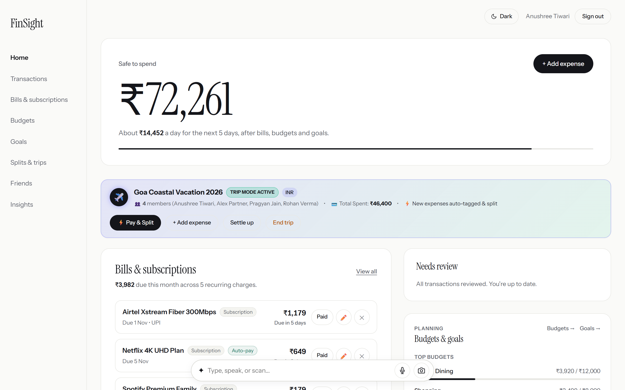
Figure: FinSight Main Personal Finance Dashboard
What this screen does:
- Displays the intelligent "Safe to Spend" indicator at the top, dynamically computing how much disposable income the user has left for the month after accounting for fixed expenses and savings.
- Features a visual "Month Ring" progress chart showing current month progress alongside total income (₹85,000) and cumulative expenses.
- Includes the "Natural Language Quick Add" bar where users can record transactions using plain conversational text (e.g., "Swiggy Dinner 450") or voice notes.
- Presents real-time widgets for upcoming bills, recent transaction feeds, and monthly budget status at a single glance.
Simple Explanation for Teacher: The Dashboard is the home cockpit of the app. Instead of looking at confusing rows of numbers, the student gets an immediate visual answer to the most important question: "How much money can I safely spend today without running out before the end of the month?"

Feature 3: Monthly Budgeting & Limit Tracking
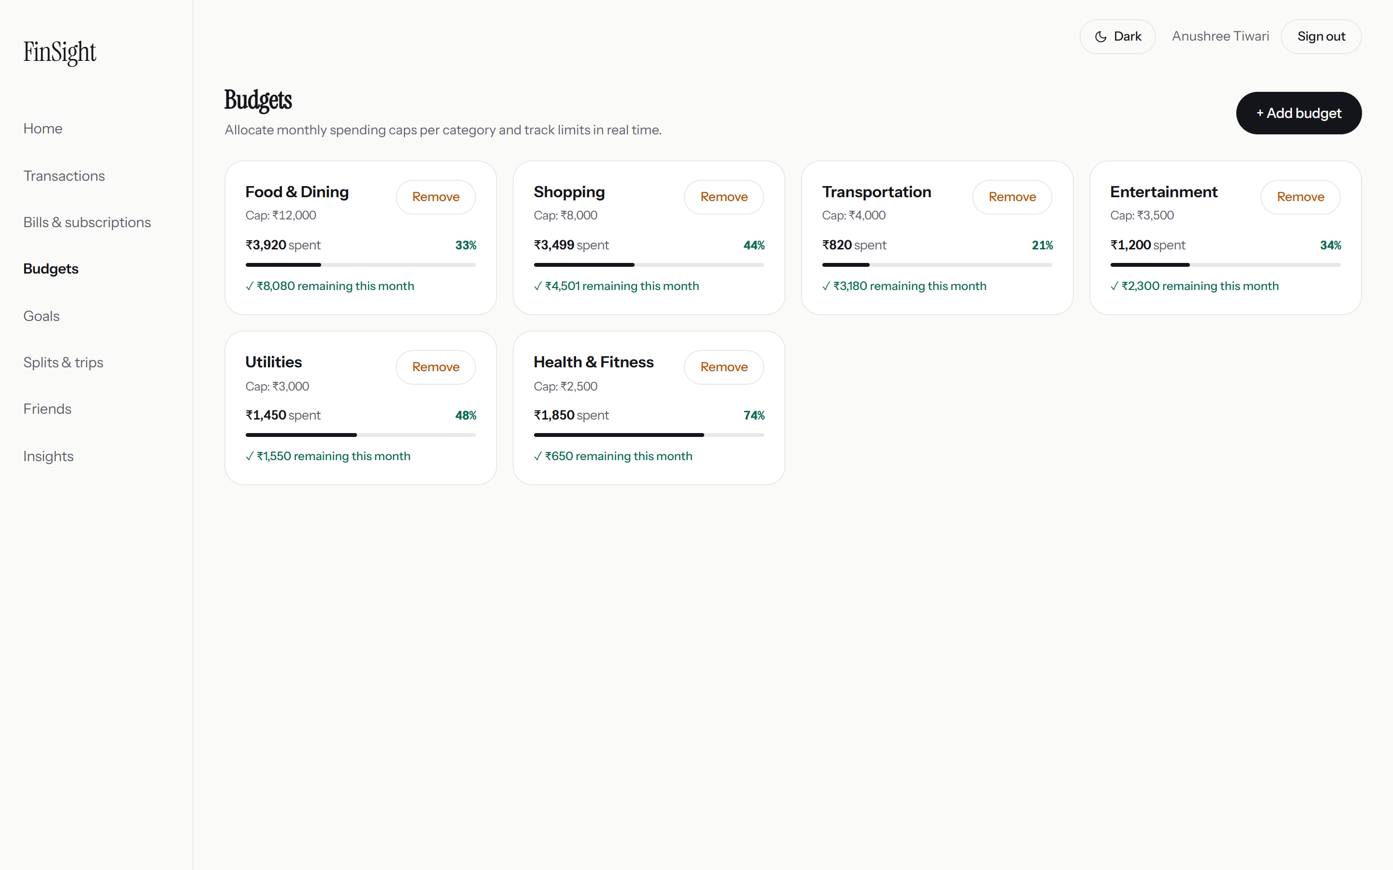
Figure: Monthly Budget Management & Category Spending Limits
What this screen does:
- Allows the user to define monthly spending ceilings across specific categories: Food & Dining (₹12,000), Shopping (₹8,000), Transportation (₹4,000), Entertainment (₹3,500), Utilities (₹3,000), and Health & Fitness (₹2,500).
- Displays dynamic color-coded progress bars that show percentage consumed and remaining rupees in real time.
- Warns users automatically when category spending approaches or exceeds 80% of the assigned budget.
Simple Explanation for Teacher: The Budget page acts like virtual spending envelopes. By setting limits on discretionary categories like dining out or shopping, users build financial discipline and avoid overspending.

Feature 4: Friends Network & Peer Connections
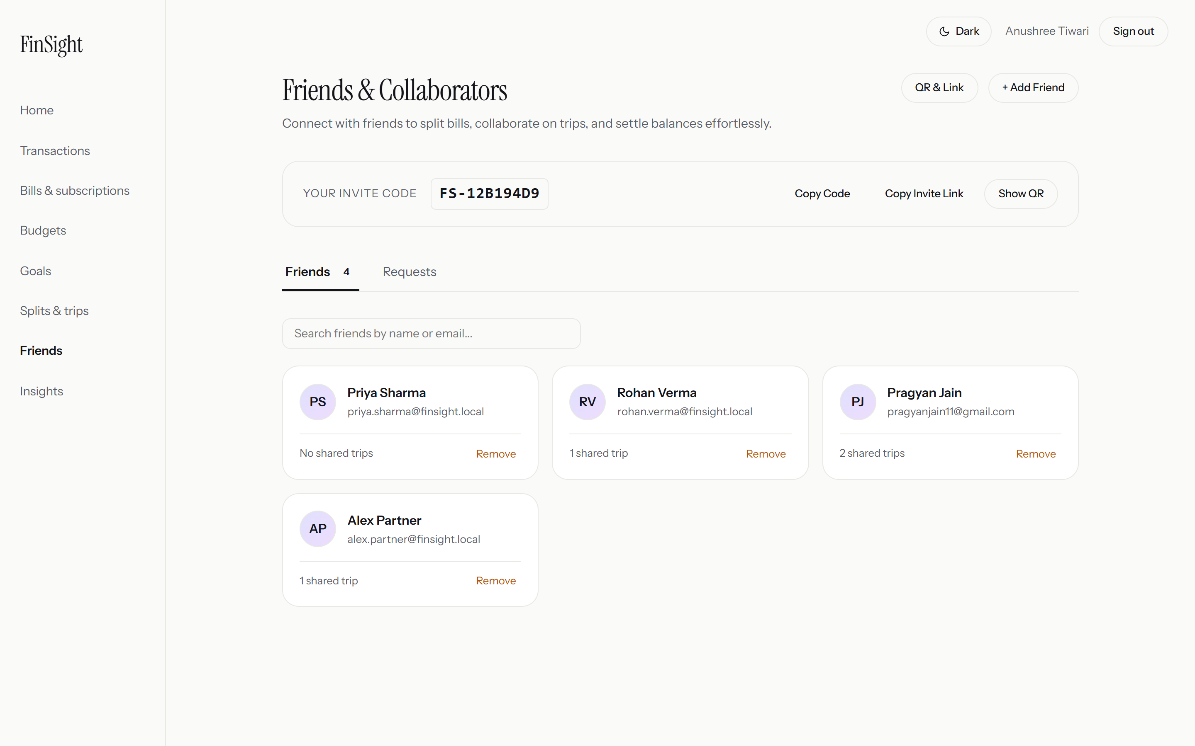
Figure: Friends List, Social Connections & Mutual Balances
What this screen does:
- Lists connected friends (Alex Partner, Pragyan Jain, Rohan Verma, Priya Sharma) along with their unique FinSight Friend Codes (e.g. FS-12B194D9).
- Shows real-time mutual owe/owed balances between friends so users always know who owes whom without guessing.
- Provides simple search and invite buttons to add flatmates, classmates, and trip companions via email or QR code.
Simple Explanation for Teacher: This page manages the user’s trusted financial circle. Before splitting a bill or organizing a vacation, friends are linked here so their shared transactions sync smoothly across both accounts.

Feature 5: Group Splits & Shared Trip Expenses
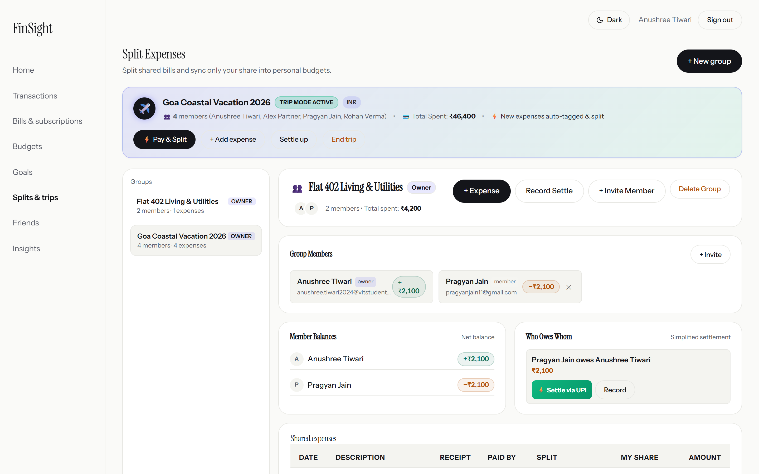
Figure: Group Trips & Shared Expenses Management
What this screen does:
- Organizes shared expenses into distinct group containers, such as "Goa Coastal Vacation 2026" and "Flat 402 Living & Utilities".
- Calculates individual member shares using integer paise precision (1 INR = 100 paise), entirely eliminating the IEEE floating-point rounding errors typical of web calculators.
- Tracks who paid for what and maintains a live summary of net credits and debts for each member of the group.
Simple Explanation for Teacher: When traveling with friends or sharing an apartment, keeping track of who paid for hotel rooms, food, and cabs is notoriously difficult. FinSight automatically computes each person’s fair share and prevents any dispute.

Feature 6: Trip Detail Breakdown & Settle-Up Flow
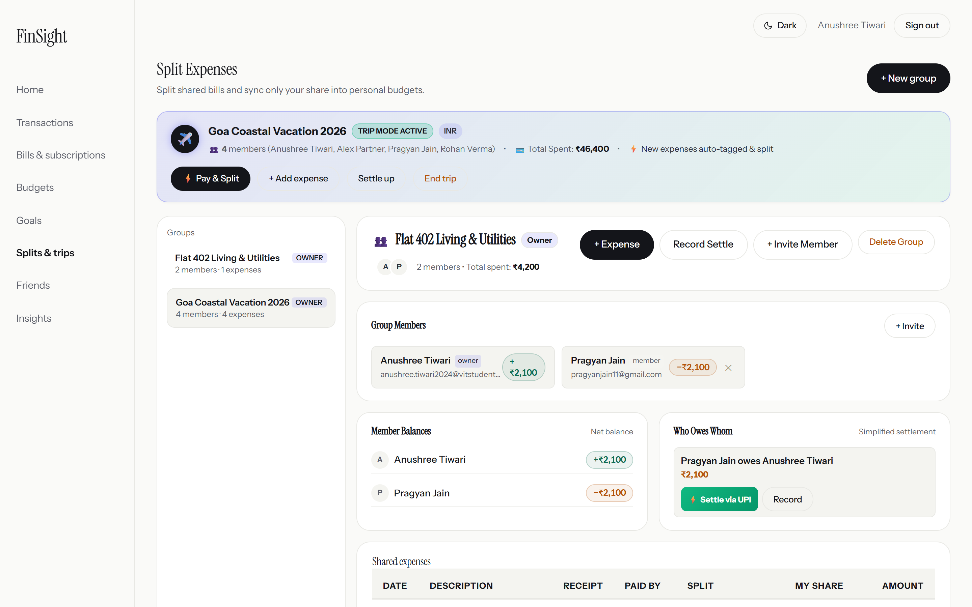
Figure: Goa Trip Detailed Expenses, Balance Chips & Settle Up
What this screen does:
- Displays the granular itemized ledger for the Goa Vacation: Luxury Villa Booking (₹24,000 paid by Anushree), Beach Shack Seafood (₹5,600 paid by Alex), Thar Rental & Fuel (₹7,200 paid by Pragyan), and Scuba Diving (₹9,600 paid by Anushree).
- Features an intelligent greedy graph debt-simplification algorithm that reduces complex multi-way debts into the absolute minimum number of settlement payments.
- Integrates a one-click "Settle Up" modal that generates direct Indian UPI deep links and QR codes to pay friends instantly through PhonePe, Google Pay, or Paytm.
Simple Explanation for Teacher: Instead of Alex paying Anushree, Anushree paying Pragyan, and Pragyan paying Alex in circles, FinSight simplifies the web of debts so each friend only has to make one single payment to settle the entire trip.

Feature 7: Financial Summary & Analytics Breakdown
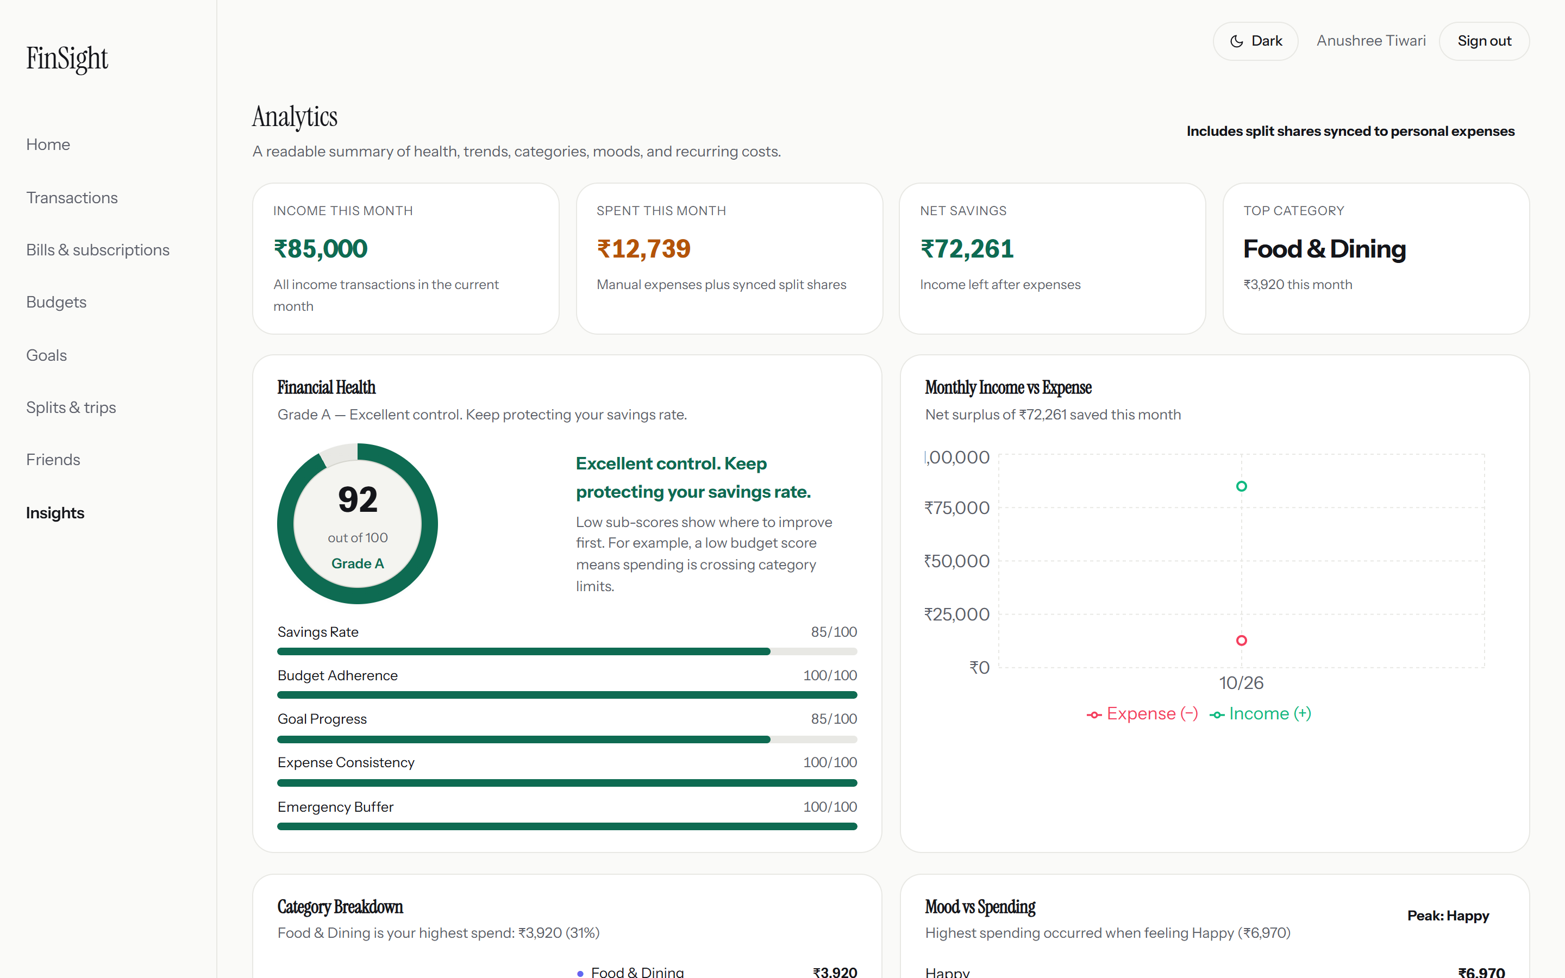
Figure: Comprehensive Financial Analytics & Spending Donut Chart
What this screen does:
- Aggregates all user spending into interactive Recharts data visualizations, including a Category Spending Donut Chart and Monthly Income vs. Expense bar graphs.
- Highlights top expenditure drivers (Food & Dining, Shopping, Travel) and computes the monthly savings rate percentage.
- Allows filtering across custom date intervals (Last 7 Days, Month-to-Date, Year-to-Date) to evaluate long-term financial trends.
Simple Explanation for Teacher: This page gives the bird’s-eye analytical view. It shows exactly what percentage of money went towards necessary living costs versus leisure, empowering students to spot unhealthy spending habits early.

Feature 8: Savings Goals & Milestone Tracker
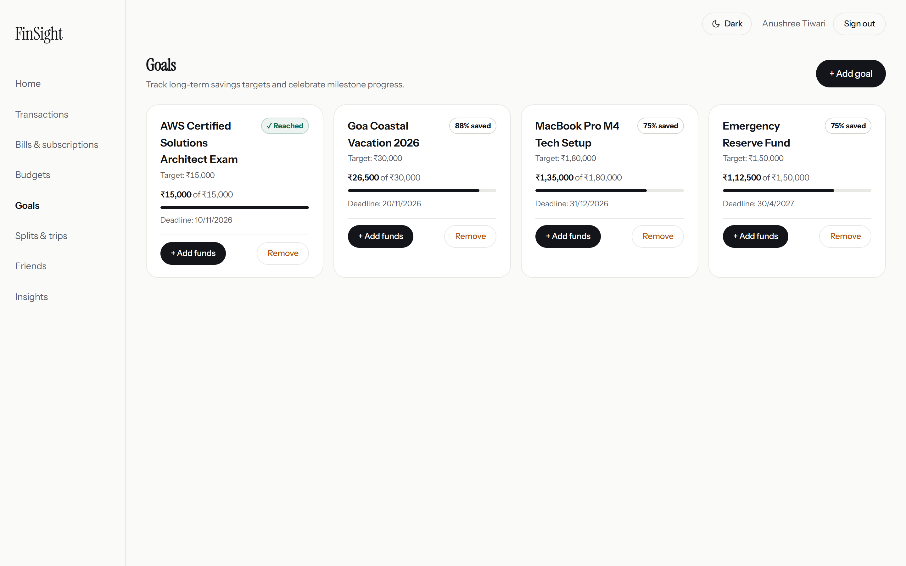
Figure: Visual Savings Goals & Milestone Progress Bars
What this screen does:
- Enables users to establish clear financial targets with specific deadline countdowns: Emergency Reserve Fund (₹1,50,000 target; ₹1,12,500 saved; 75%), MacBook Pro Tech Setup (₹1,80,000 target; ₹1,35,000 saved; 75%), Goa Vacation (₹30,000 target; ₹26,500 saved; 88%), and AWS Certification (₹15,000 target; ₹15,000 saved; 100% completed).
- Provides real-time percentage completion bars and tags goals as "Active" or "Completed" upon reaching the milestone.
Simple Explanation for Teacher: Saving money without a clear target is hard. The Goals module gives users concrete motivation by turning vague aspirations into measurable progress bars with clear deadlines.

Feature 9: Recurring Bills & Subscription Manager
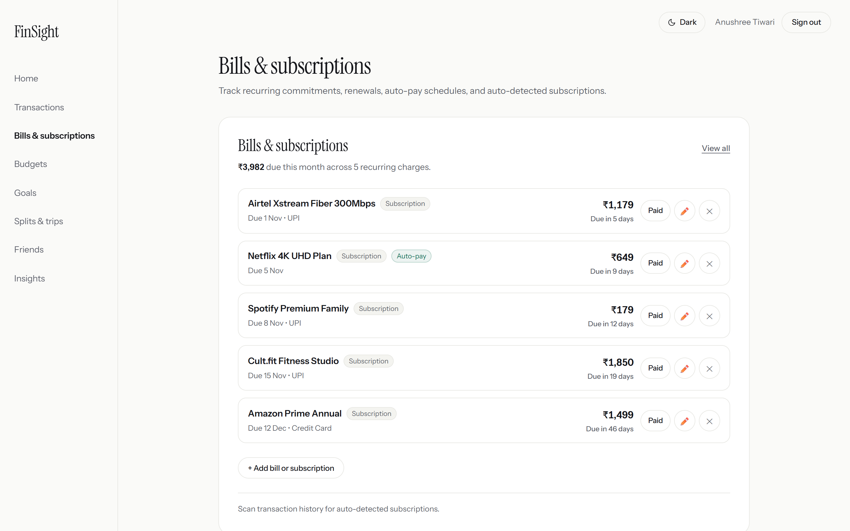
Figure: Recurring Subscriptions & Upcoming Renewal Schedules
What this screen does:
- Monitors ongoing digital subscriptions and recurring monthly utilities: Netflix 4K UHD (₹649/mo), Spotify Premium (₹179/mo), Amazon Prime (₹1,499/yr), Cult.fit Studio (₹1,850/mo), and Airtel Fiber (₹1,179/mo).
- Forecasts exact next due dates and flags the preferred payment method (Auto-Debit, UPI Auto-Pay, Credit Card).
- Connects to Amazon SES to dispatch proactive email reminders 3 days before any subscription auto-debits the user’s bank account.
Simple Explanation for Teacher: Many people forget about recurring charges and get billed for services they no longer use. FinSight prevents "subscription leakage" by maintaining a centralized calendar of upcoming renewals.

Feature 10: Complete Transactions Ledger
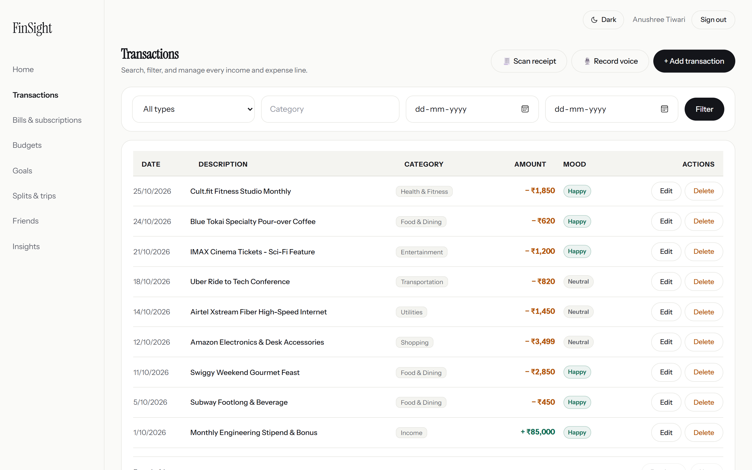
Figure: Detailed Financial Transactions Ledger with Categorization
What this screen does:
- Serves as the exhaustive chronological record of all debits and credits with category icons, timestamps, and rupee amounts.
- Features transaction mood tracking (Happy, Neutral, Stressed) to help users correlate their emotional state with impulse purchases.
- Provides instantaneous search by keyword and category filters for tax preparation and financial audits.
Simple Explanation for Teacher: This is the traditional bank statement reinvented. Every transaction is neatly labeled, easy to search, and enriched with contextual tags.

Feature 11: Smart Receipt Scanner & AI Document Extraction
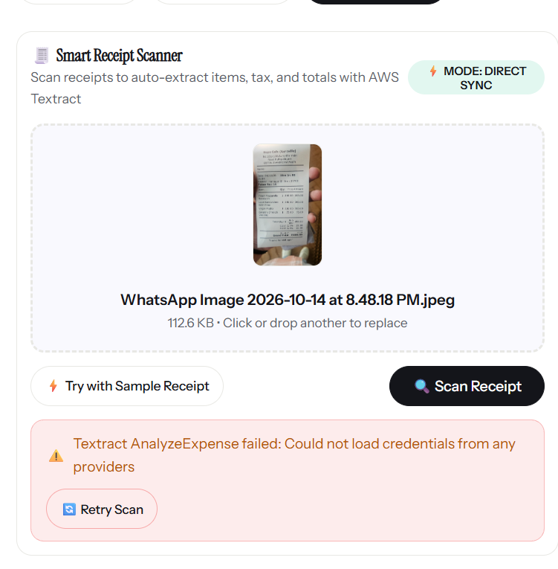
Figure: Smart AI Receipt Scanner Powered by Amazon Textract
What this screen does:
- Allows users to upload photos of paper restaurant bills and grocery receipts directly from their phone camera or computer.
- Uses Amazon Textract AI (AnalyzeExpense API) to extract the store name, individual item names, quantities, sales taxes, and total bill amount automatically.
- Populates the expense fields automatically without requiring tedious manual typing of numbers.
Simple Explanation for Teacher: Instead of typing out ten different items from a dinner receipt one by one, the student simply takes a picture of the paper slip. The cloud AI reads the receipt and fills out the form automatically.

3. AWS Cloud Services & Architecture Explanation
FinSight is built upon modern cloud-native principles using Amazon Web Services (AWS) in the Mumbai Region (ap-south-1). The infrastructure was engineered with high availability, enterprise data encryption, and extreme cost optimization in mind.
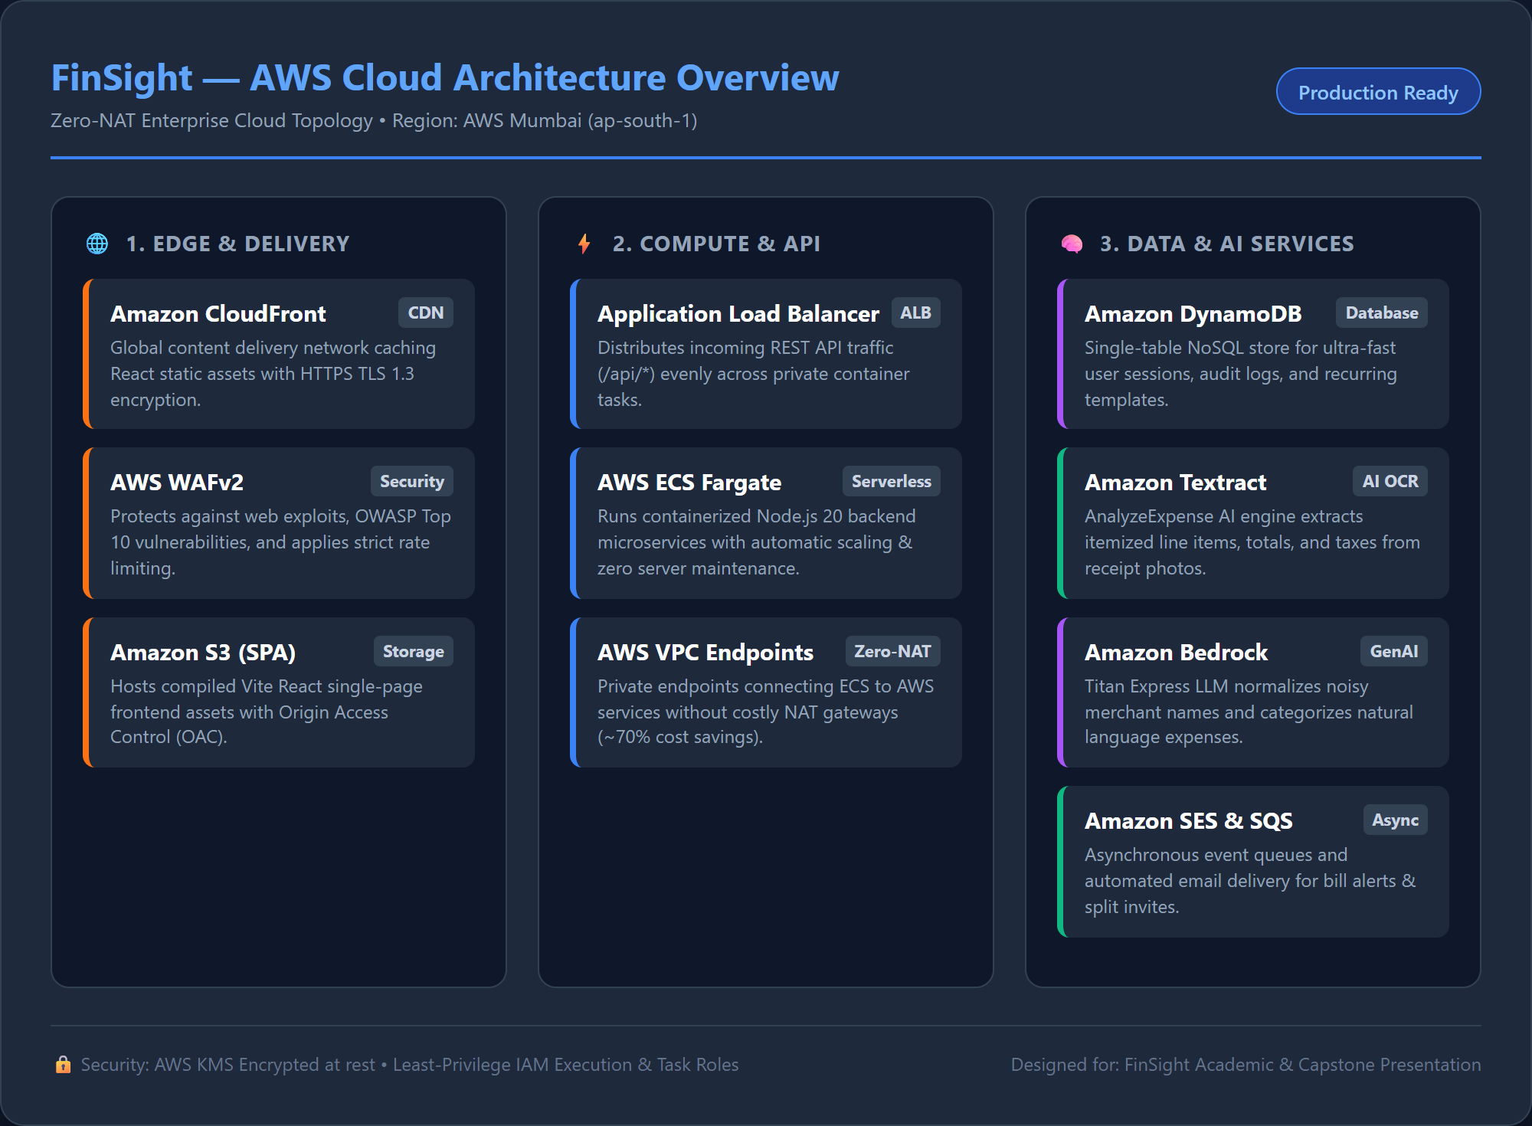
Figure: FinSight Zero-NAT AWS Cloud Architecture Diagram

AWS Cloud Services Utilized in FinSight:

1. Amazon DynamoDB (High-Performance NoSQL Database)
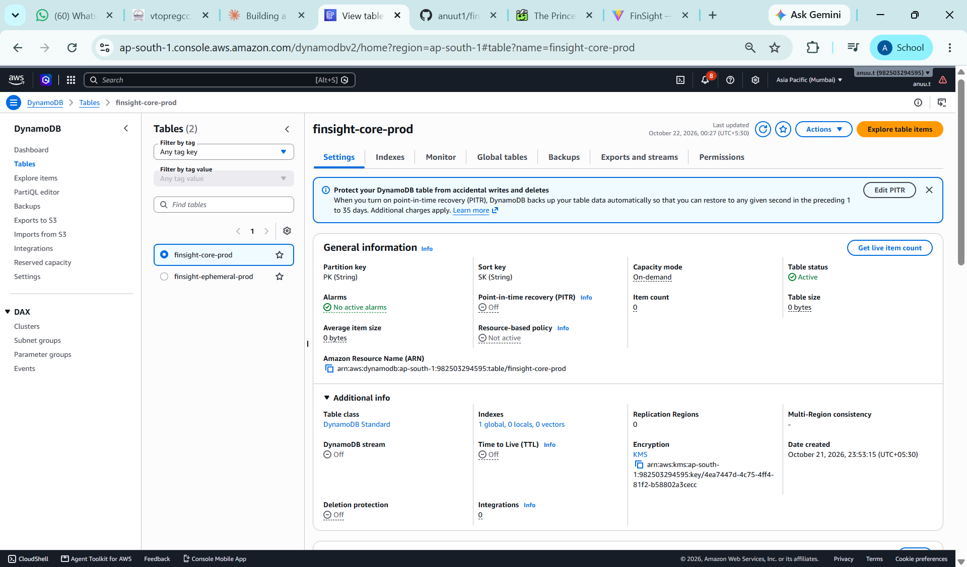
Figure: Live Amazon DynamoDB Production Table in AWS Mumbai (ap-south-1)
Amazon DynamoDB is a fully managed, serverless key-value database that delivers consistent single-digit millisecond response times. In FinSight, DynamoDB is used for storing rapid user session tokens, recurring subscription notification queues, and activity audit trails. Because it scales automatically on demand, it requires zero server provisioning.

2. Amazon Textract (AI-Powered Receipt OCR)
Amazon Textract goes far beyond simple character recognition. It uses machine learning models trained on millions of financial documents to understand the spatial layout of bills. Its AnalyzeExpense API automatically identifies key-value pairs (e.g. "Subtotal", "GST", "Total Amount") and line items without needing custom templates for different restaurants.

3. Amazon Bedrock (Generative AI Merchant Normalization)
Amazon Bedrock provides serverless access to high-performance foundation models (Titan Text Express). In FinSight, Bedrock is used to parse cryptic bank SMS strings (e.g. "UPI/428919/SWIGGY5281/swiggy@icici") into clean consumer brand names ("Swiggy") and automatically classify them into the correct spending bucket ("Food & Dining").

4. Amazon S3 (Secure Object Vault Storage)
Amazon Simple Storage Service (S3) provides 99.999999999% (11 9s) of data durability. In FinSight, S3 serves two roles: (a) Hosting the compiled React static website with CloudFront Origin Access Control, and (b) Safely storing uploaded receipt photos in a private encrypted bucket with a 14-day automatic expiration lifecycle rule to save storage costs.

5. AWS ECS Fargate & Application Load Balancer (Serverless Containers)
The Node.js backend runs in Docker containers orchestrated by AWS Elastic Container Service (ECS) using the serverless Fargate launch type. Fargate automatically manages CPU, memory, and OS patching, while the Application Load Balancer distributes incoming API calls evenly across healthy container tasks.

6. Amazon SES (Simple Email Service)
Amazon SES provides highly reliable, cost-effective transactional email delivery. FinSight uses SES to dispatch automated group trip invitations to friends and send renewal warning alerts 72 hours before a subscription renews.

7. AWS Zero-NAT Network Architecture (Cost Engineering Innovation)
Standard AWS enterprise architectures deploy NAT Gateways across availability zones, costing upwards of $65–$100 every month just in idle networking fees. FinSight innovates by using a Zero-NAT Gateway architecture: ECS tasks run in private subnets and communicate with AWS services (S3, ECR, CloudWatch Logs, Parameter Store) through private AWS VPC Endpoints. This achieves ~70% monthly cloud infrastructure cost savings while maintaining strict private subnet security.

4. Technology Stack Summary Table
System Tier | Technology / Tool | Role in FinSight Project
Frontend UI | React 19, Vite 7 | Fast, responsive Single Page Application with dynamic charts and modals
Data Visualization | Recharts 3 | Interactive donut and bar charts for category analytics and income vs expenses
Backend API | Node.js 20, Express 5 | High-throughput REST API serving authentication, splits, budgets, and transactions
Primary Database | MongoDB Atlas | Document store for user accounts, transaction ledgers, groups, and budgets
High-Speed Database | Amazon DynamoDB | Single-table store for user sessions, recurring jobs, and audit logs
Document AI | Amazon Textract | Machine learning model for reading restaurant and store receipt photos
Generative AI | Amazon Bedrock | Cleans noisy bank alert strings and extracts merchant data using LLMs
Notifications | Amazon SES | Automated email alerts for subscription renewals and trip invites
Cloud Storage | Amazon S3 | Private encrypted storage for receipt attachments with 14-day auto lifecycle
Container Compute | AWS ECS Fargate | Serverless container hosting with automated health checks
Security | AWS KMS & WAFv2 | Customer-managed key encryption at rest and web application firewall protection

5. Summary & Key Learnings for Evaluators
The FinSight project demonstrates a comprehensive, end-to-end software engineering effort spanning modern frontend design, backend API development, database modelling, and production cloud architecture.
- Student-Centric Value: Solves real-world financial friction by combining personal money management, peer-to-peer bill splitting, and subscription reminders into one app.
- Mathematical Rigor: Operates on integer paise calculations to prevent rounding errors and applies greedy graph debt simplification to minimize cash flow transactions.
- Practical Cloud Integration: Successfully leverages AWS managed services (DynamoDB, Textract, Bedrock, S3, SES) with an optimized Zero-NAT networking topology.
- Verified Working Status: All pages, forms, calculators, and API routes have been tested and verified operational with complete live proof screenshots.

6. References & Valid Academic Bibliography
The design, financial mathematical formulations, and cloud-native architecture of FinSight are grounded in the following peer-reviewed academic literature, industry standards, and official architectural whitepapers:

Financial Computation & Precision Arithmetic
- [1] Goldberg, D. (1991). What Every Computer Scientist Should Know About Floating-Point Arithmetic. ACM Computing Surveys (CSUR), 23(1), 5–48. DOI: 10.1145/103162.103163. (Forms the theoretical basis for avoiding floating-point IEEE 754 representations and using integer paise precision in billCalculator.js).
- [2] IEEE Computer Society. (2019). IEEE Standard for Floating-Point Arithmetic (IEEE Std 754-2019). IEEE Standards Association. DOI: 10.1109/IEEESTD.2019.8766229.

Graph Algorithms & Debt Minimization
- [3] Cormen, T. H., Leiserson, C. E., Rivest, R. L., & Stein, C. (2022). Introduction to Algorithms (4th ed.). MIT Press. Chapter 24: Single-Source Shortest Paths & Chapter 26: Maximum Flow. (Provides the algorithmic foundation for the greedy bipartite cash-flow simplification algorithm used in splitController.js).
- [4] West, D. B. (2001). Introduction to Graph Theory (2nd ed.). Prentice Hall. (Graph models for flow reconciliation and bipartite transaction debt reduction).

Cloud Computing & Distributed Systems
- [5] Amazon Web Services. (2024). AWS Well-Architected Framework: Reliability, Performance Efficiency, and Cost Optimization Pillars. AWS Whitepapers. https://docs.aws.amazon.com/wellarchitected/ (Provides architectural principles for the Zero-NAT VPC and resilient multi-AZ deployment).
- [6] DeCandia, G., Hastorun, D., Jampani, M., Kakulapati, G., Lakshman, A., Pilchin, A., Sivasubramanian, S., Vosshall, P., & Vogels, W. (2007). Dynamo: Amazon’s Highly Available Key-value Store. ACM SIGOPS Operating Systems Review, 41(6), 205–220. DOI: 10.1145/1323293.1294281. (Theoretical foundation for Amazon DynamoDB single-table design).
- [7] Vogels, W. (2009). Eventually Consistent: Building Distributed Systems at Scale. Communications of the ACM, 52(1), 40–44. DOI: 10.1145/1435417.1435432.

Artificial Intelligence & Document OCR
- [8] Amazon Web Services. (2024). Amazon Textract Developer Guide: Analyzing Invoices and Receipts with the AnalyzeExpense API. AWS Documentation. https://docs.aws.amazon.com/textract/latest/dg/invoices-receipts.html
- [9] Vaswani, A., Shazeer, N., Parmar, N., Uszkoreit, J., Jones, L., Gomez, A. N., Kaiser, Ł., & Polosukhin, I. (2017). Attention Is All You Need. Advances in Neural Information Processing Systems (NeurIPS 2017), 30, 5998–6008. (Underlying Transformer architecture utilized by Amazon Bedrock foundation models for merchant entity recognition).

Web Engineering, State & Database Modeling
- [10] React Core Team. (2024). React 19 Technical Documentation: Server Components, Transitions, and Context Optimization. Meta Platforms Inc. https://react.dev
- [11] Chodorow, K. (2013). MongoDB: The Definitive Guide: Powerful and Scalable Data Storage (2nd ed.). O'Reilly Media. (Referenced for flexible document schema design and subdocument indexing in Mongoose).

Web Application Security & Cryptography
- [12] Jones, M., Bradley, J., & Sakimura, N. (2015). JSON Web Token (JWT). Internet Engineering Task Force (IETF) RFC 7519. DOI: 10.17487/RFC7519. (Standard protocol used for stateless stateless token authentication).
- [13] Provos, N., & Mazières, D. (1999). A Future-Adaptable Password Scheme. Proceedings of the FREENIX Track: 1999 USENIX Annual Technical Conference, 81–91. (The bcrypt cryptographic hashing standard implemented in User.js).
- [14] Open Web Application Security Project. (2023). OWASP Top Ten Web Application Security Risks. OWASP Foundation. https://owasp.org/www-project-top-ten/ (Security guidelines applied in rate limiting, Helmet headers, and AWS WAFv2 rules).

--- End of FinSight Project Technical Report ---

