PROJECT – SWIFT SHIP TRACKER

COLLEGE CODE: 8220
COLLEGE NAME: Star Lion College of Engineering and Technology
DEPARTMENT: B.E . Computer Science & Technology
STUDENT NM-ID: BC02063F88C2FA4A12B4B5FBF9DBF527
ROLL NO: 822023104002
TEAM ID: SWTID-2026-6090
DATE: 02.10.2026

SUBMITTED BY,
NAME : SNEKA S [Team Leader]
E-Mail ID : senkasenka317@gmail.com

NAME : ANUVARSHINI SS
E-Mail ID : anuvarshini408@gmail.com

NAME : VISHAL.R

SWIFT SHIP TRACKER

User Story:
User Story
Swift Ship Tracker is designed to provide a simple and organized way to manage parcel deliveries. The system allows customers to submit shipment details and follow the progress of their parcels throughout the delivery process. Delivery staff can access the required shipment information and update the progress based on the current delivery stage. The system keeps the shipment information organized so that support staff can easily respond to customer enquiries. Administrators can monitor the overall delivery activities and keep track of ongoing shipments. By bringing these activities together, the system helps make parcel management easier, clearer, and more efficient.
.

- INTRODUCTION

1.1 Project Overview
Swift Ship Tracker is a digital parcel management system developed to make shipment handling more organized and convenient. The system provides a structured way to manage parcel information from the initial booking stage until the delivery is completed. It helps users maintain shipment details, follow delivery progress, and access the required information when needed. The application also supports delivery staff in managing their assigned shipments and updating their progress. By maintaining the important shipment activities in one system, Swift Ship Tracker helps improve the overall parcel management process.

1.2 PURPOSE:

The purpose of Swift Ship Tracker is to:
● Provide a structured platform for managing parcel delivery activities.
● Simplify the process of recording and handling shipment information.
● Help customers view the progress of their parcels during delivery.
● Enable delivery staff to maintain and update assigned shipment details.
● Improve coordination between customers, delivery teams, and support staff.
● Reduce dependency on manual methods for maintaining parcel records.
● Help administrators monitor shipment activities in an organized manner.

- IDEATION PHASE
  - Problem Statement (Customer Problem Statement Template)

PS | I am  (Customer) | I’m trying  to | But | Because | Which makes me  feel
PS-1 | Customer / Sender | send a parcel conveniently | shipment details are difficult to manage | shipment details are difficult to manage | confused

PS-2 | Customer / Sender | know my parcel progress | delivery updates are not always clear | shipment movement can change during transportation | concerned
PS-3 | Delivery Agent | manage assigned parcels | handling multiple deliveries is challenging | delivery information changes frequently | pressured
PS-4 | Customer | receive delivery information | updates may not reach me at the right time | communication can be delayed
  uncertain
PS-5 | Administrator | monitor shipment activities | tracking multiple deliveries can be difficult | operational information needs to be organized | concerned
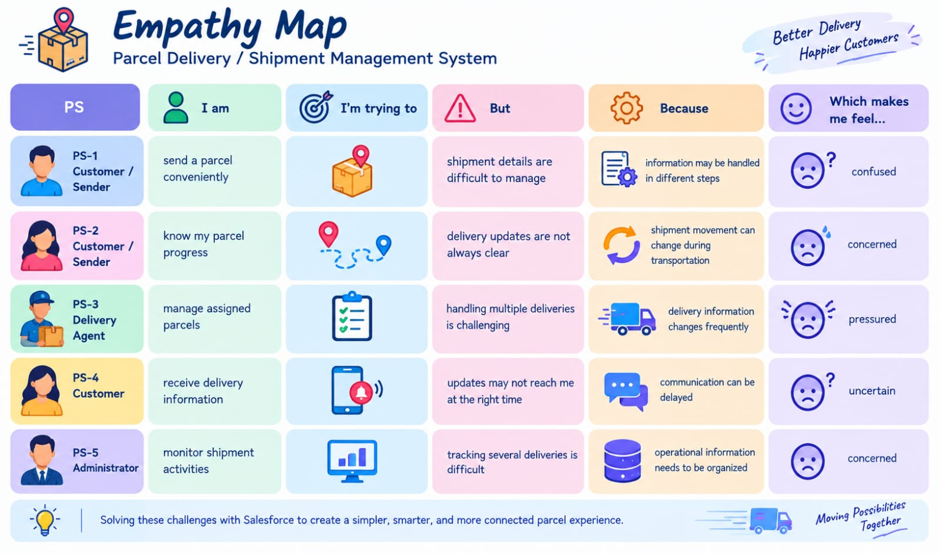

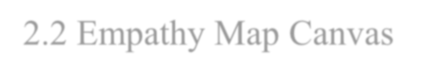
2.2
Empathy Map Canvas

User Persona: Customer / Sender

● Think & Feel: Wants a quick and reliable way to book parcels and follow their
delivery progress.
● Hear: Receives shipment updates and delivery-related messages from the service.
● See: Parcel status, shipment details, delivery progress, and expected delivery information.
● Say & Do: Books shipments, checks parcel status, and follows delivery updates.
● Pain: Unclear tracking information, delayed updates, and difficulty managing
shipment details.
● Gain: Easy parcel booking, clear tracking information, quick status updates, and timely delivery notifications.

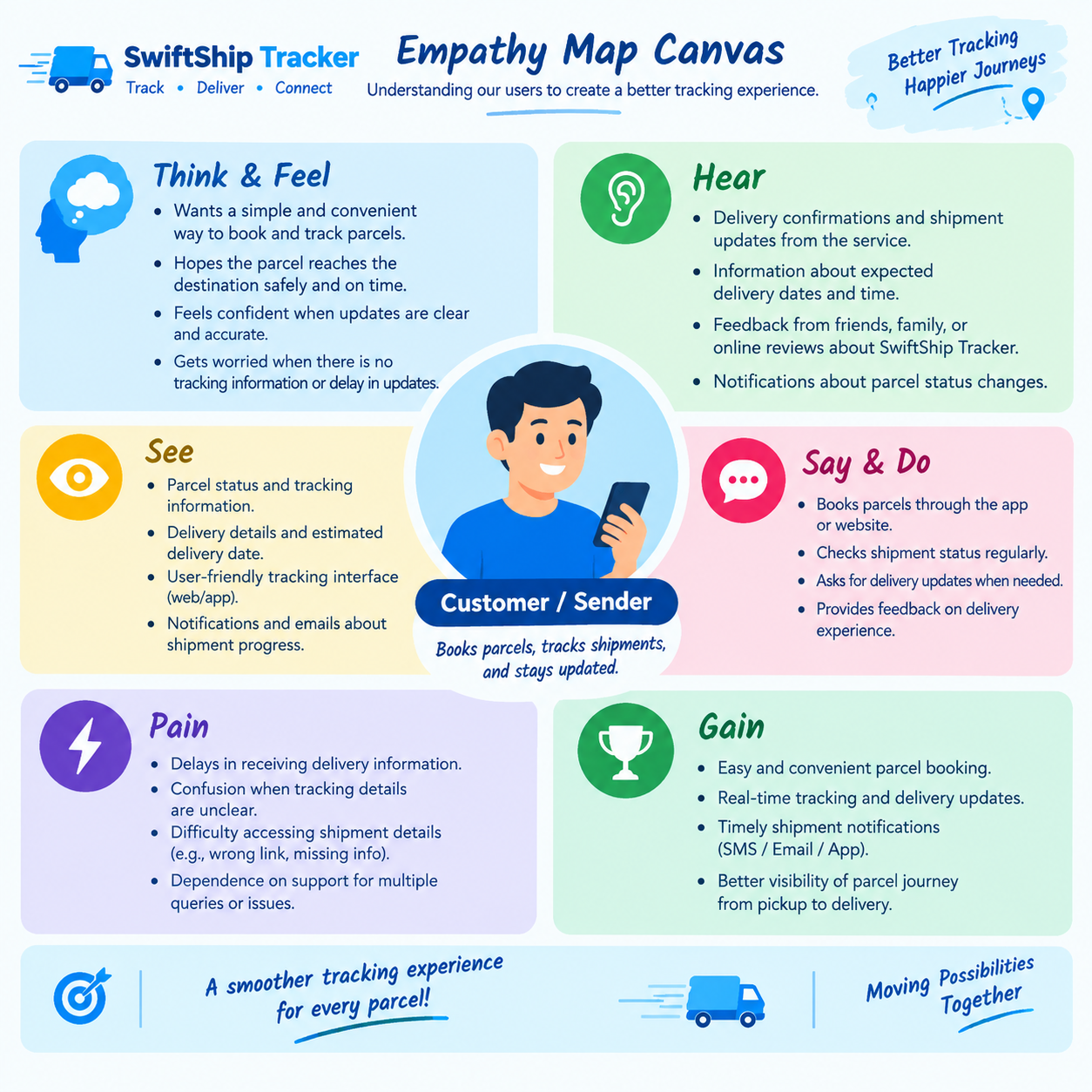

2.3 Brainstorming & Idea Prioritization

Ideas Considered
• Manual parcel registers
• Spreadsheet-based shipment tracking
• Basic online tracking system
• Salesforce CRM with AgentForce AI
Final Selection
Salesforce CRM selected due to:
• Centralized shipment information
• Automated parcel status updates
• Easy real-time tracking
• AI-based customer assistance
• Secure user access
• Reports and dashboards

3. PHASE 1 : Requirement Analysis
3.1 Business Requirements
The Swift Ship Tracker System is designed to support the day-to-day activities involved in parcel booking, shipment tracking, and delivery management. The system provides a centralized Salesforce environment for maintaining parcel, sender, receiver, delivery, and tracking information.

The major business requirements of the system are:
- Maintain parcel information including Parcel ID, parcel status, weight, and estimated delivery date.
- Maintain complete sender information such as name, email, phone, and address..
- Maintain receiver information including name, email, phone, and delivery address.
- Maintain delivery information including current location, delivery status, and estimated delivery date.
- Connect parcels with the appropriate sender and receiver records.
- Associate delivery details with the corresponding parcel.
- Allow delivery agents to update parcel status during the delivery process..
- Provide customers with parcel tracking and delivery status information.
- Automate parcel status updates using Salesforce Flows..
- Provide AI-powered parcel tracking assistance using AgentForce..
- Send automated notifications and updates during important delivery stages..
- Maintain accurate and up-to-date parcel and delivery information.
- Provide reports for monitoring parcel status and delivery performance..

  - Functional Requirements

The functional requirements define the major functions that the Swift Ship Tracker should perform.

FR No | Requirement
FR-1 | Create and manage parcel booking records.
FR-2 | Generate and maintain unique Parcel ID
FR-3
  Store sender and receiver details
FR-4 | Record parcel weight and delivery information.
FR-5
  Maintain parcel delivery status
FR-6 | Track current delivery location
FR-7 | Allow delivery agents to update shipment details
FR-8 | Automate parcel processing using Salesforce Flow
FR-9 | Provide delivery notifications and status updates
FR-10 | Provide delivery notifications and status updates
FR-11 | Generate operational reports and monitoring dashboards
FR-12 | Provide controlled access to parcel information for different users.

  - Non-Functional Requirements

NFR | Description
NFR-01 | Usability: Simple and user-friendly interface for parcel management and tracking
NFR-02 | Security: Controlled access to shipment and customer information
NFR-03 | Availability: Accessible through the Salesforce cloud environment
NFR-04 | Reliability: Consistent storage and retrieval of parcel and delivery data
NFR-05 | Maintainability: Flows, configurations, and AI components can be modified when business requirements change.
NFR-06 | Scalability:
  Supports increasing numbers of parcels, customers, and deliveries
NFR-07 | Performance: Quick response during parcel search, status updates, and tracking.
NFR-08 | Data Integrity: Maintains accurate and consistent relationships between parcel, sender, receiver, and delivery records

  - Data Model

The Swift Ship Tracker System uses a connected Salesforce data model to organize the information required for parcel booking, delivery, and shipment tracking.
The system contains the following custom objects:
- Parcel – Stores core parcel details such as Parcel ID, Status, Weight, and Estimated Delivery Date.
- Client – Stores client contact and location information.
- Delivery – Stores delivery information such as Current Location, Estimated Delivery Date, and linked Parcel details..
- Sender – Stores sender information such as Address, Contact Number, and Email.
- Receiver – Stores receiver information such as Address, Contact Number, and Email.

Object Relationships
- Parcel → Sender: Lookup relationship used to associate a parcel with the sender.
- Parcel → Receiver: Lookup relationship used to associate a parcel with the receiver.
- Delivery → Parcel: Lookup relationship used to connect delivery information with the corresponding parcel.
- Delivery → Sender: Lookup relationship used to connect delivery information with the sender.
- Receiver → Sender: Lookup relationship used to associate receiver information with the sender.
- Receiver → Parcel: Lookup relationship used to associate receiver information with the corresponding parcel

4. PHASE-2 -: Salesforce Development –Backend & Configurations
Custom Objects

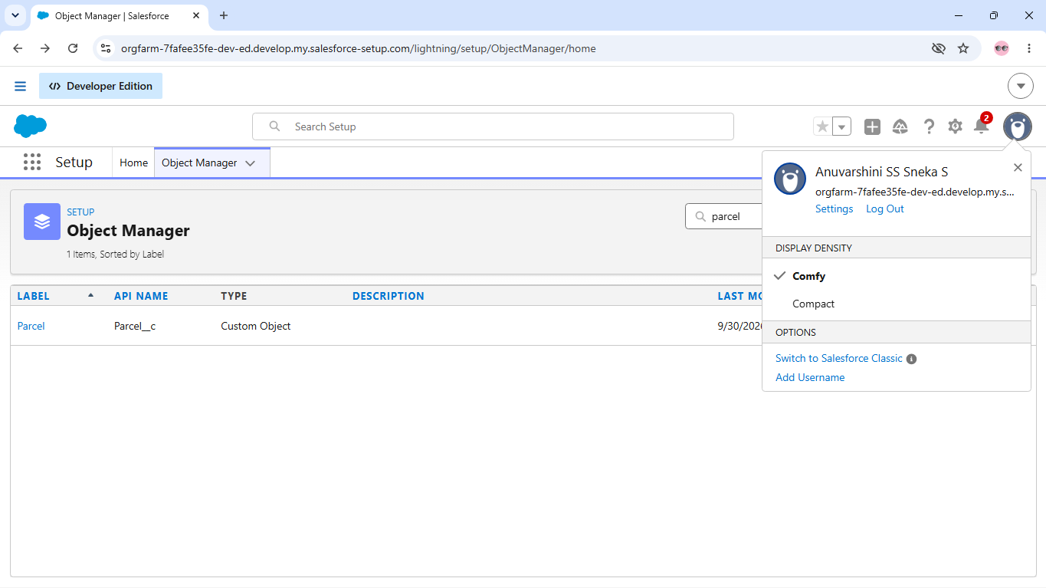

CUSTOM OBJECT
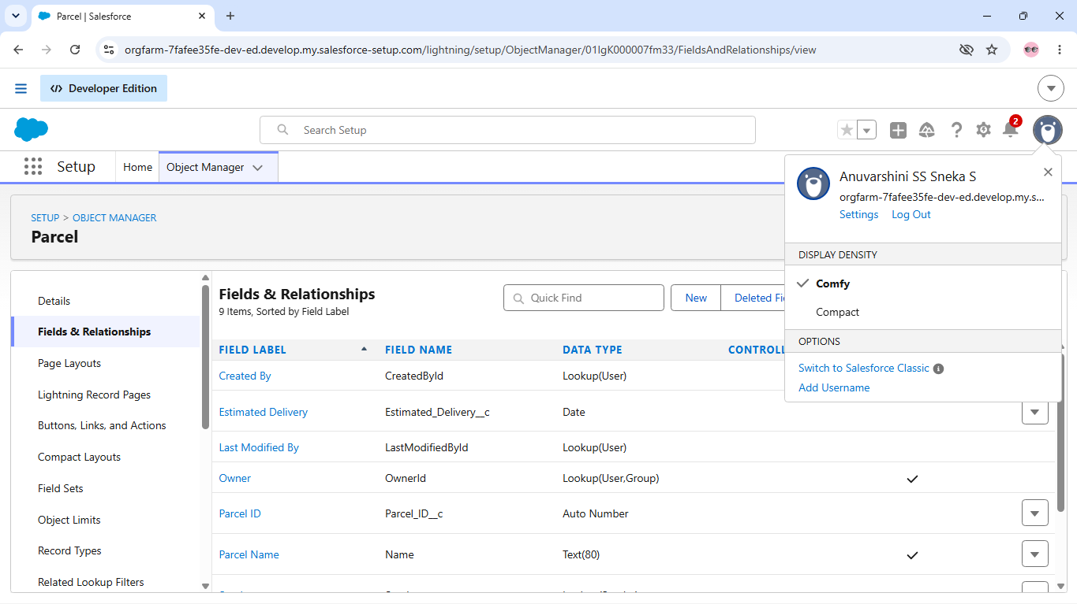

Sender
The Sender object is used to maintain sender information related to parcels. It stores details such as Sender Name, Sender Email, Sender Contact, and Sender Address. The Sender object is linked with the Parcel and Delivery objects so that each shipment can be associated with the corresponding sender.

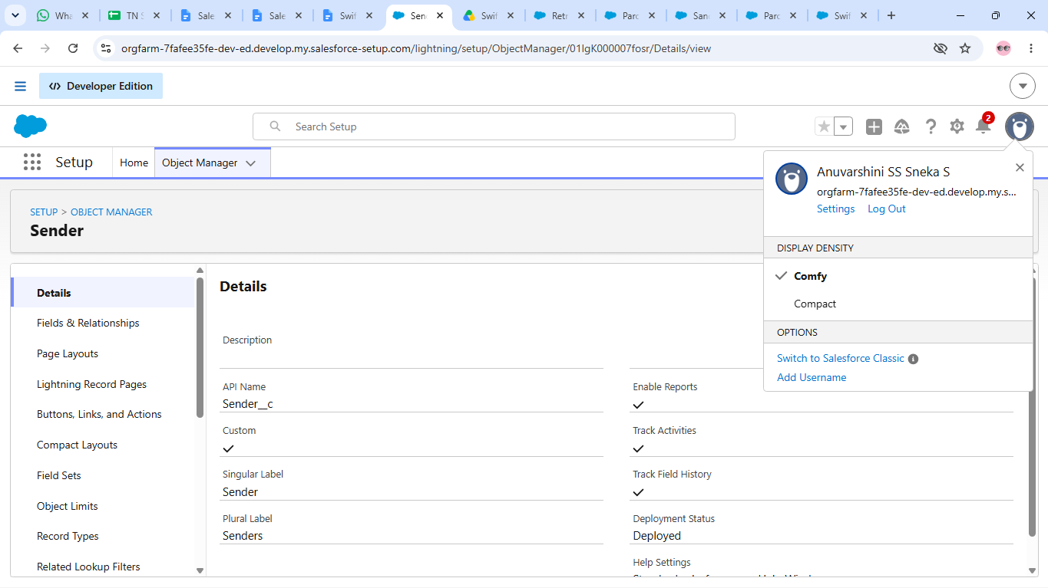

Receiver

The Receiver object is used to maintain information about receivers who receive parcels. It contains Receiver Name, Receiver Email, Receiver Contact, and Receiver Address. Receiver records are associated with the Parcel and Sender objects so that each shipment can be connected with the corresponding receiver.

. 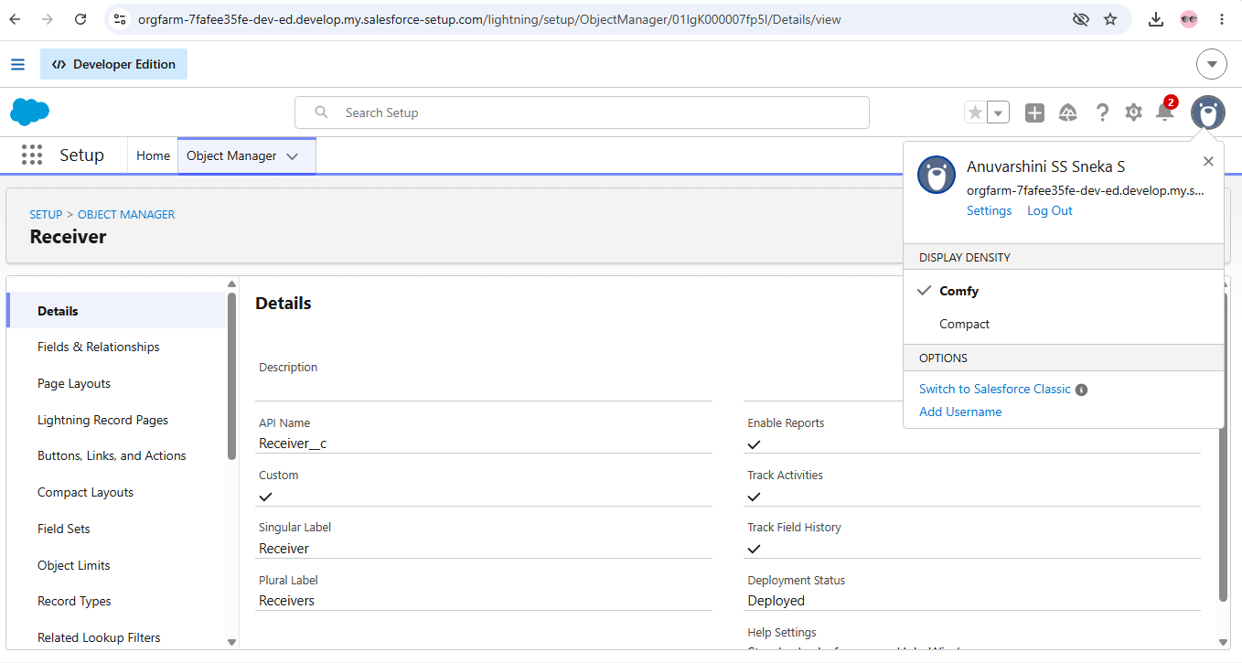

Parcel Object:

The Parcel object is used to maintain information about parcels being booked and tracked. It contains details such as Parcel ID, Status, Weight, Estimated Delivery Date, Sender, and Receiver. The Parcel object is linked with the Sender, Receiver, and Delivery objects so that each parcel can be associated with the corresponding shipment and delivery information

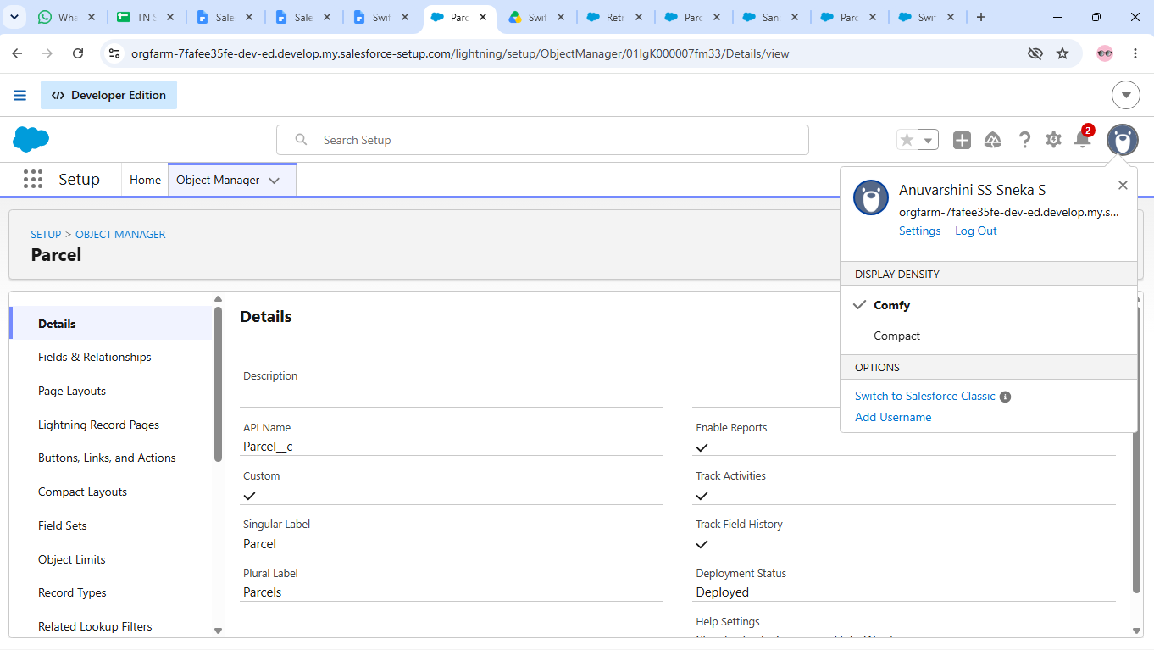

PARCEL OBJECT

TABS

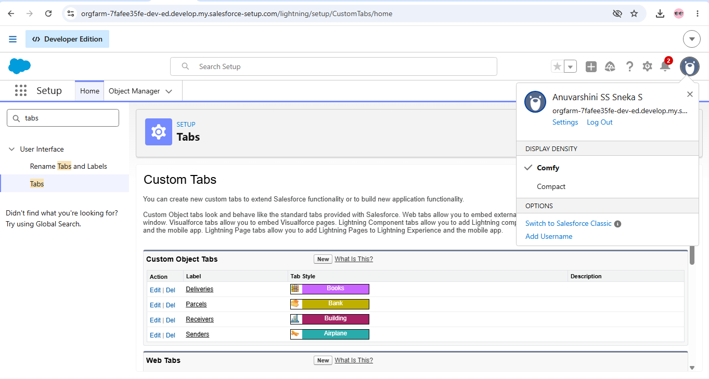
CUSTOM TABS

Project Tracker, Velocity & Burndown Chart:

Sprint | Functional Requirement  (Epic) | User Story  Number | User Story / Task | Story Points | Priority | Team Member  s
Sprint-1 | Developer  Setup | USN-1 | As a system administrator, I want to  create and configure the Salesforce  environment so that I can build the  SwiftShip Tracker parcel  management system. | 3 | High | Member1
Sprint-1 | Data Modeling | USN-2 | As an admin, I want to create  Parcel, Delivery, Sender, and  Receiver objects with proper  relationships so that parcel and  delivery data is stored and  managed systematically. | 5 | High | Member1
Sprint-2 | Data Modeling | USN-3 | As a staff member, I want dedicated  tabs and a Lightning App for  SwiftShip modules so that I can  easily navigate and manage parcel  and delivery operations.. | 5 | High | Member1
Sprint-2 | Automation | USN-4 | As a system, I want to validate  parcel details, mandatory fields, and  booking inputs so that invalid or  incomplete parcel records are  prevented.. | 3 | High | Member2
Sprint-3 | Automation | USN-5 | As a delivery coordinator, I want  automated Flows to update parcel  status and delivery information so  that parcel processing requires  minimal manual effort.. | 3 | High | Member1
Sprint-3 | Apex | USN-6 | As a system, I want Apex triggers  and classes to automatically  perform critical parcel and delivery  actions so that important processes  are handled accurately.. | 5 | High | Member1
Sprint-4 | Apex | USN-7 | As an inventory/operations  manager, I want Batch Apex jobs to  process and update parcel or  delivery records automatically so  that operational data remains  accurate and up to date. | 4 | High | Member1
Sprint-4 | Dashboards &  AI | USN-9 | As a manager, I want dashboards  showing parcel status, delivery  performance, and key metrics, while  Agentforce provides AI-powered  tracking assistance, so that I can  monitor operations efficiently.. | 4 | Medium | Member2

5. Flows

Flows are used to automate parcel-related processes in the Swift Ship Tracker system. They help automate tasks such as parcel processing, status updates, and delivery-related actions without requiring manual intervention.

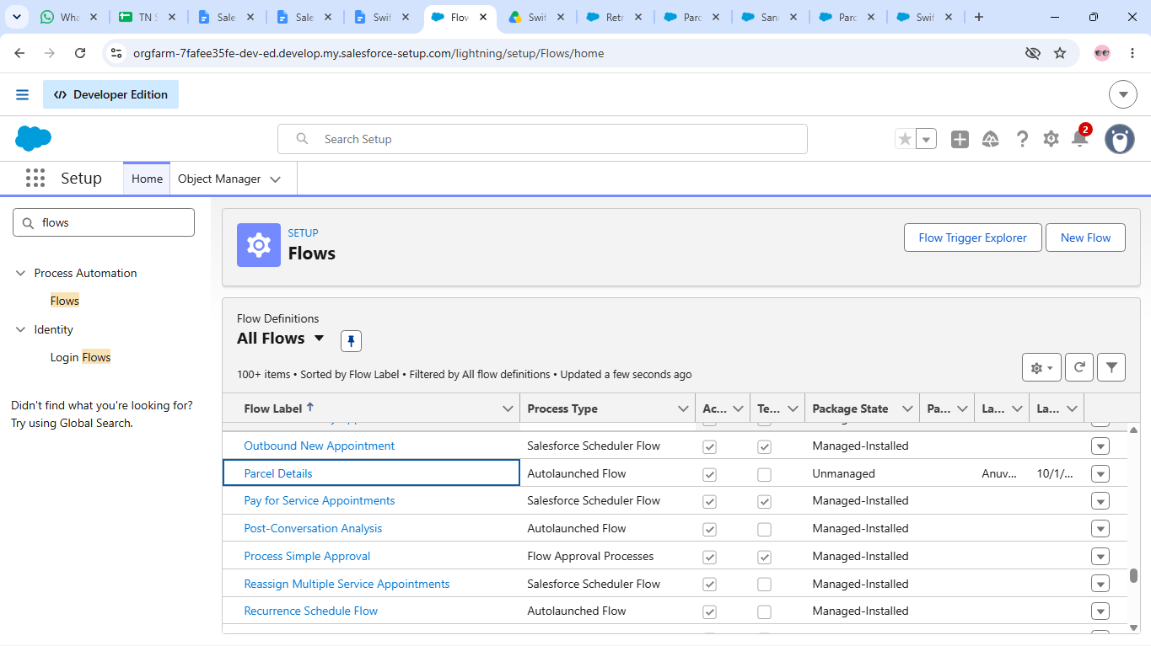

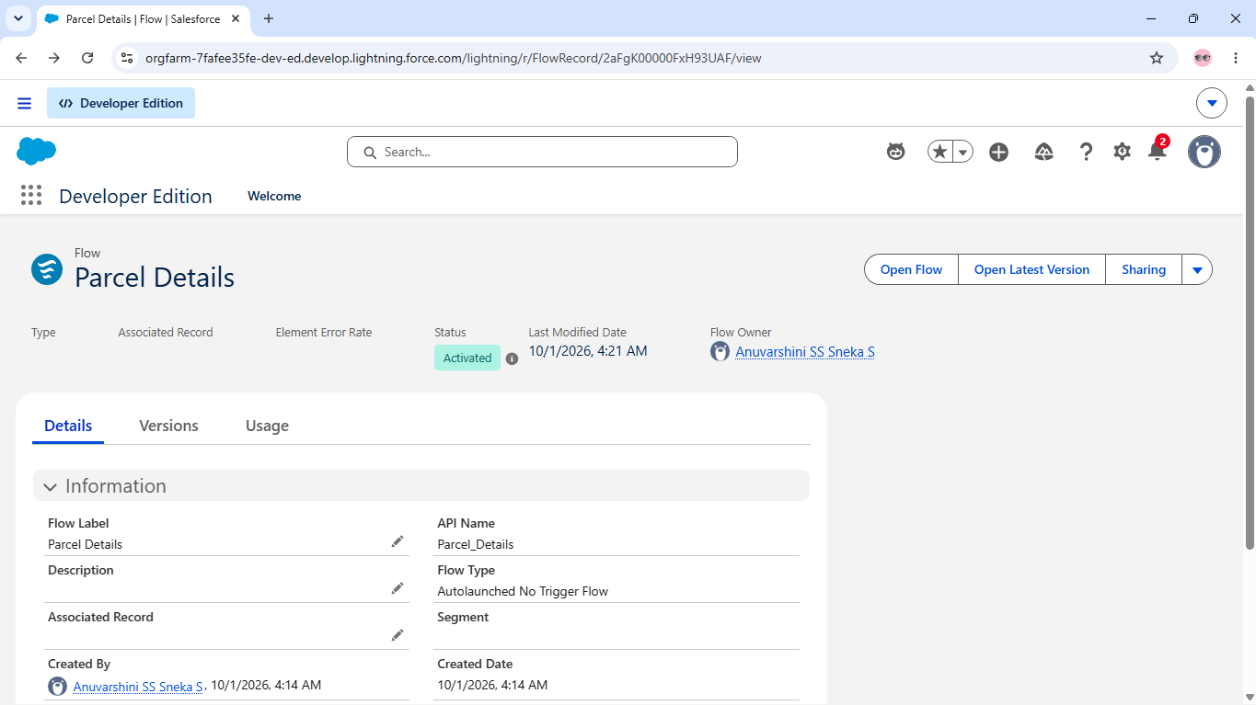

ACTIVATION STATUS

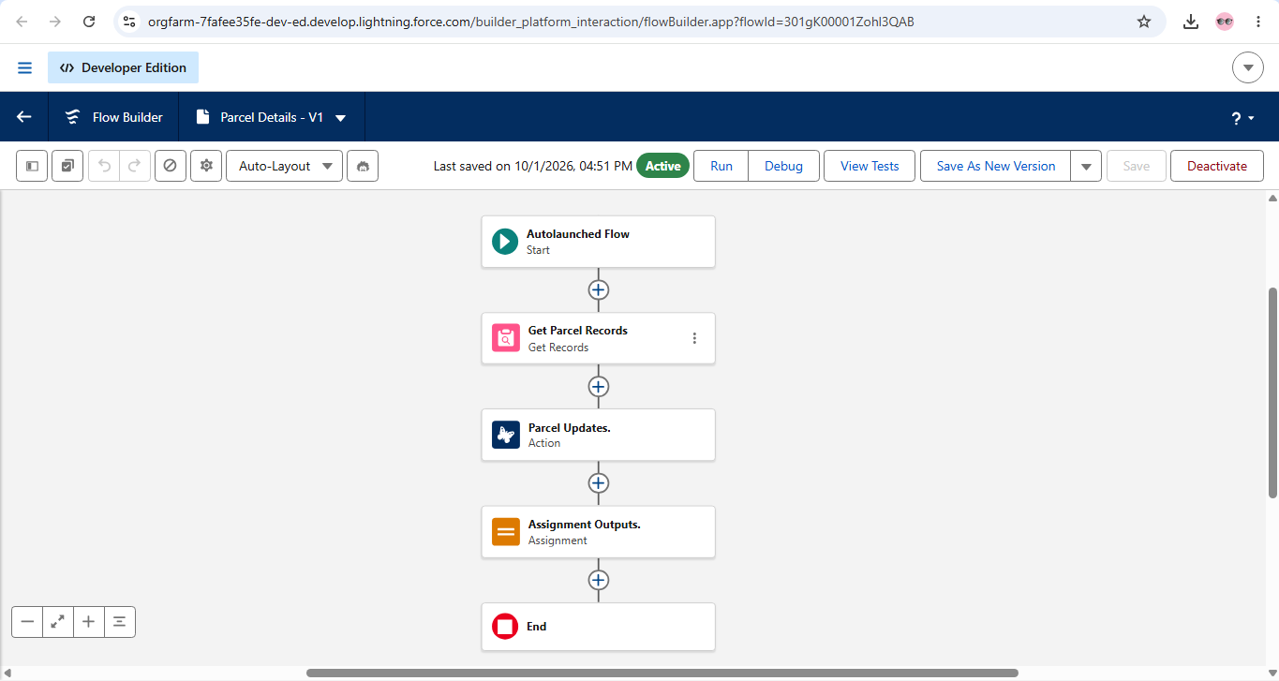

Flow builder for parcel Details

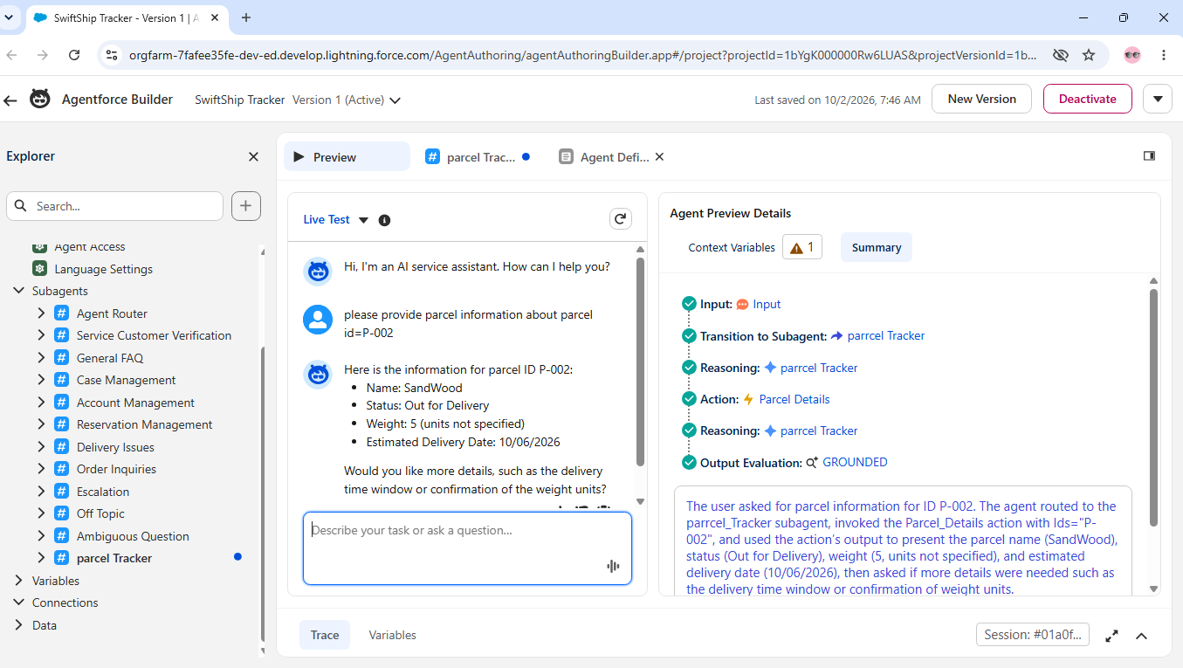
SWIFT SHIP TRACKER OUTPUT

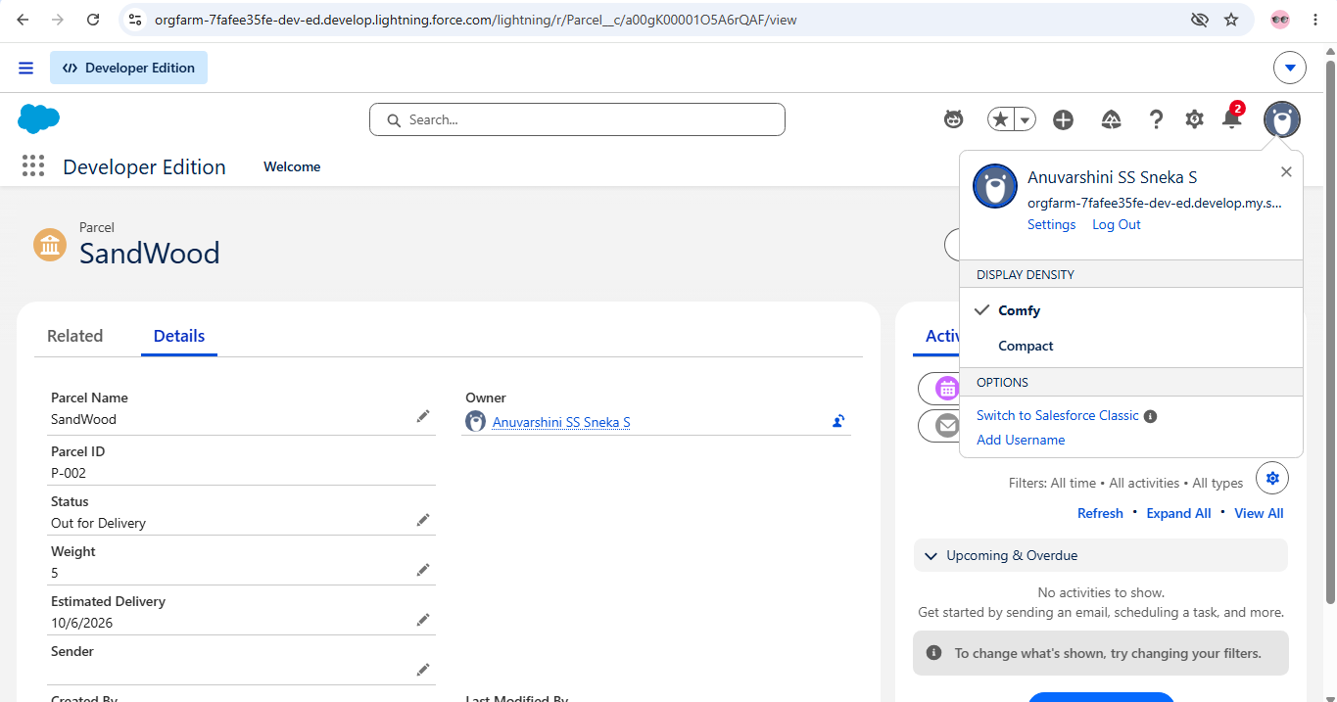

PARCEL NAME

6. PHASE 3 – UI/UX DEVELOPMENT & CUSTOMIZATION
.

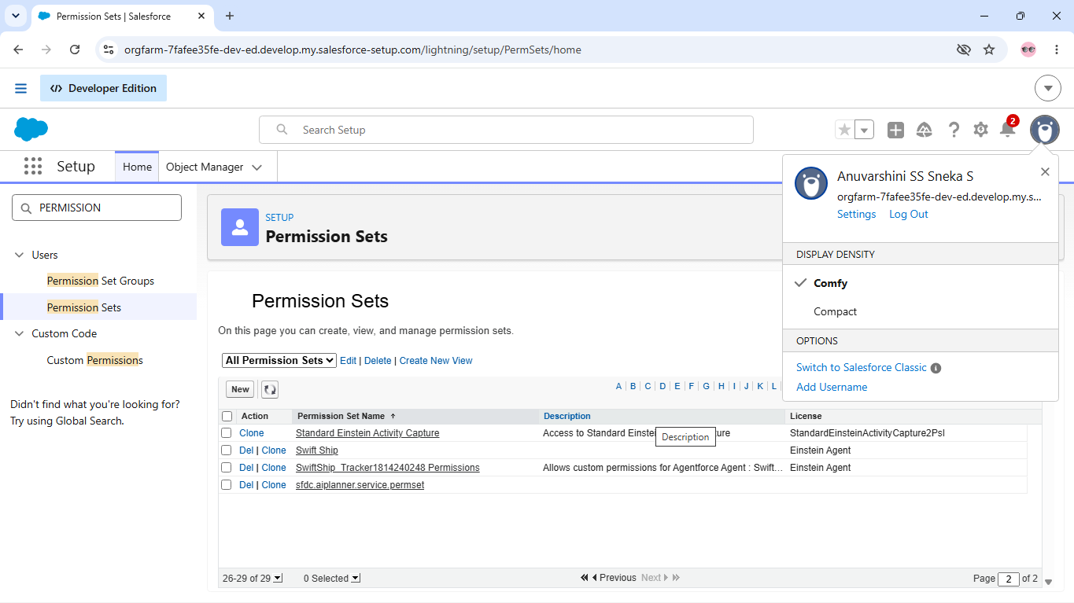

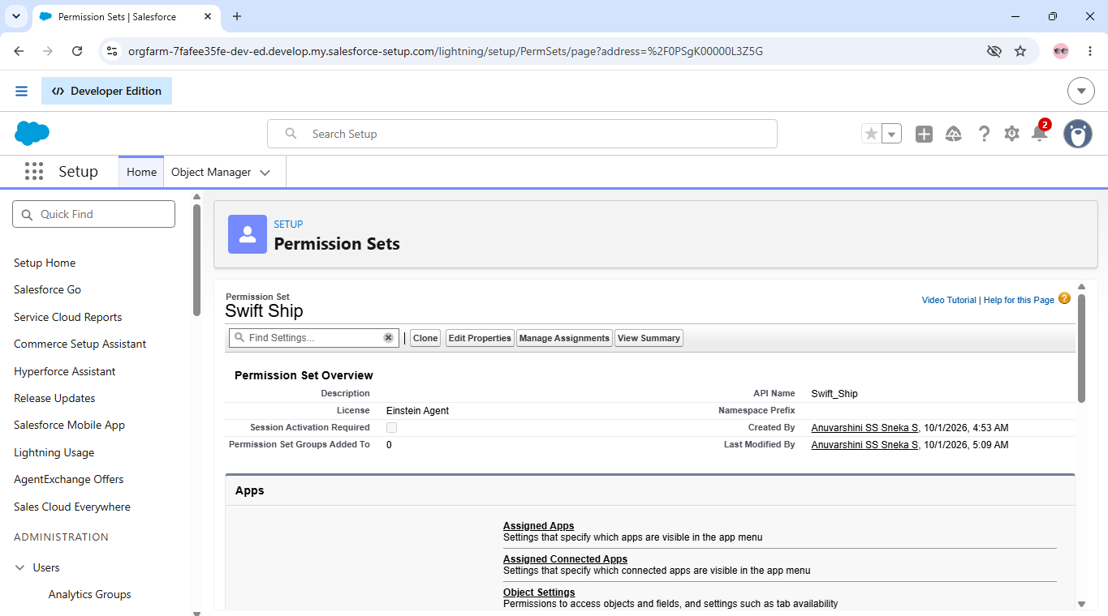
PERMISSION SETS

.

7. Phase 4 – Data Migration, Testing & Security
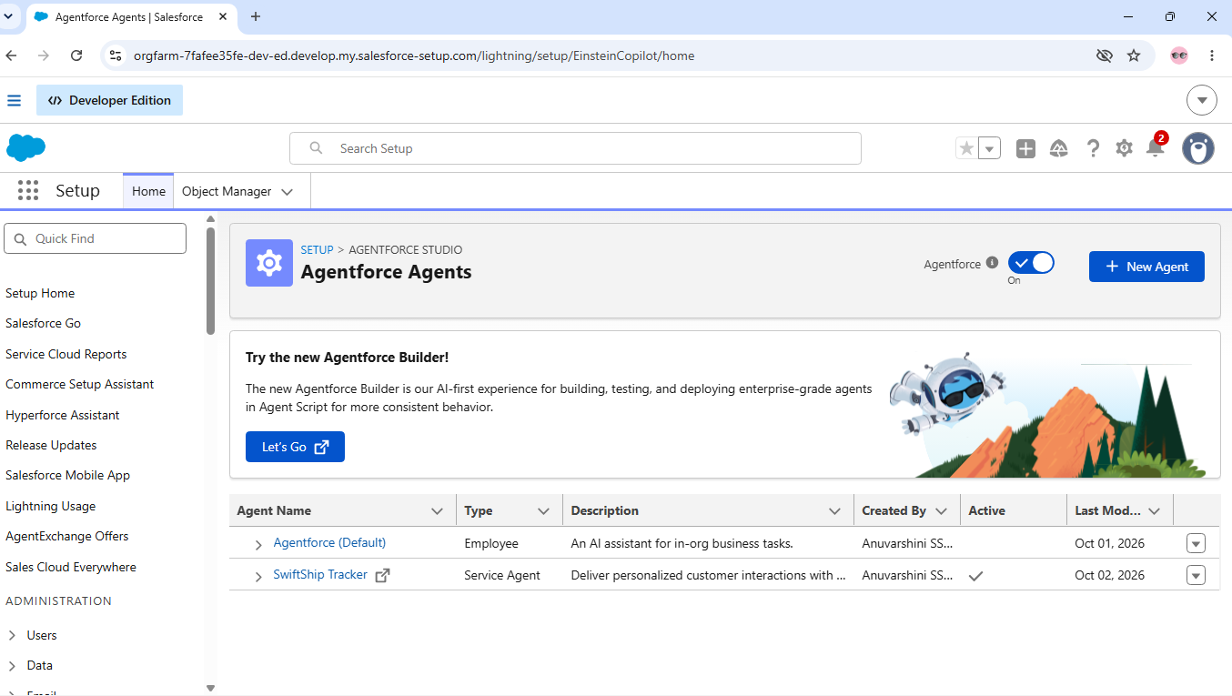

AGENT VERIFICATION

Functional & Performance Testing

Security Testing:

Security configurations were verified using Profiles, Role Hierarchy, Permission Sets, Field-Level Security, and Sharing Rules. These configurations were reviewed to ensure that parcel, sender, receiver, and delivery information is accessed only by authorized users according to their assigned responsibilities.

8. PHASE 5 – DEPLOYMENT, Documentation & Maintenance
Deployment Strategy
The Swift Ship Tracker System was developed and tested in a Salesforce Developer Edition environment. All major components, including custom objects, fields, Flows, Apex functionality, Prompt Builder, and security configurations, were configured and verified within the development environment.
Production deployment was not performed as part of this academic implementation. For a real-world implementation, the configured components can be moved to a production Salesforce environment using appropriate deployment methods such as Sandboxes, Change Sets, Salesforce DX, or DevOps/CI-CD tools.
Before production deployment, the system should be validated through proper testing to ensure that parcel tracking, delivery updates, automation, AI functionality, and user access work as expected.
.

Maintenance Approach
Regular maintenance is important to keep the Swift Ship Tracker system stable and useful as parcel management requirements change.

The maintenance activities would include:

- Monitoring parcel booking and delivery processes for any operational issues.
- Checking shipment records and correcting incomplete or inconsistent information.
- Reviewing parcel status and delivery details to ensure they remain up to date.
- Updating the system interface when users require changes or improvements
- Maintaining tracking information based on changing delivery requirements
- Reviewing user access and ensuring that the appropriate users can access the required information.
Periodically checking the overall system behaviour and resolving issues identified during usage.
.

Sprint Planning / Schedule

Sprint | Total Story  Points | Duration | Sprint Start | Planned End | Story  Points  Completed | Actual Release
Sprint-1 | 20 | 8 Days | 11 Apr  2021 | 18 Apr  2021 | 20 | 19 Apr  2021
Sprint-2 | 20 | 6 Days | 12 May  2023 | 17 May  2023 | — | —
Sprint-3 | 20 | 5 Days | 14 Nov  2023 | 18 Nov  2023 | — | —
Sprint-4 | 20 | 4 Days | 11 Dec  2023 | 14 Dec  2023 | — | —

Project Tracker, Velocity & Burndown Chart

The project progress was planned and tracked using sprint-wise story points. The project tracker records the planned story points, sprint duration, start date, planned end date, completed story points, and actual release date. Velocity and burndown tracking can be used to monitor sprint progress and support future estimation.

9.Advantages & Disadvantages
9.1.Advantages

- Centralized Shipment Management – Swift Ship Tracker brings parcel, sender, receiver, and delivery information together in one organized system..
- Improved Parcel Visibility – Users can easily follow shipment progress and view the current stage of parcel delivery.
- Efficient Delivery Handling – Delivery-related information can be maintained systematically, helping staff manage shipments more effectively..
- Reduced Manual Work – The system minimizes repetitive activities involved in maintaining and updating parcel records..
- Easy Parcel Identification – Each shipment can be identified using its unique Parcel ID, making information retrieval easier..
- Better Information Access – Required parcel and delivery details can be accessed quickly from the system
- Improved Coordination – Connecting sender, receiver, parcel, and delivery information helps maintain a clear flow of shipment details..
- Customer Convenience – Customers can obtain relevant parcel information without depending entirely on manual communication..

9.2 Disadvantages

- Data Accuracy Requirement – The system requires accurate and updated parcel and customer information for proper shipment management
- Salesforce Configuration Dependency – System functionality depends on the proper configuration of Salesforce features and automation..
- AI Response Dependency – Agentforce responses depend on suitable prompts and the availability of relevant parcel information..
- Integration Complexity – Connecting the system with external logistics services may require additional technical configuration..
- Automation Maintenance – Changes in delivery processes may require updates to existing flows and automated operations..

10.Conclusion
The SwiftShip Tracker demonstrates how Salesforce can be used to create a centralized solution for parcel management and shipment tracking. The system connects Parcel, Sender, Receiver, and Delivery information to support parcel booking, delivery monitoring, status updates, and customer communication.
The project uses Salesforce Lightning, Flows, Apex, Email Alerts, Experience Cloud, Agentforce AI, Prompt Builder, security controls, Reports, and Dashboards to support the major requirements of the parcel management process. The combination of Agentforce AI, Prompt Builder, and Salesforce Flow also provides a conversational way for users to access shipment information with less dependence on manual support.
Overall, the SwiftShip Tracker provides a structured foundation for managing parcel operations and can be further enhanced with additional tracking, automation, and customer-service capabilities.

11.Future Scope
The SwiftShip Tracker can be further enhanced to support expanding parcel operations and provide better tracking, automation, integration, and customer services..
- Delivery Route Planning – Introduce route-based planning to help delivery teams organize shipments more effectively.
- Priority Shipment Handling – Add options to identify and manage urgent or priority parcels separately..
- Delivery Slot Management – Provide customers with suitable delivery time-slot options based on operational availability.
- Exception Management – Add features to identify delayed, misplaced, or unsuccessful deliveries and record appropriate actions.
- Customer Feedback Module – Enable customers to submit feedback after delivery and use the information to improve service quality.
- Shipment History – Maintain a detailed history of previous parcel activities for easier reference and review.
- Operational Alerts – Provide alerts for important delivery events such as delays, failed delivery attempts, or pending actions..
Performance Monitoring – Introduce additional measures to monitor delivery-agent activities and overall shipment handling efficiency

12.APPENDIX

A. Custom Objects
- Parcel
- Sender
- Receiver
- Delivery

B. Automation
- Record-Triggered Flow – Parcel Status Update
- Record-Triggered Flow – Delivery Information Update
- Scheduled Flow – Shipment Monitoring
- Validation Rule – Parcel Information Validation

C. Standard Objects
- Account – Stores customer details.
- Contact – Stores contact information.
- Task – Tracks assigned activities.

D. Security
- Profiles – System Administrator, Delivery Agent, Support Staff, Customer
- Roles – Administrator, Delivery Manager, Delivery Agent, Customer
- Permission Set – Parcel Tracking Access
- Field-Level Security – Parcel and Delivery Information
- Sharing Rules – Parcel Access for Delivery Users
E. Apex
• Apex Classes – Handles custom processing.
• Parcel Record Data Management

F. UI
- Lightning App – Provides the main application interface.
- Lightning Record Pages – Displays record information.

G. Testing
- Flow – Tests automation processes.
- AgentForce – Tests AI responses.
- Security and Permission Validation – Checks user access.

H. Analytics
• Reports – Displays shipment information.
• Dashboards – Shows shipment data visually.

Thank You!!

