**Tutorial 1**

1. Consider two cooperating processes X and Y perform the concurrent execution, whose code is given below with two boolean variables ***varP*** and ***varQ*** are initialized as ***False***: Check the existence of the following conditions with proper justification a) Mutual Exclusion b) Deadlock

|  |  |
| --- | --- |
| **Process X** | **Process Y** |
| While (True)  varP=True;  while(varQ==True);  Critical Section  varP= False;  } | While (True)  varQ=True;  while(varP==True);  Critical Section  varQ= False;  } |

1. The following two functions P1 and P2 that share a variable B with an initial value 2 execute concurrently.

|  |
| --- |
| P1() P2()  { {  C=B-1; D=2*B;  B=2*C; B=D-1;  } } |

Which are the distinct values that B can possibly take after the execution?Justify your answer.

1. 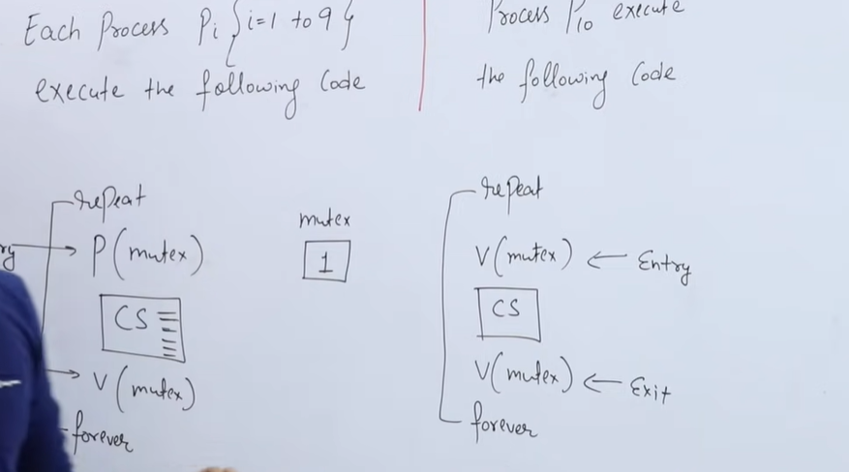

What is the maximum number of processes can be At a time how many process can be there in cs? Ans:All 10 processes.

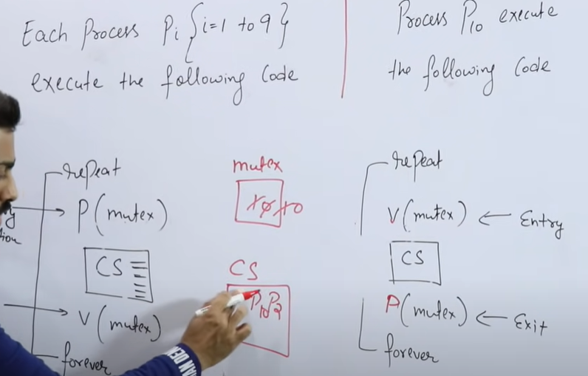

Ans: 3 processes

5.check whether Mutual exclusion and Progress satisfied or not?

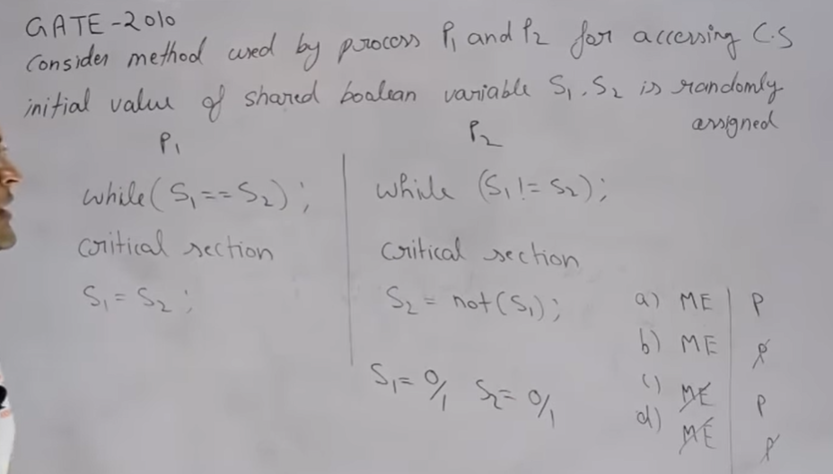

Ans: ME satisfied but Progress not be here.

1. Check whether Mutual exclusion and Deadlock are satisfied or not?

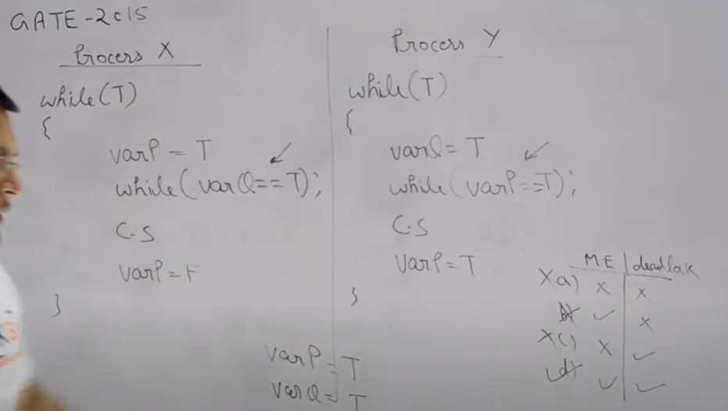

Ans: ME and deadlock are satisfied.

7. Consider three concurrent processes with three binary semaphores, initialized as S0=1 ,S1=0 and S2=0. How many times will the process P0 print “0”? Justify your answer.

