INTRODUCTION TO PYTHON
Lab sheet 1
Give proper comments in your jupyter notebook.
Answers to Lab sheets to be submitted before the due date. Download the PDF and .ipynb version of the jupyter notebook and submit in AUMS. The lab sheet should be named 22AIE205-rollnumber-Lab-number.pdf

- You are tasked with creating a program that determines whether a given year is a leap year or not. A leap year is a year that is exactly divisible by 4, except for years that are divisible by 100 but not by 400. Write a Python program that takes a year as input and prints whether it is a leap year or not.
Conditions for Leap year
- If a year is divisible by 4 and not divisible by 100, it is a leap year.
- If a year is divisible by 100 and not divisible by 400, it is not a leap year.
- If a year is divisible by 400, it is a leap year.

- You are responsible for grading the final exam of a computer science class. The grading scale is as follows:
A: 90-100
B: 80-89
C: 70-79
D: 60-69
F: Below 60
Write a Python program that takes a student's exam score as input and determines their grade using an if-else ladder. The program should display the grade earned by the student.

- You are building a program to calculate the cost of shipping a package. The cost depends on the weight of the package and the distance it needs to be shipped. Here are the rules:
• If the package weighs less than or equal to 2 pounds, the base cost is $5.00.
• If the package weighs more than 2 pounds but less than or equal to 10 pounds, the base cost is $10.00.
• If the package weighs more than 10 pounds, the base cost is $20.00.
• If the distance is less than or equal to 100 miles, there's no additional charge.
• If the distance is greater than 100 miles but less than or equal to 500 miles, there's a $5.00 additional charge.
• If the distance is greater than 500 miles, there's a $10.00 additional charge.

- Accepting user input. Write your observations of the output of (a) to (d)
(a)

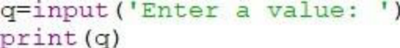

(b)

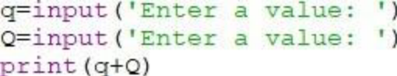

(c)

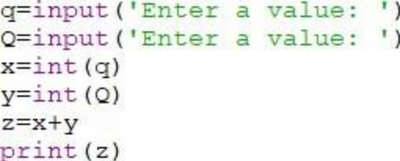

(d)

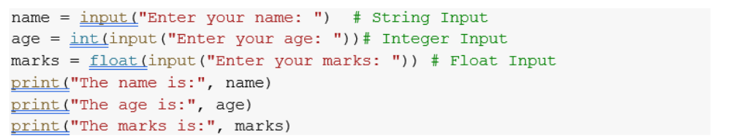

- Write a program to read the number of seconds and print it in the form
hr:min:sec.

- Which out of the code snippets below, print the numbers from 1 to 10. Give the reason for the error in the code snippets below which does not print from 1 to 10.

(a)

i=1
while i<10:
print(i)
i=i+1
(b)
i=1
while i<=10:
print(i)
i=i+1
(c)
i=3
while i<=10:
print(i)
i=i+2
(d)
i=1
while i<=10:
print(i)
i=i+1
(e)
i=1
while i>=10:
print(i)
i=i+1
(f)
i=1
while i>=10:
print(i)

- Write a Python program that prints all the numbers from 0 to 100 except multiples of 3 or 5.
[Hint: Use continue statement.]

- Write a Python program to take an n-digit integer and print the digits of the number from left to right and right to left.

- Write a python program to check if a number given by the user is a palindrome. (Hint: A number is a palindrome if the number is equal to its reverse.)

- Write a Python program to find the sum of the below series provided n is a number given by the user.
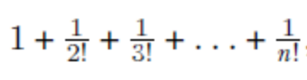
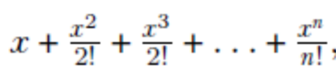

- Write a program to check whether a number is strong number or not.Strong number is a special number whose sum of factorial of digits is equal to the original number. For example: 145 is strong number. Since, 1! + 4! + 5! = 145
- Write python program to print the below patterns. Take as input no: of rows

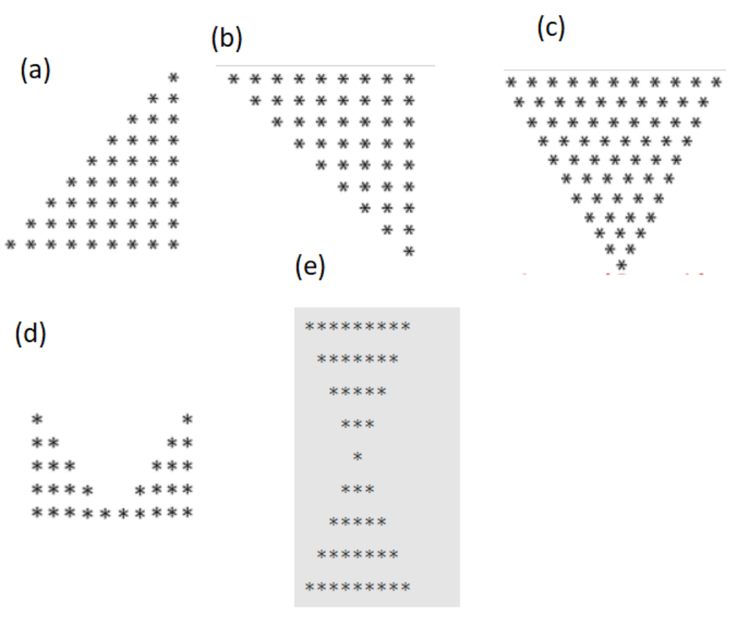

- Write a Python program to print the below patterns.

