Date: 23/4/2024

**Lab Assignment - 1**

**Signal Generation**

**Name :** Anuvind M P

**Roll no :** AM.EN.U4AIE22010

|  |
| --- |
| Course Outcome:  CO1: Familiarise the basic concepts of communication systems |

.1. Plot the following **elementary signals**.

1. Unit Impulse
2. Unit Step
3. Ramp

Continuous Signals

t = (-1:0.01:1)';

impulse = t==0; %in red

unitstep = t>=0; %in blue

ramp = t.*unitstep; %in yellow

subplot(2,1,1);

plot(t,impulse,'r', t, unitstep,'b',t, ramp,'y')

title('Unit Impulse, Unit Step & Ramp');

xlabel('Time (seconds)');

ylabel('Amplitude');

**Plot:**

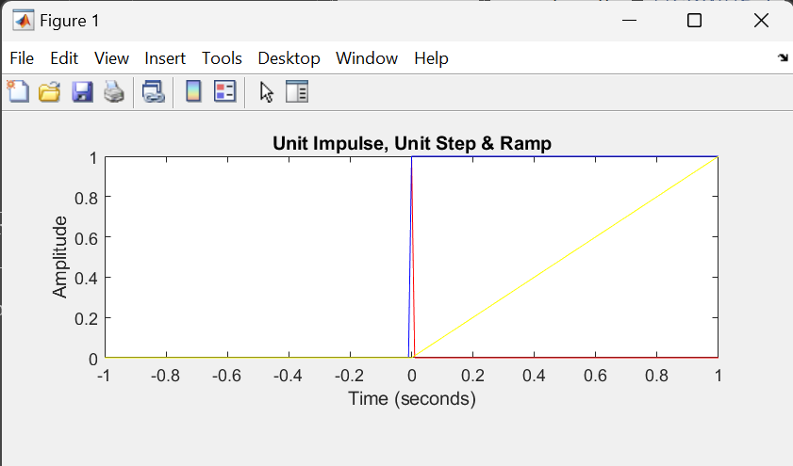

Discrete Signals

t = -1:0.2:1;

impulse_discrete = zeros(size(t));

impulse_discrete(t == 0) = 1;

step_discrete = zeros(size(t));

step_discrete(t >= 0) = 1;

ramp_discrete = t .* (t >= 0);

subplot(3,1,1);

stem(t, impulse_discrete);

title('Discrete Time: Unit Impulse Signal');

xlabel('Time (seconds)');

ylabel('Amplitude');

subplot(3,1,2);

stem(t, step_discrete);

title('Discrete Time: Unit Step Signal');

xlabel('Time (seconds)');

ylabel('Amplitude');

subplot(3,1,3);

stem(t, ramp_discrete);

title('Discrete Time: Ramp Signal');

xlabel('Time (seconds)');

ylabel('Amplitude');

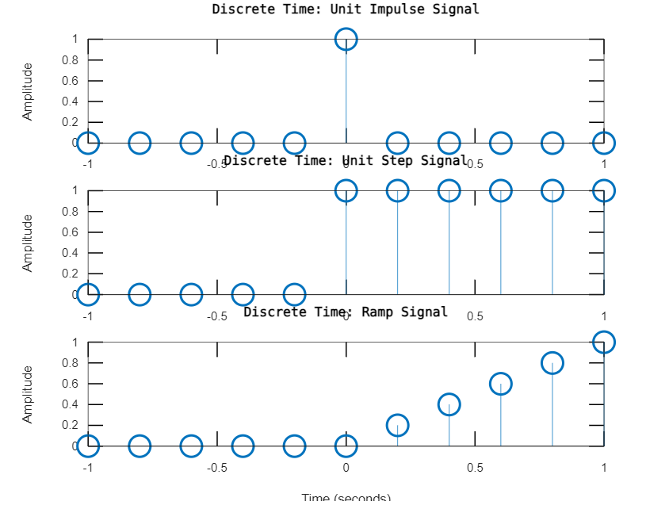

**2. Generate and plot the following continuous time signals (Define the time vector, t to range from 0 to 1 second, with a sampling rate of 1000 Hz)**

**a. Sinusoidal Signal**

**Code:**

1. **What happens if you increase the frequency? How does it affect the waveform?**
2. **How does changing the amplitude affect the waveform?**
3. **How does changing the phase affects the waveform? (Plot for phi values pi/2, pi/4, pi, -pi/2)**

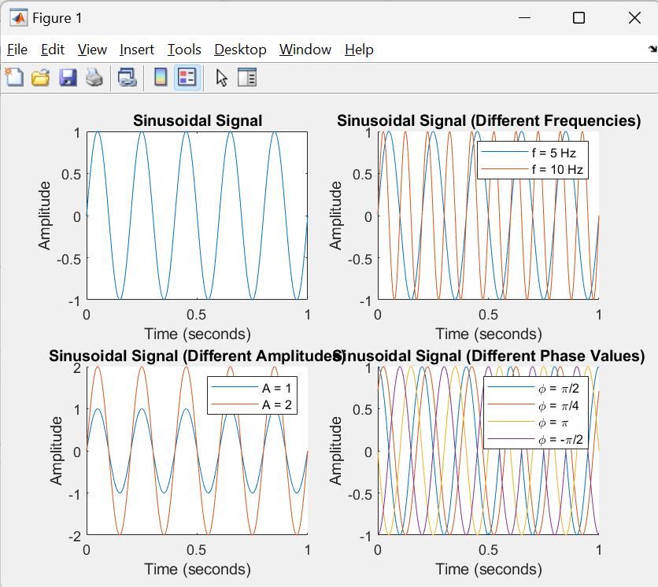

**b. square signal**

**C. exponential signal**

1. **Sawtooth signal**
2. **Triangular signal**

**t = 0:0.001:1;**

**f =5;**

**A = 1;**

**A_square = 0.81;**

**T_square = 0.5;**

**y_square = A_square * square(2 * pi * (1 / T_square) * t);**

**subplot(2, 2, 1);**

**plot(t, y_square);**

**title('Square Signal');**

**xlabel('Time (seconds)');**

**ylabel('Amplitude');**

**y_exp = exp(-2 * t);**

**subplot(2, 2, 2);**

**plot(t, y_exp);**

**title('Exponential Signal');**

**xlabel('Time (seconds)');**

**ylabel('Amplitude');**

**y_sawtooth = sawtooth(2*pi*f*t);**

**subplot(2, 2, 3);**

**plot(t, y_sawtooth);**

**title('Sawtooth Signal');**

**xlabel('Time (seconds)');**

**ylabel('Amplitude');**

**y_triangular = sawtooth(2 * pi * f*t, 0.5);**

**subplot(2, 2, 4);**

**plot(t, y_triangular);**

**title('Triangular Signal');**

**xlabel('Time (seconds)');**

**ylabel('Amplitude');**

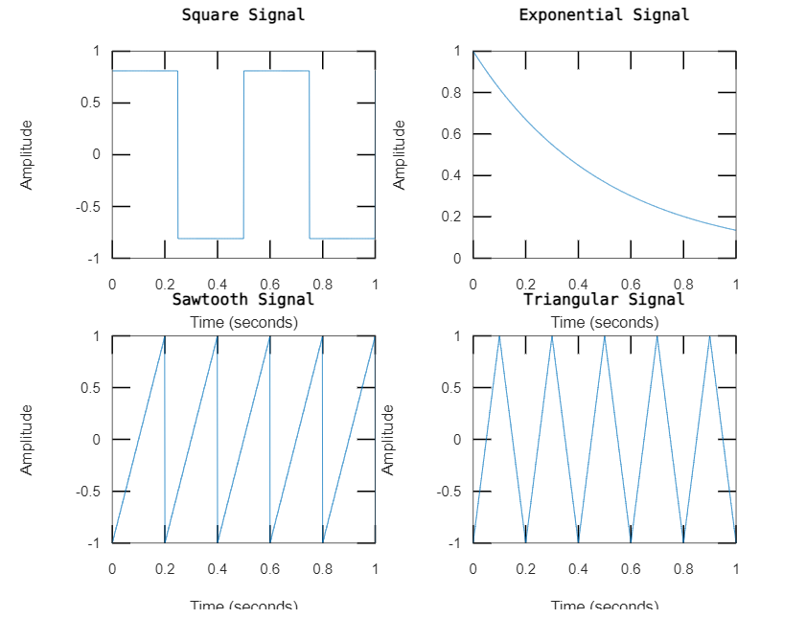

**3. Generate and plot the following signals. (Signal Operations)**

**a. x1(t) = sin(2*pi*t/T).*exp(-2*t)**

**b. x2(t) = 2*cos(2*pi*t/T2).*sin(2*pi*t/T3)**

**c. x3(t) = sin(2*pi*t/T).*exp(-2*t)+sin(2*pi*t/T1).*exp(-4*t)**

**d. x4(t) = aa*u(t), (take aa=5, u(t) is step signal, Plot both u(t) and x4(t))**

figure;

t = 0:0.01:5;

T = 2;

T2 = 2;

T3 = 3;

T1 = 3;

aa = 5;

u_t = t >= 3;

x1 = sin(2*pi*t/T) .* exp(-2*t);

x2 = 2 * cos(2*pi*t/T2) .* sin(2*pi*t/T3);

x3 = sin(2*pi*t/T) .* exp(-2*t) + sin(2*pi*t/T1) .* exp(-4*t);

x4 = aa * u_t;

subplot(3, 2, 1);

plot(t, x1);

title('x1(t) = sin(2*pi*t/T).*exp(-2*t)');

xlabel('Time');

ylabel('Amplitude');

subplot(3, 2, 2);

plot(t, x2);

title('x2(t) = 2*cos(2*pi*t/T2).*sin(2*pi*t/T3)');

xlabel('Time');

ylabel('Amplitude');

subplot(3, 2, 3);

plot(t, x3);

title('x3(t) = sin(2*pi*t/T).*exp(-2*t)+sin(2*pi*t/T1).*exp(-4*t)');

xlabel('Time');

ylabel('Amplitude');

subplot(3, 2, 4);

plot(t, u_t, 'r', t, x4, 'b');

title('x4(t) = aa*u(t)');

xlabel('Time');

ylabel('Amplitude');

legend('u(t)', 'x4(t)');

