**22AIE214 – INTRODUCTION TO ROBOTICS**

**LABSHEET 2**

Name : Anuvind M P

Roll no: AM.EN.U4AIE22010



**CODE:**

A = [0, 0];

B = [1, 1];

C = [5, 2];

P = [-1, -1];

theta = 45;

theta_rad = deg2rad(theta);

T1 = transl2(-P(1), -P(2));

R = trot2(theta_rad);

T2 = transl2(P(1), P(2));

POSE = T2 * R * T1;

vertices = [A; B; C; A];

vertices_hom = [vertices, ones(size(vertices, 1), 1)];

vertices_transformed_hom = (POSE * vertices_hom')';

vertices_transformed = vertices_transformed_hom(:, 1:2);

figure;

hold on;

axis equal;

plot(vertices(:, 1), vertices(:, 2), 'b-', 'LineWidth', 2, 'DisplayName', 'Original Triangle');

plot(vertices(:, 1), vertices(:, 2), 'bo', 'MarkerFaceColor', 'b');

text(vertices(:, 1), vertices(:, 2), {'A', 'B', 'C', 'A'}, 'VerticalAlignment', 'bottom', 'HorizontalAlignment', 'right');

plot(vertices_transformed(:, 1), vertices_transformed(:, 2), 'r-', 'LineWidth', 2, 'DisplayName', 'Transformed Triangle');

plot(vertices_transformed(:, 1), vertices_transformed(:, 2), 'ro', 'MarkerFaceColor', 'r');

text(vertices_transformed(:, 1), vertices_transformed(:, 2), {'A''', 'B''', 'C''', 'A'''}, 'VerticalAlignment', 'bottom', 'HorizontalAlignment', 'left');

title('Original and Rotated Triangles');

legend('show');

hold off;

function T = transl2(x, y)

T = [1 0 x;

0 1 y;

0 0 1];

end

function R = trot2(theta)

R = [cos(theta) -sin(theta) 0;

sin(theta) cos(theta) 0;

0 0 1];

end

**OUTPUT:**

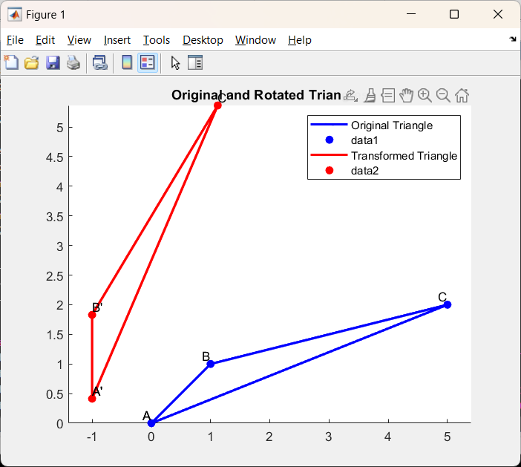



**CODE:**

A = [0, 0];

B = [1, 1];

C = [5, 2];

theta = 45;

theta_rad = deg2rad(theta);

R = trot2(theta_rad);

vertices = [A; B; C; A];

vertices_hom = [vertices, ones(size(vertices, 1), 1)];

vertices_transformed_hom = (R * vertices_hom')';

vertices_transformed = vertices_transformed_hom(:, 1:2);

figure;

hold on;

axis equal;

plot(vertices(:, 1), vertices(:, 2), 'b-', 'LineWidth', 2, 'DisplayName', 'Original Triangle');

plot(vertices(:, 1), vertices(:, 2), 'bo', 'MarkerFaceColor', 'b');

text(vertices(:, 1), vertices(:, 2), {'A', 'B', 'C', 'A'}, 'VerticalAlignment', 'bottom', 'HorizontalAlignment', 'right');

plot(vertices_transformed(:, 1), vertices_transformed(:, 2), 'r-', 'LineWidth', 2, 'DisplayName', 'Transformed Triangle');

plot(vertices_transformed(:, 1), vertices_transformed(:, 2), 'ro', 'MarkerFaceColor', 'r');

text(vertices_transformed(:, 1), vertices_transformed(:, 2), {'A''', 'B''', 'C''', 'A'''}, 'VerticalAlignment', 'bottom', 'HorizontalAlignment', 'left');

title('Original and Rotated Triangles');

legend('show');

hold off;

function R = trot2(theta)

R = [cos(theta) -sin(theta) 0;

sin(theta) cos(theta) 0;

0 0 1];

end

**OUTPUT:**

