**22AIE214 - INTRODUCTION TO ROBOTICS**

**LABSHEET 3**

Name : Anuvind M P

Roll no : AM.EN.U4AIE22010

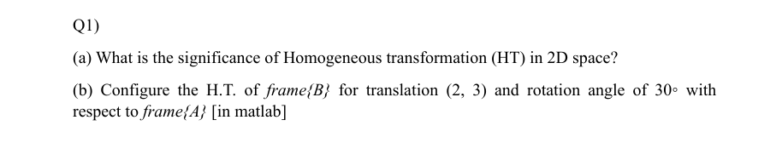

**Answer :**

* Integrate translation, rotation, and scaling into one unified 3x3 matrix.
* Utilize homogeneous coordinates [𝑥,𝑦,1] to facilitate transformations through matrix multiplication.
* Allow straightforward sequential application of multiple transformations by multiplying matrices.
* Crucial in computer graphics, robotics, and computer vision for tasks such as object manipulation and image alignment.



**CODE :**

translation = transl2(2, 3);

rotation = trot2(30, 'deg');

HT = translation * rotation;

disp('Homogeneous Transformation Matrix (HT):');

disp(HT);

figure;

trplot2(HT, 'frame', 'B', 'color', 'g');

**OUTPUT :**

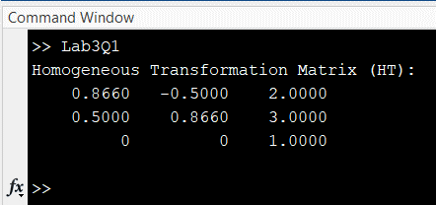

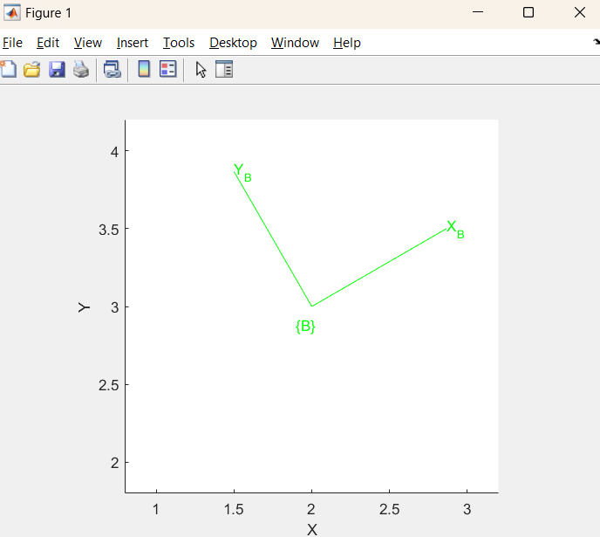

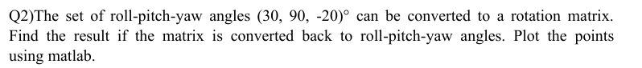

**Answer :**

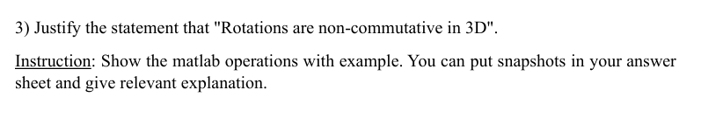

**Answer :**

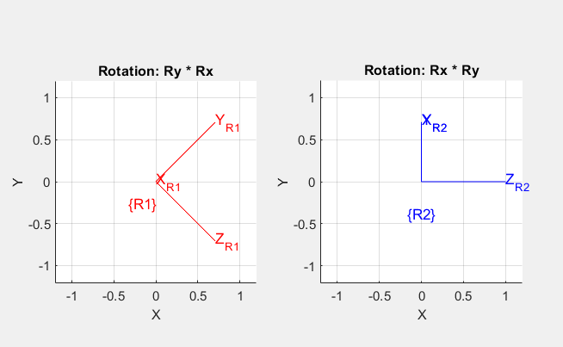

**OUTPUT :**

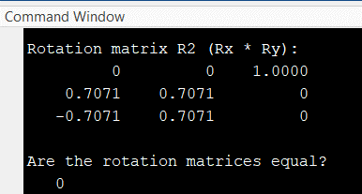

**CODE :**

Rx = rotx(45, 'deg');

Ry = roty(90, 'deg');

R1 = Ry * Rx;

R2 = Rx * Ry;

disp('Rotation matrix R1 (Ry * Rx):');

disp(R1);

disp('Rotation matrix R2 (Rx * Ry):');

disp(R2);

isEqual = isequal(round(R1, 10), round(R2, 10));

disp('Are the rotation matrices equal?');

disp(isEqual);

figure;

subplot(1,2,1);

trplot(R1, 'frame', 'R1', 'color', 'r');

title('Rotation: Ry * Rx');

subplot(1,2,2);

trplot(R2, 'frame', 'R2', 'color', 'b');

title('Rotation: Rx * Ry');