**22AIE214 – INTRODUCTION TO ROBOTICS**

**LABSHEET 5**

**Name : Anuvind M P**

**Roll no: AM.EN.U4AIE22010**

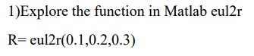

**CODE :**

R= eul2r(0.1,0.2,0.3)

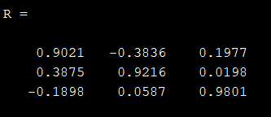

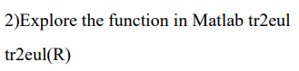

**CODE :**

R= eul2r(0.1,0.2,0.3)

tr2eul(R)

