**LABSHEET-2**

1. **Create a publisher node subscriber node to publishes consecutive integers on the topic counter at a rate of 2Hz and subscribe the count .**

**Code :**

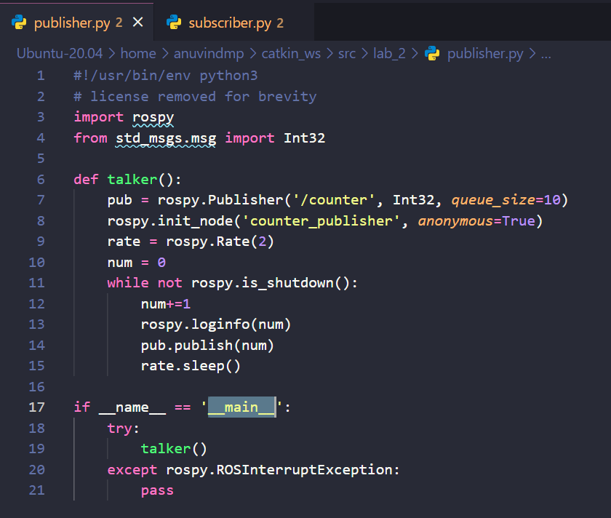

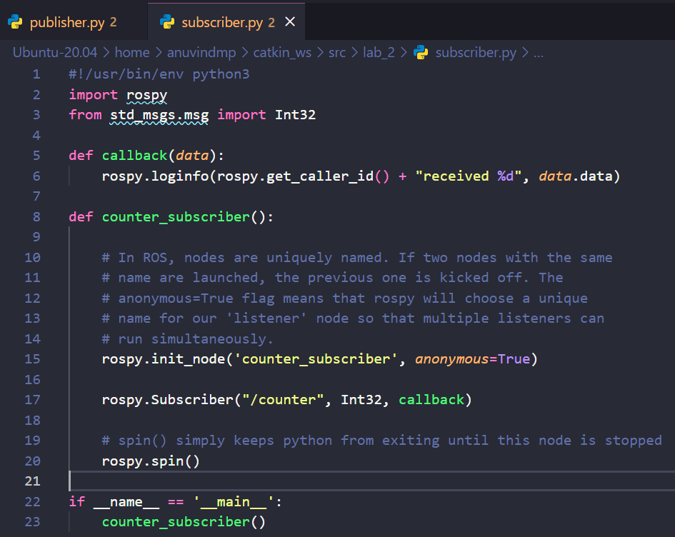

**Output :**

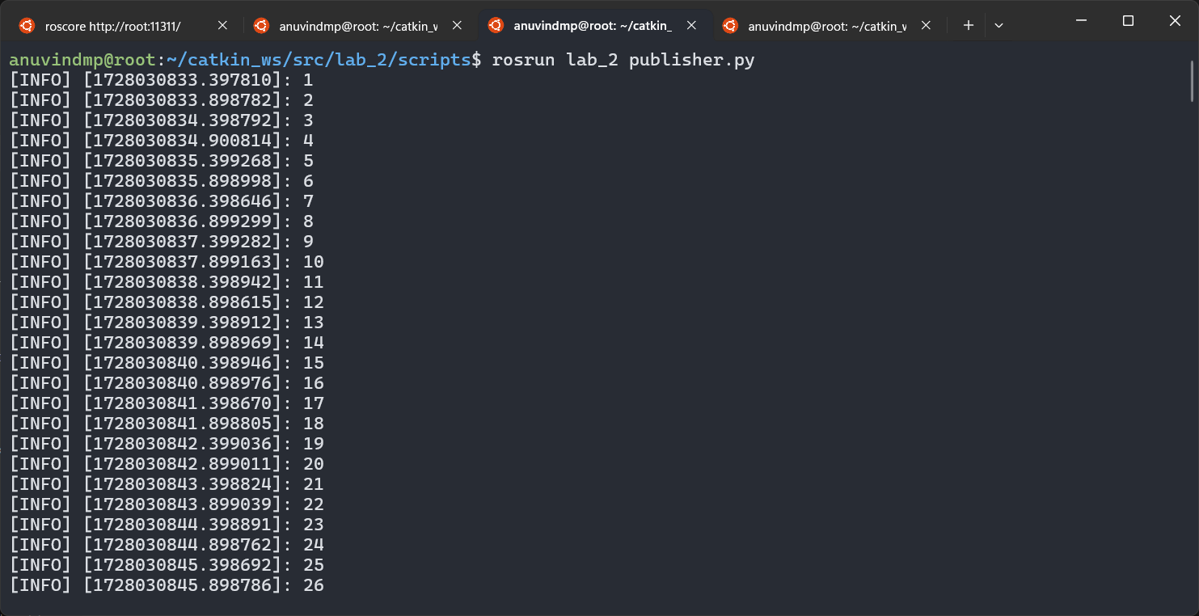

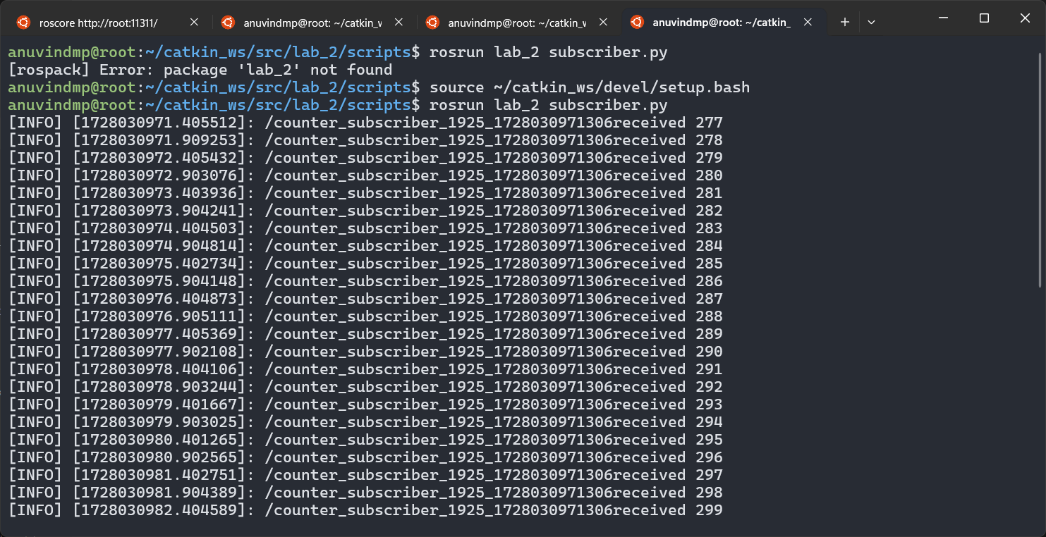

1. **Create a Communication System in ROS with multiple publisher and subscriber.**

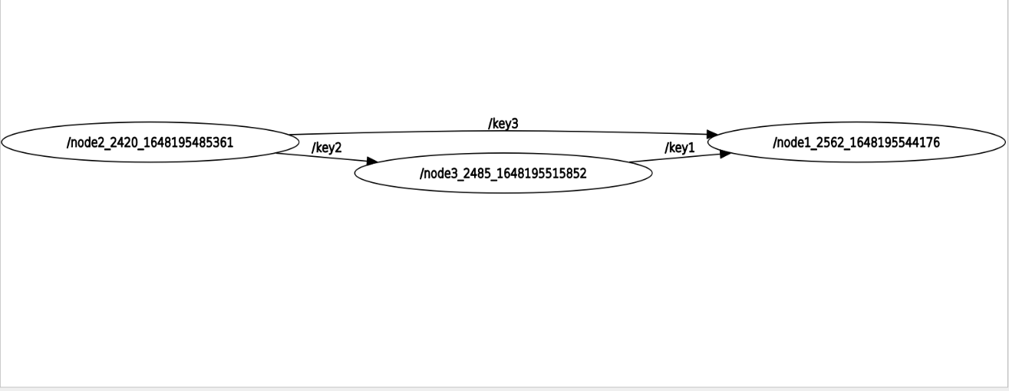

Key1-int

Key2-float

Key3-String

**Code :**

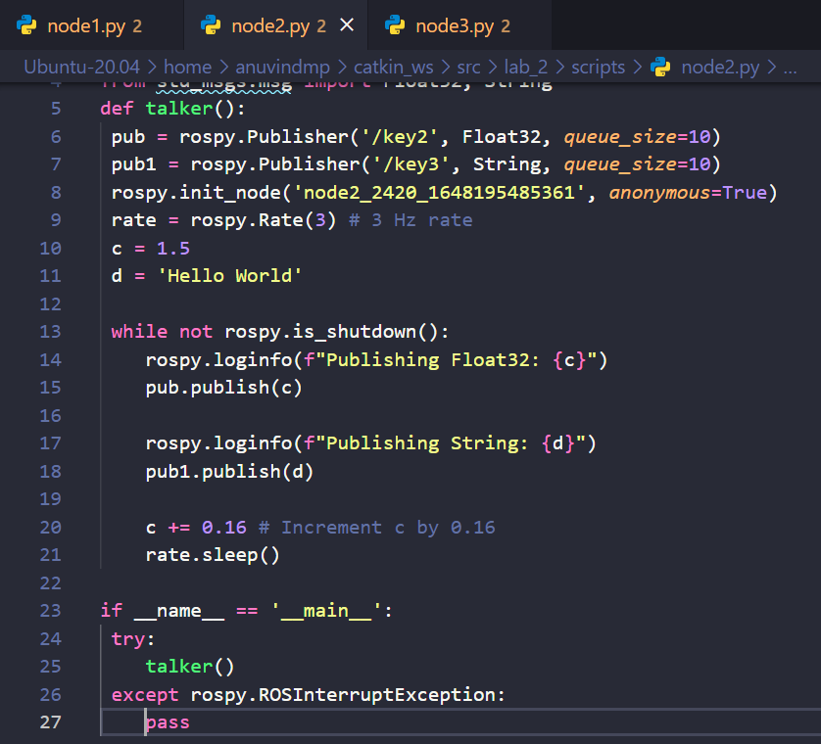



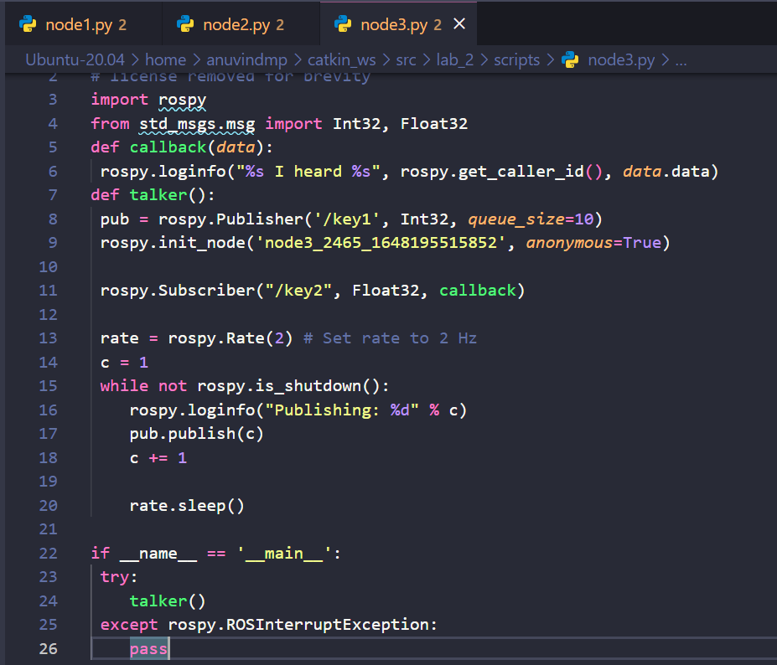

**Output :**

