**22AIE442**

**Labsheet 3**

**Name : Anuvind M P**

**Roll no : AM.EN.U4AIE22010**

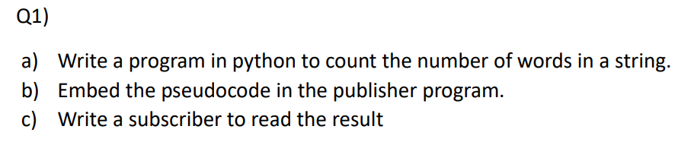



**Code (Publisher):**

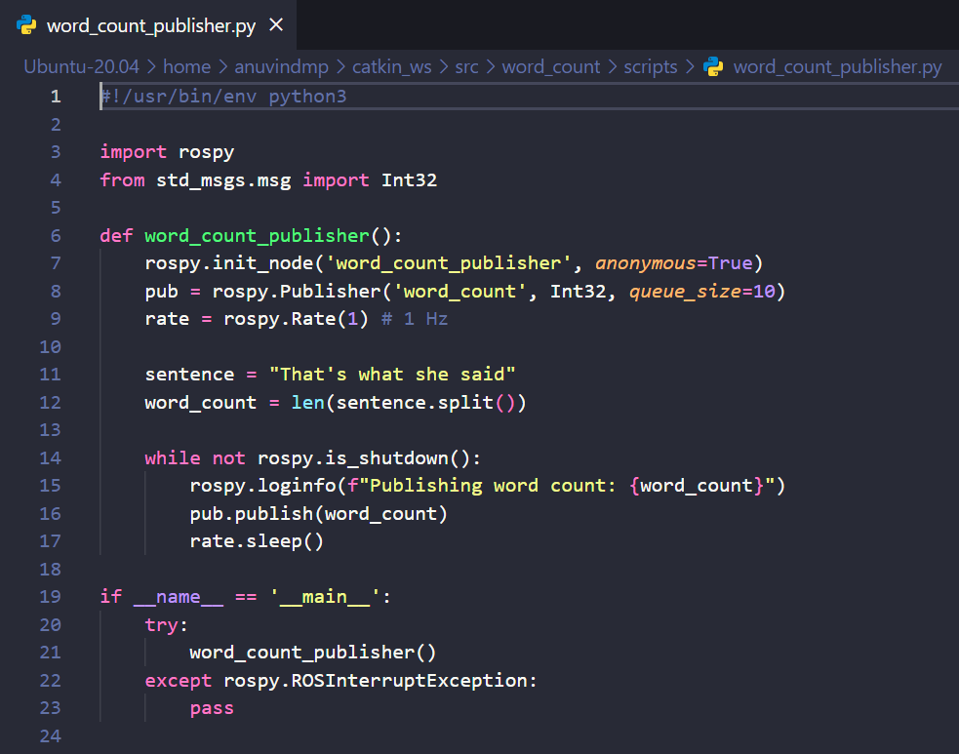

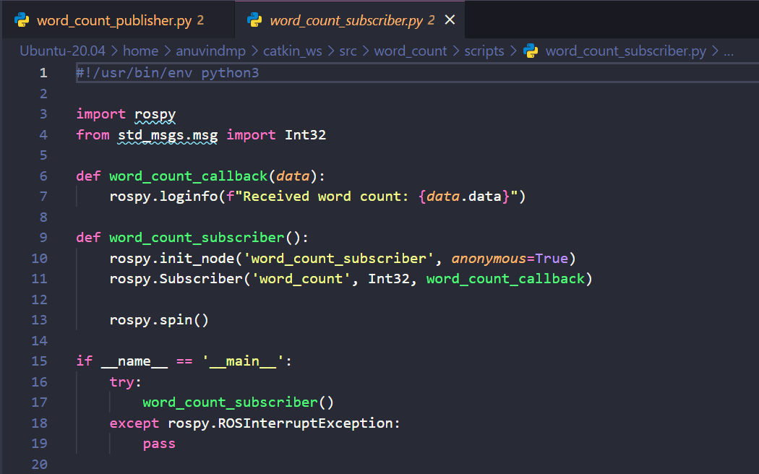**Code (Subscriber):**

**Output (Publisher):**

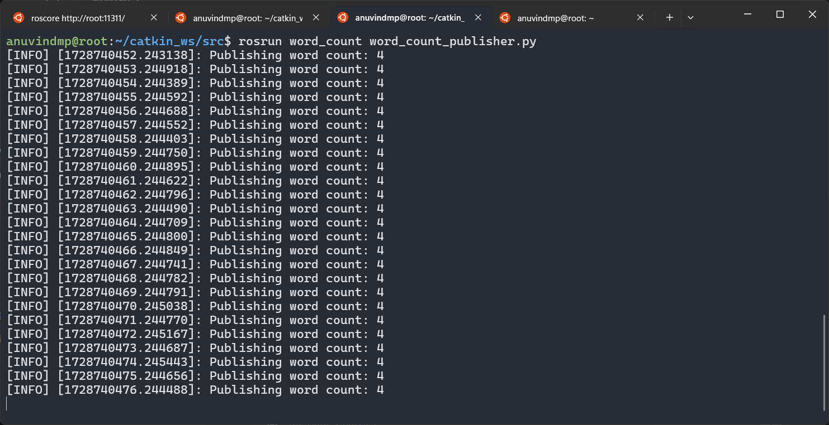

**Output (Subscriber):**

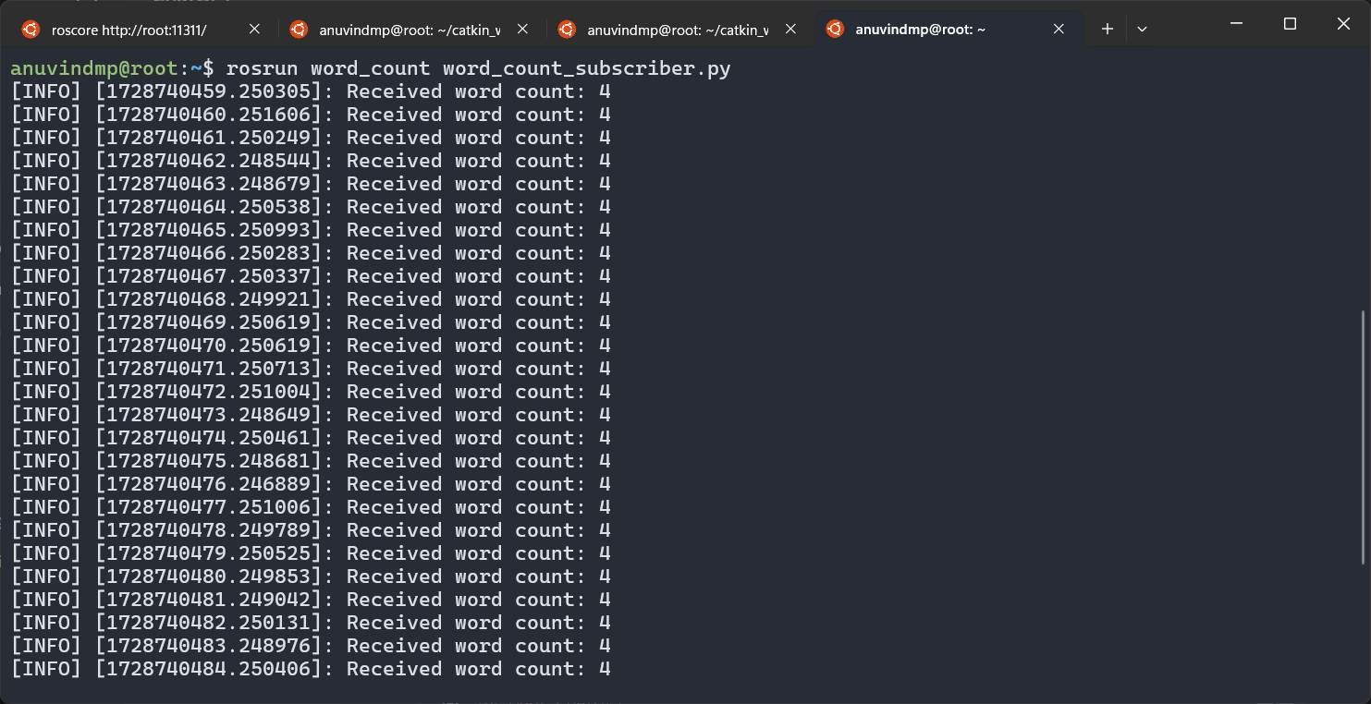



**Code (Publisher):**

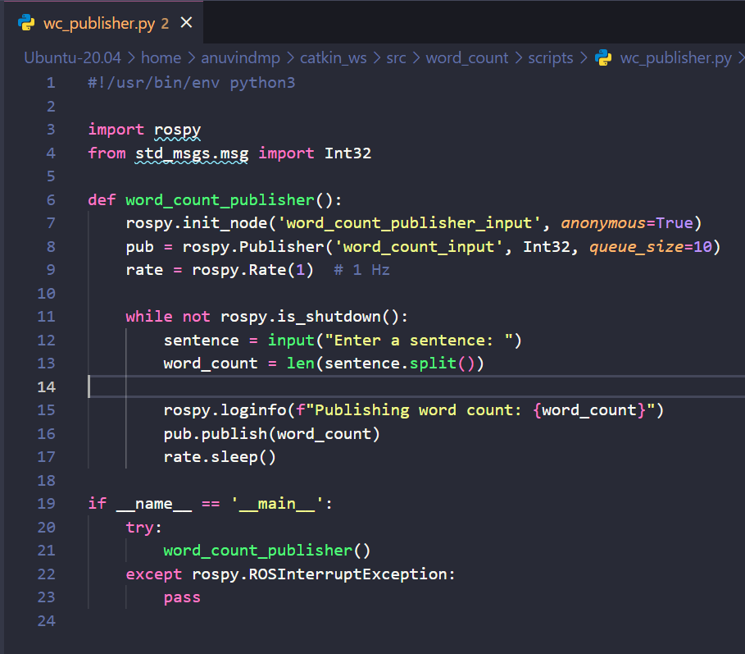

**Code (Subscriber):**

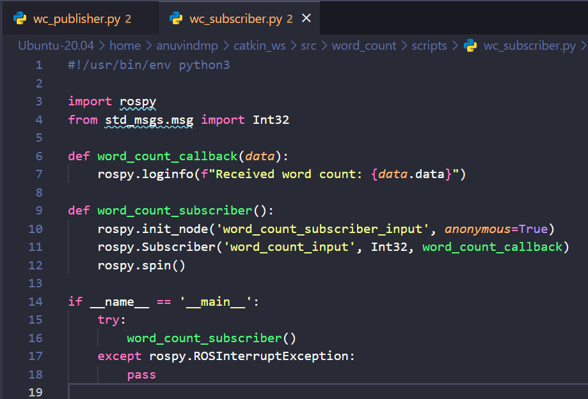

**Output (Publisher):**

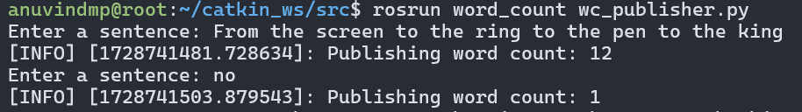

**Output (Subscriber):**

