**22AIE442 –**

**LABSHEET – 4**

Name : Anuvind M P

Roll no: AM.EN.U4AIE22010

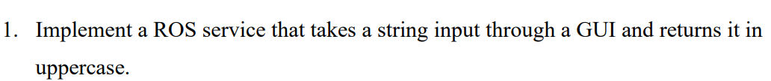

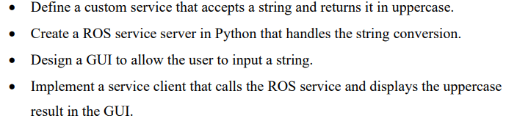

.srv file :

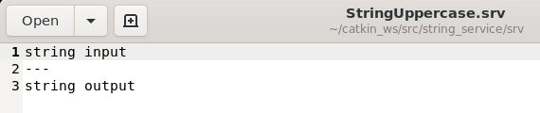

ROS service server CODE:

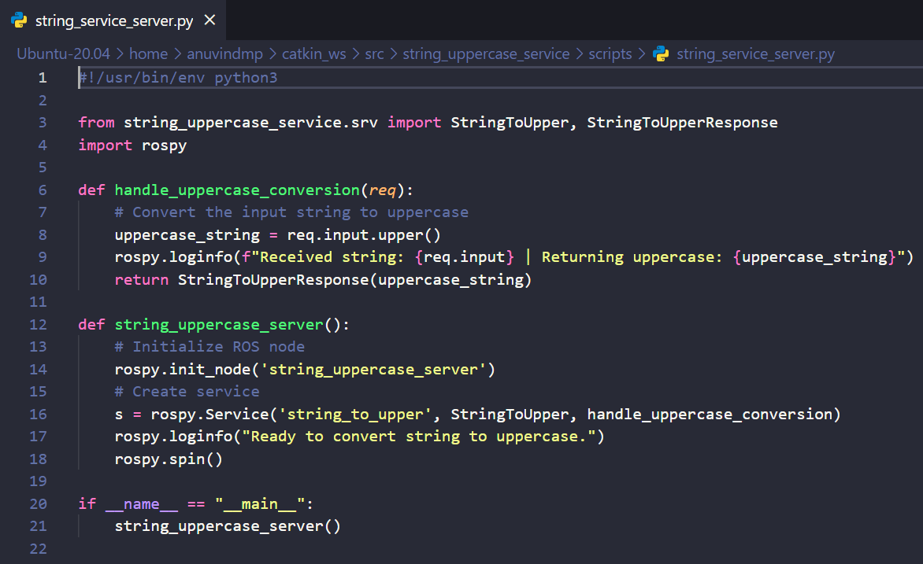

ROS service client CODE:

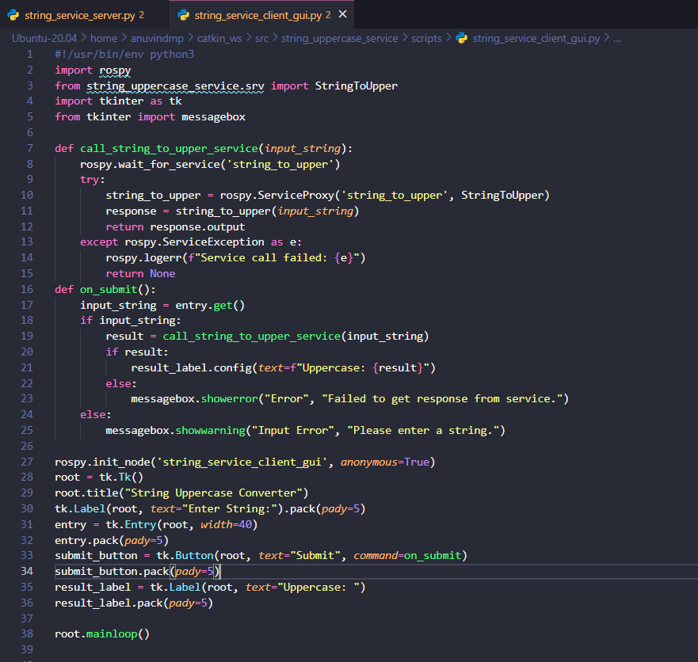

ROS service server output :

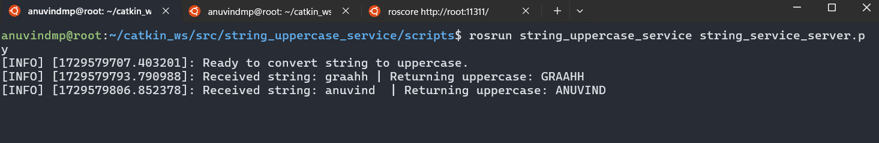

ROS service client output :

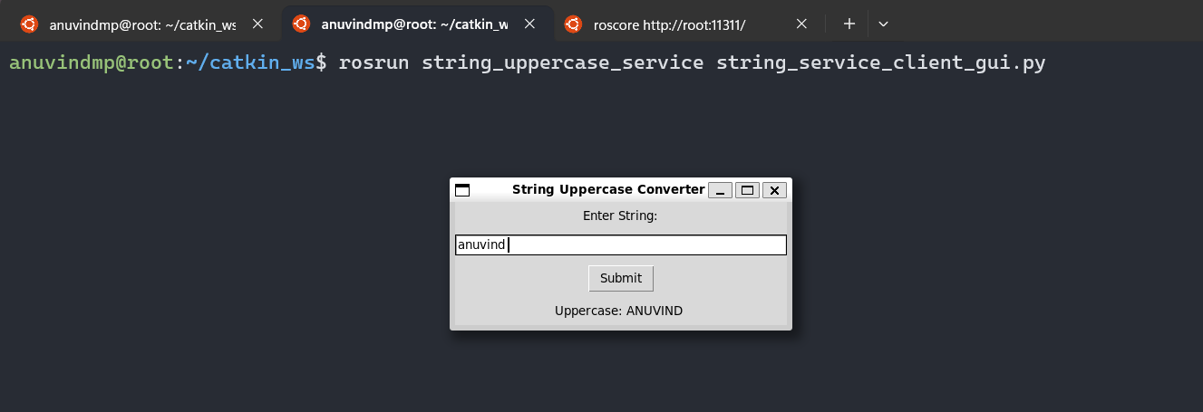

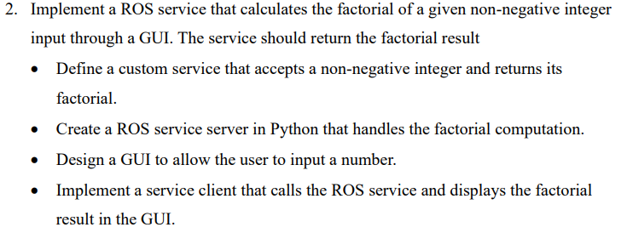

.srv file :

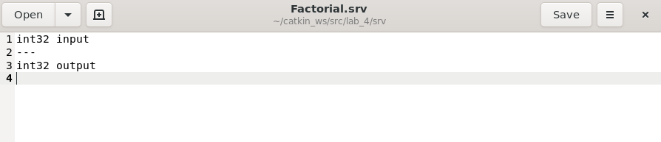

**OUTPUT :**

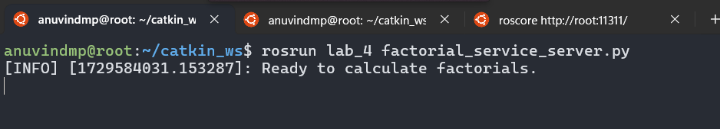

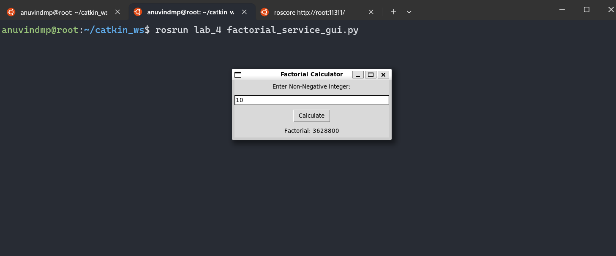

**CODE :**

