THE SLEEP PROJECT

1. System Overview
The primary objective of the system is to predict potential diseases using physiological signals obtained from Polysomnography (PSG) recordings.
The system allows users to upload PSG data, after which an AI model analyzes selected physiological signals and predicts disease-related patterns. Along with the prediction results, the system provides signal summaries, comparison across multiple recordings, and explanatory reports generated using Large Language Models (LLMs).
The application is implemented as a desktop platform using Electron, enabling users to manage sleep study analyses through a centralized dashboard.
2. Key System Features
Disease Prediction
- AI model analyses selected PSG signals
- Generates disease prediction results
- Displays prediction scores and analysis outputs
PSG Upload and Processing
- Users upload PSG recordings
- Signals are processed and relevant features are extracted
- Features are used by the prediction model
Signal Summary
- Generates summaries based on key physiological signals
- Example analyses:
  - EEG activity patterns
  - EMG movement activity
  - other relevant physiological indicators
Multi-Day Comparison
- If multiple PSG recordings are uploaded:
  - signal metrics are compared across days
  - system identifies improvements or deteriorations
LLM-Based Medical Report
- Automatically generates structured reports explaining:
  - prediction results
  - signal observations
  - important physiological patterns
LLM-Based Question Answering
- AI assistant answers user questions related to:
  - PSG signals
  - disease prediction results
  - sleep physiology
Signal Visualization
- Interactive display of PSG signals
- Highlights regions where significant variations occur
3. High-level System Flow

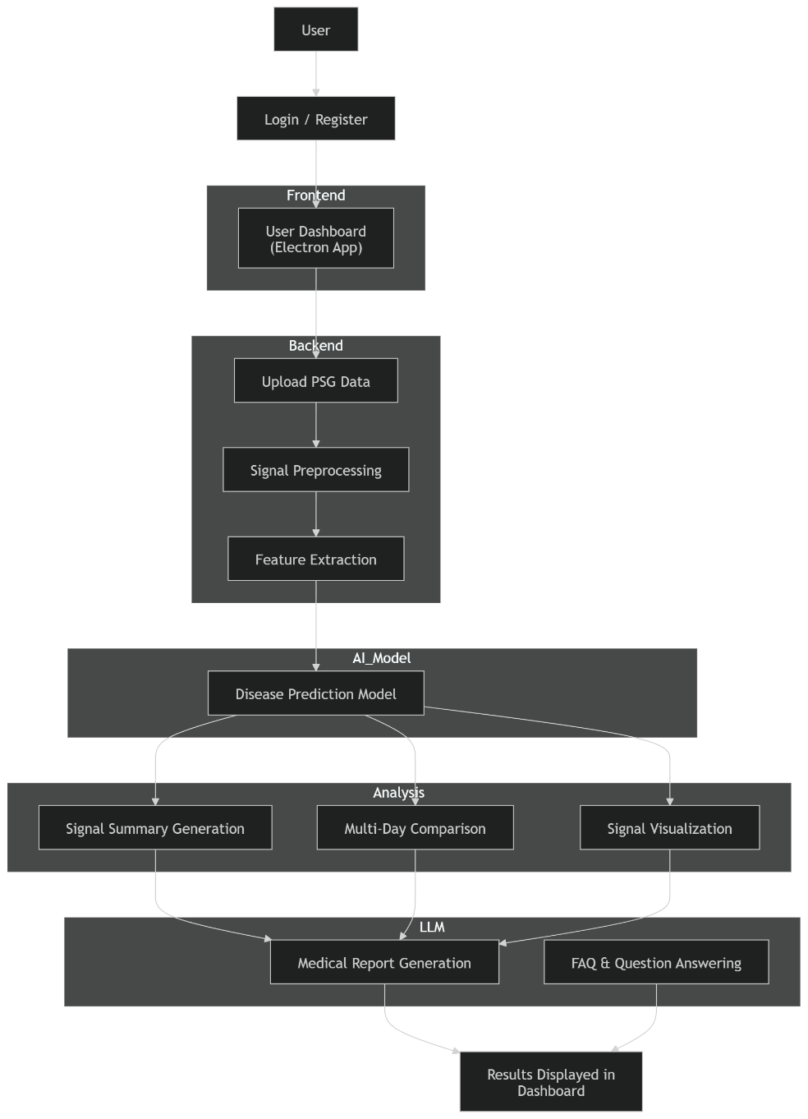
4. Component Responsibilities
Electron Desktop Application (Frontend)
Provides the user interface.
Responsibilities:
- user login and registration
- PSG data upload
- dashboard displaying results
- signal visualization
- chat interface for AI assistant
- viewing generated reports

Backend Processing Server
Acts as the central processing unit.
Responsibilities:
- handling PSG uploads
- preprocessing signals
- extracting signal features
- managing communication with AI model and LLM services
- generating signal summaries
- handling multi-day comparison

AI Disease Prediction Engine
Responsible for generating predictions from PSG features.
Responsibilities:
- receive extracted signal features
- analyze patterns in physiological data
- produce disease prediction results

LLM Service
Responsible for natural language interpretation and assistance.
Functions:
- generate medical-style reports
- answer user questions about signals and predictions
- explain physiological patterns

Database
Stores persistent application data.
Data stored includes:
- user credentials
- uploaded PSG metadata
- extracted signal summaries
- prediction results
- generated reports
- user chat history
5. Data Flow Diagram
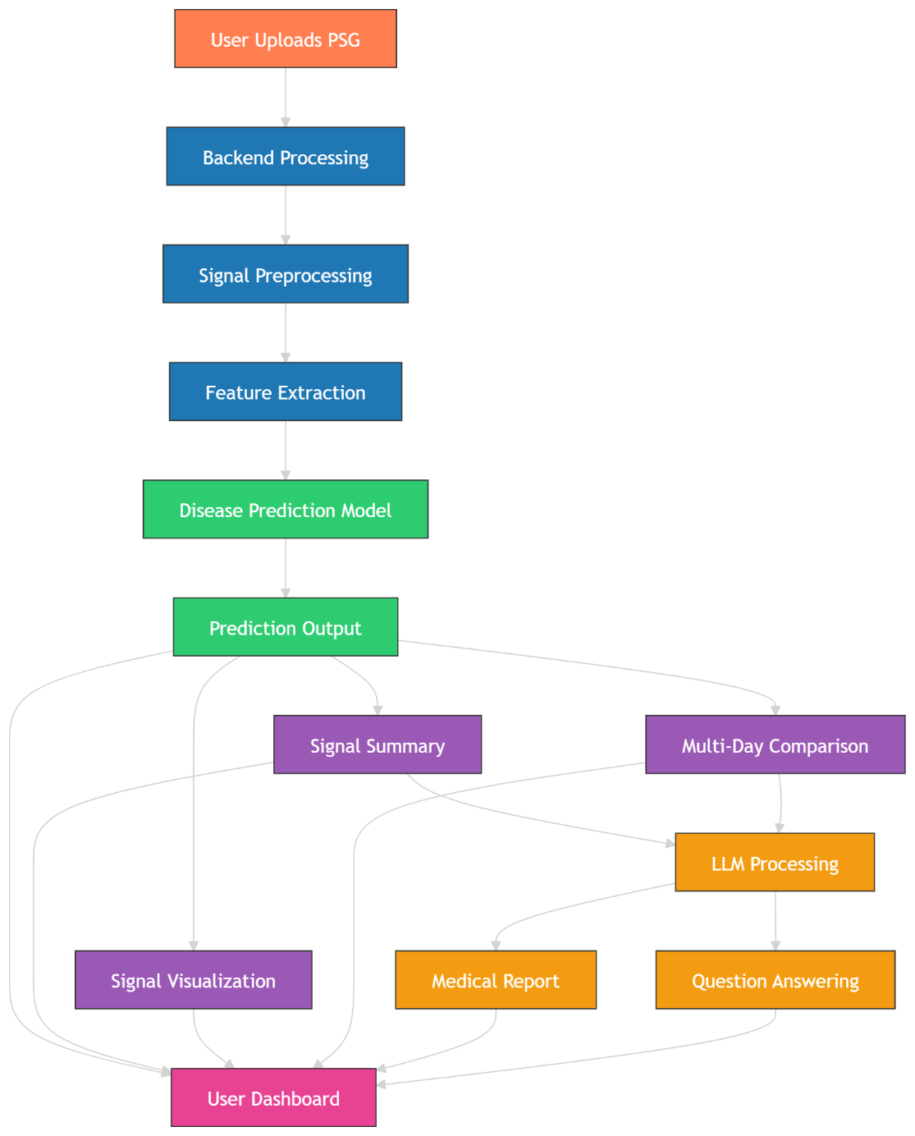
6. Multi-Day Comparison Flow
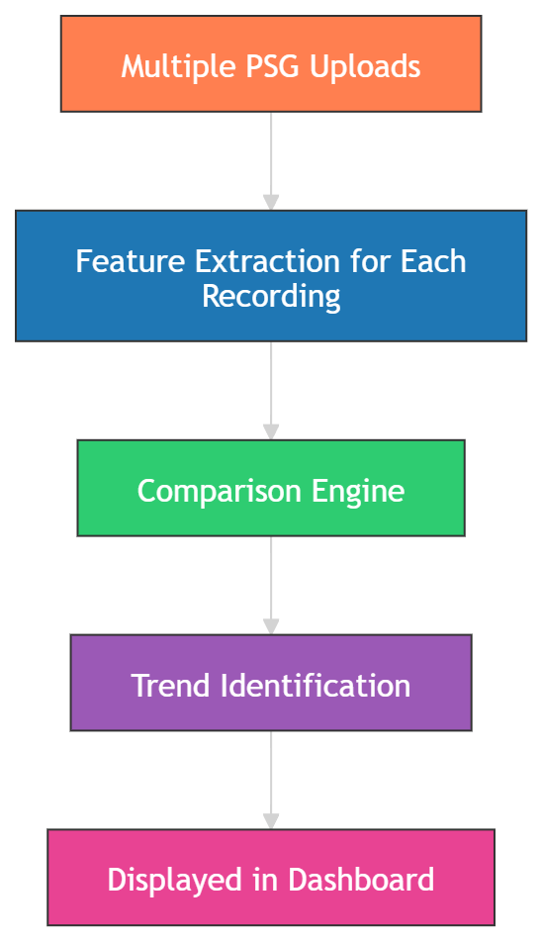

7. Outputs Provided to User
The system provides the following outputs:
- disease prediction results
- physiological signal summaries
- comparisons across multiple recordings
- automatically generated medical reports
- signal visualizations highlighting variations
- answers to user queries through AI assistant

