# November Talkies

## Screens

There will be 6 screens in total, as listed below

1. Home
2. Search
3. Profile
4. Movie
5. Notifications
6. Review

Details to follow.

### Home

This will be the landing screen for the app. The home screen will contain all new posts/reviews made by users (in what is called a review card) you follow sorted based on the upload time (most recent at the top).

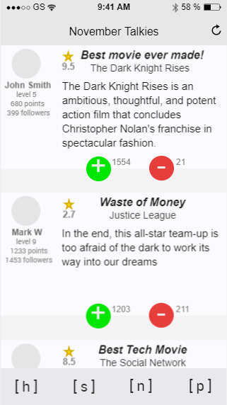

Each review card will contain the following

|  |  |  |
| --- | --- | --- |
| User Data | Display picture | Mini view of the original picture |
| Full Name |  |
| Level | Based on level calculation algorithm  TBD |
| Points | Based on points calculation algorithm  TBD |
| Follower count |  |
| Review Data | Title | Will have a character limit |
| Star image | Can go with just one static star image for all cards regardless of the rating OR can design 10 images where the gold coloring inside the star represents the integer values (1 to 10). All white will be 0, All gold will 10.  TBD |
| Rating |  |
| Movie |  |
| Review | Will have a character limit |
| Controls | Upvote button | Increments the upvote count.  Button gets a slightly different color to show it has been upvoted.  Double tap will cancel the upvote and change the color back to original. |
| Downvote button | Increments the downvote count.  Button gets a slightly different color to show it has been upvoted.  Double tap will cancel the downvote and change the color back to original. |
|  | *upvoting or downvoting a review are optional for the user. | |

Navigation

1. Display picture - takes you to the Profile page
2. Full Name - takes you to the Profile page

Additionally, you can refresh your feed by holding and pulling the home page down – like in Instagram.

How to reach the Home screen?

1. On starting the application.
2. By tapping on the Home button from the Navigation panel.



### Search

Allows you to search for a movie or a user.

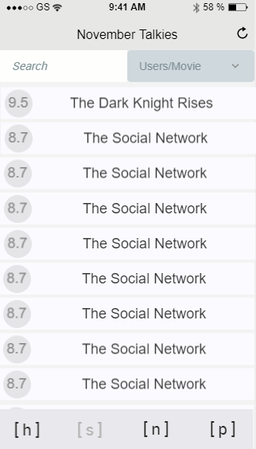

The Search page will contain

1. Search box - where you type in the name of the movie or user you are searching for. Autocomplete will be enabled.
2. Dropdown box - where you choose Users or Movie to refine the search.
3. Results – will be displayed underneath the search area. Sorting of search results TBD.

Navigation

1. Movie Title - takes you to the Movie page of that movie
2. User - takes you to the Profile page of that user

How to reach the Search screen?

1. By tapping on the Search button from the Navigation panel.



### Profile

The profile page of a user. You would ideally go to this page to check out the reviews he has submitted. The following will be displayed in the User card

1. Display picture (bigger standard size picture)
2. Full Name
3. Levels
4. Points
5. Follower count

*Note*: followers will be hidden at any stage and will not be visible to any user including yourself

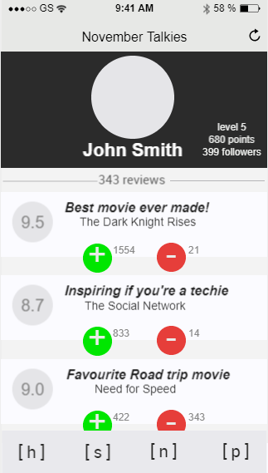

Each mini review card will be sorted based on the date of submission of the review. Although can introduce other options of sorting like rating, low to high, high to low etc. TBD.

Each mini review card will contain the following

|  |  |  |
| --- | --- | --- |
| Review Data | Title | Will have a character limit |
| Rating | The circle image will have a color scheme to represent the rating.  TBD |
| Movie |  |
| Controls | Upvote button | Increments the upvote count.  Button gets a slightly different color to show it has been upvoted.  Double tap will cancel the upvote and change the color back to original. |
| Downvote button | Increments the downvote count.  Button gets a slightly different color to show it has been upvoted.  Double tap will cancel the downvote and change the color back to original. |
|  | *upvoting or downvoting a review are optional for the user. | |

When you tap on a mini review card, it expands to display the full review. Tag again, or on another card to minimize the current card. At any point, there will only be one card in full view. The card will also go back to mini view, if outside the viewing area of the screen.

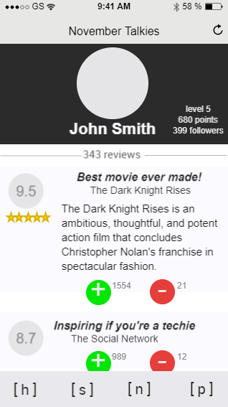

Expanding a review will display the following

1. Images of stars as a virtual representation of the rating
2. Full review by the user

How to reach the Profile screen?

1. By tapping on Full name or Display picture on Home screen
2. By tapping on the user search result on Search screen
3. By tapping on the Full name or Display picture on Movie screen
4. By tapping on the Notification card on the Notification screen (this is applicable if the notification says ‘user started following you’
5. By tapping on the Profile button from the Navigation panel



Additionally, you can refresh the Profile screen by holding and pulling the home page down – like in Instagram.

### Movie

Movie screen will contain all the reviews made by all users for this movie. The movie card will contain the following

1. Movie poster (TBD)
2. Title
3. Rating in images (10 stars) as a virtual representation of the rating value
4. Rating value (average of all the rating values)
5. Number of reviews

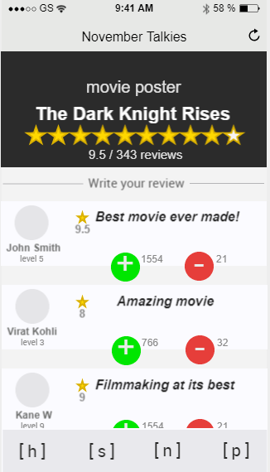

Each mini review card will be sorted based on the date of submission of the review. Although can introduce other options of sorting like rating, low to high, high to low etc. TBD.

If you have written a review for this movie, your review will be displayed at the top. If not, there will be a button that says ‘Write your Review’

Each mini review card will contain the following

|  |  |  |
| --- | --- | --- |
| User Data | Display picture | Mini view of the original picture |
| Full Name |  |
| Level | Based on level calculation algorithm  TBD |
| Review Data | Title | Will have a character limit |
| Star image | Can go with just one static star image for all cards regardless of the rating OR can design 10 images where the gold coloring inside the star represents the integer values (1 to 10). All white will be 0, All gold will 10.  TBD |
| Rating | The circle image will have a color scheme to represent the rating.  TBD |
| Controls | Upvote button | Increments the upvote count.  Button gets a slightly different color to show it has been upvoted.  Double tap will cancel the upvote and change the color back to original. |
| Downvote button | Increments the downvote count.  Button gets a slightly different color to show it has been upvoted.  Double tap will cancel the downvote and change the color back to original. |
|  | *upvoting or downvoting a review are optional for the user. | |

When you tap on a mini review card, it expands to display the full review. Tag again, or on another card to minimize the current card. At any point, there will only be one card in full view. The card will also go back to mini view, if outside the viewing area of the screen.

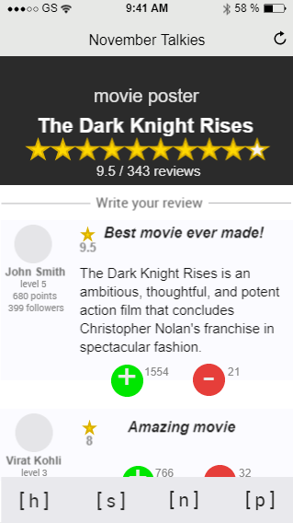

Expanding a review will display the following

1. Points of the user
2. Follower count of the user
3. The full review

How to reach the Movie screen?

1. By tapping on the Movie title on Home screen
2. By tapping on the movie search result on Search screen
3. By tapping on the Movie Title on Profile screen
4. By tapping on the Notification card on the Notification screen (this is applicable if the notification says ‘user has upvoted/downvoted your review’

Additionally, you can refresh the Movie screen by holding and pulling the home page down – like in Instagram.

### Notification

The notification screen is made up of notification cards. Each notification card will contain

1. An image – this would be a user’s display picture if the notification is about a user starting to follow you OR would be a picture of the movie poster if the notification is about a user upvoting/downvoting your review
2. The notification message

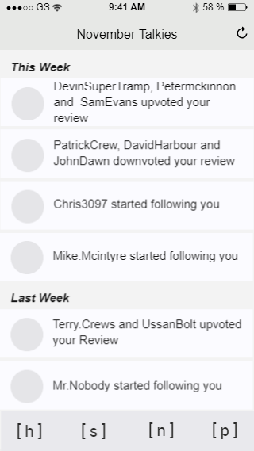

The notifications will be sorted based on their time of occurrence with the most recent one at the top.

The notifications will also be grouped by this week, last week, last month etc. (TBD)

How to reach the Notification screen?

1. By tapping on the Notification button on the Navigation panel



Additionally, you can refresh the Notification screen by holding and pulling the home page down – like in Instagram.

### Review

This screen allows you to write your Review.

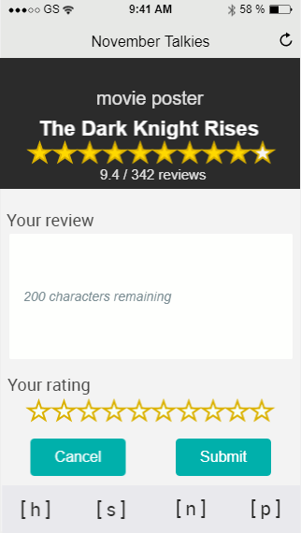

Review screen will contain the following

|  |  |  |
| --- | --- | --- |
| Movie card | Poster | TBD |
| Title |  |
| Rating (in images) | 10 stars as a virtual representation of the rating value |
| Rating value | average of all the rating values |
| Number of reviews |  |
| Review | Review field | At the moment 200 characters  TBD |
| Rating | 10 Stars | The idea is that a user can tap and drag his finger across the stars to choose the right value, with an accuracy of 0.1 decimal |
| Controls | Cancel | Takes you back to the Search screen |
| Submit | Takes you to the Movie screen |

How to reach the Movie screen?

1. At the moment, you have to search for a movie, open the Movie screen, and then tap on ‘Write your Review’
2. Other option is to have a button for Writing a review on the Navigation panel to go directly to the Review page. The problem here is, you then have to have a search box to type in the movie name and then choose the movie from the auto search result. This needs work since the UI would initially have a blank poster on the Review screen, which would then be updated with the movie poster on selecting the movie. TBD

*Note*: Any reviews once submitted cannot be edited. To make changes, you have to delete your review and write a new one.