Report
Team ID | MCA
Project Name | Strategic Employee Attrition Intelligence Dashboard
Maximum Marks | 5 Marks
A report is a comprehensive document that provides a detailed and structured account of data analysis, findings, and insights. It is typically used for in-depth analysis, documentation, and communication of results. Reports are suitable for a diverse audience, including decision-makers, analysts, and stakeholders who need a comprehensive understanding of the data.
Designing a report in Power BI involves connecting to data sources, creating visualizations like charts and graphs, customizing their appearance and interactivity, organizing them logically on the canvas, formatting elements for consistency and clarity, and optionally creating dashboards for a summarized view. Throughout the process, it’s essential to consider the audience’s needs and ensure the report effectively communicates insights from the data. Finally, iterate based on feedback to continually improve the report’s design and usefulness.
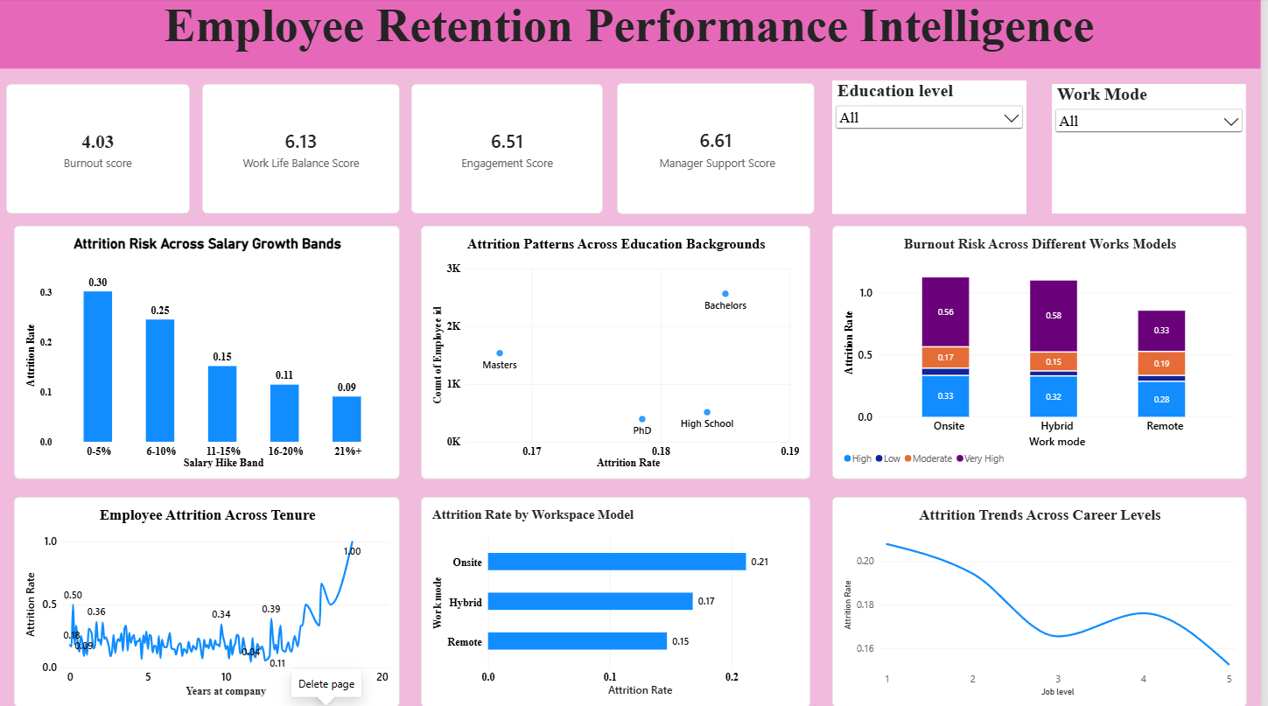
Employee Retention Analysis
Observations drawn from reports in Power BI can provide valuable insights into business performance and trends.
1. Trends Over Time & Experience
- Analyze how key metrics change over different time periods: Metrics like attrition rate fluctuate significantly based on specific employee traits like age or total tenure years at the company.
- Performance Comparisons: Compare attrition across different age milestones to identify whether younger groups or aging long-term cohorts are leaving at higher rates.
2. Customer & Employee Segmentation
- Assess demographic and environmental data: Map education backgrounds, marital status, gender, and work modes to understand key employee segments and tailor retention strategies accordingly.
3. Goal Achievement
- Measure progress against established KPIs: Use performance indicators like burnout scores, engagement ratings, and supervisor support scores to assess whether corporate culture and business health targets are being met.

Example:
1. Attrition by Salary Growth Bands
- The salary hike distribution chart indicates that employees receiving minimal salary hikes (0-5%) experience the highest overall attrition rate at 0.30, which gradually declines to 0.09 for those getting 21%+ raises.
2. Work Mode & Environment Analysis
- Among the tracked workplace configurations, Onsite environments show the highest baseline attrition rate at 0.21, followed closely by Hybrid options (0.17), while Remote workers prove the most stable at 0.15.
3. Burnout & Performance Demographics
- Burnout trends reveal severe attrition rates reaching up to 0.56 and 0.58 in high/very-high stress bands, highlighting that balanced work-life structures directly impact long-term corporate loyalty.
4. High Attrition Overtime Hour Bands
- Employees working intense extra shifts facing 21-30 hours of weekly overtime show a strong attrition rate spikes up to 0.54, making overtime moderation a crucial outreach focus strategy.

