Software Architecture and Design Specification - Online Bookstore System
Project: Online Bookstore (Software Engineering project, repository anv10/Online-Bookstore-SE-)
Version: 1.0
Authors: Sai Kishan A, Anirudh Ramesh, Anjana
Date: 11-11-2026
Status: Final - Sprint 2 close-out (all 120 Test Plan cases pass)

Revision History
Version | Date | Author | Change Summary
0.1 | 06-Sep-2026 | Sai Kishan A, Anirudh Ramesh, Anjana | Initial architecture and design derived from the team's submission
1.0 | 11-11-2026 | Sai Kishan A, Anirudh Ramesh, Anjana | Sprint 2 close-out: component diagram, sequence diagrams, API and security architecture aligned to the implemented system

Approvals
Role | Name | Signature/Date
QA Lead | Anjana | 11-11-2026
Dev Lead | Anirudh Ramesh | 11-11-2026
Product Owner | Sai Kishan A | 11-11-2026
Course Instructor | |

1. Introduction
1.1 Purpose
This document specifies the architecture and design of the Online Bookstore system, an e-commerce platform for buying and selling books. It records the chosen architecture, component responsibilities, key runtime flows, API design and security architecture, aligned with the implemented Django application and verified by the 120-case Test Plan (all passing).
1.2 Scope
Covers the server-rendered web application and its Django apps (accounts, catalog, cart, orders, reviews, wishlist, bookstore), the SQL data layer, and the external provider interfaces (payment, email/SMS, shipping webhook). Excludes production deployment topology, real payment/email/SMS provider internals, and hardware.
Developers, QA engineers, security reviewers, instructors/evaluators, and maintainers.
Django, MVT (Model-View-Template), ORM (Object-Relational Mapper), RTM (Requirements Traceability Matrix), ADR (Architecture Decision Record), STRIDE (threat-model taxonomy), CSRF (Cross-Site Request Forgery), TLS (Transport Layer Security), RBAC (Role-Based Access Control).

2. Document Overview
Read section 3 for the big picture (layers, components, pattern, security) and section 4 for the detailed design (runtime flows, API, error handling, UX). Traceability to requirements is in 3.8; verification evidence is in docs/testing/test-plan-results.md.
SRS_Online_Bookstore.pdf and SRS_Online_Bookstore_Detailed.docx, SecurityRequirements_Online_Bookstore.pdf, TestPlan_Online_Bookstore.pdf, STP_Online_Bookstore.docx, UseCaseFlow.pdf, UseCaseDiagram.png, ArchitectureDiagram.pdf, docs/deviations.md.

3. Architecture
Goals: catalogue response <= 2 s under load (NFR-1); 99.5% monthly uptime (NFR-2); responsive on mobile (NFR-5); sensitive data encrypted in transit and at rest (NFR-6); first purchase under 5 minutes (NFR-4).
Constraints: Django framework with a SQL database (NFR-8); Agile/Scrum with code review before merge (NFR-7); no card data stored by the system (SEC-21); TLS 1.2+ for all traffic (SEC-16); secrets in environment configuration, never in source (SEC-37).
Buyers: fast search, clear checkout, order visibility and reviews
Sellers: simple listing management and an order queue
Admins: moderation queue with decision history
Instructor/Evaluators: traceable requirements and execution evidence
Developers: modular Django apps, 70%+ test coverage target (NFR-9)

3.3 Component (UML) Diagram

Figure 1 - Logical component architecture (committed Documents/ArchitectureDiagram.pdf, rendered).
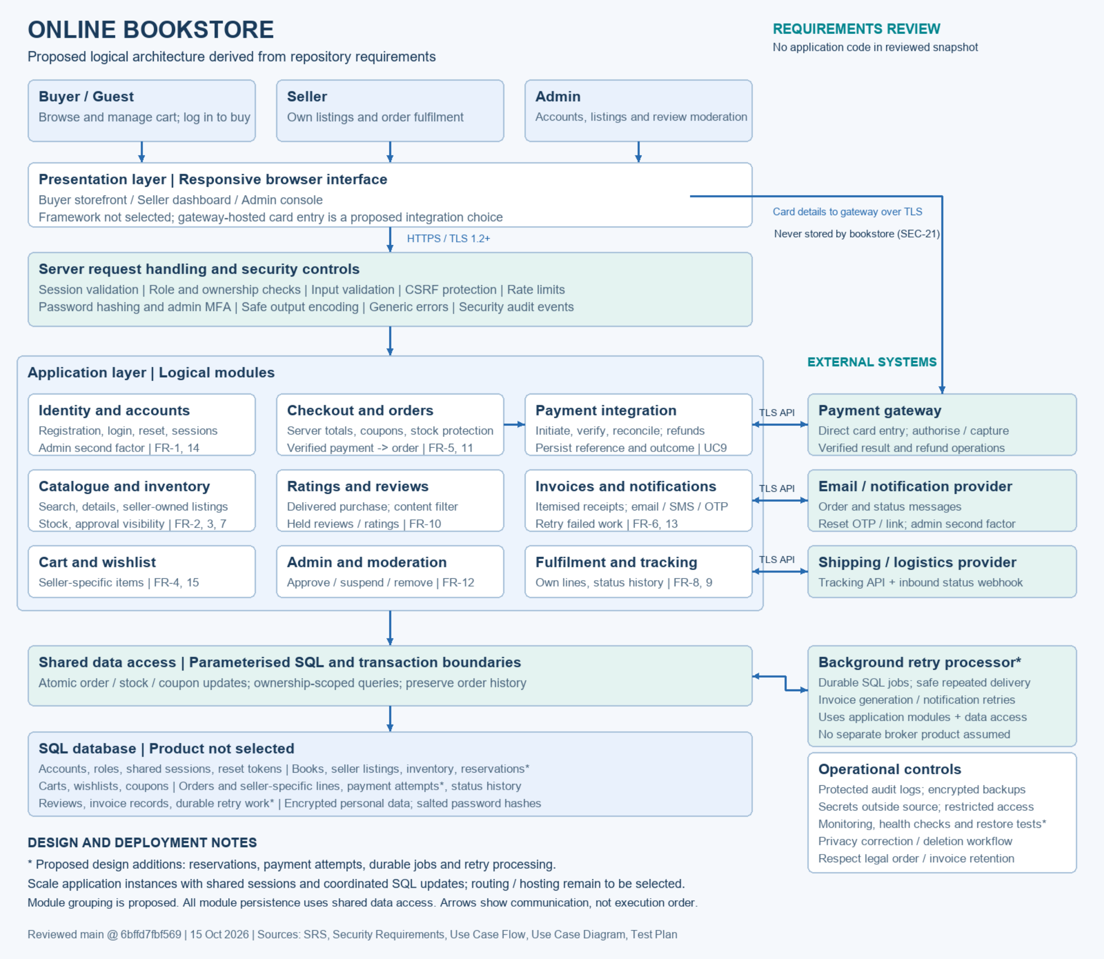

3.4 Component Descriptions
- Presentation layer: server-rendered Django templates (storefront, seller dashboard, admin console) with responsive CSS (store.css).
- accounts: registration (email + phone), login with either identifier, lockout with warning, password reset via OTP + link, profile.
- catalog: catalogue search and filters, book detail with live stock, seller listings (published as approved), buyer reports, moderation queue and decisions.
- cart: add/update/remove with session persistence and a stock guard.
- orders: checkout and payment (place_order), PAYMENT_FAILED recording, coupons, invoices, email + SMS confirmations, seller order management, buyer tracking, status history log.
- reviews: one review per purchased item with an edit guard.
- wishlist: save books for later, move to cart, responsive view.
- bookstore: project settings, root URL routing, security controls (encryption at rest, CSRF, generic errors), support page.
- Shared data access: Django ORM over SQL (PostgreSQL production / SQLite test) with parameterised queries and atomic transaction boundaries.
- External systems: payment gateway (simulated authorisation), email/SMS providers (console/outbox during tests), shipping status webhook.

3.5 Chosen Architecture Pattern and Rationale
Layered MVT (Model-View-Template) modular monolith: models encapsulate persistence, views orchestrate use cases, templates render the UI, and each Django app is a bounded module with its own URLs. A microservice split was rejected as excessive for the scale and the single-team process: the checkout must decrement stock, apply the coupon and create the order in one SQL transaction, which a shared data layer gives directly. Server-side rendering keeps security controls (CSRF, RBAC, server-side totals) in one place and avoids SPA state complexity.

3.6 Technology Stack & Data Stores
Python 3.12 and Django (MVT) on a WSGI/HTTP server; HTML/CSS templates (store.css); PostgreSQL (production) / SQLite (development and tests); email via SMTP or console/outbox backends; SMS gateway interface; payment gateway interface with simulated authorisation; Git/GitHub for source and review; headless Chrome for responsive verification.

3.7 Risks & Mitigations
Risk: single-server downtime -> Mitigation: stateless application layer allows horizontal scaling (NFR-3); encrypted, restricted backups (SEC-20).
Risk: third-party provider outage delays notifications -> Mitigation: notifications never block an order; failures are logged and retried (FR-6_IT03).
Risk: environment-only test failures (Windows strftime("%-m"), SQLite now()) -> Mitigation: documented in the STP; re-verify on Linux/PostgreSQL CI before release.
Risk: overselling the last copy -> Mitigation: stock validated and decremented atomically inside the payment transaction; the second buyer is told it sold out (FR-5_ST02).

3.8 Traceability to Requirements
FR-1, FR-14 -> accounts; FR-2, FR-3, FR-7, FR-12 -> catalog
FR-4 -> cart; FR-5, FR-6, FR-8, FR-9, FR-11, FR-13 -> orders
FR-10 -> reviews; FR-15 -> wishlist
NFR-1 -> load_test_search (catalog); NFR-5 -> responsive templates; NFR-6 -> bookstore encryption
The full requirement-to-test-case mapping is in the RTM (SRS_Online_Bookstore_Detailed.docx, section 8).

3.9 Security Architecture
STRIDE applied to the implemented system:
- Spoofing -> salted adaptive password hashes (SEC-2); lockout with warning after 3 failures (SEC-3); generic auth messages (SEC-4).
- Tampering -> server-side totals and coupon validation (SEC-22, SEC-24); CSRF tokens on all state-changing POSTs (SEC-28); parameterised ORM queries (SEC-26).
- Repudiation -> order status history log; security event logging for logins, lockouts, resets and moderation (SEC-31).
- Information disclosure -> TLS 1.2+ (SEC-16); encryption at rest for personal data (SEC-17); no card storage (SEC-21); generic error messages (SEC-19).
- Denial of service -> rate limiting on authentication and search (SEC-30); request limits at the host.
- Elevation of privilege -> server-side RBAC and ownership checks (SEC-10..SEC-13); moderation limited to admins.

4. Design

4.1 Design Overview
The design realises the layered component diagram in 3.3: presentation -> request handling/security controls -> application modules -> shared data access -> SQL database, with external systems behind narrow interfaces. Two end-to-end flows (checkout/payment and password reset) are specified in 4.2, and the HTTP interface of the central components in 4.3.

4.2 UML Sequence Diagrams
Two flows are specified below:
1. Checkout & payment (FR-4, FR-5, FR-6, FR-13): cart -> stock validation and server-side total -> gateway authorisation -> paid order with status log, stock decrement and cart clearance -> email + SMS confirmation -> confirmation page; the alternative records a PAYMENT_FAILED order and keeps the cart.
2. Password reset with OTP (FR-14): request -> single-use, expiring OTP emailed with a link -> validation -> password set with session invalidation; the alternative handles expired or reused OTPs with generic messages.
Figure 2 - UML sequence diagrams for the two flows.
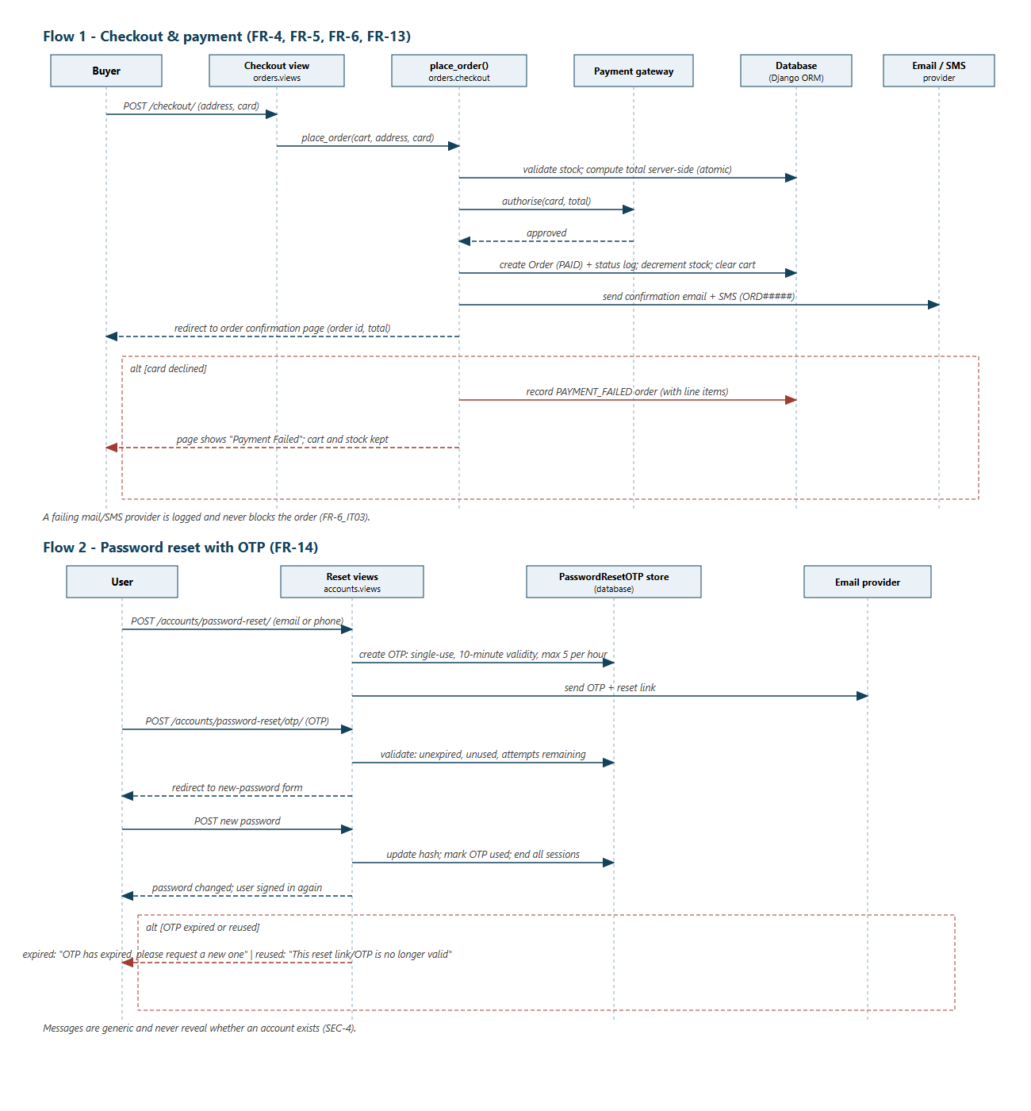

4.3 API Design
The application is server-rendered; its HTTP interface is the URL routing below. The two most significant components are specified in detail.
Component: orders (checkout, coupons, invoices, seller order management)
Endpoint: POST /checkout/ Request: address fields + card Response: 302 -> /orders/<id>/confirmation/ Errors: inline validation; declined card -> PAYMENT_FAILED order + "Payment Failed" page
Endpoint: POST /checkout/coupon/ (code) Response: total reduced Errors: "Only one coupon can be applied per order."; invalid or reused code
Endpoint: GET /orders/<id>/ Response: order detail with status history Errors: 404 for other buyers' orders
Endpoint: GET /orders/<id>/invoice/ (and /download/) Response: invoice page/file Errors: 404 unless owner or admin
Endpoint: POST /seller/orders/<id>/ship/ | /out-for-delivery/ | /deliver/ Response: status advanced Errors: invalid transitions rejected; non-owner seller -> 404
Endpoint: POST /seller/orders/bulk-ship/ Response: ready orders shipped
Endpoint: POST /tracking/webhook/ Request: carrier status update Response: status history updated
Component: accounts (identity and access)
Endpoint: POST /accounts/register/ (email, phone, password) Response: account created Errors: inline (invalid email, blank phone, weak password, duplicate email)
Endpoint: POST /accounts/login/ (identifier: email or phone + password) Response: session started Errors: 3 failures -> lockout warning (SEC-3)
Endpoint: POST /accounts/logout/ Response: session ended
Endpoint: POST /accounts/password-reset/ (email/phone) Response: generic confirmation; OTP + link emailed Errors: generic (never reveals account existence, SEC-4)
Endpoint: POST /accounts/password-reset/otp/ (OTP) Response: redirect to new-password form Errors: "OTP has expired, please request a new one"; reused -> "no longer valid"
Endpoint: POST /accounts/password-reset/otp/new-password/ Response: password updated, other sessions ended
Other components (summary): GET / and GET /books/<id>/ (catalogue and detail with q/genre/price filters); POST /books/<id>/review/ (second plain POST refused) and POST /books/<id>/flag/ (buyer report); POST /seller/new/ | /seller/<id>/edit/ | /seller/<id>/remove/ (owner-only listing CRUD); POST /cart/add/<book_id>/ | /cart/items/<id>/update/ | /cart/items/<id>/remove/ (stock-guarded); POST /wishlist/add/<book_id>/ | /wishlist/items/<id>/remove/ | /wishlist/items/<id>/to-cart/; POST /moderation/<id>/ (admin decision).
Cross-cutting errors: unauthenticated -> redirect to login; ownership violations -> 404 so existence is hidden; validation -> inline field errors; unexpected errors -> generic page with no stack traces (SEC-19).

4.4 Error Handling, Logging & Monitoring
Form validation errors render inline next to fields; authentication failures redirect to login; ownership violations return 404 (SEC-11, SEC-12); user-facing error messages are generic with no stack traces (SEC-19); passwords, OTPs and card data are never written to logs or URLs (SEC-18); a failing mail/SMS provider is logged and never blocks an order (FR-6_IT03). Monitoring: manage.py load_test_search for latency (p95 1.04 s vs 2 s budget), Django logs for security events (SEC-31), and the 480-test regression suite in CI.

4.5 UX Design
Responsive layout verified at 390x844 (mobile) and 1366x900 (desktop) with identical content (FR-15_ST02, docs/testing/wishlist-*.png); inline validation errors next to fields; confirmation pages state the order reference and total; seller dashboard lists orders newest-first with action buttons; moderation queue separates reported listings from user accounts.

4.6 Open Issues & Next Steps
- Privacy notice page and self-service data correction/deletion (NFR-10, SEC-34, SEC-35) remain out of sprint scope.
- Production wiring of the email/SMS/payment providers is configuration work, pending a hosted deployment.
- CI on Linux/PostgreSQL to retire the two documented environment-only test errors.
- Admin second authentication factor (SEC-14) is proposed but not yet implemented.

5. Appendices
5.1 Glossary: Django, MVT, ORM, ORD##### (order reference format), OTP, CSRF, TLS, STRIDE, ADR.
5.2 References: SRS_Online_Bookstore.pdf, SecurityRequirements_Online_Bookstore.pdf, TestPlan_Online_Bookstore.pdf, docs/testing/test-plan-results.md, docs/deviations.md, IEEE 42010, OWASP ASVS.
5.3 Tools: draw.io (architecture and use-case diagrams), headless Chrome (responsive and sequence-diagram rendering), Django test runner, manage.py load_test_search.

