Software Requirements Specification (SRS) - Online Bookstore System

Project: Online Bookstore (Software Engineering project, repository anv10/Online-Bookstore-SE-)
Version: 1.0
Authors: Sai Kishan A, Anirudh Ramesh, Anjana
Date: 11-11-2026
Status: Final - Sprint 2 close-out (all 120 Test Plan cases pass)

Revision history
0.1 | 06-Sep-2026 | Sai Kishan A, Anirudh Ramesh, Anjana | Initial SRS drafted (15 FRs, 12 NFRs) | Approval
1.0 | 11-11-2026 | Sai Kishan A, Anirudh Ramesh, Anjana | Sprint 2 close-out revision: requirements verified against the 120-case Test Plan

Approvals
Role | Name | Signature / Email | Date
Course Coordinator

Table of Contents
1. Introduction
2. Overall description
3. External interfaces
4. System features (detailed)
5. Non-functional requirements (detailed)
5.1 Security
6. Quality attributes & Acceptance tests
7. System models and diagrams
8. Requirements Traceability Matrix (RTM)

1. Introduction

1.1 Purpose
This document is a Software Requirements Specification (SRS) for the Online Bookstore system, an e-commerce platform where buyers browse and purchase books, sellers list and manage inventory, and admins moderate the platform. It defines functional and non-functional requirements, interfaces, and verification criteria, derived from SRS_Online_Bookstore.pdf and verified against TestPlan_Online_Bookstore.pdf (120 cases, all passing).

1.2 Scope
Covers buyer registration and login, catalogue search and book details, shopping cart, checkout and payment, order confirmation notifications, seller listing management, seller order management and buyer order tracking, ratings and reviews, discount coupons, admin moderation, invoice generation, password reset, and wishlist.
Excludes a privacy policy page and self-service account deletion (NFR-10), real outbound email/SMS provider integration (console/outbox backends are used during testing), real payment gateway internals (card authorisation is simulated), and hosting/deployment infrastructure.

Developers, QA Engineers, System Integrators, and Assessment Evaluators.

FR (Functional Requirement), NFR (Non-Functional Requirement), SRS (Software Requirements Specification), RTM (Requirements Traceability Matrix), UT/IT/ST (Unit/Integration/System Test), OTP (One-Time Password), CSRF (Cross-Site Request Forgery), TLS (Transport Layer Security), RBAC (Role-Based Access Control).

2. Overall description

The Online Bookstore is a server-rendered Django web application used by buyers, sellers and admins through a browser. It is organised into the accounts, catalog, cart, orders, reviews, wishlist and bookstore (security/settings) modules over a relational SQL database, with email/SMS notifications delivered through pluggable backends and card authorisation behind an integrated payment interface.

- Register, log in, and reset a forgotten password (OTP + link)
- Search and filter the catalogue; view book details with live stock
- Manage a shopping cart that persists across sessions
- Check out with an address and card; receive email and SMS order confirmations
- Generate an invoice after successful payment
- Sellers: add/edit/remove listings; manage incoming orders (ship, out for delivery, deliver)
- Buyers: track order status, rate and review purchased books, apply coupons, manage a wishlist
- Admins: moderate listings and user accounts driven by buyer reports

- Buyer: browses, searches, buys, tracks orders, reviews purchased books and maintains a wishlist; expects a first purchase to take under 5 minutes (NFR-4).
- Seller: lists books, keeps stock current and works through an order queue; needs a clear dashboard of incoming orders.
- Admin: moderates listings and accounts acting on buyer reports; needs a queue with decision history.
Django (Python 3.12) on a WSGI/HTTP server with a SQL database (PostgreSQL in production, SQLite for tests and local runs), served over HTTPS; used on modern browsers (Chrome, Firefox, Safari, Edge) and responsive on mobile viewports (NFR-5).

Card data handling is delegated to the payment gateway with no card storage (SEC-21); TLS 1.2+ for all traffic (SEC-16); secrets kept in environment configuration (SEC-37); Agile/Scrum process with code review before merge (NFR-7); Django framework with a SQL database (NFR-8).

3. External interface requirements

Server-rendered HTML pages with a shared stylesheet (store.css): catalogue with a search/filter form, book detail, cart, checkout, order confirmation and tracking, seller dashboard, wishlist, and the moderation queue. Forms show inline validation errors, and the layout is responsive (verified at 390x844 and 1366x900).

- Client devices: desktop and mobile browsers (no specialised peripherals required)
- Hosting server with persistent storage for the SQL database and uploaded media
- Email backend (SMTP in production; console/outbox during testing) for order confirmations, password-reset OTPs and links
- SMS gateway interface for order confirmations, keyed on the order reference (ORD#####)
- Payment gateway interface for card authorisation with deterministic success/decline outcomes
- Relational database (PostgreSQL/SQLite) accessed through the Django ORM with parameterised queries (SEC-26)

- HTTPS/TLS 1.2+ enforced for all browser traffic (SEC-16); CSRF protection on state-changing requests (SEC-28)
- Sessions carried in signed, expiring cookies; logout invalidates the session (SEC-7, SEC-8)
- Email/SMS are sent without blocking the order: a failing mail server is logged and the order proceeds (FR-6_IT03)

Requirement inventory: 15 functional requirements (FR-1..FR-15), 12 non-functional requirements (NFR-1..NFR-12), 4 security objectives and 12 security requirements (SEC-n) detailed below. Every FR maps to 8 Test Plan cases (FR-n_UT01..FR-n_ST02); all 120 cases pass as of 11-11-2026.

4. System features (detailed)
Each requirement below includes acceptance criteria and a test-case reference. IDs follow FR-n (FR-1..FR-15); every FR-n has cases FR-n_UT01..FR-n_ST02 in TestPlan_Online_Bookstore.pdf.

4.1 Buyer Accounts & Access
Registration requires a valid email address and phone number with a password of at least 8 characters; login accepts email or phone. Password reset uses an emailed OTP plus a reset link, both single-use and expiring. IDs: FR-1, FR-14.
Req ID | Requirement | Type | Priority | Source/Stakeholder | Acceptance criteria / Test case ref | Comments / Dependencies
FR-1 | The system shall allow users to register with an email address and phone number and to log in with either identifier using password authentication. | Functional | High | User | Registration with a valid email and phone creates the account; login starts a session; 3 failed logins lock with a warning. Tests: FR-1_UT01..ST02 (all passed) | SEC-1..SEC-4, SEC-7, SEC-10; NFR-6; deviation recorded (email+phone split)
FR-14 | The system shall allow users to reset a forgotten password via an emailed OTP and reset link that are single-use and expire. | Functional | High | User | Expired OTP: "OTP has expired, please request a new one"; reused link: "This reset link/OTP is no longer valid". Tests: FR-14_UT01..ST02 (all passed) | SEC-5, SEC-6, SEC-9

4.2 Catalogue & Discovery
Buyers search by title, author, ISBN, genre and price range with validated filters, and view book details with live stock, seller, condition and reviews. IDs: FR-2, FR-3.
Req ID | Requirement | Type | Priority | Source/Stakeholder | Acceptance criteria / Test case ref | Comments / Dependencies
FR-2 | The system shall allow buyers to search books by title, author, ISBN, genre, and price range, with validated filters. | Functional | High | Buyer | Search by title/author/ISBN returns matches; invalid filters rejected; p95 response 1.04 s under load. Tests: FR-2_UT01..ST02 (all passed) | NFR-1; SEC-25, SEC-30
FR-3 | The system shall display book details including price, live availability, seller, condition, and reviews. | Functional | High | Buyer | Detail page shows core details; out-of-stock is marked and cannot be added; average rating and reviews shown. Tests: FR-3_UT01..ST02 (all passed) | FR-2, FR-10

4.3 Buying Flow: Cart, Payment & Notifications
Buyers manage a persistent cart, check out with an address and card, and receive email and SMS confirmations; invoices are generated after successful payment. A declined card records a payment-failed order and keeps the cart. IDs: FR-4, FR-5, FR-6, FR-13.
Req ID | Requirement | Type | Priority | Source/Stakeholder | Acceptance criteria / Test case ref | Comments / Dependencies
FR-4 | The system shall allow buyers to add, update, and remove items in a shopping cart that persists across sessions, without exceeding available stock. | Functional | High | Buyer | Cart lists items with line totals and grand total; quantity changes and removal persist; adding more than stock is refused. Tests: FR-4_UT01..ST02 (all passed) | FR-5
FR-5 | The system shall allow buyers to place an order and complete payment through the integrated payment flow; a declined card shall record a payment-failed order and keep the cart. | Functional | High | Buyer | Successful payment creates a paid order, clears the cart and decrements stock; a declined card records a Payment Failed order outside the rolled-back transaction. Tests: FR-5_UT01..ST02 (all passed) | FR-4, FR-13; SEC-21..SEC-23; deviation recorded
FR-6 | The system shall send a confirmation email and SMS whenever an order is placed, containing the order reference (ORD#####), items and total. | Functional | High | Buyer | Confirmation is sent on checkout; a failing mail server does not block the order and is logged. Tests: FR-6_UT01..ST02 (all passed) | FR-5; SEC-36
FR-13 | The system shall generate an order invoice/receipt after successful payment, listing the date, items, prices and total. | Functional | High | Buyer | Invoice page lists order date, items, prices and total. Tests: FR-13_UT01..ST02 (all passed) | FR-5

4.4 Selling, Fulfilment & Tracking
Sellers add, edit and remove listings (published immediately as approved), manage incoming orders through status actions, and buyers track order status end to end. IDs: FR-7, FR-8, FR-9.
Req ID | Requirement | Type | Priority | Source/Stakeholder | Acceptance criteria / Test case ref | Comments / Dependencies
FR-7 | The system shall allow sellers to add, edit, and remove book listings; new listings shall be searchable by buyers immediately. | Functional | High | Seller | Invalid required values (including negative price) do not persist; the owner can edit every field; a removed listing disappears from search, detail and the seller list. Tests: FR-7_UT01..ST02 (all passed) | FR-2, FR-12; SEC-12; deviation recorded (publishes as APPROVED)
FR-8 | The system shall allow sellers to view and manage incoming orders for their listings through status actions. | Functional | High | Seller | Seller sees orders containing their books; invalid transitions rejected; other sellers cannot open the order (404). Tests: FR-8_UT01..ST02 (all passed) | FR-9; SEC-12
FR-9 | The system shall allow buyers to track order status (placed, shipped, out for delivery, delivered). | Functional | High | Buyer | Buyer sees the status history as the seller advances the order. Tests: FR-9_UT01..ST02 (all passed) | FR-5, FR-8

4.5 Engagement & Administration
Buyers rate and review purchased books (once per item, editable), apply a single coupon per order, and maintain a wishlist; admins moderate listings and accounts driven by buyer reports. IDs: FR-10, FR-11, FR-12, FR-15.
Req ID | Requirement | Type | Priority | Source/Stakeholder | Acceptance criteria / Test case ref | Comments / Dependencies
FR-10 | The system shall allow buyers to rate and review purchased books once per item, with edits through the review page. | Functional | High | Buyer | A plain second POST is refused with "You have already reviewed this item."; edits only via ?edit=1. Tests: FR-10_UT01..ST02 (all passed) | FR-3; SEC-15, SEC-29
FR-11 | The system shall allow buyers to apply at most one validated discount coupon per order at checkout. | Functional | High | Buyer | A valid coupon reduces the total; a second coupon is rejected ("Only one coupon can be applied per order."). Tests: FR-11_UT01..ST02 (all passed) | FR-5; SEC-24
FR-12 | The system shall allow admins to approve, suspend, or remove listings and user accounts, acting on buyer reports (report-driven moderation). | Functional | High | Admin | Reported listings appear in the queue; a non-approve decision resolves upheld reports; removal preserves order history. Tests: FR-12_UT01..ST02 (all passed) | FR-7; SEC-13; deviation recorded
FR-15 | The system shall maintain a wishlist allowing signed-in buyers to save books for later, consistently on desktop and mobile. | Functional | High | Buyer | An item added on desktop is visible identically at 390x844 and 1366x900. Tests: FR-15_UT01..ST02 (all passed) | NFR-5

5. Non-functional requirements (detailed)
NFRs below are measurable and tied to the Test Plan. IDs follow NFR-n. NFR-7..NFR-12 (process standards, implementation, maintainability, legal, interoperability, support) are recorded in SRS_Online_Bookstore.pdf, sections 3.2 and 3.3.

Req ID | Requirement | Category | Priority | Acceptance criteria / Measurement
NFR-1 | Page load time shall not exceed 2 seconds under normal load (up to 500 concurrent users). | Performance | High | load_test_search: 500 requests / 50 workers -> p95 1.04 s, max 1.52 s. Test: FR-2_ST02
NFR-2 | The system shall maintain 99.5% uptime, measured monthly. | Reliability | High | Deployment/operations target; monitored in production operation.
NFR-3 | Support horizontal scaling to accommodate seasonal spikes without redesign. | Scalability | Medium | Stateless application servers behind a load balancer; verified by design review.
NFR-4 | A first-time user shall complete a purchase within 5 minutes without external help. | Usability | Medium | Register -> search -> cart -> pay walkthrough completes within 5 minutes.
NFR-5 | Accessible via modern browsers (Chrome, Firefox, Safari, Edge) and responsive on mobile. | Portability | High | Headless Chrome 390x844 vs 1366x900 renders the same wishlist. Test: FR-15_ST02
NFR-6 | All sensitive data shall be encrypted in transit (TLS 1.2+) and at rest. | Security | High | HTTPS enforced in deployment; personal data encrypted at rest. Test: bookstore.test_security

5.1. Security

5.1.1 Security Objectives
1. Protect account credentials and sessions: passwords stored only as salted adaptive hashes; reset OTPs and session tokens single-use and expiring.
2. Protect personal and payment data: encryption in transit (TLS 1.2+) and at rest; no card data stored by the system.
3. Preserve the integrity of listings, orders, invoices and reviews: server-side totals and role-based, ownership-checked access.
4. Restrict moderation and administration to authorised admins, with security-relevant events logged.

5.1.2 Security Requirements
Req ID | Requirement (shall...) | Type | Priority | Acceptance criteria / Test case ref
SEC-2 | Passwords shall be stored only as salted hashes made with a slow, adaptive algorithm. | Security | High | accounts.test_models.test_create_user_hashes_password
SEC-3 | After 3 consecutive failed login attempts the system shall show a lockout warning and lock the account for a fixed period. | Security | High | FR-1_ST02: third failure locks with a warning
SEC-5 | Password reset links and OTPs shall be single use and shall expire after a short fixed time. | Security | High | FR-14_IT02/ST02: expired and reused messages verified
SEC-8 | A session shall expire after a period of inactivity, and logging out shall invalidate the session. | Security | High | test_auth.test_logout_ends_session
SEC-10 | Access shall be role based (Buyer, Seller, Admin), with permissions checked on the server. | Security | High | FR-8_IT02: other sellers cannot open the order (404)
SEC-16 | All traffic between the browser and the server shall use TLS 1.2 or higher. | Security | High | Deployment configuration; plain HTTP redirected at hosting
SEC-17 | Personal data such as phone numbers and shipping addresses shall be protected at rest by encryption. | Security | High | bookstore.test_security: one-time encryption migration test
SEC-21 | The system shall not store card numbers, CVV codes or other card details. | Security | High | Checkout stores no card data; authorisation simulated
SEC-25 | All user input shall be validated on the server before use. | Security | High | FR-2_UT03, FR-7_UT01/UT02
SEC-27 | User-written content shall be encoded when displayed to prevent cross-site scripting. | Security | High | Django template auto-escaping (reviews, listings)
SEC-28 | Requests that change data shall require a CSRF token. | Security | High | Django CSRF middleware on all POST forms
SEC-31 | The system shall log security events: logins, lockouts, password resets and moderation actions. | Security | Medium | Lockout/reset events recorded in the Django logs

6. Quality attributes & Acceptance tests
- Exit criteria for acceptance: all 120 Test Plan cases executed with 0 failures (achieved 11-11-2026), the 480-test regression suite green apart from two documented environment-only errors, and the RTM shows every requirement passed.
- Acceptance test suites: Accounts (registration/login/lockout/reset), Catalog (search/detail/listing/moderation), Cart, Checkout & Payment, Notifications, Seller orders & Tracking, Reviews, Coupons, Invoices, Wishlist, Performance (load_test_search), Security (encryption & CSRF), Portability (responsive checks).

7. System models and diagrams

7.1 UML Use-Case diagram
The committed use case diagram is reproduced below (Documents/UseCaseDiagram.png / UseCaseDiagram.drawio); the system context is shown in Documents/ArchitectureDiagram.pdf.
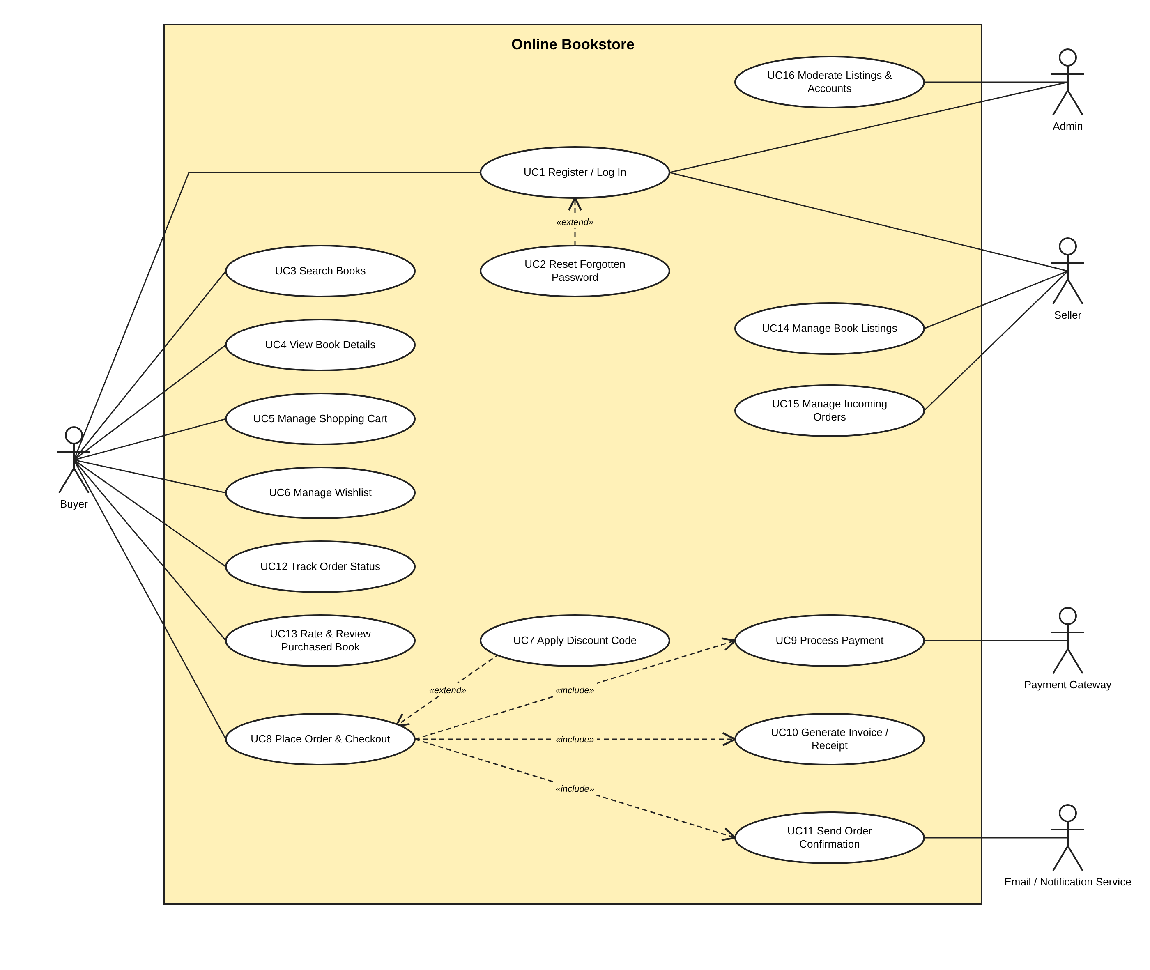

8. Requirements Traceability Matrix (RTM)

Req ID | Requirement short | Section ref / Design Spec | Module | Test case(s) | Status (N/P/A) | Comments
FR-1 | Register & login | 4.1 | accounts | FR-1_UT01..ST02 | P | email+phone at registration; login accepts either (deviation)
FR-14 | Password reset | 4.1 | accounts | FR-14_UT01..ST02 | P | OTP + link, single-use, expiring
FR-2 | Book search | 4.2 | catalog | FR-2_UT01..ST02 | P | p95 1.04 s (NFR-1)
FR-3 | Book details | 4.2 | catalog | FR-3_UT01..ST02 | P
FR-4 | Shopping cart | 4.3 | cart | FR-4_UT01..ST02 | P
FR-5 | Checkout & payment | 4.3 | orders | FR-5_UT01..ST02 | P | declined card -> PAYMENT_FAILED order
FR-6 | Order confirmation | 4.3 | orders | FR-6_UT01..ST02 | P | email + SMS with ORD##### reference
FR-13 | Invoice | 4.3 | orders | FR-13_UT01..ST02 | P
FR-7 | Seller listings | 4.4 | catalog | FR-7_UT01..ST02 | P | publishes APPROVED immediately (deviation)
FR-8 | Seller order management | 4.4 | orders | FR-8_UT01..ST02 | P
FR-9 | Order tracking | 4.4 | orders | FR-9_UT01..ST02 | P
FR-10 | Ratings & reviews | 4.5 | reviews | FR-10_UT01..ST02 | P | second POST refused; edits via ?edit=1
FR-11 | Coupons | 4.5 | orders | FR-11_UT01..ST02 | P | one coupon per order
FR-12 | Admin moderation | 4.5 | catalog | FR-12_UT01..ST02 | P | report-driven; upheld reports resolved on non-approve
FR-15 | Wishlist | 4.5 | wishlist | FR-15_UT01..ST02 | P | responsive check at 390x844
NFR-1 | Response time <= 2 s | 5 | catalog / search | FR-2_ST02 | P | p95 1.04 s, max 1.52 s
NFR-5 | Portability | 5 | all views | FR-15_ST02 | P | headless Chrome 390x844
NFR-6 | Encryption | 5 | bookstore | bookstore.test_security | P | TLS in deployment; encryption at rest
NFR-2..NFR-12 | Operational/process NFRs | 5 | deployment / process | Ops reports, code review | N | Outside the 120-case Test Plan scope

