Workshop 1: Building a static site and deploying it to the web
Resource for Week 1
● You can find all the resources for week 1 in the following GitHub repository. ● Switch to branch Week 1 for the coding exercise and the readme.md file ● The readme file covers all the important syntax and concepts needed to complete Workshop
● Tutorial Repository
Setup environment for development
Run the following in your terminal to check if your environment is setup correctly:
● git --version
● node -v
● npm -v
Make sure you have VS Code and extensions set up as well.
Follow this guide if you run into any issues.
Goals for Workshop 1
● Initialize a git repository repository
● Design all the structure and layout for all required static pages in your selected topic ● Implement the layout and structure using HTML
● Apply simple CSS rules
● Push your code to GitHub
● Deploy your site using GitHub Pages
Initialize your project using Git
● Create a new folder for the project
● Initialize git using the command
○ git init
● Create an index.html in the folder. This file will be the home page for your site. Add it to git using
○ git add index.html
● Commit the change
○ git commit -m “My first Commit”
● Open the folder in VS Code
Design a mock up for your project
● Read the requirements for your selected project from here: Topics with requirements ● Mock a design using any tool you like to use e.g. Figma, MockFlow, Microsoft Paint or even pen and paper
● When designing try to think about the layout and structure of your page rather than actual content and specifics
● This design will work as a guideline when you write your HTML and CSS ● Create a mockup folder inside your project folder and add screenshots or images of your mockup there
● You should create something similar to image below:
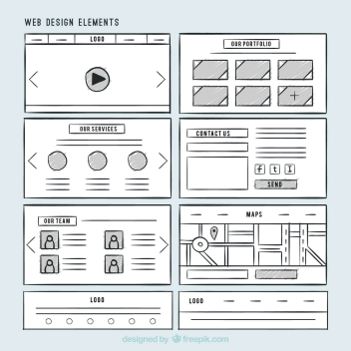
Implement your design using HTML and CSS
● Implement the static design for all of the pages required for the project ● Link all your sites together in a navigation bar
● Structure your page based on the designs you prepared
● Add the CSS rule to style your page
● Try to implement all the tags and CSS properties mentioned in the readme.md file ● Don’t worry about form submission for now, just focus on giving a structure to your design
Test you Code
● Check for any errors in your implementation
● Check if all the images are loading correctly
● Check if all the navigation links are working correctly
Push your code to GitHub
● Go to github.com and Sign in using your college email address.
● Click the + icon in the top-right corner, select New repository, name it, leave all initialization settings (README, .gitignore, license) unchecked, and click Create repository.
● Copy the HTTPS repository URL from the setup page (e.g.,
https://github.com/username/repo.git).
● Open your terminal inside your project folder and stage all changes by running: ○ git add .
● Commit your changes with your project message by running:
○ git commit -m "My Static Site Implementation"
● Ensure your local branch is named main by running:
○ git branch -M main
● Link your local repository to GitHub by running (replace the placeholder with your copied link):
○ git remote add origin PASTE_YOUR_LINK_HERE
○ (Note: If you get a "remote origin already exists" error, use git remote set-url origin PASTE_YOUR_LINK_HERE instead).
● Push your code to the remote repository by running:
○ git push -u origin main
Publish your static site to Github Pages
● On your GitHub repository page on the web, click the Settings tab (the gear icon at the top).
● Look at the left sidebar and click on Pages (under the "Code and automation" section). ● Look for Build and deployment:
● Change the Branch dropdown from None to main.
● Leave the folder dropdown as / (root).
● Click Save.
See Your Live Site
Wait about 1 minute, then refresh the Page. At the top of the Pages screen, you will see a link that looks like this: https://your-username.github.io/your-repo-name/
Click it to see your live website!
What do you need to submit?
● URL of the deployed page
● URL of the final commit for week 1

