class04.R

ashleyvang

2022-10-06

# This is a comment   
x <- 1:50  
plot (x,sin(x))

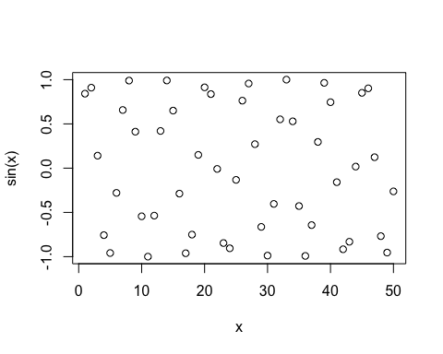

#Add more input arguments to get this how we want it   
plot(x,sin(x), typ="l", col="red", lwd=3)

