
CARGOPILOT
Finance Architecture
Operating Model and Product Blueprint
Purpose
A customer- and developer-facing blueprint for enterprise financial control across shipment revenue, carrier cost, cash custody, payment providers, reconciliation, accounting close and reporting.

Target architecture | Version 1.0 | 2 August 2026
Status: Product and engineering design - not a statement that every capability is already released
Prepared for CargoPilot customers, finance leaders, operations teams, implementation partners and software engineers.

Document guide
This document presents the target finance operating model for CargoPilot. It is deliberately readable by business stakeholders while preserving enough technical precision for implementation and integration planning.
Audience | What this document answers
Customers and executives | What financial control CargoPilot will provide and how it improves transparency, compliance and profitability.
Finance teams | How receivables, payables, cash, providers, currencies, reconciliations and close will work.
Operations teams | How shipment, carrier and cash events become accountable financial records without duplicating operational work.
Developers and integrators | Where financial boundaries sit, which events create postings, and what data and security invariants must be preserved.

Executive summary
CargoPilot Finance is designed as the financial control layer for a logistics ERP. It does not replace shipment execution, pricing or payment-provider integrations. Instead, it converts verified commercial and operational events into controlled receivables, payables, cash movements and immutable accounting entries.
Design principle
Operational systems explain what happened. Finance explains its economic effect, who owes whom, where the money is, which period it belongs to and whether the books can be closed.

The target model uses double-entry accounting, independent subledgers, multi-currency snapshots, company-scoped controls, segregation of duties, idempotent posting and complete auditability. It is inspired by enterprise ERP discipline but tailored to CargoPilot's order-leg, carrier, warehouse, payment and COD workflows.

Current state and target state
Area | Current CargoPilot capability | Target finance capability
Online payments | Provider configuration, payment intents, attempts, webhooks and payment event records. | Provider clearing, fee recognition, settlement matching, payment allocation and exception reconciliation.
Cash operations | Expected, held and settled cash with driver, warehouse, pickup-point and finance custody. | Cash subledger, custody accounts, handoff controls, variance handling, deposits and reconciliation.
Customer billing | Simple order invoice state. | Accounts receivable, invoice lines, taxes, credit notes, allocations, statements and aging.
Carrier costs | Operational carriers and order-leg bookings. | Per-leg cost accruals, carrier bills, invoice verification, disputes and accounts payable.
Ledger | Operational payment ledger events. | Immutable double-entry general ledger with posting rules, periods, reversals and trial balance.
Reporting | Operational analytics and finance exposure projections. | P&L, balance sheet, cash flow, aging, route margin and auditable drill-down to source documents.

1. Product vision and boundaries
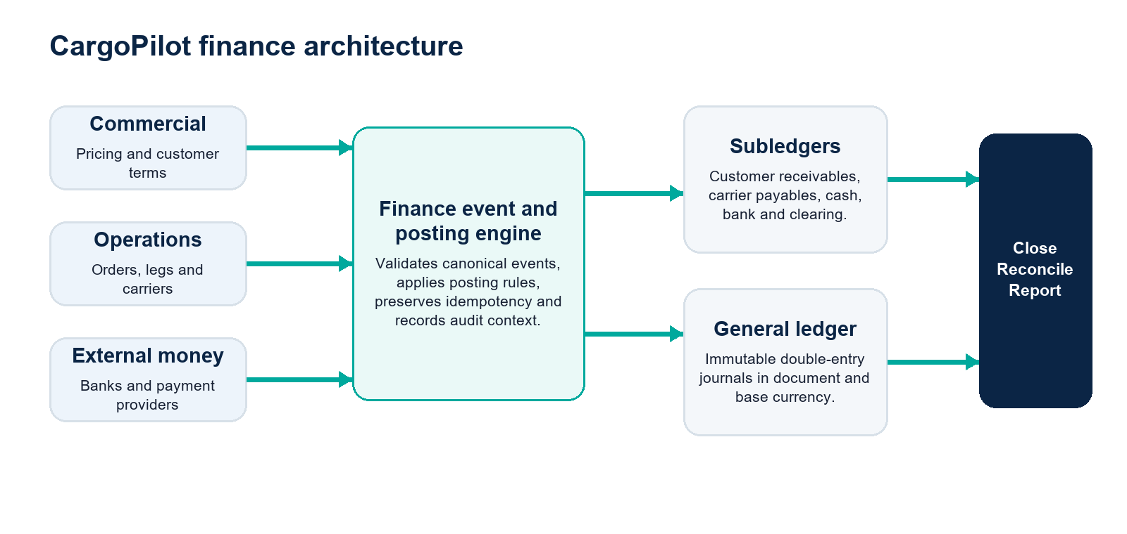
Figure 1. Finance receives canonical business events and becomes the source of truth for posted accounting.

1.1 System ownership
System area | Source of truth | Finance interaction
Pricing | Tariffs, service components, route/leg pricing and FX quote snapshots. | Supplies billable components; finance does not recalculate a commercial quote.
Orders and legs | Shipment execution, responsible parties, carrier assignment and operational status. | Supplies revenue/cost dimensions and posting triggers.
Payments | Provider intent, checkout, callback and confirmed payment state. | Creates clearing, receivable allocation, fees, refunds and reconciliation items.
Cash custody | Physical collection and handoff events. | Moves value between custody accounts; custody movement is not automatically revenue.
Finance | Posted accounting documents, open items, reconciliations, fiscal periods and statements. | Owns economic truth and audit evidence.
Analytics | Read-optimized operational and management projections. | Consumes posted finance projections; it must not create or mutate accounting truth.

1.2 Core invariants
- No client-supplied total is trusted for accounting; postings use server-verified source documents and pricing snapshots.
- Every posted journal entry balances: total debits equal total credits in company base currency.
- Posted documents are immutable. Corrections use controlled reversal and replacement documents.
- Every financial command is company-scoped, permission-checked, idempotent and audited.
- Original currency and amount are preserved even when a base/reporting amount is calculated.
- Operational event logs and the general ledger remain separate; a payment event is not itself an accounting journal.

2. Finance workspace
CargoPilot Finance should appear as a dedicated ERP workspace. Billing & Pricing remains responsible for commercial configuration; Finance is responsible for financial operations, accounting control and reporting.
Workspace | Primary users | Purpose
Finance Control Tower | Finance director, controller, treasury | Cash position, overdue exposure, unposted items, close status, exceptions and approvals.
Accounts Receivable | Billing and collections | Customer invoices, credit notes, allocations, statements, aging and credit control.
Accounts Payable | Carrier settlement and AP | Carrier accruals, bills, verification, disputes, approvals and payment runs.
Cash & Bank | Treasury and cash control | Bank accounts, statements, provider clearing, COD custody, deposits and transfers.
Reconciliation | Treasury and accounting | Match provider/bank/cash records, fees and differences to CargoPilot transactions.
General Ledger | Accountants and controller | Chart of accounts, journals, reversals, trial balance, periods and posting rules.
Shipment Profitability | Finance, operations, commercial | Revenue, expected/actual leg cost, fees, claims and margin by order, route, customer and carrier.
Period Close | Controller and approvers | Close checklist, missing accruals, FX revaluation, locks and controlled reopen.
Reports | Executives, finance, auditors | Financial statements, aging, margin, tax and cash reports with source drill-down.
Finance Settings | Authorized finance administrators | Legal entities, currencies, fiscal calendars, accounts, tax codes, cost centers and approval limits.

2.1 Finance Control Tower experience
- Cash position by bank, payment provider and currency.
- Receivables overdue today and expected in the next 7/30 days.
- Carrier payables due, blocked and awaiting approval.
- Unreconciled provider payouts, bank lines and cash variances.
- Unposted finance events and posting failures requiring intervention.
- Negative-margin shipments and carrier-cost variance.
- Current fiscal period, close completion and unresolved controls.
UX rule
Cards summarize risk; tables execute work. Every amount must drill down from aggregate to currency, legal entity, document, journal and original operational source.

3. End-to-end financial lifecycle
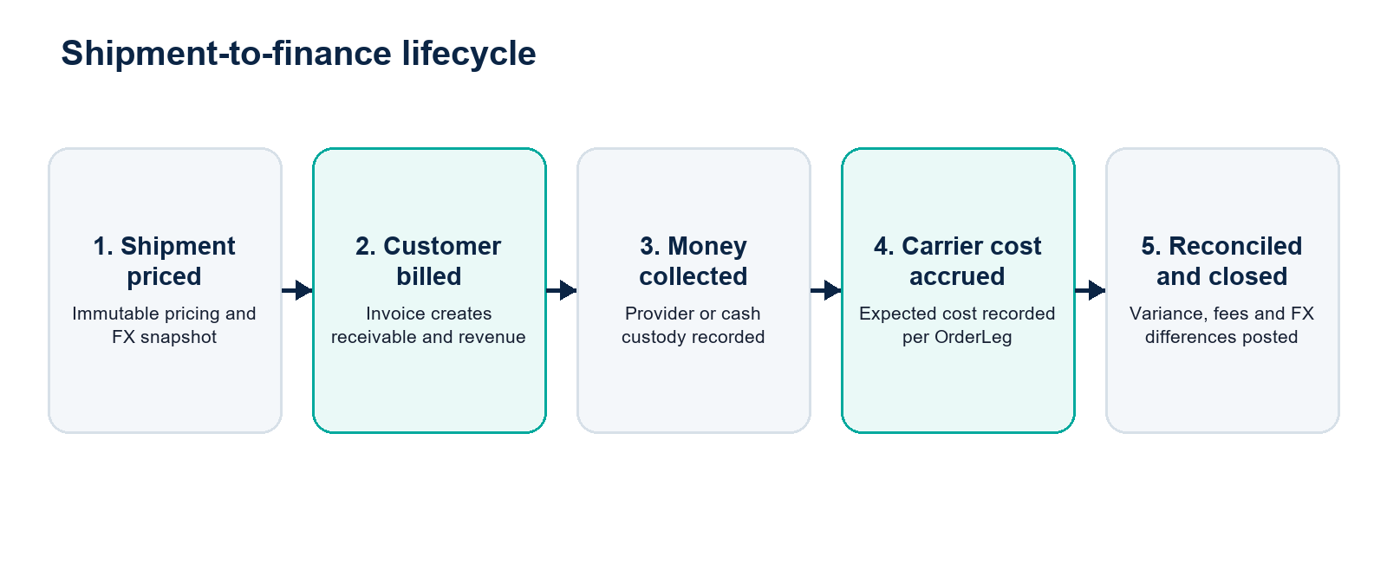
Figure 2. Financial processing follows the shipment lifecycle without coupling external providers to the ledger.

3.1 Customer revenue cycle
- Pricing produces immutable billable components for an order or leg.
- An invoice is drafted from verified pricing components and customer terms.
- Approval rules determine whether the invoice can be posted automatically or requires review.
- Posting creates customer receivable, freight revenue and applicable tax entries.
- Incoming payment is allocated against one or more open invoices; partial and excess payments remain visible.
- Credit notes and refunds reference the original invoice and use reversal-compatible accounting.

3.2 Carrier cost and payable cycle
Each OrderLeg may be executed by a different carrier and may create a separate expected cost. CargoPilot therefore accounts for transportation cost at leg level, while still consolidating shipment profitability at order level.
- Carrier rule or contract determines expected cost for the selected leg.
- When the configured execution milestone is reached, finance accrues the expected carrier cost.
- Carrier invoice or self-billing document is matched to leg, carrier, service and expected cost.
- Differences are classified as allowed variance, unplanned cost or dispute.
- Approved carrier bill creates an accounts-payable open item and clears or adjusts the accrual.
- Payment run releases only approved, due and unblocked carrier items.
Logistics-specific control
A single shipment may receive multiple carrier invoices: pickup, main carriage, customs handling and final delivery. Finance must preserve this structure instead of storing one undifferentiated order cost.

3.3 Payment-provider cycle
Event | Financial effect | Control
Customer checkout succeeds | Move value from customer receivable to provider clearing. | Use verified provider webhook or secure status sync; never trust browser return alone.
Provider settles funds | Move net funds to bank, recognize provider fee and clear provider balance. | Match payout reference, currency and gross/net amounts.
Refund completed | Reverse allocation or create customer payable/refund clearing. | Reference original intent, invoice and provider refund ID.
Chargeback/dispute | Recognize dispute receivable/expense and provider deduction. | Dedicated case, evidence and approval workflow.

3.4 COD and physical cash cycle
Cash custody represents where money is physically held. A driver-to-warehouse handoff changes custody but does not create new income. Revenue, customer receivable and third-party COD liability are posted independently according to the economic owner of the cash.
Operational event | Illustrative accounting movement
Driver collects service charge | Debit Driver Cash Custody / Credit Customer Receivable.
Driver hands cash to warehouse | Debit Warehouse Cash Custody / Credit Driver Cash Custody.
Warehouse deposits cash | Debit Bank or Cash Register / Credit Warehouse Cash Custody.
COD belongs to merchant/customer | Debit Cash Custody / Credit COD Payable until remitted.
Shortage or overage confirmed | Post approved cash variance to dedicated gain/loss account with case evidence.

4. Accounting model
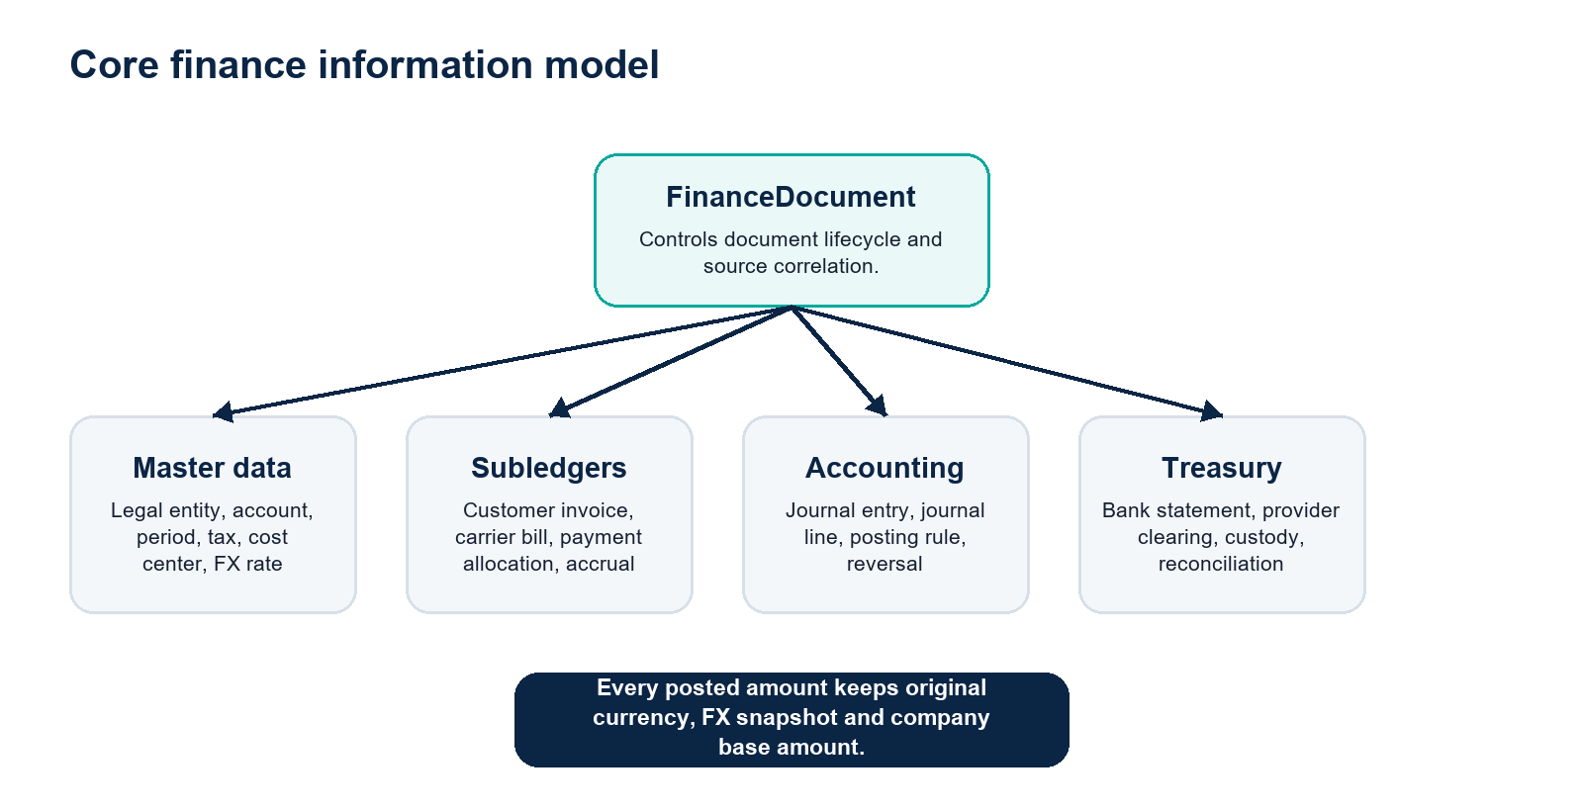
Figure 3. Finance documents connect business source records to subledgers, journals and treasury controls.

4.1 Core records
Record | Responsibility
FinanceLegalEntity | Accounting company, base currency, tax identity, fiscal calendar and reporting configuration.
LedgerAccount | Chart-of-accounts node with type, normal balance, posting permissions and company scope.
FiscalPeriod | Open, restricted or closed posting interval with controlled reopen history.
FinanceDocument | Common lifecycle and source correlation for invoice, bill, credit note, payment and adjustment.
JournalEntry / JournalLine | Immutable balanced posting with document currency, FX rate and base amount.
PostingRule | Versioned mapping from canonical business event to accounts, dimensions and posting date rules.
CustomerInvoice / CreditNote | Accounts-receivable source documents and open items.
CarrierBill / CarrierCostAccrual | Accounts-payable documents and expected cost per OrderLeg.
PaymentAllocation | Relationship between incoming/outgoing money and one or more open items.
BankStatement / ReconciliationItem | External statement evidence, match state and differences.
ExchangeRate | Approved rate, source, currency pair and effective timestamp.
CostCenter / ProfitCenter | Operational responsibility and profitability dimensions such as branch, warehouse or route.

4.2 Document lifecycle
State | Meaning | Allowed action
Draft | Editable financial proposal not yet approved. | Edit, submit, cancel.
Submitted | Ready for workflow evaluation. | Approve, reject, return.
Approved | Commercial and control approval complete. | Post or cancel before posting.
Posted | Accounting impact exists in an open period. | Allocate, settle or reverse; never edit/delete.
Reversed | Original accounting impact neutralized by linked reversal. | Inspect linked replacement or correction.
Closed | Open item settled and no further ordinary action expected. | Reopen only through defined exception process.

4.3 Posting engine
Operational modules publish canonical finance events through a durable outbox. A deterministic posting engine validates company, period, currencies, source state and posting rule version before writing the finance document and journal in one database transaction.
- Correlation key: sourceType + sourceId + eventId + postingRuleVersion.
- A unique posting key prevents duplicate journals during retries or repeated webhooks.
- Failures enter a visible finance exception queue; they are not silently dropped.
- Posting rules are versioned so historical documents remain explainable after configuration changes.
- Read models and Redis may accelerate dashboards but never replace durable accounting records.

5. Multi-currency policy
Active operating currencies
CargoPilot currently designs for UZS, USD and CNY. The model remains extensible, but unsupported currencies should be rejected until explicitly configured.

Every journal line records the original document amount and an immutable conversion into the legal entity's base currency. Reporting may additionally use a group currency, but it must never overwrite original values.
Field | Example | Rule
Document amount | 40.00 | Value shown on invoice, payment or carrier bill.
Document currency | USD | Never inferred from UI locale or company default.
FX rate | 12,650 UZS/USD | Snapshot from approved source at defined accounting date.
Base amount | 506,000 UZS | Deterministic rounded amount posted to the company ledger.
Base currency | UZS | Configured on the finance legal entity and restricted after go-live.
Rate source/as-of | CBU / 2026-08-02 | Preserved for audit and reproducibility.

5.1 Settlement and FX differences
If an invoice is posted at one FX rate and settled later at another, CargoPilot posts the difference to realized FX gain or loss. Open foreign-currency balances may be revalued at period close, producing reversible unrealized FX entries.
Non-negotiable
USD, UZS and CNY totals must never be summed under one currency label. Dashboards either display separate currency buckets or convert using an explicit, dated reporting rate.

6. Illustrative journal entries
The examples below explain the intended mechanics. Final account codes, tax treatment and posting dates are configured per legal entity and jurisdiction.

6.1 Customer invoice - USD 40 freight service
Account | Debit | Credit | Currency
Customer receivable | 40.00 |  | USD
Freight revenue |  | 40.00 | USD

6.2 Stripe collection and payout with USD 1.20 fee
Account | Debit | Credit | Currency
Stripe clearing - collection | 40.00 |  | USD
Customer receivable |  | 40.00 | USD
Bank - payout | 38.80 |  | USD
Payment provider fee expense | 1.20 |  | USD
Stripe clearing - payout |  | 40.00 | USD

6.3 Carrier cost accrual and invoice
Stage | Debit | Credit | Purpose
Accrual | Transportation expense | Carrier cost accrual | Recognize expected leg cost at configured milestone.
Invoice verification | Carrier cost accrual | Carrier payable | Replace expected liability with approved supplier open item.
Approved variance | Transport variance expense | Carrier payable | Record difference between expected and invoiced cost.
Payment | Carrier payable | Bank | Clear supplier open item when payment is released.

6.4 COD owned by the merchant
Event | Debit | Credit
Driver collection | Driver cash custody | COD payable
Warehouse handoff | Warehouse cash custody | Driver cash custody
Deposit | Bank | Warehouse cash custody
Merchant remittance | COD payable | Bank

7. Controls, security and audit

7.1 Role-independent permissions
CargoPilot continues the ERP RBAC policy: roles are configured in the UI and contain backend-defined permissions. Finance behavior must never depend on hardcoded role names.
Permission family | Examples
Read and investigate | finance.dashboard.read, finance.journal.read, finance.reports.read
Receivables | finance.invoice.create, finance.invoice.approve, finance.invoice.post, finance.invoice.reverse
Payables | finance.carrierBill.create, finance.carrierBill.approve, finance.paymentRun.create
Treasury | finance.paymentRun.approve, finance.paymentRun.release, finance.reconcile
General ledger | finance.journal.create, finance.journal.post, finance.journal.reverse
Close and configuration | finance.period.close, finance.period.reopen, finance.settings.manage

7.2 Segregation of duties
- The creator of a high-value supplier payment cannot be its final releaser.
- Provider credentials and bank-account configuration require separate elevated permission and audit trail.
- Manual journals above an approval threshold require independent approval.
- Period close and reopen are restricted and record reason, approver and timestamp.
- Bank and provider reconciliation cannot rewrite source payment records.
- Company, branch and operational scopes are applied in backend database filters, not only in the UI.

7.3 Audit evidence
Every finance document exposes a chronological audit timeline: source event, actor, approvals, posting rule version, journal IDs, allocations, reconciliation evidence, reversals, attachments and all state transitions.

8. Reconciliation and exception management
Reconciliation stream | Expected automation | Exception examples
Payment providers | Match intent, provider payment, payout and fee using provider IDs and currency. | Missing webhook, duplicate callback, net/gross mismatch, chargeback.
Bank statements | Match reference, amount, currency, date and counterparty to open finance items. | Unknown transfer, split settlement, bank fee, wrong currency.
Carrier bills | Match provider, OrderLeg, service, contract/rule and expected accrual. | Duplicate invoice, price variance, unplanned surcharge, wrong leg.
Physical cash | Reconcile custody events to deposit or handoff confirmation. | Shortage, overage, missing handoff, stale driver custody.
Exceptions become owned work items with status, assignee, evidence, due date and resolution reason. They may integrate with CargoPilot Support for cross-functional investigation, while financial approval remains inside Finance.

9. Period close and reporting

9.1 Close checklist
- Confirm all provider payouts and bank statements for the period are imported and reconciled.
- Identify delivered/in-progress legs requiring carrier cost accrual.
- Review unposted invoices, bills, cash variances and posting failures.
- Revalue open foreign-currency receivables, payables and cash balances.
- Run trial balance and control-account reconciliations.
- Approve close, lock period and publish financial statements.

9.2 Standard reports
Report | Key dimensions
Profit and loss | Legal entity, period, account, branch, cost center, customer, route and carrier.
Balance sheet | Cash/bank, provider clearing, receivables, payables, accruals, taxes and equity.
Cash flow | Operating, investing and financing classifications with currency view.
AR/AP aging | Partner, currency, due bucket, disputed/block state and responsible owner.
Shipment profitability | Order, leg, lane, customer, transport mode, carrier and pricing plan.
Reconciliation status | Provider/bank, statement period, matched, unmatched, variance and aging.
Audit and posting exceptions | Source event, rule, error category, retry count, assignee and resolution.

10. User experience blueprint

10.1 Navigation
Finance menu | Default view
Overview | Control tower and approval inbox.
Receivables | Invoices, credit notes, allocations, customers and aging.
Payables | Carrier accruals, bills, disputes and payment runs.
Cash & Bank | Balances, custody, bank statements and transfers.
Reconciliation | Provider, bank, carrier and cash workbenches.
General Ledger | Journals, accounts, trial balance and periods.
Profitability | Order and leg margin with expected/actual variance.
Close | Close checklist, blockers, revaluation and locks.
Reports | Financial and management reports.
Settings | Finance master data and posting configuration.

10.2 Workbench design rules
- Use cursor-paginated, server-filtered tables for high-volume documents and open items.
- Show document currency and company currency together when conversion matters.
- Persist filters and provide export from exactly the same backend query used by the table.
- Use explicit approval dialogs with impact summary; never use browser-native confirmation popups.
- Display accounting state separately from operational payment or shipment state.
- Provide source drill-down from journal line to invoice/payment/order/leg and back.
- Use SSE or event invalidation for freshness, with durable database reads as the correctness source.

11. Integration architecture
Finance consumes internal canonical events and external evidence through existing CargoPilot outbox, inbox and webhook patterns. External carriers and payment providers never write directly to accounting tables.
Source | Canonical finance events
Orders and pricing | shipment.priced, invoice.requested, service.completed, order.cancelled
Payments | payment.succeeded, payment.failed, refund.succeeded, chargeback.opened, payout.settled
Carrier integration | carrier.booking.confirmed, leg.started, leg.completed, carrier.invoice.received
Cash custody | cash.expected, cash.collected, cash.handed_off, cash.deposited, cash.variance.confirmed
Finance workflow | document.approved, document.posted, payment.released, period.closed, document.reversed
Delivery guarantee
Events are delivered at least once; financial effects are applied exactly once through unique source correlation and idempotent posting. Retries must be safe.

12. Delivery roadmap
Phase | Scope | Business outcome
1. Finance foundation | Legal entities, base currency, accounts, periods, journals, posting rules, audit and exception queue. | A trustworthy accounting kernel that future screens cannot bypass.
2. Receivables | Customer invoices, credit notes, allocations, aging and integration with existing payments/cash. | Controlled revenue and customer debt management.
3. Carrier payables | OrderLeg accruals, carrier bills, expected/actual verification, disputes and approvals. | True shipment cost and carrier liability visibility.
4. Treasury and reconciliation | Bank statements, payment-provider payouts, fees, COD custody and payment runs. | Explainable cash and fewer manual settlement errors.
5. Close and reporting | FX revaluation, close workflow, P&L, balance sheet, cash flow and profitability. | Auditable period reporting and management insight.
6. Advanced finance | Budgets, forecasts, tax automation, intercompany and external accounting integrations. | Enterprise scale without compromising the core ledger.

12.1 Phase 1 acceptance criteria
- Every supported source event can be processed repeatedly without duplicate journal entries.
- All posted journals balance in base currency and preserve original currency values.
- Closed periods reject unauthorized postings; controlled reopen is audited.
- Posted entries cannot be edited or deleted through API, UI or cascading operational deletion.
- Company and membership scopes prevent cross-company finance data access.
- Posting failures are visible, retryable and attributable to a specific source and rule version.
- Existing payment and cash workflows continue operating during staged finance adoption.

13. Implementation guardrails
Guardrail | Engineering implication
Finance is not analytics | Redis/read models may cache results, but PostgreSQL finance records remain authoritative.
No hardcoded roles | Routes require permission keys and backend scope filters.
No mutable posted data | Use reversals and correction documents; protect relations from operational cascade deletion.
No floating-point money | Use integer minor units or fixed precision decimal with explicit currency scale.
No implicit FX | Every conversion stores rate, source, as-of timestamp and rounding policy.
No direct provider-to-ledger writes | Provider callbacks create canonical events; posting engine owns journals.
No aggregate-only evidence | Reports must drill to journals, documents and operational sources.
No silent posting loss | Outbox/inbox, retry state, dead-letter handling and operational alerting are mandatory.

14. Glossary
Term | Meaning in CargoPilot
Accounts receivable (AR) | Amounts customers owe CargoPilot.
Accounts payable (AP) | Amounts CargoPilot owes carriers and other suppliers.
Accrual | Expected cost or revenue recognized before the final invoice or payment is received.
Clearing account | Temporary account used while payment-provider or bank settlement is incomplete.
Open item | Posted receivable or payable that is not fully settled.
Posting rule | Versioned rule that converts a canonical event into balanced journal lines.
Reconciliation | Matching external money evidence to internal transactions and resolving differences.
Subledger | Detailed record of customer, carrier, cash or bank balances that reconciles to the general ledger.
Trial balance | Account balances proving total debits and credits are equal.
OrderLeg | Operational segment of a shipment that may carry its own carrier, cost and profitability.

15. References
Internal CargoPilot architecture
- ERP Architecture Policy - module boundaries, RBAC, multi-currency and order-leg principles.
- Payments Secure Architecture - provider configuration, payment intent and webhook controls.
- Pricing Real-World Architecture - route, leg, tariff and currency design.
- Integrations ERP Architecture - provider isolation, outbox/inbox and canonical event patterns.
External reference model
- SAP S/4HANA Transportation Management - freight settlement, carrier invoice verification and freight cost accrual concepts: https://help.sap.com/docs/SAP_S4HANA_ON-PREMISE/e3dc5400c1cc41d1bc0ae0e7fd9aa5a2/7eb8bdf270d84b16ab8a755d09b11e81.html
- SAP Freight Settlement best-practice scope - freight costs, accruals, carrier invoices and stage-level charges: https://help.sap.com/docs/s4hana-cloud-best-practices/freight-settlement-6w4-pt/purpose
Document status
This is CargoPilot's target product architecture. Accounting policy, tax configuration, chart of accounts and statutory reports must be validated for each operating legal entity before production finance go-live.

