PARTNER INTEGRATION SPECIFICATION
CargoPilot Integration Partner Guide
Secure, reliable integration contracts for carriers, SMS providers, webhook partners, and enterprise systems.
Document | Value
Version | 1.0
Published | June 3, 2026
Audience | External partners and implementation teams
Classification | Partner use
Support | Assigned during partner onboarding

Integration promise: CargoPilot keeps core ERP domains provider-agnostic while providing encrypted credentials, durable delivery, secure webhooks, idempotency, retries, and operational auditability.

CargoPilot
Integration Layer | External Partner Documentation

DOCUMENT NAVIGATION
Contents
- 1. Purpose and scope
- 2. Integration operating model
- 3. Partner onboarding
- 4. Security, authentication, and idempotency
- 5. Generic carrier API contract
- 6. Generic SMS API contract
- 7. Generic outbound webhook contract
- 8. Inbound webhook contract
- 9. Reliability and operations
- 10. UML data model
- 11. Testing and production readiness
- Appendices: events, errors, and reference examples
How to use this guide: Partners that can implement the generic contract can integrate without a custom adapter. Partners with provider-specific protocols should use this guide as the canonical business and security specification while CargoPilot implements a dedicated adapter.

1. Purpose and Scope
This guide defines how external companies connect to CargoPilot ERP. It covers outbound carrier, SMS, and webhook delivery; inbound signed webhooks; provider configuration; idempotency; retries; dead-letter handling; testing; and production onboarding.
CargoPilot integrations are company-scoped. A provider configuration belongs to one company, one integration domain, and one environment. This allows different companies to use different partners, credentials, limits, and activation states.

Integration domains
Domain | Purpose | Current generic contract
carrier | Create, cancel, and track partner shipments | Available
sms | Send SMS and query delivery status | Available
webhook_sink | Deliver CargoPilot events to partner endpoints | Available
payment | Reserved for payment-provider convergence | Provider-specific today

API base URL: Sandbox and production CargoPilot base URLs are supplied during onboarding. All production communication must use HTTPS.

2. Integration Operating Model
CargoPilot core modules do not call partner APIs directly. Core modules emit canonical events into a durable integration outbox. A worker resolves the active provider, decrypts the provider configuration, dispatches the request, and records every attempt.
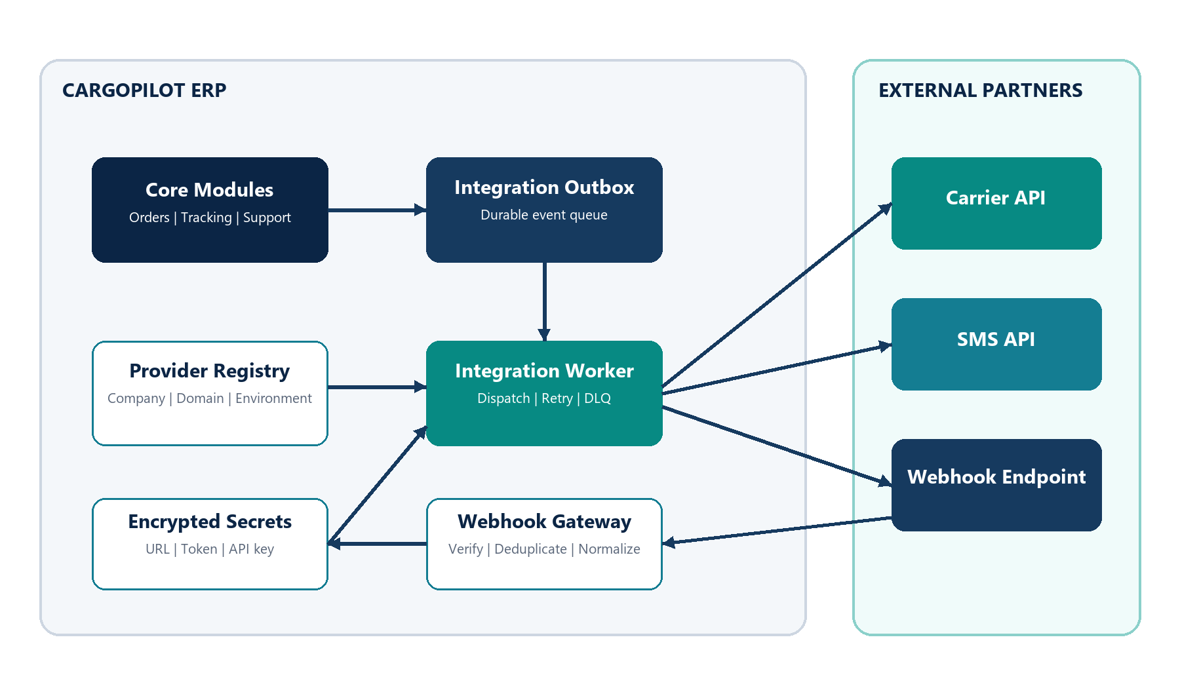
Figure 1. CargoPilot integration layer and external partner boundaries.

Core components
Component | Responsibility
Provider Registry | Stores company, domain, provider code, environment, status, capabilities, timeout, and rate limit.
Encrypted Secret Store | Stores rotatable provider endpoint and credential configuration encrypted at rest.
Integration Outbox | Durably records outbound integration events before delivery.
Integration Worker | Claims records, dispatches requests, handles retries, and moves final failures to dead letter.
Delivery Attempts | Records each request result, provider status code, retryability, and error.
Webhook Gateway | Verifies signatures, rejects stale or invalid requests, deduplicates events, and normalizes payloads.
Admin Console | Allows authorized administrators to configure providers and operate the delivery queue.

Provider lifecycle
Status | Meaning | Dispatch behavior
active | Configured and approved for use | Worker can dispatch
paused | Temporarily suspended | Worker does not dispatch
disabled | Not available for use | Worker does not dispatch

3. Partner Onboarding
Every partner integration follows a controlled onboarding process.
- Agree on the integration domain and supported business operations.
- Confirm whether the generic CargoPilot contract is sufficient or a custom adapter is required.
- Exchange sandbox URLs, credentials, webhook secrets, and technical contacts.
- Configure the provider in CargoPilot using the sandbox environment.
- Verify outbound requests, response mapping, idempotency, and temporary failure behavior.
- Verify inbound webhook signature generation, event IDs, and duplicate handling.
- Complete production readiness checks and load production credentials.
- Activate the production provider after joint approval.

When a custom adapter is required
- The partner cannot expose the generic `/shipments` or `/messages` endpoints.
- Authentication requires OAuth refresh, mutual TLS, or a provider-specific signature scheme.
- The partner uses XML, SOAP, multipart files, or multi-step workflows.
- Shipment labels, manifests, tracking statuses, or errors require provider-specific mapping.
- The partner contract has special rate limits, reconciliation, or asynchronous confirmation rules.
Architecture rule: A custom adapter belongs inside CargoPilot integrations-core. Orders, payments, pricing, tracking, and support remain provider-agnostic.

4. Security, Authentication, and Idempotency

Outbound authentication
Secret field | Behavior
baseUrl | Base URL used by carrier and SMS adapters.
endpointUrl | Full target URL used by generic outbound webhook delivery.
token | Sent as `Authorization: Bearer <token>`.
apiKey | Sent in the configured API key header.
apiKeyHeader | Header name for `apiKey`; defaults to `x-api-key`.

{
"baseUrl": "https://partner.example.com",
"token": "optional-bearer-token",
"apiKey": "optional-api-key",
"apiKeyHeader": "x-api-key"
}

Idempotency requirements
- CargoPilot sends `x-idempotency-key` for outbound business operations.
- A repeated idempotency key must not create duplicate shipments, SMS messages, invoices, or payments.
- If the first request succeeded but its response was lost, a repeat request should return the original business reference.
- Inbound webhook `eventId` values must be stable and unique per provider.
Security requirement: Partners must never place passwords, card data, personal documents, or long-lived secrets in URLs or webhook payloads.

Headers sent by CargoPilot
content-type: application/json
x-cargopilot-request-id: <outbox-record-id>
x-cargopilot-company-id: <company-id>
x-idempotency-key: <stable-idempotency-key>
authorization: Bearer <token> # when configured
x-api-key: <api-key> # when configured

5. Generic Carrier API Contract
A carrier that supports the following endpoints can integrate through the generic HTTP carrier adapter. All responses must be JSON.

5.1 Create shipment
POST /shipments

{
"externalOrderId": "990000000123",
"sender": {
"name": "Sender Name",
"phone": "+998901234567",
"address": "Tashkent, Uzbekistan",
"lat": 41.311081,
"lng": 69.240562
},
"receiver": {
"name": "Receiver Name",
"phone": "+998909876543",
"address": "Almaty, Kazakhstan",
"lat": 43.238949,
"lng": 76.889709
},
"parcels": [
{ "weightKg": 2.5, "quantity": 1, "description": "Documents" }
],
"declaredValueMinor": "1200000",
"currency": "UZS",
"transportMode": "air",
"serviceCode": "express",
"metadata": { "source": "cargopilot" }
}

Successful response:
{
"partnerShipmentId": "DHL-123456789",
"trackingNumber": "JD014600011234567890",
"labelUrl": "https://partner.example.com/labels/JD014600011234567890.pdf"
}

Required response: `partnerShipmentId` is required. CargoPilot also accepts `shipmentId` or `id` as aliases.

5.2 Cancel shipment
POST /shipments/{partnerShipmentId}/cancel
{ "reason": "Customer requested cancellation" }

5.3 Track shipment
GET /shipments/{partnerShipmentId}/track
GET /shipments/track?trackingNumber=JD014600011234567890

{
"statusCode": "in_transit",
"statusLabel": "In transit",
"happenedAt": "2026-06-03T12:00:00.000Z",
"location": "Almaty Hub"
}

Response meaning | Accepted field names
Status code | statusCode, status, code
Status label | statusLabel, statusText, label
Timestamp | happenedAt, updatedAt, timestamp
Location | location, city, place

6. Generic SMS API Contract

6.1 Send SMS
POST /messages

{
"to": "+998901234567",
"text": "Your shipment 990000000123 is ready.",
"templateCode": "shipment_ready",
"metadata": { "orderId": "990000000123" }
}

{
"messageId": "sms_123456",
"acceptedAt": "2026-06-03T12:00:00.000Z"
}

Required response: `messageId` is required. CargoPilot also accepts `id` as an alias.

6.2 Get delivery status
GET /messages/{messageId}

{
"status": "delivered",
"deliveredAt": "2026-06-03T12:00:30.000Z"
}

7. Generic Outbound Webhook Contract
For `webhook_sink` providers, CargoPilot sends the canonical event payload to the configured `endpointUrl`. Any `2xx` response is treated as successful.
content-type: application/json
x-cargopilot-provider-code: <provider-code>
x-cargopilot-idempotency-key: <idempotency-key>
x-cargopilot-event-type: <event-type>
authorization: Bearer <token> # when configured
x-api-key: <api-key> # when configured

Result | Classification
Any 2xx | Successful delivery
429 | Retryable rate limit
Any 5xx | Retryable provider/platform error
Timeout, reset, DNS temporary failure, connection refused | Retryable transport error
Most other 4xx | Non-retryable business/configuration error
Invalid or missing endpoint configuration | Non-retryable configuration error

8. Inbound Webhook Contract
Partners notify CargoPilot through the signed generic webhook gateway.
POST /api/integrations/webhooks/{providerCode}

8.1 Required signature headers
content-type: application/json
x-signature: <hmac-signature>
x-signature-timestamp: <unix-timestamp-seconds-or-ms>

Signature algorithm:
signed_payload = "<timestamp>.<raw_body>"
signature = HMAC_SHA256_HEX(secret, signed_payload)

Replay protection: CargoPilot rejects webhook timestamps outside the configured drift window. The default window is 300 seconds.

8.2 Recommended webhook payload
{
"eventId": "evt_123456",
"eventType": "carrier.status.updated",
"occurredAt": "2026-06-03T12:00:00.000Z",
"companyId": "6efc7f6d-5c31-4c5f-81b9-651ad2bd63e3",
"aggregateType": "shipment",
"aggregateId": "DHL-123456789",
"payload": {
"trackingNumber": "JD014600011234567890",
"statusCode": "delivered",
"statusLabel": "Delivered",
"location": "Tashkent"
}
}

8.3 Webhook responses
HTTP result | Meaning | Example status
202 | Signature valid and event accepted | accepted
200 | Duplicate event already recorded | duplicate
400 | Invalid signature, timestamp, provider, or payload | rejected

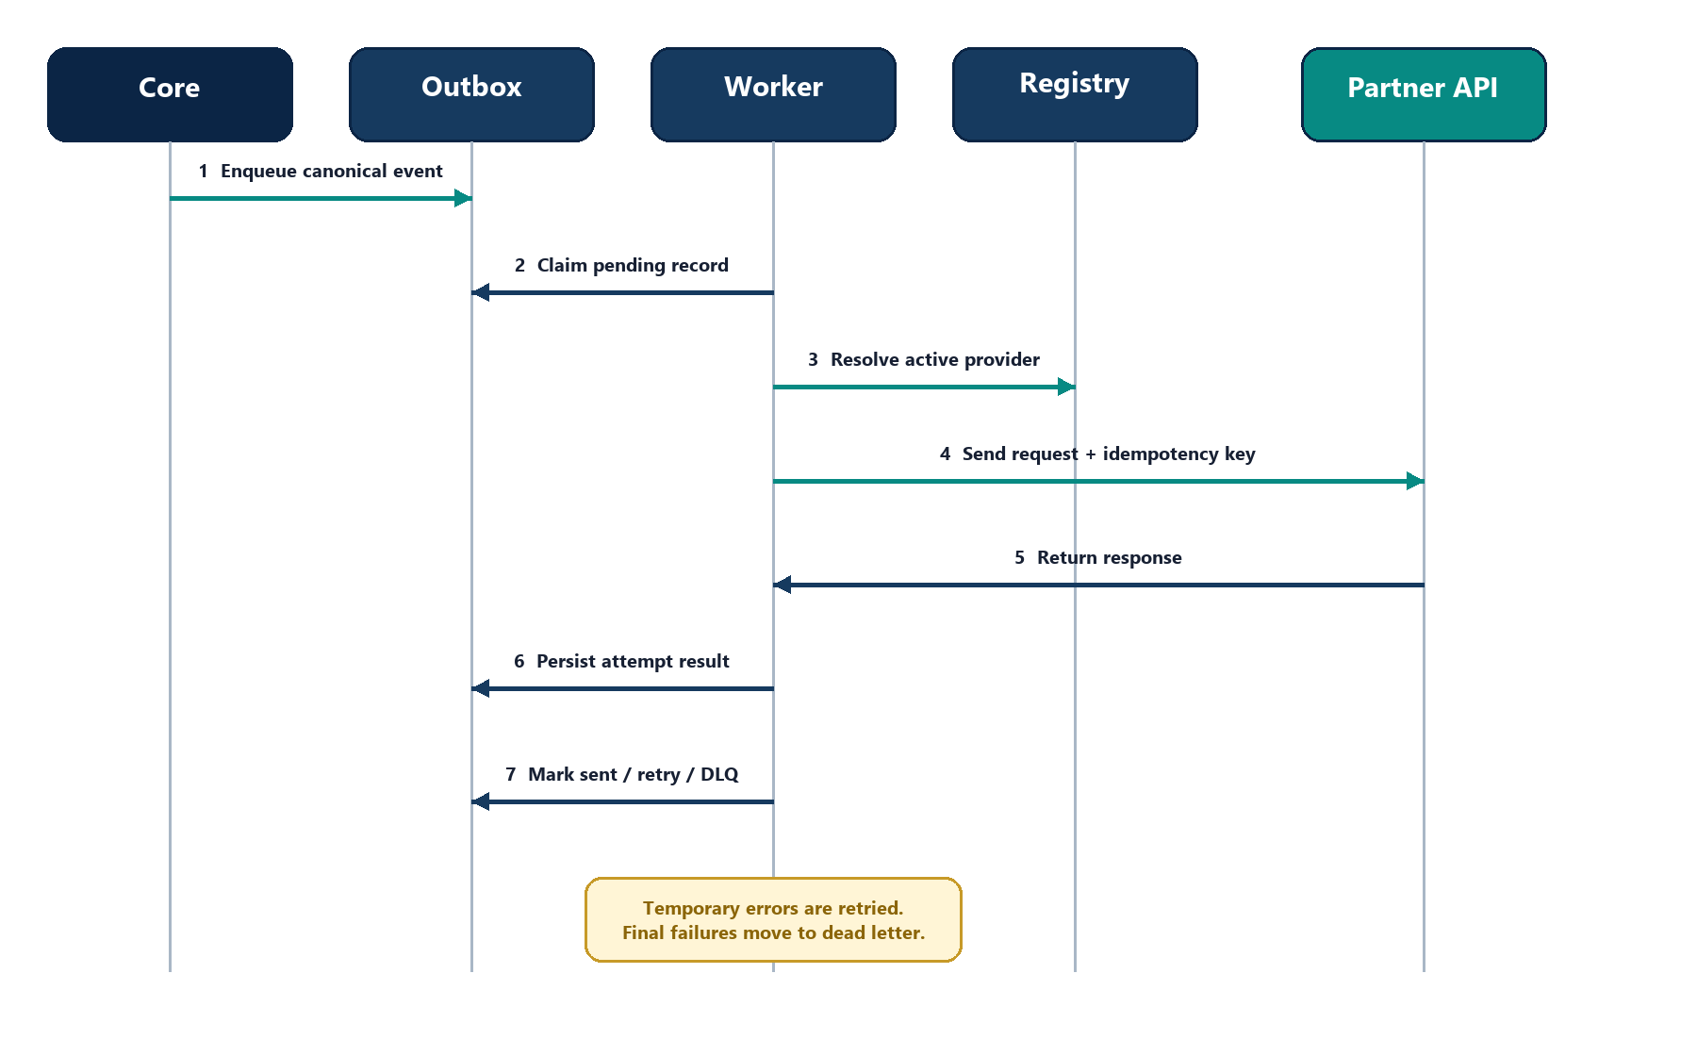
Figure 2. Outbound delivery sequence and persisted attempt handling.

9. Reliability and Operations
CargoPilot retries temporary failures and preserves a full attempt history. Operations teams can inspect records, force a retry, or replay failed/dead-letter records from the admin console.
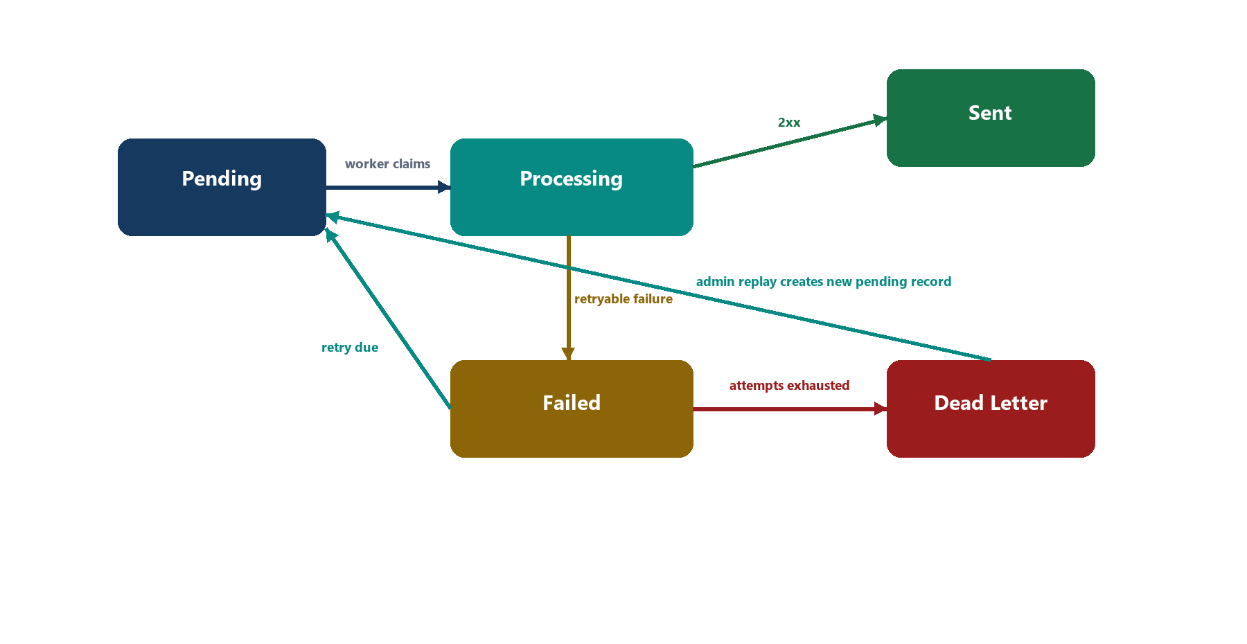
Figure 3. Integration outbox state machine.

Partner HTTP behavior
- Return `2xx` only after accepting the operation.
- Return `429` when rate limited.
- Return `5xx` for temporary provider/platform errors.
- Return `409` only for a real business conflict.
- Do not return `2xx` for a failed business operation.

Operational ownership
CargoPilot owns | Partner owns
Provider activation and environment selection | API availability and contract compliance
Credential rotation and encrypted storage | Credential issuance and revocation
Queue inspection, retry, and replay | Idempotent handling of repeated requests
Webhook verification and duplicate detection | Correct signatures and stable event IDs
Delivery audit trail | Clear HTTP status codes and error responses

10. UML Data Model
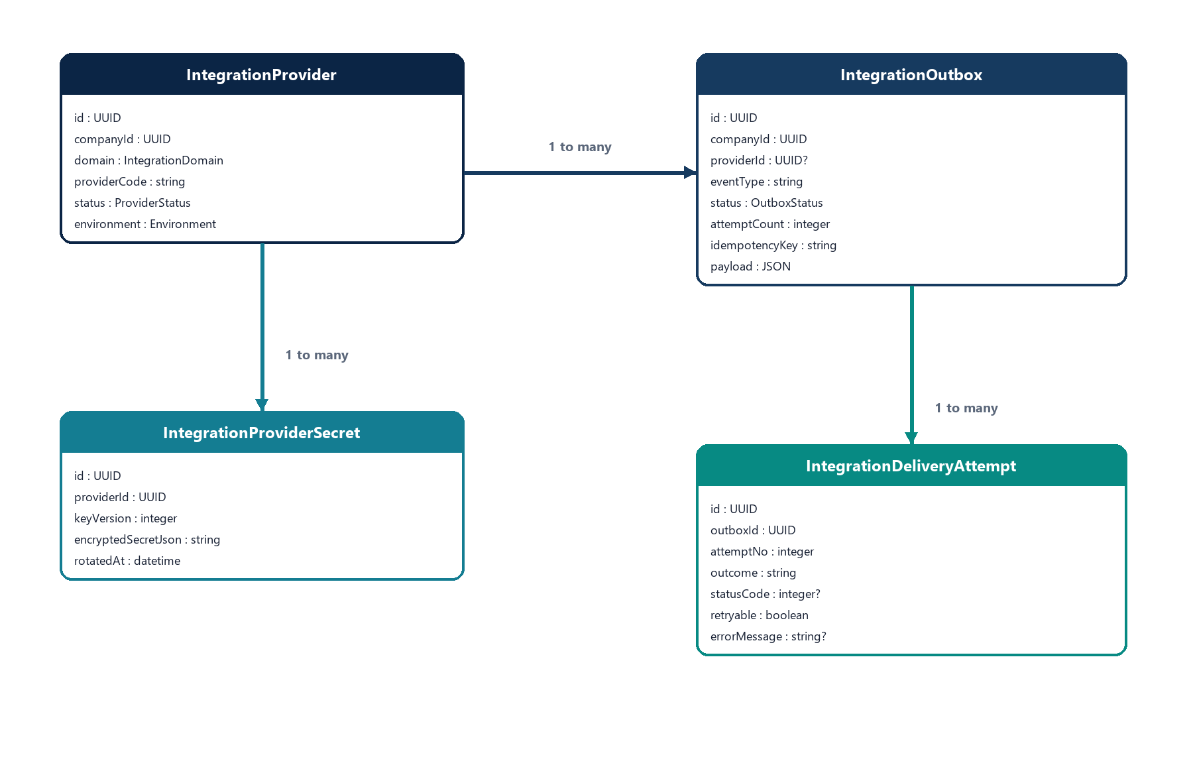
Figure 4. Main integration provider, secret, outbox, and attempt relationships.
Model | Business purpose
IntegrationProvider | Defines the company-scoped external provider and runtime controls.
IntegrationProviderSecret | Stores versioned encrypted configuration and credentials.
IntegrationOutbox | Stores each outbound event and its delivery lifecycle.
IntegrationDeliveryAttempt | Stores the result and diagnostics for every attempt.
IntegrationWebhookEvent | Stores raw inbound events after signature verification.

11. Testing and Production Readiness
Production activation requires joint acceptance of the following checks.
Test | Expected result | Owner
Sandbox outbound request | Partner accepts request and returns required reference | Joint
Idempotency replay | Repeated key does not create duplicate business effect | Partner
Temporary 5xx/timeout | CargoPilot retries and records attempts | Joint
Inbound signed webhook | CargoPilot accepts valid signature | Partner
Invalid signature | CargoPilot rejects webhook | CargoPilot
Duplicate webhook | CargoPilot returns duplicate without reapplying effect | Joint
Secret rotation | New credential works; previous credential can be revoked | Joint
Pause/disable provider | No new dispatch occurs | CargoPilot
Production credentials | Loaded, verified, and approved | Joint

Go-live gate: A provider should not be activated in production until sandbox behavior, idempotency, signatures, retries, and credential rotation have been verified.

Appendix A. Canonical Event Types
Event type | Typical use
order.created | Create or notify a partner about a new order.
order.status.changed | Notify a partner about an operational status change.
shipment.assigned | Create/assign shipment work with a carrier.
shipment.delivered | Notify delivery completion.
payment.intent.created | Notify/create a payment operation.
payment.paid | Notify confirmed payment.
support.ticket.created | Notify a support/CRM partner.
sms.delivery.updated | Normalize SMS delivery status.
carrier.status.updated | Normalize carrier shipment status.

Appendix B. Inbound Webhook Signing Example
const crypto = require("crypto");
const timestamp = Math.floor(Date.now() / 1000).toString();
const rawBody = JSON.stringify(payload);
const signature = crypto
.createHmac("sha256", webhookSecret)
.update(`${timestamp}.${rawBody}`)
.digest("hex");
// Send rawBody with:
// x-signature: signature
// x-signature-timestamp: timestamp

Important: Generate the signature from the exact raw request body bytes sent to CargoPilot. Re-serializing JSON after signing can change whitespace or field order and invalidate the signature.

Appendix C. Partner Error Response Guidance
Status | Use when | CargoPilot behavior
200-299 | Operation accepted successfully | Marks record sent
400 | Request schema is invalid | Final failure unless manually replayed after correction
401/403 | Credential is invalid or unauthorized | Final failure; rotate/fix credentials
409 | Real business conflict | Final failure; investigate business state
429 | Partner rate limit reached | Retries later
500-599 | Temporary partner/platform error | Retries later

