OOD of the Online Exam System

Table of Contents:
Step 0 — Brief 2
Step 1 — Noun & Verb ajratish 2
Step 2 — Scope’ni aniqlash (soddalashtiramiz) 3
Step 3 — Ownership 3
Step 4 — Relationship & Multiplicity 3
Step 5 — Responsibility 4
Step 6 — UML Class Model 4
Step 7 — Nega bu OOD juda yaxshi? 6

Step 0 — Brief
Brief (Talablar)
Online Exam System quyidagilarni bajaradi:
№ | Talablar
 | Student exam’ga kiradi
 | Exam’da time limit bor
 | Student exam’ni boshlaydi → Attempt yaratiladi
 | Savollarga javob beradi
 | Exam yakunlanadi (submit yoki time tugashi)
 | Natija hisoblanadi
 | Exam davomida violation (qoidabuzarlik) qayd etilishi mumkin

Step 1 — Noun & Verb ajratish

№ | Nouns (Candidate classes) | Verbs (Behaviors)
 | Student | startExam()
 | Exam | submitAnswer()
 | Question | finishExam()
 | Answer | autoSubmit()
 | ExamAttempt | calculateScore()
 | Violation | recordViolation()
 | Result

Step 2 — Scope’ni aniqlash (soddalashtiramiz)

№ | Olib tashlaymiz | Fokus
 | Proctor UI | Core exam lifecycle
 | Camera / mic | Core exam lifecycle
 | Notification | Core exam lifecycle
 | Exam creation panel | Core exam lifecycle
 | Authentication | Core exam lifecycle

Step 3 — Ownership
- Exam → ko‘p Question
- Student → ko‘p ExamAttempt
- ExamAttempt → bitta Exam
- ExamAttempt → ko‘p Answer
- ExamAttempt → ko‘p Violation
- Result → ExamAttempt’ga tegishli
Student Exam’ni emas, Attempt’ni topshiradi

Step 4 — Relationship & Multiplicity
- Exam 1 — * Question
- Student 1 — * ExamAttempt
- ExamAttempt 1 — * Answer
- ExamAttempt 1 — * Violation
- ExamAttempt 1 — 1 Result

Step 5 — Responsibility
❌ Noto‘g‘ri:
Exam.submit()

✅ To‘g‘ri
- ExamAttempt.start()
- ExamAttempt.submitAnswer(questionId, answer)
- ExamAttempt.finish()
- ExamAttempt.autoSubmit()
- Result.calculate(attempt)
Business logic entity ichida.

Step 6 — UML Class Model
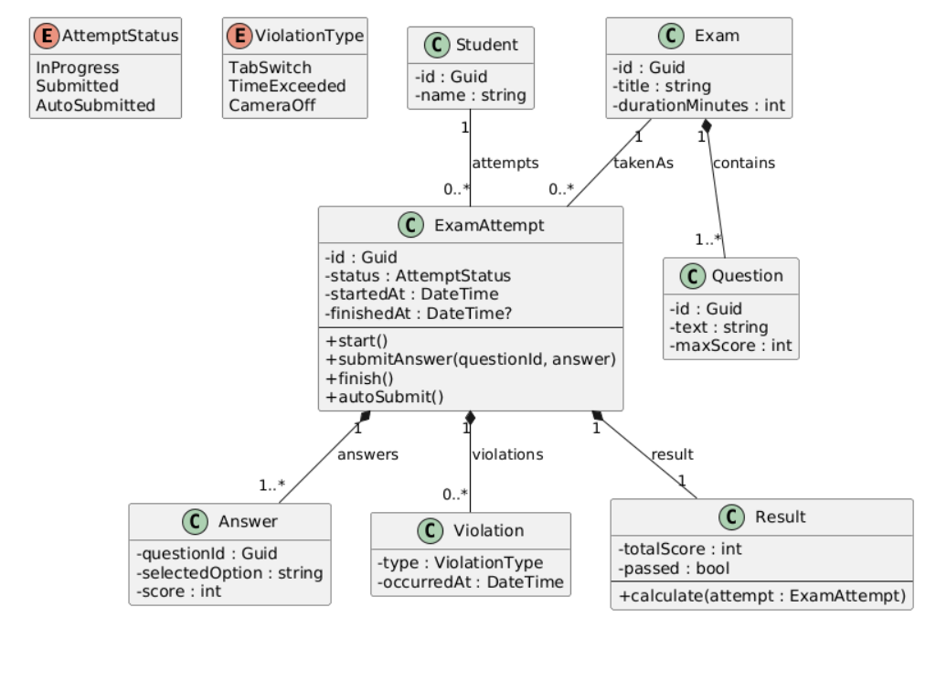
@startuml
skinparam classAttributeIconSize 0
hide empty members

' ===== Value Types / Enums =====
enum AttemptStatus {
InProgress
Submitted
AutoSubmitted
}

enum ViolationType {
TabSwitch
TimeExceeded
CameraOff
}

' ===== Core Entities =====
class Student {
- id : Guid
- name : string
}

class Exam {
- id : Guid
- title : string
- durationMinutes : int
}

class Question {
- id : Guid
- text : string
- maxScore : int
}

class ExamAttempt {
- id : Guid
- status : AttemptStatus
- startedAt : DateTime
- finishedAt : DateTime?
--
+ start()
+ submitAnswer(questionId, answer)
+ finish()
+ autoSubmit()
}

class Answer {
- questionId : Guid
- selectedOption : string
- score : int
}

class Violation {
- type : ViolationType
- occurredAt : DateTime
}

class Result {
- totalScore : int
- passed : bool
--
+ calculate(attempt : ExamAttempt)
}

' ===== Relationships =====
Exam "1" *-- "1..*" Question : contains
Student "1" -- "0..*" ExamAttempt : attempts
Exam "1" -- "0..*" ExamAttempt : takenAs
ExamAttempt "1" *-- "1..*" Answer : answers
ExamAttempt "1" *-- "0..*" Violation : violations
ExamAttempt "1" *-- "1" Result : result

@enduml

Step 7 — Nega bu OOD juda yaxshi?
- Attempt — real-life model
- Time-based lifecycle bor
- Aggregate boundary aniq
- State & behavior entity ichida

