**Ikkita tekislik orasidagi burchak**

1. 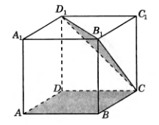 ABCDA1B1C1D1 kubda ABC va CB1D1 tekisliklar orasidagi burchak tangensini toping.
2. 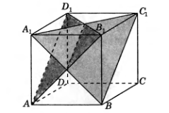 ABCDA1B1C1D1 kubda BA1C1va AB1D1 tekisliklar orasidagi burchak tangensini toping.
3. 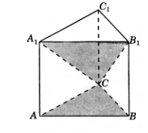Uchburchakli muntazam ABCA1B1C1 prizmada barcha qirralari 1 sm dan, ABC va CA1B1 tekisliklar orasidagi burchak tangensini toping.
4. 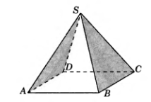To‘rtburchakli muntazam SABCD piramidada barcha qirralari 1 sm dan, SAD va SBC tekisliklar orasidagi burchak kosinusini toping.
5. To‘rtburchakli muntazam SABCD piramidada barcha qirralari 1 sm dan, SCD va SBC yoqlardan tashkil topgan ikki yoqli burchak kosinusini toping.

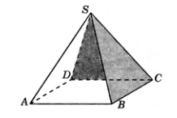

1. 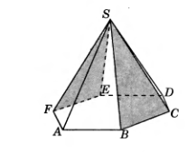Oltiburchakli muntazam SABCDEF piramidaning asosining tomoni 1sm, yon qirrasi 2 sm bo‘lsa, SEF va SBC tekisliklar orasidagi burchak kosinusini toping.
2. 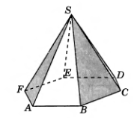Oltiburchakli muntazam SABCDEF piramidaning asosining tomoni 1sm, yon qirrasi 2 sm bo‘lsa, SAF va SBC tekisliklar orasidagi burchak kosinusini toping.
3. Oltiburchakli muntazam ABCDEFA1B1C1D1E1F1prizmada barcha qirralari 1 sm dan, ABC va DB1F1 tekisliklar orasidagi burchak tangensini toping.

