**Nuqtadan to‘g‘ri chiziqqacha bo‘lgan masofa**

1. 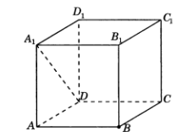 Qirrasi 1 sm ga teng ABCDA1B1C1D1 kubda B nuqtadan DA1 to‘g‘ri chiziqq acha bo‘lgan masofani toping.
2. 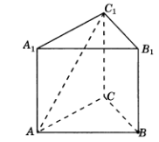Uchburchakli muntazam ABCA1B1C1prizmada barcha qirralari 1 sm dan, B nuqtadan AC1 to‘g‘ri chiziqq acha bo‘lgan masofani toping.
3. 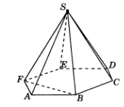Oltiburchakli muntazam SABCDEF piramidaning asosining tomoni 1sm , yon qirrasi 2 sm bo‘lsa, S nuqtadan BF to‘g‘ri chiziqq acha bo‘lgan masofani toping.
4. Oltiburchakli muntazam SABCDEF piramidaning asosining tomoni 1sm , yon qirrasi 2 sm bo‘lsa, B nuqtadan SA to‘g‘ri chiziqq acha bo‘lgan masofani toping.

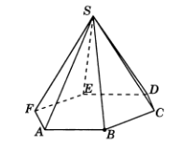

1. Oltiburchakli muntazam ABCDEFA1B1C1D1E1F1prizmada barcha qirralari 1 sm dan, B nuqtadan A1F1 to‘g‘ri chiziqq acha bo‘lgan masofani toping.

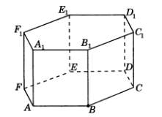

1. 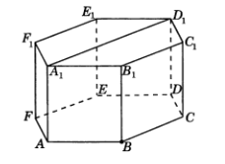Oltiburchakli muntazam ABCDEFA1B1C1D1E1F1prizmada barcha qirralari 1 sm dan, B nuqtadan A1D1 to‘g‘ri chiziqq acha bo‘lgan masofani toping.
2. 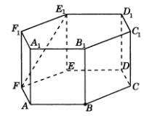Oltiburchakli muntazam ABCDEFA1B1C1D1E1F1prizmada barcha qirralari 1 sm dan, B nuqtadan FE1 to‘g‘ri chiziqqacha bo‘lgan masofani toping.
3. 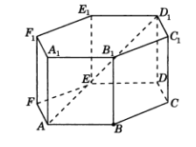Oltiburchakli muntazam ABCDEFA1B1C1D1E1F1prizmada barcha qirralari 1 sm dan, B nuqtadan AD1 to‘g‘ri chiziqq acha bo‘lgan masofani toping.