**Nuqtadan tekislikkacha bo‘lgan masofa**

1. 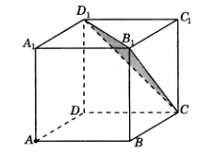 Qirrasi 1 sm ga teng ABCDA1B1C1D1 kubda A nuqtadan CB1D1 tekislikkacha bo‘lgan masofani toping.
2. 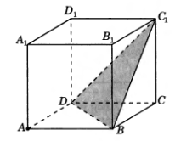 Qirrasi 1 sm ga teng ABCDA1B1C1D1 kubda A nuqtadan BDC1 tekislikkacha bo‘lgan masofani toping.
3. 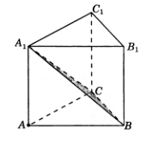Uchburchakli muntazam ABCA1B1C 1prizmada barcha qirralari 1 sm dan, A nuqtadan BCA1 tekislikkacha bo‘lgan masofani toping.
4. 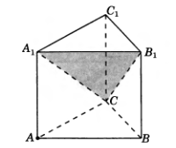Uchburchakli muntazam ABCA1B1C1 prizmada barcha qirralari 1 sm dan, A nuqtadan SA1B1 tekislikkacha bo‘lgan masofani toping.
5. 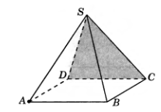To‘rtburchakli muntazam SABCD piramidada barcha qirralari 1 sm dan, A nuqtadan SCD tekislikkacha bo‘lgan masofani toping.
6. Oltiburchakli muntazam SABCDEF piramidaning asosining tomoni 1 sm, yon qirrasi 2 sm bo‘lsa, A nuqtadan SDE tekislikkacha bo‘lgan masofani toping.

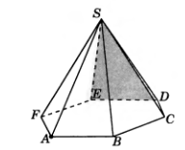

1. 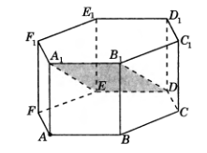Oltiburchakli muntazam ABCDEFA1B1C1D1E1F1prizmada barcha qirralari 1 sm dan, A nuqtadan DEA1 tekislikkacha bo‘lgan masofani toping.
2. 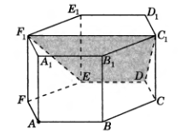Oltiburchakli muntazam ABCDEFA1B1C1D1E1F1prizmada barcha qirralari 1 sm dan, A nuqtadan DEF1 tekislikkacha bo‘lgan masofani toping.