# 1. Intro

System Zabbix allows users to observe [connected to the system] servers and provide both general and detailed servers statuses. Zabbix server can provide virtually any information about the host (server that is connected to the system) it can get. Zabbix system consists of four parts:

* Zabbix agents - that are located on monitored servers (hosts). Needed to get information from the host and send it to Zabbix server.
* Zabbix server - receives all the information from agents and analyze it.
* Database – all the information server gets from agents is being saved there. Storing previous data duration depends on the settings of each monitored item.
* Zabbix frontend – the face of the system. Allows to see the results of monitoring and configure system settings.

The latter part, frontend, currently consists of two parts:

* Old frontend – the default frontend that is provided with Zabbix system. All the configuration is done there, as well as most of advanced monitoring parts.
* New frontend – frontend that was developed specifically for internal usage in Exigen. Provides consolidated view to get quick status of the projects and servers.

That means that if you want to add/edit/remove a new host to the system, configure monitored parameters, etc, you have to visit old frontend that you can find at <http://zabbixcm02.internal.corp>.

If you are interested in monitoring results, you should visit more user-friendly new frontend that you can find at <http://zabbixcm02.internal.corp/frontend>.

# 2. Hosts configuration

In this part of documentation you can find instructions for configurational part of the system located in old frontend and other instructions on how to manage servers in the system.

## 2.1. Adding new server to the system

New server addition is dependant on server OS and in documentation there are instructions for Linux and Windows. After initial installing of agent, agent must be properly configured on frontend and instuction for that you can find in Frontend section.

Typical Zabbix hosts are the devices you want to monitor (most commonly, servers). Host are organized into host groups.

### 2.1.1a. Linux agent installation

1. Download and un-pack Zabbix source:

#wget <http://downloads.sourceforge.net/project/Zabbix/ZABBIX%20Latest%20Stable/2.0.6/Zabbix-2.0.6.tar.gz?download>

# gzip –d Zabbix-2.0.6.tar.gz

2. Create new user **Zabbix:**

# useradd Zabbix

3. Compile and configure agent:

# cd Zabbix-2.0.6

# ./configure –enable-agent

# make

4. Copy agent configurational file and daemon file:

# mkdir /etc/Zabbix

# cp misc/cond/Zabbix_agentd.conf /etc/Zabbix

# cp src/Zabbix_agent/Zabbix_agentd /usr/local/sbin

5. Add following ports in Firewall for services:

Zabbix_agent 10050/tcp

Zabbix_trap 10051/tcp

6. Run the agent:

# /usr/local/sbin/Zabbix_agentd

### 2.1.1b. Windows agent installation

1. Download Zabbix from http://www.zabbix.com/downloads/2.0.6/Zabbix_agents_2.0.6.win.zip and unpack it to C:\zabbix

2. Copy agent configurational file to C:\zabbix_agentd.conf

3. Open command promt as administrator and install zabbix agent with following command:

C:\bin\win64\zabbix_agentd.exe --config C:\Zabbix_agentd.conf –-install

4. Configure Firewall so that ports 10050 and 10051 will be able to be used by Zabbix agent to send and receive data.

5. Turn on Zabbix agent (via services, rebooting or command line). Command line command:

C:\bin\win64\zabbix_agentd.exe --start

### 2.1.2. Frontend final configuration

To configure a host in Zabbix frontend, do the following:

* Go to: *Configuration → Hosts*
* Click on *Create* to the right.

Now you should see something like this:

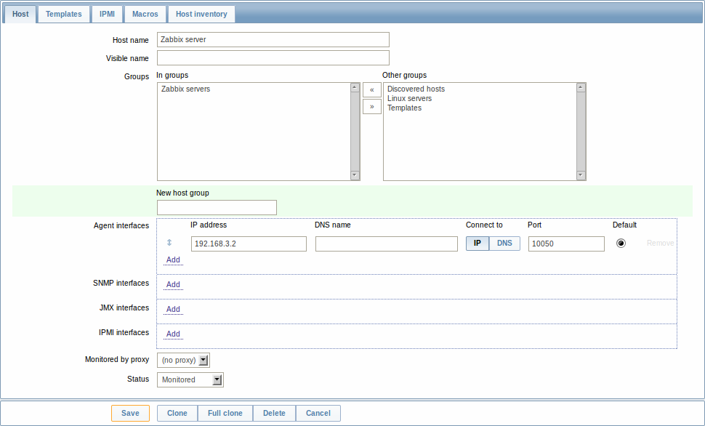

1. Enter host name (unique). Alpha-numericals, spaces, full stops and underscores are allowed. Should be full name of server with domains.
2. Enter visible name that will be shown instead of host name. This should be used to make the host names more readable.

*For example, host name: dev99somethingapp99.eqxdev.exigengroup.com can be (and* ***SHOULD*** *be) minimized to dev99somethingapp99 or if that’s not describing enough to dev99somethingapp99.eqxdev).*

1. Select existing server group (or create new). Select on the right and click arrow that points left.
2. Enter host’s IP address **OR** DNS name, then select connection method. By default, port should be left 10050.
3. Select second tab on the top – “Templates”. There you should select (like in the second step) what roles this server has. Templates are sets of predefined parameters and triggers. For example, if the server you want to add is Windows MSSQL database server, you should attach template **Template_Windows** and **Template_MSSQL**.
4. Select last tab on the top – “Host inventory”. There you should enter all the relevant information you want to be stored in the details about this server. You should choose Automatic population method that will try to populate some fields, however you really should populate fields Type, Type (Full details), OS and OS (Short) by yourself. Anything other would be good, but not a must-be.
5. Now you should save the data you entered by pressing “Save” on the bottom of the page. That’s it, you have successfully added server to Zabbix system. In few minutes you should check the latest data and the data will be there (most probably). If not, check Troubleshooting.

For more details, see: <https://www.zabbix.com/documentation/2.0/manual/config/hosts/host>

## 2.2. Editing existing in the system server

Pretty much it’s very similiar to the process of adding server.

* Go to: *Configuration → Hosts*
* Click on server name you want to change.

**Don’t forget to save the changes by clicking “Save” button on the bottom of the page.**

## 2.3. Removing existing in the system server

Pretty much it’s very similiar to the process of adding server.

* Go to: *Configuration → Hosts*
* Click on server name you want to change.
* Press Delete button on the bottom of the page.

**Don’t forget to save the changes by clicking “Save” button on the bottom of the page.**

# 3. Monitored items configuration

## 3.1. Adding/Editing monitoring items

Items in Zabbix system mostly are linked to templates, so it is advisable to add item to whole template, as it will be added to all servers that use the template. Of course, if you need this monitored item only for a specific server, then add it server directly, not templates.

### 3.1.1. Adding/Editing items for template

* Go to: *Configuration → Templates*
* *Press on link* ***Items (n)*** *of template that you are interested in.*

If you want to Create new item, press the button “Create item” top-right, if you interested in editing, then press on item you want.

Now you should see something like this:

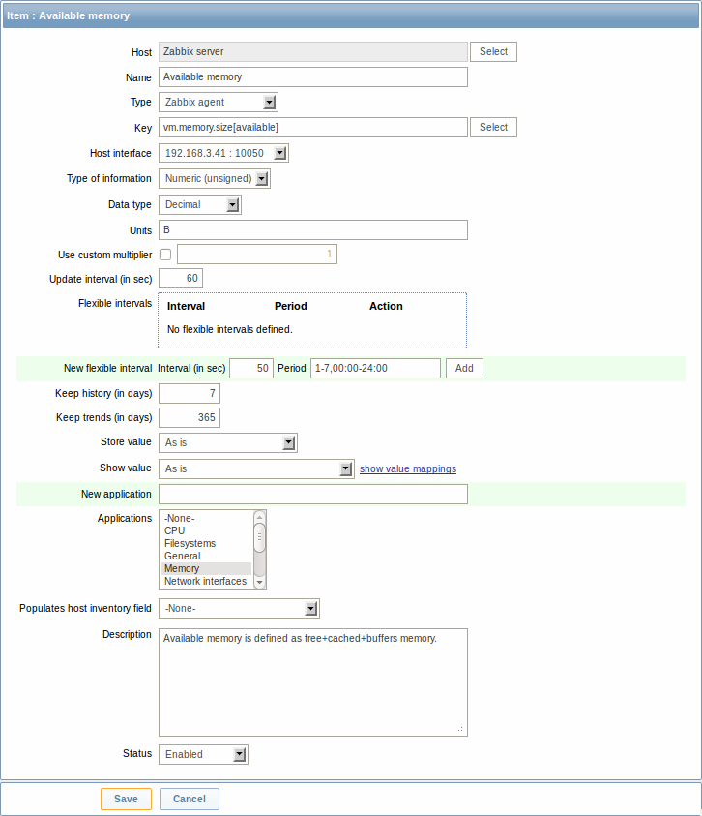

Everything there is self-describing. For more information, visit: <https://www.zabbix.com/documentation/2.0/manual/config/items/item>

For available monitoring keys, check: <https://www.zabbix.com/documentation/2.0/manual/config/items/itemtypes/zabbix_agent> and other item types.

### 3.1.2. Adding/Editing items for specific server

* Go to: *Configuration → Hosts*
* *Press on link* ***Items (n)*** *of the server that you are interested in.*
* *Press* ***Create item*** *button top-right, configure item and press* ***Save.***

## 3.2. Removing monitoring items

### 3.2.1. Removing template items

* Go to: *Configuration → Templates*
* *Press on link* ***Items (n)*** *of template that you are interested in.*
* *Select with checkbox item you want to remove.*
* *Select* ***Delete selected*** *and press Go.*

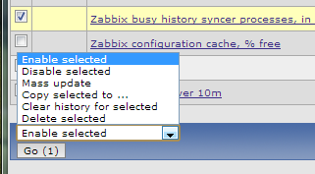

***NB: Keep in mind, that removing item in template will remove the item from every host that uses this template.******If you are not sure, it’s better to disable item!***

### 3.2.2. Removing specific server monitoring items

* Go to: *Configuration → Hosts*
* *Press on link* ***Items (n)*** *of the server that you are interested in.*
* *Press on item you are interested in deleting.*
* *If that item is not linked to any particular template, then on the bottom you should see button* ***Delete****.*



If that item is linked, but you don’t want that item to be monitored only on this particular host, then just disable the item. It will leave the same item monitored as it was on other servers, but disable it only on the server you selected.