1. Launch http://localhost:8080/SOAPClientSimulator/

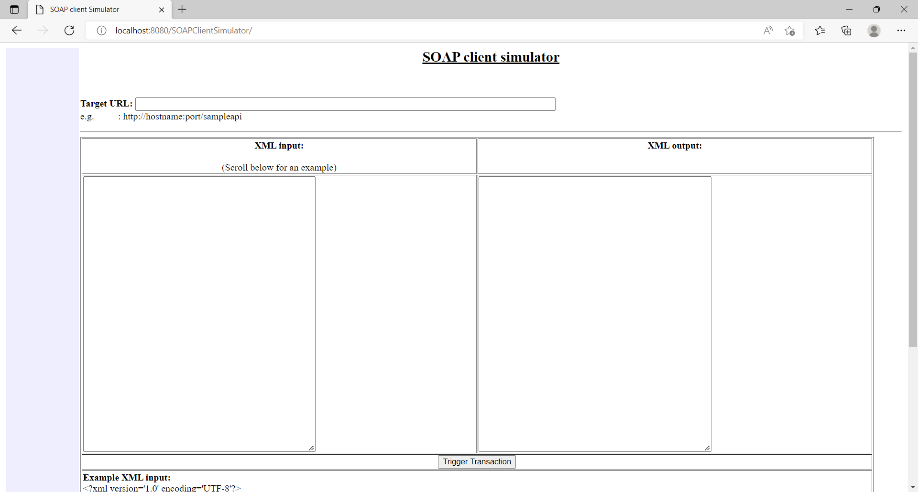

1. Provide the Target URL and XML Input

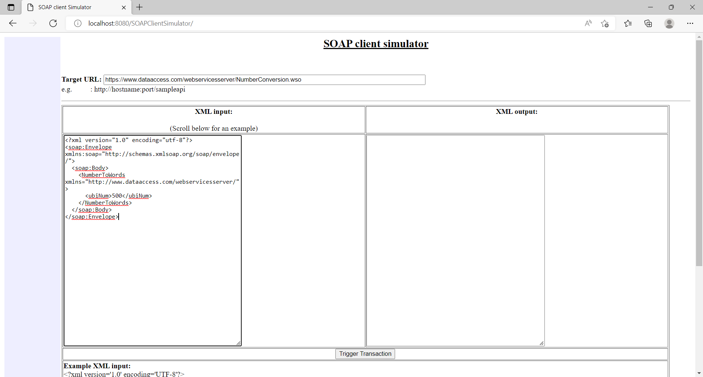

1. Click on “Trigger Transaction” and response is displayed in “XML output” block

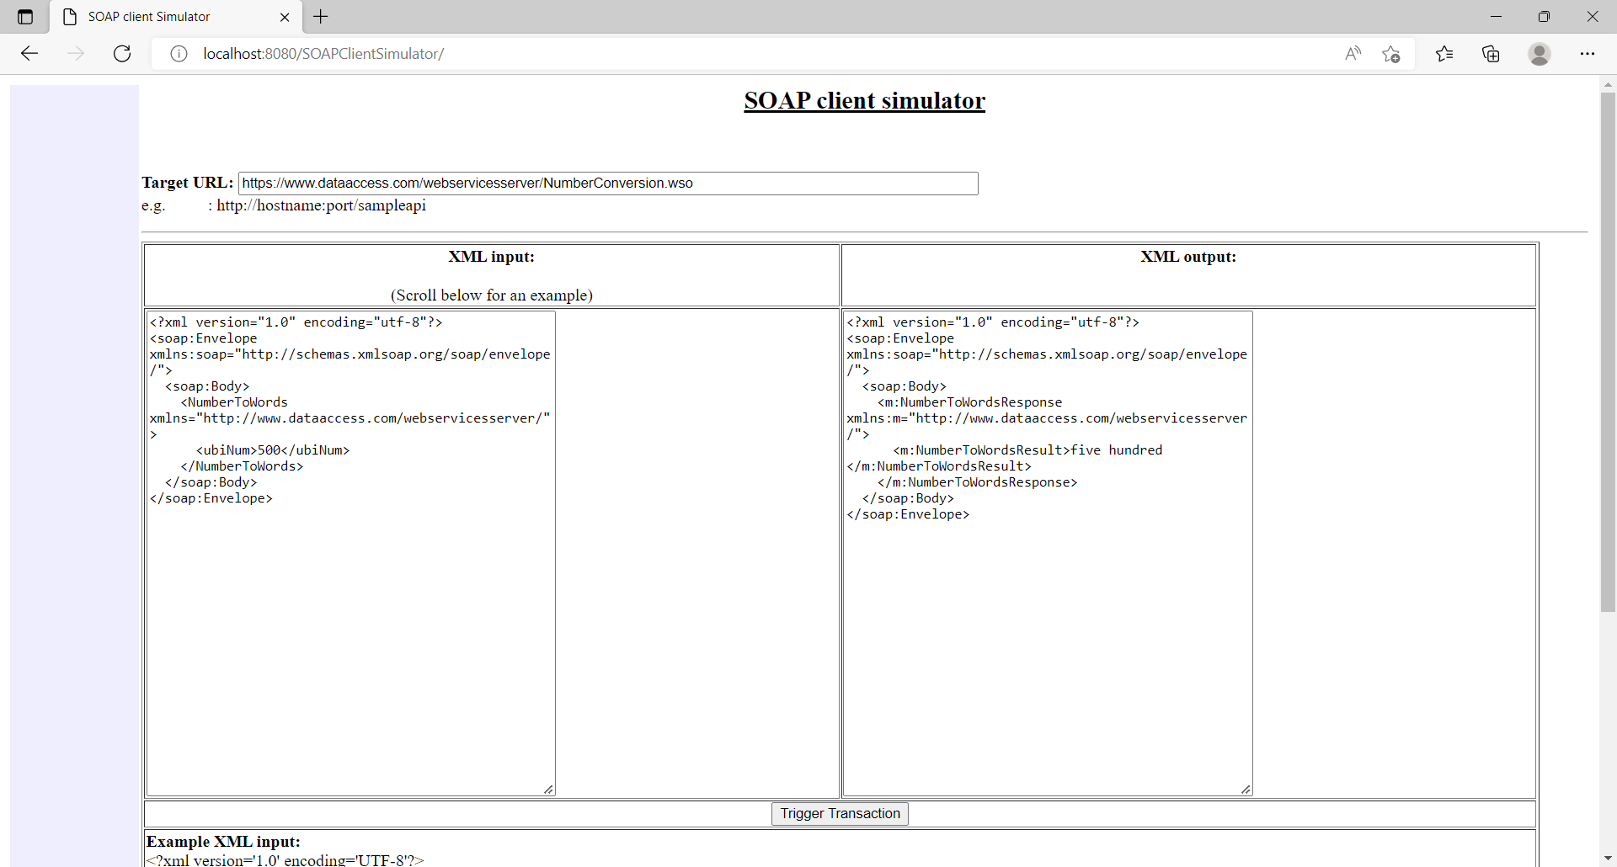

1. Logs from console

