**Supporting data, figures and tables**

**CymA dependence of in vivo and in vitro STC reduction in *E. coli***

This series of experiments was conducted to verify that the electrons being transferred from STC to methylene blue are of respiratory origin and are transported into the periplasm via CymA. Therefore, the methylene blue reduction cell suspension assay was repeated with an *E. coli* strain that produces neither CymA nor the homologous protein NapC. A *napC* deletion strain was chosen because previous experiments revealed overlapping activity of these quinol oxidases (Gescher et al., 2008). STC expression in this *cymA*- and *napC*- strain resulted in minor differences in methylene blue reduction compared to *E. coli* wild type (Fig. 2B). In other words, the positive effect of STC expression on methylene blue reduction is dependent on CymA-based electron transfer into the periplasm. Nevertheless, it remained unknown whether STC can be reduced directly by CymA or whether its reduction has to be mediated via MtrA. Previous studies demonstrated that *E. coli* membrane fractions containing CymA can be reduced in vitro using glycerol-3-phosphate as electron donor (Gescher et al., 2008) and that membrane-bound CymA can transfer electrons to purified periplasmic cytochromes, such as MtrA and FccA (Schuetz et al., 2009). In this assay, trace amounts of *E. coli* membrane fractions catalyze the reduction of higher concentrations of purified cytochromes. The reduction of hemes can be monitored at a wavelength of 552 nm. Membrane fractions of *E. coli* JG11 cells in which CymA production was previously either induced or not induced were prepared anoxically and different amounts of protein were added to an anoxic cuvette containing glycerol-3-phosphate as electron donor. After the addition of 1.5 nmol purified STChis, a reduction rate of 47 nmol/min*mg membrane protein was recorded for the CymA-expressing membrane. No reduction of STChis could be detected when non-induced membranes were tested. Membrane integrity was verified via the quantification of the NADH oxidation rate; both membranes oxidized NADH with comparable rates (554 nmol/min*mg for membranes from induced cells versus 673 nmol/min*mg for membranes from non-induced cells), confirming the integrity and electron transfer properties of the membranes.

**Material and Methods**

**Plasmid Construction**

Plasmid pBAD_STChis was constructed using the isothermal ligation method, as described above. The plasmid was digested with *NcoI* and *PmeI*. *Stc* was amplified using primers P31 and P32. Primer P32 was designed to introduce an N-terminal His-tag (Tab. S2).

**Cell fractionation and protein determination**

The periplasmic fractions of anaerobically grown *S. oneidensis* and *E. coli* cells were prepared using polymyxin B, as described by Pitts et al. (2003). To prepare membrane fractions, *E. coli* cells were grown anaerobically in M9 minimal medium (47.8 mM Na2HPO4, 22 mM KH2PO4, 9.2 mM NaCl, 18.7 mM NH4Cl) supplemented with 0.1 mM CaCl2, 1 mM MgSO4, trace elements (see above), 0.1% casein hydrolysate, and 14.8 µM thiamin hydrochloride. In addition, 0.5% glycerol was used as electron donor and 50 mM DMSO as electron acceptor. Cells were harvested at an OD600 of 0.4 and all subsequent steps were performed under anoxic conditions. The pellet was re-suspended in 1 volume of 0.1 M HEPES (pH 7.5) containing 0.1 mg/ml DNase I and passed through a French pressure cell at 137 MPa. Unbroken cells were removed by two consecutive centrifugations for 10 min at 3,000 x *g* and 4°C. The supernatant was centrifuged at 208,000 x *g* and 4°C for 90 min. The pellet containing the cell membranes was re-suspended in 0.1 M HEPES (pH 7.5). Protein concentration was determined via the Bradford method, using bovine serum albumin as a standard (Bradford, 1976).

**Protein purification**

*S. oneidensis* carrying the pBAD_STChis plasmid was grown in LB medium, and the expression of STChis was induced with 0.1 mM L-arabinose. Cells were harvested at an OD600 of 0.6 and the periplasmic fraction was isolated as described above. The periplasmic fraction was loaded onto a His Trap affinity column (GE Healthcare, Germany) and the column was washed with 20 column volumes of washing buffer (20 mM sodium phosphate, 0.5 M NaCl, 20 mM imidazole, pH 7.4). STChis was eluted using 10 column volumes of elution buffer (20 mM sodium phosphate, 0.5 M NaCl, 0.5 M imidazole, pH 7.4). The protein was subsequently concentrated using centrifugal filter units (Amicon Ultracel 3-K, Merck Millipore, Ireland).

**Enzyme assay with CymA and STC**

The enzyme assay was conducted as described previously (Schuetz et al., 2009). Strain JG11 was grown anaerobically in M9 minimal medium (see above). The *cymA*-containing operon was induced with 0.43 µM anhydrotetracycline. As a control, JG11 was grown under the same conditions without the addition of anhydrotetracycline. Membrane fractions and purified protein were prepared as described above. The membrane fraction was added to an anoxic cuvette with 0.1 M HEPES and 10 mM glycerol-3-phosphate. The reaction was started via the addition of 1.5 nmol STC, and cytochrome reduction was observed at 552 nm using a Cary 50 spectrophotometer (Varian, Germany). The determined rates varied within a range of less than 10%. Membrane integrity was confirmed using NADH dehydrogenase activity (Osborn et al., 1972). Briefly, 0.15 mg of membrane protein was added to 0.1 mM NADH in 100 mM HEPES buffer (pH 7.5) and the oxidation of NADH was monitored at 365 nm using a Cary 50 spectrophotometer.

**Supporting figures and tables**

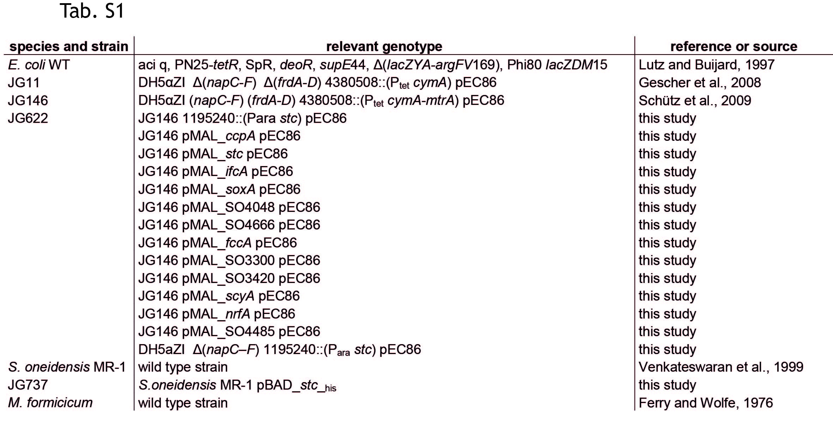

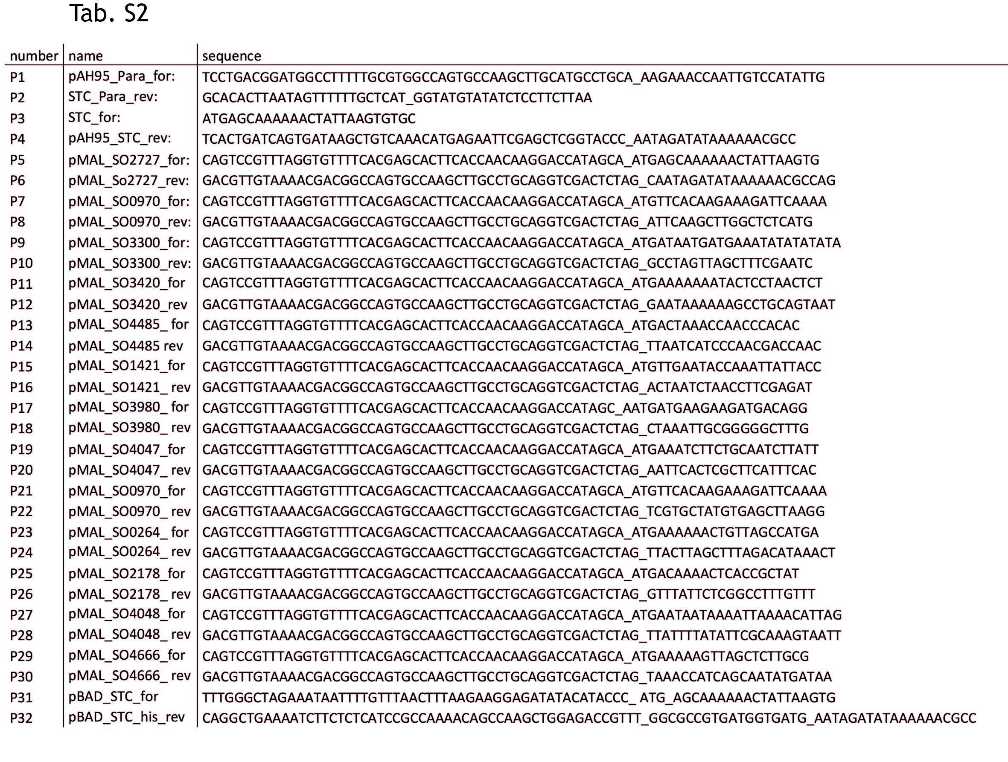

**Fig. S1**

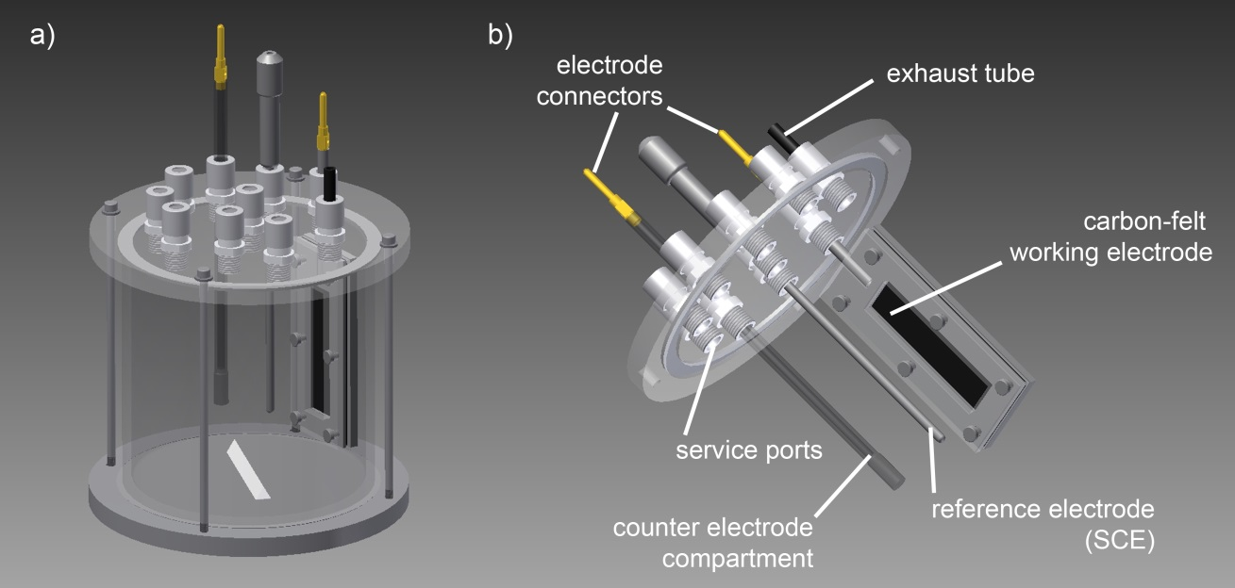

**Supporting figure and table caption**

**Tab. S1:** List of strains used in this study.

**Tab. S2:** List of primers used in this study.

**Fig. S1: CAD-drawings of the utilized 2 l microbial electrochemical cell.** a) Complete reactor setup. b) detailed description of the components of the reactor lid.

**References**

Ferry, J. G., Wolfe, R. S., 1976. Anaerobic degradation of benzoate to methane by a microbial consortium. Archives of microbiology. 107**,** 33-40.

Lutz, R., Bujard, H., 1997. Independent and tight regulation of transcriptional units in *Escherichia coli* via the LacR/O, the TetR/O and AraC/I1-I2 regulatory elements. Nucleic Acids Res. 25**,** 1203-10.

Venkateswaran, K., et al., 1999. Polyphasic taxonomy of the genus *Shewanella* and description of *Shewanella oneidensis* sp. nov. Int J Syst Bacteriol. 49 Pt 2**,** 705-24.