- Pkg.json npm command ni automatically banta ka?

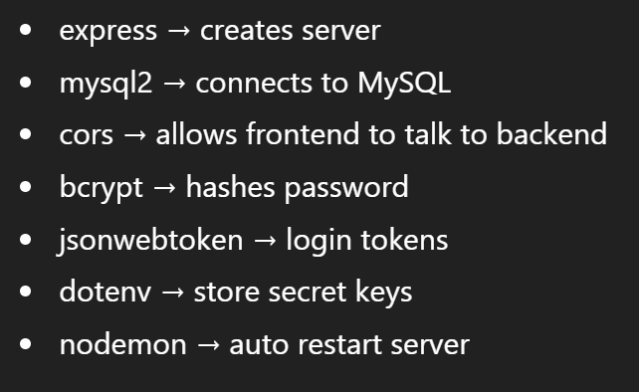

- Create database and 2 tables
- Database connection creating backend folder structure, :
- Server setup
- Authentication: Adding authRoutes and TaskRoutes
- Add code in all files --> npx nodemon server.js: runs the server, and saved changes also get executed.
Folder setup
Node initialized
Server running
Mysql connected

- Test signup :
-POST method:enter url Body: {
"username": "anvaya",
"email": "anvaya@gmail.com",
"password": "123456"
}
-success msgfirst backend endpt, password hashed bcrypt working

- Test login:
-POST method: enter urlBody: {
"email": "anvaya@gmail.com",
"password": "123456"
}
Token generateduser authenticated password, JWT signing in,bcrypt compare

ADD Task: url/tasks

