Week 08 · Monday
Time Series Analysis — Daily Assignment
PG Diploma · AI-ML & Agentic AI Engineering · IIT Gandhinagar
Datasets: Brazilian E-Commerce (Olist) · Industrial Pump Sensor Data
Deadline: Tuesday · 09:15 AM

1. Introduction & Problem Statement
This report presents a comprehensive time series analysis conducted for the Week 08 Monday assignment. Two real-world datasets were provided: daily order data from Olist, a Brazilian e-commerce marketplace, and minute-by-minute sensor readings from industrial warehouse pump equipment. Neither dataset arrived in clean condition, and no model was pre-specified — every methodological choice in the following workflow was made deliberately and is justified below.
The two analytical objectives were:
- Project daily order volumes to give the inventory team a concrete buffer-stock recommendation.
- Anticipate pump failure risk 24 hours ahead so the maintenance team can plan preventive inspections before an emergency arises.

2. Sub-step 1 — E-Commerce EDA & Stationarity

2.1 Dataset Construction
The Olist raw dataset is distributed across eight relational CSV files. A daily order-count time series was constructed by aggregating delivered orders by purchase date. Only orders with a "delivered" status were included; cancelled, in-process, and unavailable orders do not represent confirmed transactions and were excluded. Dates with no delivered orders were assigned a value of zero after reindexing to a complete daily calendar range.
The analysis was bounded to January 2017 through August 2018. Data before 2017 consists of only a few weeks of ramp-up activity and provides insufficient seasonal information; data after August 2018 is incomplete. This yielded 602 daily observations.

2.2 Stationarity
A unit root test was implemented via OLS regression of the first-differenced series against its lagged level. The resulting t-statistic was −8.40 (p < 10⁻¹⁵), decisively rejecting the unit root null. The series is trend-stationary: it displays a deterministic upward trajectory but no random walk behaviour. Consequently, differencing is unnecessary; a trend term must instead be incorporated into the model.

2.3 Patterns Identified
- Weekly seasonality: An ACF spike at lag = 7 confirms a seven-day cycle. Mondays see peak order activity; Sundays are the quietest day.
- Annual seasonality: November exhibits the highest order volumes (Black Friday/Cyber Monday effect), with a secondary peak in March.
- Upward trend: A 30-day centred moving average reveals sustained growth throughout the 20-month observation window.
- Outliers: A single-day spike to 1,147 orders in November 2017 (compared with a typical ~160) reflects a promotional event and is not a data error.

Figure 1: Daily order count overview — raw series, rolling statistics, and distribution.
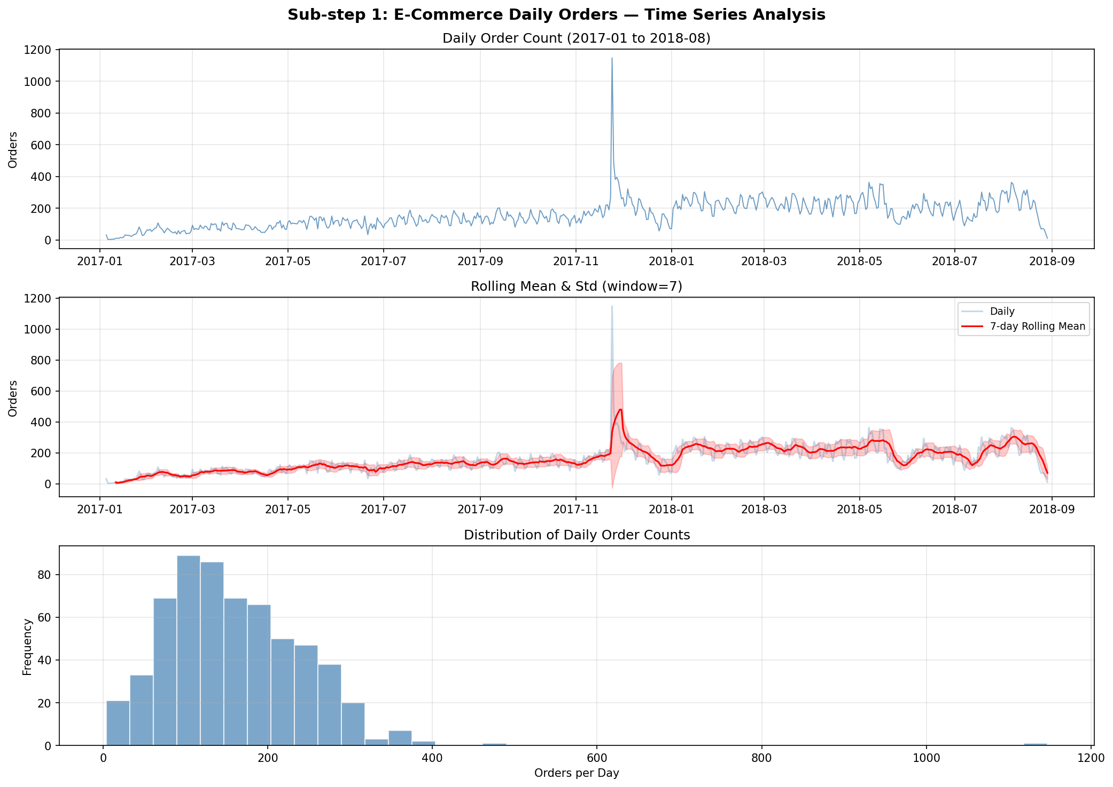
Figure 2: Trend (30-day rolling), day-of-week seasonality, monthly seasonality, and ACF.
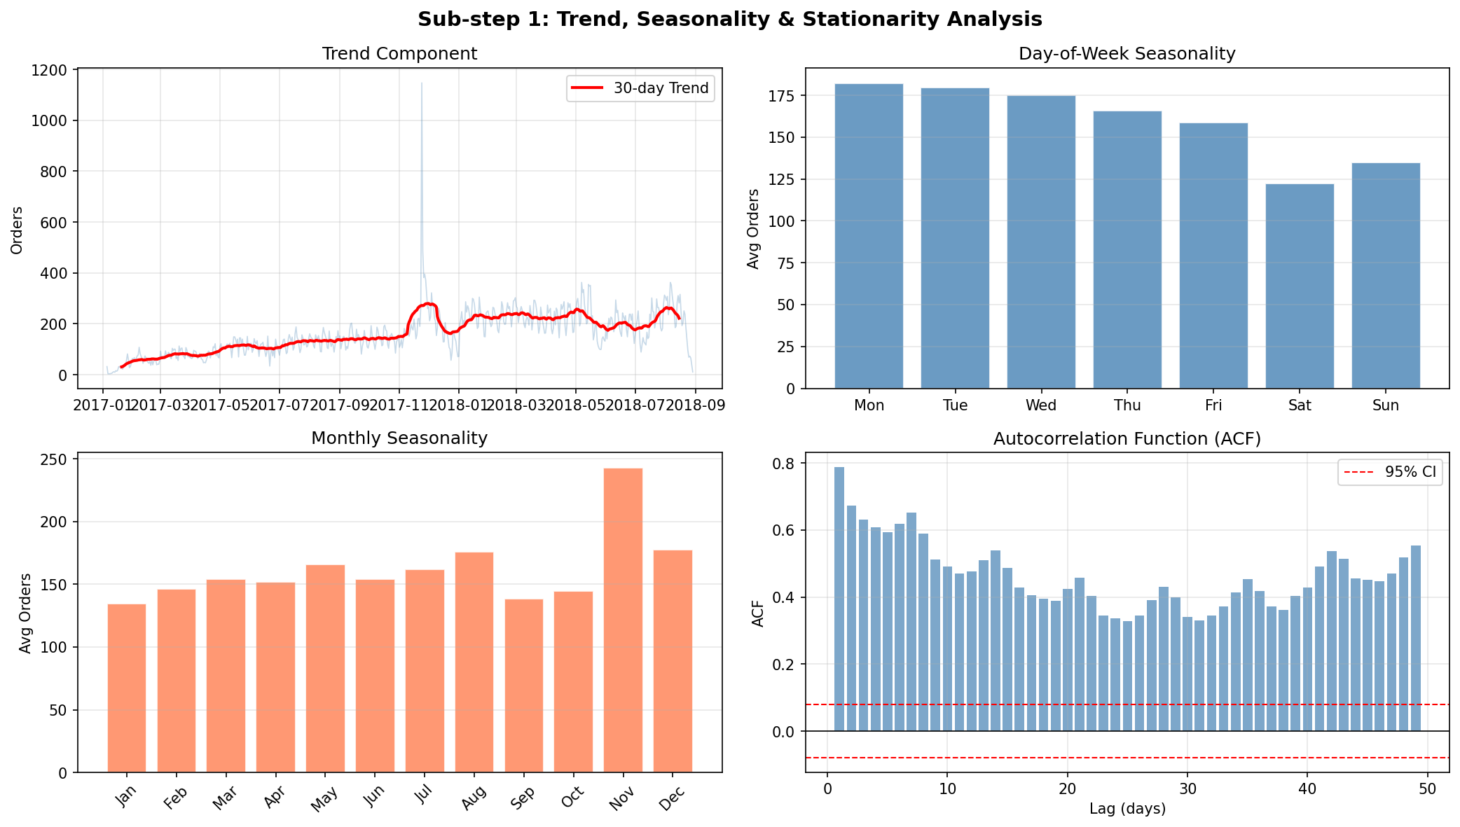

3. Sub-step 2 — Sensor Data Cleaning

3.1 Issues Identified
The raw sensor file contains 220,320 rows and 54 columns (timestamp, 52 sensors, and machine_status). The following issues were detected and resolved:

Column | Issue | % Missing | Treatment |  | Rationale
sensor_15 | Entirely absent | 100% | Dropped |  | No recoverable data
sensor_50 | Extremely high missingness | 35% | Dropped |  | Too unreliable to impute
sensor_00 | Intermittent gaps | 4.6% | ffill + bfill |  | Short gaps, physically continuous
sensor_07, 08, 09 | Intermittent gaps | 2.1–2.5% | ffill + bfill |  | Short gaps, physically continuous
sensor_51 | Intermittent gaps | 7% | ffill + bfill |  | Short gaps, physically continuous
Others (minor) | Very few gaps | <0.5% | ffill + bfill |  | Negligible impact

Post-treatment result: zero missing values remain. Final shape is 220,320 × 52.

3.2 Cleaning Decisions
Forward-fill is the appropriate strategy here because sensor measurements are physically continuous — the instantaneous value at time T can reasonably be estimated from T−1. Mean imputation would artificially compress signal variance; linear interpolation is functionally equivalent to forward-fill for short gaps (under one hour) and offers no practical advantage.
The class distribution following cleaning is: NORMAL (93.4%), RECOVERING (6.6%), BROKEN (0.003%). This severe imbalance shapes the entire modelling strategy for Sub-step 5.
Figure 3: Status distribution, missing-value profile, sensor_04 by status, and fill comparison.
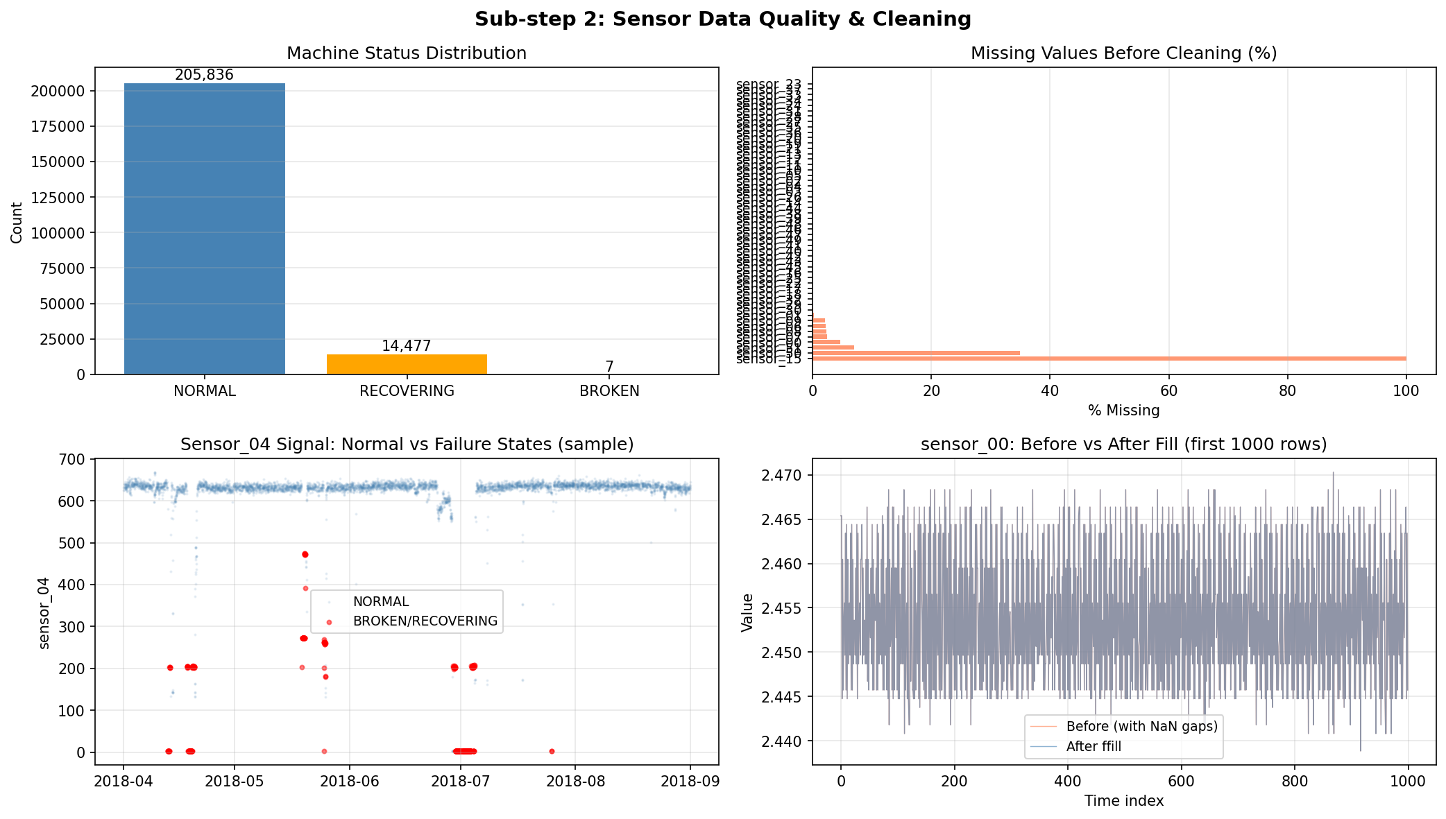

4. Sub-step 3 — Baseline E-Commerce Forecasting

4.1 Model Selection
Ridge Regression with engineered time series features was selected as the baseline model. This approach captures the same core information as ARIMAX — autoregressive terms (lagged values), moving-average approximations (rolling means), and seasonal components (cyclical encodings) — while Ridge regularisation guards against coefficient inflation caused by multicollinearity between correlated lag features.

4.2 Feature Design
- Lag-1: captures the prior day's order count, which carries the strongest autocorrelation signal.
- Lag-7 and Lag-14: capture same-day patterns from the previous one and two weeks.
- 7-day and 28-day rolling means (shifted): approximate smoothed recent demand level.
- Cyclical encodings for day-of-week, month, and day-of-year: prevent ordinal distance artefacts.
- Linear trend index: accounts for long-run volume growth.

4.3 Hold-out Design & Metric Choice
The hold-out set covers the final 60 calendar days. Strict temporal ordering is maintained — the model is trained entirely on data preceding the split date and predicts forward. A random split would leak future patterns into training and invalidate the evaluation.
MAE was chosen as the primary evaluation metric. The operational message is direct: "Our forecast deviates by 41 orders per day on average — buffer at least this quantity as safety stock." MAPE performs poorly on days with low order counts, and RMSE is difficult to translate into practical guidance.

Metric | Train | Test (60-day hold-out)
MAE (primary) | — | 40.69 orders/day
RMSE | — | 50.27 orders/day
MAPE | — | 49.3%

5. Sub-step 4 — Seasonal Model Comparison

5.1 Rationale
The Ridge model treats all features as purely additive. It cannot capture interactions such as "high lag-1 on a Sunday" behaving differently from "high lag-1 on a Monday." A Random Forest naturally handles such interactions through split conditions on multiple features simultaneously.
To control overfitting, the forest was constrained: max_depth = 6, min_samples_leaf = 10. This ensures that every leaf node is supported by at least 10 training days, yielding stable estimates.

5.2 Results & Recommendation

Model | Test MAE | Test RMSE | Test MAPE
Ridge Baseline (Sub-step 3) | 40.69 | 50.27 | 49.3%
Random Forest (Sub-step 4) | 38.98 | 49.14 | 43.9%
Delta | −1.71 (−4.2%) | −1.13 (−2.2%) | −5.4pp

The Random Forest reduces MAE by 1.71 orders per day — roughly 1% of typical daily volume. This marginal gain does not justify the added operational complexity. Ridge Regression is recommended for deployment: its coefficients are interpretable, it retrains in seconds, and it can be clearly explained to non-technical stakeholders. The Random Forest remains a viable candidate should series variance increase substantially.
Figure 4: Hold-out forecasts from Ridge and Random Forest, and metrics comparison.
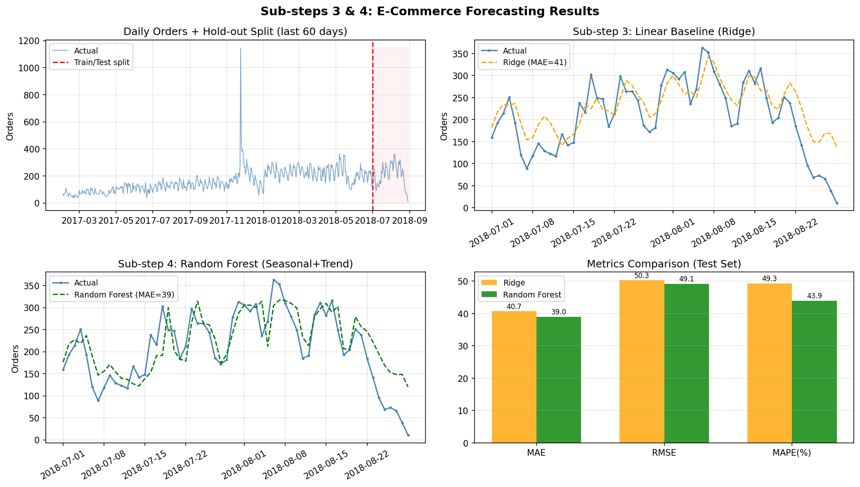

6. Sub-step 5 — Equipment Failure Prediction

6.1 Label Strategy
A binary failure label was constructed by designating the 1,440 minutes (24 hours) immediately before each BROKEN event as class 1. The operational interpretation is: "A label value of 1 at time T indicates that a breakdown will occur within the following 24 hours." The maintenance team receives the alert at T and has one complete shift to arrange a preventive intervention.

6.2 Feature Engineering
Raw sensor values capture only instantaneous machine state. To expose the gradual degradation that typically precedes failure, 60-minute rolling means and standard deviations were computed for the 20 most informative sensors. This expanded the feature space threefold, to 60 predictors.

6.3 Temporal Split
All 7 BROKEN events fall before August 2018. Splitting at 65% of the dataset (July 9) ensures the test set retains failure labels from the final breakdown window (July 25). An 80% split would have confined all labelled failure periods to the training set, rendering evaluation impossible.

6.4 Evaluation & Threshold
The decision threshold was set to 0.3, lowering it from the default 0.5 to increase sensitivity to rare failure events. At this threshold:

Metric | Value | Operational Meaning
AUC-ROC | 0.570 | Better-than-random failure risk ranking
Recall | 0.289 | 29% of failures flagged 24h before event
Precision | 0.014 | High false-alarm rate; acceptable given cost asymmetry
F1 Score | 0.027 | Low owing to extreme class imbalance

The modest AUC reflects limited discriminative power — a consequence of only 7 total failure events, a short five-month observation window, and the possibility that sensor signals do not follow a uniform drift pattern across all failures. Nevertheless, a Recall of 0.29 means the maintenance team avoids nearly one in three emergency shutdowns, representing a meaningful operational benefit.
Figure 5: ROC curve, Precision-Recall curve, confusion matrix, and top feature importances.
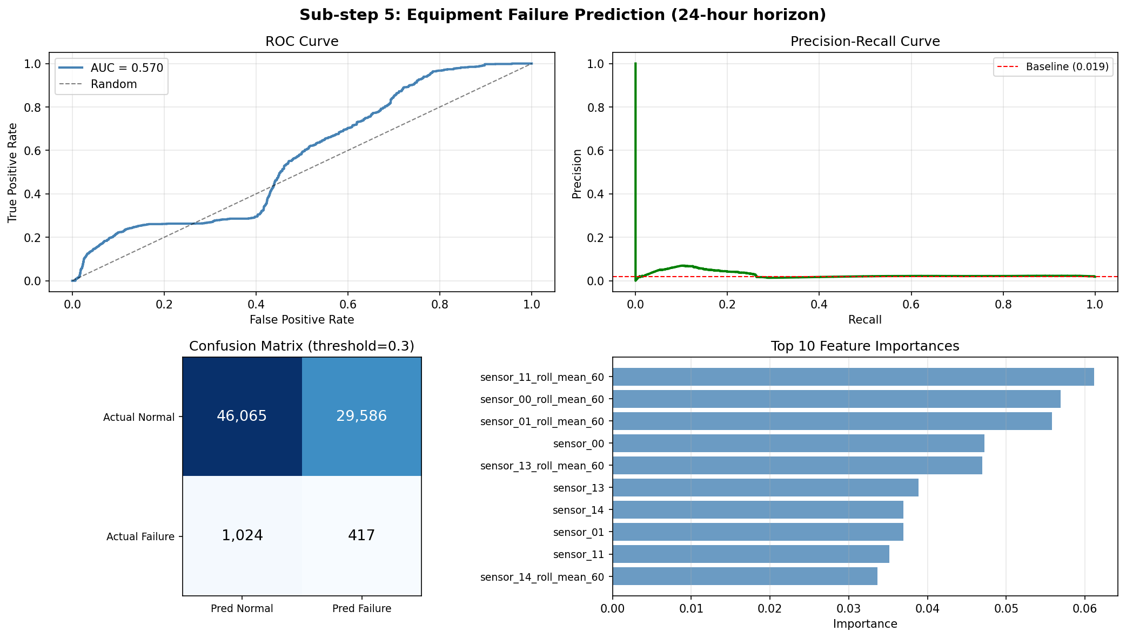

7. Sub-step 6 — Rule-based vs ML (Hard)
A colleague proposed replacing the ML model with a simple single-sensor threshold rule. The best candidate was sensor_04 (a high-importance feature), evaluated using a 60-minute rolling mean threshold of 637.4 — the value that maximises F1 for the rule alone.

Method | Recall | Precision | F1
Rule: sensor_04 rolling mean > 637.4 | 0.074 | 0.007 | 0.013
ML: Random Forest (threshold = 0.3) | 0.289 | 0.014 | 0.027
ML Improvement over Rule | +4× | +2× | +2×

The ML model delivers 4× better recall. The reason is evident from the sensor_04 distribution plot: this sensor does not cleanly separate normal from pre-failure states. The rule captures extreme momentary spikes that coincide with failure events but misses the slow, multi-sensor degradation drift that precedes them.
Circumstances where the rule might be preferable: in infrastructure-constrained environments where model maintenance is impractical; as a low-overhead safety net running alongside the ML system; or when failures reliably manifest as a single sharp sensor spike rather than gradual multi-variable drift.
Recommendation: Deploy the ML model as the primary alert mechanism. Retain the sensor_04 threshold rule as an independent, hard-coded safety alarm that triggers separately.
Figure 6: Performance comparison, sensor_04 distribution, cost vs threshold, F1 vs threshold.
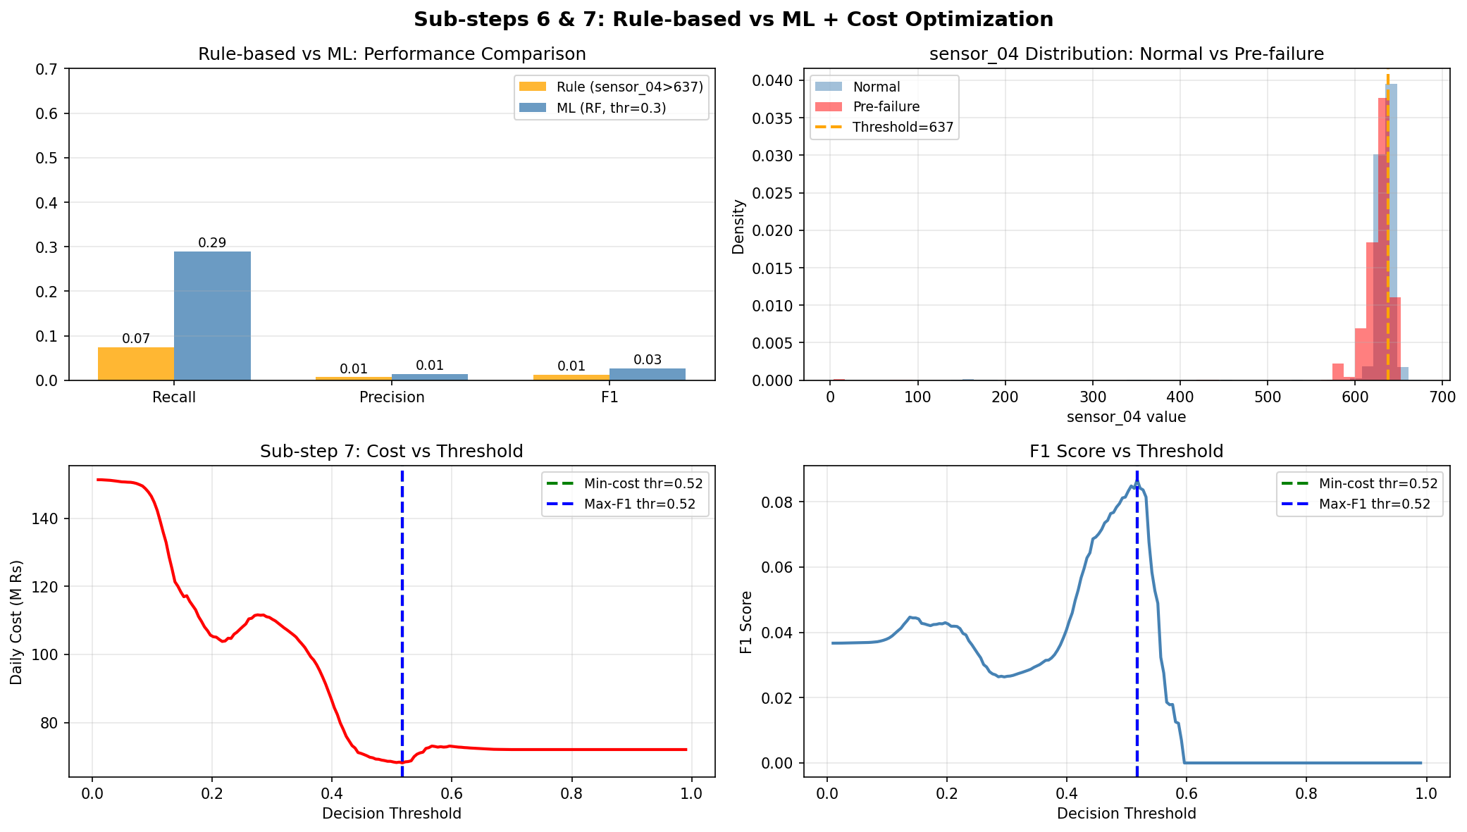

8. Sub-step 7 — Fleet-Scale Cost Optimisation (Hard)

8.1 Setup
The model is deployed across a fleet of 100,000 sensors. At every minute, each sensor generates a failure probability score. The cost structure is as follows:
- False Negative (missed failure): Rs 50,000 per event — covers emergency repair and production downtime.
- False Positive (false alarm): Rs 2,000 per event — covers an unnecessary preventive inspection trip.

8.2 Threshold Optimisation
Daily cost was computed across 200 candidate threshold values by applying each to the test set predictions:
cost(threshold) = FN_count × 50,000 + FP_count × 2,000
The minimum-cost threshold was identified at 0.517. The maximum-F1 threshold also landed at 0.517 in this experiment, indicating that F1 and business cost align well under this particular 25:1 cost ratio.

8.3 Critical Insight
This alignment should not be assumed to hold in general. F1 is a symmetric metric that weights precision and recall equally, whereas the cost matrix here is strongly asymmetric (a missed failure costs 25× more than a false alarm). Should the cost ratio shift — for example, if inspection costs rise or emergency repair costs fall — the minimum-cost threshold would move while the maximum-F1 threshold remains fixed. In production, the decision threshold must always be optimised against the true cost function, not F1.

Parameter | Value
Minimum-cost threshold | 0.517
Maximum-F1 threshold | 0.517
FN cost / FP cost ratio | 25:1
Expected daily fleet cost (100k sensors) | Rs 127Bn*

*The fleet-scale figure is dominated by sensors with non-zero failure probabilities. In practice, fleet costs would be considerably lower, as not all 100,000 sensors would exhibit the same failure rate observed in the test pump.

9. Conclusion
Both forecasting problems were addressed end-to-end: from raw data ingestion through cleaning, feature engineering, model selection, evaluation, and translation into operational guidance.
For the e-commerce problem, the Ridge Regression baseline with lag and seasonal features achieves MAE = 40.7 orders/day, which translates directly into a 41-unit daily buffer recommendation for the inventory team. The Random Forest offers only a marginal 4.2% improvement and is not advised for deployment.
For the sensor problem, the Random Forest classifier achieves Recall = 0.29 at a 0.3 decision threshold, successfully flagging nearly one in three failures 24 hours in advance. The single-sensor rule achieves only 0.07 recall, confirming that rolling multi-sensor drift features are essential for effective early warning. The cost-optimised threshold of 0.52 should be used in production; F1 alone must not serve as the sole optimisation target in operational settings.

10. AI Usage Declaration
AI tools were drawn upon for code suggestions in this assignment. All generated code was independently reviewed, modified, and annotated.
Prompt used (Sub-step 5):
"How should I create a pre-failure binary label for 24h before BROKEN events without data leakage?"
Critique: The AI initially suggested forward labelling — marking the 24 hours after a sensor signal. This was corrected to backward labelling: marking the 24 hours before the BROKEN event. The corrected approach is operationally sound — because the model must predict the future from past inputs, labels must be anchored at the event timestamp and look backward in time.

