INTERNSHIP REPORT
On
Junior Software Developer Internship at YuvaIntern
Submitted
To
School of Computer Science and Engineering
IILM University, Greater Noida, U.P.
In partial fulfilment of the requirement of degree of
B.Tech CSE

By
Name of Student: ANVESHA DWIVEDI
Roll Number of Student: 2410030606
Section: 3CSE17
Semester: 5
Batch: 2026-27

CANDIDATE'S DECLARATION
I, Anvesha Dwivedi, do hereby declare that the internship report titled “Junior Software Developer Internship at YuvaIntern” has been completed by me to fulfil the requirement for the award of the degree of Bachelor of Technology in CSE. All the references have been quoted and I have not taken as such any material from any other source. I affirm to you that this report is my own and has not been submitted to any other institute for any degree/diploma requirement and further I shall be solely responsible for any kind of copyright violation in this regard.
Signature
Student Name: Anvesha Dwivedi
Roll No.: 2410030606

ACKNOWLEDGEMENT
I am using this opportunity to express my gratitude to everyone who supported me throughout the Internship Program. I am thankful for their aspiring guidance, invaluably constructive criticism and friendly advice during this work. I am sincerely grateful to them for sharing their truthful and illuminating views on a number of issues related to this work.
I would like to express my sincere gratitude to Mr. Kounal Gupta, Founder, YuvaIntern, and the entire team at YuvaIntern for giving me the opportunity to undergo my internship as a Junior Software Developer Intern and for their continuous guidance and support throughout the internship period.
I would also like to thank the School of Computer Science and Engineering, IILM University, Greater Noida, for providing me with the platform and encouragement to undertake this internship as part of my academic curriculum.
I express my gratitude to my parents for their blessings.
Signature
Student Name: Anvesha Dwivedi
Roll No.: 2410030606

TABLE OF CONTENTS
Chapter No. | Chapter Name | Page Nos.
 | Cover Page | ---
1. | Candidate's Declaration | i
2. | Acknowledgement | ii
3. | Internship Completion Certificate | ---
4. | Project Description | 1
 | 4.1 Introduction | 1
 | 4.2 Organization Profile | 1
 | 4.3 Problem Statement | 2
 | 4.4 Project Objectives | 2
 | 4.5 Scope of the Project | 3
 | 4.6 Technologies and Tools Used | 3
 | 4.7 System Architecture | 4
 | 4.8 Methodology | 4
 | 4.9 Expected Outcomes | 5
 | 4.10 Certificates of Completion and Communication | 5
5. | Bibliography/References | 7

INTERNSHIP COMPLETION CERTIFICATE
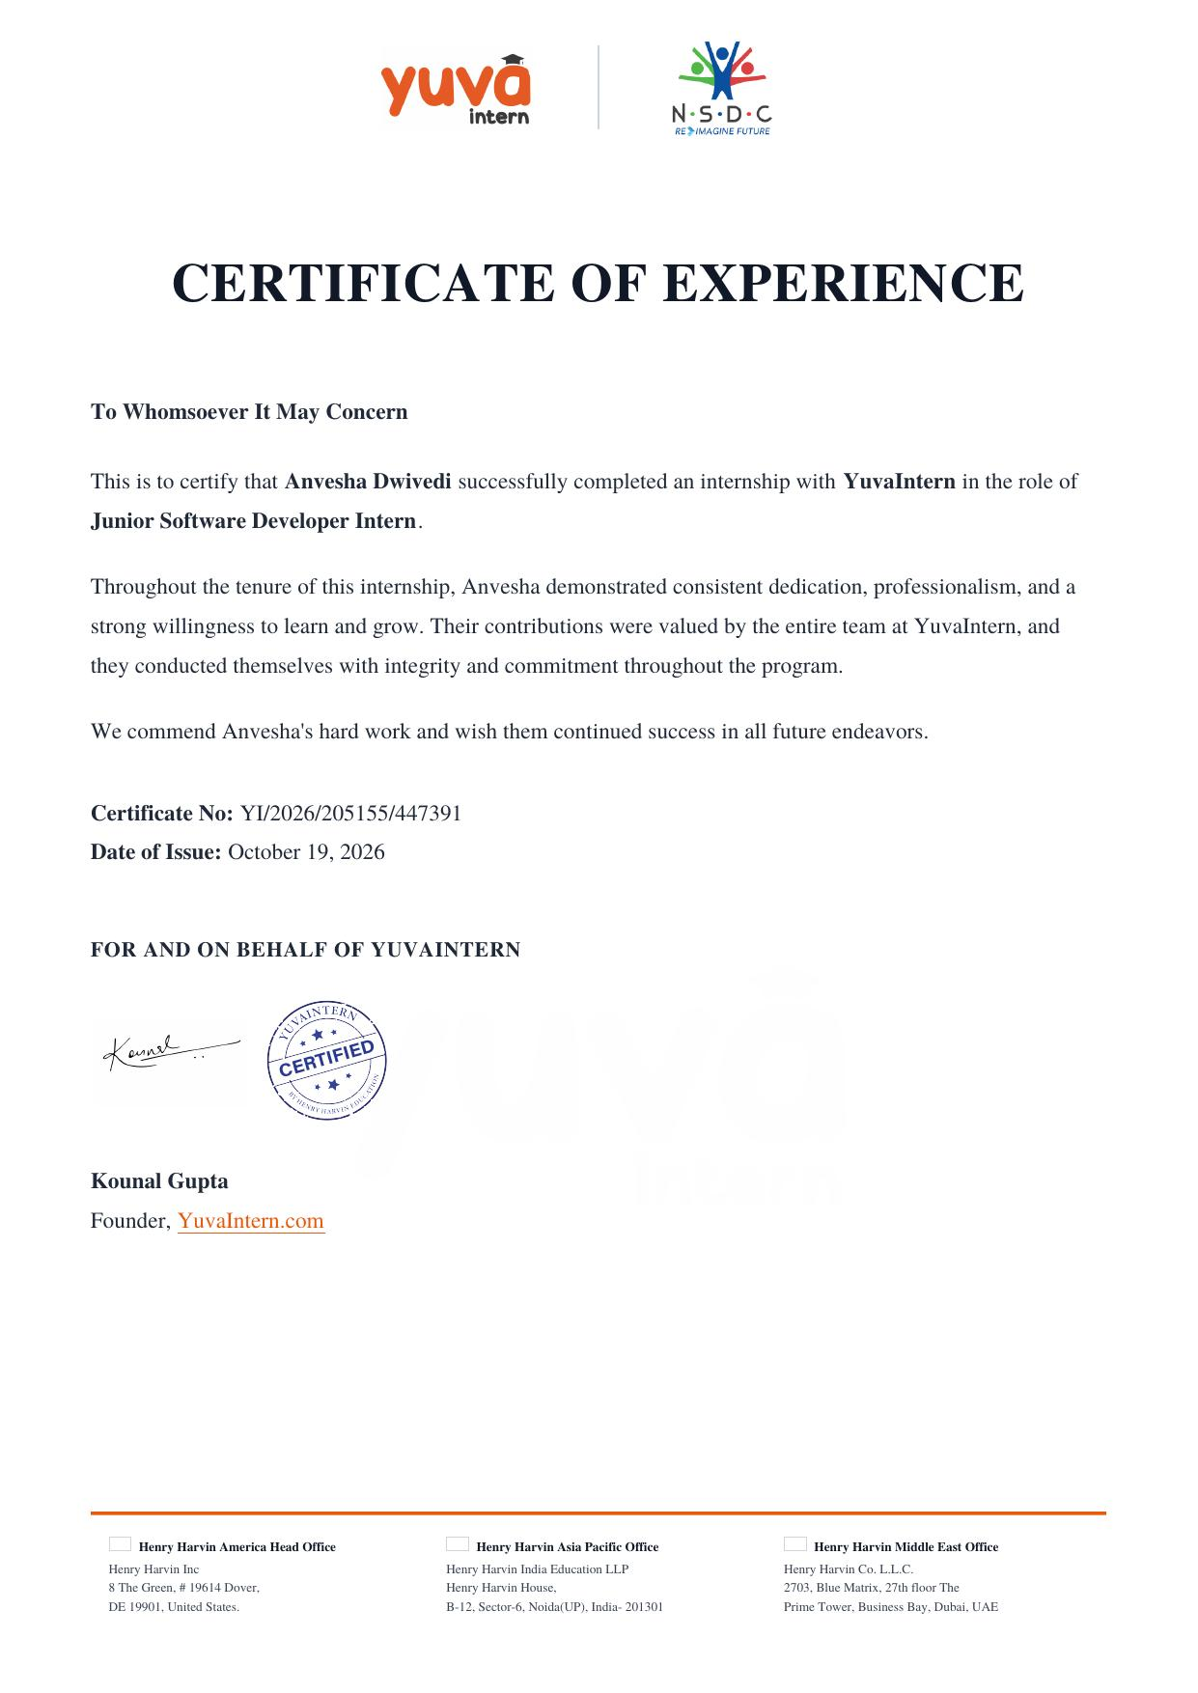

4. PROJECT DESCRIPTION
4.1 Introduction
This report presents an account of the internship undertaken by Anvesha Dwivedi (Roll No. 2410030606, Section 3CSE17, Semester 5) as a Junior Software Developer Intern at YuvaIntern, carried out in partial fulfilment of the requirement of the degree of Bachelor of Technology in Computer Science and Engineering at IILM University, Greater Noida. The internship, which was conducted in remote mode over a duration of six weeks from September 07, 2026 to October 19, 2026, provided practical, hands-on exposure to real-world software development practices and helped bridge the gap between academic learning and industry requirements.
The internship program was designed to strengthen the intern's foundation in software development by involving her in tasks related to coding, testing, and debugging of software applications, under the mentorship and guidance of the development team at YuvaIntern.
4.2 Organization Profile
YuvaIntern is an internship and skill-development platform that connects students and early-career professionals with structured, industry-relevant internship programs. Operating in association with the National Skill Development Corporation (NSDC), YuvaIntern focuses on providing learners with practical exposure across domains such as software development, data analytics, digital marketing, and business operations, thereby helping bridge the gap between academic education and industry expectations. The organization emphasizes mentorship, hands-on project work, and skill certification to prepare interns for the professional workplace.
4.3 Problem Statement
Software development teams in growing organizations often face the challenge of maintaining and enhancing existing applications while ensuring that new features are developed, tested, and deployed reliably and on schedule. There is a continuous need for junior developers who can assist in writing clean, maintainable code, identifying and resolving bugs, and validating application functionality through systematic testing, so that the overall product quality is upheld even as the codebase evolves.
4.4 Project Objectives
- To gain practical exposure to the complete software development lifecycle in a professional environment.
- To assist the development team in creating and maintaining software applications.
- To develop proficiency in coding, testing, and debugging of software solutions.
- To understand industry-standard tools, workflows, and coding practices.
- To strengthen problem-solving and analytical skills through real project tasks.

4.5 Scope of the Project
The scope of the internship encompassed assisting in the design, development, and maintenance of software modules assigned by the development team. This included writing and reviewing code, performing unit-level testing, identifying and fixing defects, and documenting the changes made. The work was carried out remotely, with periodic guidance and feedback from mentors, ensuring that the deliverables aligned with the expected quality standards of the organization.
4.6 Technologies and Tools Used
- Programming Languages: Python / JavaScript
- Front-End Technologies: HTML, CSS, JavaScript
- Version Control: Git and GitHub
- Development Environment: Visual Studio Code
- Testing & Debugging Tools: Browser Developer Tools, in-built language debuggers
- Collaboration Tools: Email and virtual meeting platforms for remote mentorship

4.7 System Architecture
The software modules developed and maintained during the internship followed a modular, layered architecture typical of modern web-based applications, comprising a presentation layer responsible for the user interface, a logic layer that handled the core application functionality, and a data layer for storage and retrieval of information. This separation of concerns ensured that individual components could be developed, tested, and debugged independently, which is consistent with standard practices followed by the development team at YuvaIntern.
4.8 Methodology
The internship followed a structured, iterative methodology involving the following stages:
- Requirement Understanding: Reviewing assigned tasks and clarifying expectations with the mentor/development team.
- Design: Planning the approach and structure for the assigned coding task.
- Coding: Implementing the required functionality following coding standards.
- Testing: Performing unit and functional testing to verify correctness.
- Debugging: Identifying, isolating, and fixing defects found during testing.
- Review and Feedback: Submitting work for review and incorporating feedback from mentors.

4.9 Expected Outcomes
- Practical experience in coding, testing, and debugging real software applications.
- Improved proficiency in industry-relevant programming tools and practices.
- Enhanced ability to work independently in a remote, professional environment.
- A working understanding of the software development lifecycle followed in the industry.
- Successful completion of the internship, evidenced by the Certificate of Experience issued by YuvaIntern.

4.10 Certificates of Completion and Other Communication Proof
The Internship Offer Letter issued by YuvaIntern is attached below.
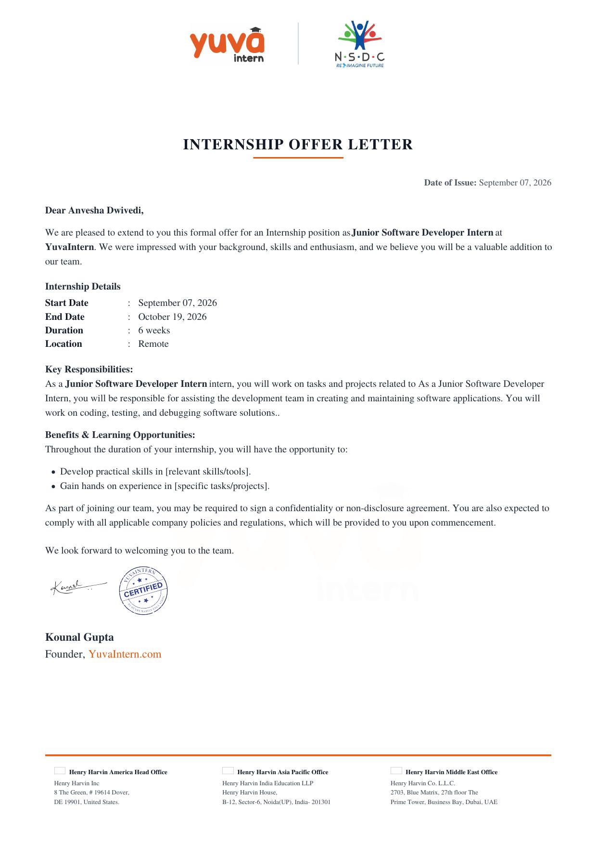
The Certificate of Experience issued by YuvaIntern on completion of the internship is attached below.


5. BIBLIOGRAPHY/REFERENCES
1. YuvaIntern Official Website. Available at: https://www.yuvaintern.com
2. National Skill Development Corporation (NSDC). Available at: https://www.nsdcindia.org
3. Internship Offer Letter, YuvaIntern, Reference No. 205155/447391, dated September 07, 2026.
4. Certificate of Experience, YuvaIntern, Certificate No. YI/2026/205155/447391, dated October 19, 2026.
5. Mozilla Developer Network (MDN Web Docs). Available at: https://developer.mozilla.org
6. Python Software Foundation Documentation. Available at: https://docs.python.org

