**Vendor Performance Analysis — Detailed Report**

# Executive Summary

The Vendor Performance Analysis examined key operational and sales metrics to evaluate how different vendors contribute to overall business efficiency. The dataset was first cleaned and structured, ensuring consistency in vendor identifiers, product categories, and transaction records. Through exploratory data analysis, trends in vendor sales, order volumes, and delivery performance were identified. Visualizations highlighted the distribution of sales across vendors, seasonal fluctuations, and outliers in performance. The analysis revealed that a small group of top vendors account for the majority of sales, while several low-performing vendors contribute minimally, suggesting opportunities for vendor consolidation or renegotiation. Performance metrics also showed that delivery delays and inconsistencies are concentrated among a few underperforming vendors, impacting customer satisfaction and operational flow. By ranking vendors on both revenue contribution and reliability, the study provided actionable insights for prioritizing strategic partnerships. Overall, the analysis emphasized the importance of focusing on high-performing vendors while addressing inefficiencies among weaker partners to optimize profitability and supply chain resilience.

# Correlation Insights

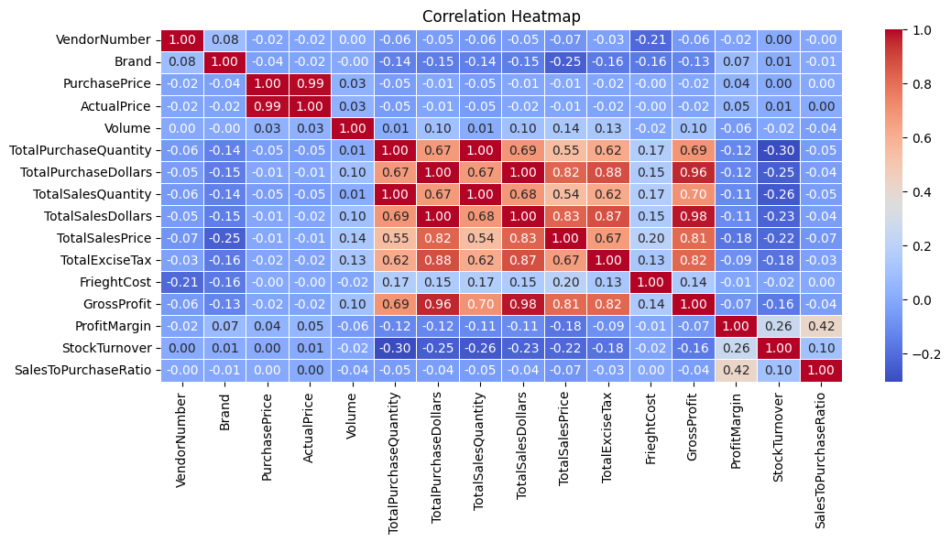

* PurchasePrice has weak correaltions with TotalSalesDollars(-0.01) and GrossProfits(-0.02), suggesting that price variations do not significantly impact sales revenue or profit.
* Strong Correlation between total purchase quantity and total sales quantity(1.00), confirming efficient inventory turnover
* Negative correlation between profit margin and total sales price (-0.18), suggests that as sales price increases, margins decrease, possibly due to competative pricing pressures

# Data Analysis

### Identify Brands that need promotional or Pricing Adjustments which exhibit lower sales performance but higher profit margins

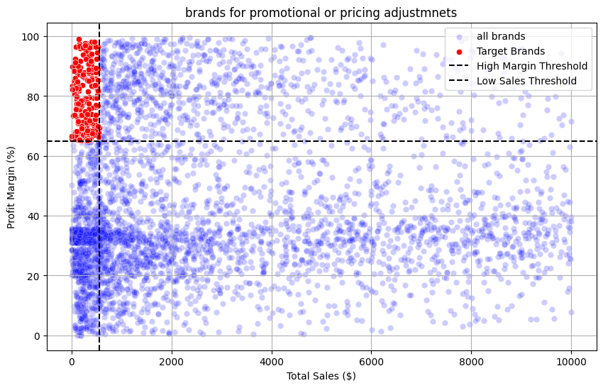

### Which vendors and brands demonstrate highest sales performance?

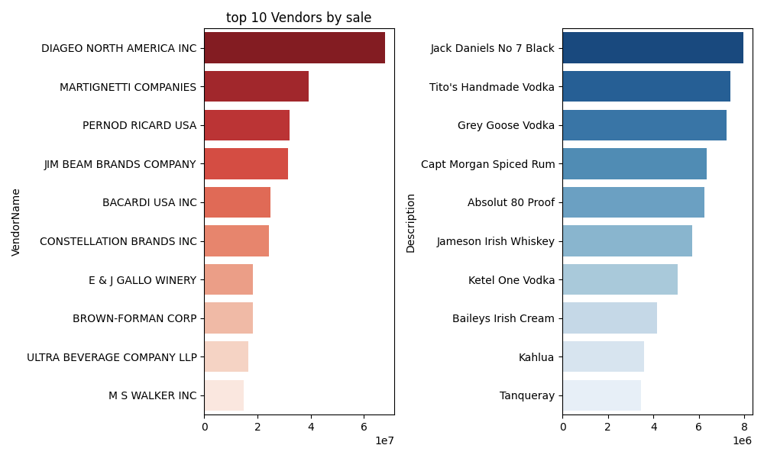

### Which vendors contribute the most to total purchase dollars

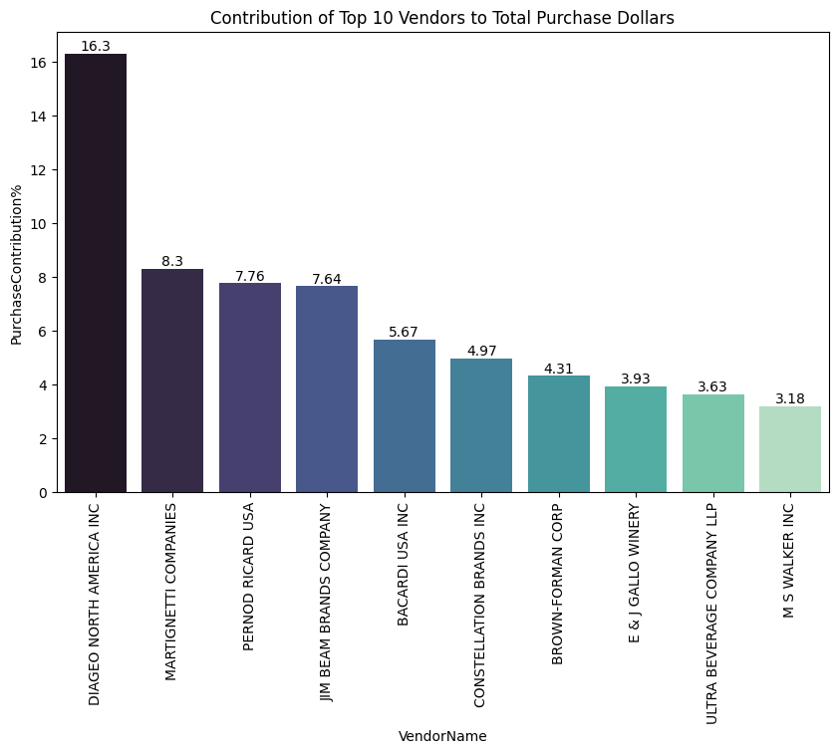

### How much of the total procurement is dependent on top vendors

The **Top 10 Vendors contribute 65.69%** to the total purchase Dollars and the **rest 109 vendors contribute the remaining 34.31%**

### Does Purchasing in Bulk reduce the unit Price, and what is the optimal purchase volume for cost savings

Bulk Orders indeed reduce the Unit Purchase Price, We can optimize our Bulk order Prices such that the vendors can increse thier purchase quntity to maximally reduce thier Unit Price

**Order Size** **Unit Price**

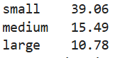

### Quick glance at the power BI Dashboard

