MULTIPLE-RUN SCRIPT

EXECUTION
./multipleRun.pl inputToMultipleRun.txt;
where file inputToMultipleRun.txt contains all configuration needed for automation of execution.

DESCRIPTION
Many times, many of us would have faced with repetitive tasks, which involves running same program after changing few parameters. If you want to run a program for different combinations of input parameters, this tool helps you to automate it. The input parameters to be changed is assumed to be inside a file. This tool create build folder for each combination of parameters and execute the program inside the build folder. Proper configuration has to be done to the input file of script multipleRun.pl. Please see Figure 1 and examples to get more information.

Entries in inputToMultipleRun.txt
1. File names and line number in the file (containing the variable). Values to be placed for the variable inside the file, separated by semicolon.
Example:
<fileName> ; <lineNumber> ; <parameterName> ;<parameter-values separated by commas>
The field <lineNumber> is optional, if unspecified, then the first line containing the parameter would be taken. Note that file(with fileName) containing parameters, will be reverted back to initial file after the execution of multipleRun.pl is over.

2. maxParallelJobs indicate the maximum parallel executions allowed for the execution of backgroundCommandToExecuteInBuildFolder. User can set this parameter looking at the number of free processors available in the machine.

3. startCommandToExecuteOutsideBuildFolder indicate the bash command which get executed in the caller's folder, at beginning (before execution of any other commands).

4. foregroundCommandToExecuteInBuildFolder indicate the bash command which would execute inside build folder.

5. backgroundCommandToExecuteInBuildFolder indicate the bash command which would execute inside build folder, after foregroundCommandToExecuteInBuildFolder execution is over. Note that this command must end with '&' just like any other background command.

6. endCommandToExecuteOutsideBuildFolder indicate the bash command which get executed in the caller's folder at the end (after execution of all other commands).

7. buildSuffixPatternsToInclude indicates an EREGEX (Extended Regular Expression) pattern, which has to be matched for eligible build folder. Build folder would be created only if this matching was successful. Please refer to example3 in this document, for more information.

8. buildSuffixPatternsToExclude is same as buildSuffixPatternsToInclude, except that success of this EREGEX match would result in exclusion of the build folder.

9. commandToKnowAllRunningJobs is a bash command which must print PID (process id) of all running jobs currently in the system.

Goto the caller's location
Create folder build_i & Goto it
Execute
startCommandToExecuteOutsideBuildFolder
Execute
endCommandToExecuteOutsideBuildFolder
i^{th} Iteration over
parameter values
Wait Until
#Jobs running now < maxParallelJobs
Execute
backgroundCommandToExecuteInBuildFolder
Execute
foregroundCommandToExecuteInBuildFolder
Is build_i matches
to eligible
BuildSuffixPatternToInclude?
Is build_i matches
to eligible
BuildSuffixPatternToExclude?
NO
YES
NO
YES
Is all jobs over?
NO
YES
Figure 1

Example 1:
Suppose, u want to change the value of parameter 'a' in file parameters.txt with '0','1' & '2', and execute program programToRun.sh (which prints the content of parameters.txt to out.txt), do as follows,
(Look inside file inputToMultipleRun.txt for the configuration done!)
cd Example1;
../multipleRun.pl inputToMultipleRun.txt;

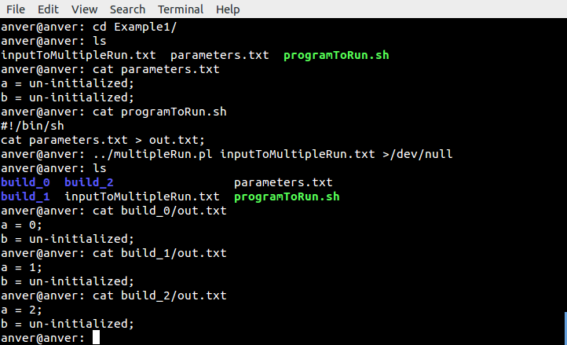

The above example is equivalent to following bash commands,
cd Example1;
## 0th iteration
perl -i -pe 's/a = .*/a = 0/' parameters.txt; ## Change parameter
mkdir build_0; ## Creates build_0 & goto it
cd build_0;
cp ../parameters.txt .; ## Execute foregroundCommandToExecuteInBuildFolder
../programToRun.sh > out.txt & ## Execute backgroundCommandToExecuteInBuildFolder
## 1st iteration
perl -i -pe 's/a = .*/a = 1/' parameters.txt; ## Change parameter
mkdir build_1; ## Creates build_1 & goto it
cd build_1;
cp ../parameters.txt .; ## Execute foregroundCommandToExecuteInBuildFolder
../programToRun.sh > out.txt & ## Execute backgroundCommandToExecuteInBuildFolder
## 2nd iteration
perl -i -pe 's/a = .*/a = 2/' parameters.txt; ## Change parameter
mkdir build_2; ## Creates build_2 & goto it
cd build_2;
cp ../parameters.txt .; ## Execute foregroundCommandToExecuteInBuildFolder
../programToRun.sh > out.txt & ## Execute backgroundCommandToExecuteInBuildFolder

Example 2:
Suppose, u want to change the value of parameter 'a' with '0','1' & '2', and value of 'b' with '0' & '1' in file parameters.txt and execute program programToRun.sh (which simply prints the content of parameters.txt to out.txt) for all combinations of parameters, do as follows,
(Look inside file inputToMultipleRun.txt for the configuration done!)
cd Example2;
../multipleRun.pl inputToMultipleRun.txt;

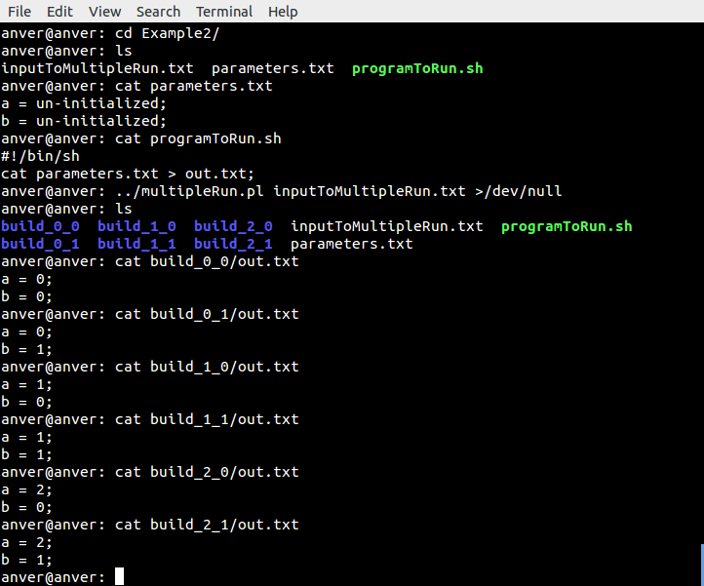

Example 3:
This example is same as example2, which execute program programToRun.sh for only certain combination of parameters of 'a' and 'b'. Here we use buildSuffixPatternsToInclude = _(\d+)_\1 instead of null. So only those build folders which has got suffixes matching to the EREGEX specified in buildSuffixPatternsToInclude, will get created.
cd Example3;
../multipleRun.pl inputToMultipleRun.txt;

