**“IOT BASED EGG INCUBATOR”**

**A Project Report**

***Submitted by***

**SUBUDHI ANVESH, SRIRAM SETTY SHANMUKHA,**

**DINESH KUMAR PATNAIK**

**University Regd. No. - *1701210127,1701210124, 1701210392***

***in partial fulfillment for the award of the degree***

***of***

**BACHELOR OF TECHNOLOGY**

**IN**

**Electronics and Communication Engineering**

***Under the esteemed guidance of***

**Mr. GAUTAM**

**Associate Professor**



**DEPARTMENT OF ELECTRONICS AND COMMUNICATION ENGINEERING**

**GIET MAIN CAMPUS AUTONOMOUS**

**GUNUPUR – 765022**

**YEAR 2020-21**

**DECLARATION**

I hereby declare that the project entitled **“IOT based Egg Incubator”** submitted for the B. Tech Degree is my original work and the project has not formed the basis for the award of any degree, associateship, fellowship or any other similar titles.

Signature of the Student: SUBUDHI ANVESH

Signature of the Student: SRIRAM SETTY SHANMUKHA

Signature of the Student: DINESH KUMAR PATNAIK

Place: Gunupur

Date: 21/04/2021

|  |  |  |
| --- | --- | --- |
|  | **GIET MAIN CAMPUS AUTONOMOUS** GUNUPUR – 765 022, Dist: Rayagada (Odisha), India *(Approved* ***by AICTE, Govt. of Orissa*** *and Affiliated* ***to Biju Patnaik University of Technology)***  : 06857 – 250172(Office), 251156(Principal), 250232(Fax),  e-mail: [gandhi_giet@yahoo.com](mailto:gandhi_giet@yahoo.com) visit us at www.giet.org | **ISO 9001:2000**  **Certified Institute** |

**DEPARTMENT OF ELECTRONICS AND COMMUNICATION ENGINEERING**

**CERTIFICATE**

This is to certify that the project entitled **“IOT BASED EGG INCUBATOR”** is the bonafide work carried out by **SUBUDHI ANVESH, SRIRAM SETTY SHANMUKHA, DINESH KUMAR PATNAIK University Regd. No.- 1701210127, 1701210124, 1701210392** student of **BACHELOR OF TECHNOLOGY, GANDHI INSTITUTE OF ENGINEERING AND TECHNOLOGY** during the academic year 2017-21 in partial fulfillment of the requirements for the award of the Degree of **BACHELOR OF TECHNOLOGY** in **ECE.**

**Mr. GAUTAM Dr. SUBHRAJIT PRADHAN**

**Associate Professor HOD**

**GIET MAIN CAMPUS AUTONOMOUS DEPARTMENT OF ECE**

**GIET MAIN CAMPUS AUTONOMOUS**

**ACKNOWLEDGEMENT**

Any work has to have contributions and supports of a few at least and a bunch at best. It gives me immense pleasure to have an opportunity to express my gratitude to various people directly or indirectly related to my present project work.

I sincerely believe that I was fortunate enough to have come across a group of human beings whose mere mode of living can inspire someone to work wonders. My project guide Mr. Gautam Department of ECE, GIET Gunupur, is paradigm of that suit. He not only encouraged me to pursue my studies but also instilled the self-belief and confidence, which helps me to take on various trivial, serious and inevitable hassles of life.

I am very much thankful to the Head, Department of Electronics and Instrumentation Engineering, GIET, Gunupur, Prof. Subhrajit Pradhan for his valuable suggestions and supports during the project periods.

I would also grab the opportunity to thank entire faculty group for their moral support and cooperation to make this thesis success.

My family has been the axis of my mental strength and their support leaves me with irreparable debt and honest gratitude. Sincere thanks to them for willingly accepting my decision of opting for higher studies.

I would like to express my heartiest gratitude to the central library staff members for their kind co-operation during my work.

I express my thanks to all my friends for their timely suggestions and encouragements.

I might have missed a many more names and they all deserve the best of my feeling for their selfless helps and supports in their own way.

Subudhi Anvesh

Sriram Setty Shanmukha

Dinesh Kumar Patnaik

**ABSTRACT**

Eggs Incubation is an interesting topic among the Arduino enthusiastic. Basically, it is similar to the type of incubator which can be used as a substitute of poultry chicken to incubate the chicken eggs automatically. It will be helpful for the farmers to incubate the eggs automatically without the need of human intervention, by keeping the physical quantities such as temperature and humidity at required level, so that the foetuses inside them will grow and incubates without the presence of mother.

The purpose of this project is to design and develop Egg Incubator. This will fill with the temperature and humidity sensor. In this project, lamps are used as heater to give suitable heat temperature for the eggs. The health of egg is very important for the development of embryo within the eggs. By using water and controlling fan, it is can make sure the humidity and ventilation in good condition. The status condition in our project will appear on the 16X2 I2C LCD screen display. The entire element will be controlled using NodeMCU. The NodeMCU is a type of microcontroller that can process a data from sensor and will execute the control system to change the condition of incubator.

The average value for temperature and humidity is 36.2°C and 36.12 %.

This project will be a user friendly product since this is portable.

**CONTENTS**

**TITLE PAGE**

ACKNOWLEDGEMENTS...............................................................................................................4

ABSTRACT.......................................................................................................................................5

LIST OF FIGURES ..........................................................................................................................8

LIST OF TABLES …………………………………………………………………………..……..9

INTRODUCTION.............................................................................................................................10

SCOPES............................................................................................................................................11

PROJECT GOAL………..................................................................................................................11

COMPONENTS REQUIRED…………………………..................................................................11

INCUBATION

1. Egg Incubator ……..............................................................................................................12
2. TYPES OF INCUBATOR
   1. Forced Air Incubator……..........................................................................................13
   2. Incubator Still-Air …….............................................................................................13
3. Manual Incubators ……........................................................................................................14
4. Semi-Automatic Incubators ……..........................................................................................14
5. Fully Automatic Incubators ……..........................................................................................14
6. Common misconception .......................................................................................................14

RELATED WORK

* 1. Pas reform integrated hatching solution ....................................................................15
  2. Magic fly Digital Mini Fully Automatic Egg Incubator 12 Eggs Poultry Hatch …..16
  3. Manufacturing 1602N Hova-Bator Incubator ...........................................................17
  4. CHIMAERA 56-Egg Automatic Incubator at cher Turner with LCD Display ……18
  5. Best Choice Products 96 Digital Clear Egg Incubator Hatcher Automatic Egg Turning Temperature Control ...................................................................................19
  6. Hova -Bator Advanced Egg Incubator Combo Kit: includes in-cubator, fan kit, egg turner, digital thermometer/hygrometer ....................................................................20
  7. Yescom Mini Digital Transparent 7 Egg Incubator Clear Chicken Poultry Hatcher w/ CE Certificated .....................................................................................................21

IDEAL CONDITIONS FOR HATCHING EGGS

1. Temperature ..............................................................................................................22
2. Humidity ...................................................................................................................22
3. Ventilation ................................................................................................................24
4. Egg Flipping...............................................................................................................24

INCUBATIONG CONDITIONS ......................................................................................................25

INCUBATING AND HATCHING EGG AND CHICK CLASSOFICATION ...............................26

STEPS

1. Acquire the eggs .......................................................................................................27
2. How to Use an Incubator to Hatch Eggs ...................................................................28
3. Egg Rotation .............................................................................................................28
4. Incubating the Eggs ..................................................................................................29

COMPONENTS REQUIRED

1. NodeMCU ................................................................................................................ 32
2. DHT 11 Temperature and Humidity Sensor .............................................................33
3. Relay Module ............................................................................................................34
4. Gear Motors ..............................................................................................................35
5. 100W Bulbs ...............................................................................................................36
6. 2 Cooling Fans ..........................................................................................................37
7. 16X2 LCD I2C Display ............................................................................................38
8. Humidifier .................................................................................................................39

HTML……........................................................................................................................................40

NGROK……......................................................................................................................................41

PROPOSED METHOD.....................................................................................................................42

CIRCUIT DIAGRAM........................................................................................................................43

SETUP…………................................................................................................................................44

BLOCK DIAGRAM...................................................................................................................…...45

WORKING………...................................................................................................................….…46

TECHNICAL SPECIFICATION…..................................................................................................47

FLOW CHART OF CONTROLLER................................................................................................48

ACTIVITIES DIAGRAM OF OUR SYSTEM ................................................................................49

FLOWCHART OF SYSTEM ..........................................................................................................50

DATA CALCULATION..................................................................................................................51

OUR APPLICATION ......................................................................................................................52

CONCLUSION…….........................................................................................................................53

RESOURCE......................................................................................................................................54

REFERENCE....................................................................................................................................55

**LIST OF FIGURES**

Fig. 1- Pas reform integrated hatching solution

Fig. 2 Magic fly Digital Mini Fully Automatic Egg Incubator 12 Eggs Poultry Hatch

Fig. 3- Manufacturing 1602N Hova-Bator Incubator

Fig. 4- CHIMAERA 56-Egg Automatic Incubator at cher Turner with LCD Display

Fig. 5- Best Choice Products 96 Digital Clear Egg Incubator Hatcher Automatic Egg Turning Temperature Control

Fig. 6- Hova -Bator Advanced Egg Incubator Combo Kit: includes in- cubator,fan kit, egg turner, digital thermometer/hygrometer

Fig. 7- YescomMini Digital Transparent 7 Egg Incubator Clear Chicken Poultry Hatcher w/ CE Certificated

Fig. 8- NodeMCU

Fig. 9- DHT11 Temperature and Humidity Sensor

Fig. 10- Relay Module

Fig. 11- Gear Motor

Fig. 12- 100W Bulb

Fig. 13- CPU Cooling Fan

Fig. 14- I2C interface 16x2 LCD display module

Fig. 15- Circuit Diagram

Fig. 16- Setup top view

Fig. 17- Setup side view

Fig. 18- Block Diagram

Fig. 19 a -Lamp Turned ON

Fig. 19 b -Fan Turned ON

Fig. 20- Flow chart of controller

Fig. 21- Activities diagram of our system

Fig. 22- Flow chart of system

Fig. 23- Our Application

**LIST OF TABLES**

Table 1: Temperature conditions for Egg Hatching

Table 2: Incubating and hatching egg and chick classification

Table 3: Data Calculation

**INTRODUCTION**

There are two main types of hatching of chicken eggs involved. They are natural & artificial. Natural hatching involves the hen warming the eggs and also manually (by its legs) tilts it at regular intervals. Artificial hatching involves incubating the eggs in an incubator where the temperature, egg rolling, humidity, ventilation are artificially provided by the sensors as decided by the microcontroller. The greatest advantage of this incubator is its success ratio where it is nearly equal to natural hatching. Also added with it is the bulk of eggs that could be hatched at a time across the seasons in the artificial nursery. Though incubation is a primitive activity, artificially incubation is relatively new and integrating IoT into it is a novice.

The incubation period of 21 days is required in order to hatch the eggs into chicken by means of monitoring temperature, humidity and turnover of the eggs. The natural factors such as temperature, humidity, rotating of eggs and the moisture content is to be precisely maintained in order to achieve good results, failing with it ends up with a loss. Therefore, the necessity arose to have a system that can continuously monitors and maintains these factors regularly in order to keep the eggs healthy. This is achieved by means of technology by incorporating a programmed microcontroller to activate the heat source (incandescent lamp) and keep the fan off. The basic necessity for the eggs to hatch is heat fed naturally by the hen sitting on them giving warmth or in this case, through heat source controlled artificially. If the temperature drops below the threshold, the heat source switches ON. If the heat source increases beyond the threshold, automatically the heat source is switched off and the exhaust is turned on which maintains the temperature. Likewise, the sources of humidity is also achieved to be precise as set by the machine.

In the natural process, the chicken post hatching seldom survives as it is exposed to other elements including diseases and their survival is low. However, in this case, since the eggs are not exposed to harsh environments and other unhygienic conditions, the survival rate is high. Further, this incubator can be used to hatch more eggs at a fraction of the cost of other incubators since it accommodates more eggs and also consumes relatively less power.

**SCOPES**

Design a system and hardware for egg incubator with automatic controlled the temperature and humidity using programmable interface controller (PIC) according to types of egg and parameters given by user.

**PROJECT GOAL**

With a bit of research we determined it would be the best course of action for several reasons. The incubator will help farmer produce product in a short time with large amount of eggs An egg incubator can be considered a replacement for incubate session of animal. The incubator will be large enough to avoid problems of less production. Ideas to incubate many types of egg in one time can be tested.

**OUR OBJECTIVE**

Our objective is to built an incubator with automatic controlling the humidity and temperature. Improper control means that the temperature or humidity is too high or too low for a sufficient length of time that it interferes with.

To built the incubator that able to incubate various types of egg. Making an egg incubator that user friendly will produce more valuable production and available for many types of egg.

**Incubation:**

It is the process by which birds hatch their eggs, and to the development of the embryo within the egg.

**Egg Incubator:**

Poultry producers usually become interested in artificial incubation of their own chicks. The success of this type project depends on proper care and incubation of the hatching eggs so healthy, vigorous chicks are produced. Many times a producer carefully attends to the incubation process but disregards the care of the eggs before the yare placed in the incubator. Even before incubation starts the embryo is developing and needs proper care. Hatching eggs suffer from reduced hatchability if the eggs are not cared for properly.

We can hatch eggs even if you have no hens by using an incubator. Incubators attempt to reproduce the conditions fertile eggs experience under a brooding hen, including appropriate temperature, humidity and ventilation levels. To successfully hatch eggs in an incubator, we will 13 need to properly calibrate the incubator and be able to keep the settings stable throughout the incubation period.

**TYPES OF INCUBATOR**

There are two famous types of incubators

**1.Forced Air Incubator:**

This type of incubator has fans that circulate the air in the incubator and around the eggs; the effect of force air is to ensure air incubating temperature which varies from 37.36C to 37.56C and an humidity which varies from 28.3C to 31.1C (wet bulb).

**2.Incubator Still-Air:**

A still air incubator consists of a box or container with appropriate dimension (30.50cm x 30.5cm x 40.5cm). There is a 0.95cm inlet at each end between the level of the eggs and the water pan, two outlets 0.95cm in size are provided by pushing tape over half of the hole to restrict the rate of air flow. Heat source is provided by the use of two 40w light bulb, and connected to thermostat in series for the controlled of the temperature. Humidity is supplied from a part half the size on the floor area placed at the bottom of the incubator, when the eggs are hatched the type placed over half of the hole is removed to increase the flow or air it common. A simple egg tray made from 0.64cm hardware cloth or wedded wire, and is placed on a platform above the cake pan containing the water. Ventilation is provided through small holes on the side of the ice chest. A total of about 16 holes approbably 0.64cm in diameter was provided. The holes are made on two sides side of the chest so that on one side four holes in series are drilled at about 5.1cm from the top of the chest and another series of four holes are spaced 10.16cm apart. A window made of glass is placed at the top of the chest is provided for observation without removing or opening the chest causing on temperature or humidity. The incubator is provided with a thermostat placed on the egg tray so that the bulb is about 2.57cm above the egg tray. This is to ensure that the temperature around the egg is taken.

**Manual Incubators:**

These requires all egg turning to be done by hand. The eggs need to be individually picked up from the incubator, turned by hand, and placed back inside the machine.

**Semi-Automatic Incubators:**

These again require egg turning to be done by hand. However, Semi-automatic incubators allow all the eggs to be turned at once, saving you time. To turn all the eggs at once, a semi-automatic incubator will use an external push/pull rod to move the incubator floor; or, the machine will have a specially shaped base which allows the incubator to be tipped from one side to the other, thus gravity will change the position of the fluid inside the egg.

**Fully Automatic Incubators:**

**These incubators**feature fully automated egg turning. Once the machine is set-up, egg turning is achieved automatically via a cradle to rock the incubator, or a moving floor. Some fully automatic incubators, include a motorised egg tray which slowly tips the eggs from side to side.

**Common misconceptions:**

The term 'automatic' is often misinterpreted by new incubator users as meaning full temperature control. To clarify this point it is important to note that all incubators (manual, semi-automatic and fully-automatic) will control temperature automatically. Without this basic function, a machine would cease to become an 'incubator' and would simply be a warm box. In all incubators, temperature is automatically controlled via a digital thermostat, or an analog thermostat. In both cases, the thermostat with fluctuate between its ‘high tolerance’ and ‘low tolerance’. The thermostat will click-on and click-off periodically in order to maintain an average temperature throughout incubation (the process is very similar to how an electric oven works, just at much lower temperatures).

When you first introduce the eggs into the incubator, the temperature will drop as the cooler eggs take a little while to warm up. Once the eggs reach temperature, they will maintain their core heat allowing the incubator to warm up and cool down as necessary, all controlled from the thermostat. This process is the same for all incubators; regardless and completely independent of their egg-turning ability.

**RELATED WORK**

**1.Pas reform integrated hatching solution:**

Pas Reform is an international company, which has specialized in the development of innovative hatchery technologies for the poultry sector since 1919. Today, the company is the world only single-source supplier of fully integrated hatchery solutions.

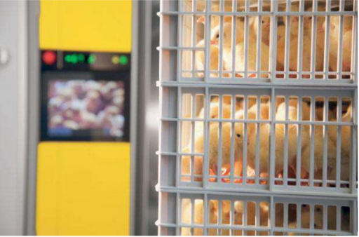

Fig. 1

**2. Magic fly Digital Mini Fully Automatic Egg Incubator 12 Eggs Poultry Hatch:**

Nowadays this is the most popular device for those who don't need a huge incubator. In terms of dimensions and shape this device resembles more of a lunch box than of a full scale new life cultivation device. This is for the best, as it will not take up much space. The price is also affordable taking into account the fact that this is an automated egg incubator First of all, there is automatic temperature control, so you will not have to set it manually. An egg turner is also available, so you will not have to do that either. The top lid of the device is equipped with an LED screen showing various indices. By the way, the device is suitable for hatching not only chicken, but also eggs, fowl and goose eggs. Such versatility is crucial for a compact device as you are likely to try it all in the beginning of your poultry farming career. Number of Eggs 12 Compatibility chicken, duck, geese Automation Temperature control, egg turner

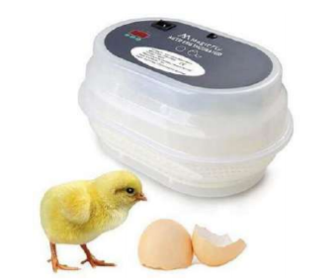

Fig. 2

**3.Manufacturing 1602N Hova-Bator Incubator:**

This is a simple large incubator with minimum equipment for the price of 59.79. It is definitely unsuitable of thermometer, without which you will hardly be able to incubate anything. Do take into account the fact that the device has been devised for 50 chicken eggs. You will be able to fit half as many goose eggs and twice as many quail eggs. Should you disregard the drawbacks of the manual operation, you will find that this is the most affordable 50 egg incubator.

Number up to 70 Eggs Compatibility chicken, duck, geese Automation Temperature control

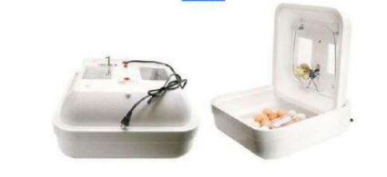

Fig. 3

**4.CHIMAERA 56-Egg Automatic Incubator at cher Turner with LCD Display:**

This is the second-large incubator of this review: the manufacturer claims it can fit 56 chicken eggs. The device is shaped as a trap, so you will not be able to lay more eggs even if were talking quail eggs. This device provides impressive volumes at the best price of 99.99. This incubator has sufficient functions: there is a large control panel for monitoring the incubation day, temperature and humidity. Such a large device is also equipped with a cooler providing for the necessary air circulation on the inside. What the gadget lacks is the possibility to watch the eggs without opening the lid: the walls are opaque and the eye cannot see all the egg rows behind the matte plastic. In general, you can rely on the data output on the screen as all the necessary operations, including the turning, will be performed by the device with out your help. This is it for the inexperienced poultry farmers.

Number up to 56 Eggs Compatibility chicken, duck, geese Automation Temperature control, egg turner.

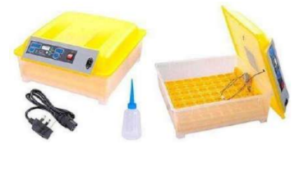

Fig. 4

**5.Best Choice Products 96 Digital Clear Egg Incubator Hatcher Automatic Egg Turning Temperature Control** :

Here before you is a mini farm. Unlike other incubators, here two 48-egg trays are supplied. When you assemble them, you will have a kind of two-storied incubator. The device is compatible with all types of poultry and is thus versatile and multi-functional. The automation is fine as there is an auto egg turn, temperature and humidity control. In 20 general, there is nothing a user should worry about as everything is automated. They two storied design raises certain questions from the customers as there are certain air circulation issues when the necessary temperature cannot be maintained on the lower storey. This issue is fairly easy to solve: you should invest into an additional fan kit and install it on the lower level. Two coolers will keep the air circulating inside the incubator and will thus maintain stable temperature on both levels. The most essential thing is to follow the rules of laying the eggs which are stated in detail in the manual.

Number up to 96 eggs Compatibility chicken, duck, geese, goose Automation Temperature control, egg turner automatic egg turner, airflow.

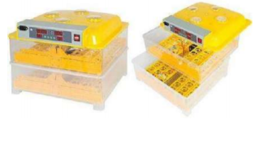

Fig. 5

**6. Hova -Bator Advanced Egg Incubator Combo Kit: includes in- cubator,fan kit, egg turner, digital thermometer/hygrometer:**

This is a smaller incubator, but its interior has been designed in a more convenient and versatile manner. 42 chicken or 70 quail or 28 goose eggs can fit here. This might as well be the handiest and roomiest item for those who breed quail. Despite the unsophisticated design (in comparison with its analogues), the equipment is more than satisfactory and the price tag of 128 dollar is completely justified. There is not only a built-in egg turner, but also everything else is supplied as separate devices, namely a digital thermometer/hygrometer and a powerful air circulation fan kit. The price tag has increased considerably thanks to 21 these devices supplied. In general, this is a noteworthy item especially for those who deal with various poultry species and need a universal produce Number up to 70 eggs Compatibility chicken, duck, geese, quill Automation Temperature control, digital thermometer, fan kit, automatic egg turner

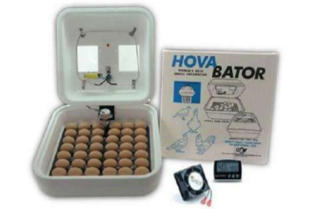

Fig. 6

**7.YescomMini Digital Transparent 7 Egg Incubator Clear Chicken Poultry Hatcher w/ CE Certificated:**

This product is the least expensive among its analogues, as it costs only 21.95 Dollar. It is not equipped with an auto egg turner; there is only temperature control available. Do you need the egg turner? It will definitely double the price, and turning 7 eggs regularly on your own is not the most difficult task given that the tray is very expedient and your chances of accidentally cracking the egg are extremely low. This incubator is also the smallest one reviewed! A 6.7” x 6.7” x 6.7” device will not take up much space even in the most crowded space, and the price tag is also the most affordable among the items reviewed. So if you are looking for a device to try your breeding skills pick this one but do not expect too much from it.

Number 7 eggs Compatibility chicken, duck, geese Automation Temperature

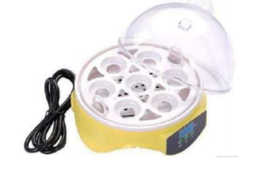

Fig. 7

**IDEAL CONDITIONS FOR HATCHING EGGS**

1.**Temperature:**

The temperature range between 37 - 38 degrees Celsius to ensure the growth and development of chickens and this degree depends on the type of hatchery and the type of machine itself. In general, the appropriate temperature for egg spawning in the Roman is about 37.5 C and in the ducks ranges from 37 to 37.8 C. For science, any rise or decrease in temperature for a long time leads to many problems in the hatching process and eventually ends with a low hatching rate In the first period of hatchery, but during the last 3 days in hatchery of any type, the temperature should be reduced by one degree Celsius because of the heat resulting from metabolism processes that are carried out inside the eggs by the embryos and usually the temperature in the last period Hatching ranges from 36.5 to 37.3 degrees percentage .

**2.Humidity:**

A source of moisture (water) must be provided in the hatchery to compensate for the evapora- tion that occurs to the water inside the eggs during incubation of the eggs, in order to obtain a chick of high quality and quality. The humidity of the chicken eggs is 50 - 60 And 70in the case of incubation of duck eggs, especially in the first two weeks of hatchery, during the first period of incubation, which is 18 days in chickens, 24 days in Romi and 26 days in ducks and geese. 80 - 85 during the last 3 days of hatching in chickens and in ducks and geese increased to 90 - 95during the last 3 days of a hatchery.

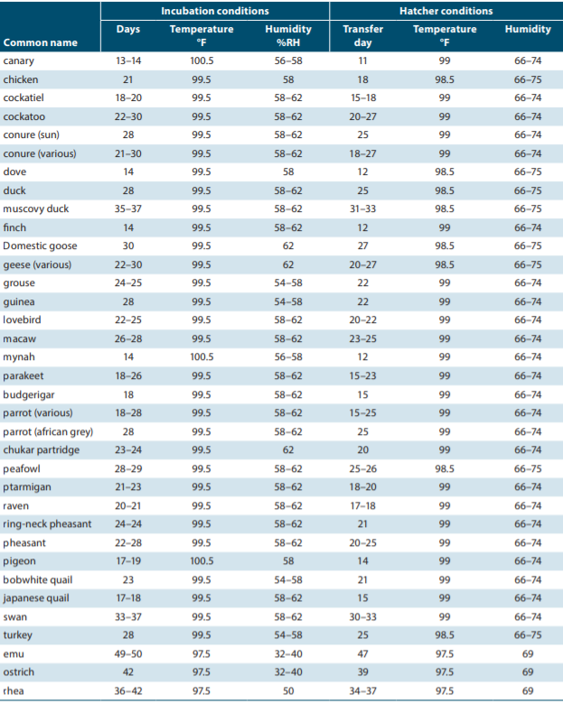

Table.1

**3.Ventilation:**

To provide oxygen and to put carbon dioxide out of the hatchery machine because there is no significant mortality in the embryos and the concentration of oxygen must be about 21, or in concentration in the normal air, but carbon dioxide not to exceed the proportion of 90 part of carbon dioxide Per 10,000 parts of the air and not to increase it for the lack of suffocation of embryos and low hatching rate. The percentage ofCO2 suitable for the growth and development of embryos is 0.4 - 0.5.

**4.Egg Flipping:**

Simulate the chicken in natural spawning by multiplying eggs several times a day. Where egg whipping several times Yuba to improve the hatching rate. The egg whip prevents embryonic membranes from sticking together and allows the fetus to take a proper position within the egg and provide adequate distribution of food, air, and heat to the fetus. In addition, the regular flipping habit prevents the embryo from adhering to the eggshell. The flocculation continues till today 18 of the hatching of the chicken eggs and the flop stops thereafter and the foo eggs stop stirring at day 24 of the hatching, the ducks and geese at day 26 and the ostriches after day 38 and in the quail after 15 days from the beginning of the hatching.

**Incubating Conditions:**

The condition of incubator is very important element. Poor results are most commonly

produced with improper control of temperature and/or humidity. Improper control means that the

temperature or humidity is too high or too low for a sufficient length of time that it interferes with

the normal growth and development of the embryo. Poor results also occur from improper

ventilation, egg turning and sanitation of the machines or eggs. The components than must be control in the incubator are temperature, humidity and ventilation. The temperature must depend on the types of egg. In order to hatch a good percentage of fertile eggs, an incubator must be able to maintain constant temperature. Though different sorts of eggs require different heat levels, most will grow and hatch well at 99 to 101°F. Sure, that does sound imposingly precise, but such accuracy isn't all that difficult to achieve. Rarely is the humidity too high in properly ventilated still air incubators. The water pan area should be equivalent to one-half the floor surface area or more. Increased ventilation during the last few days of incubation and hatching may necessitate the addition of another pan of water or a wet sponge. Humidity is maintained by increasing the exposed water surface area. Ventilation is very important during the incubation process. While the embryo is developing oxygen enters the egg through the shell and carbon dioxide escapes in the same manner. As the chicks hatch, they require an increased supply of fresh oxygen. Embryos grow; the air openings are gradually opened to satisfy increased embryonic oxygen demand. Care must be taken to maintain humidity during the hatching period. Unobstructed ventilation holes, both above and below the eggs, are essential for proper air exchange.

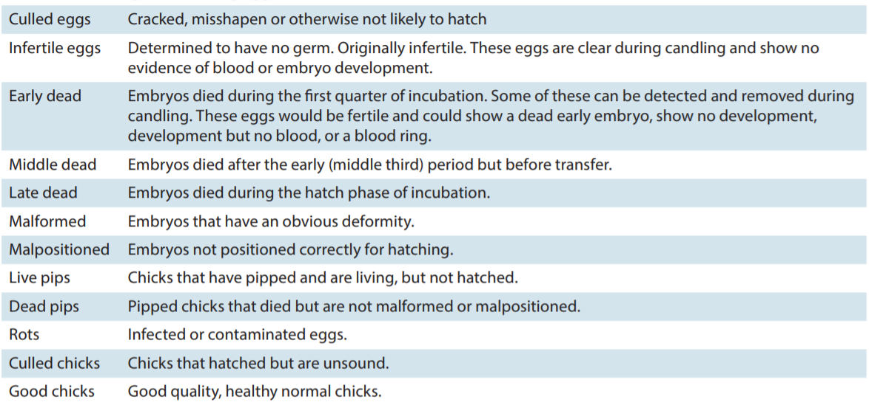**Incubating and hatching egg and chick classification:**

Table.2

**Steps:**

Prepare your incubator approximately 1 week prior to getting your eggs. Read all instructions included in the owner's manual. Familiarize yourself with how to operate the fan, light and all other functions of the incubator. Regulate the temperature in the incubator. Placement can influence regulation, so it's important to place the incubator in a location that experiences little temperature fluctuation. The temperature should be between (35-370 C).

Turn the incubator on at least 24 hours before putting the eggs into the incubator.

**Acquire the eggs:**

* Order the eggs from 1 supplier. Ordering from 1 place helps to guarantee that your eggs are approximately the same age and type. Allow the eggs to settle for at least 24 hours before putting them into the incubator. Point the small ends down as the eggs are settling.
* Place the chicken eggs in the incubator. Set the eggs on their sides.
* Turn the eggs 2 or 3 times per day during the first 18 days. Do not turn the eggs after 18 days have elapsed.
* Check the temperature levels in the incubator each time you turn the eggs.
* Keep the temperature as close to 101.5 degrees F (38.6 degrees C0) as possible in an incubator without a fan. Measure the air temperature at the top of the eggs.
* Aim for temperatures close to 99.5 degrees F (37.5 degrees C0) in an incubator with a fan.
* This temperature reading can be done anywhere within the incubator.
* Keep checking the temperature during the last 3 days of incubation, even though you won't be turning the eggs.
* Regulate the humidity in your incubator by measuring it with a hygrometer.
* Create an environment for your eggs where the humidity is at 60 to 65 percent during the first 18 days.
* Raise the humidity levels to 80 to 85 percent for the last 3 days (days 18 to 21).
* Add moist surface area to the incubator to increase the humidity level. Add a big pan of water or wet sponges.
* Remove moist surface area to decrease the humidity level. Change a big pan of water out for a smaller dish or remove wet sponges.
* Refrain from opening the incubator door between the 18th and 21st days. Opening the door causes severe fluctuations in the temperature and humidity levels of the incubator, which has a negative impact on the incubated eggs.

**How to Use an Incubator to Hatch Eggs:**

We can hatch eggs even if you have no hens by using an incubator. Incubators attempt to reproduce the conditions fertile eggs experience under a brooding hen, including appropriate temperature, humidity and ventilation levels. To successfully hatch eggs in an incubator, we will need to properly calibrate the incubator and be able to keep the settings stable throughout the incubation period.

**Egg Rotation:**

It is mandatory to mimic near natural conditions to have high yield and low mortality rate. It is observed that the hen, every couple of hours rotates its eggs upon which it sits and this ensures that the embryo within the shell does not stick to it and is also not void of all the nutrients it deserves. The same thing is achieved in the incubator by low-speed DC motors wherein the eggs are tilted to 45 ° angle periodically so as to ensure the embryo is not trapped. In order to obtain the near accurate placement and timing, the eggs have to be turned at least five times a day. It is important to select the eggs in the first week when there is no body fat. The duration, periodicity and angle of egg rotation is pre-programmed (programmable by the user) and is automated within the incubator.

Eggs in the system get rotated 4 times every day to equally distribute the heat and humidity

for 18 days.

**Incubating the Eggs:**

* Warm the fertile eggs to room temperature. Allowing the eggs to warm up will decrease the amount and duration of temperature fluctuation in the incubator after you've added the eggs.
* Mark each side of the eggs with a symbol. Many people use X and O to indicate each side of the egg.
* Use a pencil and lightly draw a symbol of your choice on 1 side of the egg and draw a second symbol on the other side.
* Place the eggs carefully into the incubator. Make sure the eggs are lying on their sides. The larger end of each egg should be slightly higher than the pointy end. This is important as the embryos can become misaligned if the pointy end is higher and may have difficult piping, or breaking through the shell, when it comes time to hatch.
* Allow the temperature to drop after adding the eggs. The temperature will temporarily lower after you've introduced the eggs into the incubator, but it should readjust if we calibrated the incubator correctly.
* Don't increase the temperature to compensate for this fluctuation or we may damage or kill our embryos.
* Record the day and how many eggs you've added to the incubator. we should be able to estimate your hatch date based on average incubation times for the bird species you want to hatch. For example, chicken eggs typically take 21 days to hatch, while many duck varieties and peafowl may take 28 days.
* Turn the eggs daily. Rotating the eggs and changing their position helps mitigate the effects of any temperature differences within the incubator and mimics the behaviour of a brooding hen.
* Turn eggs an odd number of times each day. This way, the symbol on the eggs will change every day after you turn the eggs, making it easy to see whether or not you've turned the eggs yet for that day.
* Move eggs around to different positions in the incubator.
* Stop turning the eggs during the last 3 days of incubation, as at this point, the eggs will soon hatch and turning is no longer necessary.
* Adjust the humidity levels in the incubator. Humidity should be around 50 to 55 percent throughout incubation, except during the last 3 days when you will want to raise it to 65 percent. We may need higher or lower humidity levels depending on the type of eggs you wish to hatch. Consult your hatchery or the available literature on hatching your species of bird.
* Replenish the water in the water pan on a regular basis or the humidity levels will drop too low. Always add warm water.
* Add a sponge to the water pan if you need to increase the humidity.
* Measure the humidity level in the incubator using a wet bulb thermometer. Take a reading with the wet bulb thermometer and also record the temperature in the incubator at the time. Consult a chart or psychometric chart online or in a book to find the relative humidity from the relationship between the wet bulb and dry bulb temperature readings.
* Ensure the incubator has adequate ventilation. There should be openings on the sides and top of the incubator to allow air flow-check to make sure these are at least partially opened. You will need to increase the amount of ventilation once the chicks begin to hatch.
* Candle the eggs after 7 to 10 days. Candling the eggs is when you use a light source to view how much space the embryo occupies within an egg. After 7 to 10 days, you should see development of the embryo. Candling allows you to remove eggs with embryos that are not viable.
* Find a tin can or a box that can fit over a light bulb.
* Cut a hole in the can or box that is smaller in diameter than an egg.
* Turn on the light bulb.
* Take 1 of the incubated eggs and hold it over the hole. If the egg appears clear, the embryo has not developed or the egg may never have been fertile. You should see a cloudy mass if the embryo is developing. The embryo will increase in size as you near the hatch date.
* Remove any eggs that do not show a developing embryo from the incubator.
* Prepare for the hatch. Discontinue turning and rotating eggs 3 days prior to the estimated hatch date. Most viable eggs will hatch within a 24 hour period.
* Place cheesecloth under the egg tray prior to hatching. The cheesecloth will help catch bits of eggshell and other matter during and after the hatch.
* Increase the humidity level in the incubator by adding more water or a sponge. Leave the incubator closed until after the chicks hatch.

**COMPONENTS REQUIRED**

* NodeMCU
* 16X2 LCD I2C Display
* Relay Module
* 100W Bulbs
* 2 Cooling Fans
* Gear Motors
* DHT 11 Temperature and Humidity Sensor
* Humidifier

**NodeMCU-**

The NodeMCU (Node Micro Controller Unit) is an open-source software and hardware development environment built around an inexpensive System-on-a-Chip (SoC) called the ESP8266. The ESP8266, designed and manufactured by Espressif Systems, contains the crucial elements of a computer: CPU, RAM, networking (Wi-Fi), and even a modern operating system and SDK. That makes it an excellent choice for the Internet of Things (IoT) projects of all kinds.

EPS8266 is incorporated as a Node MCU in an open-source development program based on a widely used module. The ESP8266 is an independent Wi-Fi module solution that provides seamless connectivity.

It acts as a host or allows other host to be downloaded to the system. Node MCU is utilized to keep the relevant data such as humidity, temperature, rotation of eggs and ventilation onto the memory and serves to post this feature on a cloud server for ease of access.

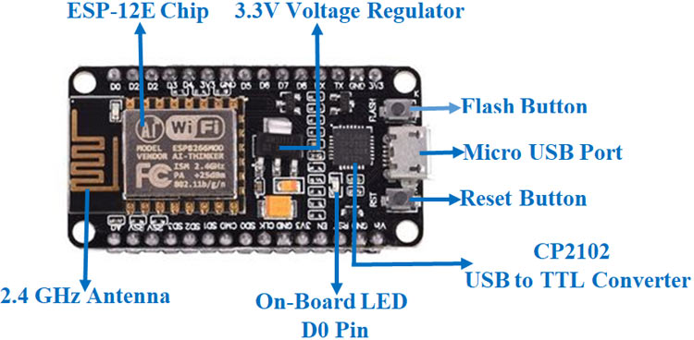

Fig.8

## DHT11 Temperature and Humidity Sensor:

The DHT11 is a basic, ultra-low-cost digital temperature and humidity sensor. It uses a capacitive humidity sensor and a thermistor to measure the surrounding air, and spits out a digital signal on the data pin (no analog input pins needed). It’s fairly simple to use, but requires careful timing to grab data.

Specifications:

* 3 to 5V power and I/O
* 2.5mA max current use during conversion (while requesting data)
* Good for 20-80% humidity readings with 5% accuracy
* Good for 0-50 °C temperature readings +-2 °C accuracy
* No more than 1 Hz sampling rate (once every second)
* Body size 15.5mm x 12mm x 5.5mm
* 4 pins with 0.1" spacing
* Adafruit Learning Documentation for DHTxx Sensors
* RoHS compliant

Temperature and humidity, being the main factors for healthy hatching, the DHT11 sensor plays a crucial role. The primary role is to quantify the temperature and humidity. It has a humidity range between 40% to 99% (± 5%) and temperature varies between 30°C to 40°C ( ±1°C). The relative humidity of the incubator should be maintained at around 60% for the first 18 days and should then be increased in the last three days.

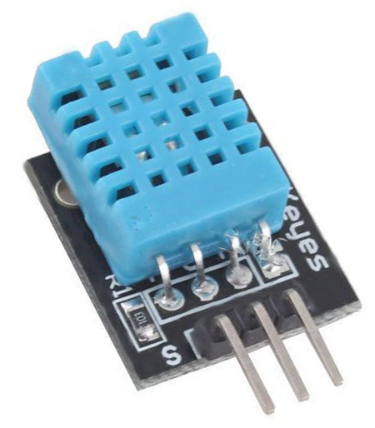

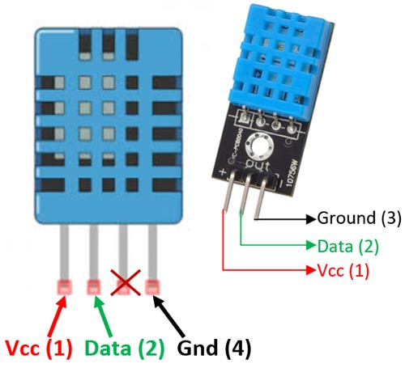

Fig.9

**Relay Module:**

A Relay Module is an electronic switching device that switches on or off when an external voltage (AC or DC) is applied across its control terminals. It serves the same function as an electromechanical relay, but has no moving parts and therefore results in a longer operational lifetime. SSRs consist of a sensor which responds to an appropriate input (control signal), a solid-state electronic switching device which switches power to the load circuitry, and a coupling mechanism to enable the control signal to activate this switch without mechanical parts. The relay may be designed to switch either AC or DC loads.

Relays are miniature electromagnetic switches that are controlled by minute electrical signals from the controller. A small current makes or breaks the relay circuit which in turn switches OFF or ON the corresponding load connected to it like air circulator, humidifier, heater etc. The incubator, being fully automatic and smart, decides on itself based on the sensor input of a pre-determined parameter to operate the required apparatus without human intervention.

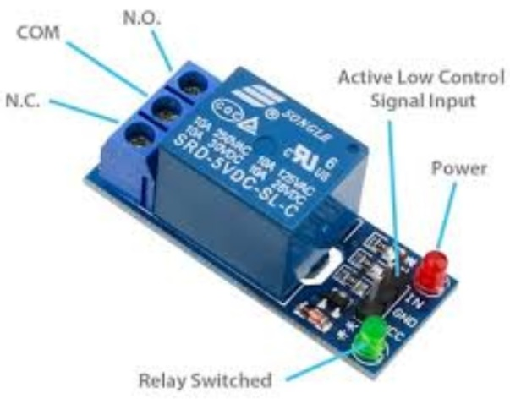

Fig.10

**Gear Motor:**

A geared motor is a component whose mechanism adjusts the speed of the motor, leading them to operate at a certain speed. geared motor has the ability to deliver high torque at low speeds, as the gearhead functions as a torque multiplier and can allow small motors to generate higher speeds.

A geared motor can also be defined as a gear reducer because essentially, it is a combination of a speed reducer with a motor typically functioning as a gearbox, to reduce speed making more torque available.

Geared motor can be classified based on the motor they are paired with, including bevel, helical, hypoid, spur and worm gears.

Each of these gears have advantages and disadvantages. For example, helical gears possess more torque capacity than spur gears, hence, generating less noise. Worm gears work efficiently in the low torque angel and are good for high-speed reductions.

Geared motors can be classified based on different elements. The two most common geared motor types are right angle geared motor and inline geared motor.

* Right-angle geared motor use worm, bevel or hypoid gearing.
* Inline geared motor typically uses spur gears, helical or planetary gear sets.
* Parallel shaft geared motors type helical gears

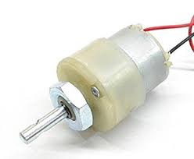

Fig.11

**100W Bulbs-**

The incandescent bulb consists of a sealed glass bulb with a filament inside. When electricity is passed through the filament, the filament gets hot. Depending on the temperature of the filament, radiation is emitted from the filament.

The filament's temperature is very high, generally over 2,000º C, or 3,600º F. In a "standard" 60-,

75-, or 100-Watt bulb, the filament temperature is roughly 2,550º C, or roughly 4,600º F. At high temperatures like this, the thermal radiation from the filament includes a significant amount of visible light.

This principle of obtaining light from heat is called ‘incandescence.” At this high temperature of 2,000º C, about 5 percent of the electrical energy converts into visible light and the rest of it is emitted as heat or infrared radiation.

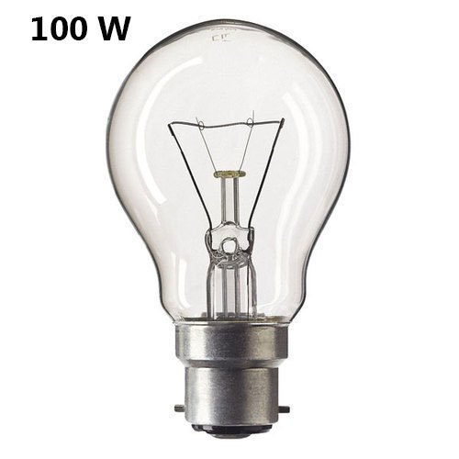

Fig. 12

**CPU Cooling Fans:**

A computer fan is any [fan](https://en.wikipedia.org/wiki/Fan_(machine)) inside, or attached to, a [computer case](https://en.wikipedia.org/wiki/Computer_case) used for [active cooling](https://en.wikipedia.org/wiki/Active_cooling). Fans are used to draw cooler air into the case from the outside, expel warm air from inside and move air across a [heat sink](https://en.wikipedia.org/wiki/Heat_sink) to cool a particular component. Both [axial](https://en.wikipedia.org/wiki/Axial_fan) and sometimes [centrifugal](https://en.wikipedia.org/wiki/Centrifugal_fan) (blower/squirrel-cage) fans are used in computers. Computer fans commonly come in standard sizes, and are powered and controlled using 3-pin or 4-pin fan [connectors](https://en.wikipedia.org/wiki/Electrical_connector).

While in earlier personal computers it was possible to cool most components using natural [convection](https://en.wikipedia.org/wiki/Convection) ([passive cooling](https://en.wikipedia.org/wiki/Passive_cooling)), many modern components require more effective active cooling. To cool these components, fans are used to move heated air away from the components and draw cooler air over them. Fans attached to components are usually used in combination with a [heat sink](https://en.wikipedia.org/wiki/Heat_sink) to increase the area of heated surface in contact with the air, thereby improving the efficiency of cooling. Fan control is not always an automatic process. A computer's BIOS (basic input/output system) can control the speed of the built-in fan system for the computer. A user can even supplement this function with additional cooling components or connect a manual fan controller with knobs that set fans to different speeds.[[1]](https://en.wikipedia.org/wiki/Computer_fan#cite_note-1)

In the [IBM PC compatible](https://en.wikipedia.org/wiki/IBM_PC_compatible) market, the computer's [power supply unit](https://en.wikipedia.org/wiki/Power_supply_unit_(computer)) (PSU) almost always uses an exhaust fan to expel warm air from the PSU. Active cooling on CPUs started to appear on the [Intel 80486](https://en.wikipedia.org/wiki/Intel_80486), and by 1997 was standard on all desktop processors. Chassis or case fans, usually one exhaust fan to expel heated air from the rear and optionally an intake fan to draw cooler air in through the front, became common with the arrival of the [Pentium 4](https://en.wikipedia.org/wiki/Pentium_4) in late 2000.

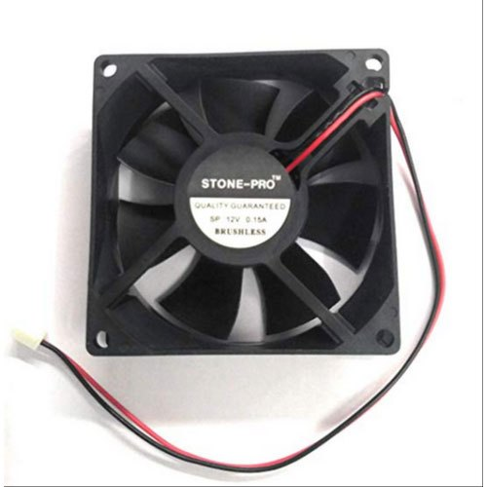

Fig. 13

**I2C interface 16x2 LCD display module:**

I2C interface 16x2 LCD display module, a high-quality 2 line 16 character LCD module with on-board contrast control adjustment, backlight and I2C communication interface. For Arduino beginners, no more cumbersome and complex LCD driver circuit connection. The real significance advantages of this I2C Serial LCD module will simplify the circuit connection, save some I/O pins on Arduino board, simplified firmware development with widely available Arduino library.

* Compatible with Arduino Board or other controller board with I2C bus.
* Display Type: Negative white on Blue backlight.
* I2C Address:0x38-0x3F (0x3F default)
* Supply voltage: 5V
* Interface: I2C to 4bits LCD data and control lines.
* Contrast Adjustment: built-in Potentiometer.
* Backlight Control: Firmware or jumper wire.
* Board Size: 80x36 mm.

Using the LCD piggy-back board, desired data can be displayed on the LCD through the I2C bus. In principle, such backpacks are built around PCF8574 (from NXP) which is a general purpose bidirectional 8 bit I/O port expander that uses the I2C protocol. The PCF8574 is a silicon CMOS circuit provides general purpose remote I/O expansion (an 8-bit quasi-bidirectional) for most microcontroller families via the two-line bidirectional bus (I2C-bus). Note that most piggy-back modules are centered around PCF8574T (SO16 package of PCF8574 in DIP16 package) with a default slave address of 0x27. If your piggy-back board holds a PCF8574AT chip, then the default slave address will change to 0x3F. In short, if the piggy-back board is based on PCF8574T and the address connections (A0-A1-A2) are not bridged with solder it will have the slave address 0x27.

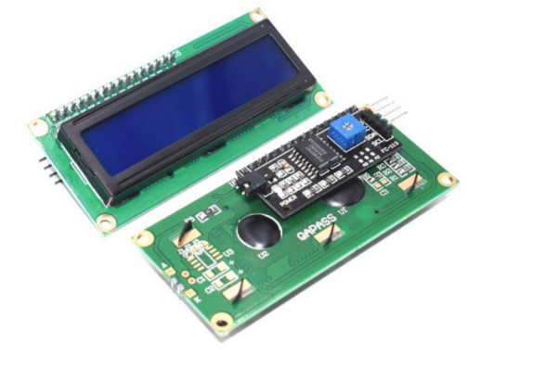

Fig. 14

**Humidifier:**

Humidifier therapy adds moisture to the air to prevent dryness that can cause irritation in many parts of the body. Humidifiers can be particularly effective for treating dryness of the skin, nose, throat, and lips. They can also ease some of the symptoms caused by the [flu](https://www.healthline.com/health/cold-flu/flu) or [common cold](https://www.healthline.com/health/cold-flu/cold). However, overusing humidifiers can potentially worsen respiratory problems. It’s important to know how to use them correctly.

Humidity acts as a natural moisturizing agent that can relieve dryness. For this reason, humidifiers are often used for relieving:

* dry skin
* sinus congestion/headache
* dry throat
* nose irritation
* bloody noses
* irritated vocal cords
* dry cough
* cracked lips

Humidifier is a device which introduces humidity into the enclosed incubator. Primarily, it is an electrical device which generates and pumps water vapor or steam to increase moisture levels in the air within the incubator (humidity). Presence of moisture reduces skin dehydration and improves body temperature from birth, but it does not delay the normal skin development. Hatched chicken nursed without moisture often become hypothermic despite the high air temperature in the incubator. In incubator, the humidity is kept at about 50-60% for initial 18 days and thereafter it is increased to 70% during hatching.

**HTML:**

HTML is a mark-up language used for structuring and presenting content on the World Wide Web. HTML includes detailed processing models to encourage more interoperable implementations; it extends, improves and rationalizes the mark-up available for documents, and introduces mark-up and application programming interfaces (APIs) for complex web applications. For the same reasons, HTML is also a candidate for cross-platform mobile applications, because it includes features designed with low-powered devices in mind. Here in the Smart incubator System the current status of both parameters are viewed in the smart phone through a web page designed by HTML.

In order to monitor and control the current status of temperature and humidity, some instructions are written on the browser search bar and search. It will goes to the corresponding web pages. The instruction contain the IP address of the processor Wi-Fi module. The processor Wi-Fi module act as a host device, so by properly type the username and password in the smart phone a connection established between the processor and the smartphone. To view the current temperature and humidity status of the smart incubator uses the IP : 192.168.43.70, for setting new reference values of temperature and humidity uses another instruction code IP : 192.168.43.70/set?a=36b=76. Where the variable ‘a’ assigned for temperature and ‘b’ is assigned for humidity.

**Ngrok:**

Ngrok allows you to expose a web server running on your local machine to the internet. Just tell ngrok what port your web server is listening on.

If you don't know what port your web server is listening on, it's probably port 80, the default for HTTP.

Ngrok provides a real-time web UI where you can introspect all of the HTTP traffic running over your tunnels. After you've started ngrok, just open [http://localhost:4040](http://localhost:4040/) in a web browser to inspect request details.

Try making a request to your public URL. After you have, look back at the inspection UI. You will see all of the details of the request and response including the time, duration, headers, query parameters and request payload as well as the raw bytes on the wire.

Ngrok 's local web interface has a dedicated status page that shows configuration and metrics information about the running ngrok process. You can access it at <http://localhost:4040/status>.

The status page displays the configuration of each running tunnel and any global configuration options that ngrok has parsed from its configuration file.  
The status page also display metrics about the traffic through each tunnel. It display connection rates and connection duration percentiles for all tunnels. For http tunnels, it also displays http request rates and http response duration percentiles.

By using this we can make a local data to global which means the whole data can be accessed by anywhere and anyone.

**PROPOSED METHOD**

Accurate and precise measurements of the environmental parameters within the incubator are obtained by means of highly sensitive instruments wherein sensors collect the data on temperature, humidity, angle of egg tilt, water level, and intensity of light. The system utilizes NodeMCU to control all the peripherals which are connected to the system. This controller is fast enough and also possesses the ability to run multiple programs. DHT11 digital sensor is used to obtain the temperature & humidity. Incorporating an incandescent lamp as the heat source reduces substantial power consumption as against using heater. High efficiency fans are used to circulate the heated air within the chamber to maintain required temperature. A humidifier is used to maintain the pre set humidity in the entire internal system. A standard widely available 16x2 I2C LCD display unit is integrated to the electronic module that is used as a display unit. The outputs from all the sensors are connected to the heart of the incubator, which gives the command to power on or off the desired peripheral connected to it, as deemed fit. A battery is also employed for backup purposes. IoT and Node MCU (ESP8266) are used to integrate on the smart phone or any desktop that provides the overall monitoring and configuration to the user.

**CIRCUIT DIAGRAM**

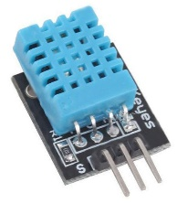

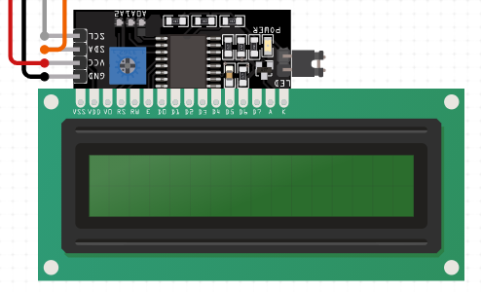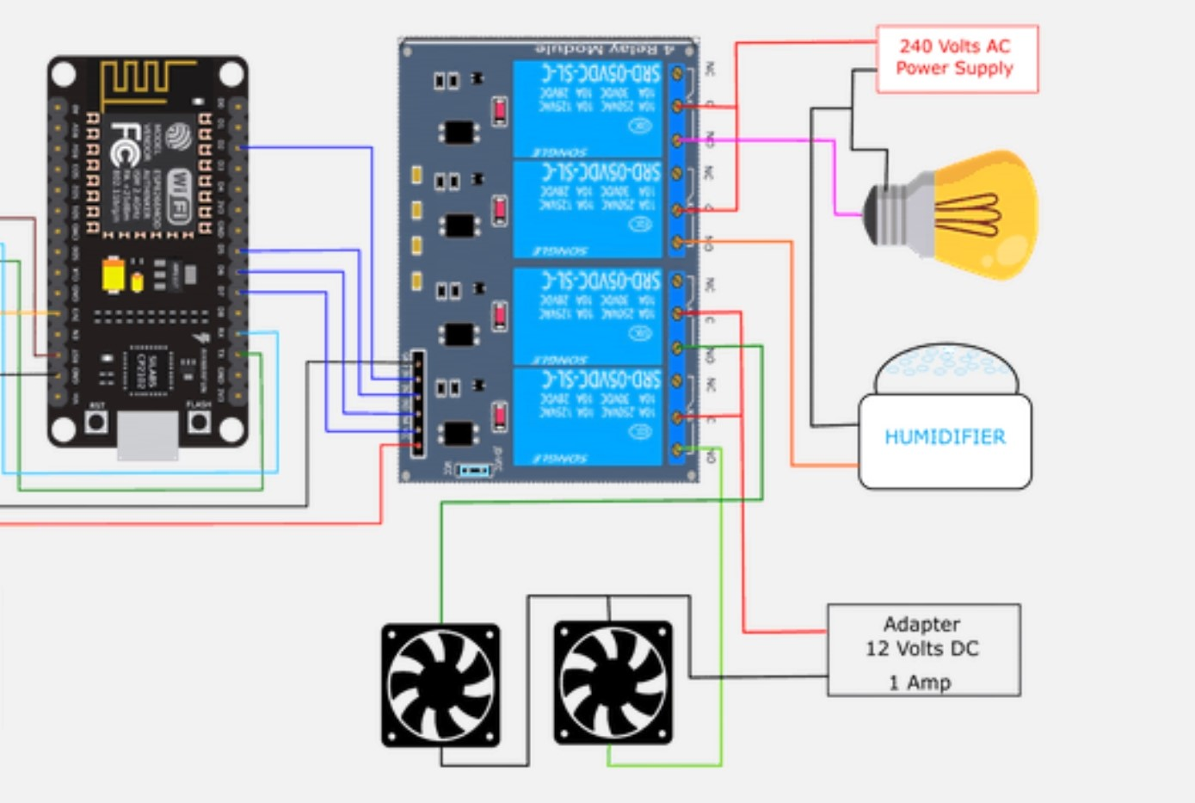

Fig. 15

**SETUP**

* NodeMCU is connected to DHT11 as an input device to measure temperature and humidity.

Input-D4

* NodeMCU is connected to 16X2 LCD I2C Display to display temperature and humidity.

SDA -D2

SCL-D1

* NodeMCU is connected to Relay Module for ON OFF fans, bulb and for humidifier.

Relay 1(for bulb)- D5

Relay 2(for fans) – D6

* The temperature and humidity are displayed day wise in Web Page to user using HTML and Ngrok.

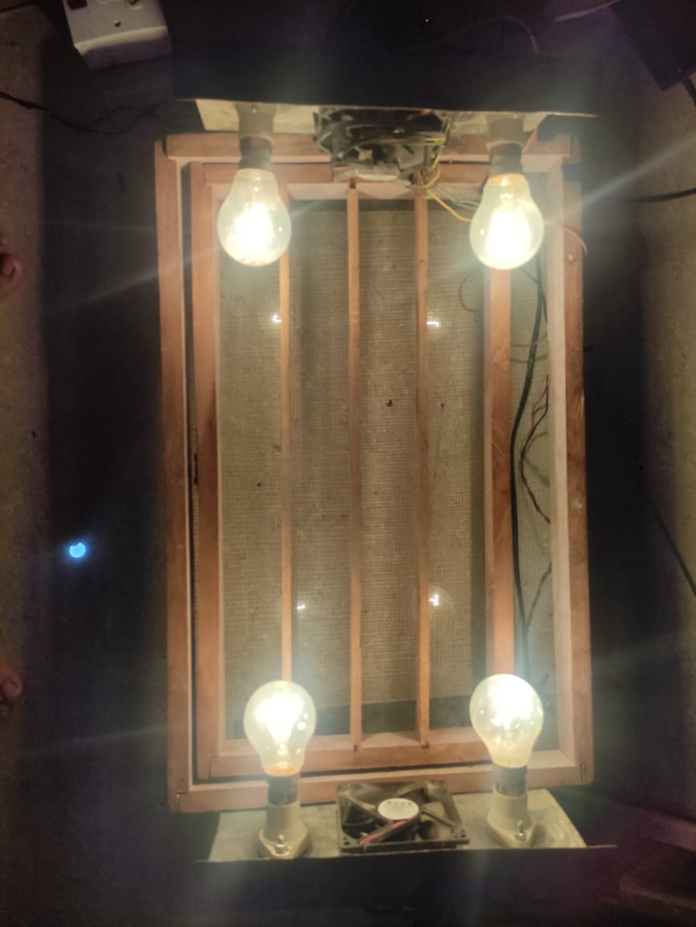



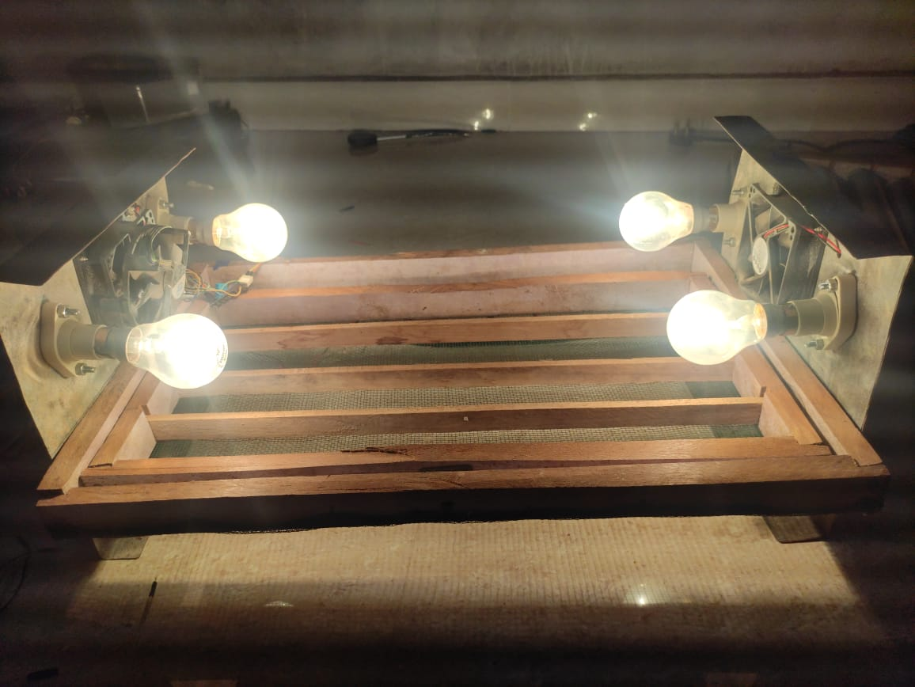

Fig. 17

Fig. 16

**BLOCK DIAGRAM**

|  |
| --- |
| INTERNET |



WEBPAGE

Fig. 18

**WORKING**

* Using DHT11 we will measure the temperature and humidity of incubator.
* Temperature Control

When the temperature is below 35 °C, the bulb goes on.

When the temperature is equal to the 37 °C, the bulb goes off and fan goes on.

* Humidity Control

when the humidity is below the optimum value, the humidifier goes on.

when the humidity reaches the maximum value, the humidifier goes off.

* Egg Rotation

Eggs in the system get rotated 4 times every day to equally distribute the heat and humidity

for 18 days.

* The LCD Display is used to display the temperature and humidity.
* The whole process continues for 21-22 days without any human interference, and it is controlled by NodeMCU with the help of Sensors and Relays.
* In our project the webpage which was created, it was for local(which means the Wi-Fi connected to same network of NodeMCU).
* Now with the help of ngrok the whole will become global(which means whole webpage can be accessed and seen by everyone and everyplace).

**TECHNICAL SPECIFICATIONS**

In automatic mode, when the temperature is below the optimum temperature, the light goes on. The goal is that the temperature will rise to the optimum temperature. When the temperature is above the optimal temperature, the fan will turn on to lower the temperature. Whereas when it reaches the optimum temperature, fan and lights will be off.

Fig. shows the time during lamp will be turn on. When the temperature is below the desired temperature, the light will be turn on to increase the temperature in Smart Egg Incubator.

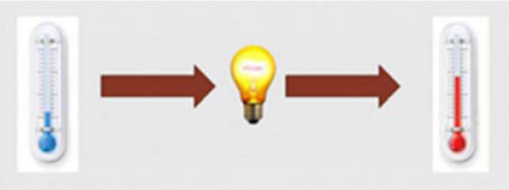

Fig. 19(a)

Fig. shows the time during fan will be turn on. The current temperature is above the desired temperature, the fan will turn on to decrease the temperature in Smart Egg Incubator.

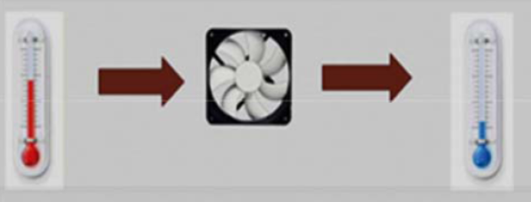

Fig. 19(b)

**FLOW CHART OF CONTROLLER**

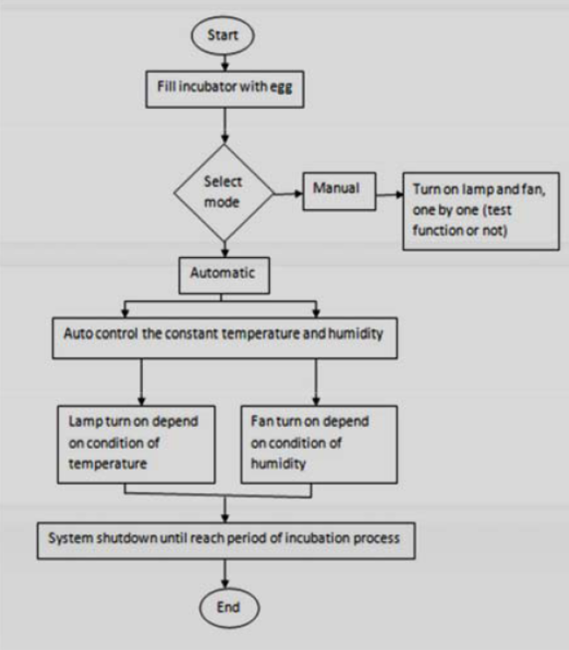

Fig 20

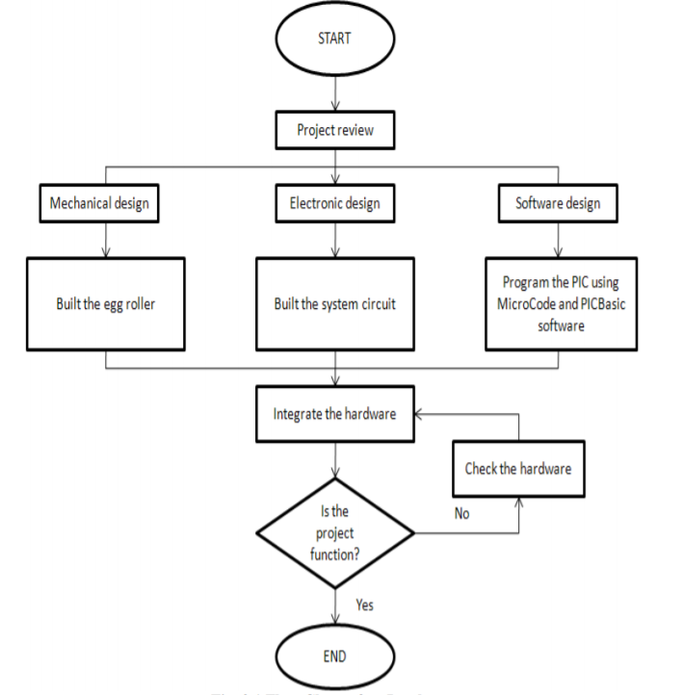**ACTIVITIES DIAGRAM OF OUR SYSTEM**

Fig 21

**FLOWCHART OF SYSTEM**

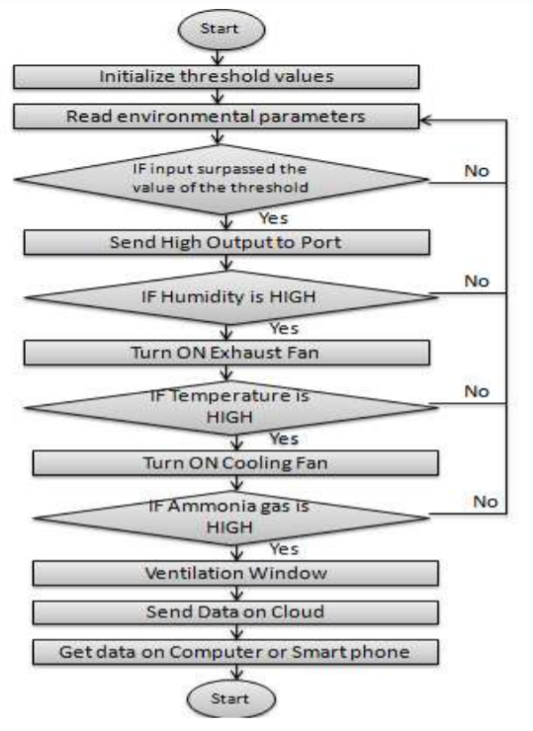

Fig 22

**DATA CALCULATION**

The Table 6 below shows the data of temperature and humidity in Smart Egg Incubator for each hour until 24 hours. To get average value of temperature and humidity for one day, need to calculate the mean value by using the formula:

Mean value = Total of temperature or humidity / Total hours

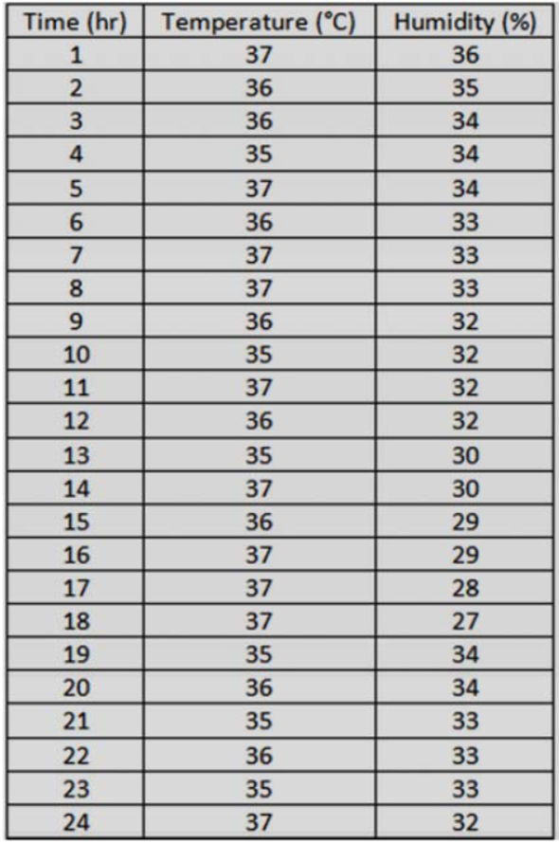

Table 3

The calculation to find the mean value for one day:

For temperature

37 °C – 10 times = 370

36 °C – 9 times = 324

35 °C – 5 times = 175

370 + 324 + 175 = 869

Mean temperature = 869/24 = 36.2 C

For humidity

Mean humidity = 772/24 = 32.16%

**OUR APPLICATION**

We have implemented a simple application that allows us to see the temperature and humidity of incubator and also display how many days the incubation process had been stated in any mobile, PC, or in any desktop.

This webpage can be accessed by everyone and everywhere.

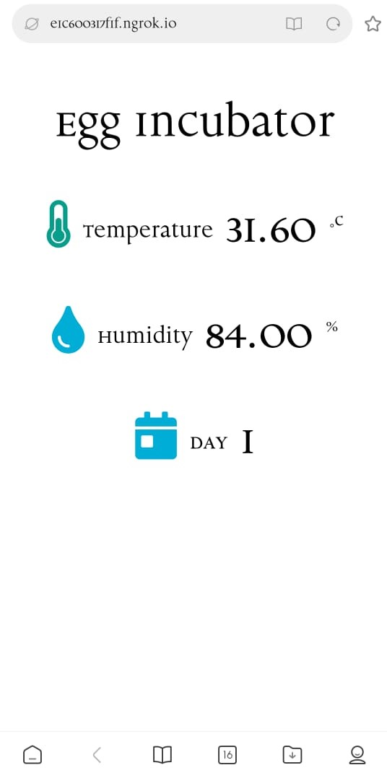

Fig. 23

**CONCLUSION**

This incubator was conceptualized, designed and constructed keeping in mind the sole intention of having a large scale/ small scale hatcher at affordable cost, not only of the incubator, but also that of its running cost with substantial survival/ hatch rate at near natural hatching state. This incubator is prepared for chicken and duck eggs. The current incubator combines the incubator and brooder in the same room. The exact parameters within the incubator will be displayed on the LCD screen. Smart egg incubator monitoring has been developed and implemented by IoT and successfully implemented in this case. The smart console is designed in such a way to ensure the right conditions within the incubator for healthy fetal development. The compact incubator can accommodate huge number of eggs, which is impossible to be done in a natural way. Apart from that, the eggs were also well fertilized with little or no infected eggs. During the hatching test, the eggs were collected from breeders, free from infection or infertility problems, and the chickens were found to be in good health, good size, and 100% incubated. Farmers of this incubator can confidently rely on poultry farming on a small scale and can also be used in egg embryo research and laboratory work.

**RESOURCES**

<https://www.researchgate.net/publication/343961158_Universal_Egg_Incubation_System_for_Hatching_using_Atemga328P_Proteus_Design_Tool_and_IoT>

<https://create.arduino.cc/projecthub/vilaswkhade/automatic-iot-eggs-incubator-0722fc>

<https://shop.evilmadscientist.com/productsmenu/716#:~:text=The%20DHT11%20is%20a%20basic,careful%20timing%20to%20grab%20data>.

[https://premium-transmission.com/blog/geared-motor-types-and-their importance/#:~:text=A%20geared%20motor%20is%20a,motors%20to%20generate%20higher%20speeds](https://premium-transmission.com/blog/geared-motor-types-and-their%20importance/#:~:text=A%20geared%20motor%20is%20a,motors%20to%20generate%20higher%20speeds).

<https://www.eeducation.psu.edu/egee102/node/2035#:~:text=The%20incandescent%20bulb%20consists%20of,bulb%20with%20a%20filament%20inside.&text=In%20a%20%22standard%22%2060%2D,significant%20amount%20of%20visible%20light>.

**REFERENCES**

[1] M. A. Kabir., M. A. Abedin., “Design and Implementation of A Microcontroller Based Forced Air Egg Incubator,” International Conference On Advancement in Electrical and Electronic Engineering 22-24 November, 2018, Gazipur, Bangladesh.

[2] IDOKO E., OGBEH G.O., IKULE F.T., “Design and Implementation of Automatic Fixed Factors Egg Incubator,” International journal for Innovative research in multidisciplinary Field, ISSN: 2455-0620 Volume - 5, Issue - 6, June – 2019 Monthly.

[3] Ammar A. Aldair., Abdulmuttalib T. Rashid., Mastaneh Mokayef., “Design And Implementation of Intelligent Control System for Egg Incubator Based on IoT Technology,” Proceedings of 2018 4th International Conference on Electrical, Electronics And System Engineering.

[4] G. V. Kutsira, N. I. Nwulu, E. M. Dogo, “Development of a Small Scaled Microcontroller-Base Poultry Egg Incubation System,” Department of Electrical and Electronic Engineering Science, University of Johannesburg, South Africa.

[5] Lean Karlo S. Tolentinoa.b, Emmanuel Justine G. Enricoa, a Electronics Engineering Department, Technological University of the Philippines, Manila, “Development of Fertile Egg Detection and Incubation System Using Image Processing and Automatic Candling,” Proceedings of TENCON 2018- 2018 IEEE Region 10 Conference (Jeju, Korea, 28- 31 October 2018).