Name: Anvesha Singh
Batch: B20
Sap ID: 590022234
Week: 03

Q1 objective:Take a random input of thousand number and perform the following algorithm
1.Time comparison of linear and binary search.
2.comparison of bubble sort,insertion sort,quick sort,merge sort.

-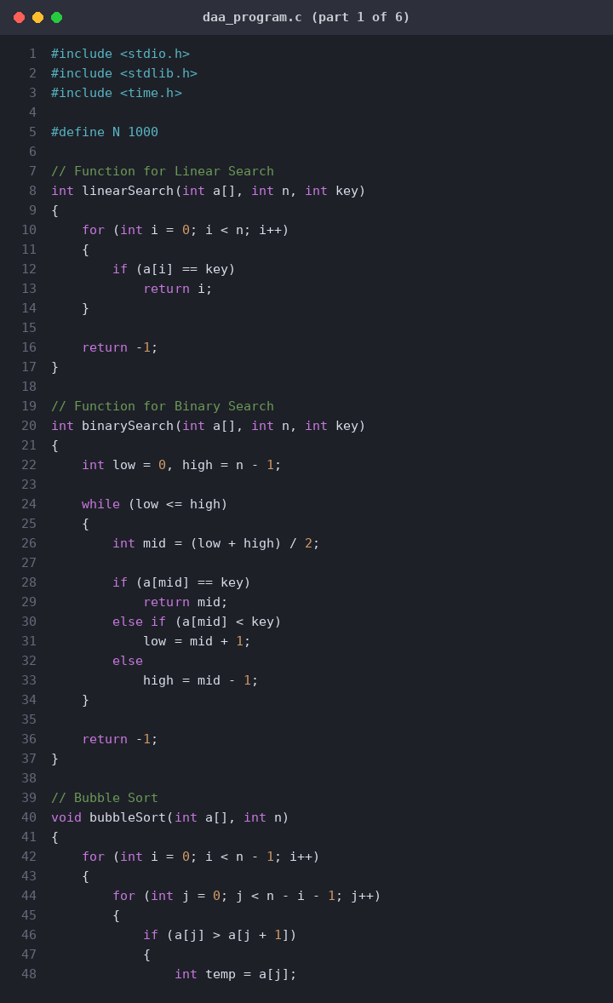

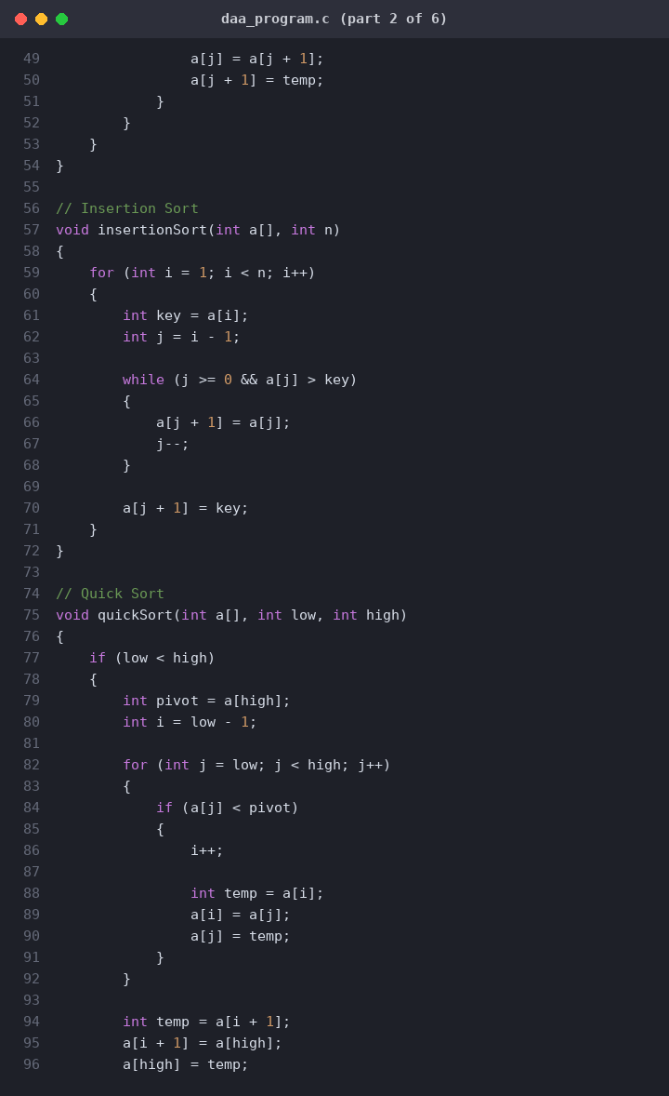
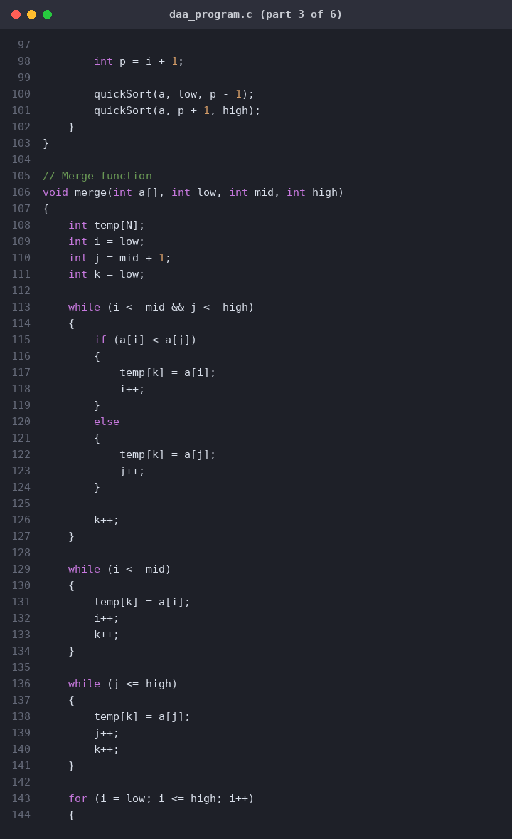
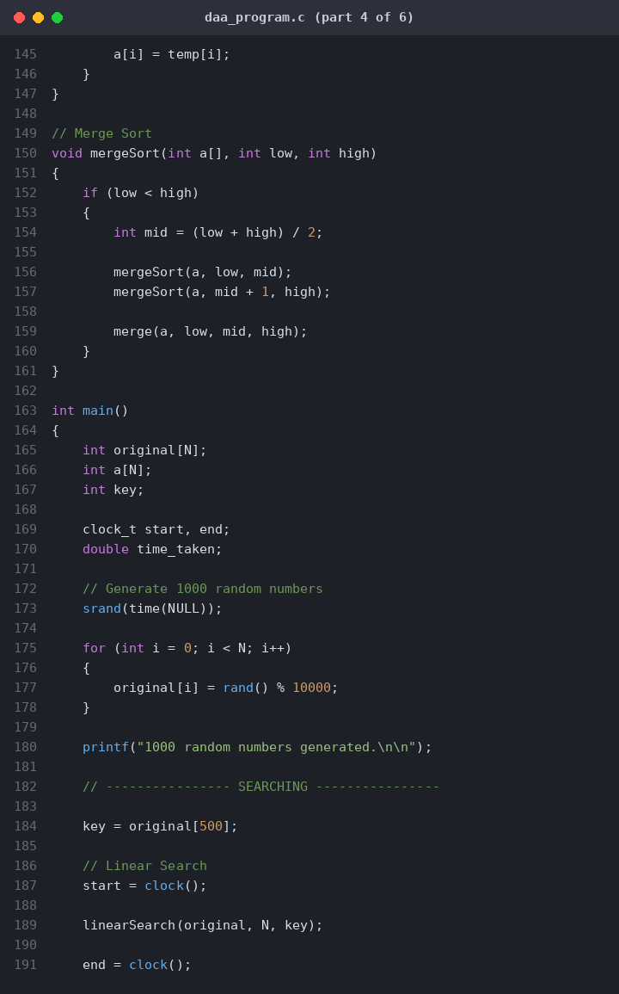
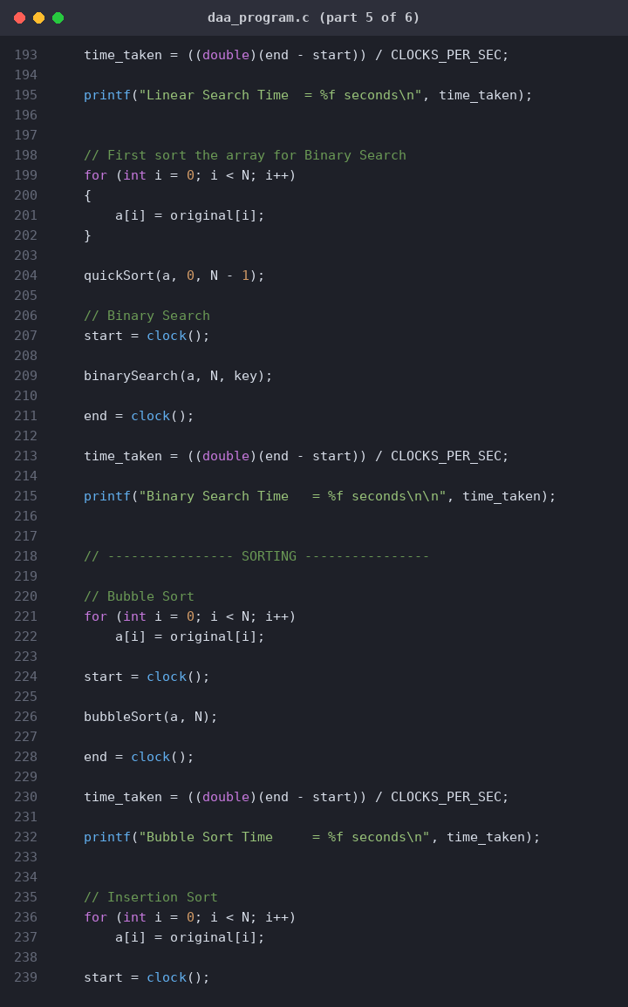
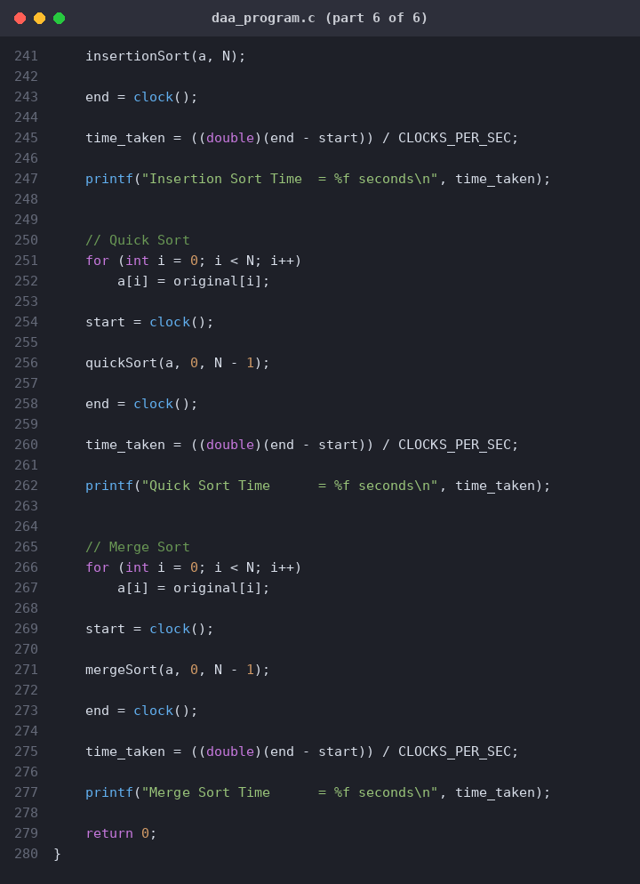

Code for graph:
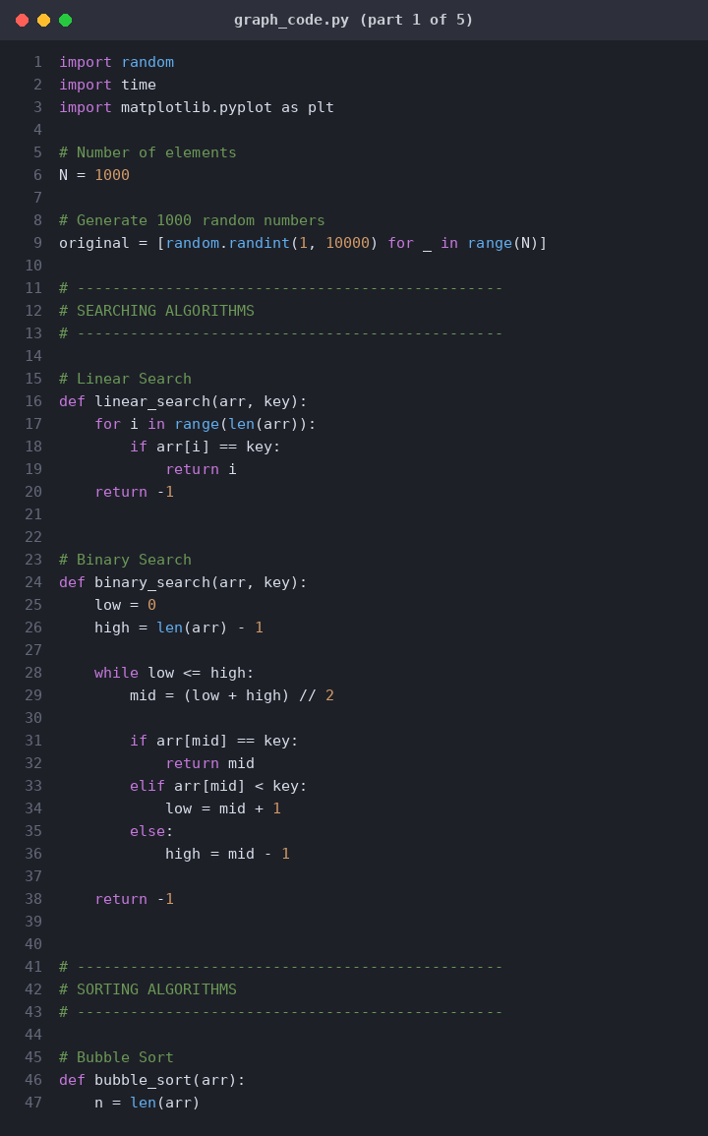
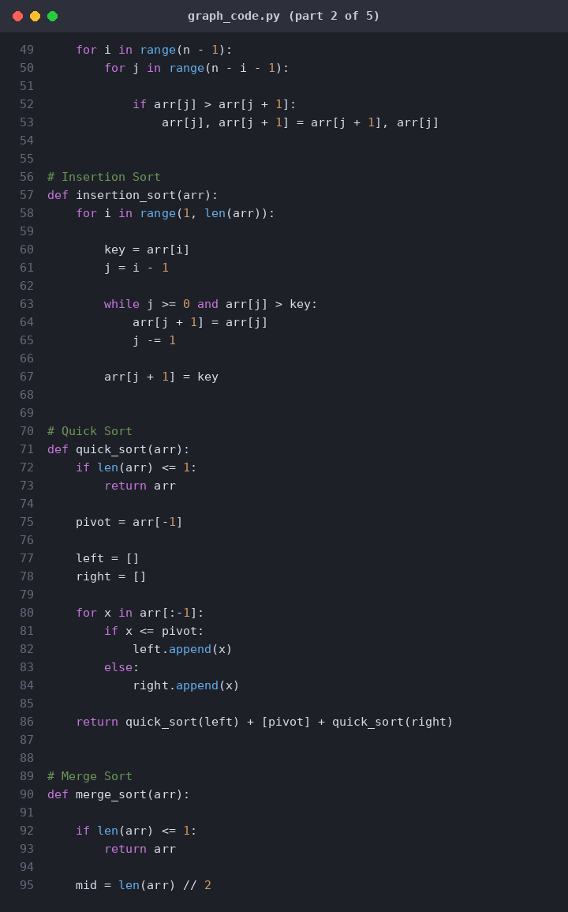
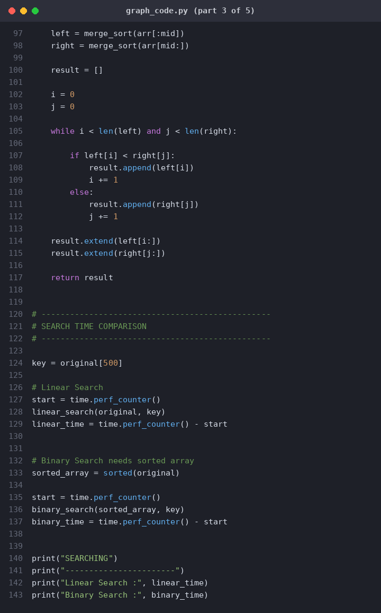
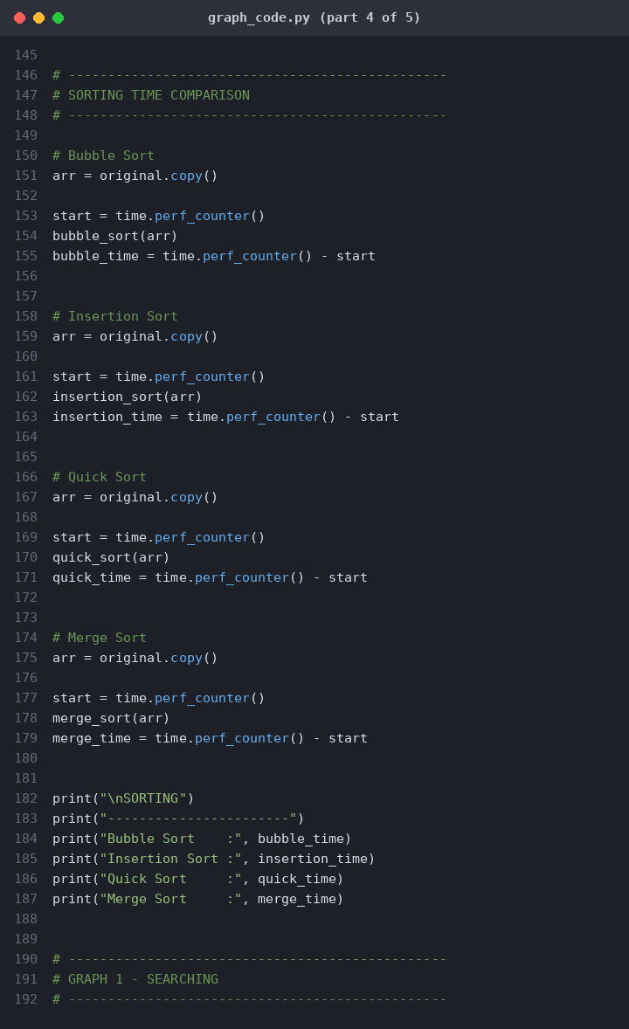
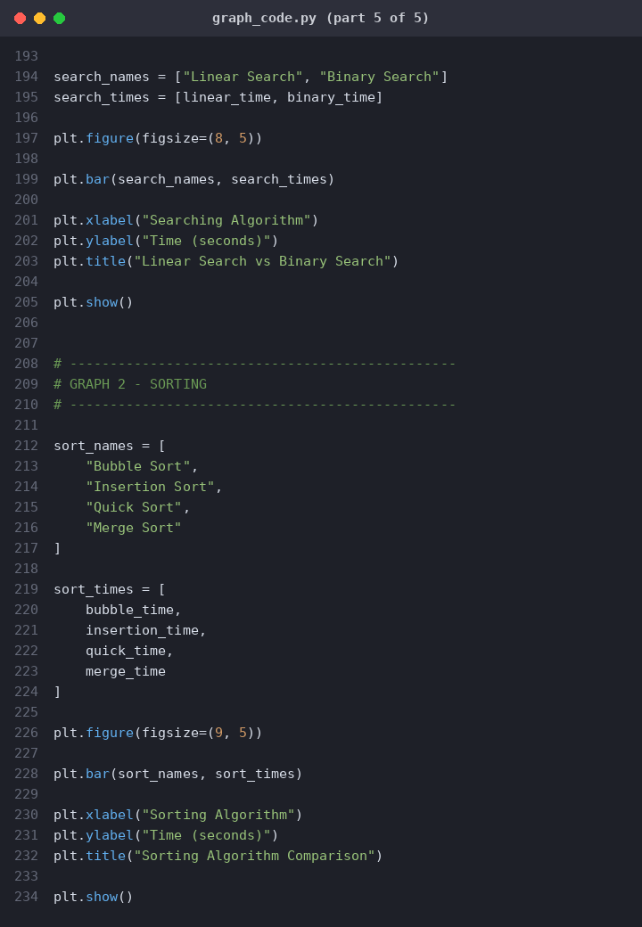

Output-
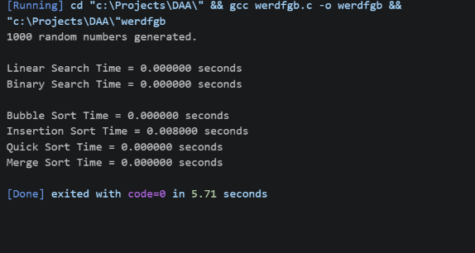
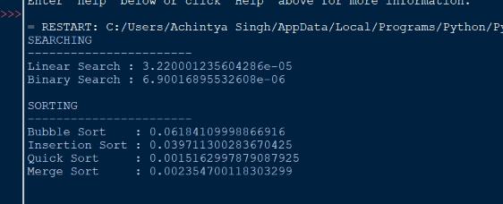

Graph of time comparison:
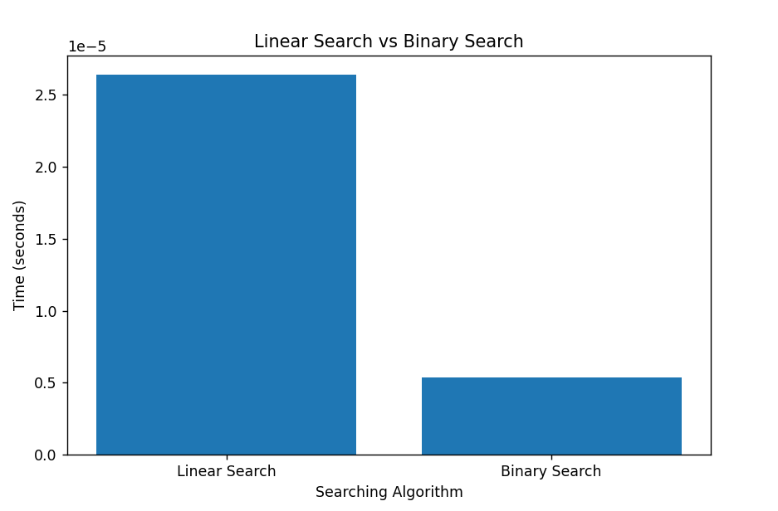
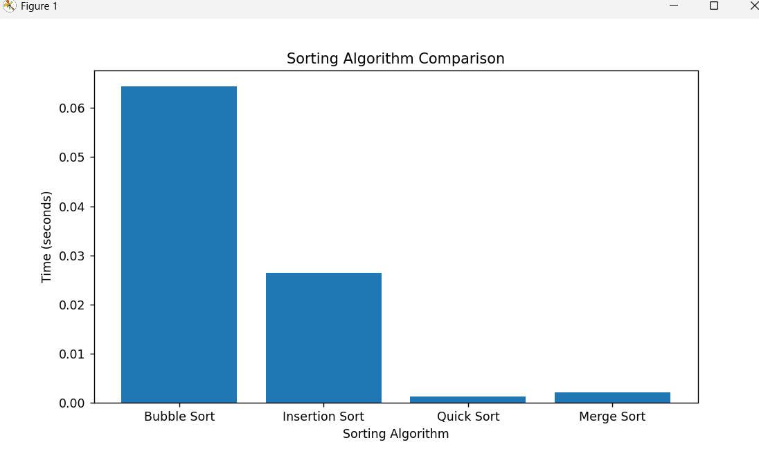

Understanding:
This experiment showed me how different searching and sorting algorithms compare in speed.
For searching, Linear Search checks items one by one, which takes longer. Binary Search splits a sorted list in half repeatedly, making it much faster.
For sorting, Bubble Sort and Insertion Sort take more time as data grows. Quick Sort and Merge Sort perform much better on larger datasets.
The Python script uses the time module to track execution speeds and matplotlib to graph the results. These visual charts clearly highlight why choosing the right algorithm matters when managing large amounts of data.

