Name: Anvesha Singh
Batch: B20
Sap ID: 590022234
Week: 02

Linear Search vs Binary Search

Linear Search 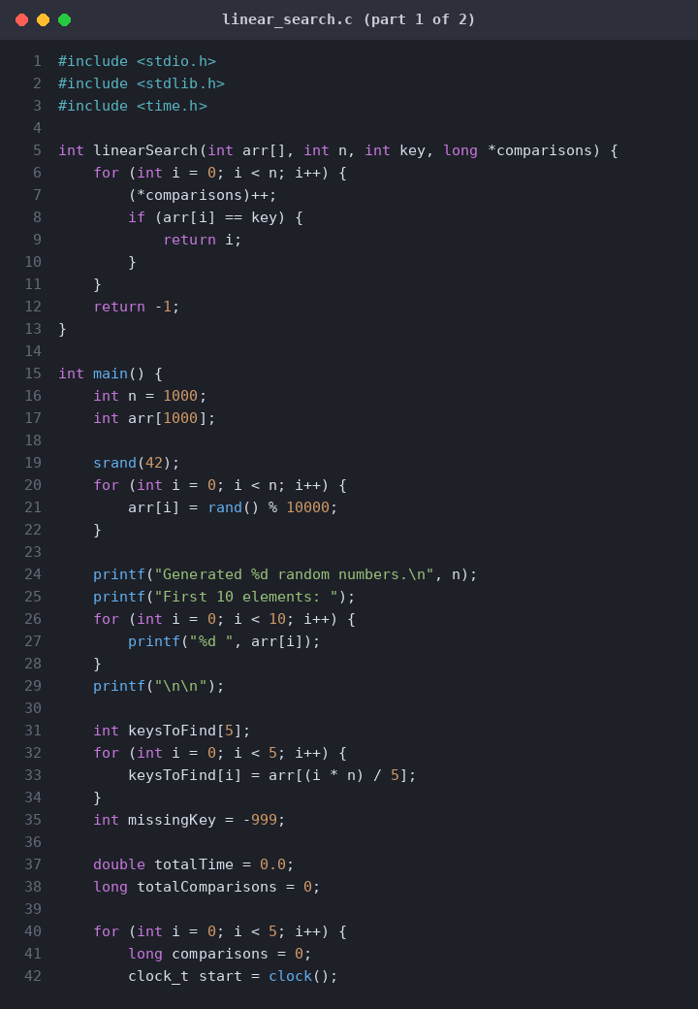

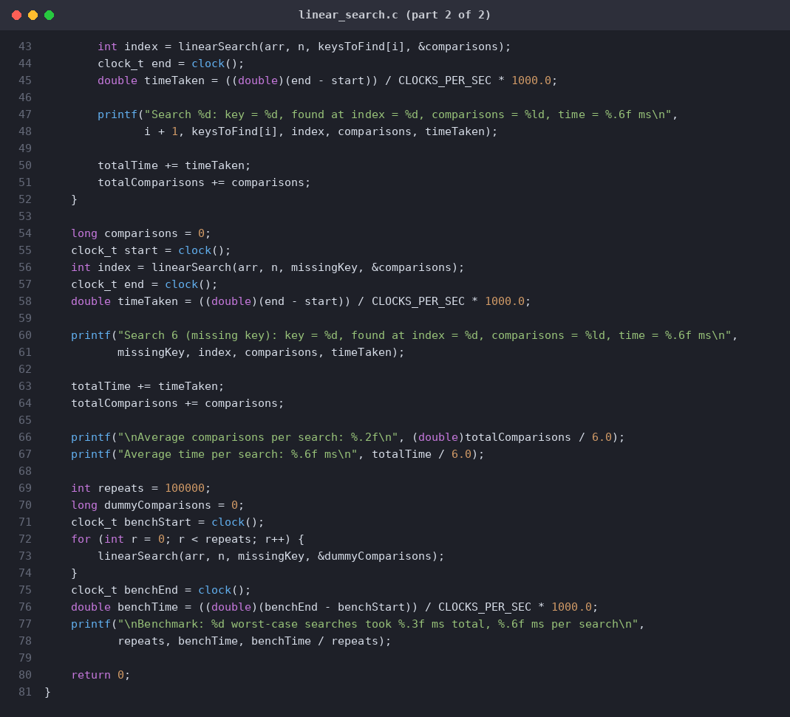
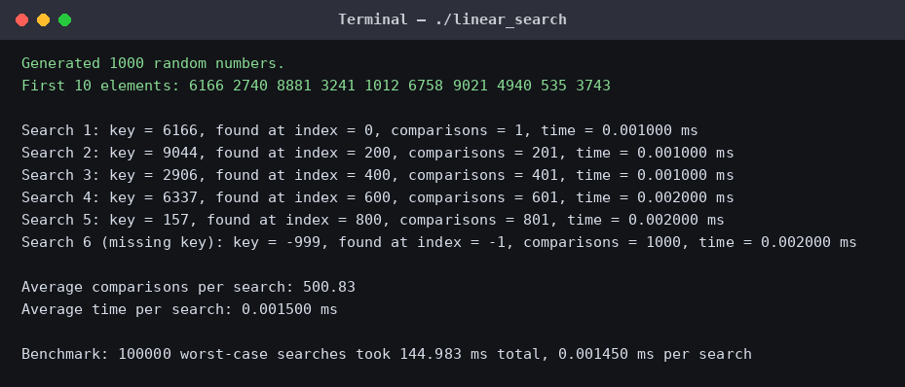

Binary Search 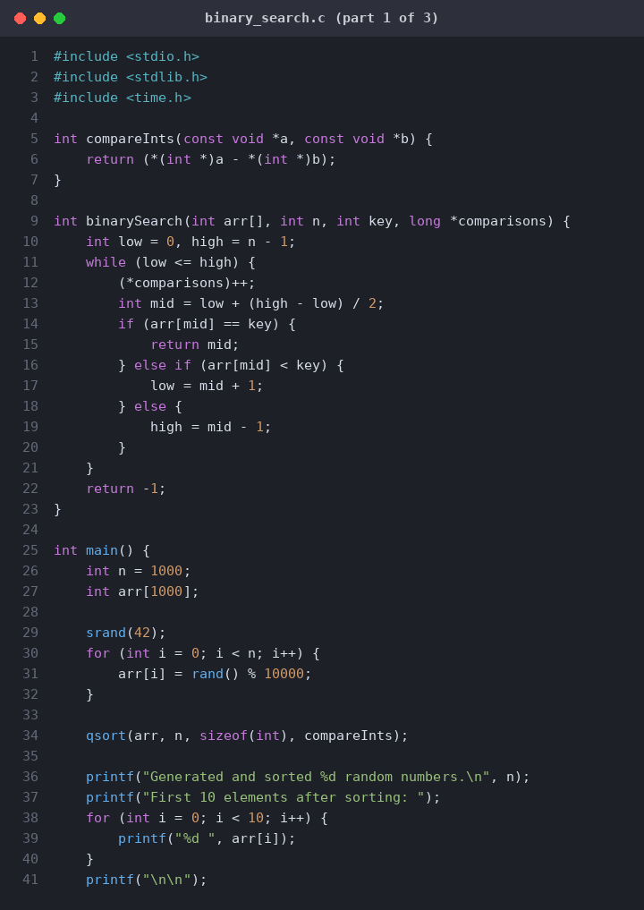

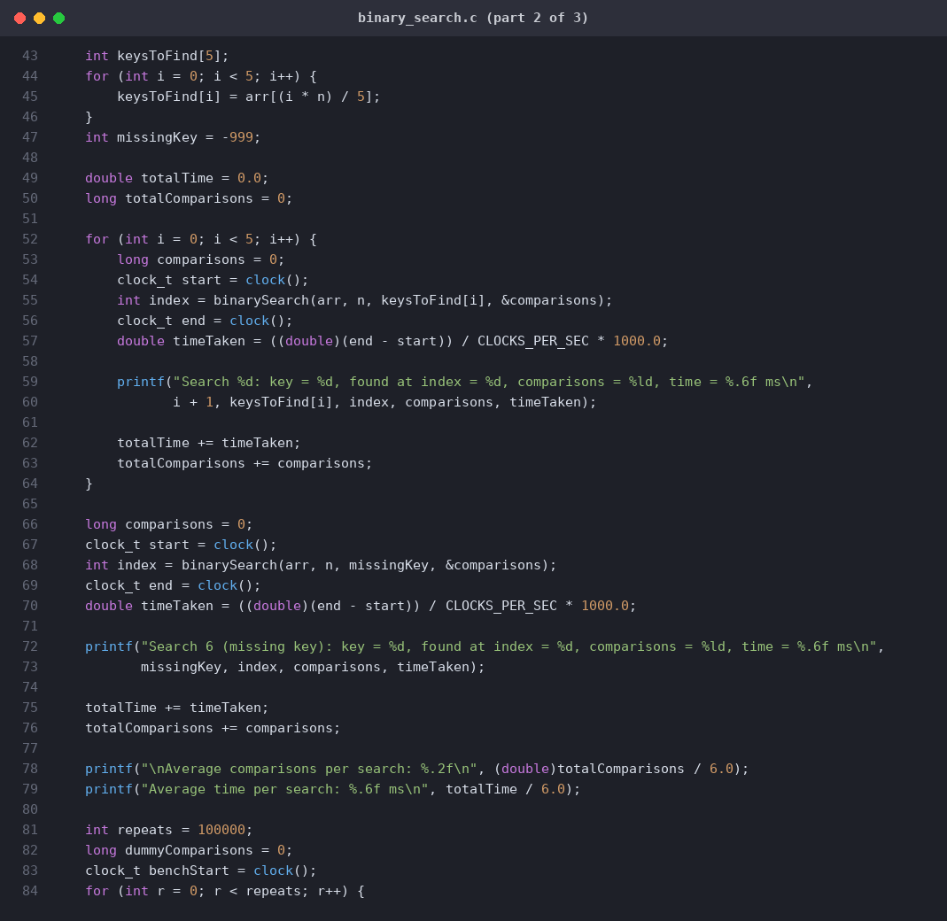
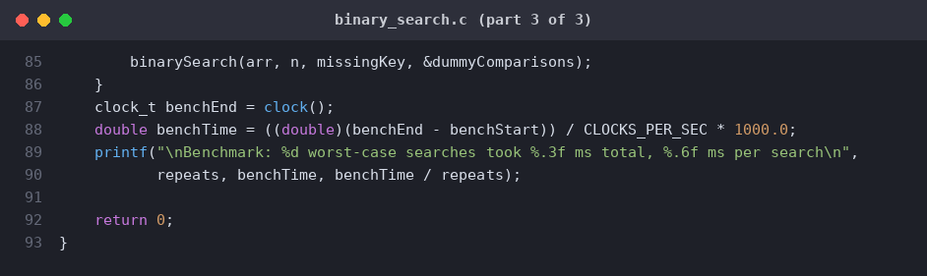

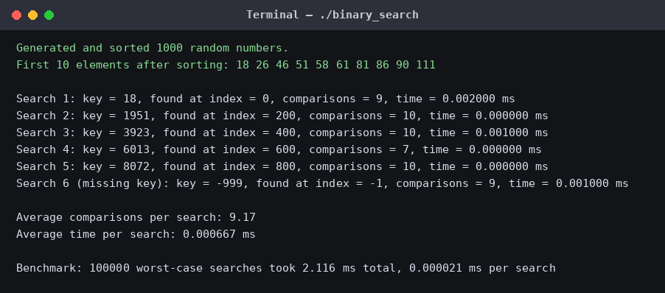Graphical Comparison
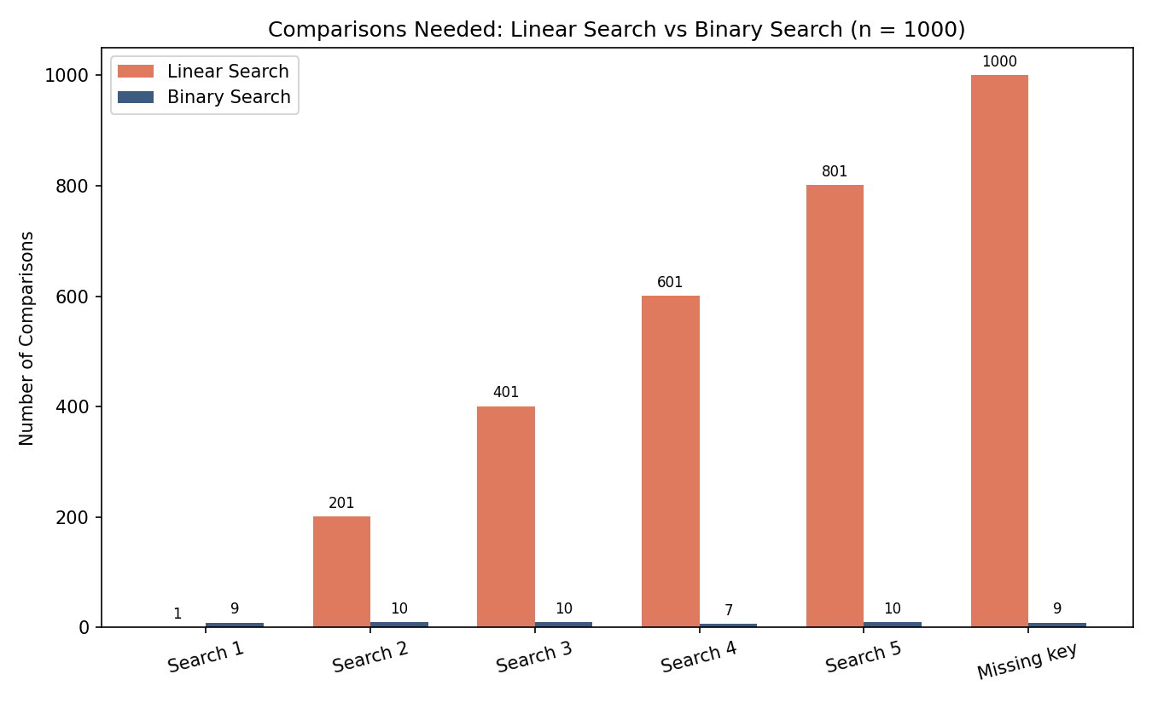
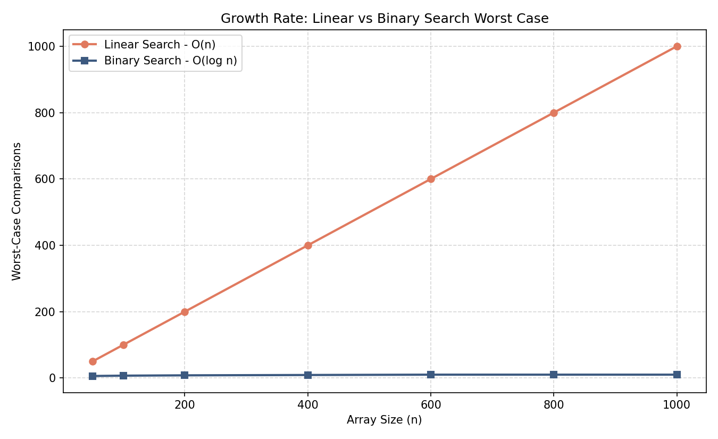
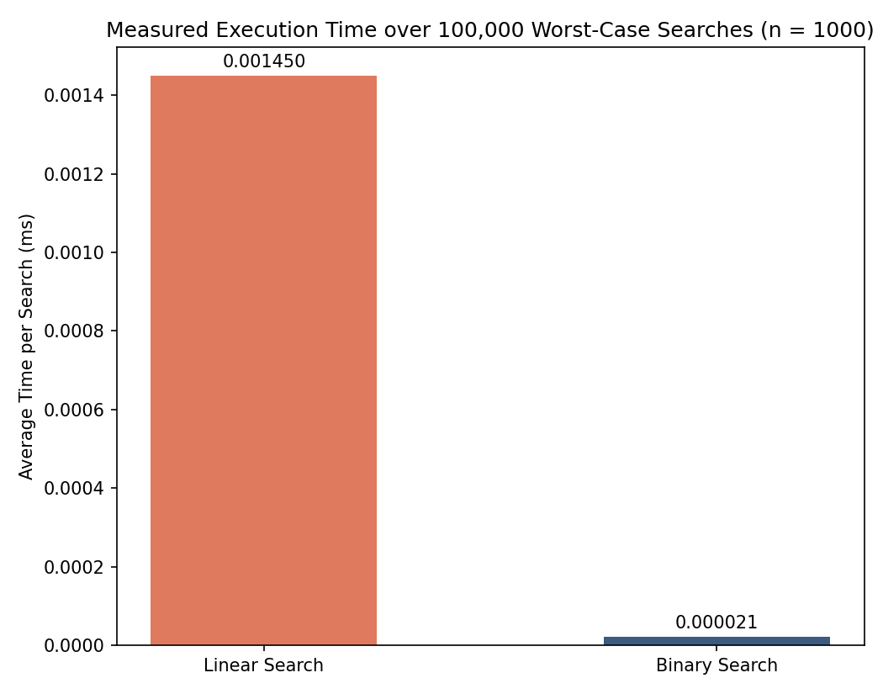

Understanding
Binary search is better for large datasets because it finds items much faster than linear search. However, the data must be sorted first, which takes extra time and effort. For small lists or a single search, linear search can be simpler and more efficient.

