

PRODUCT REQUIREMENTS DOCUMENT
Benefits Intelligence Suite
Dashboard & Prototype Specification
Screens, user flows, AI/ML simulation, data model and build plan
Companion to the NivoTime Live Company Project Report

Broker Workspace · Benchmarking Cockpit · Quote Desk · AI Simulation Lab · GTM Command Centre
Prepared by
Anvesha
PGDM (E-Business), Batch 2025–27
Prin. L.N. Welingkar Institute of Management Development & Research (WeSchool), Mumbai
Industry partner
NivoTime Private Limited, Mumbai
Version 1.0 · September 2026

Table of Contents

Document Control 4
1. Purpose, Scope and Objectives 4
1.1 Why this document exists 4
1.2 Prototype objectives 5
1.3 Scope 5
1.4 Guiding principles (from the report) 5
2. Users and Personas 6
3. Product Overview 7
3.1 Architecture 7
3.2 Information architecture 8
3.3 Screen inventory 8
4. Key User Journeys 9
4.1 Renewal preparation (the core journey) 9
4.2 Broker onboarding 10
4.3 Employee zero-login engagement 10
5. Functional Requirements by Screen 11
5.1 S1 — Portfolio Home (Broker Workspace) 11
5.2 S2 — Benefits Benchmarking Cockpit (Module 1) 12
5.3 S3 — Quote & Renewal Desk (Module 2) 13
5.4 S4 — AI Simulation Lab 15
5.5 S5 — Vendor & TPA Management (Module 3) 16
5.6 S6 — Employee zero-login engagement (Module 4) 17
5.7 S7 — Advisory Pack Builder (Module 5) 17
5.8 S8 — GTM Command Centre (internal NivoTime dashboard) 18
5.9 S9 — Business Case Simulator (internal) 20
5.10 ICP scoring logic (used in S8) 21
5.11 S10 — Admin: data ingestion and model monitoring 22
6. AI / ML Requirements 23
7. Prototype Simulation of the AI/ML Layer 24
7.1 Synthetic dataset 24
7.2 Results 24
7.3 Synthetic data and model pipeline 25
8. Data Requirements 26
8.1 Data model 26
8.2 Key data fields 26
8.3 Data sourcing plan (solving the “cold start”, report Section 7.5) 27
9. Non-Functional Requirements 27
10. Technology Recommendations for the Prototype 28
11. Dashboard and Chart Catalogue 28
12. Build Plan, Testing and Demo 30
12.1 Sprint plan 30
12.2 Acceptance tests 30
12.3 Broker demo script (15 minutes) 31
13. Success Metrics 31
14. Risks, Assumptions and Open Questions 31
14.1 Prototype risks 31
14.2 Assumptions 32
14.3 Open questions for NivoTime 32
15. Traceability Matrix 32
Appendix A: Synthetic Data Specification 34
Appendix B: Glossary 34

Document Control
Item | Detail
Document | Product Requirements Document (PRD): Benefits Intelligence Suite, dashboard and prototype
Product | NivoTime Benefits Intelligence Suite (proposed in the Live Company Project report)
Version | 1.0, September 2026
Prepared by | Anvesha, PGDM (E-Business) 2025–27, WeSchool
Status | Draft for prototype build and broker-pilot demo
Parent document | From Services Breadth to Benefits Intelligence, Live Company Project Report (Sections 7, 9–13, 15)
Data used | Public market data from the report; synthetic data for all screens and AI/ML simulations. No real client data.
How to read requirement IDs
Prefix | Meaning
FR-xx | Functional requirement (what the product must do)
AI-xx | AI / ML model requirement
DR-xx | Data requirement
NFR-xx | Non-functional requirement (security, speed, privacy, usability)
Priority | Must = needed for the pilot prototype; Should = strongly wanted; Could = nice to have; Won’t (now) = later phase

1. Purpose, Scope and Objectives

1.1 Why this document exists
- The Live Company Project report recommends that NivoTime build an AI-powered Benefits Intelligence Suite and sell it mainly through mid-size insurance brokers (report, Sections 7–9).
- This PRD turns that recommendation into a buildable specification: every screen, chart, user flow, data field and AI model the prototype needs, with acceptance criteria.
- It covers two things:
  - The customer-facing product used by brokers, HR teams, employees and vendors.
  - The internal NivoTime dashboards (go-to-market command centre and business-case simulator) that track whether the strategy is working.

1.2 Prototype objectives
Kept separate, as in the report: what the prototype must do, and how we will measure whether it works.
Product objectives
- Let a broker compare a client’s benefits with a peer group, filtered by co-pay, company size, industry, family cover and sum insured.
- Turn 4–6 insurer quotes (PDF or Excel) into one structured comparison with flagged differences.
- Simulate the premium effect of plan changes and forecast next year’s renewal loading.
- Track insurer, TPA and wellness vendor service levels in one place.
- Reach employees through nudges without requiring routine logins.
- Give NivoTime management one view of segments, pipeline and business-case scenarios.
Measurement and validation objectives
- Renewal pack preparation time falls by ≥50% in pilot (report KPI, Section 13.4).
- Quote field extraction accuracy is ≥95%; low-confidence fields go to human review.
- Renewal forecast error is within ±5 percentage points on back-tested renewals.
- ≥70% of broker users are active weekly by day 60; ≥60% employee activation.
- ≥50% of pilots convert to paid contracts (report Appendix C).

1.3 Scope
In scope (prototype) | Out of scope (later phases)
Broker Workspace: portfolio, cockpit, quote desk, simulation lab, advisory packs | Native mobile apps (responsive web only)
HR/CFO views (read-only benchmark, forecast, engagement) | Live insurer API integrations (file upload used instead)
Employee zero-login nudge flow (demo channel) | Bima Sugam integration (roadmap item, report Section 13.2)
Vendor/TPA SLA tracking | Payments, billing and invoicing
Internal GTM Command Centre and business simulator | GCC / ZOYAME localisation
Admin: data ingestion, consent tags, model monitoring | Production-grade ISO 27001 controls (designed for, not certified)

1.4 Guiding principles (from the report)
- AI for work, not as a label: every AI feature must replace a measurable manual task.
- Broker-first, white-label: the broker’s brand faces the client; NivoTime stays in the background.
- Human in the loop: no AI output reaches a client without broker review.
- Privacy by design: anonymised benchmarks, minimum peer set of 10 companies, DPDP-ready consent tags.
- Configure, don’t customise: industry needs are met by templates and settings, not separate code.

2. Users and Personas
Persona | Role | Main goal | Top pain today | Key screens
Rohit, Broker MD | Economic buyer at a mid-size broker | Look as sharp as tech-first brokers; keep clients | Losing clients to Plum/Pazcare-type brokers | Portfolio home, GTM-style reports
Meera, Account manager | Daily user at the broker | Renewal pack in hours, not weeks | Re-typing quotes; no peer data | Cockpit, Quote Desk, Simulation Lab
Anita, CHRO / Total Rewards | Employer decision maker | Prove benefits are competitive; control premium | Renewal surprises; spreadsheets | HR benchmark snapshot, forecast
Vikram, CFO | Employer economic influencer | Predictable benefits cost | No forward view of renewal | Forecast, scenario summary
Priya, Employee | End user | Understand and use benefits easily | Forgets benefits; portal fatigue | Zero-login nudges, deep links
TPA coordinator | Vendor user | Meet SLAs, close tickets | Scattered requests | Vendor portal
NivoTime leadership | Internal | Know if the strategy is working | No pipeline or segment view | GTM Command Centre, business simulator
NivoTime admin / analyst | Internal | Clean data, healthy models | Messy files; no monitoring | Admin & model monitoring
Roles and permissions (summary)
Capability | Broker MD | Account manager | HR / CFO | Employee | Vendor | NivoTime admin
View client benchmarks | All clients | Assigned clients | Own company | — | — | Anonymised only
Upload quotes and data | — | Yes | Census only | — | SLA data | Yes
Run simulations | Yes | Yes | View shared scenarios | — | — | Yes
Approve client-facing pack | Yes | Draft only | Approve decision | — | — | —
See individual employee data | No | Limited (renewal tasks) | Own employees | Own record | Claim status only | No (anonymised)
GTM and business dashboards | — | — | — | — | — | Yes

3. Product Overview

3.1 Architecture
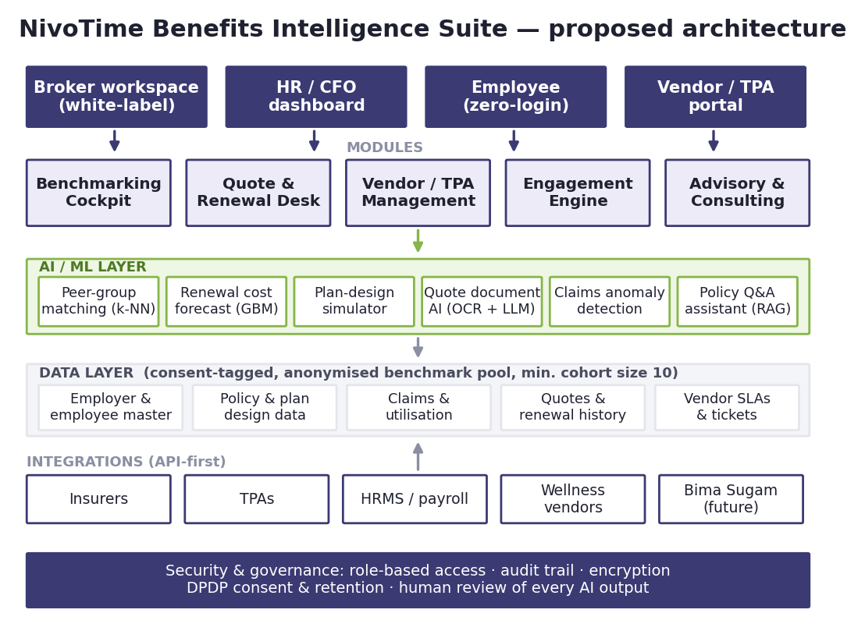
Proposed architecture of the Benefits Intelligence Suite (from the report)

3.2 Information architecture
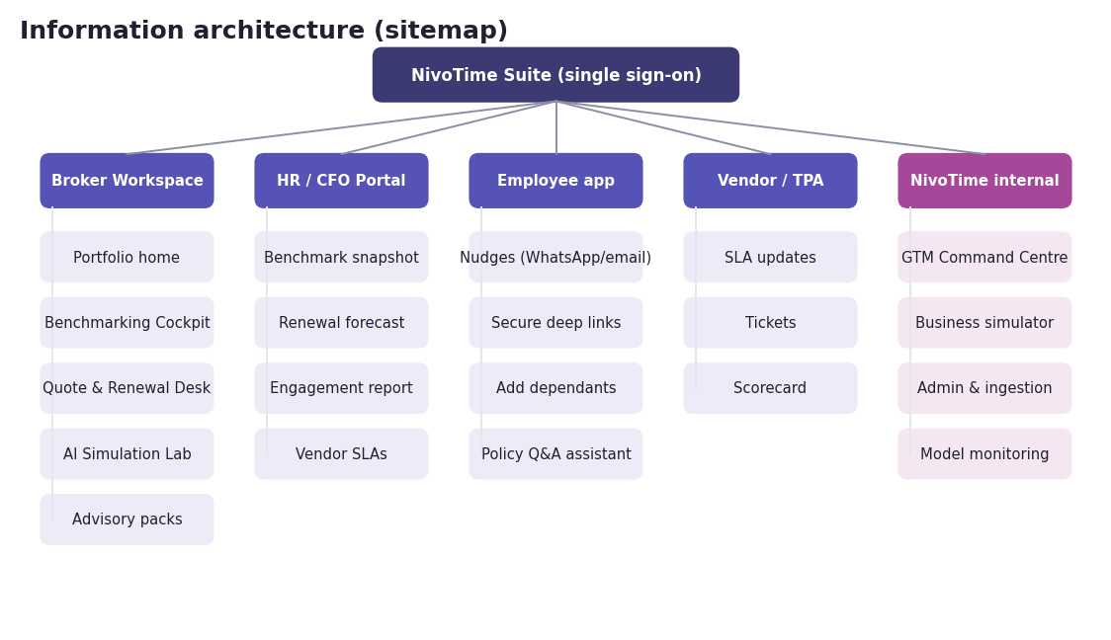
Sitemap of the prototype

3.3 Screen inventory
# | Screen | Users | Module | Priority
S1 | Portfolio Home | Broker MD, account manager | Broker Workspace | Must
S2 | Benefits Benchmarking Cockpit | Broker, HR, CFO | M1 | Must
S3 | Quote & Renewal Desk | Account manager | M2 | Must
S4 | AI Simulation Lab | Broker, HR | M1/M2 + AI layer | Should
S5 | Vendor & TPA Management | Broker, HR, vendor | M3 | Should
S6 | Employee zero-login flow | Employee | M4 | Should
S7 | Advisory pack builder | Broker | M5 | Should
S8 | GTM Command Centre | NivoTime leadership | Internal | Could
S9 | Business Case Simulator | NivoTime leadership | Internal | Could
S10 | Admin: ingestion and model monitoring | NivoTime admin | Platform | Must

4. Key User Journeys

4.1 Renewal preparation (the core journey)
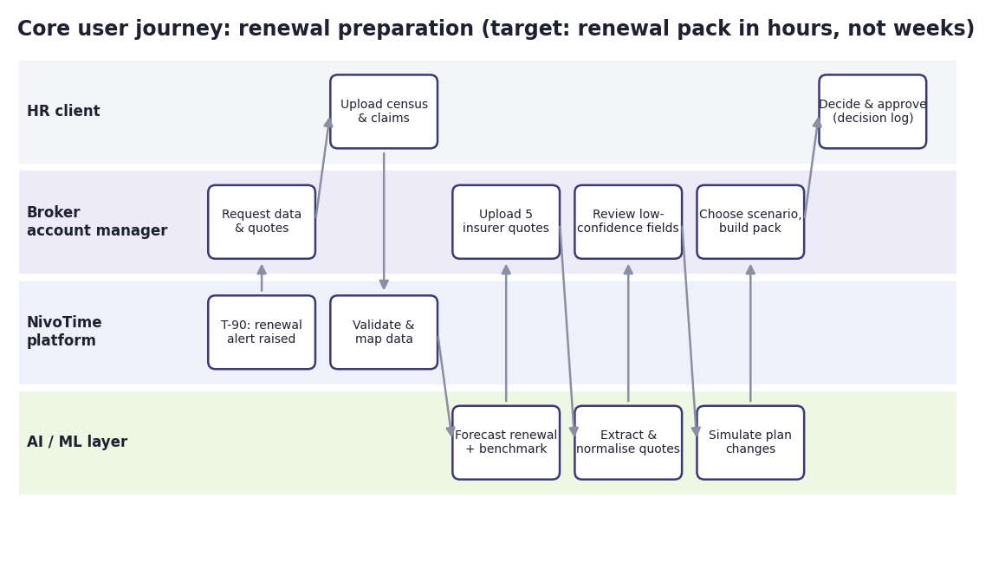
Renewal preparation swimlane
Step | Actor | What happens | System response | Target time
1 | Platform | Renewal date is 90 days away | Alert on Portfolio Home; task list created | Automatic
2 | Account manager | Requests census, claims and quotes | Secure upload links sent to HR and insurers | 5 min
3 | HR client | Uploads census and claims | Validation and column mapping; errors shown | 10 min
4 | AI layer | Forecast and benchmark | Cockpit refreshed; renewal loading forecast | < 1 min
5 | Account manager | Uploads 5 insurer quotes | Quote AI extracts terms into the standard schema | < 60 s per quote
6 | Account manager | Reviews low-confidence fields only | Comparison grid with flags | 15 min
7 | Account manager | Runs 2–3 plan scenarios | Premium impact and trade-offs | 10 min
8 | Broker MD / HR | Approves recommendation | Pack generated; decision logged | 15 min
Target: a full renewal pack in under 2 hours of working time, against a manual baseline of about 30 hours per account (report assumption A13).

4.2 Broker onboarding
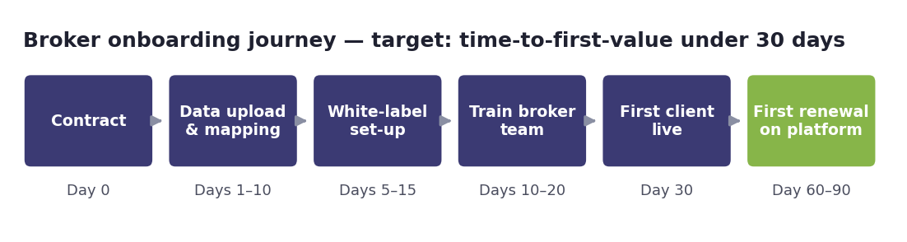
Broker onboarding journey (from the report)

4.3 Employee zero-login engagement
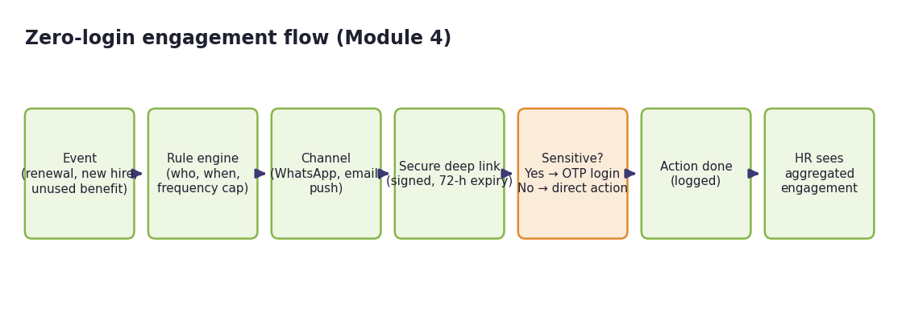
Zero-login engagement flow

5. Functional Requirements by Screen

5.1 S1 — Portfolio Home (Broker Workspace)
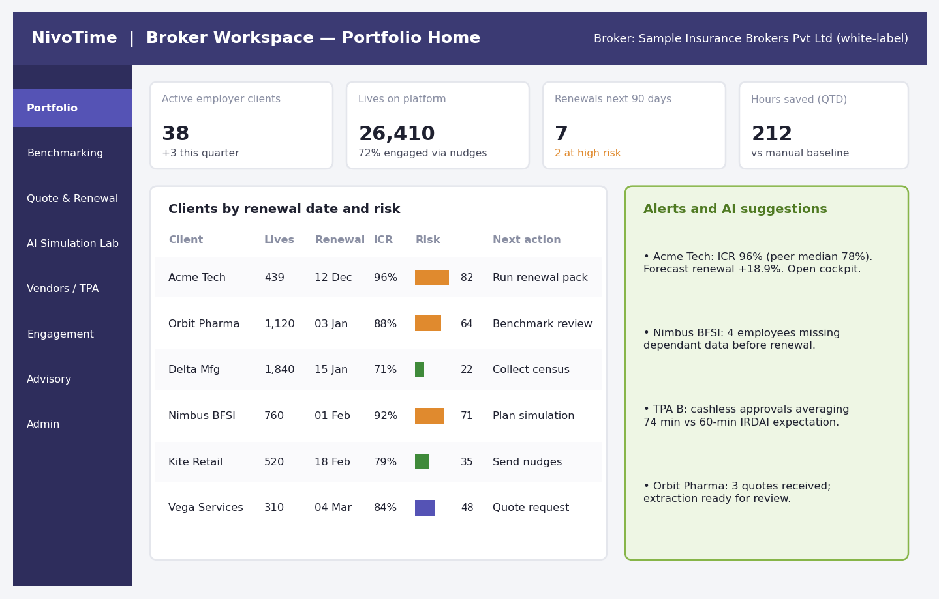
S1 Portfolio Home (synthetic data)
Purpose: give the broker one view of all employer clients, upcoming renewals, risk and next actions.
ID | Requirement | Priority | Acceptance criteria
FR-01 | Show KPI tiles: active clients, lives on platform, renewals in next 90 days, hours saved this quarter | Must | Tiles refresh on page load; values match the underlying tables
FR-02 | List clients with lives, renewal date, claims ratio (ICR), renewal risk score (0–100) and next action | Must | Sortable by every column; default sort by renewal date
FR-03 | Colour the risk score by band (≥60 high, 40–59 medium, <40 low) and show the number next to the bar | Must | Band is never shown by colour alone
FR-04 | Alerts panel: AI suggestions and SLA breaches, each linking to the relevant screen | Should | Clicking an alert opens the filtered screen
FR-05 | Apply the broker’s white-label theme (logo, colours, domain) | Must | No NivoTime branding visible to the broker’s clients
FR-06 | Create a renewal task list automatically 90 days before each renewal | Must | Tasks appear on day T-90 with owners
Hours saved (FR-01) = Σ (baseline hours per task − actual logged hours). The baseline is set during pilot onboarding (Appendix C of the report).

5.2 S2 — Benefits Benchmarking Cockpit (Module 1)
This is the dashboard shown in the report (Section 7.4), rebuilt here on the synthetic dataset so every number comes from the simulation in Section 7.
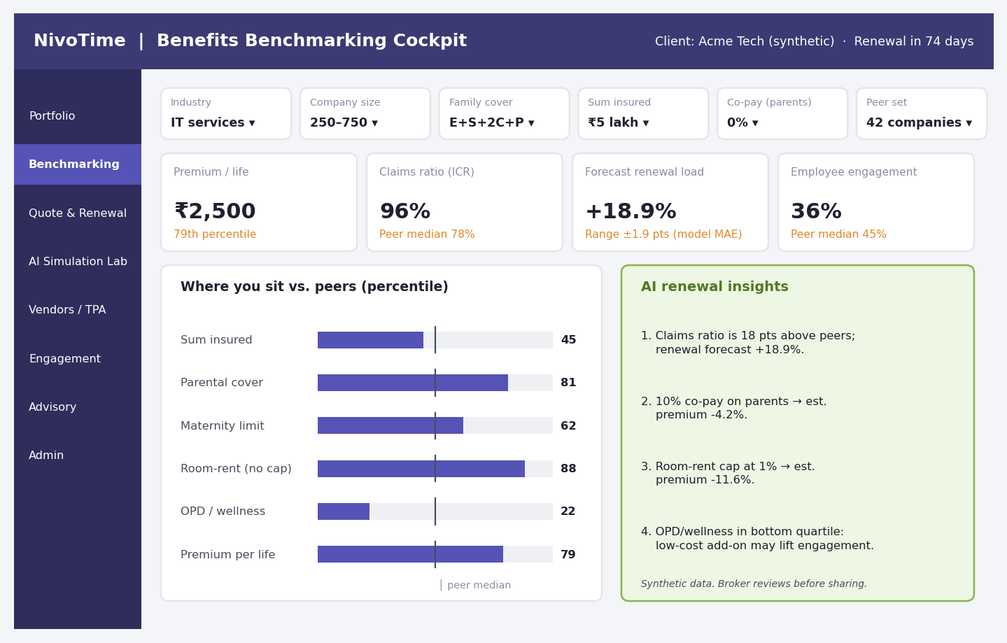
S2 Benefits Benchmarking Cockpit (synthetic data)
Purpose: answer the HR head’s question, “Are we paying more than similar companies, and what should we change before renewal?”
Filters (top bar)
Filter | Values | Default
Industry | IT services, manufacturing, BFSI, pharma, retail, professional services | Client’s own industry
Company size | 250–750, 750–2,000, 2,000+ | Client’s band
Family cover | Employee only; E + spouse + 2 children; E+S+2C + parents | Client’s definition
Sum insured | ₹3 lakh, ₹5 lakh, ₹10 lakh, custom | Client’s value
Co-pay (parents) | 0%, 10%, 20% | Client’s value
Peer set | Auto (k-nearest neighbours) or manual | Auto, shown as “n companies”
KPI tiles
Tile | Definition | Comparison shown
Premium per life | Annual premium ÷ covered lives | Percentile within peer set
Claims ratio (ICR) | Incurred claims ÷ earned premium, last 12 months | Peer median
Forecast renewal load | Output of the renewal forecast model (AI-02) | ± model error range
Employee engagement | Employees who acted on at least one nudge or login in 90 days ÷ eligible employees | Peer median
Requirements
ID | Requirement | Priority | Acceptance criteria
FR-10 | Filter bar with the six filters above; changes refresh all tiles and charts | Must | Refresh in < 3 seconds for a peer pool of 5,000 companies
FR-11 | Peer set must contain at least 10 companies; otherwise the filter is widened automatically and the user is told | Must | No chart ever shows a peer set < 10
FR-12 | Percentile chart for six plan features (sum insured, parental cover, maternity, room-rent, OPD/wellness, premium per life) with a peer-median marker | Must | Numbers printed on bars; median marker labelled
FR-13 | AI renewal insights panel: 3–5 plain-language insights, each with the number behind it and a link to the Simulation Lab | Must | Every insight cites its data; broker can hide any insight
FR-14 | “Export benchmark pack” to PDF and PowerPoint in the broker’s branding | Should | Export in < 20 seconds
FR-15 | Data freshness label on every tile (for example “claims to 31 Aug”) | Must | Label visible on screen and in exports

5.3 S3 — Quote & Renewal Desk (Module 2)
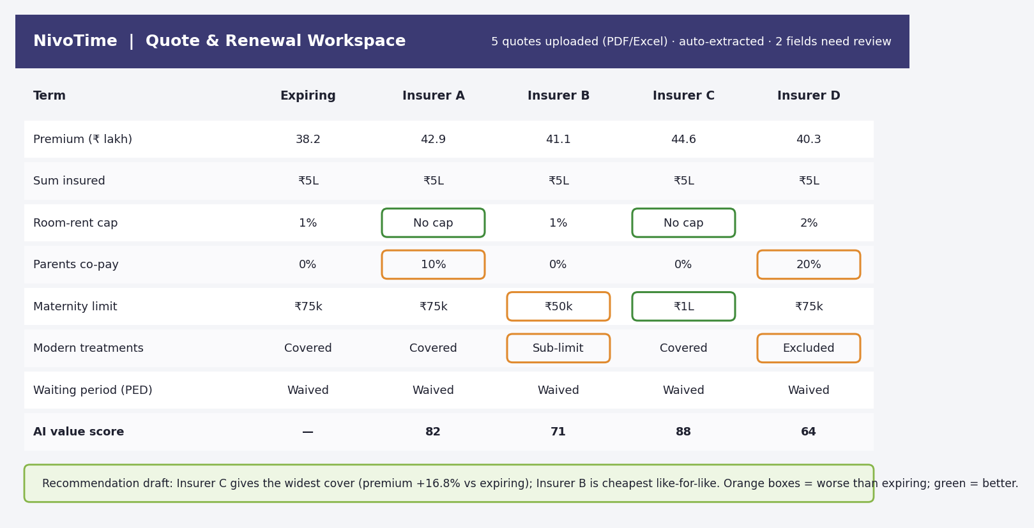
S3 Quote & Renewal Desk (illustrative data, from the report)
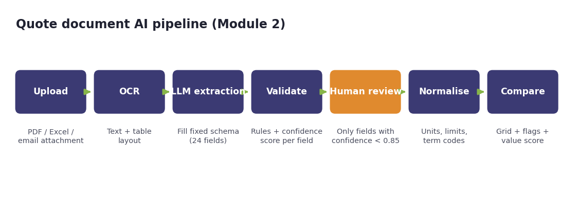
Quote document AI pipeline
Standard quote schema (24 fields, grouped)
Group | Fields
Commercials | Insurer, TPA, premium, GST, policy period, payment terms
Cover | Sum insured, family definition, floater/individual, corporate buffer
Limits | Room-rent cap, ICU cap, maternity limit, new-born cover, disease-wise sub-limits
Cost sharing | Co-pay (employees), co-pay (parents), deductible
Waiting periods | Pre-existing disease, 30-day, specific illness, maternity
Other | Modern treatments, OPD, wellness add-ons, exclusions list

ID | Requirement | Priority | Acceptance criteria
FR-20 | Upload quotes as PDF, Excel or email attachment (up to 10 per renewal) | Must | Files up to 20 MB accepted; virus-scanned
FR-21 | Extract all 24 fields with a confidence score per field (AI-04) | Must | Field accuracy ≥95% on the labelled test set
FR-22 | Send only fields with confidence < 0.85 to human review, highlighted in the grid | Must | Reviewer sees the source snippet next to the field
FR-23 | Comparison grid vs the expiring policy; orange box = worse than expiring, green = better | Must | Flags also shown as text labels, not colour alone
FR-24 | “AI value score” (0–100) per quote, combining price and coverage, with the formula visible on hover | Should | Weights editable by the broker
FR-25 | Renewal calendar and decision log (who chose what, when, why) | Must | Log cannot be edited after approval
FR-26 | Approval workflow: account manager drafts → broker MD approves → HR decides | Must | Status visible to all three roles
Regulatory guardrail (report Section 7.7): the comparison is a tool for the licensed broker. It is never shown publicly to prospects, so NivoTime does not act as a web aggregator.

5.4 S4 — AI Simulation Lab
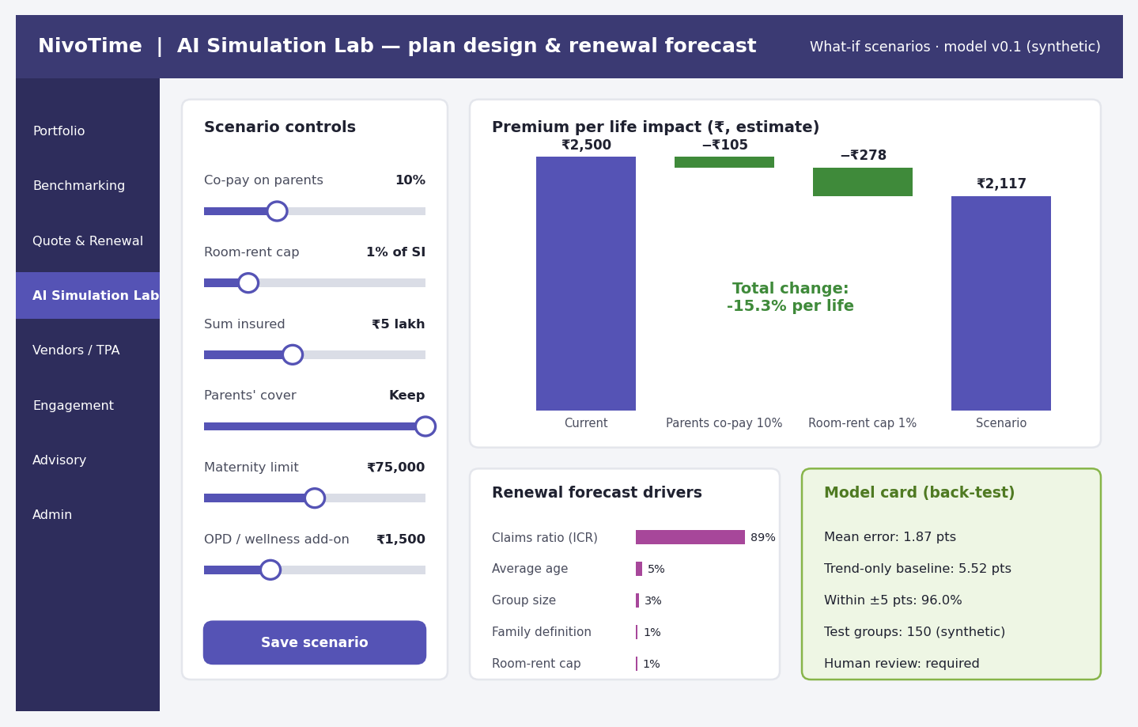
S4 AI Simulation Lab (synthetic data; numbers from the simulation in Section 7)
Purpose: let the broker and HR test plan changes and see the likely premium impact and renewal forecast before talking to insurers.
ID | Requirement | Priority | Acceptance criteria
FR-30 | Sliders or dropdowns for: parents’ co-pay, room-rent cap, sum insured, parents’ cover, maternity limit, OPD/wellness add-on | Should | Each control shows current and new value
FR-31 | Waterfall chart: current premium per life → effect of each change → scenario premium | Should | Steps add up exactly to the scenario total
FR-32 | Renewal forecast drivers chart (share of forecast explained by each factor) | Should | Uses model explanations (AI-02)
FR-33 | Model card: mean error, baseline error, share within ±5 pts, test size, “human review required” | Must (if S4 built) | Values read from the latest model run, never typed in
FR-34 | Save up to 5 scenarios per client and compare them side by side | Should | Saved scenarios appear in the advisory pack
FR-35 | Show employees affected by each change (for example, number of parents affected by a co-pay) | Could | Count shown next to each change

5.5 S5 — Vendor & TPA Management (Module 3)
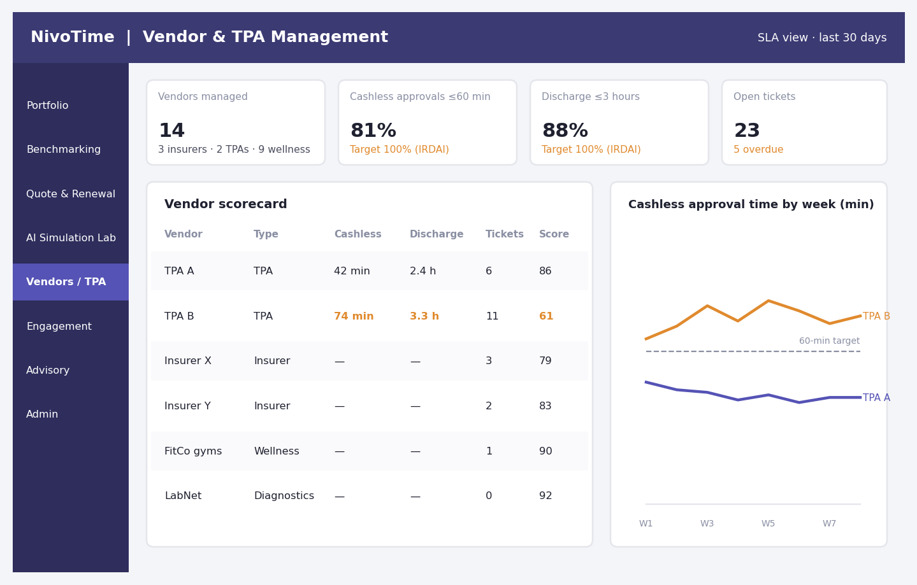
S5 Vendor & TPA Management (synthetic data)
ID | Requirement | Priority | Acceptance criteria
FR-40 | Vendor register: insurers, TPAs, wellness and diagnostic vendors, contract dates and contacts | Should | Import from Excel supported
FR-41 | Track cashless approval time against the 60-minute IRDAI expectation and discharge time against 3 hours | Should | Breaches flagged within 24 hours of data upload
FR-42 | Ticket tracking (open, overdue, resolved) with owner and due date | Should | Overdue tickets shown on Portfolio Home alerts
FR-43 | Vendor scorecard (0–100): SLA compliance 50%, ticket closure 30%, employee feedback 20% | Could | Weights editable; formula shown
FR-44 | Weekly trend chart of approval times per TPA with the target line | Should | Direct labels on each line

5.6 S6 — Employee zero-login engagement (Module 4)
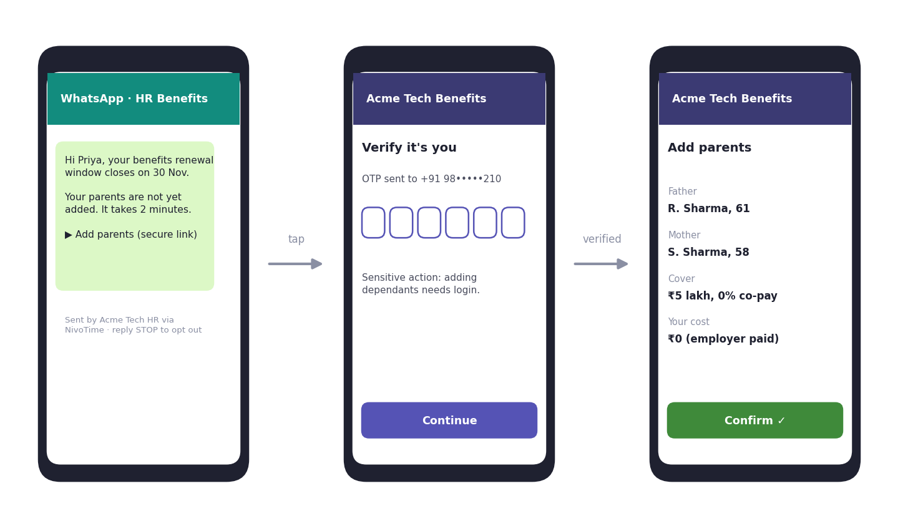
S6 Employee zero-login flow (synthetic example)
ID | Requirement | Priority | Acceptance criteria
FR-50 | Event-driven nudges: welcome, add dependants, policy card ready, renewal window, unused benefits, claim status | Should | Each event type can be switched on/off per employer
FR-51 | Channels: email and WhatsApp (via an approved business provider); push later | Should | Opt-out honoured within one message (“STOP”)
FR-52 | Secure deep links: signed, single-use, expire in 72 hours | Must (if S6 built) | Expired link asks the user to log in
FR-53 | OTP login required for sensitive actions (adding dependants, claims detail) | Must | No health data visible without authentication
FR-54 | Frequency cap: max 2 nudges per employee per week | Should | Cap enforced across all event types
FR-55 | HR sees only aggregated engagement (activation, action rate, completion) | Must | No individual health data in HR reports
FR-56 | Multilingual templates (English, Hindi, plus regional languages later) | Could | Template language chosen per employee

5.7 S7 — Advisory Pack Builder (Module 5)
ID | Requirement | Priority | Acceptance criteria
FR-60 | Assemble a renewal pack: benchmark summary, quote comparison, chosen scenario, forecast and recommendation | Should | One click from an approved scenario
FR-61 | Broker-branded PDF and PowerPoint output | Should | Uses the white-label theme
FR-62 | AI-drafted narrative, editable, with every number linked to its source | Should | Draft marked “AI draft — review before sending” until approved
FR-63 | Record advisory engagements for billing (₹75,000 pack, report Section 9.5) | Could | Engagement count visible to NivoTime admin

5.8 S8 — GTM Command Centre (internal NivoTime dashboard)
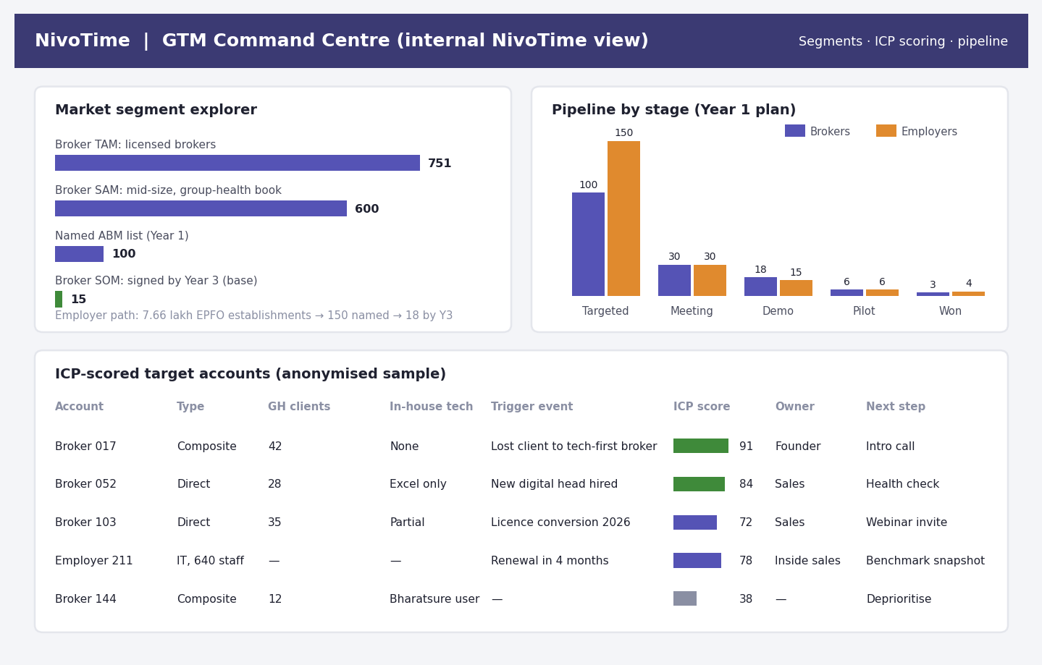
S8 GTM Command Centre (figures from the report; account names anonymised)
Purpose: show NivoTime leadership whether the go-to-market plan in the report is on track.
ID | Requirement | Priority | Acceptance criteria
FR-70 | Segment explorer: broker TAM (751), SAM (~600), named ABM list (100), SOM target (15 by Year 3); employer path 7.66 lakh → 150 → 18 | Could | Numbers editable; source note shown
FR-71 | Pipeline by stage for brokers and employers (targeted, meeting, demo, pilot, won) | Could | Pulled from the CRM (HubSpot or Zoho) nightly
FR-72 | ICP-scored account list: type, group-health clients, in-house tech, trigger event, score, owner, next step | Could | Score formula visible (Section 5.10)
FR-73 | Funnel conversion rates vs plan (report assumption A14) | Could | Variance highlighted when > 20% off plan
FR-74 | Lost-deal reasons summary | Could | Mandatory field when a deal is marked lost
Reference charts carried over from the report:
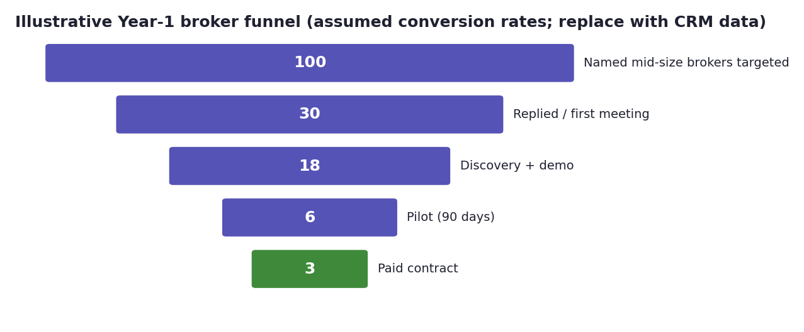
Illustrative Year-1 broker funnel (report Section 10.4)
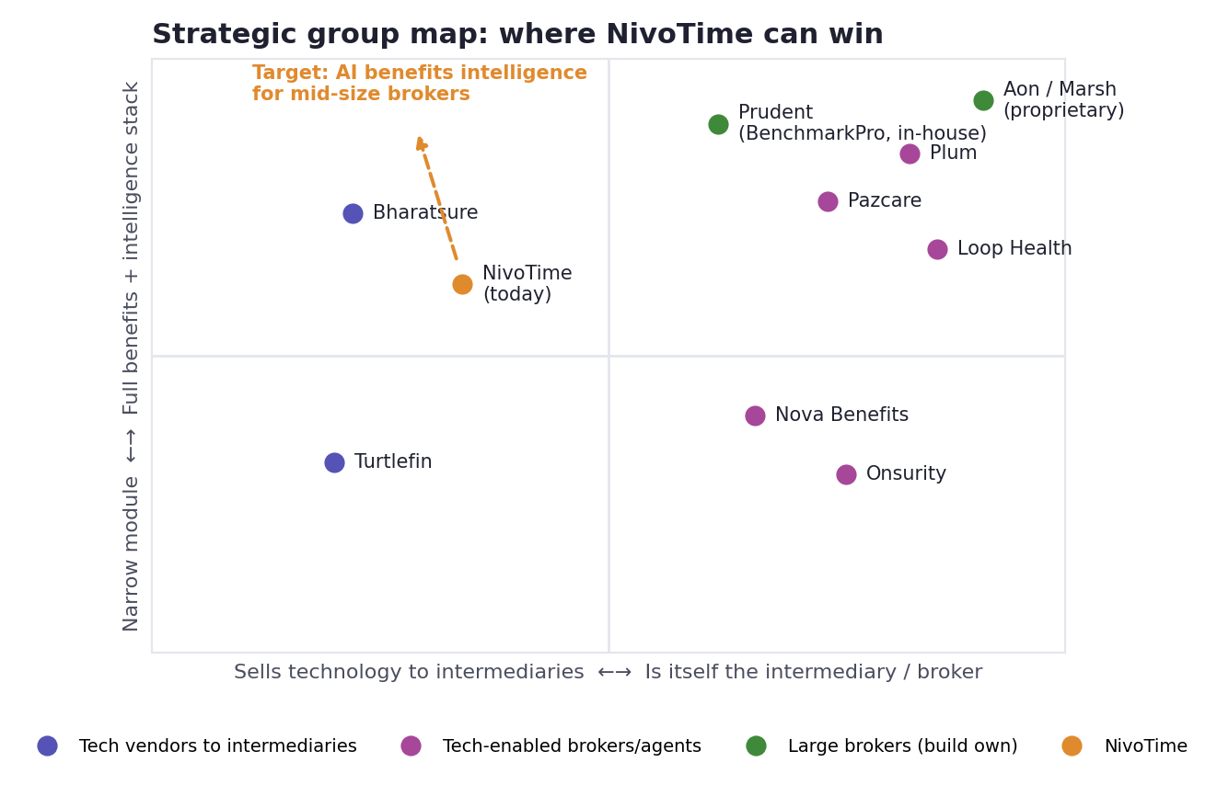
Strategic group map (report Section 5.3)

5.9 S9 — Business Case Simulator (internal)
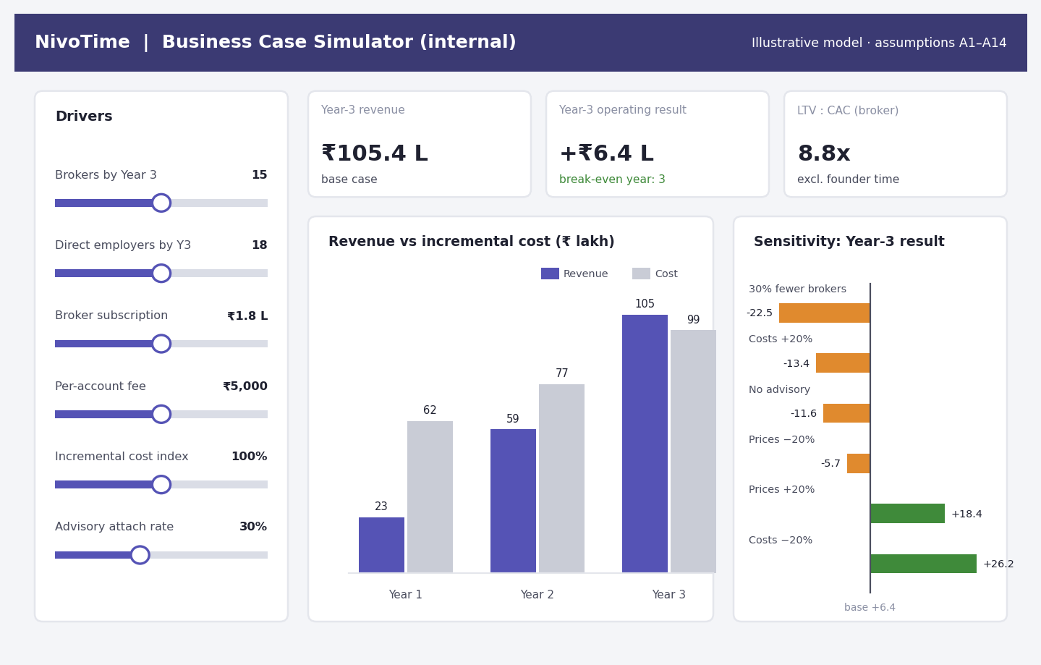
S9 Business Case Simulator (base-case figures from the report’s financial model)
ID | Requirement | Priority | Acceptance criteria
FR-80 | Sliders for brokers by Year 3, direct employers, subscription price, per-account fee, cost index, advisory attach rate | Could | Results update instantly
FR-81 | Revenue vs incremental cost by year; operating result; LTV:CAC; break-even year | Could | Base case reproduces the report: Year-3 revenue ₹105.4 lakh, result +₹6.4 lakh
FR-82 | Sensitivity chart (brokers −30%, costs ±20%, prices ±20%, no advisory) | Could | Matches report Section 13.3
FR-83 | Downside / base / upside presets | Could | Presets match report scenarios
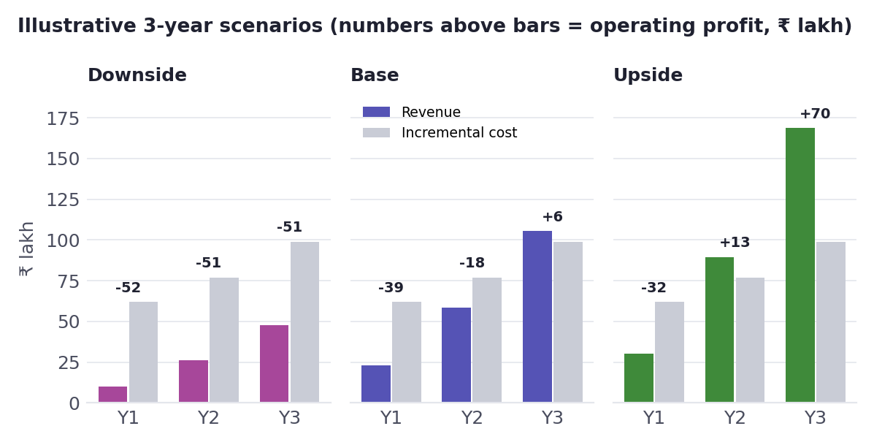
Illustrative three-year scenarios (report Section 13.3)

5.10 ICP scoring logic (used in S8)
Factor | Weight | Scoring rule
Group-health book size | 30% | 15–60 corporate clients = full score
In-house technology | 25% | None or Excel only = full; partial = half; existing vendor = zero
Trigger event present | 25% | Lost client to tech-first broker, new digital head, licence conversion, renewal pressure
Relationship access | 20% | Founder contact = full; second-degree = half; cold = low
Accounts scoring ≥80 go to founder outreach; 60–79 to sales; <60 are deprioritised (report Sections 8.4 and 10.1).

5.11 S10 — Admin: data ingestion and model monitoring
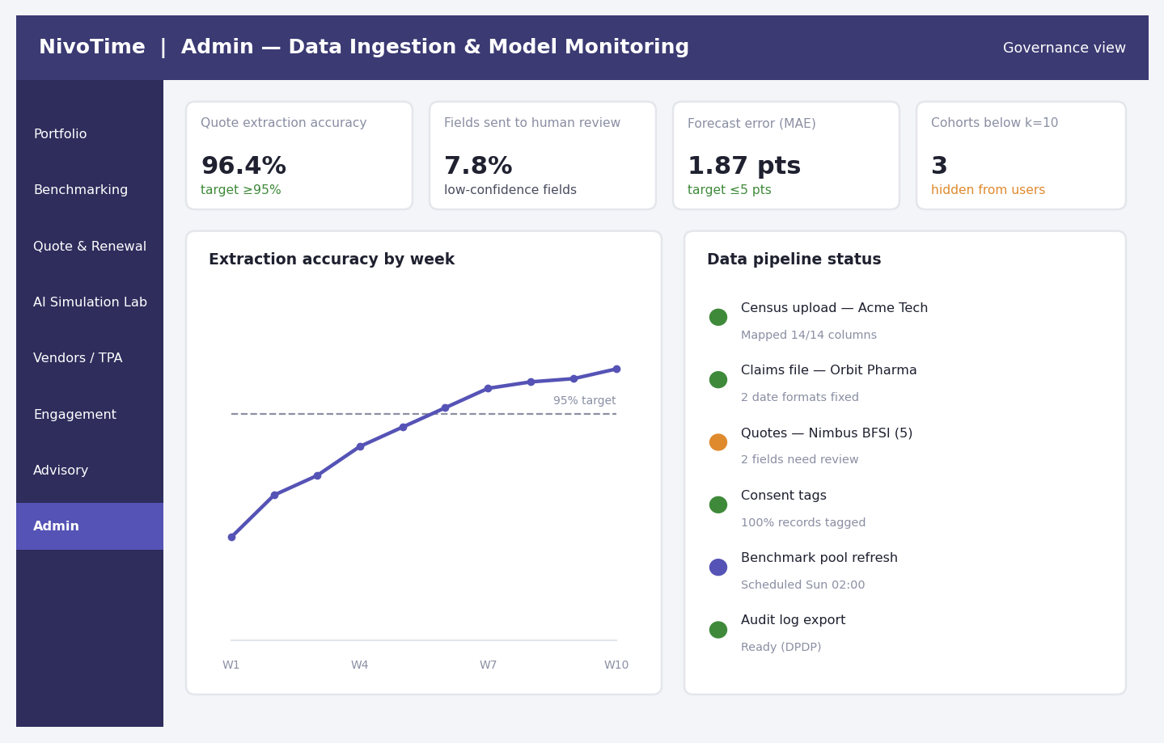
S10 Admin and model monitoring (synthetic data)
ID | Requirement | Priority | Acceptance criteria
FR-90 | Upload census, claims and policy files; auto-map columns to the standard template (census mapping assistant) | Must | ≥90% of columns auto-mapped on pilot files
FR-91 | Data validation rules (dates, duplicates, missing dependants, age vs relation) | Must | Errors listed with row numbers
FR-92 | Consent tag on every member record; records without consent excluded from the benchmark pool | Must | 100% of records tagged before pooling
FR-93 | Model monitoring: extraction accuracy, share of fields sent to review, forecast error, override rate | Must | Weekly trend charts with targets
FR-94 | Cohort guard: count of peer sets below 10 companies (hidden from users) | Must | Guard runs on every benchmark refresh
FR-95 | Audit log export for DPDP and client audits | Must | Export includes user, action, object, time

6. AI / ML Requirements
Each model below comes from report Section 7.3. For each one, the table sets the input, the method, the output, the quality bar and what happens when the model is unsure.
ID | Model | Method | Inputs | Output | Quality bar | Fallback / human control
AI-01 | Peer-group matching | k-nearest neighbours on standardised features | Industry, size, age mix, family definition, sum insured, city | Peer set of ≥10 companies | Stable peer set (≥70% overlap week to week) | Widen filters automatically; never show < 10
AI-02 | Renewal cost forecast | Gradient-boosted trees; permutation or SHAP explanations | Claims ratio, demographics, plan design, group size, medical trend | Renewal loading % with range and top drivers | Mean error ≤5 pts on back-test | Show range, not a single number; broker review
AI-03 | Plan-design simulator | Log-linear rating relativities + AI-02 | Current plan, proposed changes | Premium impact per change | Model fit R² ≥0.85; results within ±2 pts of insurer quotes in pilot | Labelled “estimate”; insurer quote is final
AI-04 | Quote document AI | OCR + large language model extraction to a fixed schema | Quote PDFs and Excel files | 24 structured fields with confidence | ≥95% field accuracy | Confidence < 0.85 → human review
AI-05 | Claims anomaly flags | Isolation forest + rules (cost per day, length of stay) | Claims lines | Flags for review | Precision ≥50% before use with clients | Advisory only; no automatic decisions
AI-06 | Policy Q&A assistant | Retrieval-augmented generation over the employer’s own policy documents | Policy wording, FAQs | Plain-language answer with clause citation | ≥90% answers correct on a 100-question test set | Sensitive or unclear queries go to a human
AI-07 | Renewal risk score | Classifier on engagement, claims trend, service issues | Account-level data | 0–100 risk of client loss | Top-decile risk captures ≥40% of actual losses (once data exists) | Shown as a prompt for action only
AI governance requirements
ID | Requirement | Priority
AI-G1 | Every model output shown to a client is logged (ModelRun) with version, inputs hash, reviewer and any override | Must
AI-G2 | A model card is visible in the product for AI-02, AI-03, AI-04 | Must
AI-G3 | No personal data is sent to external AI services without masking; data stays in India-region cloud where possible | Must
AI-G4 | Quarterly bias and accuracy review by industry, city tier and group size | Should
AI-G5 | Models retrained monthly once real pilot data exists; version can be rolled back | Should

7. Prototype Simulation of the AI/ML Layer
No real client data was available, so the AI layer was simulated on a synthetic dataset to prove that the pipeline works end to end and to produce realistic screens. Treat these results as a proof of mechanics, not proof of accuracy. Real data will be noisier, and real errors will be higher.

7.1 Synthetic dataset
Item | Value
Employer groups generated | 600
Industries | IT services 168, manufacturing 132, BFSI 100, retail 74, pharma 71, professional services 55
Group size | 250–2,000 employees (log-normal, median ~650)
Plan features | Family definition, sum insured (₹3L/5L/10L), parents’ co-pay (0/10/20%), room-rent cap (1%, 2%, none), city tier
Calibration | Mean premium per life ₹2,234, matching the report’s ₹2,233 derived from IRDAI data (₹61,435 cr ÷ 27.51 cr lives)
Mean claims ratio | 81.6% (IRDAI all-health ratio: 85.34% in FY25)
Renewal loading | 12% medical trend + claims-experience effect weighted by group size + plan-design effects + noise

7.2 Results
AI-02 Renewal cost forecast (back-test on 150 held-out groups)
Measure | Result | Target
Mean absolute error | 1.87 percentage points | ≤5 pts
Trend-only baseline (everyone gets +12%) | 5.52 pts | —
Improvement over baseline | 66% | —
Forecasts within ±5 pts | 96% | ≥90%
Forecast drivers (share of explained effect): claims ratio 89%, average age 5%, group size 3%, family definition 1%, room-rent cap 1%. So what: past claims experience dominates renewal pricing. Accurate, clean claims data is the most valuable input, which supports the data-ingestion priority (FR-90 to FR-92).
AI-01 Peer matching (sample client “Acme Tech”, synthetic)
Measure | Client | Peer set (42 companies)
Premium per life | ₹2,500 | Client at 79th percentile
Claims ratio | 96% | Median 78%
Employee engagement | 36% | Median 45%
Forecast renewal loading | +18.9% | —
AI-03 Plan-design simulator (rating model fit R² = 0.954 on synthetic data)
Change | Estimated premium impact
10% co-pay on parents | −4.2%
20% co-pay on parents | −8.2%
Room-rent cap at 1% (from no cap) | −11.6%
Sum insured ₹5 lakh → ₹10 lakh | +24.2%
Remove parents’ cover | −30.3%
AI-05 Claims anomaly flags (5,000 synthetic claims, 100 planted anomalies)
Approach | Flagged | Precision | Recall
Isolation forest alone | 100 | 29% | 29%
Isolation forest + cost-per-day rule | 75 | 56% | 42%
So what: an unsupervised model alone flags too many genuine large claims. The hybrid approach passes the 50% precision bar, but flags must stay advisory, reviewed by a person, exactly as the report’s guardrails require.
AI-04 and AI-06 use language models and cannot be meaningfully simulated without real documents. Their acceptance test is defined in Section 12: 50 labelled insurer quotes and 100 policy questions collected during pilots.

7.3 Synthetic data and model pipeline
Stage | What happens | Tool (prototype)
Generate | Create employer groups, plans, claims with known rules | Python (NumPy, pandas)
Store | Load into the prototype database | SQLite / PostgreSQL
Train | Fit AI-01 to AI-03 and AI-05 | scikit-learn
Evaluate | Hold-out back-test; write metrics to ModelRun | scikit-learn metrics
Serve | Screens read metrics and predictions from the database | Streamlit / FastAPI
Replace | Swap synthetic data for consented pilot data, retrain, compare | Same pipeline

8. Data Requirements

8.1 Data model
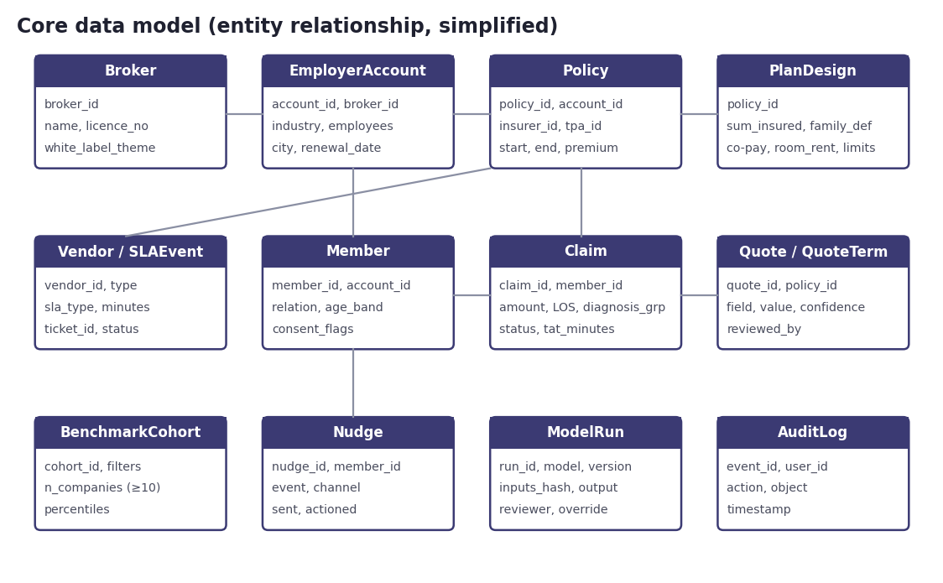
Core data model

8.2 Key data fields
ID | Entity | Key fields | Source | Sensitivity
DR-01 | EmployerAccount | Industry, employees, city, renewal date, broker | Broker CRM / onboarding form | Business
DR-02 | PlanDesign | Sum insured, family definition, co-pays, room-rent, sub-limits | Policy schedule | Business
DR-03 | Member | Relation, age band, consent flags (no names in benchmark pool) | HR census | Personal
DR-04 | Claim | Amount, length of stay, diagnosis group, status, turnaround minutes | TPA MIS file | Sensitive health data
DR-05 | Quote / QuoteTerm | 24 schema fields, confidence, reviewer | Insurer quotes | Business
DR-06 | Vendor / SLAEvent | SLA type, minutes, ticket status | TPA reports, tickets | Business
DR-07 | BenchmarkCohort | Filters, company count (≥10), percentiles | Computed | Anonymised
DR-08 | Nudge | Event, channel, sent, actioned | Engagement engine | Personal
DR-09 | ModelRun | Model, version, output, reviewer, override | Platform | Internal
DR-10 | AuditLog | User, action, object, time | Platform | Internal

8.3 Data sourcing plan (solving the “cold start”, report Section 7.5)
Phase | Source | Enables
Prototype | Synthetic data (this document) | Demos, UI testing, pipeline proof
Pilot (months 3–6) | Each broker’s own anonymised book | Portfolio benchmarking within one broker
Scale (months 6–18) | Pooled, consented, anonymised data across brokers | True market peer benchmarks
Ongoing | Public IRDAI/GI Council aggregates; annual benefits survey | Market context and plan-design data
Data rules
- Benchmarks use only records with a consent tag (FR-92) and cohorts of ≥10 companies (FR-11).
- Health data (claims) is kept at diagnosis-group level in the benchmark pool; no individual-level health data leaves the client’s own workspace.
- Retention: follow the DPDP Rules timeline, with core obligations from 14 May 2027 (report Section 3.2); logs kept at least one year and CERT-In logs for 180 days.

9. Non-Functional Requirements
ID | Area | Requirement | Priority
NFR-01 | Performance | Dashboards load in < 3 s; filter changes refresh in < 3 s; quote extraction < 60 s per document | Must
NFR-02 | Security | HTTPS only on a branded domain; role-based access (Section 2); encryption at rest and in transit | Must
NFR-03 | Authentication | SSO for broker and HR users; OTP for employees; session timeout 30 minutes | Must
NFR-04 | Privacy | DPDP-aligned consent, purpose limitation, data-processing agreements with brokers; breach response plan | Must
NFR-05 | Incident reporting | Cyber incidents reported within 6 hours (CERT-In) | Must
NFR-06 | Audit | Immutable audit log for data access, approvals and AI outputs | Must
NFR-07 | Availability | 99.5% monthly uptime for the pilot; daily backups | Should
NFR-08 | Accessibility | WCAG 2.1 AA contrast; values never shown by colour alone; keyboard navigation | Should
NFR-09 | White-label | Broker logo, colours and domain configurable without code | Must
NFR-10 | Scalability | 50 brokers, 2,000 employer accounts, 1.5 million lives without redesign | Could
NFR-11 | Localisation | English first; Hindi and regional languages for employee nudges | Could
NFR-12 | Data residency | Cloud region in India preferred for client data | Should

10. Technology Recommendations for the Prototype
Layer | Prototype (weeks 0–20) | Production path
Clickable design | Figma (all 10 screens, linked flows) | Design system reused
Front end | Streamlit (fast, Python-native) | React + a charting library
Back end / API | FastAPI | FastAPI or Node.js
Database | SQLite → PostgreSQL | Managed PostgreSQL
AI/ML | scikit-learn, XGBoost; cloud OCR + LLM API for quotes | Same, with model registry
Internal dashboards | Power BI or Looker Studio (GTM and business simulator) | Embedded BI
CRM | HubSpot (free/starter) or Zoho CRM | Same
Messaging | Email + WhatsApp Business API (sandbox) | Approved provider
Hosting | India-region cloud; synthetic data only | Hardened cloud, ISO 27001 path
Recommended data flow for the go-to-market stack (report Section 12.1): lead sources → CRM → marketing automation → sales → customer success → BI dashboard.

11. Dashboard and Chart Catalogue
Every chart in the prototype, the question it answers, and how it is built.
Chart ID | Screen | Question it answers | Chart type | Data | Interaction
C-01 | S1 | Which clients need attention first? | Table with inline risk bars | Accounts, renewal dates, risk score | Sort, click to open client
C-02 | S2 | Are we above or below peers? | KPI tiles with percentile | Premium, ICR, forecast, engagement | Filter bar
C-03 | S2 | Where does our plan sit feature by feature? | Horizontal percentile bars + median marker | Peer percentiles | Hover shows peer values
C-04 | S3 | Which quote is best and what got worse? | Comparison grid with flags | 24 quote fields | Click field to see source text
C-05 | S4 | What do plan changes save? | Waterfall | Simulator output | Sliders update live
C-06 | S4 | What drives the renewal forecast? | Horizontal bars (driver share) | Model explanations | Hover shows definition
C-07 | S5 | Are TPAs meeting IRDAI timelines? | Line chart with 60-min target line | Weekly median approval time | Toggle TPA
C-08 | S5 | Which vendors perform worst? | Scorecard table | SLA, tickets, feedback | Sort
C-09 | S6 | Are employees engaging? | KPI tiles + funnel (sent → opened → actioned) | Nudge log | Filter by event type
C-10 | S8 | How big is each segment? | Horizontal bars TAM → SAM → ABM → SOM | Report sizing | Edit assumptions
C-11 | S8 | Is the pipeline on plan? | Grouped bars by stage and path | CRM stages | Filter by quarter
C-12 | S8 | Where do we sit vs competitors? | Strategic group scatter | Report Section 5.3 | Static
C-13 | S9 | When does the suite break even? | Grouped bars revenue vs cost | Business model | Sliders
C-14 | S9 | Which lever matters most? | Diverging sensitivity bars | Model sensitivities | Static per scenario
C-15 | S10 | Are the models healthy? | Line with target line | Accuracy and error by week | Toggle model
Chart design rules: one y-axis per chart; numbers printed on or next to bars; colour never used alone to carry meaning; a validated colour palette for series; brand purple and green reserved for navigation and headers.

12. Build Plan, Testing and Demo

12.1 Sprint plan
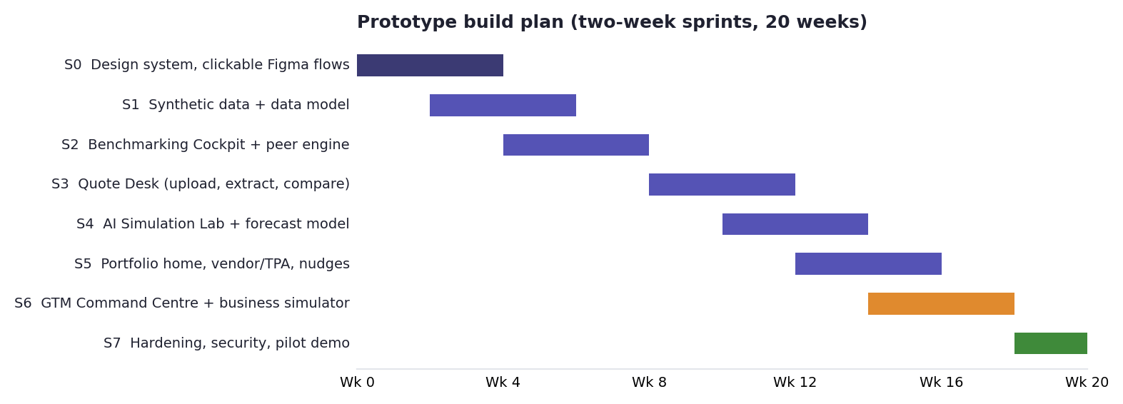
Prototype build plan
Sprint | Weeks | Deliverable | Linked requirements
S0 | 0–4 | Design system; clickable Figma flows for all 10 screens | All screens
S1 | 2–6 | Data model, synthetic data generator, ingestion and validation | DR-01 to DR-10, FR-90 to FR-92
S2 | 4–8 | Benchmarking Cockpit + peer engine | FR-10 to FR-15, AI-01
S3 | 8–12 | Quote & Renewal Desk (upload, extract, review, compare, approve) | FR-20 to FR-26, AI-04
S4 | 10–14 | AI Simulation Lab + renewal forecast + model card | FR-30 to FR-35, AI-02, AI-03
S5 | 12–16 | Portfolio home, vendor/TPA, zero-login nudges | FR-01 to FR-06, FR-40 to FR-56
S6 | 14–18 | GTM Command Centre + business simulator | FR-70 to FR-83
S7 | 18–20 | Security hardening, audit log, pilot demo script | NFR-01 to NFR-09, FR-93 to FR-95
This aligns with the report roadmap: Benchmarking Cockpit MVP by month 5, broker pilots from month 3, Quote Desk by months 4–8 (report Section 13.2).

12.2 Acceptance tests
Test | Method | Pass criterion
Quote extraction accuracy | 50 real insurer quotes (from pilots), hand-labelled | ≥95% of fields correct
Renewal forecast | Back-test on pilot clients’ last 2 renewals | Mean error ≤5 pts
Simulator realism | Compare scenario estimate with the insurer’s revised quote | Within ±2 pts on ≥70% of scenarios
Peer-set privacy | Automated test on every refresh | Zero cohorts shown with < 10 companies
Policy Q&A | 100-question test set per pilot client | ≥90% correct, with correct clause citation
Usability | 5 account managers complete a renewal pack unaided | Median time < 2 hours; SUS score ≥70
Security | External vulnerability scan before pilot | No high or critical findings open

12.3 Broker demo script (15 minutes)
- Portfolio Home (2 min): “Here are your 38 clients; 7 renew in 90 days, 2 at high risk.”
- Benchmarking Cockpit (4 min): open Acme Tech; show claims ratio 18 points above peers and a +18.9% forecast.
- Simulation Lab (3 min): apply a 10% parents’ co-pay and a 1% room-rent cap; premium per life falls 15.3%.
- Quote Desk (4 min): drop in five quote PDFs; show extraction, flags and the draft recommendation.
- Close (2 min): “Let’s run this on three of your clients for 90 days and measure the hours saved.”

13. Success Metrics
Metric | Definition | Pilot target | Source
Renewal prep time | Hours per renewal pack vs baseline | −50% | Report KPI 13.4
Extraction accuracy | Correct fields ÷ total fields | ≥95% | Report 7.3
Forecast error | Mean absolute error, pts | ≤5 | Report 7.3
Broker weekly active users | Active users ÷ licensed users | ≥70% by day 60 | Report 11.1
Employee activation | Employees acting on ≥1 nudge ÷ eligible | ≥60% | Report 13.4
Insights accepted without edits | Accepted ÷ shown | ≥80% | Report Appendix C
Pilot-to-paid conversion | Paid ÷ pilots | ≥50% | Report 13.4
Time to first value | Contract to first client live | ≤30 days | Report 11.1

14. Risks, Assumptions and Open Questions

14.1 Prototype risks
Risk | Impact | Mitigation
Synthetic data makes models look better than reality | Over-confidence in AI accuracy | Label every screen “synthetic”; re-test on pilot data before any client claim
Too few real quotes to test extraction | Cannot prove ≥95% accuracy | Collect 50 quotes in the first two pilots as a condition of the pilot
Brokers reluctant to share data | Benchmark pool stays small | Start with portfolio benchmarking (works with one broker); pooled-data clause in contracts
Scope creep from custom requests | Delays | Apply the report’s product governance rule: core / configurable / paid custom / reject
Regulatory boundary on comparison | Legal risk | Broker-facing only; legal opinion before launch

14.2 Assumptions
- NivoTime’s existing Flex, TPA-integration and analytics code can be reused for data ingestion and dashboards; the extent is not yet confirmed (report Appendix B).
- Pilot brokers will provide anonymised claims and census data under a data-processing agreement.
- Pricing and business-case figures follow report assumptions A1–A14 and are illustrative.

14.3 Open questions for NivoTime
- Which of the described features (benchmarking dashboard, vendor management, quote comparison) already exist in code, and in what state?
- How many insurers and TPAs send data in a usable format today?
- Which CRM, if any, is in use, so S8 can connect to it?
- Who will own the product (product manager) and the AI models during the pilot?

15. Traceability Matrix
Report recommendation (section) | PRD requirements | Screen | KPI
Benchmarking Cockpit with co-pay, size, family, SI filters (7.2, 7.4) | FR-10 to FR-15, AI-01 | S2 | Insights accepted ≥80%
Quote & Renewal Desk with AI extraction (7.2, 7.3) | FR-20 to FR-26, AI-04 | S3 | Accuracy ≥95%; prep time −50%
Plan simulator and renewal forecast (7.3) | FR-30 to FR-35, AI-02, AI-03 | S4 | Forecast error ≤5 pts
Vendor/TPA management (7.2) | FR-40 to FR-44 | S5 | SLA compliance trend
Zero-login engagement (11.2) | FR-50 to FR-56 | S6 | Activation ≥60%
Advisory & consulting layer (7.2, 9.5) | FR-60 to FR-63 | S7 | Advisory packs sold
Cold-start data plan (7.5) | DR-01 to DR-10, FR-90 to FR-92 | S10 | Consent coverage 100%
Regulatory guardrails (7.7) | FR-23 note, FR-53, NFR-02 to NFR-06 | All | Zero incidents
Segmentation, TAM/SAM/SOM, ICP (8.2–8.4) | FR-70, FR-72, Section 5.10 | S8 | Named accounts contacted
Funnel and sales engine (10.1, 10.4) | FR-71, FR-73, FR-74 | S8 | Pilot-to-paid ≥50%
Financial case and sensitivity (13.3) | FR-80 to FR-83 | S9 | Break-even by Year 3
Governance and AI review (12.4, 13.6) | AI-G1 to AI-G5, FR-93 to FR-95 | S10 | Override rate tracked

Appendix A: Synthetic Data Specification
Field | Generation rule
industry | Categorical: IT 28%, manufacturing 22%, BFSI 16%, pharma 12%, retail 12%, professional services 10%
employees | Log-normal around 650, clipped to 250–2,000
avg_age | Industry base (IT 30 … manufacturing 37) + normal noise (sd 2.5)
family | E 15%, E+S+2C 50%, E+S+2C+P 35%
sum_insured | ₹3L 35%, ₹5L 45%, ₹10L 20%
copay_parents | 0/10/20% (only where parents are covered)
room_rent | 1% 45%, 2% 30%, no cap 25%
premium_per_life | Base × age × family × SI × room-rent × co-pay × city factors × noise; calibrated to mean ₹2,234
claims_ratio | 78% base + parents-without-co-pay +10 pts + no cap +4 pts + age effect + noise scaled by group size
renewal_loading | 12% trend + credibility-weighted claims effect + plan effects + noise
engagement | Normal around 44% (sd 12%)
The generator and model code (Python) are kept with this document so the prototype team can reproduce every number.

Appendix B: Glossary
Term | Meaning
ICR (claims ratio) | Claims paid and outstanding ÷ premium earned
Renewal loading | Percentage change in premium at renewal
Peer set | Group of comparable companies used for benchmarking (minimum 10)
Co-pay | Share of each claim paid by the employee or family member
Room-rent cap | Limit on daily hospital room charges, often a % of sum insured
TPA | Third-party administrator that processes health claims
Zero-login | Engagement through nudges and secure links, without routine portal logins
Model card | Short summary of a model’s purpose, data, accuracy and limits
MAE | Mean absolute error: the average size of a forecast miss
White-label | Product shown under the broker’s own brand
DPDP | Digital Personal Data Protection Act 2023 and Rules 2025
MoSCoW | Must / Should / Could / Won’t prioritisation

