

LIVE COMPANY PROJECT REPORT
From Services Breadth to
Benefits Intelligence
An AI-led product, customer-targeting and go-to-market strategy
for NivoTime Private Limited

Strategy · Product & AI · Customer Targeting · Go-to-Market · Sales Engine · Financials
Prepared by
Anvesha
PGDM (E-Business), Batch 2025–27
Prin. L.N. Welingkar Institute of Management Development & Research (WeSchool), Mumbai
Industry partner
NivoTime Private Limited, Mumbai
September 2026

Table of Contents

CEO One-Page Summary 4
Executive Summary 5
1. Introduction 7
1.1 Background 7
1.2 Objectives 7
1.3 Scope 8
1.4 Methodology and evidence discipline 8
SECTION A — BUSINESS AND INDUSTRY UNDERSTANDING
2. NivoTime: Company Snapshot 9
3. Industry and Market Analysis 10
3.1 Market size and growth 10
3.2 PESTEL — only the factors that change NivoTime’s decisions 11
3.3 Porter’s Five Forces (benefits technology for brokers and employers) 11
3.4 Value chain — where NivoTime adds value and where it leaks 12
4. Business Model and Unit Economics 12
4.1 Business Model Canvas (proposed, both paths) 12
4.2 Unit economics (outside-in, illustrative) 13
SECTION B — DIAGNOSIS
5. Competitive Landscape 15
5.1 Who NivoTime is really up against 15
5.2 Capability comparison 16
5.3 Strategic group map 17
5.4 Win/loss view (outside-in proxy) 17
6. Internal Diagnosis 18
6.1 VRIO — which resources can create an advantage 18
6.2 SWOT to TOWS 18
6.3 The problem statement 18
SECTION C — THE FLAGSHIP RECOMMENDATION
7. The NivoTime Benefits Intelligence Suite 19
7.1 The customer problem 19
7.2 The product: five modules, one data layer 20
7.3 The AI/ML layer — practical models, not an “AI” label 21
7.4 What the user sees 22
7.5 Solving the data “cold start” 22
7.6 Where the suite differs from competitors 23
7.7 Build, partner or buy — and regulatory guardrails 23
7.8 Why this is defensible: the data flywheel 24
7.9 Options screened 25
SECTION D — CUSTOMER TARGETING
8. Segmentation, Market Size and Ideal Customer 26
8.1 Decision on the customer framing 26
8.2 Segmentation 26
8.3 Market sizing (TAM, SAM, SOM) 26
8.4 Ideal customer profiles 27
8.5 Buying committee 28
8.6 Industry playbooks (second-phase differentiation) 28
SECTION E — GO-TO-MARKET AND SALES ENGINE
9. Go-to-Market Strategy 29
9.1 Positioning 29
9.2 Messaging pyramid 29
9.3 Go-to-market motion 29
9.4 Three acquisition engines 29
9.5 Packaging and pricing (proposed) 30
9.6 Launch sequence 30
10. Sales Engine 30
10.1 Two sales processes 30
10.2 Qualification 31
10.3 Objection handling 31
10.4 Funnel and pipeline arithmetic 32
SECTION F — ONBOARDING AND CUSTOMER EXPERIENCE
11. Onboarding, Engagement and Experience 33
11.1 Broker onboarding journey 33
11.2 Zero-login employee engagement 33
11.3 Customer journey pain points (employer via broker) 33
SECTION G — DATA, TECHNOLOGY AND AI
12. Data, Technology and AI Architecture 35
12.1 Go-to-market data flow 35
12.2 Management dashboards 35
12.3 AI opportunity matrix for NivoTime’s own growth engine 36
12.4 Security, privacy and governance 36
SECTION H — IMPLEMENTATION, FINANCIALS AND RISK
13. Implementation, Financials and Risk 37
13.1 Gap analysis: current state vs. target state 37
13.2 Roadmap 37
13.3 Financial case (illustrative) 38
13.4 KPI scorecard 39
13.5 Risk register 40
13.6 Governance 41
14. Conclusion and Recommendations 42
15. Limitations and Validation Plan 42
Appendix A: Assumptions Register 44
Appendix B: Management Validation Checklist 44
Appendix C: Pilot Scorecard 45
Appendix D: Broker Pitch (60 seconds) 45
References 46

CEO One-Page Summary
The one-line answer: NivoTime should turn its benefits know-how into an AI-powered Benefits Intelligence Suite (benchmarking, quote comparison, renewal intelligence, vendor/TPA management and advisory) and sell it mainly through mid-size insurance brokers, who cannot afford to build this themselves. Direct employer sales should be used to prove the product and create reference clients.
Area | Summary
Where NivoTime is today | ~17-person, founder-led, bootstrapped Mumbai company (est. 2018) selling IT services, digital marketing, InsurTech and HealthTech together [2][3][4]. Strong product ideas, but no public client names, pricing or case studies.
The market | Group health premium ₹68,641 cr in FY26, growing 12.9% [6]; 27.51 crore lives covered by group health [5]; medical costs rising 11.5–12.9% a year [8][9]. Every renewal is a price fight.
The gap | Large brokers build their own benchmarking (Prudent’s BenchmarkPro covers 3,900 organisations [22]). Funded players became brokers themselves (Plum, Pazcare) [42]. The ~600+ mid-size brokers have neither. No Indian vendor was found selling them benchmarking + quote comparison + renewal workflow as one white-label product.
The proposal | Five modules on one data layer, with six practical AI/ML models (peer matching, renewal-cost forecast, plan simulator, quote-document AI, claims anomaly flags, policy Q&A).
Why it can win | Every broker added makes the anonymised benchmark pool bigger, so the insights get better — a data network effect a single broker cannot copy. Proven abroad: Employee Navigator serves 7,000+ brokers and 195,000 employers through the broker channel [24].
Economics (illustrative) | Base case: 15 brokers and 18 direct employers by Year 3 → ~₹1.05 cr revenue, break-even in Year 3 on an incremental cost base of ~₹1 cr (A1–A12). For a 40-client broker, estimated value ~₹10 lakh a year against a ~₹6.6 lakh fee.
First 90 days | Fix login security, audit what is live, set up a CRM, build a 100-broker target list, launch a benchmarking MVP, sign 2 broker pilots and 3 employer pilots.
Biggest risks | Benchmark “cold start” (not enough data at launch), no proof points yet, and staying inside IRDAI rules on quote comparison. Each has a named mitigation (Section 13.5).

Executive Summary
Situation
- NivoTime Private Limited (Mumbai, founded 2018) is a director-owned technology company. It sells custom IT, digital marketing, InsurTech (Flex benefits, H&B, TPA integration, analytics) and HealthTech services [1][2][3].
- Its strongest and most specific capability is in employee benefits: flexible benefits, claims analytics and benchmarking. The founder has over two decades in insurance and broking [1][43].
Complication
- The company tells too many stories at once. The pitch deck leads with generic IT services; the website leads with InsurTech [1][2]. A buyer cannot tell what NivoTime is best at.
- There are no public proof points: no named clients, no pricing, no case studies, no published funding. Every competitor studied has at least one of these [14]–[19].
- The market has split in two: tech vendors that serve intermediaries (Bharatsure, Turtlefin) and tech-first companies that became brokers themselves (Plum, Pazcare, Loop Health) [18][19][42]. NivoTime sits between the two without choosing.
- Medical costs are rising 11.5–12.9% a year [8][9] and the health claims ratio is 85% [7], so employers and brokers face hard renewals every year. Yet brokers still compare quotes and benchmark plans largely by hand.
Key question
What single, focused product and go-to-market strategy can turn NivoTime’s scattered capabilities into a repeatable, scalable InsurTech business?
Answer (recommendation)
- Focus: make Employee Benefits / InsurTech the core business. Keep IT services only as a controlled cash and implementation layer.
- Product: build the NivoTime Benefits Intelligence Suite: Benchmarking Cockpit (filters for co-pay, company size, family cover, sum insured), Quote & Renewal Desk, Vendor/TPA Management, Engagement Engine (zero-login nudges), and an Advisory layer, all powered by six practical AI/ML models.
- Customer: lead with mid-size IRDAI-licensed brokers (the broker channel as the multiplier). Use mid-market employers (250–2,000 employees) directly to validate the product and build references.
- Go-to-market: account-based marketing to a named list of 100 brokers, a “free benefits health check” offer, 90-day pilots, and an annual India benefits benchmark report for thought leadership.
- Sales engine: two separate sales processes (MEDDIC for brokers, BANT for employers), a CRM from day one, and a pilot-to-contract conversion playbook.
Expected impact (illustrative, to be validated with company data)
Metric | Year 1 | Year 3 (base case)
Brokers on platform | 3 | 15
Direct employer clients | 4 | 18
Covered lives on platform | ~18,500 | ~1.6 lakh
Revenue from the suite | ~₹23 lakh | ~₹1.05 crore
Operating result of the suite | −₹39 lakh | +₹6 lakh (break-even)
All financial figures are outside-in estimates built from public market data and labelled assumptions (Appendix A). NivoTime’s internal pricing, cost and pipeline data were not available for this project.

1. Introduction

1.1 Background
- NivoTime approached this project to understand how to sharpen its market position and grow its InsurTech business.
- The initial project scope, agreed with the industry mentor, covered three stages of the funnel: market positioning, customer segmentation and competitive sales intelligence, each looked at through a broker path and a company (employer) path.
- This report builds on that scope and adds a product strategy (the Benefits Intelligence Suite), because the research showed that positioning alone will not fix the core issue: NivoTime needs one clear, differentiated product to position.

1.2 Objectives
Following good research practice, the objectives are split into what the project sets out to find (substantive) and how the answers will be checked (measurement and validation).
Substantive research objectives
- Map NivoTime’s current business model, product portfolio and positioning.
- Diagnose its competitive position against Indian and global benefits-tech players.
- Design a differentiated, AI-enabled product that solves a real broker and employer problem.
- Define the target customers (segments, market size, ideal customer profile).
- Build a go-to-market plan and a sales process for both the broker and the employer path.
- Lay out the implementation roadmap, economics and risks.
Measurement and validation objectives
- Tag every claim by evidence type (sourced fact, estimate, or assumption) so a reader can see what is proven and what is not.
- Build the financial case from explicit, adjustable assumptions (Appendix A), with downside and upside scenarios.
- Define the pilot metrics and success thresholds that would confirm or reject the strategy (Section 15 and Appendix C).

1.3 Scope
- In scope: the InsurTech / employee-benefits business in India; broker and employer customers; product, targeting, go-to-market, sales, onboarding, technology and economics.
- Out of scope: detailed plans for the IT-services and digital-marketing lines, HealthTech as a standalone business, and the ZOYAME (Dubai/GCC) venture. These are covered only as they affect focus.

1.4 Methodology and evidence discipline
- Secondary research: NivoTime’s website and pitch deck; company registries; IRDAI, General Insurance Council and CareEdge data; broker and competitor websites (each searched separately); consulting reports (Aon, WTW, Mercer Marsh Benefits, McKinsey, BCG); regulatory and legal summaries. All accessed in September 2026.
- Company inputs: the project brief and mentor discussions (scope, the broker/company framing, and feature descriptions such as the benchmarking dashboard filters, vendor management and quote comparison).
- Analysis frameworks: used only where they answer a real question, each ending with a “so what”. Frameworks skipped, and why, are noted where relevant.
- Limitation: internal data (pricing, costs, pipeline, win/loss, live feature status) was not available. The report fills these gaps with transparent outside-in estimates and a validation plan, and never presents an assumption as a fact.
How to read the evidence tags
Tag | Meaning
[n] | Sourced fact; see the numbered reference list
(Est.) | Our own calculation from named inputs
(A#) | An assumption, listed with its reasoning in Appendix A
Company input | Stated by NivoTime or the mentor, not publicly verifiable

SECTION A — BUSINESS AND INDUSTRY UNDERSTANDING

2. NivoTime: Company Snapshot
Item | Detail | Source
Legal entity | NivoTime Private Limited, CIN U72900MH2018PTC314348 | [3]
Founded | 2018 (registries differ on the month) | [3]
Founder | Pramod Pandey, Founder, Chairman and CEO; 20+ years across insurance, broking, technology and digital marketing; earlier roles include Tata-AIG, Wipro, Reliance, Marsh, Willis Towers Watson and UIB India | [1][43]
Team size | LinkedIn: 11–50 band, 17 employees listed; pitch deck: “30+” | [2][4]
Capital | ₹1 lakh paid-up; no external funding found | [3]
Location | Mumbai (Mira Road registered office); Dubai venture ZOYAME announced | [3][44]
Claimed scale | 50+ clients, 95% staff retention, 99% on-time delivery (deck claims, not independently verified) | [2]
What NivoTime sells today
Business line | Offer | Strategic read
Technology services | Websites, portals, mobile apps, custom software, cloud, security | Cash generator; scales only with headcount
Digital marketing | SEO, social, campaigns | Separate skill set; useful only if it feeds NivoTime’s own lead generation
InsurTech | Flex benefits, H&B, Affinity, TPA integration, analytics, survey, Nivo Kiosk | Strongest candidate for a scalable product
Benefits analytics and consulting | Benchmarking, claims utilisation review, claims audit, fraud flags, monthly MIS | Highest-value know-how; can feed the product
HealthTech | Online consultation, diagnostics, pharmacy, gym, wellness vendors | Attach-on layer, not the core story
Company inputs from the mentor (not yet visible on the public website): a real-time benchmarking dashboard filterable by co-pay, company size, family cover and sum insured; deep HealthTech vendor management; quotation comparison; and consulting. These are the building blocks of the proposed suite in Section 7.
Observations from the research
- Positioning mismatch: the deck leads with IT services; the website leads with InsurTech [1][2].
- No public proof: no client logos, case studies, app-store listing or pricing were found.
- A trust gap to fix first: at the time of research, the admin and user login links pointed to a raw IP address over plain HTTP, not a secure branded domain [1]. A broker’s IT team would flag this in due diligence.
- So what: NivoTime has more product than proof. The fix is focus and evidence, not more features.

3. Industry and Market Analysis

3.1 Market size and growth
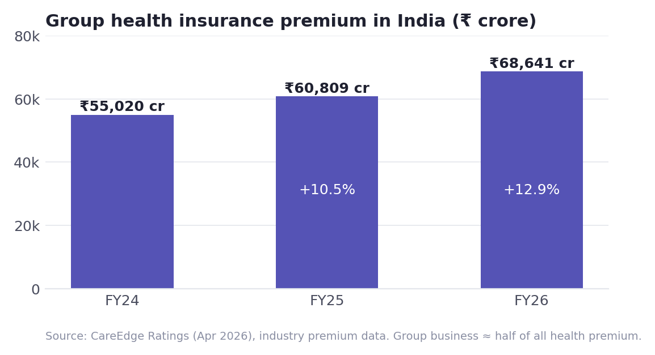
Group health premium in India, FY24–FY26
- Group health is the engine of Indian health insurance. Group premium was ₹61,435 cr in FY25, 52.3% of all health premium, covering 27.51 crore lives [5]. CareEdge puts FY26 group premium at ₹68,641 cr, up 12.9% [6].
- Costs are rising fast. India’s medical trend is forecast at 11.5% (Aon) to 12.9% (WTW) for 2026, among the highest in Asia [8][9]. The overall health claims ratio was 85.34% in FY25 [7].
- Average premium per group life ≈ ₹2,233 a year (₹61,435 cr ÷ 27.51 cr lives) (Est.). Group lives include some non-employer groups, so treat this as an order of magnitude.
- Penetration is still low: insurance penetration was 3.7% in FY25 against a 7.3% global average [41]. Growth has a long runway.
- Benefits are getting more flexible: flexible health insurance adoption in India grew ~300% in five years [13]; globally 72% of employees say benefit choice matters, but only 41% get it [40].
So what: the demand is real and growing. The fight is over who helps employers manage rising renewal costs, and that is exactly where benchmarking and quote comparison create value.

3.2 PESTEL — only the factors that change NivoTime’s decisions
Factor | What is happening | So what for NivoTime
Political / regulatory | Bima Sugam, IRDAI’s digital insurance marketplace, now targeted to go live by November 2026 [30]. IRDAI updated intermediary rules in July 2026 (perpetual registration, conversions by Jan 2027) [34]. | Brokers must digitise. “Bima Sugam readiness” becomes a selling point for broker technology.
Regulatory (comparison) | Showing insurance comparisons and premiums to prospects is a regulated activity (web aggregators need registration, ₹25 lakh capital and insurer agreements) [33]. | Quote comparison must be a tool used by the licensed broker, not a public comparison site run by NivoTime. This shapes the product design (Section 7.7).
Legal (data) | DPDP Rules notified 14 Nov 2025; core obligations (consent, security, breach notice) apply from 14 May 2027 [31][32]. CERT-In requires cyber incidents to be reported within 6 hours [36]. | Health and claims data needs privacy-by-design. This is a cost, but also a trust advantage over less careful rivals.
Legal (service levels) | IRDAI’s health master circular expects cashless authorisation within 1 hour and discharge within 3 hours [37]. | Brokers and employers need faster claims visibility, which supports the vendor/TPA management module.
Economic | Medical trend 11.5–12.9% [8][9]; IRDAI scrutiny of broker commissions, which grew faster than premiums over FY23–FY25 [12]. | Brokers are squeezed on both price and margin, so they need productivity tools, not more headcount.
Technological | Insurers and TPAs are adopting AI: Medi Assist’s AI tools, Policybazaar’s ClaimSetu engine (claims processed “up to 50% faster”) [20][21]. IRDAI set up an AI working group in June 2026 [35]. | AI is becoming table stakes in claims. The next frontier is AI in advice and renewals.
Social | India is still an “immature” flex-benefits market [39]; employees expect digital, personalised benefits [40]. | Category education is still needed, which favours brokers, who already have trusted relationships.
Environmental factors were skipped: not material for a B2B software business.

3.3 Porter’s Five Forces (benefits technology for brokers and employers)
Force | Rating | Evidence and meaning
Threat of new entrants | High | 717 InsurTech startups tracked in India [38]; software is cheaper to build with AI. Differentiation must come from data and relationships, not code.
Threat of substitutes | High | Plum and Pazcare are licensed brokers themselves [42]; large brokers build in-house (Prudent BenchmarkPro [22], Aon benchmarking [46]). Spreadsheets remain the cheapest substitute.
Buyer power (brokers) | High | Only 751 licensed brokers (678 direct, 69 composite, 4 reinsurance) [10]. A small, well-networked buyer pool that compares vendors.
Supplier power (insurers, TPAs) | Medium | Integrations depend on insurer and TPA cooperation, but this affects all rivals equally.
Rivalry | Medium–High | Bharatsure (60+ partners, 4 lakh+ lives) and Turtlefin (40+ insurers) already sell to intermediaries [18][19]; Pazcare’s Claims IQ benchmarks claims ratios for renewals [17].
So what: the hardest force is substitutes, not direct rivals. NivoTime should not target large brokers (they build) or tech-first brokers (they are competitors). The realistic buyer is the mid-size broker that can neither build nor afford to fall behind.

3.4 Value chain — where NivoTime adds value and where it leaks
Activity | NivoTime today | Strength or gap
Data and partner onboarding | Insurer, TPA and wellness vendor integrations claimed [1] | Number of live integrations not public; must be proven
Platform operations | Flex, H&B, analytics, claims modules | Wide product for a small team; depth needs testing
Delivery to clients | Employer and employee dashboards, mobile app claimed [1] | No app-store listing found
Marketing and sales | Founder-led; no visible content, case studies or logos | Weakest link
Service | TPA integration, claims review, MIS reporting | Analytics depth is a real asset
So what: value is created in analytics and integration, and lost in marketing and proof. The broker channel helps because brokers bring the trust and the relationships NivoTime lacks.

4. Business Model and Unit Economics

4.1 Business Model Canvas (proposed, both paths)
Block | Broker path (primary) | Employer path (validation)
Customer segments | Mid-size IRDAI-licensed brokers with a group-health book | Employers with 250–2,000 staff
Value proposition | “Win and service more corporate accounts without adding headcount”: white-label benchmarking, quote comparison and renewal tools | “Know if your benefits are competitive and cut renewal surprises”
Channels | Founder network, account-based marketing, broker events | Direct sales, benefits health check, content
Customer relationships | Long-term platform partner; broker owns the client | Direct account management
Revenue streams | Broker subscription + per-account renewal pack + per-life engagement fee | Per-life platform fee + advisory packs
Key resources | Founder’s broker network; Flex and analytics code; anonymised benchmark data | Same platform
Key activities | Product and AI development, integrations, broker enablement | Onboarding, customer success
Key partners | Insurers, TPAs, HRMS vendors, wellness vendors | Same
Cost structure | Engineering, cloud and AI usage, security and compliance, sales | Shared

4.2 Unit economics (outside-in, illustrative)
NivoTime’s actual prices and costs are not public, so the figures below are built from market data and labelled assumptions (Appendix A). They show the logic and the levers, not NivoTime’s current numbers.
Pricing logic: price against the broker’s own economics
- Average group premium per life ≈ ₹2,233 (Est., [5]).
- At an assumed 7.5% brokerage (A3), a broker earns ~₹167 per covered life per year (Est.).
- Proposed broker pricing (A4): ₹1.8 lakh a year workspace subscription + ₹5,000 per active employer account (AI renewal and quote pack) + ₹10 per engaged employee life.
- For a typical mid-size broker at maturity (25 accounts, 700 lives each), that is ~₹4.8 lakh ARR per broker (Est.), about 16% of the broker’s revenue from those lives.
Unit metric | Estimate | Basis
ARR per broker (mature) | ₹4.8 lakh | A4, A8
Gross margin | ~70% | A10 (cloud, AI usage and support)
Customer lifetime | 5 years | A11
Lifetime value (LTV) | ~₹16.8 lakh | ARR × margin × lifetime
CAC per broker | ~₹1.9 lakh (excl. founder time) | 60% of sales and marketing spend ÷ brokers won (A12)
LTV : CAC | ~8.8x (likely 4–6x when founder time is costed) | Healthy benchmark is >3x
CAC payback | ~7 months | CAC ÷ monthly gross margin
So what: per-life software fees are small in rupees, so the model only works with a lean, reused team and many brokers, not a few large deals. That is why distribution through brokers matters more than the product’s list price.

SECTION B — DIAGNOSIS

5. Competitive Landscape

5.1 Who NivoTime is really up against
Each competitor was researched separately from its own website or recent press (September 2026).
Player | Model | Scale / proof | Benchmarking, quote or AI features found
Plum | Tech-first licensed broker | 6,000+ organisations; ₹193 cr Series B (Mar 2026) [14] | AI-driven claims operations; no broker tools
Pazcare | Tech-first licensed broker | Licensed broker [42] | Claims IQ: compares a client’s claims ratio with industry figures for renewal talks [17]
Loop Health | Tech-first broker | 1M+ lives, 1,250+ enterprises [15] | Claims dashboard; no benchmarking tool found
Onsurity | Corporate agent, SME focus | 2M+ members [16] | Usage analytics; no broker tools
Bharatsure | Tech vendor to intermediaries | 60+ partners, 4 lakh+ lives, ₹191 cr+ premium [18] | Benefits and claims stack for brokers; no quote comparison found
Turtlefin | White-label distribution tech | 40+ insurers [19] | Distribution for banks and agents; not employee benefits
Prudent (broker) | Large broker | BenchmarkPro scorecard: 3,900 organisations, 50 lakh+ employees [22] | In-house benchmarking, not sold to other brokers
Policybazaar for Business | Broker / marketplace | — | ClaimSetu AI claims scoring [20]
NivoTime | Tech vendor + services | No public clients or funding | Benchmarking dashboard, quote comparison, vendor management (company input)
Global proof that the broker-channel model works
- Employee Navigator (US): benefits administration sold through brokers; 7,000+ brokers, 195,000+ employers, 14M employees [24].
- Zywave (US): quoting, proposal and plan-design benchmarking used by 6,000+ brokerages; claims to “double account managers’ productivity” [25].
- AI in broker workflows: Vertafore reports a 50% cut in submission time [45]; Quandri’s AI renewal reviews cut one broker’s review time from 3–5 weeks to 1 day (vendor claim) [26]; underwriters spend 40–50% of their time reading submissions, the problem Cytora’s AI targets [27].

5.2 Capability comparison
Yes = clearly offered; Partial = partly offered; — = not found publicly
Capability | NivoTime (proposed) | Bharatsure | Pazcare | Plum | Loop | Prudent (in-house)
Sold to other brokers (white-label) | Yes | Yes | — | — | — | —
Peer benchmarking (co-pay, size, family, SI) | Yes | — | Partial | — | — | Yes
Quote comparison and renewal workflow | Yes | — | Partial | — | — | Partial
AI / ML insights | Yes | — | Partial | Partial | — | —
Vendor / TPA management | Yes | Yes | Yes | Partial | Partial | —
Employee engagement layer | Yes | Partial | Yes | Yes | Yes | —
Public proof points | — | Yes | Yes | Yes | Yes | Yes
So what: the combination of broker white-label + benchmarking + quote/renewal intelligence is open space in India. But NivoTime’s weakest cell, public proof, is every rival’s strongest. Speed to the first named reference matters more than feature count.

5.3 Strategic group map
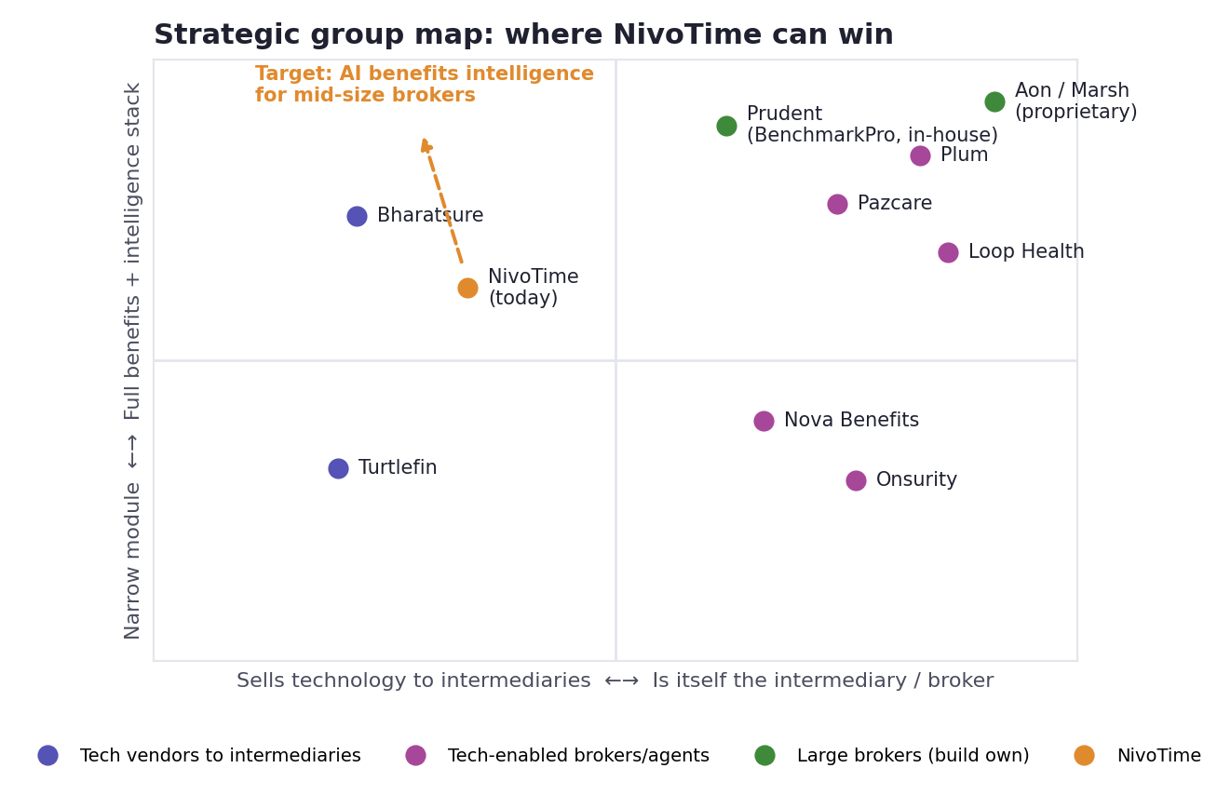
Strategic group map
- Top right is crowded and funded: Plum, Pazcare and Loop compete by being the broker.
- Large brokers build their own: Prudent and the global majors are not buyers.
- Top left is thin: only Bharatsure sells a full stack to intermediaries, and it leads on claims and administration, not on intelligence.
- So what: NivoTime should move up, into “benefits intelligence for intermediaries”, not right into competing with its own potential customers.

5.4 Win/loss view (outside-in proxy)
No deal history was available, so this is a proxy based on what a broker would see when evaluating NivoTime today.
Likely reason a broker says “no” | Evidence | Fix
“We have never heard of you” | No logos, case studies or press | One named pilot → public case study
“Is our client data safe?” | Login on raw IP over HTTP at the time of research [1] | Secure domain, ISO 27001 roadmap, DPDP controls
“What exactly does it cost?” | No public pricing | Simple published packages (Section 9.5)
“How is this better than Excel or Bharatsure?” | Features not shown publicly | Live demo of the Benchmarking Cockpit on the broker’s own data
Validation: replace this proxy with a review of NivoTime’s last 10–20 opportunities once available (Appendix B).

6. Internal Diagnosis

6.1 VRIO — which resources can create an advantage
Resource | Valuable | Rare | Hard to copy | Organised | Verdict
Founder’s 20+ year insurance and broking network [1][43] | Yes | Somewhat | Moderately | Partly (founder-dependent) | Temporary advantage; must be systemised
Benefits analytics know-how (claims review, MIS, benchmarking) | Yes | Yes, in the mid-size broker segment | Yes, once data accumulates | Not yet productised | Sustained advantage if turned into a data product
Existing Flex / TPA integration code | Yes | No | No | Yes | Parity
Multi-line service breadth | Unclear | No | No | Spread thin | Weakness dressed as strength

6.2 SWOT to TOWS
 | Opportunities — Bima Sugam push; medical trend 11.5–12.9%; ~600+ mid-size brokers with no tools; AI now cheap to build | Threats — Tech-first brokers; large brokers build in-house; well-funded rivals; data-privacy rules
Strengths — Insurance-domain founder; analytics know-how; existing integrations | SO: Launch an AI Benchmarking Cockpit for mid-size brokers, using the founder’s network for the first 10 meetings. | ST: Position as the broker’s ally (“stay independent, look like Plum”), never as a rival broker.
Weaknesses — No proof points; unclear focus; small team; security gap | WO: Run 90-day pilots that create public case studies; publish an annual benchmark report. | WT: Fix security and DPDP basics first; stay out of regulated comparison activity; cap custom work.

6.3 The problem statement
NivoTime has more capability than proof, and more products than focus. Its most valuable asset, benefits analytics know-how, is not packaged as a product, while its public story is spread across four businesses. Mid-size brokers need exactly this intelligence and have no one selling it to them.
This is the bridge to Section C: what product should NivoTime build and sell?

SECTION C — THE FLAGSHIP RECOMMENDATION

7. The NivoTime Benefits Intelligence Suite

7.1 The customer problem
For a mid-size broker’s account manager, renewal season looks like this:
- Collect claims data, census and the expiring policy from the employer and the TPA, usually as Excel and PDF files.
- Request quotes from 4–6 insurers; each arrives in a different format.
- Re-type the terms (sum insured, room-rent cap, co-pay, maternity, sub-limits, exclusions) into a comparison sheet by hand.
- Try to answer the HR head’s question, “Are we paying more than similar companies?”, without any reliable peer data.
- Do all this for many clients at once, while commissions face scrutiny [12] and costs rise 11.5–12.9% a year [8][9].
Jobs to be done
Buyer | Job | What gets in the way
Broker leadership | “Help me look as sharp as Plum or Prudent to my clients, without becoming a tech company.” | Building is expensive; no product exists for mid-size brokers
Broker account manager | “Get my renewal pack ready in hours, not weeks.” | Manual quote comparison and data cleaning
Employer HR / CFO | “Prove our benefits are competitive and control next year’s premium.” | No peer benchmarks; renewal surprises
Employee | “Understand and use my benefits without logging in to another portal.” | Low awareness; forgotten benefits

7.2 The product: five modules, one data layer
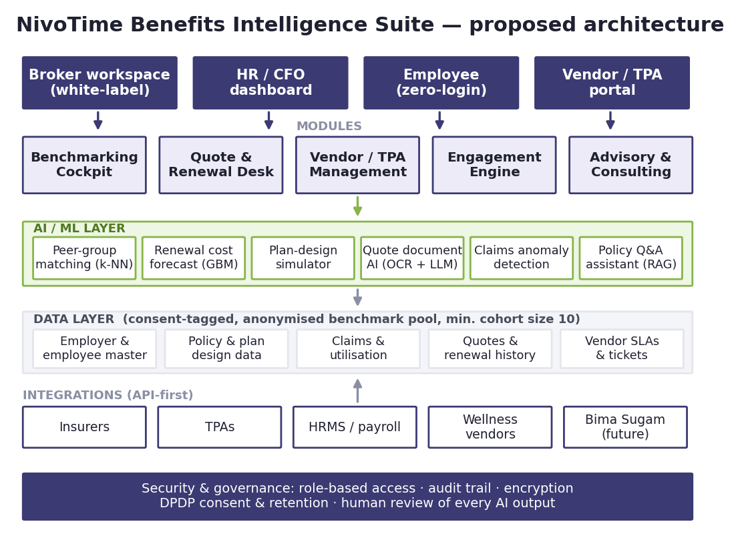
Proposed architecture of the Benefits Intelligence Suite
Module | What it does | Who uses it
1. Benchmarking Cockpit | Real-time peer comparison with filters for co-pay, company size, industry, family cover, sum insured, premium and claims; percentile scores; AI renewal insights | Broker, HR, CFO
2. Quote & Renewal Desk | Upload insurer quotes (PDF/Excel), AI extracts and normalises terms, side-by-side comparison, flags worse-than-expiring terms, renewal calendar and decision log | Broker account manager
3. Vendor / TPA Management | Single register of insurers, TPAs and wellness vendors; SLA and turnaround tracking; issue tickets; vendor scorecards | Broker, HR
4. Engagement Engine (zero-login) | Event-driven nudges by email, WhatsApp or push (enrolment, dependants, renewal, unused benefits); secure deep links; login only for sensitive actions | Employees, HR
5. Advisory & Consulting | Human-led renewal strategy, plan redesign and annual benefits review, powered by the platform’s data | Broker (co-branded) or employer

7.3 The AI/ML layer — practical models, not an “AI” label
# | Model | Method | Input data | Output | Quality bar before launch
1 | Peer-group matching | k-nearest neighbours on industry, size, location, age mix, family definition | Employer profile, policy data | A peer set of comparable companies | Minimum 10 companies per peer set (privacy and stability)
2 | Renewal cost forecast | Gradient-boosted trees (e.g. XGBoost) with explainable drivers (SHAP) | Claims history, demographics, medical trend | Expected renewal loading with a range, and top cost drivers | Forecast error within ±5 points on back-tested renewals
3 | Plan-design simulator | Rule-based rating logic + model 2 | Current plan, proposed changes | “What if” premium impact of changes such as co-pay or room-rent caps | Broker sign-off on every scenario shown to a client
4 | Quote document AI | OCR + large language model extraction into a fixed schema | Insurer quote PDFs and Excel files | Structured, comparable terms with confidence scores | ≥95% field accuracy; low-confidence fields sent for human review
5 | Claims anomaly flags | Isolation forest / rule engine | Claims line items | Unusual claims patterns for review | Flags are advisory only; no automatic decisions
6 | Policy Q&A assistant | Retrieval-augmented generation over the employer’s own policy documents | Policy wording, FAQs | Plain-language answers for employees and HR | Answers cite the policy clause; sensitive queries escalate to a human
Why these six: each replaces a manual task with a measurable time or cost baseline (renewal preparation hours, quote re-typing, HR queries). This follows the principle “use AI for work, not as a marketing label”. Industry evidence supports the size of the prize: McKinsey estimates 10–20% gains in agent productivity from AI in insurance distribution [28]; BCG reports 30%+ productivity gains from AI assistants in service and operations [29].

7.4 What the user sees
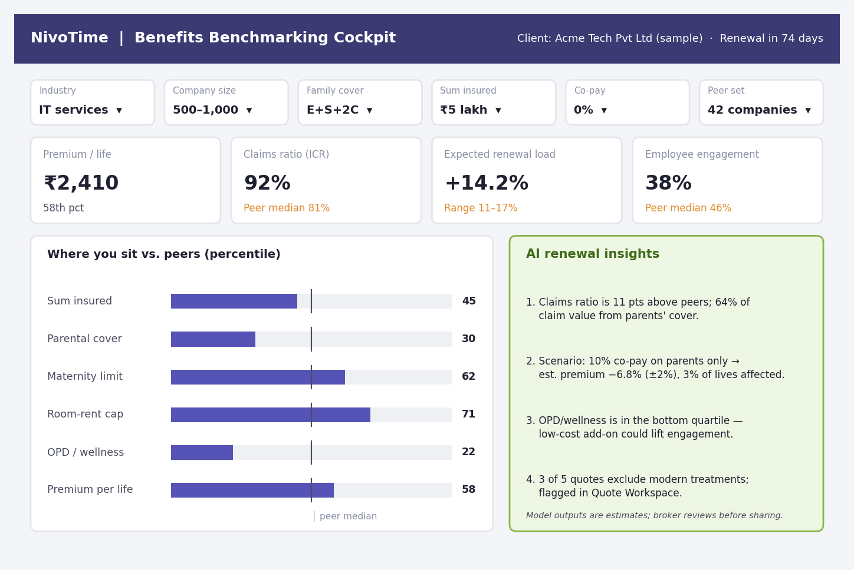
Mock-up: Benefits Benchmarking Cockpit (illustrative data)
The filters mirror NivoTime’s described dashboard (co-pay, company size, family cover, sum insured). All data shown is illustrative.
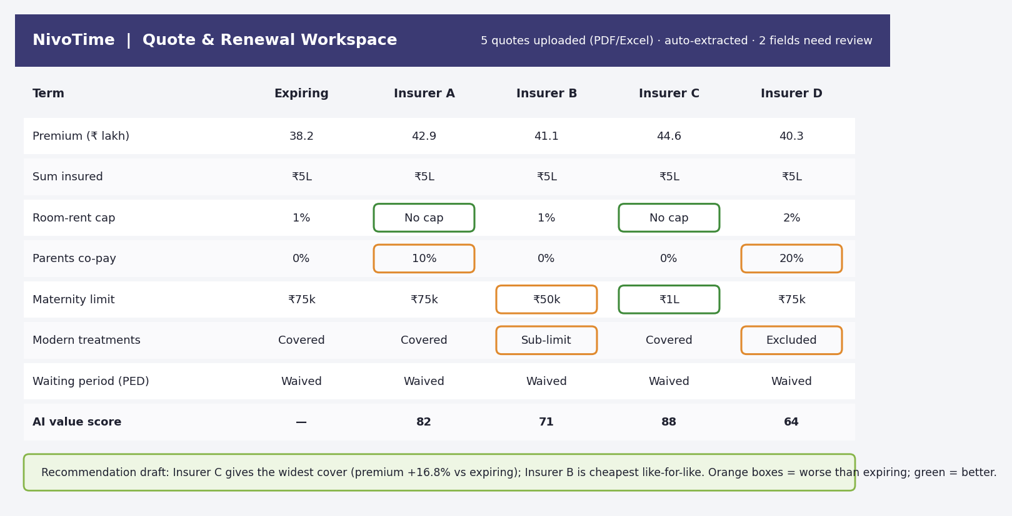
Mock-up: Quote & Renewal Desk (illustrative data)

7.5 Solving the data “cold start”
A benchmark is only as good as its data. This is the biggest execution risk, and the plan must address it openly.
Stage | Data source | What it enables
Day 1 | Public data: IRDAI and GI Council aggregates, insurer product filings, published broker and consultant surveys [5][6][22][23] | Market-level context (premium per life, trends)
Months 1–6 | Each broker’s own book of clients (anonymised) | “Portfolio benchmarking” inside one broker, which works even with a single customer
Months 6–18 | Pooled, consented, anonymised data across brokers | True cross-market peer benchmarks, with minimum cohort sizes
Ongoing | Annual NivoTime–broker benefits survey | Plan-design data that claims data does not capture
Contract design: broker agreements should allow anonymised, aggregated use of data for benchmarking, with clear DPDP consent and retention rules [31][32]. This clause is the legal basis of the moat.

7.6 Where the suite differs from competitors
Kano view (to be tested in interviews)
Feature | Category | Why
Claims and TPA integration | Must-have | Every rival offers it
White-label branding for brokers | Must-have (broker path) | The broker’s brand must face the client
Quote comparison with AI extraction | Performance | More insurers and faster turnaround = more value
Peer benchmarking with filters | Delighter today, must-have within 2–3 years | Only large brokers have it now
AI renewal insights and plan simulator | Delighter | Not seen in any mid-size broker’s toolkit
ERRC grid (Blue Ocean)
Eliminate | Reduce | Raise | Create
Competing with brokers for the client relationship | Bespoke, one-off custom builds | Depth and transparency of benchmarking; data security | Pooled benchmark network for mid-size brokers; AI renewal pack; “Bima Sugam readiness” support

7.7 Build, partner or buy — and regulatory guardrails
Component | Recommendation | Reason
Benchmarking logic, data model, broker workspace | Build | This is the core IP and the moat
OCR and language models | Use existing cloud APIs | Commodity capability; pay per use keeps cost low
HRMS / payroll connectors | Partner | Many HRMS tools already offer APIs
Security certification (ISO 27001) | Buy advisory support | Faster credibility with brokers
Regulatory guardrails built into the design
- NivoTime acts as a technology service provider to licensed brokers. The broker, not NivoTime, presents quotes and advice to the client. This avoids operating as an unlicensed web aggregator [33].
- NivoTime’s own licence status and the exact boundary for white-label comparison tools should be confirmed by legal counsel before launch. Public records reviewed show no IRDAI broker or corporate-agent registration for NivoTime.
- Every AI output shown to a client is reviewed by a human, in line with emerging IRDAI attention to AI governance [35].

7.8 Why this is defensible: the data flywheel
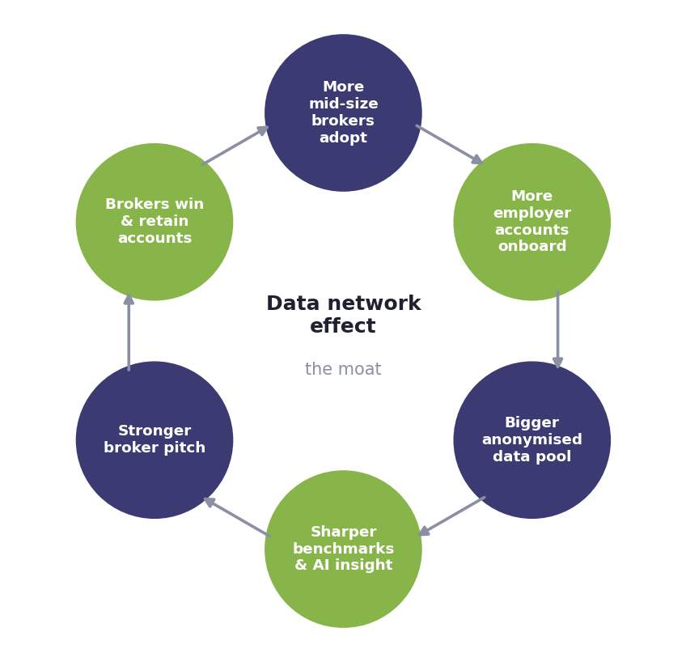
Broker data network flywheel
- Each new broker adds anonymised data, which sharpens benchmarks for every broker.
- A single broker cannot copy a cross-market benchmark; only a neutral platform can build one.
- This is the same logic that let Employee Navigator and Zywave scale through thousands of brokers in the US [24][25].

7.9 Options screened
Criterion (weight) | A. AI Benefits Intelligence Suite via brokers | B. Direct-only Flex platform | C. Bima Sugam integration module only | D. GCC expansion (ZOYAME)
Strength of need (30%) | 5 | 3 | 3 | 2
Fit with current capability (20%) | 4 | 4 | 3 | 1
Revenue potential (20%) | 4 | 2 | 2 | 3
Speed to launch (15%) | 3 | 4 | 2 | 1
Defensibility (15%) | 5 | 1 | 3 | 2
Weighted score (out of 5) | 4.30 | 2.85 | 2.65 | 1.85
Scores are the author’s judgement from the evidence in Sections 3–6; they should be re-scored with NivoTime management. Option C is folded into A as a feature; Option D is deferred until the core business has proof points.

SECTION D — CUSTOMER TARGETING

8. Segmentation, Market Size and Ideal Customer

8.1 Decision on the customer framing
The mentor’s original split, broker path vs. company path, holds up well against the evidence and is kept, with two refinements:
- The broker channel is the primary growth multiplier. One broker can bring 20–40 employer accounts.
- The employer path is a validation and reference engine, not a volume engine. Direct wins prove the product and produce case studies that help the broker sale.
- Custom IT services are treated as a separate, controlled revenue line, not a customer path for the suite.

8.2 Segmentation
Broker path
Segment | Description | Fit | Why
Global and large Indian brokers | Aon, Marsh/MMB, WTW, Prudent and similar | Low | Build their own tools [22][46]
Tech-first brokers | Plum, Pazcare, Loop, Nova | Low | They are competitors [42]
Mid-size composite and direct brokers | Active group-health book, no in-house tech team | Primary | Cannot build; under pressure to look modern; Bima Sugam push [30]
Small and regional brokers | Mostly retail or motor, few corporate clients | Later | Low budget; a light package later
Employer path
Segment | Fit | Why
Mid-market employers (250–2,000 staff) | Primary | Complex enough to need benchmarking; too small for top-tier broker attention
Large enterprises (2,000+) | Via brokers | Usually tied to a large broker
Small firms (<250) | Low | Price-sensitive; well served by Onsurity-type offers [16]

8.3 Market sizing (TAM, SAM, SOM)
Broker path (bottom-up, the more reliable method)
Level | Definition | Size | Basis
TAM | All IRDAI-licensed brokers | 751 brokers | [10]
SAM | Mid-size brokers with a group-health book (excludes reinsurance, large and tech-first brokers) | ~600 brokers → ~₹29 cr/year software pool | 600 × ₹4.8 lakh ARR (A2, A4)
SOM (Year 3) | Base case | 15 brokers (2.5% of SAM) → ~₹60 lakh recurring | Section 13 model
Top-down cross-check: if every one of the 27.51 crore group lives [5] were served by similar tooling at ~₹27 per life a year (the per-life equivalent of the broker price), the theoretical ceiling would be ~₹750 crore a year (Est.). The gap between ₹29 cr and ₹750 cr shows that most group lives sit with large brokers and insurers, which is why the mid-size segment is underserved.
Employer path
Level | Size | Basis
TAM | 7.66 lakh EPFO-contributing establishments (FY24, all sizes) | [11]
SAM | Employers with 250–2,000 staff and a group-health policy | Not publicly available; to be built from a data provider
SOM (Year 3) | 18 direct clients from a named list of 150 target accounts | Section 13 model

8.4 Ideal customer profiles
Broker ICP
- IRDAI-licensed direct or composite broker, mid-size, with a group-health / employee-benefits practice
- 15–60 corporate clients; no in-house benchmarking or quote tool
- Leadership worried about losing clients to tech-first brokers
- Trigger events: lost a client to Plum/Pazcare/Loop; new digital head hired; Bima Sugam readiness project; licence conversion under the 2026 rules [34]
- Negative signals: already using Bharatsure’s full stack; mostly retail or motor business
Employer ICP
- 250–2,000 employees, in IT, BFSI, pharma, manufacturing or professional services
- Group health renewal is a material cost; claims ratio above 85%
- HR runs benefits on spreadsheets, email and multiple portals
- Trigger events: renewal in the next 3–6 months; large premium increase last year; new CHRO or CFO

8.5 Buying committee
Role | Broker path | Employer path
Economic buyer | Broker CEO / MD | CFO or CHRO
Champion | Head of employee benefits / digital | Head of Total Rewards / HR Ops
Users | Account managers, servicing team | HR team, employees
Technical evaluator | IT / compliance lead | IT / information security
Likely blocker | “We will build it” instinct; existing vendor | Incumbent broker; procurement

8.6 Industry playbooks (second-phase differentiation)
Industry | Benefit themes to package
IT / technology | Young workforce, mental wellness, parental cover flexibility, digital-first communication
Manufacturing | Large, shift-based workforce, dependants’ cover, offline-to-digital servicing, multilingual nudges
BFSI | High expectations of employee experience, executive benefits, analytics
Pharma and healthcare | Family benefits, preventive health, compliance-sensitive workflows
Each playbook is a configuration (templates, benchmarks, nudges) on the same platform, not a separate product. Validate each with broker and employer interviews before building.

SECTION E — GO-TO-MARKET AND SALES ENGINE

9. Go-to-Market Strategy

9.1 Positioning
Broker path
For mid-size insurance brokers who want to compete with tech-first brokers, NivoTime is a white-label benefits intelligence platform that turns renewals into a sales advantage with AI benchmarking and quote comparison. Unlike building in-house or using spreadsheets, it is ready now, carries the broker’s brand, and gets smarter with every broker on the network.
Employer path
For HR and finance leaders at mid-market companies, NivoTime shows whether your benefits are competitive and what next year’s renewal should cost, before the insurer tells you.

9.2 Messaging pyramid
Level | Message | Proof needed
Core promise | “Win the renewal before it starts.” | Pilot results
Pillar 1: Speed | Renewal pack in hours, not weeks | Time saved per account in pilots (target: 50% [45])
Pillar 2: Insight | Peer benchmarks by co-pay, size, family cover and sum insured | Live demo on the client’s own data
Pillar 3: Independence | The broker keeps the brand and the client | White-label demo; contract terms
Pillar 4: Trust | Secure, DPDP-ready, human-reviewed AI | Security certificate, audit trail

9.3 Go-to-market motion
Path | Motion | Why
Broker | Sales-led, founder-assisted, moving to partner-led once 10+ brokers are live | High value, few buyers, several decision makers
Employer | Hybrid: content and a free “benefits health check” create demand; inside sales converts | Mid-size deals; buyers research online first

9.4 Three acquisition engines
Engine | Approach | Offer
Account-based marketing | Named list of 100 mid-size brokers and 150 employers; personalised LinkedIn and email outreach; founder introductions | Free 30-minute benefits health check with a benchmark snapshot
Broker pilot programme | 90-day white-label pilot on 3 of the broker’s clients | Pilot fee credited against the first-year contract
Thought leadership | Quarterly “India Benefits Pulse” and an annual benchmark report from anonymised data; webinars with broker partners | Report download in exchange for contact details

9.5 Packaging and pricing (proposed)
Package | For | Structure (A4, A5)
Broker Workspace | Mid-size brokers | ₹1.8 lakh/year + ₹5,000 per active employer account + ₹10 per engaged employee life
Employer Essentials | 250–750 staff | ₹60 per covered life/year (≈₹5 per employee per month) + onboarding
Employer Growth | 750–2,000 staff | Essentials + engagement engine + analytics add-ons
Renewal Advisory Pack | Any client | ₹75,000 per renewal engagement
Implementation | All | ₹3 lakh (broker), ₹75,000 (employer), one-time
Customer value check (illustrative)
- Broker with 40 clients: fee ~₹6.6 lakh/year. Estimated value ~₹10.1 lakh/year: 600 hours saved on renewals and quotes (~₹4.2 lakh at ₹700/hour), 2 accounts retained (~₹2.3 lakh brokerage) and 3 accounts won (~₹3.5 lakh) (A13). ~1.5x return.
- Employer with 700 staff: premium ~₹15.6 lakh; fee ₹42,000. The platform pays for itself if benchmarking and plan redesign cut the renewal by 2.7% of premium, against a medical trend of 11.5–12.9% [8][9].

9.6 Launch sequence
- Soft launch (months 3–6): pilots only, no public pricing.
- Proof launch (months 6–9): first case study, benchmark report, public packages.
- Channel launch (months 9–12): broker referral programme; presence at broker events.

10. Sales Engine

10.1 Two sales processes
Broker path (target cycle: 3–5 months)
Stage | What happens | Exit criterion | Owner
1. Target | Named broker researched; trigger event identified | ICP fit confirmed | Sales / founder
2. Engage | Founder intro or ABM outreach | Meeting booked | Founder
3. Discover | Current renewal process, client count, tools, pain | Pain quantified | Sales + product
4. Demo | Cockpit and Quote Desk on the broker’s own sample data | Champion confirms value | Product
5. Pilot | 90 days, 3 of the broker’s clients, agreed success metrics | Metrics met | Customer success
6. Paper process | Commercials, data-processing agreement, security review | Signed contract | Founder
7. Expand | Roll out to all clients; referrals to other brokers | 50%+ of clients live | Customer success
Employer path (target cycle: 1–2 months)
Stage | What happens | Exit criterion
1. Attract | Health-check offer, content, referral | Health check booked
2. Qualify (BANT) | Budget, authority, need, renewal timing | Renewal within 6 months
3. Health check | Benchmark snapshot on their own data | Gap agreed with HR/CFO
4. Proposal | Package and price | Offer accepted
5. Onboard | Data upload, employee launch | First value delivered

10.2 Qualification
- Broker path → MEDDIC (Metrics, Economic buyer, Decision criteria, Decision process, Identify pain, Champion): several stakeholders, a formal security review and a longer cycle.
- Employer path → BANT (Budget, Authority, Need, Timing): smaller, faster deals where renewal timing is the key filter.

10.3 Objection handling
Objection | Response
“We have never heard of NivoTime.” | “Start with a free health check on one client. Judge us on your own data.”
“We can do this in Excel.” | “You can, and it takes weeks per renewal. The pilot measures the hours saved.”
“Is our client data safe?” | Show security controls, the DPDP-aligned data agreement and audit trail.
“Will you go around us to our clients?” | White-label by design; contractual non-solicit; NivoTime never holds an intermediary licence to sell insurance.
“What if the AI gets it wrong?” | Every output carries a confidence score and is reviewed by the broker before it reaches a client.

10.4 Funnel and pipeline arithmetic
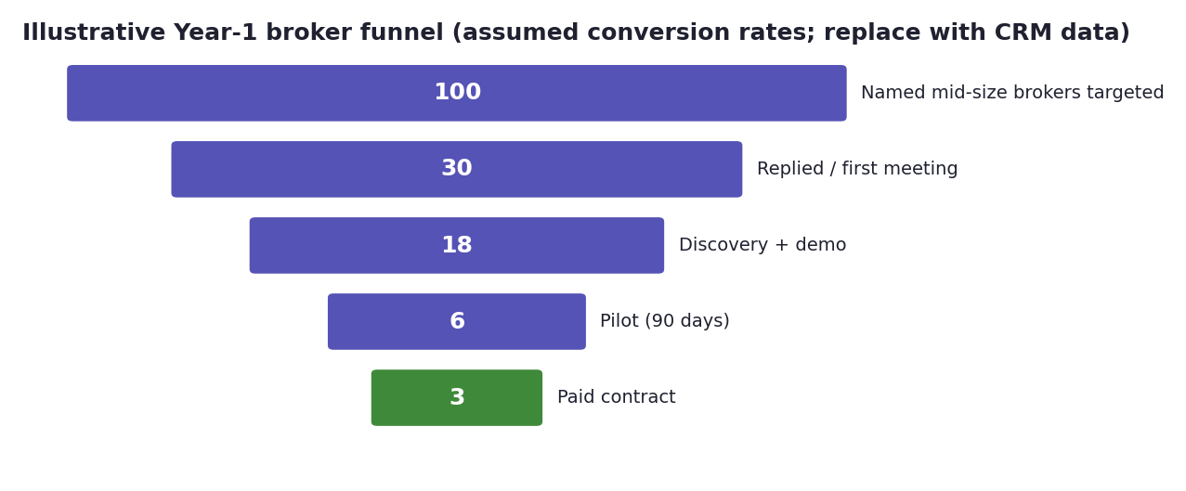
Illustrative Year-1 broker funnel
Funnel (Year 1, illustrative) | Broker path | Employer path
Named accounts targeted | 100 | 150
First meeting (30% / 20%) | 30 | 30
Demo or health check | 18 | 15
Pilot | 6 | 6
Won (50% / 67% of pilots) | 3 | 4
Conversion rates are assumptions for planning (A14). Cold outreach reply rates in B2B are often in the low single digits, so warm founder introductions matter.
Pipeline formula: Revenue = accounts targeted × meeting rate × pilot rate × win rate × average contract value. Every term becomes a tracked CRM field from month 1.

SECTION F — ONBOARDING AND CUSTOMER EXPERIENCE

11. Onboarding, Engagement and Experience

11.1 Broker onboarding journey
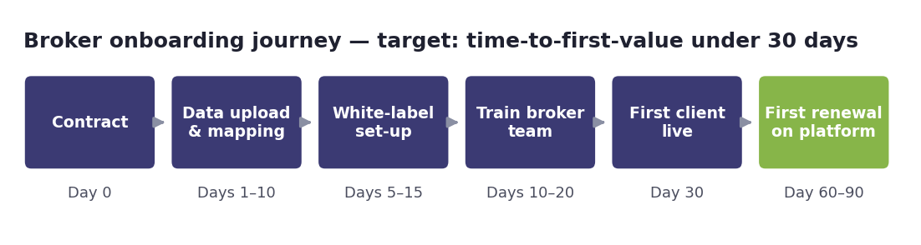
Broker onboarding journey
Metric | Target
Time to first value (first client live) | ≤30 days
Onboarding completion | 100% of pilot clients within 45 days
Activation (broker users logging in weekly) | ≥70% by day 60
First renewal run on the platform | Within 90 days

11.2 Zero-login employee engagement
Employees rarely log in to benefits portals. If they do not engage, the employer sees little value and the platform is at risk at renewal. The fix is to bring benefits to the employee, not the other way round.
- Event-driven nudges: welcome, dependant addition, policy card ready, renewal window, unused wellness benefits, claim status.
- Channels: email, WhatsApp or app push, through employer-approved channels.
- Secure deep links: one tap to the exact action; login only for sensitive or transactional steps. “Zero-login” means zero routine navigation, not zero security.
- Measure: activation rate, notification action rate, benefit discovery, completion of enrolment tasks, and HR queries per 100 employees.

11.3 Customer journey pain points (employer via broker)
Stage | Pain point today | Suite response
Awareness | Benefits seen as a cost, not a lever | Benchmark snapshot shows the gap
Consideration | No neutral data to compare plans | Peer benchmarks and plan simulator
Purchase / renewal | Quotes in different formats; slow comparison | Quote & Renewal Desk
Onboarding | Census errors, missing dependants | Data validation and nudges
Support | Claims delays, unclear status | Vendor/TPA SLA tracking
Renewal | Surprise premium increases | Renewal forecast 90 days ahead

SECTION G — DATA, TECHNOLOGY AND AI

12. Data, Technology and AI Architecture

12.1 Go-to-market data flow
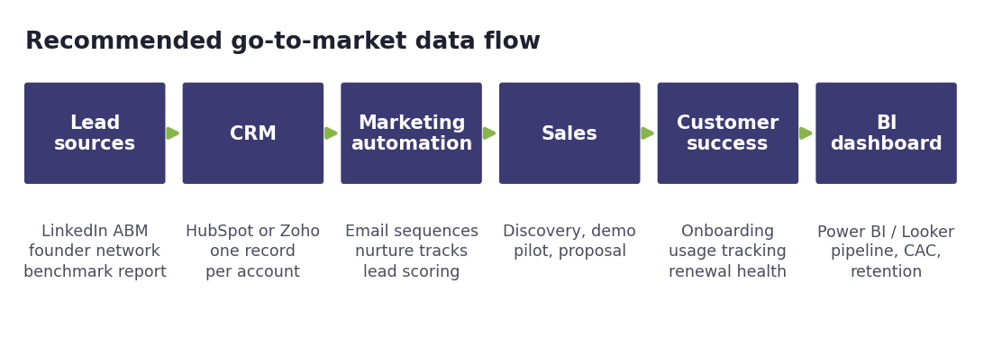
Recommended go-to-market data flow
Recommended stack (NivoTime’s current tools were not disclosed, so this is a proposal, not an audit)
Layer | Recommended tool | Why
CRM | HubSpot (free/starter) or Zoho CRM | Low cost, fast to set up, good for a small team
Marketing automation | HubSpot sequences / Zoho Campaigns | Same record as the CRM
Product analytics | Mixpanel or open-source PostHog | Track activation and feature use
BI and reporting | Power BI or Looker Studio | Pipeline, CAC, retention dashboards
Workflow automation | Zapier or Make | Connect forms, CRM and email without code
AI services | Cloud OCR + large language model APIs | Pay per use; no model training up front

12.2 Management dashboards
Dashboard | Key measures
Sales | Pipeline by stage and path, win rate, sales cycle, average contract value, lost reasons
Marketing | Leads by source, cost per lead, CAC, content downloads, health checks booked
Customer | Activation, engagement, NPS/CSAT, renewal rate, net revenue retention
Product and AI | Extraction accuracy, forecast error, time saved per renewal, model review overrides
Strategy | % revenue from the suite vs. services; % engineering time on reusable product

12.3 AI opportunity matrix for NivoTime’s own growth engine
Area | AI use case | How it works | Estimated benefit (illustrative)
Marketing | Benchmark insight content | Model drafts the quarterly “Benefits Pulse” from anonymised data; human edits | ~50% less writing time
Marketing | ABM account research | AI summarises each target broker’s website, news and LinkedIn before outreach | 20–30 minutes saved per account
Sales | Account fit scoring | Scores accounts on ICP fit and trigger events | Better focus of founder time
Sales | Call notes to CRM | Automatic call summary and next steps | ~1 hour saved per rep per day
Customer success | Census mapping assistant | Maps messy employer files to the standard template | Onboarding time cut from days to hours
Customer success | Renewal risk score | Flags low-engagement clients 90 days before renewal | Earlier save actions, lower churn

12.4 Security, privacy and governance
- Move all portals to a branded domain over HTTPS immediately (quick win).
- Role-based access, encryption at rest and in transit, full audit trail.
- DPDP readiness before May 2027: consent records, data-processing agreements with brokers, breach response plan, retention rules [31][32].
- CERT-In incident reporting within 6 hours; logs retained for 180 days [36].
- AI governance: human review, confidence scores, bias and accuracy checks each quarter, and a log of every client-facing AI output [35].
- Target ISO 27001 certification within 12–18 months.

SECTION H — IMPLEMENTATION, FINANCIALS AND RISK

13. Implementation, Financials and Risk

13.1 Gap analysis: current state vs. target state
Area | Current state (public evidence) | Target state (12 months)
Positioning | Four business stories; deck leads with IT services | One story: benefits intelligence for brokers
Product | Features described, live status not public | Demoable suite; live vs. roadmap clearly labelled
Proof | No named clients or case studies | 2 case studies, 1 benchmark report
Pricing | Not published | 4 published packages
Sales process | Founder-led, CRM status unknown | CRM with defined stages; weekly pipeline review
Lead generation | Network and referrals | ABM + health-check offer + content
Security | Login on raw IP over HTTP at time of research | HTTPS, audit trail, DPDP controls, ISO 27001 in progress
Data | No benchmark dataset | Consented, anonymised benchmark pool
Reporting | Not visible | BI dashboards for sales, customers and product

13.2 Roadmap
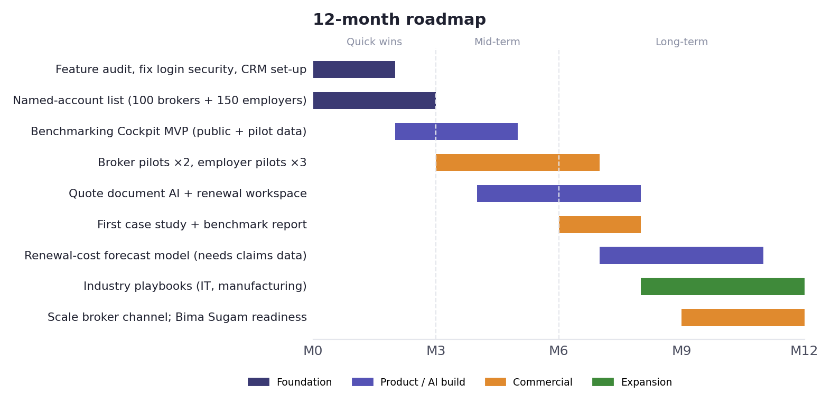
12-month roadmap
Phase | Timing | Actions | Owner
Quick wins | Months 0–3 | Feature audit (live / pilot / roadmap); fix login security; set up CRM; build named lists; product governance rule | Founder, IT Head
Mid-term | Months 3–6 | Benchmarking Cockpit MVP; 2 broker and 3 employer pilots; quote document AI prototype | Product, founder
Long-term | Months 6–12 | Quote & Renewal Desk live; first case study and benchmark report; renewal forecast model; industry playbooks; broker referral programme | Leadership
Beyond 12 months | Year 2+ | Bima Sugam readiness features; more integrations; revisit GCC (ZOYAME) once India proof exists | Leadership
Product governance rule: every custom request is classified as Core product / Configurable / Paid customisation / Reject. Custom work is accepted only if it earns cash, wins a strategic account, creates reusable IP or adds integration capability. This stops one-off projects from pulling the roadmap apart.

13.3 Financial case (illustrative)
Every number below is an outside-in estimate built on the assumptions in Appendix A. It shows the shape of the business and the key levers; it is not a forecast of NivoTime’s actual results.
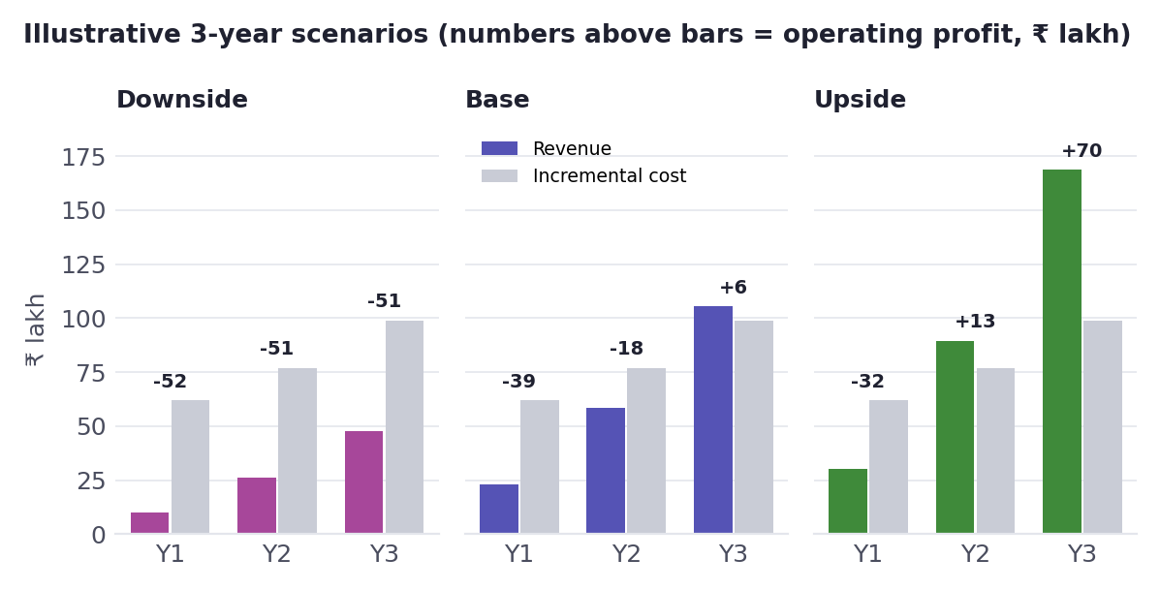
Illustrative three-year scenarios
Base case
₹ lakh | Year 1 | Year 2 | Year 3
Brokers on platform (cumulative) | 3 | 8 | 15
Direct employers (cumulative) | 4 | 10 | 18
Covered lives on platform | 18,550 | 70,000 | 1,63,100
Recurring revenue | 7.1 | 29.4 | 60.4
Implementation fees | 12.0 | 19.5 | 27.0
Advisory packs | 3.8 | 9.8 | 18.0
Total revenue | 22.8 | 58.6 | 105.4
Incremental cost (team, cloud and AI, sales, security) | 62.0 | 77.0 | 99.0
Operating result | −39.2 | −18.4 | +6.4
Scenarios (Year 3)
 | Downside | Base | Upside
Brokers / employers | 6 / 14 | 15 / 18 | 24 / 26
Revenue | ₹47.6 lakh | ₹105.4 lakh | ₹168.7 lakh
Operating result | −₹51.4 lakh | +₹6.4 lakh | +₹69.7 lakh
Sensitivity of Year-3 base result (₹6.4 lakh)
Change | Year-3 result
Recurring prices −20% | −₹5.7 lakh
Recurring prices +20% | +₹18.4 lakh
30% fewer brokers | −₹22.5 lakh
Costs +20% | −₹13.4 lakh
No advisory revenue | −₹11.6 lakh
What the numbers say
- Investment need: about ₹58 lakh of cumulative losses in Years 1–2 in the base case. This is fundable from services cash flow, which is exactly why services should be kept as a controlled “funding engine”.
- The biggest lever is broker count, not price. A 30% shortfall in brokers hurts more than a 20% price cut. Go-to-market execution matters most.
- Advisory revenue matters early. Human-led renewal advisory bridges the gap until recurring revenue scales, and it uses NivoTime’s existing consulting strength.
- In the downside case, stop and rethink by month 18 if fewer than 3 brokers have converted (see kill criteria in Section 15).

13.4 KPI scorecard
Dimension | KPI | 12-month target
Growth | Brokers signed / employers signed | 3 / 4
Pipeline | Qualified broker opportunities | 18
Product | Quote extraction accuracy | ≥95%
Product | Time saved per renewal (pilot) | ≥50%
Customer | Pilot-to-paid conversion | ≥50%
Customer | Employee activation (zero-login) | ≥60% of eligible employees
Proof | Public case studies | 2
Strategy | Share of engineering time on reusable product | ≥60%
Economics | CAC payback | ≤12 months

13.5 Risk register
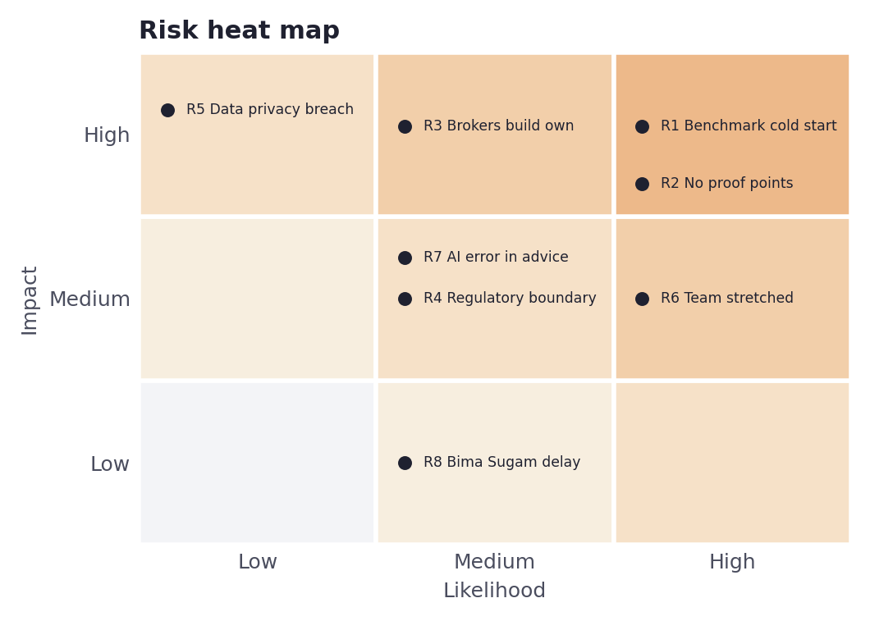
Risk heat map
# | Risk | Likelihood / impact | Mitigation | Early warning
R1 | Benchmark cold start: not enough data | High / High | Start with portfolio benchmarking and public data; pooled-data clause in contracts (7.5) | Peer sets below 10 companies
R2 | No proof points slows every deal | High / High | Pilot-first offer; case study by month 9 | Pilots decline to be named
R3 | Brokers build or buy elsewhere | Medium / High | Move fast on the mid-size segment; network-effect pricing | Target broker announces own tool
R4 | Regulatory boundary on comparison and advice | Medium / Medium | Broker-facing tool only; legal opinion before launch [33] | Any client-facing comparison without a broker
R5 | Data privacy breach | Low / High | Security-by-design, DPDP controls, ISO 27001 [31][36] | Security review findings
R6 | Small team stretched across four lines | High / Medium | Product governance rule; ring-fenced suite team | Pilot deadlines slip
R7 | AI error reaches a client | Medium / Medium | Confidence scores, human review, audit log [35] | Rising review overrides
R8 | Bima Sugam delay or scope change | Medium / Low | Treat as a feature, not the core pitch [30] | Launch date moves again

13.6 Governance
Activity | Responsible | Accountable | Consulted | Informed
Product roadmap and governance rule | Product lead | Founder / CEO | Sales, IT Head | Team
Broker sales and pilots | Sales lead | Founder / CEO | Product | Leadership
Data, security and DPDP | IT Head | Founder / CEO | Legal counsel | Brokers
AI model quality | Data / AI engineer | IT Head | Brokers (pilot) | Leadership
KPI review (monthly) | Sales lead | Founder / CEO | All leads | Team

14. Conclusion and Recommendations
NivoTime does not lack ideas or features. It lacks focus and proof. The research points to one clear direction:
- Focus on benefits intelligence. Make the InsurTech / employee-benefits platform the core; run IT services as a controlled funding and implementation engine.
- Build the Benefits Intelligence Suite around the capabilities NivoTime already describes (benchmarking dashboard with co-pay, company-size, family and sum-insured filters; vendor management; quote comparison; consulting), made smarter with six practical AI/ML models.
- Sell through mid-size brokers first. They cannot build this, they are under pressure from tech-first brokers, and each one brings many employer accounts. Use direct employer wins as proof.
- Win on data, not code. A consented, anonymised benchmark pool that grows with every broker is the moat.
- Prove before scaling. Pilots, a case study and a benchmark report within 9 months; clear kill criteria if the broker channel does not convert.
If executed well, the base case reaches break-even for the suite in Year 3 with 15 brokers and 18 direct employers, and positions NivoTime as the neutral intelligence layer for India’s mid-size broker community.

15. Limitations and Validation Plan
Limitations
- NivoTime’s internal data (pricing, costs, customers, pipeline, win/loss, live feature status and integration count) was not available. Financials are therefore illustrative, and all assumptions are listed in Appendix A.
- Some features (benchmarking dashboard filters, vendor management, quote comparison) are based on company inputs and could not be verified publicly.
- Regulatory interpretations are based on published summaries and should be confirmed by legal counsel.
- Competitor information reflects public websites and press as of September 2026 and may be incomplete.
Validation plan
What to validate | Method | Decision rule
Broker pain and willingness to pay | 10–15 broker interviews; 2 pilots | ≥60% rate the renewal pain 4/5 or higher; ≥1 pilot converts
Employer value | 5–10 HR/CFO interviews; 3 health checks | ≥2 health checks lead to a pilot
Product performance | Pilot measurement | ≥50% renewal time saved; ≥95% extraction accuracy
Economics | Actual CAC, pricing and cost data | CAC payback ≤12 months
Kill / pivot criteria | Month-18 review | Fewer than 3 paying brokers → pivot to direct employer analytics or advisory-led model

Appendix A: Assumptions Register
# | Assumption | Value used | Reasoning / source
A1 | Average group premium per life | ₹2,233/year | ₹61,435 cr ÷ 27.51 cr lives, FY25 [5]
A2 | Addressable mid-size brokers | ~600 | 751 licensed [10], minus reinsurance, large and tech-first brokers (Est.)
A3 | Broker brokerage on group health | 7.5% of premium | Conservative planning figure; actual rates vary by contract
A4 | Broker pricing | ₹1.8 lakh/yr + ₹5,000/account + ₹10/engaged life | Set at ~15–20% of broker revenue on the lives served
A5 | Direct employer pricing | ₹60 per life per year | ~2.7% of premium per life; must be covered by renewal savings
A6 | Implementation fees | ₹3 lakh broker; ₹75,000 employer | Covers data mapping and set-up effort
A7 | Advisory pack | ₹75,000 per engagement | Priced below typical consulting day rates
A8 | Mature broker size on platform | 25 accounts × 700 lives | Mid-size broker assumption
A9 | Broker ramp-up | 30% / 70% / 100% of mature lives in years 1/2/3 | Gradual client rollout
A10 | Gross margin | ~70% | Cloud, AI usage and support costs
A11 | Customer lifetime | 5 years | ~20% annual churn
A12 | Incremental cost | ₹62 / ₹77 / ₹99 lakh (Y1–Y3) | 3–5 new hires plus reallocated staff, cloud/AI, sales, security
A13 | Broker value inputs | 30 hours per account per renewal cycle; 50% saved; ₹700/hour; +2 retained and +3 won accounts | Time-saving anchored to published broker-tech results [26][45]
A14 | Funnel rates | Brokers: 30% meeting, 60% demo, 33% pilot, 50% win | Planning figures; replace with CRM data

Appendix B: Management Validation Checklist
Questions to close the remaining evidence gaps (grouped so one answer closes several gaps):
- Customers and pricing: How many paying InsurTech clients are there, split by broker and direct? What is the current pricing and average contract value?
- Costs: What are the monthly engineering, hosting and sales costs? What does it cost to win a broker vs. an employer?
- Product reality: Which features are live, in pilot, or on the roadmap? How many insurers and TPAs are integrated in production? Is the mobile app live?
- Pipeline: Is there a CRM or lead list? What happened in the last 10–20 opportunities, and why were deals lost?
- Brokers: Which brokers have been approached, and with what outcome?
- Focus: How is the team split across IT services, digital marketing, InsurTech and HealthTech? Is custom work a funding engine or a distraction?
- Regulation: Does NivoTime hold, or plan to seek, any IRDAI registration? Is any Bima Sugam work planned?
- International: What resources are committed to ZOYAME?

Appendix C: Pilot Scorecard
Pilot measure | Baseline | Target (90 days) | Actual | Status
Hours to prepare one renewal pack |  | −50%
Quote fields extracted correctly |  | ≥95%
Broker users active weekly |  | ≥70%
Employee activation |  | ≥60%
HR queries per 100 employees |  | −30%
Client-facing insights accepted without edits |  | ≥80%
Pilot converted to paid contract |  | Yes

Appendix D: Broker Pitch (60 seconds)
“Your biggest clients are being pitched by tech-first brokers who show them dashboards and benchmarks. You don’t need to build that. NivoTime gives you a white-label benefits intelligence platform: peer benchmarks by co-pay, company size, family cover and sum insured; AI that turns five insurer quotes into one comparison in minutes; and renewal forecasts before the insurer calls. Your brand, your client, our technology. Let’s run it on three of your clients for 90 days and measure the hours saved.”

References
All sources accessed September 2026 unless a date is shown.
Company sources
- NivoTime Pvt Ltd website: Home, About, Director Desk, InsurTech, Flex, Analytics, HealthTech, Employer and Employee pages. https://www.nivotime.com/
- NivoTime corporate pitch deck (company-provided), slides 2–6 and 8.
- ZaubaCorp, NivoTime Private Limited company record (CIN U72900MH2018PTC314348). https://www.zaubacorp.com/NIVOTIME-PRIVATE-LIMITED-U72900MH2018PTC314348
- NivoTime LinkedIn company page. https://in.linkedin.com/company/nivotime
Market and industry data
- Outlook, “Employer-led insurance becomes India’s main coverage engine: IRDAI Annual Report”, 17 Feb 2026. https://www.outlookindia.com/xhub/featured-insights/employer-led-insurance-becomes-indias-main-coverage-engine-irdai-annual-report
- CareEdge Ratings, “Non-Life Premiums in FY26 End at Rs 3.4 Lakh Cr; Health Segment Drives the Growth”, 21 Apr 2026. https://www.careratings.com/
- IRDAI Annual Report 2024-25, Table I.14 (claims ratios). https://lifeinscouncil.org/component/IRDAI%20Annual%20Report%202024-25.pdf
- Aon, “India outpaces global average with 2026 medical trend at 11.5 percent”, 11 Dec 2025. https://www.aon.com/apac/in-the-press/asia-newsroom/2025/india-outpaces-global-average-with-2026-medical-trend-at-11-5-percent-aon-reports
- WTW, “Asia Pacific medical inflation continues to soar in 2026”, Dec 2025. https://www.wtwco.com/en-in/insights/2025/12/asia-pacific-medical-inflation-continues-to-soar-in-2026
- Vaatun, “Insurance brokers in India” (count derived from the IRDAI broker register), Jul 2026. https://www.vaatun.com/insurance-brokers-india
- Business Standard, EPFO contributing establishments rise to 7.66 lakh in FY24 (Labour Ministry statement, EPFO Annual Report 2023-24), 11 Nov 2024.
- BusinessToday, “Insurance commissions grew up to 6 times faster than premiums: what IRDAI wants to change”, 26 Sep 2026. https://www.businesstoday.in/latest/corporate/story/insurance-commissions-grew-up-to-6-times-faster-than-premiums-what-irdai-wants-to-change-558050-2026-09-26
- Zee News, “Flexible health insurance surges by 300% in last 5 years in India: report” (Mercer Marsh Benefits), 11 Mar 2025. https://zeenews.india.com/personal-finance/flexible-health-insurance-surges-by-300-in-last-5-years-in-india-report-2870732.html
Competitors and global analogs
- Indian Startup News, “Insurtech startup Plum raises Rs 193 crore to scale AI-driven claims and employee benefits”, 26 Mar 2026. https://indianstartupnews.com/funding/insurtech-startup-plum-raises-rs-193-crore-to-scale-ai-driven-claims-and-employee-benefits-11265409
- ANI, “Loop Health hits 1 million lives as employers bet on prevention-led healthcare”, 12 Jan 2026. https://www.aninews.in/news/business/loop-health-hits-1-million-lives-as-employers-bet-on-prevention-led-healthcare20260112165407/
- Onsurity website. https://www.onsurity.com/
- Pazcare, “Product updates: simplifying group health insurance at scale” (Claims IQ), 8 Jun 2026. https://www.pazcare.com/blog/product-updates-simplifying-group-health-insurance-at-scale
- Bharatsure website. https://bharatsure.com/
- Turtlefin website. https://www.turtlefin.com/
- Business Standard, “Policybazaar for Business introduces ClaimSetu”, 1 Aug 2025. https://www.business-standard.com/content/press-releases-ani/policybazaar-for-business-introduces-claimsetu-india-s-first-ai-led-claims-insights-scoring-engine-for-group-health-insurance-claims-125080101370_1.html
- Indian Pharma Post, “Medi Assist unveils AI-powered platforms to accelerate cashless health insurance claims”, 5 Aug 2026. https://www.indianpharmapost.com/healthcare/medi-assist-unveils-ai-powered-platforms-to-accelerate-cashless-health-insurance-claims-21252
- MediaBrief, “Prudent Insurance Brokers Annual Benefits Scorecard 2025-26”, 1 Nov 2025. https://mediabrief.com/prudent-insurance-brokers-annual-benefits-scorecard-2025-26/
- IndiaMedToday, “Mercer Marsh Benefits releases 2026 Health Trends report”, 1 Dec 2025. https://indiamedtoday.com/mercer-marsh-benefits-releases-2026-health-trends-report/
- Employee Navigator, About page. https://www.employeenavigator.com/about/
- Yahoo Finance, “Zywave introduces exclusive end-to-end quoting and proposal solution”, 22 Jul 2020; Zywave Decision Master Warehouse page. https://www.zywave.com/employee-benefits/dmw-pa/
- Quandri, “Mackay Insurance cut renewal review time” (vendor case study). https://www.quandri.io/us/customer-story/mackay-insurance-cut-renewal-review-time
- Insurance Journal, Applied acquires Cytora, 9 Sep 2025. https://www.insurancejournal.com/news/national/2025/09/09/838445.htm
- McKinsey & Company, “How AI will reshape the economics of insurance: a CEO’s guide to strategy”, 23 Jul 2026. https://www.mckinsey.com/industries/financial-services/our-insights/how-ai-will-reshape-the-economics-of-insurance-a-ceos-guide-to-strategy
- BCG, “Insurance leads AI adoption: now it’s time to scale”, 2025. https://www.bcg.com/publications/2025/insurance-leads-ai-adoption-now-time-to-scale
Regulation and policy
- NewsBytes, “IRDAI’s digital insurance marketplace Bima Sugam to go live soon”, 27 Sep 2026. https://www.newsbytesapp.com/news/business/irdai-s-digital-insurance-marketplace-bima-sugam-to-go-live-soon/story
- Press Information Bureau, Digital Personal Data Protection Rules 2025, Nov 2025. https://static.pib.gov.in/WriteReadData/specificdocs/documents/2025/nov/doc20251117695301.pdf
- Shardul Amarchand Mangaldas, “Enforcement of the DPDP Act and notification of the DPDP Rules”, 21 Nov 2025. https://www.amsshardul.com/insight/enforcement-of-the-dpdp-act-and-notification-of-the-dpdp-rules/
- Chambers and Partners, Insurance & Reinsurance 2026: India, Trends and Developments, 22 Jan 2026. https://practiceguides.chambers.com/practice-guides/insurance-reinsurance-2026/india/trends-and-developments
- PwC India, “IRDAI streamlines regulatory framework for insurers and insurance intermediaries”, 30 Jul 2026. https://www.pwc.in/research-insights/news_alert/regulatory-insights/irdai-streamlines-regulatory-framework-for-insurers-and-insurance-intermediaries.html
- Business Standard, “IRDAI sets up working group to guide AI adoption in insurance sector”, 18 Jun 2026. https://www.business-standard.com/finance/insurance/irdai-sets-up-working-group-to-guide-ai-adoption-in-insurance-sector-126061801084_1.html
- CERT-In, Directions under Section 70B(6) of the IT Act, 28 Apr 2022. https://www.cert-in.org.in/PDF/CERT-In_Directions_70B_28.04.2022.pdf
- NYVO, “IRDAI Master Circular on Health Insurance 2024” (summary). https://nyvo.in/health-insurance/irdai-master-circular-2024
Other
- Tracxn, InsurTech startups in India (717 tracked companies), Aug 2026. https://tracxn.com/
- Pacific Prime, “The complete guide to flexible benefits”. https://www.pacificprime.com/blog/the-complete-guide-to-flexible-benefits.html
- Aon, Employee Sentiment Study 2025, via Aon APAC insights blog on flexible benefits. https://www.aon.com/apac/insights/
- Business Standard, “Insurance for All 2047: IRDAI roadmap and the penetration gap”, 28 Apr 2026. https://www.business-standard.com/economy/analysis/insurance-for-all-2047-india-irda-roadmap-penetration-gap-126042800528_1.html
- Plum (Plum Benefits Insurance Brokers Pvt Ltd, IRDAI Reg. 897) and Pazcare (Get Paz Insurance Brokers Pvt Ltd, Cert. 780), website footers. https://www.plumhq.com/ · https://www.pazcare.com/
- Pramod Pandey, LinkedIn announcement on founding NivoTime. https://www.linkedin.com/posts/pramod-pandey-92b24014_im-happy-to-share-that-im-starting-new-activity-7062725162399391744-DIYn
- LinkedIn post announcing ZOYAME (NivoTime venture in Dubai, UAE and GCC), via NivoTime team profiles. https://www.linkedin.com/in/kiran-kale-a55380112/
- IA Magazine, “Vertafore unveils commercial quoting solution for independent insurance agents”, 31 Mar 2022. https://www.iamagazine.com/news/vertafore-unveils-commercial-quoting-solution-for-independent-insurance-agents/
- Aon, Employee benefits benchmarking. https://www.aon.com/en/capabilities/health-and-benefits/employee-benefits-benchmarking

