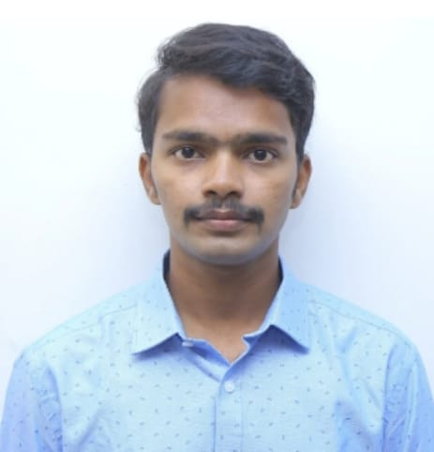

SARVASUDDI DURGA GANESH
+918978301601 | sarvasuddidurgaganesh@gmail.com

To make best use of my skills and technologies in a way that will benefit the organization and which could provide me with opportunities for my career growth.

TECHNICAL SKILLS

- HTML
- CSS
- JavaScript
- MySQL
- Python

PROJECT

- Responsive web design:
Responsive web design is about using HTML5 and CSS3 to automatically Resize, hide, shrink or enlarge, a website to make it look good on all devices like desktop computers, laptops, tablets and smartphones.

STRENGTHS

- Dedication towards work.
- Good at time management.
- Self-Motivated.
- Flexible and hardworking.

ACHIEVEMENTS

- NCC Cadre Camp conducted in 1(T) CTR – 2021.
- Winner of Cricket Tournament - 2019.
- Runner of Technical Quiz Competition - 2019.
- NCC Combined Annual Training Camp - 2019.
- Cultural Programs of Telangana State Formation Celebrations – 2018.
- Bala Chitra Ratna award - 2014.

EDUCATION

Bachelor of Technology (2018-2021)
Aggregate CGPA - 6.89/10
EEE - Vaagdevi College of Engineering

Diploma (2015-2018)
Percentage - 68%
EEE – Talla Padmavathi College of Engineering

Secondary School Certificate (2015)
Aggregate CGPA - 8.0/10
Raman High School

EXTRA CURRICULAR ACTIVITIES

- NCC.
- Cricket Tournament.
- Cultural Programs.
- Drawing Competition.

PERSONAL DETAILS

Date of Birth : 18 February 2000.
Languages known : English, Telugu.
Address : Kukatpally, Hyderabad.

DECLARATION

The above information is true to the best of my knowledge and belief.

- S Durga Ganesh

