Association Rules

Assignment 2

BP: Prepare rules for the all the data sets

1) Try different values of support and confidence. Observe the change in number of rules for different support,confidence values

2) Change the minimum length in apriori algorithm

3) Visulize the obtained rules using different plots

PROCEDURE:

STEP 1: First we have to Exploratory Data Analysis which can be done by plotting scattered plot, box plots and summary.

summary(book_1_)

V1 V2 V3 V4 V5

Gladiator :6 Harry Potter2:1 Braveheart :1 Green Mile:2 LOTR2:1

Harry Potter1:1 LOTR :1 Gladiator :1 NA's :8 NA's :9

LOTR1 :1 LOTR1 :1 Harry Potter1:1

Sixth Sense :2 LOTR2 :1 Sixth Sense :4

Patriot :6 NA's :3

Sixth Sense Gladiator LOTR1 Harry Potter1 Patriot

Min. :0.0 Min. :0.00 Min. :0.0 Min. :0.0 Min. :0.0

1st Qu.:0.0 1st Qu.:0.25 1st Qu.:0.0 1st Qu.:0.0 1st Qu.:0.0

Median :1.0 Median :1.00 Median :0.0 Median :0.0 Median :1.0

Mean :0.6 Mean :0.70 Mean :0.2 Mean :0.2 Mean :0.6

3rd Qu.:1.0 3rd Qu.:1.00 3rd Qu.:0.0 3rd Qu.:0.0 3rd Qu.:1.0

Max. :1.0 Max. :1.00 Max. :1.0 Max. :1.0 Max. :1.0

LOTR2 Harry Potter2 LOTR Braveheart Green Mile

Min. :0.0 Min. :0.0 Min. :0.0 Min. :0.0 Min. :0.0

1st Qu.:0.0 1st Qu.:0.0 1st Qu.:0.0 1st Qu.:0.0 1st Qu.:0.0

Median :0.0 Median :0.0 Median :0.0 Median :0.0 Median :0.0

Mean :0.2 Mean :0.1 Mean :0.1 Mean :0.1 Mean :0.2

3rd Qu.:0.0 3rd Qu.:0.0 3rd Qu.:0.0 3rd Qu.:0.0 3rd Qu.:0.0

Max. :1.0 Max. :1.0 Max. :1.0 Max. :1.0 Max. :1.0

From the summary we can see that all are lying in the same level , it can my confirmed by using Box Plot .

Box Plot for the Following data frame is:

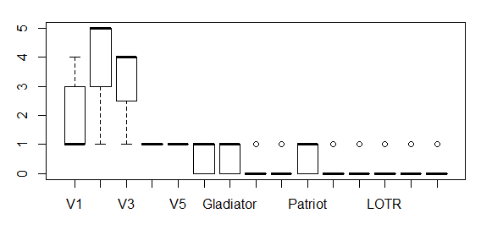

Scatter plot is given by :

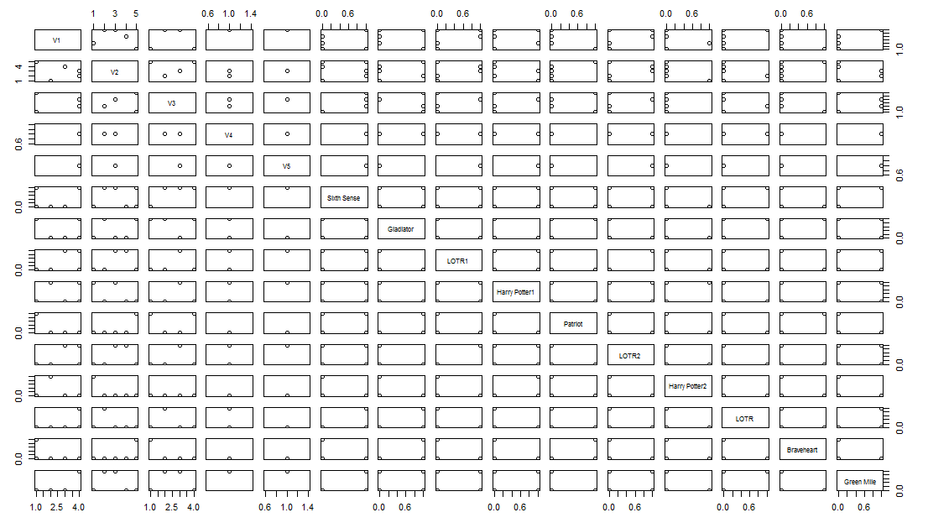

STEP 2:

Building Rules using Apriori algorithm which is given by :

Rules <-apriori(my_movies,parameter=list(support=0.002,confidence=0.7))

Apriori

Parameter specification:

confidence minval smax arem aval originalSupport maxtime support minlen maxlen

0.7 0.1 1 none FALSE TRUE 5 0.02 1 10

target ext

rules FALSE

Algorithmic control:

filter tree heap memopt load sort verbose

0.1 TRUE TRUE FALSE TRUE 2 TRUE

Absolute minimum support count: 40

set item appearances ...[0 item(s)] done [0.00s].

set transactions ...[11 item(s), 2000 transaction(s)] done [0.00s].

sorting and recoding items ... [11 item(s)] done [0.00s].

creating transaction tree ... done [0.00s].

checking subsets of size 1 2 3 4 5 6 done [0.00s].

writing ... [299 rule(s)] done [0.00s].

creating S4 object ... done [0.00s].

inspect(rules)

lhs rhs support confidence

[1] {ItalAtlas} => {RefBks} 0.0370 1.0000000

[2] {ItalAtlas} => {ChildBks} 0.0285 0.7702703

[3] {ItalAtlas} => {CookBks} 0.0285 0.7702703

[4] {ItalArt} => {ItalCook} 0.0375 0.7731959

[5] {ItalArt} => {ArtBks} 0.0485 1.0000000

[6] {ItalArt} => {ChildBks} 0.0360 0.7422680

[7] {ItalArt} => {CookBks} 0.0410 0.8453608

[8] {ItalCook} => {ChildBks} 0.0850 0.7488987

[9] {ItalCook} => {CookBks} 0.1135 1.0000000

[10] {RefBks} => {ChildBks} 0.1515 0.7062937

[11] {RefBks} => {CookBks} 0.1525 0.7109557

[12] {GeogBks} => {ChildBks} 0.1950 0.7065217

[13] {ItalCook,ItalAtlas} => {RefBks} 0.0230 1.0000000

[14] {ItalCook,ItalAtlas} => {ChildBks} 0.0200 0.8695652

[15] {ChildBks,ItalAtlas} => {ItalCook} 0.0200 0.7017544

[16] {ItalCook,ItalAtlas} => {CookBks} 0.0230 1.0000000

[17] {CookBks,ItalAtlas} => {ItalCook} 0.0230 0.8070175

[18] {GeogBks,ItalAtlas} => {RefBks} 0.0205 1.0000000

[19] {RefBks,ItalAtlas} => {ChildBks} 0.0285 0.7702703

[20] {ChildBks,ItalAtlas} => {RefBks} 0.0285 1.0000000

[21] {RefBks,ItalAtlas} => {CookBks} 0.0285 0.7702703

[22] {CookBks,ItalAtlas} => {RefBks} 0.0285 1.0000000

[23] {ChildBks,ItalAtlas} => {CookBks} 0.0225 0.7894737

[24] {CookBks,ItalAtlas} => {ChildBks} 0.0225 0.7894737

[25] {ItalCook,ItalArt} => {ArtBks} 0.0375 1.0000000

[26] {ArtBks,ItalArt} => {ItalCook} 0.0375 0.7731959

[27] {DoItYBks,ItalArt} => {ItalCook} 0.0250 0.8333333

[28] {GeogBks,ItalArt} => {ItalCook} 0.0240 0.8135593

[29] {ItalCook,ItalArt} => {ChildBks} 0.0285 0.7600000

[30] {ChildBks,ItalArt} => {ItalCook} 0.0285 0.7916667

[31] {ItalCook,ItalArt} => {CookBks} 0.0375 1.0000000

[32] {CookBks,ItalArt} => {ItalCook} 0.0375 0.9146341

[33] {RefBks,ItalArt} => {ArtBks} 0.0200 1.0000000

[34] {YouthBks,ItalArt} => {ArtBks} 0.0230 1.0000000

[35] {DoItYBks,ItalArt} => {ArtBks} 0.0300 1.0000000

[36] {GeogBks,ItalArt} => {ArtBks} 0.0295 1.0000000

[37] {ArtBks,ItalArt} => {ChildBks} 0.0360 0.7422680

[38] {ChildBks,ItalArt} => {ArtBks} 0.0360 1.0000000

[39] {ArtBks,ItalArt} => {CookBks} 0.0410 0.8453608

[40] {CookBks,ItalArt} => {ArtBks} 0.0410 1.0000000

[41] {DoItYBks,ItalArt} => {ChildBks} 0.0220 0.7333333

[42] {DoItYBks,ItalArt} => {CookBks} 0.0270 0.9000000

[43] {GeogBks,ItalArt} => {ChildBks} 0.0230 0.7796610

[44] {GeogBks,ItalArt} => {CookBks} 0.0250 0.8474576

[45] {ChildBks,ItalArt} => {CookBks} 0.0300 0.8333333

[46] {CookBks,ItalArt} => {ChildBks} 0.0300 0.7317073

[47] {YouthBks,Florence} => {CookBks} 0.0200 0.7843137

[48] {DoItYBks,Florence} => {ArtBks} 0.0245 0.7777778

[49] {GeogBks,Florence} => {ArtBks} 0.0300 0.7058824

[50] {DoItYBks,Florence} => {ChildBks} 0.0225 0.7142857

[51] {DoItYBks,Florence} => {CookBks} 0.0235 0.7460317

[52] {GeogBks,Florence} => {ChildBks} 0.0305 0.7176471

[53] {GeogBks,Florence} => {CookBks} 0.0310 0.7294118

[54] {CookBks,Florence} => {ChildBks} 0.0335 0.7052632

[55] {RefBks,ItalCook} => {ChildBks} 0.0415 0.8924731

[56] {RefBks,ItalCook} => {CookBks} 0.0465 1.0000000

[57] {YouthBks,ItalCook} => {ChildBks} 0.0460 0.7796610

[58] {YouthBks,ItalCook} => {CookBks} 0.0590 1.0000000

[59] {ArtBks,ItalCook} => {ChildBks} 0.0455 0.8053097

[60] {ArtBks,ItalCook} => {CookBks} 0.0565 1.0000000

[61] {DoItYBks,ItalCook} => {ChildBks} 0.0460 0.7863248

[62] {DoItYBks,ItalCook} => {CookBks} 0.0585 1.0000000

[63] {GeogBks,ItalCook} => {ChildBks} 0.0525 0.8203125

[64] {GeogBks,ItalCook} => {CookBks} 0.0640 1.0000000

[65] {ChildBks,ItalCook} => {CookBks} 0.0850 1.0000000

[66] {CookBks,ItalCook} => {ChildBks} 0.0850 0.7488987

[67] {YouthBks,RefBks} => {ChildBks} 0.0830 0.8601036

[68] {YouthBks,RefBks} => {CookBks} 0.0775 0.8031088

[69] {RefBks,ArtBks} => {ChildBks} 0.0760 0.8491620

[70] {RefBks,ArtBks} => {CookBks} 0.0700 0.7821229

[71] {DoItYBks,RefBks} => {ChildBks} 0.0900 0.8530806

[72] {DoItYBks,RefBks} => {CookBks} 0.0845 0.8009479

[73] {RefBks,GeogBks} => {ChildBks} 0.0940 0.8506787

[74] {RefBks,GeogBks} => {CookBks} 0.0890 0.8054299

[75] {ChildBks,RefBks} => {CookBks} 0.1225 0.8085809

[76] {CookBks,RefBks} => {ChildBks} 0.1225 0.8032787

[77] {YouthBks,ArtBks} => {ChildBks} 0.0805 0.7970297

[78] {YouthBks,ArtBks} => {CookBks} 0.0810 0.8019802

[79] {YouthBks,DoItYBks} => {ChildBks} 0.0950 0.8225108

[80] {YouthBks,DoItYBks} => {CookBks} 0.0950 0.8225108

[81] {YouthBks,GeogBks} => {ChildBks} 0.0990 0.8215768

[82] {YouthBks,GeogBks} => {CookBks} 0.0970 0.8049793

[83] {ChildBks,YouthBks} => {CookBks} 0.1290 0.7818182

[84] {YouthBks,CookBks} => {ChildBks} 0.1290 0.7962963

[85] {DoItYBks,ArtBks} => {ChildBks} 0.0950 0.7692308

[86] {DoItYBks,ArtBks} => {CookBks} 0.1015 0.8218623

[87] {ArtBks,GeogBks} => {ChildBks} 0.1020 0.8000000

[88] {ArtBks,GeogBks} => {CookBks} 0.1035 0.8117647

[89] {ChildBks,ArtBks} => {CookBks} 0.1265 0.7784615

[90] {CookBks,ArtBks} => {ChildBks} 0.1265 0.7574850

[91] {DoItYBks,GeogBks} => {ChildBks} 0.1045 0.7886792

[92] {DoItYBks,GeogBks} => {CookBks} 0.1085 0.8188679

[93] {ChildBks,DoItYBks} => {CookBks} 0.1460 0.7934783

[94] {CookBks,DoItYBks} => {ChildBks} 0.1460 0.7786667

[95] {ChildBks,GeogBks} => {CookBks} 0.1495 0.7666667

[96] {CookBks,GeogBks} => {ChildBks} 0.1495 0.7766234

[97] {RefBks,ItalCook,ItalAtlas} => {ChildBks} 0.0200 0.8695652

[98] {ChildBks,ItalCook,ItalAtlas} => {RefBks} 0.0200 1.0000000

[99] {ChildBks,RefBks,ItalAtlas} => {ItalCook} 0.0200 0.7017544

[100] {RefBks,ItalCook,ItalAtlas} => {CookBks} 0.0230 1.0000000

[101] {CookBks,ItalCook,ItalAtlas} => {RefBks} 0.0230 1.0000000

[102] {CookBks,RefBks,ItalAtlas} => {ItalCook} 0.0230 0.8070175

[103] {ChildBks,ItalCook,ItalAtlas} => {CookBks} 0.0200 1.0000000

[104] {CookBks,ItalCook,ItalAtlas} => {ChildBks} 0.0200 0.8695652

[105] {ChildBks,CookBks,ItalAtlas} => {ItalCook} 0.0200 0.8888889

[106] {ChildBks,RefBks,ItalAtlas} => {CookBks} 0.0225 0.7894737

[107] {CookBks,RefBks,ItalAtlas} => {ChildBks} 0.0225 0.7894737

[108] {ChildBks,CookBks,ItalAtlas} => {RefBks} 0.0225 1.0000000

[109] {DoItYBks,ItalCook,ItalArt} => {ArtBks} 0.0250 1.0000000

[110] {DoItYBks,ArtBks,ItalArt} => {ItalCook} 0.0250 0.8333333

[111] {GeogBks,ItalCook,ItalArt} => {ArtBks} 0.0240 1.0000000

[112] {ArtBks,GeogBks,ItalArt} => {ItalCook} 0.0240 0.8135593

[113] {ArtBks,ItalCook,ItalArt} => {ChildBks} 0.0285 0.7600000

[114] {ChildBks,ItalCook,ItalArt} => {ArtBks} 0.0285 1.0000000

[115] {ChildBks,ArtBks,ItalArt} => {ItalCook} 0.0285 0.7916667

[116] {ArtBks,ItalCook,ItalArt} => {CookBks} 0.0375 1.0000000

[117] {CookBks,ItalCook,ItalArt} => {ArtBks} 0.0375 1.0000000

[118] {CookBks,ArtBks,ItalArt} => {ItalCook} 0.0375 0.9146341

[119] {DoItYBks,ItalCook,ItalArt} => {CookBks} 0.0250 1.0000000

[120] {CookBks,DoItYBks,ItalArt} => {ItalCook} 0.0250 0.9259259

[121] {GeogBks,ItalCook,ItalArt} => {CookBks} 0.0240 1.0000000

[122] {CookBks,GeogBks,ItalArt} => {ItalCook} 0.0240 0.9600000

[123] {ChildBks,ItalCook,ItalArt} => {CookBks} 0.0285 1.0000000

[124] {CookBks,ItalCook,ItalArt} => {ChildBks} 0.0285 0.7600000

[125] {ChildBks,CookBks,ItalArt} => {ItalCook} 0.0285 0.9500000

[126] {DoItYBks,ArtBks,ItalArt} => {ChildBks} 0.0220 0.7333333

[127] {ChildBks,DoItYBks,ItalArt} => {ArtBks} 0.0220 1.0000000

[128] {DoItYBks,ArtBks,ItalArt} => {CookBks} 0.0270 0.9000000

[129] {CookBks,DoItYBks,ItalArt} => {ArtBks} 0.0270 1.0000000

[130] {ArtBks,GeogBks,ItalArt} => {ChildBks} 0.0230 0.7796610

[131] {ChildBks,GeogBks,ItalArt} => {ArtBks} 0.0230 1.0000000

[132] {ArtBks,GeogBks,ItalArt} => {CookBks} 0.0250 0.8474576

[133] {CookBks,GeogBks,ItalArt} => {ArtBks} 0.0250 1.0000000

[134] {ChildBks,ArtBks,ItalArt} => {CookBks} 0.0300 0.8333333

[135] {CookBks,ArtBks,ItalArt} => {ChildBks} 0.0300 0.7317073

[136] {ChildBks,CookBks,ItalArt} => {ArtBks} 0.0300 1.0000000

[137] {ChildBks,DoItYBks,ItalArt} => {CookBks} 0.0200 0.9090909

[138] {CookBks,DoItYBks,ItalArt} => {ChildBks} 0.0200 0.7407407

[139] {ArtBks,GeogBks,Florence} => {ChildBks} 0.0230 0.7666667

[140] {ChildBks,GeogBks,Florence} => {ArtBks} 0.0230 0.7540984

[141] {ArtBks,GeogBks,Florence} => {CookBks} 0.0230 0.7666667

[142] {CookBks,ArtBks,Florence} => {GeogBks} 0.0230 0.7301587

lift count

[1] 4.662005 74

[2] 1.820970 57

[3] 1.787170 57

[4] 6.812298 75

[5] 4.149378 97

[6] 1.754771 72

[7] 1.961394 82

[8] 1.770446 170

[9] 2.320186 227

[10] 1.669725 303

[11] 1.649549 305

[12] 1.670264 390

[13] 4.662005 46

[14] 2.055710 40

[15] 6.182858 40

[16] 2.320186 46

[17] 7.110287 46

[18] 4.662005 41

[19] 1.820970 57

[20] 4.662005 57

[21] 1.787170 57

[22] 4.662005 57

[23] 1.831725 45

[24] 1.866368 45

[25] 4.149378 75

[26] 6.812298 75

[27] 7.342144 50

[28] 7.167924 48

[29] 1.796690 57

[30] 6.975037 57

[31] 2.320186 75

[32] 8.058451 75

[33] 4.149378 40

[34] 4.149378 46

[35] 4.149378 60

[36] 4.149378 59

[37] 1.754771 72

[38] 4.149378 72

[39] 1.961394 82

[40] 4.149378 82

[41] 1.733649 44

[42] 2.088167 54

[43] 1.843170 46

[44] 1.966259 50

[45] 1.933488 60

[46] 1.729805 60

[47] 1.819753 40

[48] 3.227294 49

[49] 2.928972 60

[50] 1.688619 45

[51] 1.730932 47

[52] 1.696565 61

[53] 1.692371 62

[54] 1.667289 67

[55] 2.109866 83

[56] 2.320186 93

[57] 1.843170 92

[58] 2.320186 118

[59] 1.903806 91

[60] 2.320186 113

[61] 1.858924 92

[62] 2.320186 117

[63] 1.939273 105

[64] 2.320186 128

[65] 2.320186 170

[66] 1.770446 170

[67] 2.033342 166

[68] 1.863362 155

[69] 2.007475 152

[70] 1.814670 140

[71] 2.016739 180

[72] 1.858348 169

[73] 2.011061 188

[74] 1.868747 178

[75] 1.876058 245

[76] 1.899004 245

[77] 1.884231 161

[78] 1.860743 162

[79] 1.944470 190

[80] 1.908378 190

[81] 1.942262 198

[82] 1.867701 194

[83] 1.813963 258

[84] 1.882497 258

[85] 1.818512 190

[86] 1.906873 203

[87] 1.891253 204

[88] 1.883445 207

[89] 1.806175 253

[90] 1.790745 253

[91] 1.864490 209

[92] 1.899926 217

[93] 1.841017 292

[94] 1.840820 292

[95] 1.778809 299

[96] 1.835989 299

[97] 2.055710 40

[98] 4.662005 40

[99] 6.182858 40

[100] 2.320186 46

[101] 4.662005 46

[102] 7.110287 46

[103] 2.320186 40

[104] 2.055710 40

[105] 7.831620 40

[106] 1.831725 45

[107] 1.866368 45

[108] 4.662005 45

[109] 4.149378 50

[110] 7.342144 50

[111] 4.149378 48

[112] 7.167924 48

[113] 1.796690 57

[114] 4.149378 57

[115] 6.975037 57

[116] 2.320186 75

[117] 4.149378 75

[118] 8.058451 75

[119] 2.320186 50

[120] 8.157938 50

[121] 2.320186 48

[122] 8.458150 48

[123] 2.320186 57

[124] 1.796690 57

[125] 8.370044 57

[126] 1.733649 44

[127] 4.149378 44

[128] 2.088167 54

[129] 4.149378 54

[130] 1.843170 46

[131] 4.149378 46

[132] 1.966259 50

[133] 4.149378 50

[134] 1.933488 60

[135] 1.729805 60

[136] 4.149378 60

[137] 2.109260 40

[138] 1.751160 40

[139] 1.812451 46

[140] 3.129039 46

[141] 1.778809 46

[142] 2.645503 46

inspect(sort(rules, by="lift"))

lhs rhs support confidence lift count

[1] {Harry Potter2=1} => {V2=Harry Potter2} 0.1 1.0000000 10.0000000 1

[2] {V2=Harry Potter2} => {Harry Potter2=1} 0.1 1.0000000 10.0000000 1

[3] {Harry Potter2=1} => {V1=Harry Potter1} 0.1 1.0000000 10.0000000 1

[4] {V1=Harry Potter1} => {Harry Potter2=1} 0.1 1.0000000 10.0000000 1

[5] {V2=Harry Potter2} => {V1=Harry Potter1} 0.1 1.0000000 10.0000000 1

[6] {V1=Harry Potter1} => {V2=Harry Potter2} 0.1 1.0000000 10.0000000 1

[7] {V2=LOTR2} => {V1=LOTR1} 0.1 1.0000000 10.0000000 1

[8] {V1=LOTR1} => {V2=LOTR2} 0.1 1.0000000 10.0000000 1

[9] {Braveheart=1} => {V3=Braveheart} 0.1 1.0000000 10.0000000 1

[10] {V3=Braveheart} => {Braveheart=1} 0.1 1.0000000 10.0000000 1

[11] {V3=Gladiator} => {V2=LOTR} 0.1 1.0000000 10.0000000 1

[12] {V2=LOTR} => {V3=Gladiator} 0.1 1.0000000 10.0000000 1

[13] {V3=Gladiator} => {LOTR=1} 0.1 1.0000000 10.0000000 1

[14] {LOTR=1} => {V3=Gladiator} 0.1 1.0000000 10.0000000 1

[15] {V2=LOTR} => {LOTR=1} 0.1 1.0000000 10.0000000 1

[16] {LOTR=1} => {V2=LOTR} 0.1 1.0000000 10.0000000 1

[17] {V2=LOTR1} => {V3=Harry Potter1} 0.1 1.0000000 10.0000000 1

[18] {V3=Harry Potter1} => {V2=LOTR1} 0.1 1.0000000 10.0000000 1

[19] {V2=LOTR1} => {V5=LOTR2} 0.1 1.0000000 10.0000000 1

[20] {V5=LOTR2} => {V2=LOTR1} 0.1 1.0000000 10.0000000 1

[21] {V3=Harry Potter1} => {V5=LOTR2} 0.1 1.0000000 10.0000000 1

[22] {V5=LOTR2} => {V3=Harry Potter1} 0.1 1.0000000 10.0000000 1

[23] {V2=Harry Potter2,

Harry Potter2=1} => {V1=Harry Potter1} 0.1 1.0000000 10.0000000 1

[24] {V1=Harry Potter1,

Harry Potter2=1} => {V2=Harry Potter2} 0.1 1.0000000 10.0000000 1

[25] {V1=Harry Potter1,

V2=Harry Potter2} => {Harry Potter2=1} 0.1 1.0000000 10.0000000 1

[26] {Harry Potter1=1,

Harry Potter2=1} => {V2=Harry Potter2} 0.1 1.0000000 10.0000000 1

[27] {V2=Harry Potter2,

Harry Potter1=1} => {Harry Potter2=1} 0.1 1.0000000 10.0000000 1

[28] {Gladiator=0,

Harry Potter2=1} => {V2=Harry Potter2} 0.1 1.0000000 10.0000000 1

[29] {V2=Harry Potter2,

Gladiator=0} => {Harry Potter2=1} 0.1 1.0000000 10.0000000 1

[30] {Sixth Sense=0,

Harry Potter2=1} => {V2=Harry Potter2} 0.1 1.0000000 10.0000000 1

[31] {V2=Harry Potter2,

Sixth Sense=0} => {Harry Potter2=1} 0.1 1.0000000 10.0000000 1

[32] {Patriot=0,

Harry Potter2=1} => {V2=Harry Potter2} 0.1 1.0000000 10.0000000 1

[33] {V2=Harry Potter2,

Patriot=0} => {Harry Potter2=1} 0.1 1.0000000 10.0000000 1

[34] {Harry Potter2=1,

Green Mile=0} => {V2=Harry Potter2} 0.1 1.0000000 10.0000000 1

[35] {V2=Harry Potter2,

Green Mile=0} => {Harry Potter2=1} 0.1 1.0000000 10.0000000 1

[36] {LOTR2=0,

Harry Potter2=1} => {V2=Harry Potter2} 0.1 1.0000000 10.0000000 1

[37] {V2=Harry Potter2,

LOTR2=0} => {Harry Potter2=1} 0.1 1.0000000 10.0000000 1

[38] {LOTR1=0,

Harry Potter2=1} => {V2=Harry Potter2} 0.1 1.0000000 10.0000000 1

[39] {V2=Harry Potter2,

LOTR1=0} => {Harry Potter2=1} 0.1 1.0000000 10.0000000 1

[40] {Harry Potter2=1,

LOTR=0} => {V2=Harry Potter2} 0.1 1.0000000 10.0000000 1

[41] {V2=Harry Potter2,

LOTR=0} => {Harry Potter2=1} 0.1 1.0000000 10.0000000 1

[42] {Harry Potter2=1,

Braveheart=0} => {V2=Harry Potter2} 0.1 1.0000000 10.0000000 1

[43] {V2=Harry Potter2,

Braveheart=0} => {Harry Potter2=1} 0.1 1.0000000 10.0000000 1

[44] {Harry Potter1=1,

Harry Potter2=1} => {V1=Harry Potter1} 0.1 1.0000000 10.0000000 1

[45] {V1=Harry Potter1,

Harry Potter1=1} => {Harry Potter2=1} 0.1 1.0000000 10.0000000 1

[46] {Gladiator=0,

Harry Potter2=1} => {V1=Harry Potter1} 0.1 1.0000000 10.0000000 1

[47] {V1=Harry Potter1,

Gladiator=0} => {Harry Potter2=1} 0.1 1.0000000 10.0000000 1

[48] {Sixth Sense=0,

Harry Potter2=1} => {V1=Harry Potter1} 0.1 1.0000000 10.0000000 1

[49] {V1=Harry Potter1,

Sixth Sense=0} => {Harry Potter2=1} 0.1 1.0000000 10.0000000 1

[50] {Patriot=0,

Harry Potter2=1} => {V1=Harry Potter1} 0.1 1.0000000 10.0000000 1

[51] {V1=Harry Potter1,

Patriot=0} => {Harry Potter2=1} 0.1 1.0000000 10.0000000 1

[52] {Harry Potter2=1,

Green Mile=0} => {V1=Harry Potter1} 0.1 1.0000000 10.0000000 1

[53] {V1=Harry Potter1,

Green Mile=0} => {Harry Potter2=1} 0.1 1.0000000 10.0000000 1

[54] {LOTR2=0,

Harry Potter2=1} => {V1=Harry Potter1} 0.1 1.0000000 10.0000000 1

[55] {V1=Harry Potter1,

LOTR2=0} => {Harry Potter2=1} 0.1 1.0000000 10.0000000 1

[56] {LOTR1=0,

Harry Potter2=1} => {V1=Harry Potter1} 0.1 1.0000000 10.0000000 1

[57] {V1=Harry Potter1,

LOTR1=0} => {Harry Potter2=1} 0.1 1.0000000 10.0000000 1

[58] {Harry Potter2=1,

LOTR=0} => {V1=Harry Potter1} 0.1 1.0000000 10.0000000 1

[59] {V1=Harry Potter1,

LOTR=0} => {Harry Potter2=1} 0.1 1.0000000 10.0000000 1

[60] {Harry Potter2=1,

Braveheart=0} => {V1=Harry Potter1} 0.1 1.0000000 10.0000000 1

[61] {V1=Harry Potter1,

Braveheart=0} => {Harry Potter2=1} 0.1 1.0000000 10.0000000 1

[62] {Sixth Sense=0,

Harry Potter1=1} => {Harry Potter2=1} 0.1 1.0000000 10.0000000 1

[63] {Harry Potter1=1,

Green Mile=0} => {Harry Potter2=1} 0.1 1.0000000 10.0000000 1

[64] {Harry Potter1=1,

LOTR2=0} => {Harry Potter2=1} 0.1 1.0000000 10.0000000 1

[65] {LOTR1=0,

Harry Potter1=1} => {Harry Potter2=1} 0.1 1.0000000 10.0000000 1

[66] {Gladiator=0,

LOTR2=0} => {Harry Potter2=1} 0.1 1.0000000 10.0000000 1

[67] {Gladiator=0,

LOTR1=0} => {Harry Potter2=1} 0.1 1.0000000 10.0000000 1

[68] {V2=Harry Potter2,

Harry Potter1=1} => {V1=Harry Potter1} 0.1 1.0000000 10.0000000 1

[69] {V1=Harry Potter1,

Harry Potter1=1} => {V2=Harry Potter2} 0.1 1.0000000 10.0000000 1

[70] {V2=Harry Potter2,

Gladiator=0} => {V1=Harry Potter1} 0.1 1.0000000 10.0000000 1

[71] {V1=Harry Potter1,

Gladiator=0} => {V2=Harry Potter2} 0.1 1.0000000 10.0000000 1

[72] {V2=Harry Potter2,

Sixth Sense=0} => {V1=Harry Potter1} 0.1 1.0000000 10.0000000 1

[73] {V1=Harry Potter1,

Sixth Sense=0} => {V2=Harry Potter2} 0.1 1.0000000 10.0000000 1

[74] {V2=Harry Potter2,

Patriot=0} => {V1=Harry Potter1} 0.1 1.0000000 10.0000000 1

[75] {V1=Harry Potter1,

Patriot=0} => {V2=Harry Potter2} 0.1 1.0000000 10.0000000 1

[76] {V2=Harry Potter2,

Green Mile=0} => {V1=Harry Potter1} 0.1 1.0000000 10.0000000 1

[77] {V1=Harry Potter1,

Green Mile=0} => {V2=Harry Potter2} 0.1 1.0000000 10.0000000 1

[78] {V2=Harry Potter2,

LOTR2=0} => {V1=Harry Potter1} 0.1 1.0000000 10.0000000 1

[79] {V1=Harry Potter1,

LOTR2=0} => {V2=Harry Potter2} 0.1 1.0000000 10.0000000 1

[80] {V2=Harry Potter2,

LOTR1=0} => {V1=Harry Potter1} 0.1 1.0000000 10.0000000 1

[81] {V1=Harry Potter1,

LOTR1=0} => {V2=Harry Potter2} 0.1 1.0000000 10.0000000 1

[82] {V2=Harry Potter2,

LOTR=0} => {V1=Harry Potter1} 0.1 1.0000000 10.0000000 1

[83] {V1=Harry Potter1,

LOTR=0} => {V2=Harry Potter2} 0.1 1.0000000 10.0000000 1

[84] {V2=Harry Potter2,

Braveheart=0} => {V1=Harry Potter1} 0.1 1.0000000 10.0000000 1

[85] {V1=Harry Potter1,

Braveheart=0} => {V2=Harry Potter2} 0.1 1.0000000 10.0000000 1

[86] {Sixth Sense=0,

Harry Potter1=1} => {V2=Harry Potter2} 0.1 1.0000000 10.0000000 1

[87] {Harry Potter1=1,

Green Mile=0} => {V2=Harry Potter2} 0.1 1.0000000 10.0000000 1

[88] {Harry Potter1=1,

LOTR2=0} => {V2=Harry Potter2} 0.1 1.0000000 10.0000000 1

[89] {LOTR1=0,

Harry Potter1=1} => {V2=Harry Potter2} 0.1 1.0000000 10.0000000 1

[90] {Gladiator=0,

LOTR2=0} => {V2=Harry Potter2} 0.1 1.0000000 10.0000000 1

[91] {Gladiator=0,

LOTR1=0} => {V2=Harry Potter2} 0.1 1.0000000 10.0000000 1

[92] {Sixth Sense=0,

Harry Potter1=1} => {V1=Harry Potter1} 0.1 1.0000000 10.0000000 1

[93] {Harry Potter1=1,

Green Mile=0} => {V1=Harry Potter1} 0.1 1.0000000 10.0000000 1

[94] {Harry Potter1=1,

LOTR2=0} => {V1=Harry Potter1} 0.1 1.0000000 10.0000000 1

[95] {LOTR1=0,

Harry Potter1=1} => {V1=Harry Potter1} 0.1 1.0000000 10.0000000 1

[96] {Gladiator=0,

LOTR2=0} => {V1=Harry Potter1} 0.1 1.0000000 10.0000000 1

[97] {Gladiator=0,

LOTR1=0} => {V1=Harry Potter1} 0.1 1.0000000 10.0000000 1

[98] {V2=LOTR2,

LOTR2=1} => {V1=LOTR1} 0.1 1.0000000 10.0000000 1

[99] {V1=LOTR1,

LOTR2=1} => {V2=LOTR2} 0.1 1.0000000 10.0000000 1

[100] {V2=LOTR2,

LOTR1=1} => {V1=LOTR1} 0.1 1.0000000 10.0000000 1

[101] {V1=LOTR1,

LOTR1=1} => {V2=LOTR2} 0.1 1.0000000 10.0000000 1

[102] {V2=LOTR2,

Gladiator=0} => {V1=LOTR1} 0.1 1.0000000 10.0000000 1

[103] {V1=LOTR1,

Gladiator=0} => {V2=LOTR2} 0.1 1.0000000 10.0000000 1

[104] {V2=LOTR2,

Sixth Sense=0} => {V1=LOTR1} 0.1 1.0000000 10.0000000 1

[105] {V1=LOTR1,

Sixth Sense=0} => {V2=LOTR2} 0.1 1.0000000 10.0000000 1

[106] {V2=LOTR2,

Patriot=0} => {V1=LOTR1} 0.1 1.0000000 10.0000000 1

[107] {V1=LOTR1,

Patriot=0} => {V2=LOTR2} 0.1 1.0000000 10.0000000 1

[108] {V2=LOTR2,

Green Mile=0} => {V1=LOTR1} 0.1 1.0000000 10.0000000 1

[109] {V1=LOTR1,

Green Mile=0} => {V2=LOTR2} 0.1 1.0000000 10.0000000 1

[110] {V2=LOTR2,

Harry Potter1=0} => {V1=LOTR1} 0.1 1.0000000 10.0000000 1

[111] {V1=LOTR1,

Harry Potter1=0} => {V2=LOTR2} 0.1 1.0000000 10.0000000 1

[112] {V2=LOTR2,

LOTR=0} => {V1=LOTR1} 0.1 1.0000000 10.0000000 1

[113] {V1=LOTR1,

LOTR=0} => {V2=LOTR2} 0.1 1.0000000 10.0000000 1

[114] {V2=LOTR2,

Braveheart=0} => {V1=LOTR1} 0.1 1.0000000 10.0000000 1

[115] {V1=LOTR1,

Braveheart=0} => {V2=LOTR2} 0.1 1.0000000 10.0000000 1

[116] {V2=LOTR2,

Harry Potter2=0} => {V1=LOTR1} 0.1 1.0000000 10.0000000 1

[117] {V1=LOTR1,

Harry Potter2=0} => {V2=LOTR2} 0.1 1.0000000 10.0000000 1

[118] {Sixth Sense=0,

LOTR2=1} => {V2=LOTR2} 0.1 1.0000000 10.0000000 1

[119] {LOTR2=1,

Green Mile=0} => {V2=LOTR2} 0.1 1.0000000 10.0000000 1

[120] {Harry Potter1=0,

LOTR2=1} => {V2=LOTR2} 0.1 1.0000000 10.0000000 1

[121] {Sixth Sense=0,

LOTR1=1} => {V2=LOTR2} 0.1 1.0000000 10.0000000 1

[122] {LOTR1=1,

Green Mile=0} => {V2=LOTR2} 0.1 1.0000000 10.0000000 1

[123] {LOTR1=1,

Harry Potter1=0} => {V2=LOTR2} 0.1 1.0000000 10.0000000 1

[124] {Gladiator=0,

Harry Potter1=0} => {V2=LOTR2} 0.1 1.0000000 10.0000000 1

[125] {Sixth Sense=0,

LOTR2=1} => {V1=LOTR1} 0.1 1.0000000 10.0000000 1

[126] {LOTR2=1,

Green Mile=0} => {V1=LOTR1} 0.1 1.0000000 10.0000000 1

[127] {Harry Potter1=0,

LOTR2=1} => {V1=LOTR1} 0.1 1.0000000 10.0000000 1

[128] {Sixth Sense=0,

LOTR1=1} => {V1=LOTR1} 0.1 1.0000000 10.0000000 1

[129] {LOTR1=1,

Green Mile=0} => {V1=LOTR1} 0.1 1.0000000 10.0000000 1

[130] {LOTR1=1,

Harry Potter1=0} => {V1=LOTR1} 0.1 1.0000000 10.0000000 1

[131] {Gladiator=0,

Harry Potter1=0} => {V1=LOTR1} 0.1 1.0000000 10.0000000 1

[132] {Sixth Sense=0,

Braveheart=1} => {V3=Braveheart} 0.1 1.0000000 10.0000000 1

[133] {V3=Braveheart,

Sixth Sense=0} => {Braveheart=1} 0.1 1.0000000 10.0000000 1

[134] {Patriot=1,

Braveheart=1} => {V3=Braveheart} 0.1 1.0000000 10.0000000 1

[135] {V3=Braveheart,

Patriot=1} => {Braveheart=1} 0.1 1.0000000 10.0000000 1

[136] {V2=Patriot,

Braveheart=1} => {V3=Braveheart} 0.1 1.0000000 10.0000000 1

[137] {V2=Patriot,

V3=Braveheart} => {Braveheart=1} 0.1 1.0000000 10.0000000 1

[138] {V1=Gladiator,

Braveheart=1} => {V3=Braveheart} 0.1 1.0000000 10.0000000 1

[139] {V1=Gladiator,

V3=Braveheart} => {Braveheart=1} 0.1 1.0000000 10.0000000 1

[140] {Gladiator=1,

Braveheart=1} => {V3=Braveheart} 0.1 1.0000000 10.0000000 1

[141] {V3=Braveheart,

Gladiator=1} => {Braveheart=1} 0.1 1.0000000 10.0000000 1

[142] {Braveheart=1,

Green Mile=0} => {V3=Braveheart} 0.1 1.0000000 10.0000000 1

[143] {V3=Braveheart,

Green Mile=0} => {Braveheart=1} 0.1 1.0000000 10.0000000 1

[144] {LOTR2=0,

Braveheart=1} => {V3=Braveheart} 0.1 1.0000000 10.0000000 1

[145] {V3=Braveheart,

LOTR2=0} => {Braveheart=1} 0.1 1.0000000 10.0000000 1

[146] {Harry Potter1=0,

Braveheart=1} => {V3=Braveheart} 0.1 1.0000000 10.0000000 1

[147] {V3=Braveheart,

Harry Potter1=0} => {Braveheart=1} 0.1 1.0000000 10.0000000 1

[148] {LOTR1=0,

Braveheart=1} => {V3=Braveheart} 0.1 1.0000000 10.0000000 1

[149] {V3=Braveheart,

LOTR1=0} => {Braveheart=1} 0.1 1.0000000 10.0000000 1

[150] {LOTR=0,

Braveheart=1} => {V3=Braveheart} 0.1 1.0000000 10.0000000 1

[151] {V3=Braveheart,

LOTR=0} => {Braveheart=1} 0.1 1.0000000 10.0000000 1

[152] {Harry Potter2=0,

Braveheart=1} => {V3=Braveheart} 0.1 1.0000000 10.0000000 1

[153] {V3=Braveheart,

Harry Potter2=0} => {Braveheart=1} 0.1 1.0000000 10.0000000 1

[154] {V2=LOTR,

V3=Gladiator} => {LOTR=1} 0.1 1.0000000 10.0000000 1

[155] {V3=Gladiator,

LOTR=1} => {V2=LOTR} 0.1 1.0000000 10.0000000 1

[156] {V2=LOTR,

LOTR=1} => {V3=Gladiator} 0.1 1.0000000 10.0000000 1

[157] {V3=Gladiator,

V4=Green Mile} => {V2=LOTR} 0.1 1.0000000 10.0000000 1

[158] {V2=LOTR,

V4=Green Mile} => {V3=Gladiator} 0.1 1.0000000 10.0000000 1

[159] {V1=Sixth Sense,

V3=Gladiator} => {V2=LOTR} 0.1 1.0000000 10.0000000 1

[160] {V1=Sixth Sense,

V2=LOTR} => {V3=Gladiator} 0.1 1.0000000 10.0000000 1

[161] {V3=Gladiator,

Green Mile=1} => {V2=LOTR} 0.1 1.0000000 10.0000000 1

[162] {V2=LOTR,

Green Mile=1} => {V3=Gladiator} 0.1 1.0000000 10.0000000 1

[163] {V3=Gladiator,

Patriot=0} => {V2=LOTR} 0.1 1.0000000 10.0000000 1

[164] {V2=LOTR,

Patriot=0} => {V3=Gladiator} 0.1 1.0000000 10.0000000 1

[165] {V3=Gladiator,

Sixth Sense=1} => {V2=LOTR} 0.1 1.0000000 10.0000000 1

[166] {V2=LOTR,

Sixth Sense=1} => {V3=Gladiator} 0.1 1.0000000 10.0000000 1

[167] {V3=Gladiator,

Gladiator=1} => {V2=LOTR} 0.1 1.0000000 10.0000000 1

[168] {V2=LOTR,

Gladiator=1} => {V3=Gladiator} 0.1 1.0000000 10.0000000 1

[169] {V3=Gladiator,

LOTR2=0} => {V2=LOTR} 0.1 1.0000000 10.0000000 1

[170] {V2=LOTR,

LOTR2=0} => {V3=Gladiator} 0.1 1.0000000 10.0000000 1

[171] {V3=Gladiator,

Harry Potter1=0} => {V2=LOTR} 0.1 1.0000000 10.0000000 1

[172] {V2=LOTR,

Harry Potter1=0} => {V3=Gladiator} 0.1 1.0000000 10.0000000 1

[173] {V3=Gladiator,

LOTR1=0} => {V2=LOTR} 0.1 1.0000000 10.0000000 1

[174] {V2=LOTR,

LOTR1=0} => {V3=Gladiator} 0.1 1.0000000 10.0000000 1

[175] {V3=Gladiator,

Braveheart=0} => {V2=LOTR} 0.1 1.0000000 10.0000000 1

[176] {V2=LOTR,

Braveheart=0} => {V3=Gladiator} 0.1 1.0000000 10.0000000 1

[177] {V3=Gladiator,

Harry Potter2=0} => {V2=LOTR} 0.1 1.0000000 10.0000000 1

[178] {V2=LOTR,

Harry Potter2=0} => {V3=Gladiator} 0.1 1.0000000 10.0000000 1

[179] {V3=Gladiator,

V4=Green Mile} => {LOTR=1} 0.1 1.0000000 10.0000000 1

[180] {V4=Green Mile,

LOTR=1} => {V3=Gladiator} 0.1 1.0000000 10.0000000 1

[181] {V1=Sixth Sense,

V3=Gladiator} => {LOTR=1} 0.1 1.0000000 10.0000000 1

[182] {V1=Sixth Sense,

LOTR=1} => {V3=Gladiator} 0.1 1.0000000 10.0000000 1

[183] {V3=Gladiator,

Green Mile=1} => {LOTR=1} 0.1 1.0000000 10.0000000 1

[184] {LOTR=1,

Green Mile=1} => {V3=Gladiator} 0.1 1.0000000 10.0000000 1

[185] {V3=Gladiator,

Patriot=0} => {LOTR=1} 0.1 1.0000000 10.0000000 1

[186] {Patriot=0,

LOTR=1} => {V3=Gladiator} 0.1 1.0000000 10.0000000 1

[187] {V3=Gladiator,

Sixth Sense=1} => {LOTR=1} 0.1 1.0000000 10.0000000 1

[188] {Sixth Sense=1,

LOTR=1} => {V3=Gladiator} 0.1 1.0000000 10.0000000 1

[189] {V3=Gladiator,

Gladiator=1} => {LOTR=1} 0.1 1.0000000 10.0000000 1

[190] {Gladiator=1,

LOTR=1} => {V3=Gladiator} 0.1 1.0000000 10.0000000 1

[191] {V3=Gladiator,

LOTR2=0} => {LOTR=1} 0.1 1.0000000 10.0000000 1

[192] {LOTR2=0,

LOTR=1} => {V3=Gladiator} 0.1 1.0000000 10.0000000 1

[193] {V3=Gladiator,

Harry Potter1=0} => {LOTR=1} 0.1 1.0000000 10.0000000 1

[194] {Harry Potter1=0,

LOTR=1} => {V3=Gladiator} 0.1 1.0000000 10.0000000 1

[195] {V3=Gladiator,

LOTR1=0} => {LOTR=1} 0.1 1.0000000 10.0000000 1

[196] {LOTR1=0,

LOTR=1} => {V3=Gladiator} 0.1 1.0000000 10.0000000 1

[197] {V3=Gladiator,

Braveheart=0} => {LOTR=1} 0.1 1.0000000 10.0000000 1

[198] {LOTR=1,

Braveheart=0} => {V3=Gladiator} 0.1 1.0000000 10.0000000 1

[199] {V3=Gladiator,

Harry Potter2=0} => {LOTR=1} 0.1 1.0000000 10.0000000 1

[200] {Harry Potter2=0,

LOTR=1} => {V3=Gladiator} 0.1 1.0000000 10.0000000 1

[201] {V4=Green Mile,

Gladiator=1} => {V3=Gladiator} 0.1 1.0000000 10.0000000 1

[202] {V4=Green Mile,

LOTR2=0} => {V3=Gladiator} 0.1 1.0000000 10.0000000 1

[203] {V4=Green Mile,

Harry Potter1=0} => {V3=Gladiator} 0.1 1.0000000 10.0000000 1

[204] {V4=Green Mile,

LOTR1=0} => {V3=Gladiator} 0.1 1.0000000 10.0000000 1

[205] {V1=Sixth Sense,

Gladiator=1} => {V3=Gladiator} 0.1 1.0000000 10.0000000 1

[206] {V1=Sixth Sense,

LOTR2=0} => {V3=Gladiator} 0.1 1.0000000 10.0000000 1

[207] {V1=Sixth Sense,

Harry Potter1=0} => {V3=Gladiator} 0.1 1.0000000 10.0000000 1

[208] {V1=Sixth Sense,

LOTR1=0} => {V3=Gladiator} 0.1 1.0000000 10.0000000 1

[209] {Gladiator=1,

Green Mile=1} => {V3=Gladiator} 0.1 1.0000000 10.0000000 1

[210] {LOTR2=0,

Green Mile=1} => {V3=Gladiator} 0.1 1.0000000 10.0000000 1

[211] {Harry Potter1=0,

Green Mile=1} => {V3=Gladiator} 0.1 1.0000000 10.0000000 1

[212] {LOTR1=0,

Green Mile=1} => {V3=Gladiator} 0.1 1.0000000 10.0000000 1

[213] {Gladiator=1,

Patriot=0} => {V3=Gladiator} 0.1 1.0000000 10.0000000 1

[214] {V2=LOTR,

V4=Green Mile} => {LOTR=1} 0.1 1.0000000 10.0000000 1

[215] {V4=Green Mile,

LOTR=1} => {V2=LOTR} 0.1 1.0000000 10.0000000 1

[216] {V1=Sixth Sense,

V2=LOTR} => {LOTR=1} 0.1 1.0000000 10.0000000 1

[217] {V1=Sixth Sense,

LOTR=1} => {V2=LOTR} 0.1 1.0000000 10.0000000 1

[218] {V2=LOTR,

Green Mile=1} => {LOTR=1} 0.1 1.0000000 10.0000000 1

[219] {LOTR=1,

Green Mile=1} => {V2=LOTR} 0.1 1.0000000 10.0000000 1

[220] {V2=LOTR,

Patriot=0} => {LOTR=1} 0.1 1.0000000 10.0000000 1

[221] {Patriot=0,

LOTR=1} => {V2=LOTR} 0.1 1.0000000 10.0000000 1

[222] {V2=LOTR,

Sixth Sense=1} => {LOTR=1} 0.1 1.0000000 10.0000000 1

[223] {Sixth Sense=1,

LOTR=1} => {V2=LOTR} 0.1 1.0000000 10.0000000 1

[224] {V2=LOTR,

Gladiator=1} => {LOTR=1} 0.1 1.0000000 10.0000000 1

[225] {Gladiator=1,

LOTR=1} => {V2=LOTR} 0.1 1.0000000 10.0000000 1

[226] {V2=LOTR,

LOTR2=0} => {LOTR=1} 0.1 1.0000000 10.0000000 1

[227] {LOTR2=0,

LOTR=1} => {V2=LOTR} 0.1 1.0000000 10.0000000 1

[228] {V2=LOTR,

Harry Potter1=0} => {LOTR=1} 0.1 1.0000000 10.0000000 1

[229] {Harry Potter1=0,

LOTR=1} => {V2=LOTR} 0.1 1.0000000 10.0000000 1

[230] {V2=LOTR,

LOTR1=0} => {LOTR=1} 0.1 1.0000000 10.0000000 1

[231] {LOTR1=0,

LOTR=1} => {V2=LOTR} 0.1 1.0000000 10.0000000 1

[232] {V2=LOTR,

Braveheart=0} => {LOTR=1} 0.1 1.0000000 10.0000000 1

[233] {LOTR=1,

Braveheart=0} => {V2=LOTR} 0.1 1.0000000 10.0000000 1

[234] {V2=LOTR,

Harry Potter2=0} => {LOTR=1} 0.1 1.0000000 10.0000000 1

[235] {Harry Potter2=0,

LOTR=1} => {V2=LOTR} 0.1 1.0000000 10.0000000 1

[236] {V4=Green Mile,

Gladiator=1} => {V2=LOTR} 0.1 1.0000000 10.0000000 1

[237] {V4=Green Mile,

LOTR2=0} => {V2=LOTR} 0.1 1.0000000 10.0000000 1

[238] {V4=Green Mile,

Harry Potter1=0} => {V2=LOTR} 0.1 1.0000000 10.0000000 1

[239] {V4=Green Mile,

LOTR1=0} => {V2=LOTR} 0.1 1.0000000 10.0000000 1

[240] {V1=Sixth Sense,

Gladiator=1} => {V2=LOTR} 0.1 1.0000000 10.0000000 1

[241] {V1=Sixth Sense,

LOTR2=0} => {V2=LOTR} 0.1 1.0000000 10.0000000 1

[242] {V1=Sixth Sense,

Harry Potter1=0} => {V2=LOTR} 0.1 1.0000000 10.0000000 1

[243] {V1=Sixth Sense,

LOTR1=0} => {V2=LOTR} 0.1 1.0000000 10.0000000 1

[244] {Gladiator=1,

Green Mile=1} => {V2=LOTR} 0.1 1.0000000 10.0000000 1

[245] {LOTR2=0,

Green Mile=1} => {V2=LOTR} 0.1 1.0000000 10.0000000 1

[246] {Harry Potter1=0,

Green Mile=1} => {V2=LOTR} 0.1 1.0000000 10.0000000 1

[247] {LOTR1=0,

Green Mile=1} => {V2=LOTR} 0.1 1.0000000 10.0000000 1

[248] {Gladiator=1,

Patriot=0} => {V2=LOTR} 0.1 1.0000000 10.0000000 1

[249] {V4=Green Mile,

Gladiator=1} => {LOTR=1} 0.1 1.0000000 10.0000000 1

[250] {V4=Green Mile,

LOTR2=0} => {LOTR=1} 0.1 1.0000000 10.0000000 1

[251] {V4=Green Mile,

Harry Potter1=0} => {LOTR=1} 0.1 1.0000000 10.0000000 1

[252] {V4=Green Mile,

LOTR1=0} => {LOTR=1} 0.1 1.0000000 10.0000000 1

[253] {V1=Sixth Sense,

Gladiator=1} => {LOTR=1} 0.1 1.0000000 10.0000000 1

[254] {V1=Sixth Sense,

LOTR2=0} => {LOTR=1} 0.1 1.0000000 10.0000000 1

[255] {V1=Sixth Sense,

Harry Potter1=0} => {LOTR=1} 0.1 1.0000000 10.0000000 1

[256] {V1=Sixth Sense,

LOTR1=0} => {LOTR=1} 0.1 1.0000000 10.0000000 1

[257] {Gladiator=1,

Green Mile=1} => {LOTR=1} 0.1 1.0000000 10.0000000 1

[258] {LOTR2=0,

Green Mile=1} => {LOTR=1} 0.1 1.0000000 10.0000000 1

[259] {Harry Potter1=0,

Green Mile=1} => {LOTR=1} 0.1 1.0000000 10.0000000 1

[260] {LOTR1=0,

Green Mile=1} => {LOTR=1} 0.1 1.0000000 10.0000000 1

[261] {Gladiator=1,

Patriot=0} => {LOTR=1} 0.1 1.0000000 10.0000000 1

[262] {V2=LOTR1,

V3=Harry Potter1} => {V5=LOTR2} 0.1 1.0000000 10.0000000 1

[263] {V2=LOTR1,

V5=LOTR2} => {V3=Harry Potter1} 0.1 1.0000000 10.0000000 1

head(quality(rules))

support confidence lift count

1 0.7 0.7 1 7

2 0.8 0.8 1 8

3 0.8 0.8 1 8

4 0.8 0.8 1 8

5 0.8 0.8 1 8

6 0.9 0.9 1 9

plot(rules)  
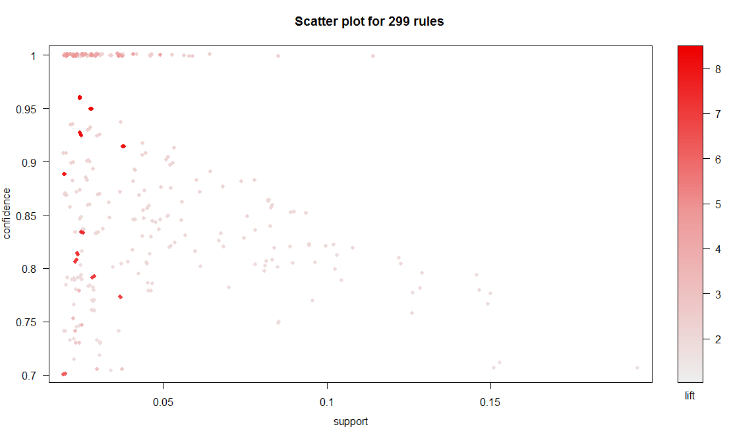

For better visualizations we can use other methods to plot and we can do   
that in a new window

windows()

plot(rules,method = "grouped")

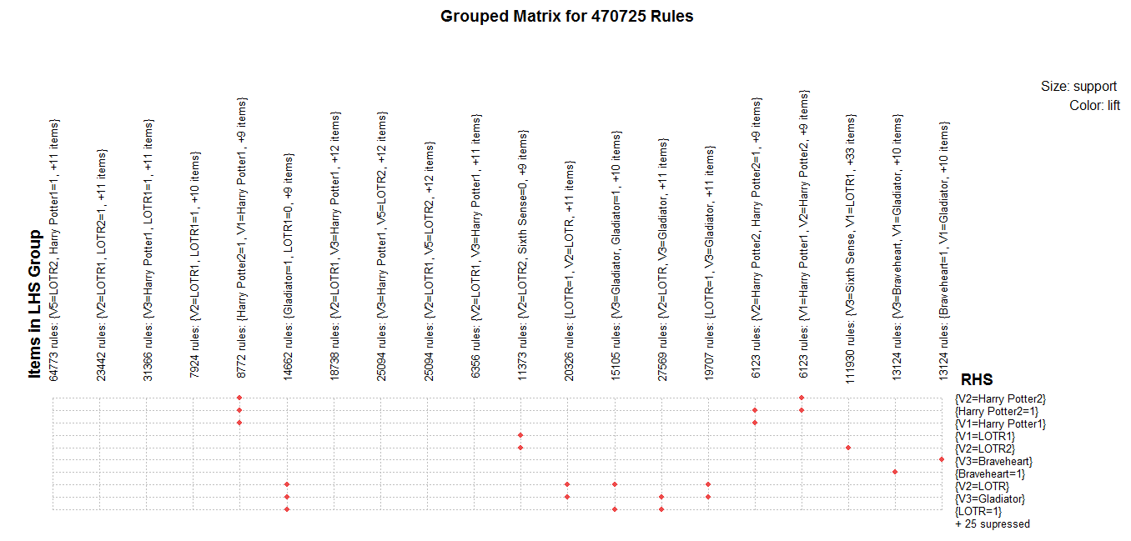

plot(rules[1:20] , method = "graph")

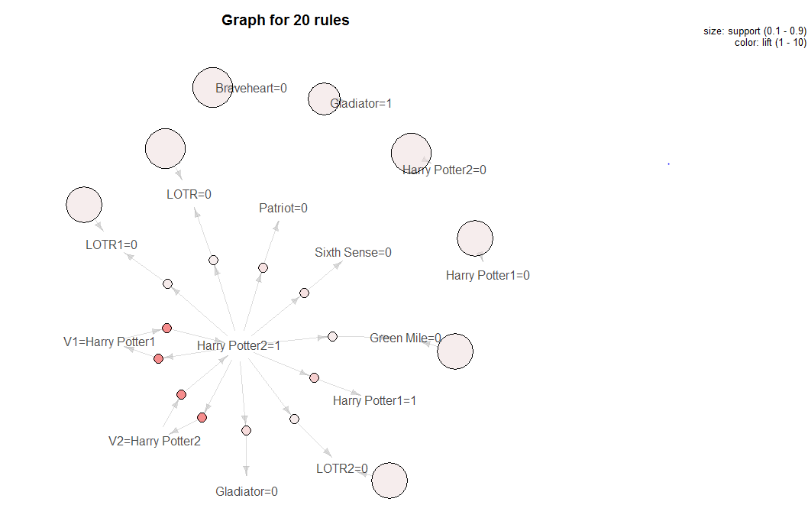  
  
Thus , we can Association rules are formed , we can by :

write(rules , file = " arulessol.csv" , sep="," )