Association Rules

Assignment 1

BP: Prepare rules for the all the data sets

1) Try different values of support and confidence. Observe the change in number of rules for different support,confidence values

2) Change the minimum length in apriori algorithm

3) Visulize the obtained rules using different plots

PROCEDURE:

STEP 1: First we have to Exploratory Data Analysis which can be done by plotting scattered plot, box plots and summary.

summary(book_1_)

ChildBks YouthBks CookBks DoItYBks RefBks

Min. :0.000 Min. :0.0000 Min. :0.000 Min. :0.000 Min. :0.0000

1st Qu.:0.000 1st Qu.:0.0000 1st Qu.:0.000 1st Qu.:0.000 1st Qu.:0.0000

Median :0.000 Median :0.0000 Median :0.000 Median :0.000 Median :0.0000

Mean :0.423 Mean :0.2475 Mean :0.431 Mean :0.282 Mean :0.2145

3rd Qu.:1.000 3rd Qu.:0.0000 3rd Qu.:1.000 3rd Qu.:1.000 3rd Qu.:0.0000

Max. :1.000 Max. :1.0000 Max. :1.000 Max. :1.000 Max. :1.0000

ArtBks GeogBks ItalCook ItalAtlas ItalArt

Min. :0.000 Min. :0.000 Min. :0.0000 Min. :0.000 Min. :0.0000

1st Qu.:0.000 1st Qu.:0.000 1st Qu.:0.0000 1st Qu.:0.000 1st Qu.:0.0000

Median :0.000 Median :0.000 Median :0.0000 Median :0.000 Median :0.0000

Mean :0.241 Mean :0.276 Mean :0.1135 Mean :0.037 Mean :0.0485

3rd Qu.:0.000 3rd Qu.:1.000 3rd Qu.:0.0000 3rd Qu.:0.000 3rd Qu.:0.0000

Max. :1.000 Max. :1.000 Max. :1.0000 Max. :1.000 Max. :1.0000

Florence

Min. :0.0000

1st Qu.:0.0000

Median :0.0000

Mean :0.1085

3rd Qu.:0.0000

Max. :1.0000

From the summary we can see that all are lying in the same level , it can my confirmed by using Box Plot .

Scatter Plot for the Following data frame is:

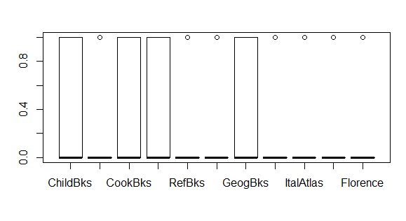

Scatter plot is given by :

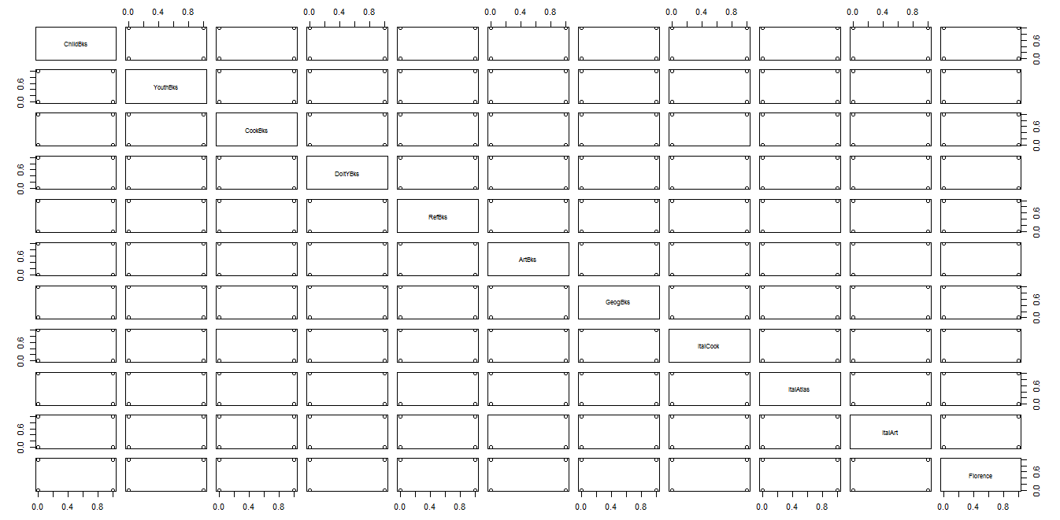

STEP 2:

Building Rules using Apriori algorithm which is given by :

Rules <-apriori(as.matrix(book_1_[,1:11]),parameter=list(support=0.002,confidence=0.7))

Apriori

Parameter specification:

confidence minval smax arem aval originalSupport maxtime support minlen maxlen

0.7 0.1 1 none FALSE TRUE 5 0.02 1 10

target ext

rules FALSE

Algorithmic control:

filter tree heap memopt load sort verbose

0.1 TRUE TRUE FALSE TRUE 2 TRUE

Absolute minimum support count: 40

set item appearances ...[0 item(s)] done [0.00s].

set transactions ...[11 item(s), 2000 transaction(s)] done [0.00s].

sorting and recoding items ... [11 item(s)] done [0.00s].

creating transaction tree ... done [0.00s].

checking subsets of size 1 2 3 4 5 6 done [0.00s].

writing ... [299 rule(s)] done [0.00s].

creating S4 object ... done [0.00s].

inspect(rules)

lhs rhs support confidence lift count

[1] {} => {Gladiator=1} 0.7 0.7000000 1.0000000 7

[2] {} => {Green Mile=0} 0.8 0.8000000 1.0000000 8

[3] {} => {LOTR2=0} 0.8 0.8000000 1.0000000 8

[4] {} => {Harry Potter1=0} 0.8 0.8000000 1.0000000 8

[5] {} => {LOTR1=0} 0.8 0.8000000 1.0000000 8

[6] {} => {LOTR=0} 0.9 0.9000000 1.0000000 9

[7] {} => {Braveheart=0} 0.9 0.9000000 1.0000000 9

[8] {} => {Harry Potter2=0} 0.9 0.9000000 1.0000000 9

[9] {Harry Potter2=1} => {V2=Harry Potter2} 0.1 1.0000000 10.0000000 1

[10] {V2=Harry Potter2} => {Harry Potter2=1} 0.1 1.0000000 10.0000000 1

[11] {Harry Potter2=1} => {V1=Harry Potter1} 0.1 1.0000000 10.0000000 1

[12] {V1=Harry Potter1} => {Harry Potter2=1} 0.1 1.0000000 10.0000000 1

[13] {Harry Potter2=1} => {Harry Potter1=1} 0.1 1.0000000 5.0000000 1

[14] {Harry Potter2=1} => {Gladiator=0} 0.1 1.0000000 3.3333333 1

[15] {Harry Potter2=1} => {Sixth Sense=0} 0.1 1.0000000 2.5000000 1

[16] {Harry Potter2=1} => {Patriot=0} 0.1 1.0000000 2.5000000 1

[17] {Harry Potter2=1} => {Green Mile=0} 0.1 1.0000000 1.2500000 1

[18] {Harry Potter2=1} => {LOTR2=0} 0.1 1.0000000 1.2500000 1

[19] {Harry Potter2=1} => {LOTR1=0} 0.1 1.0000000 1.2500000 1

[20] {Harry Potter2=1} => {LOTR=0} 0.1 1.0000000 1.1111111 1

[21] {Harry Potter2=1} => {Braveheart=0} 0.1 1.0000000 1.1111111 1

[22] {V2=Harry Potter2} => {V1=Harry Potter1} 0.1 1.0000000 10.0000000 1

[23] {V1=Harry Potter1} => {V2=Harry Potter2} 0.1 1.0000000 10.0000000 1

[24] {V2=Harry Potter2} => {Harry Potter1=1} 0.1 1.0000000 5.0000000 1

[25] {V2=Harry Potter2} => {Gladiator=0} 0.1 1.0000000 3.3333333 1

[26] {V2=Harry Potter2} => {Sixth Sense=0} 0.1 1.0000000 2.5000000 1

[27] {V2=Harry Potter2} => {Patriot=0} 0.1 1.0000000 2.5000000 1

[28] {V2=Harry Potter2} => {Green Mile=0} 0.1 1.0000000 1.2500000 1

[29] {V2=Harry Potter2} => {LOTR2=0} 0.1 1.0000000 1.2500000 1

[30] {V2=Harry Potter2} => {LOTR1=0} 0.1 1.0000000 1.2500000 1

[31] {V2=Harry Potter2} => {LOTR=0} 0.1 1.0000000 1.1111111 1

[32] {V2=Harry Potter2} => {Braveheart=0} 0.1 1.0000000 1.1111111 1

[33] {V1=Harry Potter1} => {Harry Potter1=1} 0.1 1.0000000 5.0000000 1

[34] {V1=Harry Potter1} => {Gladiator=0} 0.1 1.0000000 3.3333333 1

[35] {V1=Harry Potter1} => {Sixth Sense=0} 0.1 1.0000000 2.5000000 1

[36] {V1=Harry Potter1} => {Patriot=0} 0.1 1.0000000 2.5000000 1

[37] {V1=Harry Potter1} => {Green Mile=0} 0.1 1.0000000 1.2500000 1

[38] {V1=Harry Potter1} => {LOTR2=0} 0.1 1.0000000 1.2500000 1

[39] {V1=Harry Potter1} => {LOTR1=0} 0.1 1.0000000 1.2500000 1

[40] {V1=Harry Potter1} => {LOTR=0} 0.1 1.0000000 1.1111111 1

[41] {V1=Harry Potter1} => {Braveheart=0} 0.1 1.0000000 1.1111111 1

[42] {V2=LOTR2} => {V1=LOTR1} 0.1 1.0000000 10.0000000 1

[43] {V1=LOTR1} => {V2=LOTR2} 0.1 1.0000000 10.0000000 1

[44] {V2=LOTR2} => {LOTR2=1} 0.1 1.0000000 5.0000000 1

[45] {V2=LOTR2} => {LOTR1=1} 0.1 1.0000000 5.0000000 1

[46] {V2=LOTR2} => {Gladiator=0} 0.1 1.0000000 3.3333333 1

[47] {V2=LOTR2} => {Sixth Sense=0} 0.1 1.0000000 2.5000000 1

[48] {V2=LOTR2} => {Patriot=0} 0.1 1.0000000 2.5000000 1

[49] {V2=LOTR2} => {Green Mile=0} 0.1 1.0000000 1.2500000 1

[50] {V2=LOTR2} => {Harry Potter1=0} 0.1 1.0000000 1.2500000 1

[51] {V2=LOTR2} => {LOTR=0} 0.1 1.0000000 1.1111111 1

[52] {V2=LOTR2} => {Braveheart=0} 0.1 1.0000000 1.1111111 1

[53] {V2=LOTR2} => {Harry Potter2=0} 0.1 1.0000000 1.1111111 1

[54] {V1=LOTR1} => {LOTR2=1} 0.1 1.0000000 5.0000000 1

[55] {V1=LOTR1} => {LOTR1=1} 0.1 1.0000000 5.0000000 1

[56] {V1=LOTR1} => {Gladiator=0} 0.1 1.0000000 3.3333333 1

[57] {V1=LOTR1} => {Sixth Sense=0} 0.1 1.0000000 2.5000000 1

[58] {V1=LOTR1} => {Patriot=0} 0.1 1.0000000 2.5000000 1

[59] {V1=LOTR1} => {Green Mile=0} 0.1 1.0000000 1.2500000 1

[60] {V1=LOTR1} => {Harry Potter1=0} 0.1 1.0000000 1.2500000 1

[61] {V1=LOTR1} => {LOTR=0} 0.1 1.0000000 1.1111111 1

[62] {V1=LOTR1} => {Braveheart=0} 0.1 1.0000000 1.1111111 1

[63] {V1=LOTR1} => {Harry Potter2=0} 0.1 1.0000000 1.1111111 1

[64] {Braveheart=1} => {V3=Braveheart} 0.1 1.0000000 10.0000000 1

[65] {V3=Braveheart} => {Braveheart=1} 0.1 1.0000000 10.0000000 1

[66] {Braveheart=1} => {Sixth Sense=0} 0.1 1.0000000 2.5000000 1

[67] {Braveheart=1} => {Patriot=1} 0.1 1.0000000 1.6666667 1

[68] {Braveheart=1} => {V2=Patriot} 0.1 1.0000000 1.6666667 1

[69] {Braveheart=1} => {V1=Gladiator} 0.1 1.0000000 1.6666667 1

[70] {Braveheart=1} => {Gladiator=1} 0.1 1.0000000 1.4285714 1

[71] {Braveheart=1} => {Green Mile=0} 0.1 1.0000000 1.2500000 1

[72] {Braveheart=1} => {LOTR2=0} 0.1 1.0000000 1.2500000 1

[73] {Braveheart=1} => {Harry Potter1=0} 0.1 1.0000000 1.2500000 1

[74] {Braveheart=1} => {LOTR1=0} 0.1 1.0000000 1.2500000 1

[75] {Braveheart=1} => {LOTR=0} 0.1 1.0000000 1.1111111 1

[76] {Braveheart=1} => {Harry Potter2=0} 0.1 1.0000000 1.1111111 1

[77] {V3=Braveheart} => {Sixth Sense=0} 0.1 1.0000000 2.5000000 1

[78] {V3=Braveheart} => {Patriot=1} 0.1 1.0000000 1.6666667 1

[79] {V3=Braveheart} => {V2=Patriot} 0.1 1.0000000 1.6666667 1

[80] {V3=Braveheart} => {V1=Gladiator} 0.1 1.0000000 1.6666667 1

[81] {V3=Braveheart} => {Gladiator=1} 0.1 1.0000000 1.4285714 1

[82] {V3=Braveheart} => {Green Mile=0} 0.1 1.0000000 1.2500000 1

[83] {V3=Braveheart} => {LOTR2=0} 0.1 1.0000000 1.2500000 1

[84] {V3=Braveheart} => {Harry Potter1=0} 0.1 1.0000000 1.2500000 1

[85] {V3=Braveheart} => {LOTR1=0} 0.1 1.0000000 1.2500000 1

[86] {V3=Braveheart} => {LOTR=0} 0.1 1.0000000 1.1111111 1

[87] {V3=Braveheart} => {Harry Potter2=0} 0.1 1.0000000 1.1111111 1

[88] {V3=Gladiator} => {V2=LOTR} 0.1 1.0000000 10.0000000 1

[89] {V2=LOTR} => {V3=Gladiator} 0.1 1.0000000 10.0000000 1

[90] {V3=Gladiator} => {LOTR=1} 0.1 1.0000000 10.0000000 1

[91] {LOTR=1} => {V3=Gladiator} 0.1 1.0000000 10.0000000 1

[92] {V3=Gladiator} => {V4=Green Mile} 0.1 1.0000000 5.0000000 1

[93] {V3=Gladiator} => {V1=Sixth Sense} 0.1 1.0000000 5.0000000 1

[94] {V3=Gladiator} => {Green Mile=1} 0.1 1.0000000 5.0000000 1

[95] {V3=Gladiator} => {Patriot=0} 0.1 1.0000000 2.5000000 1

[96] {V3=Gladiator} => {Sixth Sense=1} 0.1 1.0000000 1.6666667 1

[97] {V3=Gladiator} => {Gladiator=1} 0.1 1.0000000 1.4285714 1

[98] {V3=Gladiator} => {LOTR2=0} 0.1 1.0000000 1.2500000 1

[99] {V3=Gladiator} => {Harry Potter1=0} 0.1 1.0000000 1.2500000 1

[100] {V3=Gladiator} => {LOTR1=0} 0.1 1.0000000 1.2500000 1

[101] {V3=Gladiator} => {Braveheart=0} 0.1 1.0000000 1.1111111 1

[102] {V3=Gladiator} => {Harry Potter2=0} 0.1 1.0000000 1.1111111 1

[103] {V2=LOTR} => {LOTR=1} 0.1 1.0000000 10.0000000 1

[104] {LOTR=1} => {V2=LOTR} 0.1 1.0000000 10.0000000 1

[105] {V2=LOTR} => {V4=Green Mile} 0.1 1.0000000 5.0000000 1

[106] {V2=LOTR} => {V1=Sixth Sense} 0.1 1.0000000 5.0000000 1

[107] {V2=LOTR} => {Green Mile=1} 0.1 1.0000000 5.0000000 1

[108] {V2=LOTR} => {Patriot=0} 0.1 1.0000000 2.5000000 1

[109] {V2=LOTR} => {Sixth Sense=1} 0.1 1.0000000 1.6666667 1

[110] {V2=LOTR} => {Gladiator=1} 0.1 1.0000000 1.4285714 1

[111] {V2=LOTR} => {LOTR2=0} 0.1 1.0000000 1.2500000 1

[112] {V2=LOTR} => {Harry Potter1=0} 0.1 1.0000000 1.2500000 1

[113] {V2=LOTR} => {LOTR1=0} 0.1 1.0000000 1.2500000 1

[114] {V2=LOTR} => {Braveheart=0} 0.1 1.0000000 1.1111111 1

[115] {V2=LOTR} => {Harry Potter2=0} 0.1 1.0000000 1.1111111 1

[116] {LOTR=1} => {V4=Green Mile} 0.1 1.0000000 5.0000000 1

[117] {LOTR=1} => {V1=Sixth Sense} 0.1 1.0000000 5.0000000 1

[118] {LOTR=1} => {Green Mile=1} 0.1 1.0000000 5.0000000 1

[119] {LOTR=1} => {Patriot=0} 0.1 1.0000000 2.5000000 1

[120] {LOTR=1} => {Sixth Sense=1} 0.1 1.0000000 1.6666667 1

[121] {LOTR=1} => {Gladiator=1} 0.1 1.0000000 1.4285714 1

[122] {LOTR=1} => {LOTR2=0} 0.1 1.0000000 1.2500000 1

[123] {LOTR=1} => {Harry Potter1=0} 0.1 1.0000000 1.2500000 1

[124] {LOTR=1} => {LOTR1=0} 0.1 1.0000000 1.2500000 1

[125] {LOTR=1} => {Braveheart=0} 0.1 1.0000000 1.1111111 1

[126] {LOTR=1} => {Harry Potter2=0} 0.1 1.0000000 1.1111111 1

[127] {V2=LOTR1} => {V3=Harry Potter1} 0.1 1.0000000 10.0000000 1

[128] {V3=Harry Potter1} => {V2=LOTR1} 0.1 1.0000000 10.0000000 1

[129] {V2=LOTR1} => {V5=LOTR2} 0.1 1.0000000 10.0000000 1

[130] {V5=LOTR2} => {V2=LOTR1} 0.1 1.0000000 10.0000000 1

[131] {V2=LOTR1} => {LOTR2=1} 0.1 1.0000000 5.0000000 1

[132] {V2=LOTR1} => {LOTR1=1} 0.1 1.0000000 5.0000000 1

[133] {V2=LOTR1} => {Harry Potter1=1} 0.1 1.0000000 5.0000000 1

[134] {V2=LOTR1} => {V4=Green Mile} 0.1 1.0000000 5.0000000 1

[135] {V2=LOTR1} => {V1=Sixth Sense} 0.1 1.0000000 5.0000000 1

[136] {V2=LOTR1} => {Green Mile=1} 0.1 1.0000000 5.0000000 1

[137] {V2=LOTR1} => {Gladiator=0} 0.1 1.0000000 3.3333333 1

[138] {V2=LOTR1} => {Patriot=0} 0.1 1.0000000 2.5000000 1

[139] {V2=LOTR1} => {Sixth Sense=1} 0.1 1.0000000 1.6666667 1

[140] {V2=LOTR1} => {LOTR=0} 0.1 1.0000000 1.1111111 1

[141] {V2=LOTR1} => {Braveheart=0} 0.1 1.0000000 1.1111111 1

[142] {V2=LOTR1} => {Harry Potter2=0} 0.1 1.0000000 1.1111111 1

[143] {V3=Harry Potter1} => {V5=LOTR2} 0.1 1.0000000 10.0000000 1

[144] {V5=LOTR2} => {V3=Harry Potter1} 0.1 1.0000000 10.0000000 1

[145] {V3=Harry Potter1} => {LOTR2=1} 0.1 1.0000000 5.0000000 1

[146] {V3=Harry Potter1} => {LOTR1=1} 0.1 1.0000000 5.0000000 1

[147] {V3=Harry Potter1} => {Harry Potter1=1} 0.1 1.0000000 5.0000000 1

[148] {V3=Harry Potter1} => {V4=Green Mile} 0.1 1.0000000 5.0000000 1

[149] {V3=Harry Potter1} => {V1=Sixth Sense} 0.1 1.0000000 5.0000000 1

[150] {V3=Harry Potter1} => {Green Mile=1} 0.1 1.0000000 5.0000000 1

[151] {V3=Harry Potter1} => {Gladiator=0} 0.1 1.0000000 3.3333333 1

[152] {V3=Harry Potter1} => {Patriot=0} 0.1 1.0000000 2.5000000 1

[153] {V3=Harry Potter1} => {Sixth Sense=1} 0.1 1.0000000 1.6666667 1

[154] {V3=Harry Potter1} => {LOTR=0} 0.1 1.0000000 1.1111111 1

[155] {V3=Harry Potter1} => {Braveheart=0} 0.1 1.0000000 1.1111111 1

[156] {V3=Harry Potter1} => {Harry Potter2=0} 0.1 1.0000000 1.1111111 1

[157] {V5=LOTR2} => {LOTR2=1} 0.1 1.0000000 5.0000000 1

[158] {V5=LOTR2} => {LOTR1=1} 0.1 1.0000000 5.0000000 1

[159] {V5=LOTR2} => {Harry Potter1=1} 0.1 1.0000000 5.0000000 1

[160] {V5=LOTR2} => {V4=Green Mile} 0.1 1.0000000 5.0000000 1

[161] {V5=LOTR2} => {V1=Sixth Sense} 0.1 1.0000000 5.0000000 1

[162] {V5=LOTR2} => {Green Mile=1} 0.1 1.0000000 5.0000000 1

[163] {V5=LOTR2} => {Gladiator=0} 0.1 1.0000000 3.3333333 1

[164] {V5=LOTR2} => {Patriot=0} 0.1 1.0000000 2.5000000 1

[165] {V5=LOTR2} => {Sixth Sense=1} 0.1 1.0000000 1.6666667 1

[166] {V5=LOTR2} => {LOTR=0} 0.1 1.0000000 1.1111111 1

[167] {V5=LOTR2} => {Braveheart=0} 0.1 1.0000000 1.1111111 1

[168] {V5=LOTR2} => {Harry Potter2=0} 0.1 1.0000000 1.1111111 1

[169] {LOTR2=1} => {LOTR1=1} 0.2 1.0000000 5.0000000 2

[170] {LOTR1=1} => {LOTR2=1} 0.2 1.0000000 5.0000000 2

[171] {LOTR2=1} => {Gladiator=0} 0.2 1.0000000 3.3333333 2

[172] {LOTR2=1} => {Patriot=0} 0.2 1.0000000 2.5000000 2

[173] {LOTR2=1} => {LOTR=0} 0.2 1.0000000 1.1111111 2

[174] {LOTR2=1} => {Braveheart=0} 0.2 1.0000000 1.1111111 2

[175] {LOTR2=1} => {Harry Potter2=0} 0.2 1.0000000 1.1111111 2

[176] {LOTR1=1} => {Gladiator=0} 0.2 1.0000000 3.3333333 2

[177] {LOTR1=1} => {Patriot=0} 0.2 1.0000000 2.5000000 2

[178] {LOTR1=1} => {LOTR=0} 0.2 1.0000000 1.1111111 2

[179] {LOTR1=1} => {Braveheart=0} 0.2 1.0000000 1.1111111 2

[180] {LOTR1=1} => {Harry Potter2=0} 0.2 1.0000000 1.1111111 2

[181] {Harry Potter1=1} => {Gladiator=0} 0.2 1.0000000 3.3333333 2

[182] {Harry Potter1=1} => {Patriot=0} 0.2 1.0000000 2.5000000 2

[183] {Harry Potter1=1} => {LOTR=0} 0.2 1.0000000 1.1111111 2

[184] {Harry Potter1=1} => {Braveheart=0} 0.2 1.0000000 1.1111111 2

[185] {V4=Green Mile} => {V1=Sixth Sense} 0.2 1.0000000 5.0000000 2

[186] {V1=Sixth Sense} => {V4=Green Mile} 0.2 1.0000000 5.0000000 2

[187] {V4=Green Mile} => {Green Mile=1} 0.2 1.0000000 5.0000000 2

[188] {Green Mile=1} => {V4=Green Mile} 0.2 1.0000000 5.0000000 2

[189] {V4=Green Mile} => {Patriot=0} 0.2 1.0000000 2.5000000 2

[190] {V4=Green Mile} => {Sixth Sense=1} 0.2 1.0000000 1.6666667 2

[191] {V4=Green Mile} => {Braveheart=0} 0.2 1.0000000 1.1111111 2

[192] {V4=Green Mile} => {Harry Potter2=0} 0.2 1.0000000 1.1111111 2

[193] {V1=Sixth Sense} => {Green Mile=1} 0.2 1.0000000 5.0000000 2

[194] {Green Mile=1} => {V1=Sixth Sense} 0.2 1.0000000 5.0000000 2

[195] {V1=Sixth Sense} => {Patriot=0} 0.2 1.0000000 2.5000000 2

[196] {V1=Sixth Sense} => {Sixth Sense=1} 0.2 1.0000000 1.6666667 2

[197] {V1=Sixth Sense} => {Braveheart=0} 0.2 1.0000000 1.1111111 2

[198] {V1=Sixth Sense} => {Harry Potter2=0} 0.2 1.0000000 1.1111111 2

[199] {Green Mile=1} => {Patriot=0} 0.2 1.0000000 2.5000000 2

[200] {Green Mile=1} => {Sixth Sense=1} 0.2 1.0000000 1.6666667 2

[201] {Green Mile=1} => {Braveheart=0} 0.2 1.0000000 1.1111111 2

[202] {Green Mile=1} => {Harry Potter2=0} 0.2 1.0000000 1.1111111 2

[203] {Gladiator=0} => {Patriot=0} 0.3 1.0000000 2.5000000 3

[204] {Patriot=0} => {Gladiator=0} 0.3 0.7500000 2.5000000 3

[205] {Gladiator=0} => {LOTR=0} 0.3 1.0000000 1.1111111 3

[206] {Gladiator=0} => {Braveheart=0} 0.3 1.0000000 1.1111111 3

[207] {Sixth Sense=0} => {Green Mile=0} 0.4 1.0000000 1.2500000 4

[208] {Sixth Sense=0} => {LOTR2=0} 0.3 0.7500000 0.9375000 3

[209] {Sixth Sense=0} => {Harry Potter1=0} 0.3 0.7500000 0.9375000 3

[210] {Sixth Sense=0} => {LOTR1=0} 0.3 0.7500000 0.9375000 3

[211] {Sixth Sense=0} => {LOTR=0} 0.4 1.0000000 1.1111111 4

[212] {Sixth Sense=0} => {Braveheart=0} 0.3 0.7500000 0.8333333 3

[213] {Sixth Sense=0} => {Harry Potter2=0} 0.3 0.7500000 0.8333333 3

[214] {V3=Sixth Sense} => {Patriot=1} 0.4 1.0000000 1.6666667 4

[215] {V3=Sixth Sense} => {V2=Patriot} 0.4 1.0000000 1.6666667 4

[216] {V3=Sixth Sense} => {V1=Gladiator} 0.4 1.0000000 1.6666667 4

[217] {V3=Sixth Sense} => {Sixth Sense=1} 0.4 1.0000000 1.6666667 4

[218] {V3=Sixth Sense} => {Gladiator=1} 0.4 1.0000000 1.4285714 4

[219] {V3=Sixth Sense} => {Green Mile=0} 0.4 1.0000000 1.2500000 4

[220] {V3=Sixth Sense} => {LOTR2=0} 0.4 1.0000000 1.2500000 4

[221] {V3=Sixth Sense} => {Harry Potter1=0} 0.4 1.0000000 1.2500000 4

[222] {V3=Sixth Sense} => {LOTR1=0} 0.4 1.0000000 1.2500000 4

[223] {V3=Sixth Sense} => {LOTR=0} 0.4 1.0000000 1.1111111 4

[224] {V3=Sixth Sense} => {Braveheart=0} 0.4 1.0000000 1.1111111 4

[225] {V3=Sixth Sense} => {Harry Potter2=0} 0.4 1.0000000 1.1111111 4

[226] {Patriot=0} => {LOTR=0} 0.3 0.7500000 0.8333333 3

[227] {Patriot=0} => {Braveheart=0} 0.4 1.0000000 1.1111111 4

[228] {Patriot=0} => {Harry Potter2=0} 0.3 0.7500000 0.8333333 3

[229] {Patriot=1} => {V2=Patriot} 0.6 1.0000000 1.6666667 6

[230] {V2=Patriot} => {Patriot=1} 0.6 1.0000000 1.6666667 6

[231] {Patriot=1} => {V1=Gladiator} 0.6 1.0000000 1.6666667 6

[232] {V1=Gladiator} => {Patriot=1} 0.6 1.0000000 1.6666667 6

[233] {Patriot=1} => {Gladiator=1} 0.6 1.0000000 1.4285714 6

[234] {Gladiator=1} => {Patriot=1} 0.6 0.8571429 1.4285714 6

[235] {Patriot=1} => {Green Mile=0} 0.6 1.0000000 1.2500000 6

[236] {Green Mile=0} => {Patriot=1} 0.6 0.7500000 1.2500000 6

[237] {Patriot=1} => {LOTR2=0} 0.6 1.0000000 1.2500000 6

[238] {LOTR2=0} => {Patriot=1} 0.6 0.7500000 1.2500000 6

[239] {Patriot=1} => {Harry Potter1=0} 0.6 1.0000000 1.2500000 6

[240] {Harry Potter1=0} => {Patriot=1} 0.6 0.7500000 1.2500000 6

[241] {Patriot=1} => {LOTR1=0} 0.6 1.0000000 1.2500000 6

[242] {LOTR1=0} => {Patriot=1} 0.6 0.7500000 1.2500000 6

[243] {Patriot=1} => {LOTR=0} 0.6 1.0000000 1.1111111 6

[244] {Patriot=1} => {Braveheart=0} 0.5 0.8333333 0.9259259 5

[245] {Patriot=1} => {Harry Potter2=0} 0.6 1.0000000 1.1111111 6

[246] {V2=Patriot} => {V1=Gladiator} 0.6 1.0000000 1.6666667 6

[247] {V1=Gladiator} => {V2=Patriot} 0.6 1.0000000 1.6666667 6

[248] {V2=Patriot} => {Gladiator=1} 0.6 1.0000000 1.4285714 6

[249] {Gladiator=1} => {V2=Patriot} 0.6 0.8571429 1.4285714 6

[250] {V2=Patriot} => {Green Mile=0} 0.6 1.0000000 1.2500000 6

[251] {Green Mile=0} => {V2=Patriot} 0.6 0.7500000 1.2500000 6

[252] {V2=Patriot} => {LOTR2=0} 0.6 1.0000000 1.2500000 6

[253] {LOTR2=0} => {V2=Patriot} 0.6 0.7500000 1.2500000 6

[254] {V2=Patriot} => {Harry Potter1=0} 0.6 1.0000000 1.2500000 6

[255] {Harry Potter1=0} => {V2=Patriot} 0.6 0.7500000 1.2500000 6

[256] {V2=Patriot} => {LOTR1=0} 0.6 1.0000000 1.2500000 6

[257] {LOTR1=0} => {V2=Patriot} 0.6 0.7500000 1.2500000 6

[258] {V2=Patriot} => {LOTR=0} 0.6 1.0000000 1.1111111 6

[259] {V2=Patriot} => {Braveheart=0} 0.5 0.8333333 0.9259259 5

[260] {V2=Patriot} => {Harry Potter2=0} 0.6 1.0000000 1.1111111 6

[261] {V1=Gladiator} => {Gladiator=1} 0.6 1.0000000 1.4285714 6

[262] {Gladiator=1} => {V1=Gladiator} 0.6 0.8571429 1.4285714 6

[263] {V1=Gladiator} => {Green Mile=0} 0.6 1.0000000 1.2500000 6

[264] {Green Mile=0} => {V1=Gladiator} 0.6 0.7500000 1.2500000 6

[265] {V1=Gladiator} => {LOTR2=0} 0.6 1.0000000 1.2500000 6

[266] {LOTR2=0} => {V1=Gladiator} 0.6 0.7500000 1.2500000 6

[267] {V1=Gladiator} => {Harry Potter1=0} 0.6 1.0000000 1.2500000 6

[268] {Harry Potter1=0} => {V1=Gladiator} 0.6 0.7500000 1.2500000 6

[269] {V1=Gladiator} => {LOTR1=0} 0.6 1.0000000 1.2500000 6

[270] {LOTR1=0} => {V1=Gladiator} 0.6 0.7500000 1.2500000 6

[271] {V1=Gladiator} => {LOTR=0} 0.6 1.0000000 1.1111111 6

[272] {V1=Gladiator} => {Braveheart=0} 0.5 0.8333333 0.9259259 5

[273] {V1=Gladiator} => {Harry Potter2=0} 0.6 1.0000000 1.1111111 6

[274] {Sixth Sense=1} => {Gladiator=1} 0.5 0.8333333 1.1904762 5

[275] {Gladiator=1} => {Sixth Sense=1} 0.5 0.7142857 1.1904762 5

[276] {Sixth Sense=1} => {LOTR2=0} 0.5 0.8333333 1.0416667 5

[277] {Sixth Sense=1} => {Harry Potter1=0} 0.5 0.8333333 1.0416667 5

[278] {Sixth Sense=1} => {LOTR1=0} 0.5 0.8333333 1.0416667 5

[279] {Sixth Sense=1} => {LOTR=0} 0.5 0.8333333 0.9259259 5

[280] {Sixth Sense=1} => {Braveheart=0} 0.6 1.0000000 1.1111111 6

[281] {Sixth Sense=1} => {Harry Potter2=0} 0.6 1.0000000 1.1111111 6

[282] {Gladiator=1} => {Green Mile=0} 0.6 0.8571429 1.0714286 6

[283] {Green Mile=0} => {Gladiator=1} 0.6 0.7500000 1.0714286 6

[284] {Gladiator=1} => {LOTR2=0} 0.7 1.0000000 1.2500000 7

[285] {LOTR2=0} => {Gladiator=1} 0.7 0.8750000 1.2500000 7

[286] {Gladiator=1} => {Harry Potter1=0} 0.7

inspect(sort(rules, by="lift"))

lhs rhs support confidence

[1] {CookBks,GeogBks,ItalArt} => {ItalCook} 0.0240 0.9600000

[2] {CookBks,ArtBks,GeogBks,ItalArt} => {ItalCook} 0.0240 0.9600000

[3] {ChildBks,CookBks,ItalArt} => {ItalCook} 0.0285 0.9500000

[4] {ChildBks,CookBks,ArtBks,ItalArt} => {ItalCook} 0.0285 0.9500000

[5] {CookBks,DoItYBks,ItalArt} => {ItalCook} 0.0250 0.9259259

[6] {CookBks,DoItYBks,ArtBks,ItalArt} => {ItalCook} 0.0250 0.9259259

[7] {CookBks,ItalArt} => {ItalCook} 0.0375 0.9146341

[8] {CookBks,ArtBks,ItalArt} => {ItalCook} 0.0375 0.9146341

[9] {ChildBks,CookBks,ItalAtlas} => {ItalCook} 0.0200 0.8888889

[10] {ChildBks,CookBks,RefBks,ItalAtlas} => {ItalCook} 0.0200 0.8888889

[11] {DoItYBks,ItalArt} => {ItalCook} 0.0250 0.8333333

[12] {DoItYBks,ArtBks,ItalArt} => {ItalCook} 0.0250 0.8333333

[13] {GeogBks,ItalArt} => {ItalCook} 0.0240 0.8135593

[14] {ArtBks,GeogBks,ItalArt} => {ItalCook} 0.0240 0.8135593

[15] {CookBks,ItalAtlas} => {ItalCook} 0.0230 0.8070175

[16] {CookBks,RefBks,ItalAtlas} => {ItalCook} 0.0230 0.8070175

[17] {ChildBks,ItalArt} => {ItalCook} 0.0285 0.7916667

[18] {ChildBks,ArtBks,ItalArt} => {ItalCook} 0.0285 0.7916667

[19] {ItalArt} => {ItalCook} 0.0375 0.7731959

[20] {ArtBks,ItalArt} => {ItalCook} 0.0375 0.7731959

[21] {ChildBks,ItalAtlas} => {ItalCook} 0.0200 0.7017544

[22] {ChildBks,RefBks,ItalAtlas} => {ItalCook} 0.0200 0.7017544

[23] {ItalAtlas} => {RefBks} 0.0370 1.0000000

[24] {ItalCook,ItalAtlas} => {RefBks} 0.0230 1.0000000

[25] {GeogBks,ItalAtlas} => {RefBks} 0.0205 1.0000000

[26] {ChildBks,ItalAtlas} => {RefBks} 0.0285 1.0000000

[27] {CookBks,ItalAtlas} => {RefBks} 0.0285 1.0000000

[28] {ChildBks,ItalCook,ItalAtlas} => {RefBks} 0.0200 1.0000000

[29] {CookBks,ItalCook,ItalAtlas} => {RefBks} 0.0230 1.0000000

[30] {ChildBks,CookBks,ItalAtlas} => {RefBks} 0.0225 1.0000000

[31] {ChildBks,CookBks,ItalCook,ItalAtlas} => {RefBks} 0.0200 1.0000000

[32] {ItalArt} => {ArtBks} 0.0485 1.0000000

[33] {ItalCook,ItalArt} => {ArtBks} 0.0375 1.0000000

[34] {RefBks,ItalArt} => {ArtBks} 0.0200 1.0000000

[35] {YouthBks,ItalArt} => {ArtBks} 0.0230 1.0000000

[36] {DoItYBks,ItalArt} => {ArtBks} 0.0300 1.0000000

[37] {GeogBks,ItalArt} => {ArtBks} 0.0295 1.0000000

[38] {ChildBks,ItalArt} => {ArtBks} 0.0360 1.0000000

[39] {CookBks,ItalArt} => {ArtBks} 0.0410 1.0000000

[40] {DoItYBks,ItalCook,ItalArt} => {ArtBks} 0.0250 1.0000000

[41] {GeogBks,ItalCook,ItalArt} => {ArtBks} 0.0240 1.0000000

[42] {ChildBks,ItalCook,ItalArt} => {ArtBks} 0.0285 1.0000000

[43] {CookBks,ItalCook,ItalArt} => {ArtBks} 0.0375 1.0000000

[44] {ChildBks,DoItYBks,ItalArt} => {ArtBks} 0.0220 1.0000000

[45] {CookBks,DoItYBks,ItalArt} => {ArtBks} 0.0270 1.0000000

[46] {ChildBks,GeogBks,ItalArt} => {ArtBks} 0.0230 1.0000000

[47] {CookBks,GeogBks,ItalArt} => {ArtBks} 0.0250 1.0000000

[48] {ChildBks,CookBks,ItalArt} => {ArtBks} 0.0300 1.0000000

[49] {CookBks,DoItYBks,ItalCook,ItalArt} => {ArtBks} 0.0250 1.0000000

[50] {CookBks,GeogBks,ItalCook,ItalArt} => {ArtBks} 0.0240 1.0000000

[51] {ChildBks,CookBks,ItalCook,ItalArt} => {ArtBks} 0.0285 1.0000000

[52] {ChildBks,CookBks,DoItYBks,ItalArt} => {ArtBks} 0.0200 1.0000000

[53] {DoItYBks,Florence} => {ArtBks} 0.0245 0.7777778

[54] {ChildBks,GeogBks,Florence} => {ArtBks} 0.0230 0.7540984

[55] {ChildBks,CookBks,Florence} => {ArtBks} 0.0250 0.7462687

[56] {CookBks,GeogBks,Florence} => {ArtBks} 0.0230 0.7419355

[57] {GeogBks,Florence} => {ArtBks} 0.0300 0.7058824

[58] {ChildBks,CookBks,Florence} => {GeogBks} 0.0245 0.7313433

[59] {CookBks,ArtBks,Florence} => {GeogBks} 0.0230 0.7301587

[60] {YouthBks,CookBks,DoItYBks,ArtBks} => {GeogBks} 0.0370 0.7047619

[61] {ItalCook} => {CookBks} 0.1135 1.0000000

[62] {ItalCook,ItalAtlas} => {CookBks} 0.0230 1.0000000

[63] {ItalCook,ItalArt} => {CookBks} 0.0375 1.0000000

[64] {RefBks,ItalCook} => {CookBks} 0.0465 1.0000000

[65] {YouthBks,ItalCook} => {CookBks} 0.0590 1.0000000

[66] {ArtBks,ItalCook} => {CookBks} 0.0565 1.0000000

[67] {DoItYBks,ItalCook} => {CookBks} 0.0585 1.0000000

[68] {GeogBks,ItalCook} => {CookBks} 0.0640 1.0000000

[69] {ChildBks,ItalCook} => {CookBks} 0.0850 1.0000000

[70] {RefBks,ItalCook,ItalAtlas} => {CookBks} 0.0230 1.0000000

[71] {ChildBks,ItalCook,ItalAtlas} => {CookBks} 0.0200 1.0000000

[72] {ArtBks,ItalCook,ItalArt} => {CookBks} 0.0375 1.0000000

[73] {DoItYBks,ItalCook,ItalArt} => {CookBks} 0.0250 1.0000000

[74] {GeogBks,ItalCook,ItalArt} => {CookBks} 0.0240 1.0000000

[75] {ChildBks,ItalCook,ItalArt} => {CookBks} 0.0285 1.0000000

[76] {YouthBks,RefBks,ItalCook} => {CookBks} 0.0265 1.0000000

[77] {RefBks,ArtBks,ItalCook} => {CookBks} 0.0235 1.0000000

[78] {DoItYBks,RefBks,ItalCook} => {CookBks} 0.0250 1.0000000

[79] {RefBks,GeogBks,ItalCook} => {CookBks} 0.0290 1.0000000

[80] {ChildBks,RefBks,ItalCook} => {CookBks} 0.0415 1.0000000

[81] {YouthBks,ArtBks,ItalCook} => {CookBks} 0.0305 1.0000000

[82] {YouthBks,DoItYBks,ItalCook} => {CookBks} 0.0310 1.0000000

[83] {YouthBks,GeogBks,ItalCook} => {CookBks} 0.0345 1.0000000

[84] {ChildBks,YouthBks,ItalCook} => {CookBks} 0.0460 1.0000000

[85] {DoItYBks,ArtBks,ItalCook} => {CookBks} 0.0365 1.0000000

[86] {ArtBks,GeogBks,ItalCook} => {CookBks} 0.0360 1.0000000

[87] {ChildBks,ArtBks,ItalCook} => {CookBks} 0.0455 1.0000000

[88] {DoItYBks,GeogBks,ItalCook} => {CookBks} 0.0345 1.0000000

[89] {ChildBks,DoItYBks,ItalCook} => {CookBks} 0.0460 1.0000000

[90] {ChildBks,GeogBks,ItalCook} => {CookBks} 0.0525 1.0000000

[91] {ChildBks,RefBks,ItalCook,ItalAtlas} => {CookBks} 0.0200 1.0000000

[92] {DoItYBks,ArtBks,ItalCook,ItalArt} => {CookBks} 0.0250 1.0000000

[93] {ArtBks,GeogBks,ItalCook,ItalArt} => {CookBks} 0.0240 1.0000000

[94] {ChildBks,ArtBks,ItalCook,ItalArt} => {CookBks} 0.0285 1.0000000

[95] {ChildBks,YouthBks,RefBks,ItalCook} => {CookBks} 0.0245 1.0000000

[96] {ChildBks,RefBks,ArtBks,ItalCook} => {CookBks} 0.0220 1.0000000

[97] {ChildBks,DoItYBks,RefBks,ItalCook} => {CookBks} 0.0225 1.0000000

[98] {ChildBks,RefBks,GeogBks,ItalCook} => {CookBks} 0.0270 1.0000000

[99] {YouthBks,ArtBks,GeogBks,ItalCook} => {CookBks} 0.0200 1.0000000

[100] {ChildBks,YouthBks,ArtBks,ItalCook} => {CookBks} 0.0255 1.0000000

[101] {ChildBks,YouthBks,DoItYBks,ItalCook} => {CookBks} 0.0245 1.0000000

[102] {ChildBks,YouthBks,GeogBks,ItalCook} => {CookBks} 0.0300 1.0000000

[103] {DoItYBks,ArtBks,GeogBks,ItalCook} => {CookBks} 0.0215 1.0000000

[104] {ChildBks,DoItYBks,ArtBks,ItalCook} => {CookBks} 0.0285 1.0000000

[105] {ChildBks,ArtBks,GeogBks,ItalCook} => {CookBks} 0.0300 1.0000000

[106] {ChildBks,DoItYBks,GeogBks,ItalCook} => {CookBks} 0.0270 1.0000000

[107] {RefBks,ArtBks,ItalCook} => {ChildBks} 0.0220 0.9361702

[108] {CookBks,RefBks,ArtBks,ItalCook} => {ChildBks} 0.0220 0.9361702

[109] {RefBks,GeogBks,ItalCook} => {ChildBks} 0.0270 0.9310345

[110] {CookBks,RefBks,GeogBks,ItalCook} => {ChildBks} 0.0270 0.9310345

[111] {YouthBks,CookBks,DoItYBks,RefBks,GeogBks} => {ChildBks} 0.0270 0.9310345

[112] {YouthBks,RefBks,ItalCook} => {ChildBks} 0.0245 0.9245283

[113] {YouthBks,CookBks,RefBks,ItalCook} => {ChildBks} 0.0245 0.9245283

[114] {YouthBks,DoItYBks,RefBks,GeogBks} => {ChildBks} 0.0300 0.9230769

[115] {YouthBks,DoItYBks,ArtBks,GeogBks} => {CookBks} 0.0370 0.9367089

[116] {YouthBks,CookBks,RefBks,GeogBks} => {ChildBks} 0.0440 0.9166667

[117] {YouthBks,DoItYBks,RefBks} => {ChildBks} 0.0530 0.9137931

[118] {CookBks,DoItYBks,RefBks,GeogBks} => {ChildBks} 0.0450 0.9090909

[119] {ChildBks,YouthBks,DoItYBks,ArtBks,GeogBks} => {CookBks} 0.0310 0.9253731

[120] {YouthBks,CookBks,DoItYBks,RefBks} => {ChildBks} 0.0440 0.9072165

[121] {YouthBks,RefBks,GeogBks} => {ChildBks} 0.0515 0.9035088

[122] {DoItYBks,RefBks,ItalCook} => {ChildBks} 0.0225 0.9000000

[123] {CookBks,DoItYBks,RefBks,ItalCook} => {ChildBks} 0.0225 0.9000000

[124] {DoItYBks,RefBks,GeogBks} => {ChildBks} 0.0525 0.8974359

[125] {RefBks,ItalCook} => {ChildBks} 0.0415 0.8924731

[126] {CookBks,RefBks,ItalCook} => {ChildBks} 0.0415 0.8924731

[127] {ChildBks,DoItYBks,ItalArt} => {CookBks} 0.0200 0.9090909

[128] {ChildBks,DoItYBks,ArtBks,ItalArt} => {CookBks} 0.0200 0.9090909

[129] {ChildBks,YouthBks,DoItYBks,GeogBks} => {CookBks} 0.0510 0.9026549

[130] {YouthBks,RefBks,ArtBks,GeogBks} => {ChildBks} 0.0270 0.8852459

[131] {YouthBks,DoItYBks,RefBks,ArtBks} => {ChildBks} 0.0265 0.8833333

[132] {DoItYBks,ItalArt} => {CookBks} 0.0270 0.9000000

[133] {DoItYBks,ArtBks,ItalArt} => {CookBks} 0.0270 0.9000000

[134] {ChildBks,YouthBks,DoItYBks,RefBks,GeogBks} => {CookBks} 0.0270 0.9000000

[135] {ChildBks,DoItYBks,ArtBks,GeogBks} => {CookBks} 0.0535 0.8991597

[136] {YouthBks,CookBks,RefBks,ArtBks,GeogBks} => {ChildBks} 0.0225 0.8823529

[137] {CookBks,RefBks,GeogBks} => {ChildBks} 0.0785 0.8820225

[138] {CookBks,DoItYBks,RefBks} => {ChildBks} 0.0745 0.8816568

[139] {CookBks,RefBks,ArtBks,GeogBks} => {ChildBks} 0.0405 0.8804348

[140] {YouthBks,CookBks,RefBks} => {ChildBks} 0.0680 0.8774194

[141] {RefBks,ArtBks,GeogBks} => {ChildBks} 0.0495 0.8761062

[142] {YouthBks,DoItYBks,RefBks,GeogBks} => {CookBks} 0.0290 0.8923077

lift count

[1] 8.458150 48

[2] 8.458150 48

[3] 8.370044 57

[4] 8.370044 57

[5] 8.157938 50

[6] 8.157938 50

[7] 8.058451 75

[8] 8.058451 75

[9] 7.831620 40

[10] 7.831620 40

[11] 7.342144 50

[12] 7.342144 50

[13] 7.167924 48

[14] 7.167924 48

[15] 7.110287 46

[16] 7.110287 46

[17] 6.975037 57

[18] 6.975037 57

[19] 6.812298 75

[20] 6.812298 75

[21] 6.182858 40

[22] 6.182858 40

[23] 4.662005 74

[24] 4.662005 46

[25] 4.662005 41

[26] 4.662005 57

[27] 4.662005 57

[28] 4.662005 40

[29] 4.662005 46

[30] 4.662005 45

[31] 4.662005 40

[32] 4.149378 97

[33] 4.149378 75

[34] 4.149378 40

[35] 4.149378 46

[36] 4.149378 60

[37] 4.149378 59

[38] 4.149378 72

[39] 4.149378 82

[40] 4.149378 50

[41] 4.149378 48

[42] 4.149378 57

[43] 4.149378 75

[44] 4.149378 44

[45] 4.149378 54

[46] 4.149378 46

[47] 4.149378 50

[48] 4.149378 60

[49] 4.149378 50

[50] 4.149378 48

[51] 4.149378 57

[52] 4.149378 40

[53] 3.227294 49

[54] 3.129039 46

[55] 3.096550 50

[56] 3.078570 46

[57] 2.928972 60

[58] 2.649795 49

[59] 2.645503 46

[60] 2.553485 74

[61] 2.320186 227

[62] 2.320186 46

[63] 2.320186 75

[64] 2.320186 93

[65] 2.320186 118

[66] 2.320186 113

[67] 2.320186 117

[68] 2.320186 128

[69] 2.320186 170

[70] 2.320186 46

[71] 2.320186 40

[72] 2.320186 75

[73] 2.320186 50

[74] 2.320186 48

[75] 2.320186 57

[76] 2.320186 53

[77] 2.320186 47

[78] 2.320186 50

[79] 2.320186 58

[80] 2.320186 83

[81] 2.320186 61

[82] 2.320186 62

[83] 2.320186 69

[84] 2.320186 92

[85] 2.320186 73

[86] 2.320186 72

[87] 2.320186 91

[88] 2.320186 69

[89] 2.320186 92

[90] 2.320186 105

[91] 2.320186 40

[92] 2.320186 50

[93] 2.320186 48

[94] 2.320186 57

[95] 2.320186 49

[96] 2.320186 44

[97] 2.320186 45

[98] 2.320186 54

[99] 2.320186 40

[100] 2.320186 51

[101] 2.320186 49

[102] 2.320186 60

[103] 2.320186 43

[104] 2.320186 57

[105] 2.320186 60

[106] 2.320186 54

[107] 2.213168 44

[108] 2.213168 44

[109] 2.201027 54

[110] 2.201027 54

[111] 2.201027 54

[112] 2.185646 49

[113] 2.185646 49

[114] 2.182215 60

[115] 2.173338 74

[116] 2.167061 88

[117] 2.160267 106

[118] 2.149151 90

[119] 2.147037 62

[120] 2.144720 88

[121] 2.135955 103

[122] 2.127660 45

[123] 2.127660 45

[124] 2.121598 105

[125] 2.109866 83

[126] 2.109866 83

[127] 2.109260 40

[128] 2.109260 40

[129] 2.094327 102

[130] 2.092780 54

[131] 2.088258 53

[132] 2.088167 54

[133] 2.088167 54

[134] 2.088167 54

[135] 2.086217 107

[136] 2.085941 45

[137] 2.085160 157

[138] 2.084295 149

[139] 2.081406 81

[140] 2.074277 136

[141] 2.071173 99

[142] 2.070319 58

head(quality(rules))

support confidence lift count

1 0.0370 1.0000000 4.662005 74

2 0.0285 0.7702703 1.820970 57

3 0.0285 0.7702703 1.787170 57

4 0.0375 0.7731959 6.812298 75

5 0.0485 1.0000000 4.149378 97

6 0.0360 0.7422680 1.754771 72

plot(rules)  
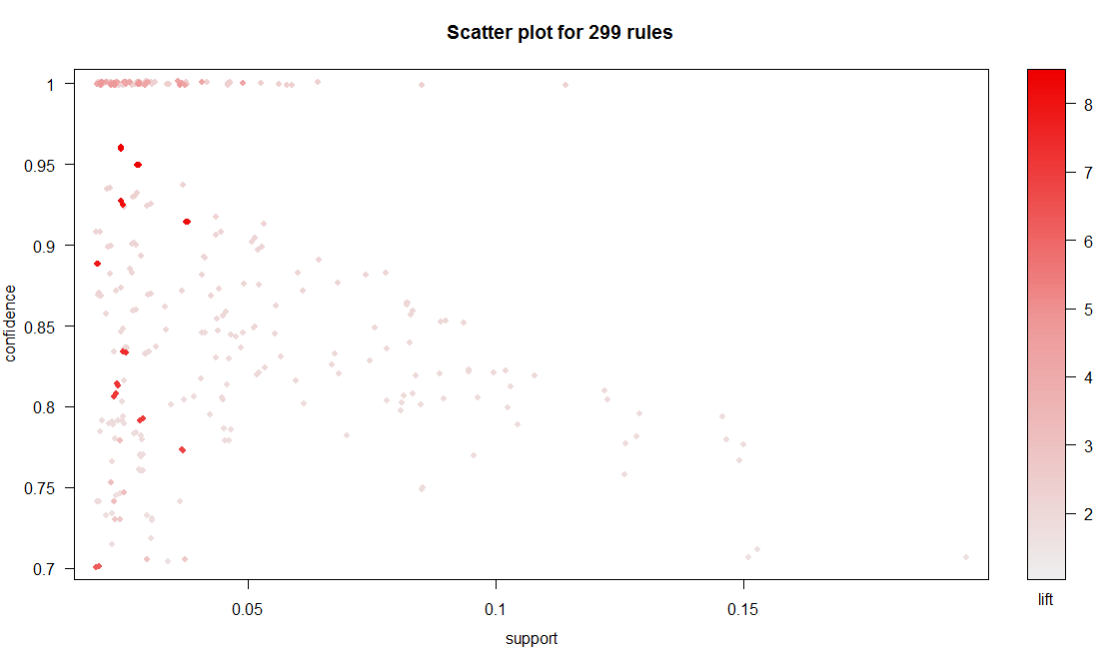

For better visualizations we can use other methods to plot and we can do   
that in a new window

windows()

plot(rules,method = "grouped")

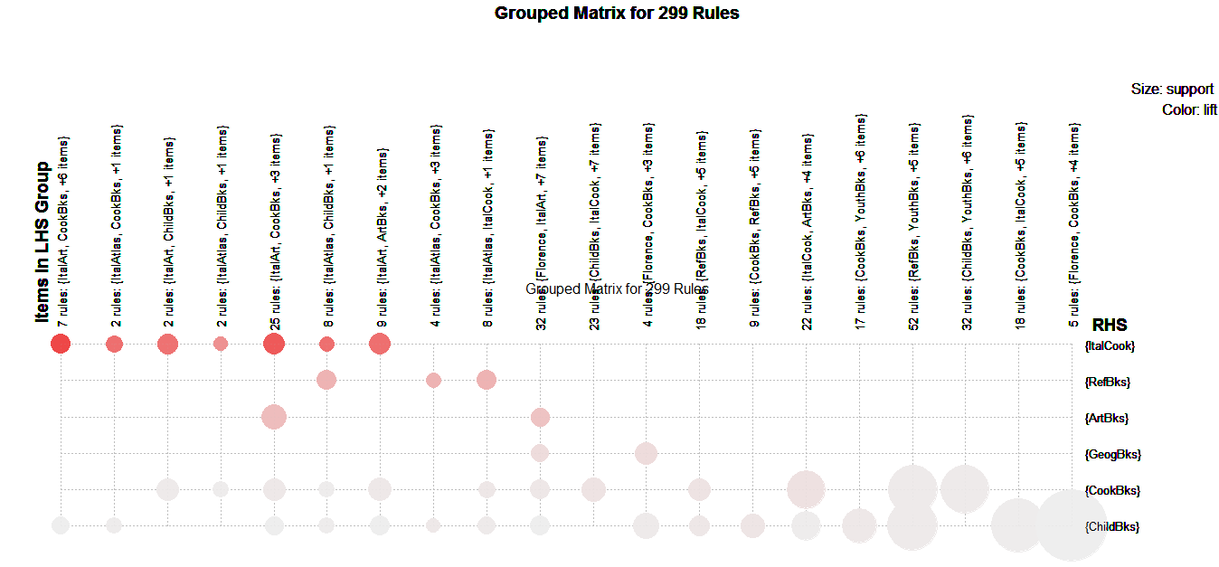

plot(rules[1:20] , method = "graph")

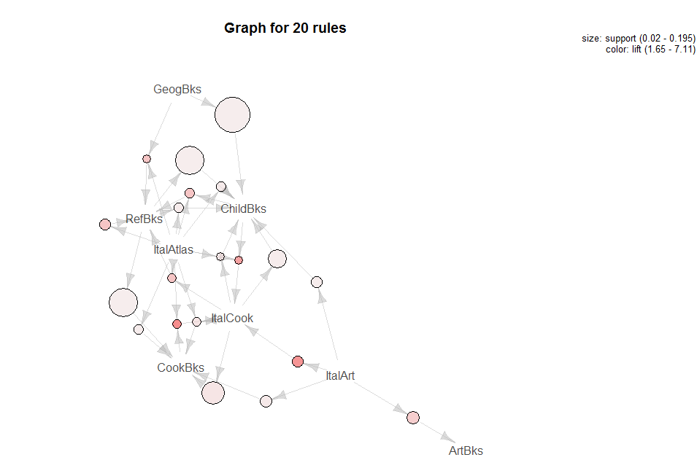  
  
Thus , we can Association rules are formed , we can by :

write(rules , file = " arulessol.csv" , sep="," )