**PARTYGUARD TEST PLAN**

**Product:** PartyGuard Web Application

**Client:** Jacob Stansbury

**Team name: PartyFreaks**

**Roles and responsibilities:**

|  |  |
| --- | --- |
| **Team Member** | **Project Roles** |
| Prem Abishai Parise | Primary Contact |
| Nihitha Reddy Bhimireddy | Client Management |
| Lokesh Reddy Pothapu | Requirements Management |
| Srichaitanya Peddinti | Database Management |
| Spandana Velaga | Quality and Testing Management |
| Sindhuja Pannala | Issues Management |
| Gopinadh Cherupally | Communications and Documentation Management |

**VERSION HISTORY**

|  |  |  |  |
| --- | --- | --- | --- |
| **Version No.** | **Date** | **Changed By** | **Changes Made** |
| 1 | **10/07/2016** | **Nihitha Reddy Bhimireddy** | Initial Commit |
| 2 | **10/28/2016** | **Gopinadh Cherupally** | Update test cases of unit testing and integration testing |

**UNIT TESTING**

1. **Home page**

Gopinadh Cherupally – 100% contribution

<https://github.com/s525080/PartyGuardWeb/blob/2051aa7d93bd7e08f1432dbaf88f2dec7035b4fa/homepage.xlsx>

|  |  |  |  |  |  |
| --- | --- | --- | --- | --- | --- |
| Test case number | Test case description | Steps | Expected result | Actual Result | Status(Pass/Fail) |
| 1 | Check the text fields | click on the text field | Should be able to type | User can be able to type | Pass |
|  |  | text field should be enabled |  |  |  |
| 2 | Image carousel | Redirect to homepage | Images should be changed automatically | Images are changing automatically | Pass |
|  |  | View the image carousel |  |  |  |
|  |  | Images should change automatically for every 5 seconds |  |  |  |
| 3 | Submit button | Click on Submit button | Details about the application should be sent to the user | Functionality is yet to be done | Fail |
|  |  | Send the quote to the registered user |  |  |  |
| 4 | Home button | Click on the home button | Homepage is displayed | Home page is displayed | Pass |
|  |  | Home page should be displayed |  |  |  |
| 5 | About us button | Go to homepage of partyguard | Redirect to About us page | About us page is displayed | Pass |
|  |  | View the About us button on the top |  |  |  |
|  |  | Press on the button About us |  |  |  |
| 6 | How it works button | Go to homepage of partyguard | Redirects to the how it works page | How it works page is displayed | Pass |
|  |  | View the button How it works |  |  |  |
|  |  | Click on the button How it works |  |  |  |
| 7 | FAQs button | Go to homepage of partyguard | Redirect to FAQs page | FAQs page is displayed | Pass |
|  |  | View the FAQs button on the top |  |  |  |
|  |  | Press on the button FAQs |  |  |  |
| 8 | Contact us button | Go to homepage of partyguard | Redirect to Contact us page | Contact us page is displayed | Pass |
|  |  | View the Contact us button on the top |  |  |  |
|  |  | Press on the button Contact us |  |  |  |
| 9 | Login button | Go to homepage of partyguard | Redirect to login page | login page is displayed | Pass |
|  |  | View the Login button on the top |  |  |  |
|  |  | Press on the button Login |  |  |  |
| 10 | Name text field | Go to homepage | Should be able to type a valid name | Functionality is yet to be done | Fail |
|  |  | View the text field |  |  |  |
|  |  | Type in the text field |  |  |  |
| 11 | Email text field | Go to homepage | Should be able to type a valid email address | Functionality is yet to be done | Fail |
|  |  | View the text field |  |  |  |
|  |  | Should be able to type email address |  |  |  |
| 12 | Download link | Go to home page | Should be able to download the app through the link | Functionality is yet to be done | Fail |
|  |  | View the link download here |  |  |  |
|  |  | Click on the link |  |  |  |
| 13 | Host link | Go to home page | Should be able to redirect to host page | Functionality is yet to be done | Fail |
|  |  | View the link know more |  |  |  |
|  |  | Click on the link |  |  |  |
| 14 | Guard link | Go to home page | Should be able to redirect to guard page | Functionality is yet to be done | Fail |
|  |  | View the link know more |  |  |  |
|  |  | Click on the link |  |  |  |
| 15 | contact partyguard link | Go to homepage of partyguard | redirect to contact page | Functionality is yet to be done | fail |
|  |  | view the contact partyguard link |  |  |  |
|  |  | click on the link |  |  |  |
| 16 | about partyguard link | Go to homepage of partyguard | redirect to about partyguard page | Functionality is yet to be done | fail |
|  |  | view the about partyguard link |  |  |  |
|  |  | click on the link |  |  |  |
| 17 | employment link | Go to homepage of partyguard | redirect to employment page | Functionality is yet to be done | fail |
|  |  | view the about employment link |  |  |  |
|  |  | click on the link |  |  |  |
| 18 | maps and directions link | Go to homepage of partyguard | redirect to maps directions page | Functionality is yet to be done | fail |
|  |  | view the maps and directions link |  |  |  |
|  |  | click on the link |  |  |  |
| 19 | emergency information link | Go to homepage of partyguard | redirect to emergency page | Functionality is yet to be done | fail |
|  |  | view the emergency link |  |  |  |
|  |  | click on the link |  |  |  |

**Screenshot:**

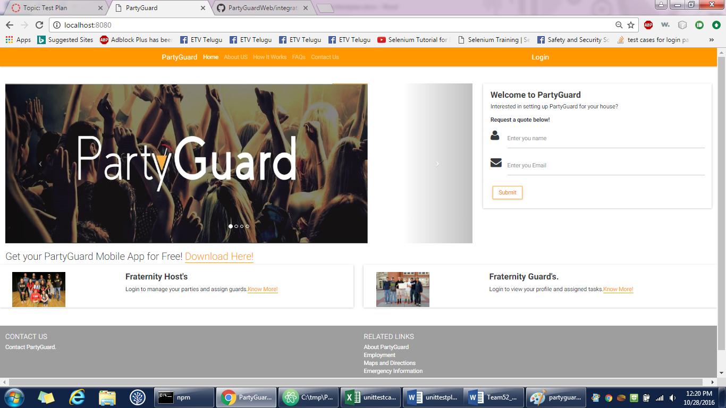

1. **Login page**

Gopinadh Cherupally – 100% contribution

<https://github.com/s525080/PartyGuardWeb/blob/b3c04d4cb9bdad9be56ba5cf242fa960d22cadac/loginpage.xlsx>

|  |  |  |  |  |  |
| --- | --- | --- | --- | --- | --- |
| Test case number | Test case description | Steps | Expected result | Actual Result | Status(Pass/Fail) |
| 1 | login button | Open a web browser and type the url | Redirect to login page | Login page is displayed | Pass |
|  |  | View the login button |  |  |  |
|  |  | Press the login button |  |  |  |
| 2 | forgot password link | View the forgot password link | Details page should be displayed | Functionality is yet to be done | Fail |
|  |  | Click the forgot password link |  |  |  |
| 3 | Check the text fields | click on the text field | Should be able to type | Able to type | Pass |
|  |  | text field should be enabled |  |  |  |
| 4 | Home button | Click on the home button | Homepage is displayed | Homepage is displayed | Pass |
|  |  | Homepage should be displayed |  |  |  |
| 5 | About us button | Go to homepage of partyguard | Redirect to About us page | About us page is displayed | Pass |
|  |  | View the About us button on the top |  |  |  |
|  |  | Press on the button About us |  |  |  |
| 6 | How it works button | Go to homepage of partyguard | Redirects to the how it works page | How it works page is displayed | Pass |
|  |  | View the button How it works |  |  |  |
|  |  | Click on the button How it works |  |  |  |
| 7 | FAQs button | Go to homepage of partyguard | Redirect to FAQs page | FAQs page is displayed | Pass |
|  |  | View the FAQs button on the top |  |  |  |
|  |  | Press on the button FAQs |  |  |  |
| 8 | Contact us button | Go to homepage of partyguard | Redirect to Contact us page | Contact us page is displayed | Pass |
|  |  | View the Contact us button on the top |  |  |  |
|  |  | Press on the button Contact us |  |  |  |
| 9 | Login button | Go to homepage of partyguard | Redirect to login page | Login page is displayed | Pass |
|  |  | View the Login button on the top |  |  |  |
|  |  | Press on the button Login |  |  |  |
| 10 | Sign up link | Go to login page | Redirect to signup page | Sign up page is displayed | Pass |
|  |  | View the sign up link |  |  |  |
|  |  | should be able to view the sign up page |  |  |  |
| 11 | Register as a guard button | Go to login page | Registration page is displayed | Functionality is yet to be done | Fail |
|  |  | View the register as a guard button |  |  |  |
|  |  | Click on the register as a guard button |  |  |  |
| 12 | contact partyguard link | Go to about us page of partyguard | redirect to contact page | Functionality is yet to be done | fail |
|  |  | view the contact partyguard link |  |  |  |
|  |  | click on the link |  |  |  |
| 13 | about partyguard link | go to about us page | redirect to about partyguard page | Functionality is yet to be done | fail |
|  |  | view the about partyguard link |  |  |  |
|  |  | click on the link |  |  |  |
| 14 | employment link | go to about us page | redirect to employment page | Functionality is yet to be done | fail |
|  |  | view the about employment link |  |  |  |
|  |  | click on the link |  |  |  |
| 15 | maps and directions link | go to about us page | redirect to maps directions page | Functionality is yet to be done | fail |
|  |  | view the maps and directions link |  |  |  |
|  |  | click on the link |  |  |  |
| 16 | emergency information link | go to about us page | redirect to emergency page | Functionality is yet to be done | fail |
|  |  | view the emergency link |  |  |  |
|  |  | click on the link |  |  |  |

**Screenshot:**

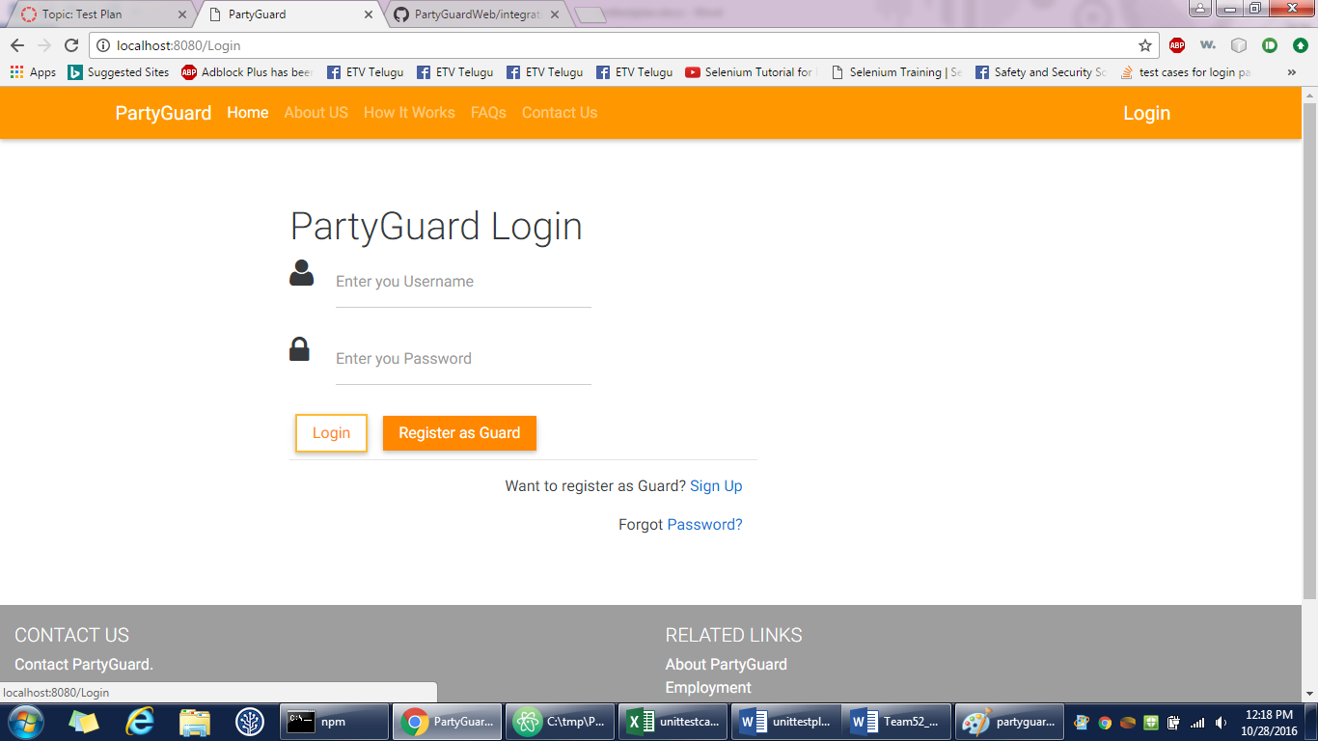

1. **About us page**

Gopinadh Cherupally – 100% contribution

<https://github.com/s525080/PartyGuardWeb/blob/Documents/about%20us%20page.xlsx>

|  |  |  |  |  |  |
| --- | --- | --- | --- | --- | --- |
| Test case number | Test case description | Steps | Expected result | Actual result | Status(Pass/Fail) |
| 1 | About us button | Go to homepage of partyguard | Redirect to About us page | About us page is displayed | pass |
|  |  | View the About us button on the top |  |  |  |
|  |  | Press on the button About us |  |  |  |
| 2 | Home button | Click on the home button | Homepage is displayed | Homepage is displayed | Pass |
|  |  | Homepage should be displayed |  |  |  |
| 3 | About us button | Go to about us of partyguard | Redirect to About us page | About us page is displayed | Pass |
|  |  | View the About us button on the top |  |  |  |
|  |  | Press on the button About us |  |  |  |
| 4 | How it works button | Go to about us page of partyguard | Redirects to the how it works page | How it works page is displayed | Pass |
|  |  | View the button How it works |  |  |  |
|  |  | Click on the button How it works |  |  |  |
| 5 | FAQs button | Go to about us page of partyguard | Redirect to FAQs page | FAQs page is displayed | Pass |
|  |  | View the FAQs button on the top |  |  |  |
|  |  | Press on the button FAQs |  |  |  |
| 6 | Contact us button | Go to about us page of partyguard | Redirect to Contact us page | Contact us page is displayed | Pass |
|  |  | View the Contact us button on the top |  |  |  |
|  |  | Press on the button Contact us |  |  |  |
| 7 | contact partyguard link | Go to about us page of partyguard | redirect to contact page | Functionality is yet to be done | fail |
|  |  | view the contact partyguard link |  |  |  |
|  |  | click on the link |  |  |  |
| 8 | about partyguard link | go to about us page | redirect to about partyguard page | Functionality is yet to be done | fail |
|  |  | view the about partyguard link |  |  |  |
|  |  | click on the link |  |  |  |
| 9 | employment link | go to about us page | redirect to employment page | Functionality is yet to be done | fail |
|  |  | view the about employment link |  |  |  |
|  |  | click on the link |  |  |  |
| 10 | maps and directions link | go to about us page | redirect to maps directions page | Functionality is yet to be done | fail |
|  |  | view the maps and directions link |  |  |  |
|  |  | click on the link |  |  |  |
| 11 | emergency information link | go to about us page | redirect to emergency page | Functionality is yet to be done | fail |
|  |  | view the emergency link |  |  |  |
|  |  | click on the link |  |  |  |

**Screenshot:**

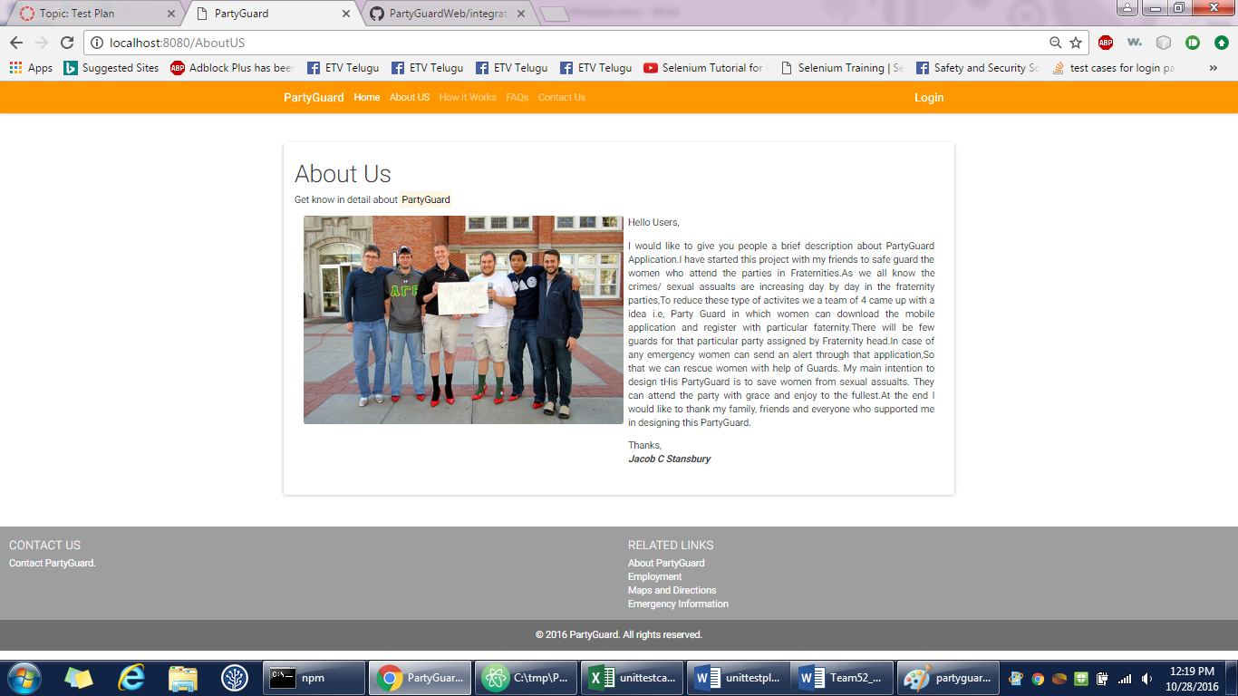

1. **Contact us page**

Gopinadh Cherupally – 100% contribution

<https://github.com/s525080/PartyGuardWeb/blob/0cc023775d30bd1b43e4d477b3b119f7de8d2284/contactus.xlsx>

|  |  |  |  |  |  |
| --- | --- | --- | --- | --- | --- |
| Test case number | Test case description | Steps | Expected result | Actual result | Status(Pass/Fail) |
| 1 | Contact us button | Go to homepage of partyguard | Redirect to Contact us page | contact us page is displayed | pass |
|  |  | View the Contact us button on the top |  |  |  |
|  |  | Press on the button Contact us |  |  |  |
| 2 | Home button | Click on the home button | Homepage is displayed | Homepage is displayed | Pass |
|  |  | Homepage should be displayed |  |  |  |
| 3 | About us button | Go to contact us page of partyguard | Redirect to About us page | About us page is displayed | Pass |
|  |  | View the About us button on the top |  |  |  |
|  |  | Press on the button About us |  |  |  |
| 4 | How it works button | Go to contact us page of partyguard | Redirects to the how it works page | How it works page is displayed | Pass |
|  |  | View the button How it works |  |  |  |
|  |  | Click on the button How it works |  |  |  |
| 5 | FAQs button | Go to contact us page of partyguard | Redirect to FAQs page | FAQs page is displayed | Pass |
|  |  | View the FAQs button on the top |  |  |  |
|  |  | Press on the button FAQs |  |  |  |
| 6 | Contact us button | Go to contact us page of partyguard | Redirect to Contact us page | Contact us page is displayed | Pass |
|  |  | View the Contact us button on the top |  |  |  |
|  |  | Press on the button Contact us |  |  |  |
| 7 | contact partyguard link | Go to contact us page of partyguard | redirect to contact page | Functionality is yet to be done | fail |
|  |  | view the contact partyguard link |  |  |  |
|  |  | click on the link |  |  |  |
| 8 | about partyguard link | Go to contact us page of partyguard | redirect to about partyguard page | Functionality is yet to be done | fail |
|  |  | view the about partyguard link |  |  |  |
|  |  | click on the link |  |  |  |
| 9 | employment link | Go to contact us page of partyguard | redirect to employment page | Functionality is yet to be done | fail |
|  |  | view the about employment link |  |  |  |
|  |  | click on the link |  |  |  |
| 10 | maps and directions link | Go to contact us page of partyguard | redirect to maps directions page | Functionality is yet to be done | fail |
|  |  | view the maps and directions link |  |  |  |
|  |  | click on the link |  |  |  |
| 11 | emergency information link | Go to contact us page of partyguard | redirect to emergency page | Functionality is yet to be done | fail |
|  |  | view the emergency link |  |  |  |
|  |  | click on the link |  |  |  |

**Screenshot:**



1. **FAQs page**

Gopinadh Cherupally – 100% contribution

<https://github.com/s525080/PartyGuardWeb/blob/bce930a3e53861df6288298ef80e9ab528fdf21b/FAQs%20page.xlsx>

|  |  |  |  |  |  |
| --- | --- | --- | --- | --- | --- |
| Test case number | Test case description | Steps | Expected result | Actual Result | Status(Pass/Fail) |
| 1 | FAQs button | Go to homepage of partyguard | Redirect to FAQs page | FAQs page is displayed | Pass |
|  |  | View the FAQs button on the top |  |  |  |
|  |  | Press on the button FAQs |  |  |  |
| 2 | Host user questions | View the How it works page | Should view the answer related to that question | answer is displayed | Pass |
|  |  | Click on the question |  |  |  |
| 3 | Guard user questions | View the How it works page | Should view the answer related to that question | answer is displayed | Pass |
|  |  | Click on the question |  |  |  |
| 4 | Basic user questions | View the How it works page | Should view the answer related to that question | answer is displayed | Pass |
|  |  | Click on the question |  |  |  |
| 5 | Links | Should be able to view the link | should be able to view the data of the link | data is viewed | Pass |
|  |  | Click on the link |  |  |  |
|  |  | View the data of that link |  |  |  |
| 6 | Home button | Click on the home button | Homepage is displayed | Homepage is displayed | Pass |
|  |  | Homepage should be displayed |  |  |  |
| 7 | About us button | Go to FAQs page of partyguard | Redirect to About us page | About us page is displayed | Pass |
|  |  | View the About us button on the top |  |  |  |
|  |  | Press on the button About us |  |  |  |
| 8 | How it works button | Go to FAQs page of partyguard | Redirects to the how it works page | How it works page is displayed | Pass |
|  |  | View the button How it works |  |  |  |
|  |  | Click on the button How it works |  |  |  |
| 9 | FAQs button | Go to FAQs page of partyguard | Redirect to FAQs page | FAQs page is displayed | Pass |
|  |  | View the FAQs button on the top |  |  |  |
|  |  | Press on the button FAQs |  |  |  |
| 10 | Contact us button | Go to FAQs page of partyguard | Redirect to Contact us page | Contact us page is displayed | Pass |
|  |  | View the Contact us button on the top |  |  |  |
|  |  | Press on the button Contact us |  |  |  |
| 11 | contact partyguard link | Go to FAQs page of partyguard | redirect to contact page | Functionality is yet to be done | fail |
|  |  | view the contact partyguard link |  |  |  |
|  |  | click on the link |  |  |  |
| 12 | about partyguard link | Go to FAQs page of partyguard | redirect to about partyguard page | Functionality is yet to be done | fail |
|  |  | view the about partyguard link |  |  |  |
|  |  | click on the link |  |  |  |
| 13 | employment link | Go to FAQs page of partyguard | redirect to employment page | Functionality is yet to be done | fail |
|  |  | view the about employment link |  |  |  |
|  |  | click on the link |  |  |  |
| 14 | maps and directions link | Go to FAQs page of partyguard | redirect to maps directions page | Functionality is yet to be done | fail |
|  |  | view the maps and directions link |  |  |  |
|  |  | click on the link |  |  |  |
| 15 | emergency information link | Go to FAQs page of partyguard | redirect to emergency page | Functionality is yet to be done | fail |
|  |  | view the emergency link |  |  |  |
|  |  | click on the link |  |  |  |

**Screenshot:**

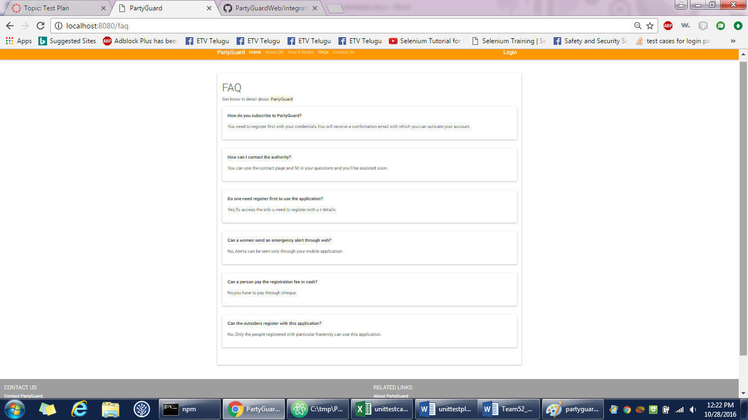

1. **How it works page**

Gopinadh Cherupally – 100% contribution

<https://github.com/s525080/PartyGuardWeb/blob/36eb1022c468be8240e7559e24fbb4241b966182/howitworkspag.xlsx>

|  |  |  |  |  |  |
| --- | --- | --- | --- | --- | --- |
| Test case number | Test case description | Steps | Expected result | Actual Result | Status(Pass/Fail) |
| 1 | How it works button | Go to homepage of partyguard | Redirects to the how it works page | How it works page is displayed | Pass |
|  |  | View the button How it works | |  |  |
|  |  | Click on the button How it works | | |  |
| 2 | Host user questions | View the How it works page | Should view the answer related to that question | answer is dsplayed | pass |
|  |  | Click on the question | |  |  |
| 3 | Guard user questions | View the How it works page | Should view the answer related to that question | answer is dsplayed | pass |
|  |  | Click on the question | |  |  |
| 4 | Basic user questions | View the How it works page | Should view the answer related to that question | answer is dsplayed | pass |
|  |  | Click on the question | |  |  |
| 5 | Links | Should be able to view the link | should be able to view the data of the link | data is displayed | pass |
|  |  | Click on the link | |  |  |
|  |  | View the data of that link | |  |  |
| 6 | Home button | Click on the home button | Homepage is displayed | Homepage is displayed | Pass |
|  |  | Homepage should be displayed | |  |  |
| 7 | About us button | Go to faqs page of partyguard | Redirect to About us page | About us page is displayed | Pass |
|  |  | View the About us button on the top | | |  |
|  |  | Press on the button About us | |  |  |
| 8 | How it works button | Go to faqs page of partyguard | Redirects to the how it works page | How it works page is displayed | Pass |
|  |  | View the button How it works | |  |  |
|  |  | Click on the button How it works | |  |  |
| 9 | FAQs button | Go to faqs page of partyguard | Redirect to FAQs page | FAQs page is displayed | Pass |
|  |  | View the FAQs button on the top | |  |  |
|  |  | Press on the button FAQs | |  |  |
| 10 | Contact us button | Go to faqs page of partyguard | Redirect to Contact us page | Contact us page is displayed | Pass |
|  |  | View the Contact us button on the top | | |  |
|  |  | Press on the button Contact us | |  |  |
| 11 | contact partyguard link | Go to faqs page of partyguard | redirect to contact page | Functionality is yet to be done | fail |
|  |  | view the contact partyguard link | |  |  |
|  |  | click on the link |  |  |  |
| 12 | about partyguard link | Go to faqs page of partyguard | redirect to about partyguard page | Functionality is yet to be done | fail |
|  |  | view the about partyguard link | |  |  |
|  |  | click on the link |  |  |  |
| 13 | employment link | Go to faqs page of partyguard | redirect to employment page | Functionality is yet to be done | fail |
|  |  | view the about employment link | |  |  |
|  |  | click on the link |  |  |  |
| 14 | maps and directions link | Go to faqs page of partyguard | redirect to maps directions page | Functionality is yet to be done | fail |
|  |  | view the maps and directions link | |  |  |
|  |  | click on the link |  |  |  |
| 15 | emergency information link | Go to faqs page of partyguard | redirect to emergency page | Functionality is yet to be done | fail |
|  |  | view the emergency link | |  |  |
|  |  | click on the link |  |  |  |

**Screenshot:**

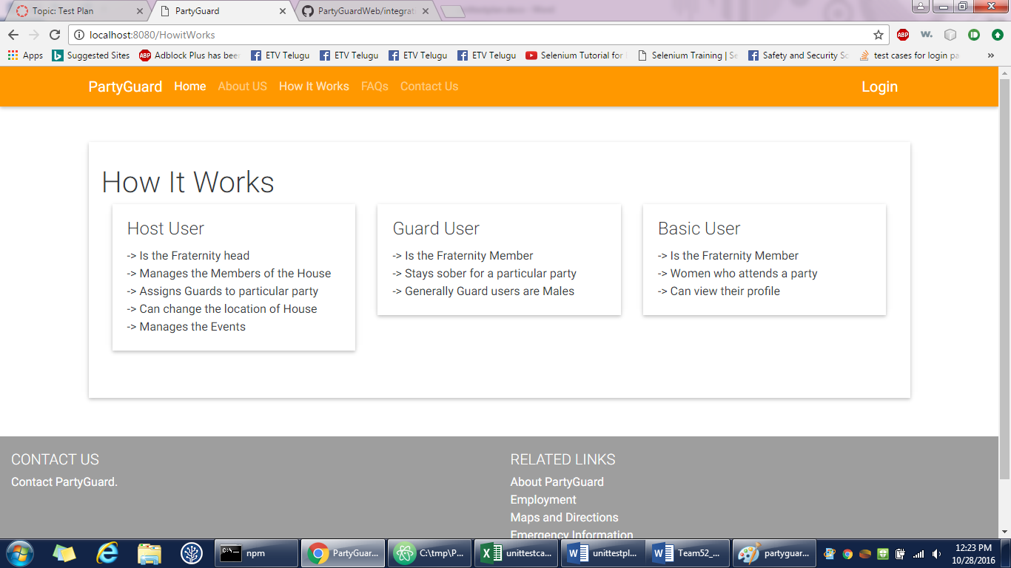

1. **Basic user login page**

Gopinadh Cherupally – 100% contribution

<https://github.com/s525080/PartyGuardWeb/blob/4e22e91dfcc9289aa4a5710a65c95b80e9184bf3/basicuserlogin.xlsx>

|  |  |  |  |  |  |
| --- | --- | --- | --- | --- | --- |
| Test case number | Test case description | Steps | Expected result | Actual result | Status(Pass/Fail) |
| 1 | login button | Open a web browser and type the url | Redirect to login page | Login page is displayed | Pass |
|  |  | View the login button |  |  |  |
|  |  | Press the login button |  |  |  |
| 2 | forgot password link | View the forgot password link | Details page should be displayed | Functionality is yet to be done | Fail |
|  |  | Click the forgot password link |  |  |  |
| 3 | Check the text fields | click on the text field | Should be able to type | Able to type | Pass |
|  |  | text field should be enabled |  |  |  |
| 4 | Home button | Click on the home button | Homepage is displayed | Homepage is displayed | Pass |
|  |  | Homepage should be displayed |  |  |  |
| 5 | About us button | Go to login page of partyguard | Redirect to About us page | About us page is displayed | Pass |
|  |  | View the About us button on the top |  |  |  |
|  |  | Press on the button About us |  |  |  |
| 6 | How it works button | Go to login page of partyguard | Redirects to the how it works page | How it works page is displayed | Pass |
|  |  | View the button How it works |  |  |  |
|  |  | Click on the button How it works |  |  |  |
| 7 | FAQs button | Go to login page of partyguard | Redirect to FAQs page | FAQs page is displayed | Pass |
|  |  | View the FAQs button on the top |  |  |  |
|  |  | Press on the button FAQs |  |  |  |
| 8 | Contact us button | Go to login page of partyguard | Redirect to Contact us page | Contact us page is displayed | Pass |
|  |  | View the Contact us button on the top |  |  |  |
|  |  | Press on the button Contact us |  |  |  |
| 9 | Login button | Go to login page of partyguard | Redirect to login page | Login page is displayed | Pass |
|  |  | View the Login button on the top |  |  |  |
|  |  | Press on the button Login |  |  |  |
| 10 | Sign up link | Go to login page | Redirect to signup page | Sign up page is displayed | Pass |
|  |  | View the sign up link |  |  |  |
|  |  | should be able to view the sign up page |  |  |  |
| 11 | Register as a guard button | Go to login page | Registration page should be displayed | Registration page is displayed | Pass |
|  |  | View the register as a guard button |  |  |  |
|  |  | Click on the register as a guard button |  |  |  |
| 12 | Check for empty validation | Click login button without entering any values in user name and password fields | Validation should be shown as please verify your username and password | validation is shown | Pass |
| 13 | Enter user name | Enter a valid username and leave password field empty | Validation should be shown as please verify your password | validation is shown | Pass |
|  |  | Click login button |  |  |  |
| 14 | Invalid username | Enter invalid username and valid password | Validation should be shown as invalid username or password | validation is shown | Pass |
| 15 | Enter password | Leave username field name blank and enter a valid password | Validation is given to enter username | validation is shown | pass |
|  |  | Click login button |  |  |  |
| 16 | Invalid password | Enter valid username and invalid password | Validation should be shown as please verify your password | validation is shown | Pass |
|  |  | Click login button |  |  |  |
| 17 | Hiding password | Enable the password text field | Password should be visible as dots | password is visible as dots | Pass |
|  |  | Type the password |  |  |  |
| 18 | login successful | Type the username as "basic" | Basic user profile page should be displayed | Basic user page is displayed | Pass |
|  |  | Type the password as "basic" |  |  |  |
|  |  | Press login |  |  |  |
| 19 | contact partyguard link | go to login page | redirect to contact page | Functionality is yet to be done | fail |
|  |  | view the contact partyguard link |  |  |  |
|  |  | click on the link |  |  |  |
| 20 | about partyguard link | go to login page | redirect to about partyguard page | Functionality is yet to be done | fail |
|  |  | view the about partyguard link |  |  |  |
|  |  | click on the link |  |  |  |
| 21 | employment link | go to login page | redirect to employment page | Functionality is yet to be done | fail |
|  |  | view the about employment link |  |  |  |
|  |  | click on the link |  |  |  |
| 22 | maps and directions link | go to login page | redirect to maps directions page | Functionality is yet to be done | fail |
|  |  | view the maps and directions link |  |  |  |
|  |  | click on the link |  |  |  |
| 23 | emergency information link | go to login page | redirect to emergency page | Functionality is yet to be done | fail |
|  |  | view the emergency link |  |  |  |
|  |  | click on the link |  |  |  |

**Screenshot:**

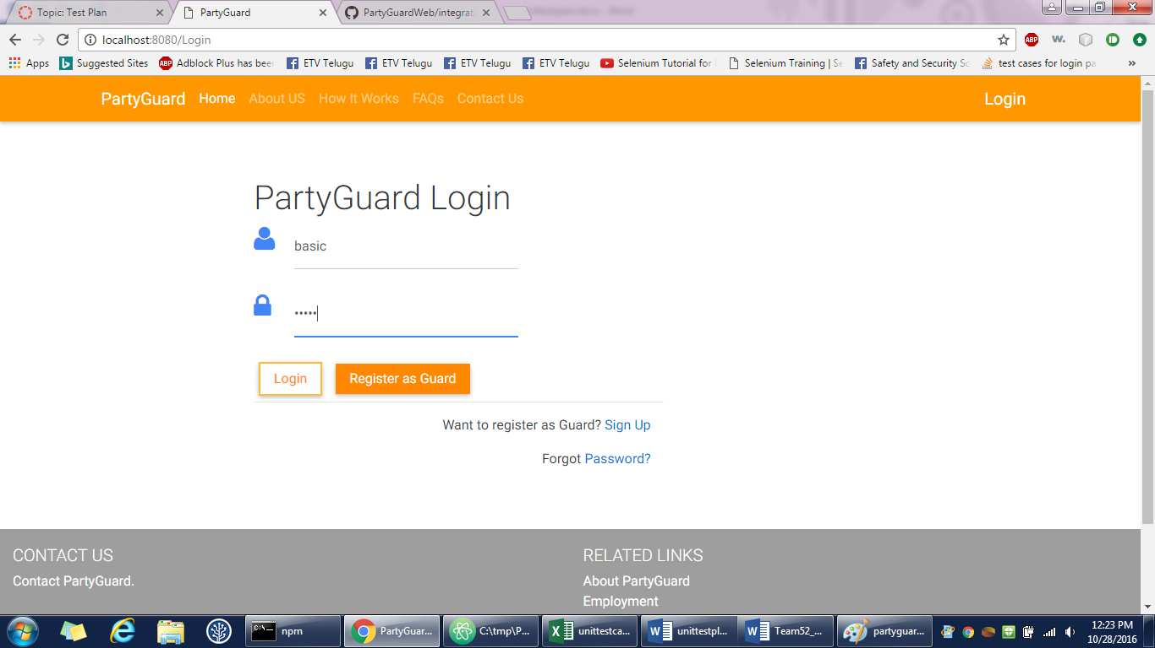

1. **Basic user page**

Gopinadh Cherupally – 100% contribution

<https://github.com/s525080/PartyGuardWeb/blob/8c3cd225325561ccecf2de36877401dc9483debf/basicuserprofile.xlsx>

|  |  |  |  |  |  |  |
| --- | --- | --- | --- | --- | --- | --- |
| Test case number | Test case description | Steps | Expected result | Actual Result | Status(Pass/Fail) | |
| 1 | logout button | Login with the credentials | logout button is displayed on the top right | Functionality is yet to be done | pass | |
|  |  | Go to the basic user page | |  |  | |
| 2 | profile button | login to the basic user page | able to view the personal details | personal details are viewed | pass | |
|  |  | click on the profile button | |  |  | |
| 3 | change password button | Go to the basic user page | able to see the change password page | password change page is displayed | pass | |
|  |  | click on the change password button | | |  | |
| 4 | edit button | go to profile page | edit page should be displayed | edit page is displayed | pass | |
|  |  | click on edit button | |  |  | |
| 5 | Edit full name text field | go to profile page | should be able to edit full name | full name is edited | pass | |
|  |  | click on edit button | |  |  | |
|  |  | click on the text field full name | |  |  | |
| 6 | edit fraternity name text field | go to profile page | should be able to edit fraternity name | fraternity name is edited | pass | |
|  |  | click on edit button | |  |  | |
|  |  | click on the text field fraternity name | | |  | |
| 7 | edit email | go to profile page | should be able to edit email | email is edited | pass | |
|  |  | click on edit button | |  |  | |
|  |  | click on the text field email | |  |  | |
| 8 | "@" validation for email | go to profile page | validation should be displayed | validation is displayed | pass | |
|  |  | click on edit button | |  |  | |
|  |  | click on the text field email | |  |  | |
|  |  | enter email without "@" | |  |  | |
| 9 | edit phone number | go to profile page | should be able to edit with numbers | numbers are edited | pass | |
|  |  | click on edit button | |  |  | |
|  |  | click on the text field phone number | | |  | |
| 10 | save changes button | go to profile page | should be able to view the changes saved | changes are displayed | pass | |
|  |  | click on edit button | |  |  | |
|  |  | edit the changes |  |  |  | |
|  |  | click on the save button | |  |  | |
| 11 | empty text field validations | go to profile page | validation about empty text field should be displayed | validation is displayed | pass | |
|  |  | click on edit button | |  |  | |
|  |  | click the save changes button with empty text fields | | | | |
| 12 | Home button | Click on the home button | Homepage is displayed | Homepage is displayed | | Pass |
|  |  | Homepage should be displayed | | | |  |
| 13 | About us button | Go to login page of partyguard | Redirect to About us page | About us page is displayed | | Pass |
|  |  | View the About us button on the top | | | |  |
|  |  | Press on the button About us | |  | |  |
| 14 | How it works button | Go to login page of partyguard | Redirects to the how it works page | How it works page is displayed | | Pass |
|  |  | View the button How it works | |  | |  |
|  |  | Click on the button How it works | | | |  |
| 15 | FAQs button | Go to login page of partyguard | Redirect to FAQs page | FAQs page is displayed | | Pass |
|  |  | View the FAQs button on the top | | | |  |
|  |  | Press on the button FAQs | |  | |  |
| 16 | Contact us button | Go to login page of partyguard | Redirect to Contact us page | Contact us page is displayed | | Pass |
|  |  | View the Contact us button on the top | | | |  |
|  |  | Press on the button Contact us | |  | |  |
| 17 | contact partyguard link | go to profile page | redirect to contact page | Functionality is yet to be done | | fail |
|  |  | view the contact partyguard link | | | |  |
|  |  | click on the link |  |  | |  |
| 18 | about partyguard link | go to profile page | redirect to about partyguard page | Functionality is yet to be done | | fail |
|  |  | view the about partyguard link | |  | |  |
|  |  | click on the link |  |  | |  |
| 19 | employment link | go to profile page | redirect to employment page | Functionality is yet to be done | | fail |
|  |  | view the about employment link | | | |  |
|  |  | click on the link |  |  | |  |
| 20 | maps and directions link | go to profile page | redirect to maps directions page | Functionality is yet to be done | | fail |
|  |  | view the maps and directions link | | | |  |
|  |  | click on the link |  |  | |  |
| 21 | emergency information link | go to profile page | redirect to emergency page | Functionality is yet to be done | | fail |
|  |  | view the emergency link | |  | |  |
|  |  | click on the link |  |  | |  |

**Screenshot:**

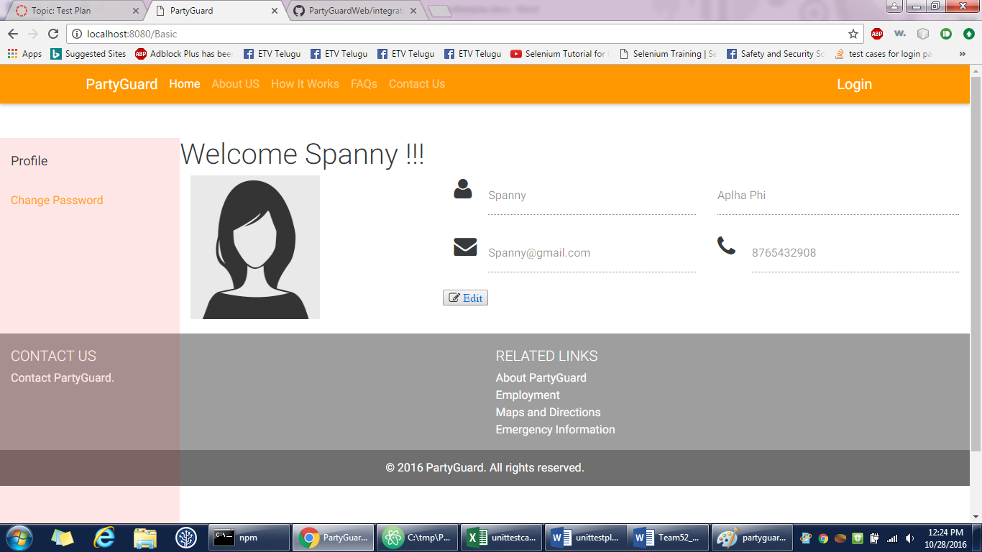

1. **Change password page**

Gopinadh Cherupally – 100% contribution

<https://github.com/s525080/PartyGuardWeb/blob/402429a8de094915449b8679de657308939eb730/basicchangepassword.xlsx>

|  |  |  |  |  |  |
| --- | --- | --- | --- | --- | --- |
| Test case number | Test case description | Steps | Expected result | Actual Result | Status(Pass/Fail) |
| 1 | Check the text fields | click on the text field | Should be able to type | Able to type | Pass |
|  |  | text field should be enabled |  |  |  |
| 2 | Hiding password | Enable the password text field | Password should be visible as dots | password is visible as dots | Pass |
|  |  | Type the password |  |  |  |
| 3 | Old password text field | login to basic user page | Should be able to type the password | Able to type password | Pass |
|  |  | redirect to change password page |  |  |  |
|  |  | click on the text field old password |  |  |  |
| 4 | password text field | login to basic user page | Should be able to type the password | Able to type password | pass |
|  |  | redirect to change password page |  |  |  |
|  |  | click on the text field password |  |  |  |
| 5 | Confirm password text field | login to basic user page | Should be able to type the password | Able to type password | pass |
|  |  | redirect to change password page |  |  |  |
|  |  | click on the text field confirm password |  |  |  |
| 6 | submit button | login to basic user page | password should be updated | functionality is yet to be done | fail |
|  |  | redirect to change password page |  |  |  |
|  |  | click on the submit button |  |  |  |
| 7 | empty text field validation | login to basic user page | validation should be shown | functionality is yet to be done | fail |
|  |  | redirect to change password page |  |  |  |
|  |  | click on submit button directly |  |  |  |
| 8 | Home button | Click on the home button | Homepage is displayed | Homepage is displayed | Pass |
|  |  | Homepage should be displayed |  |  |  |
| 9 | About us button | Go to basic user page of partyguard | Redirect to About us page | About us page is displayed | Pass |
|  |  | View the About us button on the top |  |  |  |
|  |  | Press on the button About us |  |  |  |
| 10 | How it works button | Go to basic user page of partyguard | Redirects to the how it works page | How it works page is displayed | Pass |
|  |  | View the button How it works |  |  |  |
|  |  | Click on the button How it works |  |  |  |
| 11 | FAQs button | Go to basic user page of partyguard | Redirect to FAQs page | FAQs page is displayed | Pass |
|  |  | View the FAQs button on the top |  |  |  |
|  |  | Press on the button FAQs |  |  |  |
| 12 | Contact us button | Go to basic user page of partyguard | Redirect to Contact us page | Contact us page is displayed | Pass |
|  |  | View the Contact us button on the top |  |  |  |
|  |  | Press on the button Contact us |  |  |  |
| 13 | contact partyguard link | go to profile page | redirect to contact page | Functionality is yet to be done | fail |
|  |  | view the contact partyguard link |  |  |  |
|  |  | click on the link |  |  |  |
| 14 | about partyguard link | go to profile page | redirect to about partyguard page | Functionality is yet to be done | fail |
|  |  | view the about partyguard link |  |  |  |
|  |  | click on the link |  |  |  |
| 15 | employment link | go to profile page | redirect to employment page | Functionality is yet to be done | fail |
|  |  | view the about employment link |  |  |  |
|  |  | click on the link |  |  |  |
| 16 | maps and directions link | go to profile page | redirect to maps directions page | Functionality is yet to be done | fail |
|  |  | view the maps and directions link |  |  |  |
|  |  | click on the link |  |  |  |
| 17 | emergency information link | go to profile page | redirect to emergency page | Functionality is yet to be done | fail |

**Screenshot:**

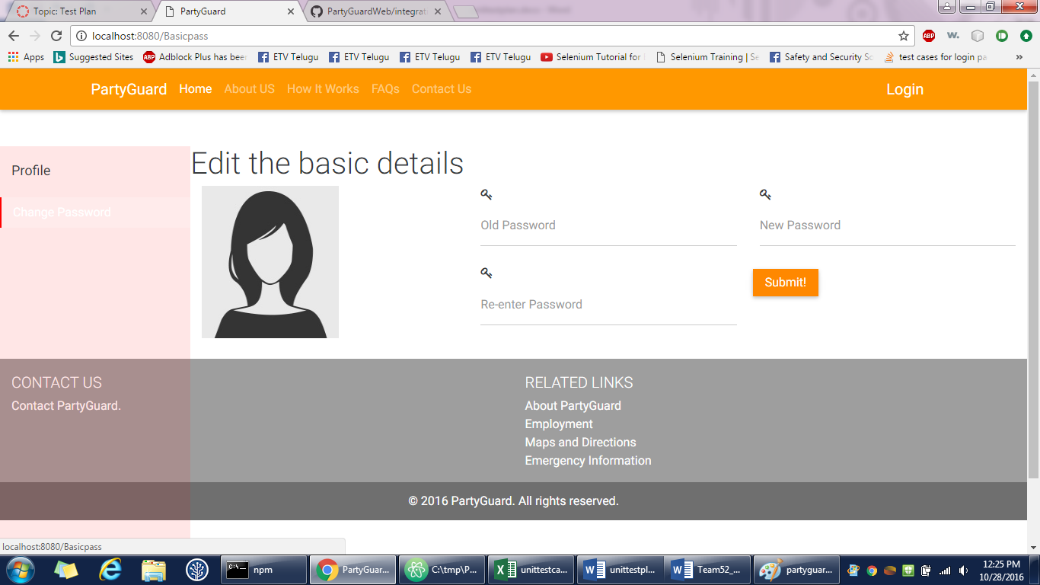

1. **Guard login**

Gopinadh Cherupally – 100% contribution

<https://github.com/s525080/PartyGuardWeb/blob/a97fa45b9757717370c7d11e5ca6b32ed2015741/guardlogin.xlsx>

|  |  |  |  |  |  |
| --- | --- | --- | --- | --- | --- |
| Test case number | Test case description | Steps | Expected result | Actual result | Status(Pass/Fail) |
| 1 | login button | Open a web browser and type the url | Redirect to login page | Login page is displayed | Pass |
|  |  | View the login button | |  |  |
|  |  | Press the login button | |  |  |
| 2 | forgot password link | View the forgot password link | Details page should be displayed | Functionality is yet to be done | Fail |
|  |  | Click the forgot password link | |  |  |
| 3 | Check the text fields | click on the text field | Should be able to type | Able to type | Pass |
|  |  | text field should be enabled | |  |  |
| 4 | Home button | Click on the home button | Homepage is displayed | Homepage is displayed | Pass |
|  |  | Homepage should be displayed | |  |  |
| 5 | About us button | Go to login page of partyguard | Redirect to About us page | About us page is displayed | Pass |
|  |  | View the About us button on the top | | |  |
|  |  | Press on the button About us | |  |  |
| 6 | How it works button | Go to login page of partyguard | Redirects to the how it works page | How it works page is displayed | Pass |
|  |  | View the button How it works | |  |  |
|  |  | Click on the button How it works | |  |  |
| 7 | FAQs button | Go to login page of partyguard | Redirect to FAQs page | FAQs page is displayed | Pass |
|  |  | View the FAQs button on the top | |  |  |
|  |  | Press on the button FAQs | |  |  |
| 8 | Contact us button | Go to login page of partyguard | Redirect to Contact us page | Contact us page is displayed | Pass |
|  |  | View the Contact us button on the top | | |  |
|  |  | Press on the button Contact us | |  |  |
| 9 | Login button | Go to login page of partyguard | Redirect to login page | Login page is displayed | Pass |
|  |  | View the Login button on the top | |  |  |
|  |  | Press on the button Login | |  |  |
| 10 | Sign up link | Go to login page | Redirect to signup page | Sign up page is displayed | Pass |
|  |  | View the sign up link | |  |  |
|  |  | should be able to view the sign up page | | |  |
| 11 | Register as a guard button | Go to login page | Registration page should be displayed | Registraton page is displayed | Pass |
|  |  | View the register as a guard button | |  |  |
|  |  | Click on the register as a guard button | | |  |
| 12 | Check for empty validation | Click login button without entering any values in user name and password fields | Validation should be shown as please verify your username and password | validation is shown | Pass |
| 13 | Enter user name | Enter a valid username and leave password field empty | Validation should be shown as please verify your password | validation is shown | Pass |
|  |  | Click login button | |  |  |
| 14 | Invalid username | Enter invalid username and valid password | Validation should be shown as invalid username or password | validation is shown | Pass |
| 15 | Enter password | Leave username field name blank and enter a valid password | Validation is given to enter username | validation is shown | pass |
|  |  | Click login button | |  |  |
| 16 | Invalid password | Enter valid username and invalid password | Validation should be shown as please verify your password | validation is shown | Pass |
|  |  | Click login button | |  |  |
| 17 | Hiding password | Enable the password text field | Password should be visible as dots | password is visible as dots | Pass |
|  |  | Type the password | |  |  |
| 18 | login successful | Type the username as "basic" | Basic user profile page should be displayed | Basic user page is displayed | Pass |
|  |  | Type the password as "basic" | |  |  |
|  |  | Press login |  |  |  |
| 19 | contact partyguard link | go to login page | redirect to contact page | Functionality is yet to be done | fail |
|  |  | view the contact partyguard link | |  |  |
|  |  | click on the link |  |  |  |
| 20 | about partyguard link | go to login page | redirect to about partyguard page | Functionality is yet to be done | fail |
|  |  | view the about partyguard link | |  |  |
|  |  | click on the link |  |  |  |
| 21 | employment link | go to login page | redirect to employment page | Functionality is yet to be done | fail |
|  |  | view the about employment link | |  |  |
|  |  | click on the link |  |  |  |
| 22 | maps and directions link | go to login page | redirect to maps directions page | Functionality is yet to be done | fail |
|  |  | view the maps and directions link | |  |  |
|  |  | click on the link |  |  |  |
| 23 | emergency information link | go to login page | redirect to emergency page | Functionality is yet to be done | fail |
|  |  | view the emergency link | |  |  |
|  |  | click on the link |  |  |  |

**Screenshot:**

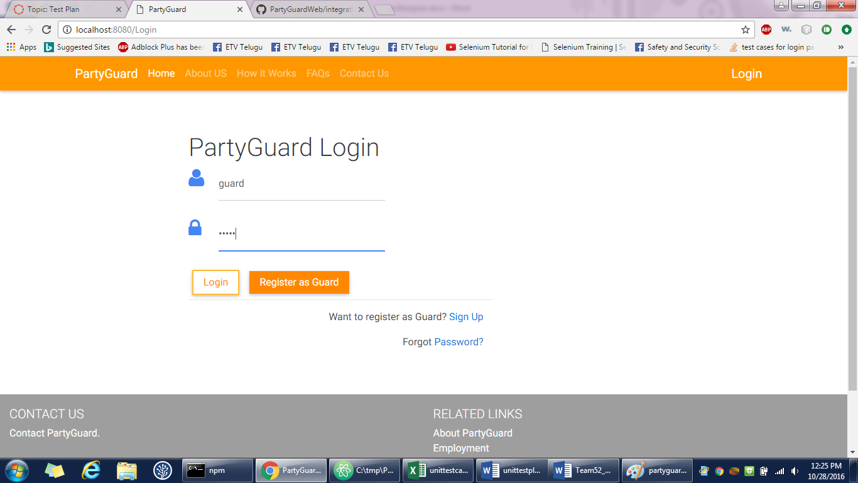

1. **Guard profile**

Gopinadh Cherupally – 100% contribution

<https://github.com/s525080/PartyGuardWeb/blob/d616386a16f30f4300ddaf325ed136a4d1e20588/guardprofile.xlsx>

|  |  |  |  |  |  |
| --- | --- | --- | --- | --- | --- |
| Test case number | Test case description | Steps | Expected result | Actual Result | Status(Pass/Fail) |
| 1 | logout button | Login with the credentials | logout button is displayed on the top right | Functionality is yet to be done | pass |
|  |  | Go to the guard user page | |  |  |
| 2 | profile button | login to the guard user page | able to view the personal details | personal details are viewed | pass |
|  |  | click on the profile button | |  |  |
| 3 | change password button | login to the guard user page | able to see the change password page | password change page is displayed | pass |
|  |  | click on the change password button | | |  |
| 4 | edit button | go to profile page | edit page should be displayed | edit page is displayed | pass |
|  |  | click on edit button | |  |  |
| 5 | Edit full name text field | go to profile page | should be able to edit full name | full name is edited | pass |
|  |  | click on edit button | |  |  |
|  |  | click on the text field full name | |  |  |
| 6 | edit fraternity name text field | go to profile page | should be able to edit fraternity name | fraternity name is edited | pass |
|  |  | click on edit button | |  |  |
|  |  | click on the text field fraternity name | | |  |
| 7 | edit email | go to profile page | should be able to edit email | email is edited | pass |
|  |  | click on edit button | |  |  |
|  |  | click on the text field email | |  |  |
| 8 | "@" validation for email | go to profile page | validation should be displayed | validation is displayed | pass |
|  |  | click on edit button | |  |  |
|  |  | click on the text field email | |  |  |
|  |  | enter email without "@" | |  |  |
| 9 | edit phone number | go to profile page | should be able to edit with numbers | numbers are edited | pass |
|  |  | click on edit button | |  |  |
|  |  | click on the text field phone number | | |  |
| 10 | save changes button | go to profile page | should be able to view the changes saved | changes are displayed | pass |
|  |  | click on edit button | |  |  |
|  |  | edit the changes | |  |  |
|  |  | click on the save button | |  |  |
| 11 | empty text field validations | go to profile page | validation about empty text field should be displayed | validation is displayed | pass |
|  |  | click on edit button | |  |  |
|  |  | click the save changes button with empty textfields | | | |
| 12 | Home button | Click on the home button | Homepage is displayed | Homepage is displayed | Pass |
|  |  | Homepage should be displayed | | |  |
| 13 | About us button | Go to login page of partyguard | Redirect to About us page | About us page is displayed | Pass |
|  |  | View the About us button on the top | | |  |
|  |  | Press on the button About us | |  |  |
| 14 | How it works button | Go to login page of partyguard | Redirects to the how it works page | How it works page is displayed | Pass |
|  |  | View the button How it works | |  |  |
|  |  | Click on the button How it works | |  |  |
| 15 | FAQs button | Go to login page of partyguard | Redirect to FAQs page | FAQs page is displayed | Pass |
|  |  | View the FAQs button on the top | | |  |
|  |  | Press on the button FAQs | |  |  |
| 16 | Contact us button | Go to login page of partyguard | Redirect to Contact us page | Contact us page is displayed | Pass |
|  |  | View the Contact us button on the top | | |  |
|  |  | Press on the button Contact us | |  |  |
| 17 | contact partyguard link | go to profile page | redirect to contact page | Functionality is yet to be done | fail |
|  |  | view the contact partyguard link | |  |  |
|  |  | click on the link |  |  |  |
| 18 | about partyguard link | go to profile page | redirect to about partyguard page | Functionality is yet to be done | fail |
|  |  | view the about partyguard link | |  |  |
|  |  | click on the link |  |  |  |
| 19 | employment link | go to profile page | redirect to employment page | Functionality is yet to be done | fail |
|  |  | view the about employment link | |  |  |
|  |  | click on the link |  |  |  |
| 20 | maps and directions link | go to profile page | redirect to maps directions page | Functionality is yet to be done | fail |
|  |  | view the maps and directions link | | |  |
|  |  | click on the link |  |  |  |
| 21 | emergency information link | go to profile page | redirect to emergency page | Functionality is yet to be done | fail |
|  |  | view the emergency link | |  |  |
|  |  | click on the link |  |  |  |

**Screenshot:**

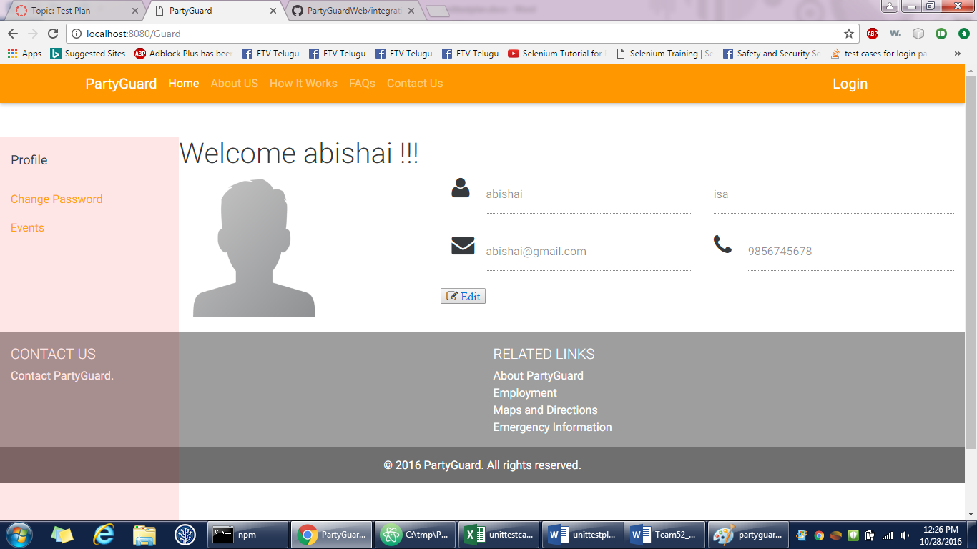

1. **Guard change password**

Gopinadh Cherupally – 100% contribution

<https://github.com/s525080/PartyGuardWeb/blob/36945d1a7df20436e1baec4d8a0b12a1ba8af2d1/guardchangepassword.xlsx>

|  |  |  |  |  |  |
| --- | --- | --- | --- | --- | --- |
| Test case number | Test case description | Steps | Expected result | Actual Result | Status(Pass/Fail) |
| 1 | Check the text fields | click on the text field | Should be able to type | Able to type | Pass |
|  |  | text field should be enabled | | |  |
| 2 | Hiding password | Enable the password text field | Password should be visible as dots | password is visible as dots | Pass |
|  |  | Type the password | |  |  |
| 3 | Old password text field | login to guard user page | Should be able to type the password | Able to type password | Pass |
|  |  | redirect to change password page | | |  |
|  |  | click on the text field old password | | |  |
| 4 | password text field | login to guard user page | Should be able to type the password | Able to type password | pass |
|  |  | redirect to change password page | | |  |
|  |  | click on the text field password | | |  |
| 5 | Confirm password text field | login to guard user page | Should be able to type the password | Able to type password | pass |
|  |  | redirect to change password page | | |  |
|  |  | click on the text field confirm password | | | |
| 6 | submit button | login to guard user page | password should be updated | functionality is yet to be done | fail |
|  |  | redirect to change password page | | |  |
|  |  | click on the submit button | | |  |
| 7 | empty text field validation | login to guard user page | validation should be shown | functionality is yet to be done | fail |
|  |  | redirect to change password page | | |  |
|  |  | click on submit button directly | | |  |
| 8 | Home button | Click on the home button | Homepage is displayed | Homepage is displayed | Pass |
|  |  | Homepage should be displayed | | |  |
| 9 | About us button | login to guard user page | Redirect to About us page | About us page is displayed | Pass |
|  |  | View the About us button on the top | | |  |
|  |  | Press on the button About us | | |  |
| 10 | How it works button | login to guard user page | Redirects to the how it works page | How it works page is displayed | Pass |
|  |  | View the button How it works | | |  |
|  |  | Click on the button How it works | | |  |
| 11 | FAQs button | login to guard user page | Redirect to FAQs page | FAQs page is displayed | Pass |
|  |  | View the FAQs button on the top | | |  |
|  |  | Press on the button FAQs | | |  |
| 12 | Contact us button | login to guard user page | Redirect to Contact us page | Contact us page is displayed | Pass |
|  |  | View the Contact us button on the top | | | |
|  |  | Press on the button Contact us | | |  |
| 13 | contact partyguard link | go to profile page | redirect to contact page | Functionality is yet to be done | fail |
|  |  | view the contact partyguard link | | |  |
|  |  | click on the link | |  |  |
| 14 | about partyguard link | go to profile page | redirect to about partyguard page | Functionality is yet to be done | fail |
|  |  | view the about partyguard link | | |  |
|  |  | click on the link | |  |  |
| 15 | employment link | go to profile page | redirect to employment page | Functionality is yet to be done | fail |
|  |  | view the about employment link | | |  |
|  |  | click on the link | |  |  |
| 16 | maps and directions link | go to profile page | redirect to maps directions page | Functionality is yet to be done | fail |
|  |  | view the maps and directions link | | |  |
|  |  | click on the link | |  |  |
| 17 | emergency information link | go to profile page | redirect to emergency page | Functionality is yet to be done | fail |
|  |  | view the emergency link | | |  |
|  |  | click on the link | |  |  |

**Screenshot:**

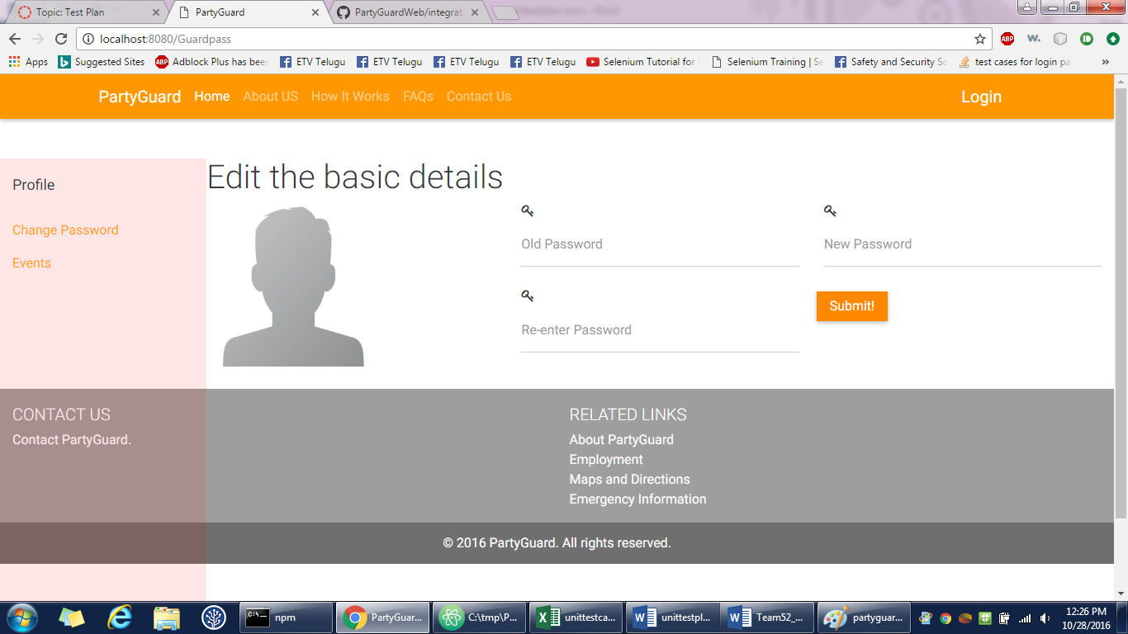

**INTEGRATION TESTING**

Gopinadh Cherupally – 100% contribution

<https://github.com/s525080/PartyGuardWeb/blob/54c7eb5c6eb00fecc532088a17bb80c93f365ee8/integrationesting.xlsx>

|  |  |  |  |  |  |  |  |
| --- | --- | --- | --- | --- | --- | --- | --- |
| Test case number | Test case description | Steps | Expected result | Actual result | Status(Pass/Fail) |  |  |
| 1 | admin user flow | go to homepage of partyguard | If the data entered is matched with data in database admin dashboard page is displayed | Dashboard page is displayed | pass |  |  |
|  |  | click on the login button | |  |  |  |  |
|  |  | enter username as admin | |  |  |  |  |
|  |  | enter password as admin | |  |  |  |  |
|  |  | click login button | |  |  |  |  |
| 2 | Admin add customer page | go to homepage of partyguard | If the data entered is matched with data in database add customer page is displayed | Add customer page is displayed | pass |  |  |
|  |  | click on the login button | |  |  |  |  |
|  |  | enter username as admin | |  |  |  |  |
|  |  | enter password as admin | |  |  |  |  |
|  |  | click login button | |  |  |  |  |
|  |  | click on the add customer button | | |  |  |  |
| 3 | View customers page | go to homepage of partyguard | If the data entered is matched with data in database view customers page is displayed | view customers page is displayed | pass |  |  |
|  |  | click on the login button | |  |  |  |  |
|  |  | enter username as admin | |  |  |  |  |
|  |  | enter password as admin | |  |  |  |  |
|  |  | click login button | |  |  |  |  |
|  |  | click on view customers page | |  |  |  |  |
| 4 | Adding the customer | go to homepage of partyguard | data is saved in the database and displayed on the next page | data entered is displayed on the next page | pass |  |  |
|  |  | click on the login button | |  |  |  |  |
|  |  | enter username as admin | |  |  |  |  |
|  |  | enter password as admin | |  |  |  |  |
|  |  | click login button | |  |  |  |  |
|  |  | click on the add customer button | | |  |  |  |
|  |  | select the university | |  |  |  |  |
|  |  | enter house address | |  |  |  |  |
|  |  | enter house name | |  |  |  |  |
|  |  | enter nickname | |  |  |  |  |
|  |  | enter chapter |  |  |  |  |  |
|  |  | enter user name | |  |  |  |  |
|  |  | enter email |  |  |  |  |  |
|  |  | enter mobile number | |  |  |  |  |
|  |  | click on create account | |  |  |  |  |
| 5 | host user login flow | go to homepage of partyguard | If the data entered is matched with data in database new customer login page is displayed | New customer login page is displayed | pass |  |  |
|  |  | click on the login button | |  |  |  |  |
|  |  | enter username as host | |  |  |  |  |
|  |  | enter password as host | |  |  |  |  |
|  |  | click login button | |  |  |  |  |
| 6 | New customer login | go to homepage of partyguard | data is saved in the database and host profile page is displayed | Host page is displayed | pass |  |  |
|  |  | click on the login button | |  |  |  |  |
|  |  | enter username as host | |  |  |  |  |
|  |  | enter password as host | |  |  |  |  |
|  |  | click login button | |  |  |  |  |
|  |  | enter username | |  |  |  |  |
|  |  | enter temporary password | |  |  |  |  |
|  |  | enter subscription code | |  |  |  |  |
|  |  | enter your new password | |  |  |  |  |
|  |  | click on login |  |  |  |  |  |
| 7 | house location page | go to homepage of partyguard | new location changes are saved in the database | data is saved and displayed | pass |  |  |
|  |  | click on the login button | |  |  |  |  |
|  |  | enter username as host | |  |  |  |  |
|  |  | enter password as host | |  |  |  |  |
|  |  | click login button | |  |  |  |  |
|  |  | enter username | |  |  |  |  |
|  |  | enter temporary password | |  |  |  |  |
|  |  | enter subscription code | |  |  |  |  |
|  |  | enter your new password | |  |  |  |  |
|  |  | click on login |  |  |  |  |  |
|  |  | click house location | |  |  |  |  |
|  |  | enter location |  |  |  |  |  |
|  |  | submit request | |  |  |  |  |
| 8 | create event page | go to homepage of partyguard | data should be saved and event is successfully created | event is created | pass |  |  |
|  |  | click on the login button | |  |  |  |  |
|  |  | enter username as host | |  |  |  |  |
|  |  | enter password as host | |  |  |  |  |
|  |  | click login button | |  |  |  |  |
|  |  | enter username | |  |  |  |  |
|  |  | enter temporary password | |  |  |  |  |
|  |  | enter subscription code | |  |  |  |  |
|  |  | enter your new password | |  |  |  |  |
|  |  | click on login |  |  |  |  |  |
|  |  | click on create event button | |  |  |  |  |
|  |  | enter event name | |  |  |  |  |
|  |  | enter date |  |  |  |  |  |
|  |  | enter time |  |  |  |  |  |
|  |  | select guard |  |  |  |  |  |
|  |  | click submit |  |  |  |  |  |
| 9 | view/edit events page` | go to homepage of partyguard | events should be edited | events are edited | pass |  |  |
|  |  | click on the login button | |  |  |  |  |
|  |  | enter username as host | |  |  |  |  |
|  |  | enter password as host | |  |  |  |  |
|  |  | click login button | |  |  |  |  |
|  |  | enter username | |  |  |  |  |
|  |  | enter temporary password | |  |  |  |  |
|  |  | enter subscription code | |  |  |  |  |
|  |  | enter your new password | |  |  |  |  |
|  |  | click on login |  |  |  |  |  |
|  |  | click on view/edit events page | |  |  |  |  |
| 10 | Members page | go to homepage of partyguard | should be able to delete the members | functionality is yet to be done | fail |  |  |
|  |  | click on the login button | |  |  |  |  |
|  |  | enter username as host | |  |  |  |  |
|  |  | enter password as host | |  |  |  |  |
|  |  | click login button | |  |  |  |  |
|  |  | enter username | |  |  |  |  |
|  |  | enter temporary password | |  |  |  |  |
|  |  | enter subscription code | |  |  |  |  |
|  |  | enter your new password | |  |  |  |  |
|  |  | click on login |  |  |  |  |  |
|  |  | click on members | |  |  |  |  |
| 11 | guard login flow | go to homepage of partyguard | If the data entered is matched with data in database guard profile page is displayed | guard profile page is displayed | pass |  |  |
|  |  | click on the login button | |  |  |  |  |
|  |  | enter username as guard | |  |  |  |  |
|  |  | enter password as guard | |  |  |  |  |
|  |  | click login button | |  |  |  |  |
| 12 | Guard change password page | go to homepage of partyguard | should be able to change the old password | functionality is yet to be done | fail |  |  |
|  |  | click on the login button | |  |  |  |  |
|  |  | enter username as guard | |  |  |  |  |
|  |  | enter password as guard | |  |  |  |  |
|  |  | click login button | |  |  |  |  |
|  |  | click on change password | |  |  |  |  |
| 13 | Events page | go to homepage of partyguard | should be able to view events of the guard | functionality is yet to be done | fail |  |  |
|  |  | click on the login button | |  |  |  |  |
|  |  | enter username as guard | |  |  |  |  |
|  |  | enter password as guard | |  |  |  |  |
|  |  | click login button | |  |  |  |  |
|  |  | click on events button | |  |  |  |  |
| 14 | guard profile page | go to homepage of partyguard | edit details should be saved in to the database and displayed | edited data is displayed | fail |  |  |
|  |  | click on the login button | |  |  |  |  |
|  |  | enter username as guard | |  |  |  |  |
|  |  | enter password as guard | |  |  |  |  |
|  |  | click login button | |  |  |  |  |
|  |  | click on edit |  |  |  |  |  |
|  |  | enter the details | |  |  |  |  |
| 15 | basic user login flow | go to homepage of partyguard | If the data entered is matched with data in database basic user profile page is displayed | basic user page is displayed | pass |  |  |
|  |  | click on the login button | |  |  |  |  |
|  |  | enter username as basic | |  |  |  |  |
|  |  | enter password as basic | |  |  |  |  |
|  |  | click login button | |  |  |  |  |
| 16 | basic user profile page | go to homepage of partyguard | edit details should be saved in to the database and displayed | edited data is displayed | pass |  |  |
|  |  | click on the login button | |  |  |  |  |
|  |  | enter username as basic | |  |  |  |  |
|  |  | enter password as basic | |  |  |  |  |
|  |  | click login button | |  |  |  |  |
|  |  | click edit |  |  |  |  |  |
| 17 | basic user change password page | go to homepage of partyguard | should be able to change the old password | functionality is yet to be done | fail |  |  |
|  |  | click on the login button | |  |  |  |  |
|  |  | enter username as guard | |  |  |  |  |
|  |  | enter password as guard | |  |  |  |  |
|  |  | click login button | |  |  |  |  |
|  |  | click on change password | |  |  |  |  |