**User Interface Design Document**

**Purpose:**

This document defines the PartyGuard web application graphical interface design.

**Scope:**

The primary purpose of this document is to present the design approach for the graphical user interface of PartyGuard web application.

The primary intended audience of this document are website designers and website developers. The document intents to provide the members of the PartyGuard project a unified view of the technical details of the system design to be followed during the development of the respective application. The document may need to be updated later to incorporate possible changes during development.

**Graphical User Interface**

**Guest User**

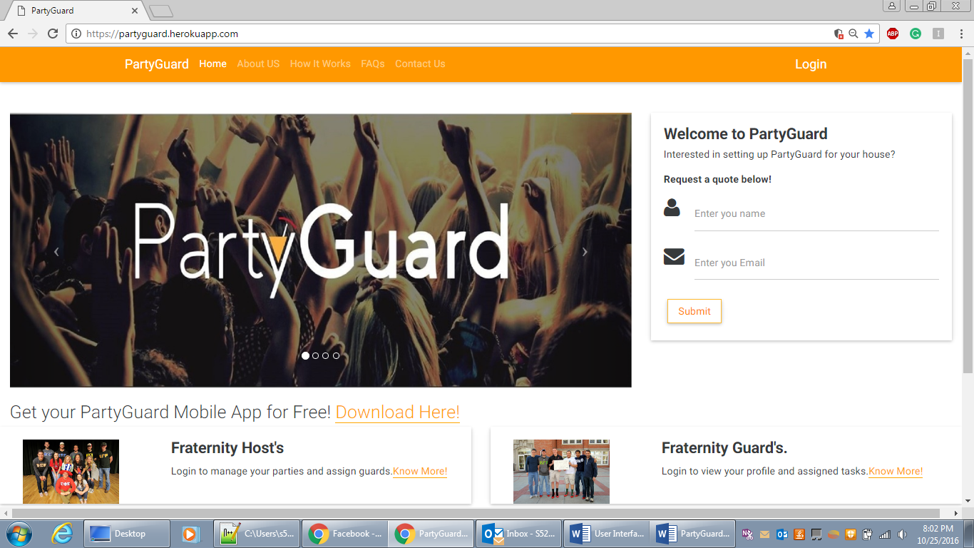

**Screen:** Home page

**Purpose:** ThePage allows the user view basic details of the party guard web application

**Navigation and User Interaction:**

1. Guest users can enter his email and name and request a quote.
2. Guest users can also navigate to About us, Contact us, FAQs, How it works pages.
3. Guest user can navigate to download page to download mobile app.

**About Us:**

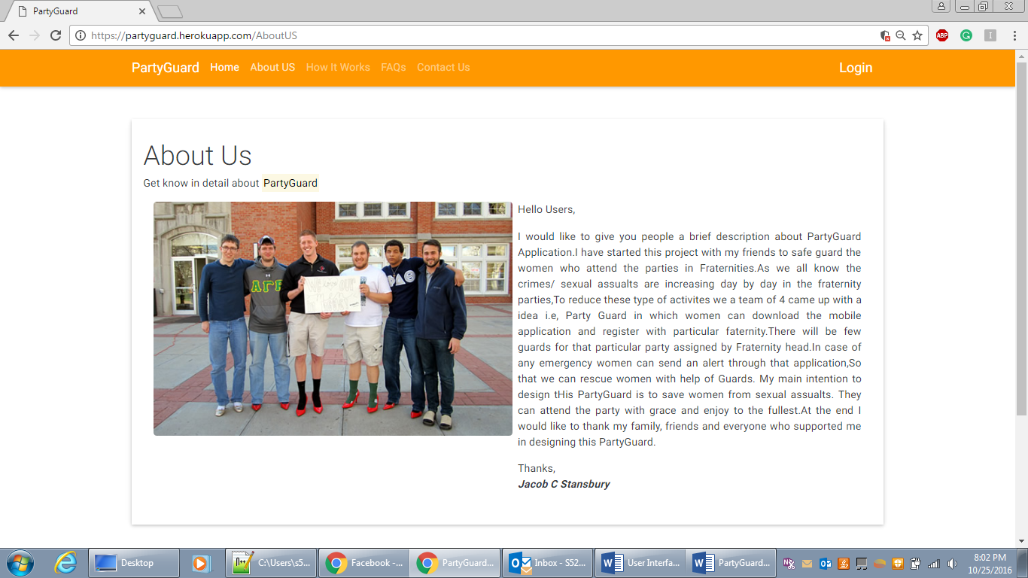

**Screen:** About Us

**Purpose:** ThePage allows the user to know the details of the PartyGuard application founders.

**Navigation and User Interaction:**

1. User can navigate to other pages on navbar.

**How it Works:**

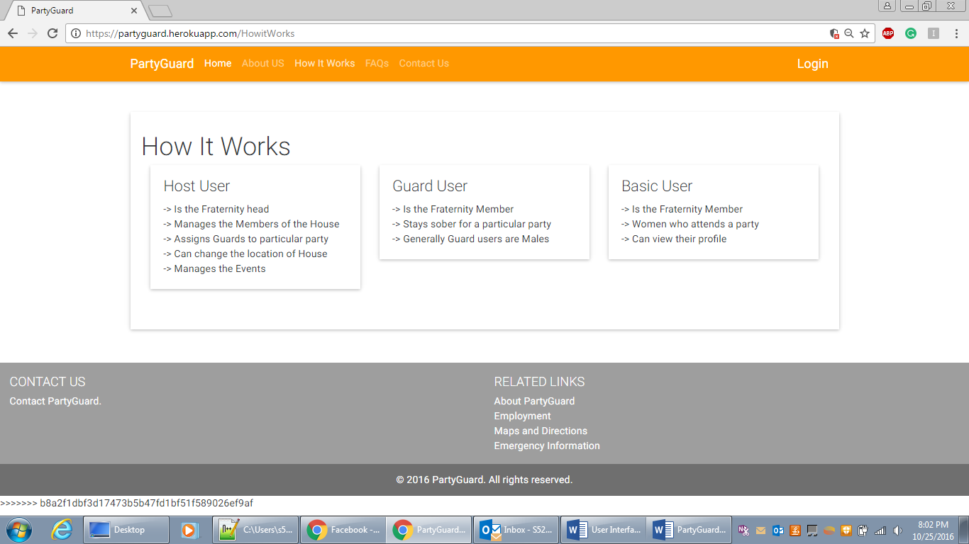

**Screen:** How it Works

**Purpose:** ThePage allows the user to details like how he can use this application

**Navigation and User Interaction:**

1. User can navigate to other pages on navbar.

**FAQs Page:**

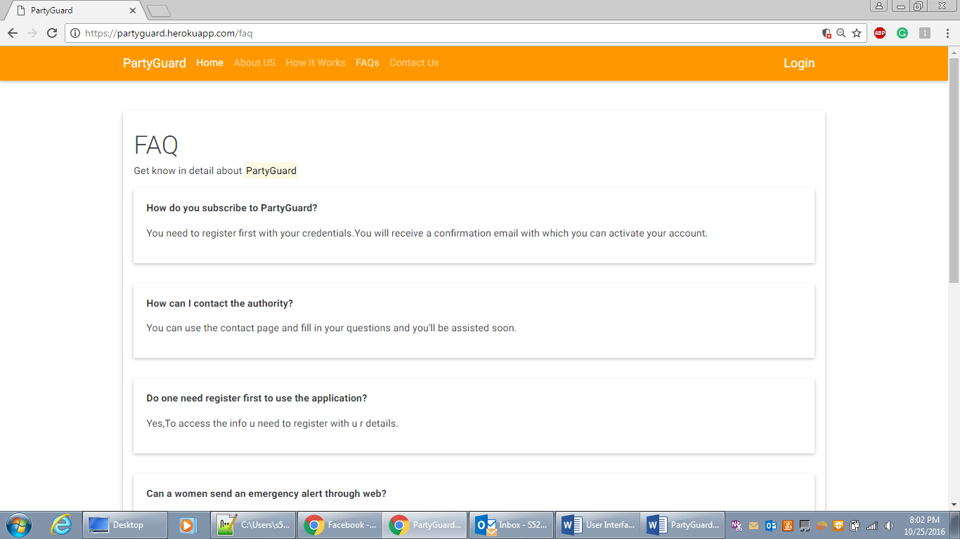

**Screen:** FAQs

**Purpose:** ThePage allows the user to most frequently asked questions

**Navigation and User Interaction:**

1. User can navigate to other pages on navbar.

**Login Page:**

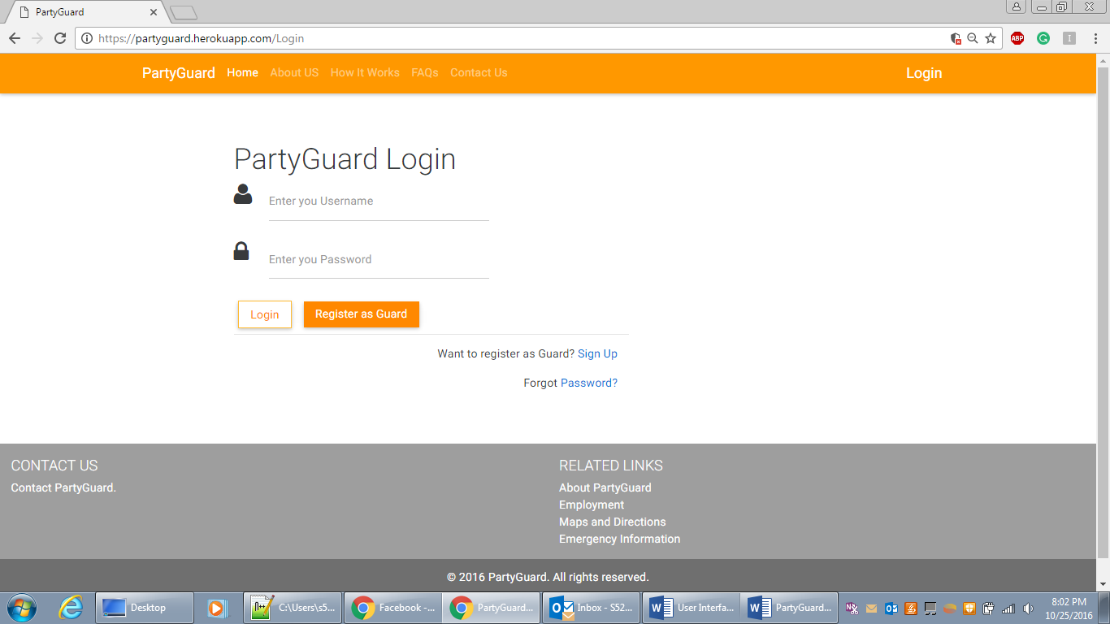

**Screen:** User Login

**Purpose:** ThePage allows the user to login, create a new Guard account and reset password

**Navigation and User Interaction:**

1. Registered users can login to the application by entering valid details (E- mail, Password), and the successful login will direct the user to their respective profile pages.
2. The Page directs the user to reset Password through Forgot Password? Link, if the user forgets her password
3. A new Guard user can register through Register as Guard Button

**Admin Screens:**

**Dashboard:**

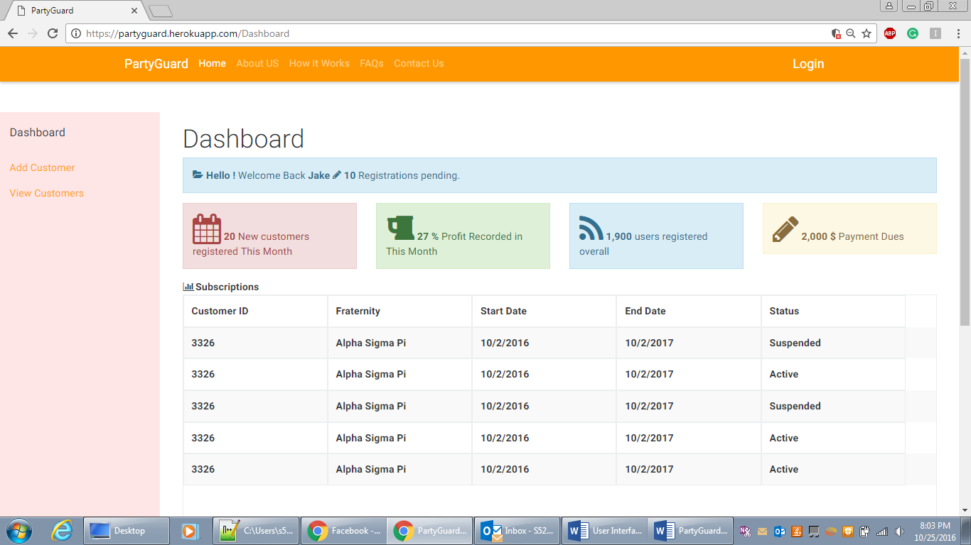

**Screen:** Admin Dashboard

**Purpose:** ThePage allows the admin to view primary details like customer list and updates like how many new customers registers, how much profit recorded, how many users etc.

**Navigation and User Interaction:**

1. Admin can view all the displayed details.
2. Admin can navigate to Add Customer page to add new customer.
3. Admin can navigate to view Customer page to view/edit customer.

**Add Customer:**

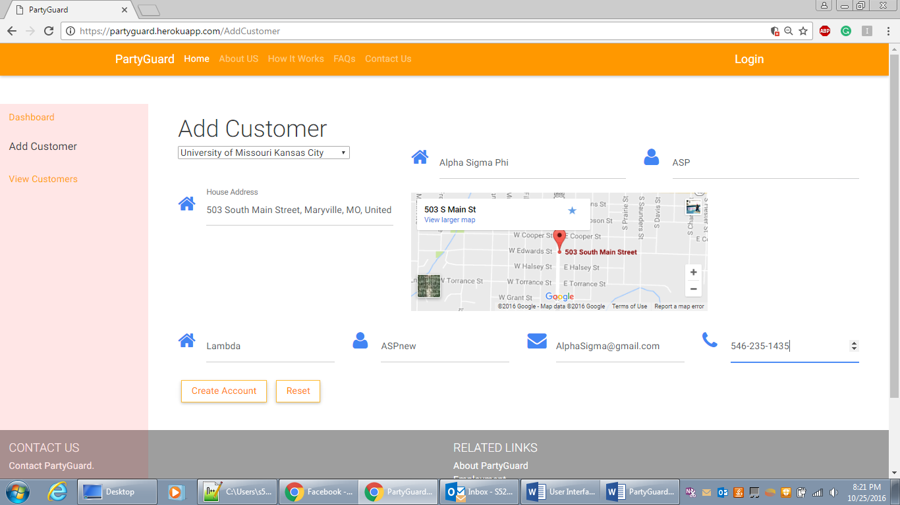

**Screen:** Add Customer

**Purpose:** ThePage allows the admin to add a new customer (Fraternity) by entering all his details.

**Navigation and User Interaction:**

1. Admin can select university from the drop down.
2. Admin can auto populate map by entering address in the address field.
3. Admin can navigate to Add Acknowledgement page after clicking Create Account.
4. Admin can reset the details enters.
5. Admin can navigate to view Customer page to view/edit customer.
6. Admin can navigate to dashboard.

**Add Acknowledgement:**

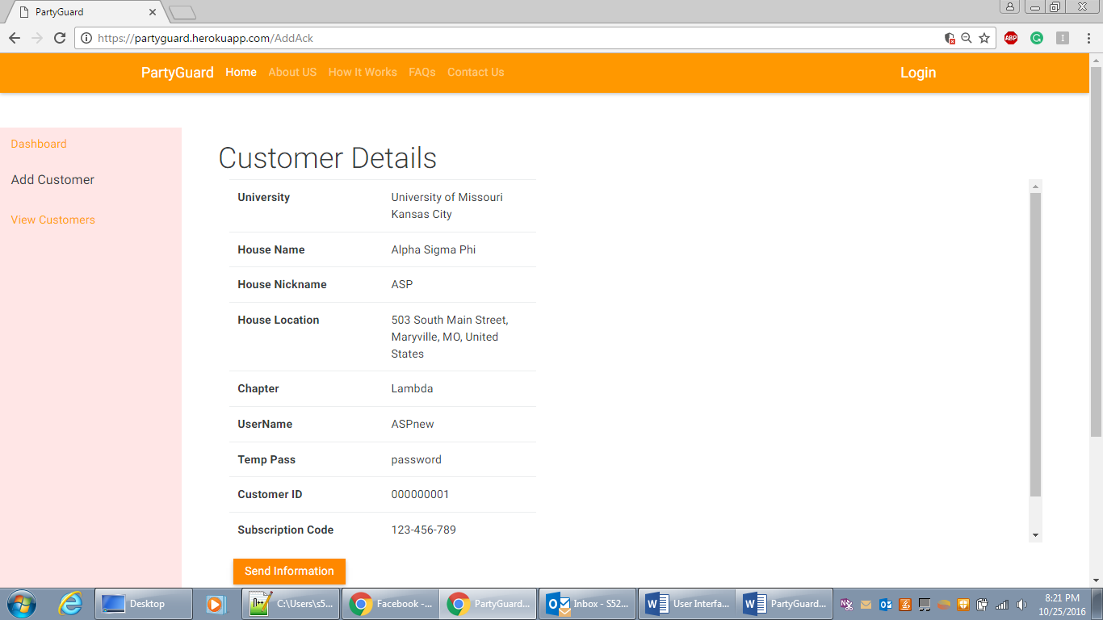

**Screen:** Add Acknowledgement

**Purpose:** ThePage allows the admin to cross check the details of the registered fraternity.

**Navigation and User Interaction:**

1. Admin can cross check the details.
2. Admin can send the information to the fraternity host by clicking on Send information.

**View Customers:**

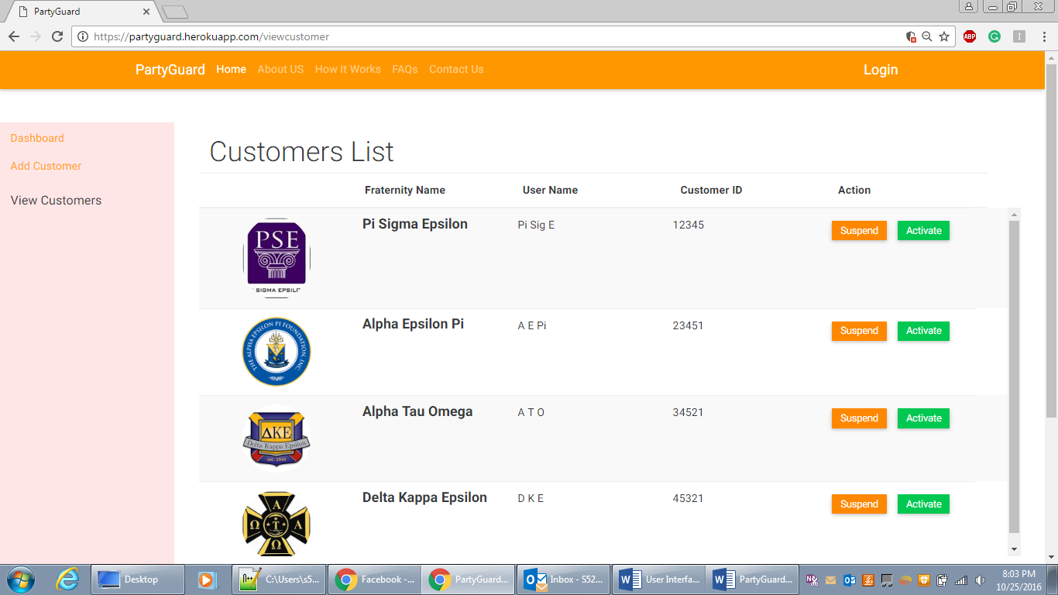

**Screen:** View Customers

**Purpose:** ThePage allows the admin to View all registered customers.

**Navigation and User Interaction:**

1. Admin can view all the registered customers.
2. Admin can either suspend or activate the subscription of a particular customer.

**Host User:**

New Customer Login:

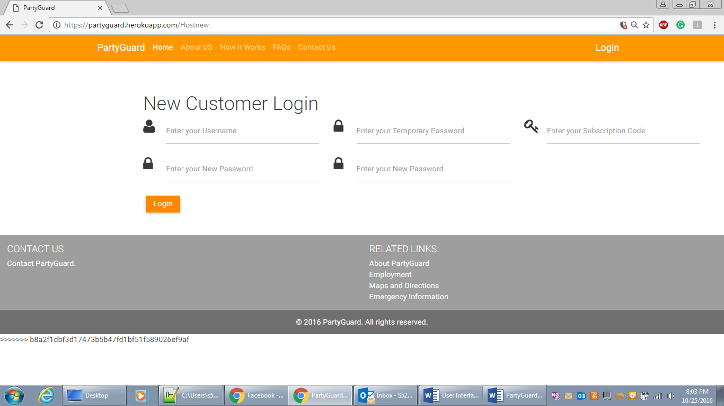

**Screen:** New Customer login

**Purpose:** ThePage allows first time login customers to change their password by providing authenticated details.

**Navigation and User Interaction:**

1. During first time login, Host user must enter his details like temp password, Guard user code and new password details to change his password.
2. On clicking login, host user can navigate into his profile page.

**Host profile:**

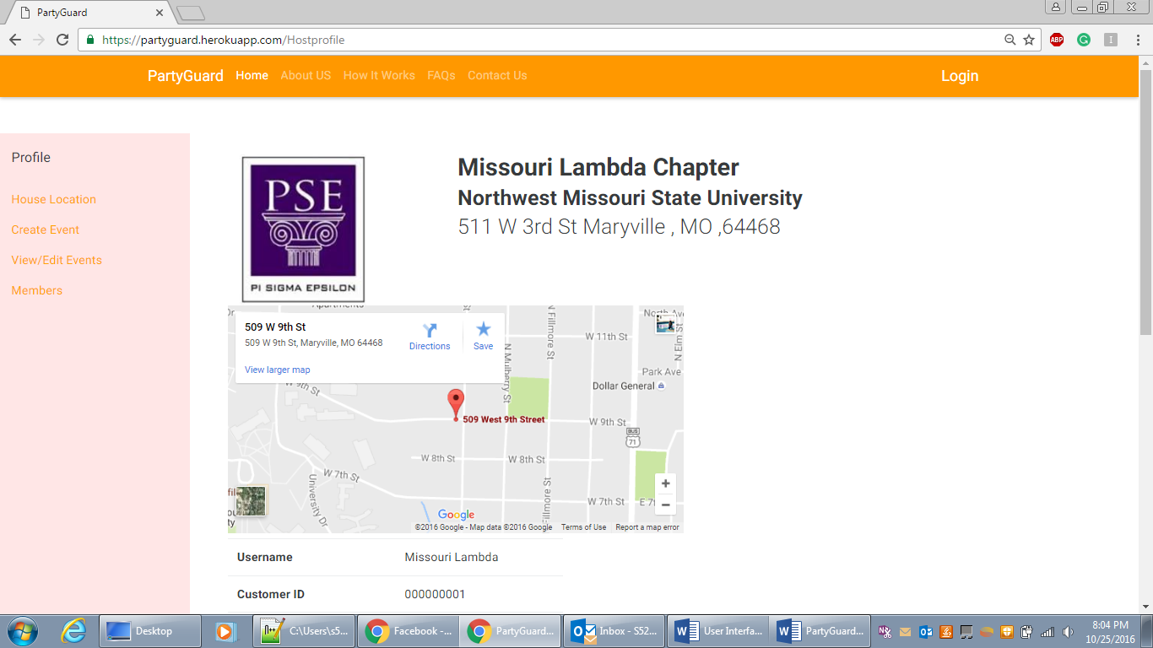

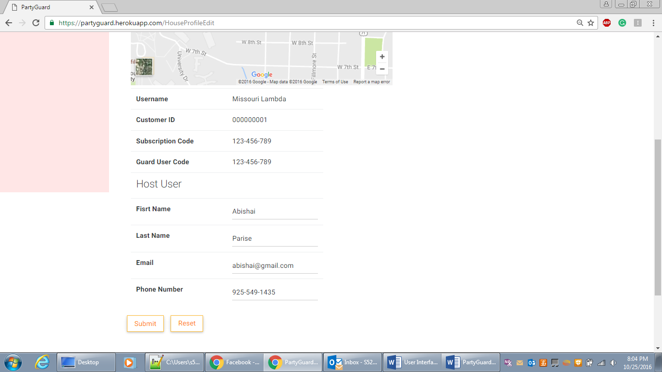

**Screen:** Host user profile.

**Purpose:** ThePage allows Host user to view his profile

**Navigation and User Interaction:**

1. User can edit his profile by clicking on Edit profile.
2. User can navigate to house location change page
3. User can navigate to Create event page.
4. User can navigate to View/Edit events page.
5. User can navigate to member page.

**Change Location page:**

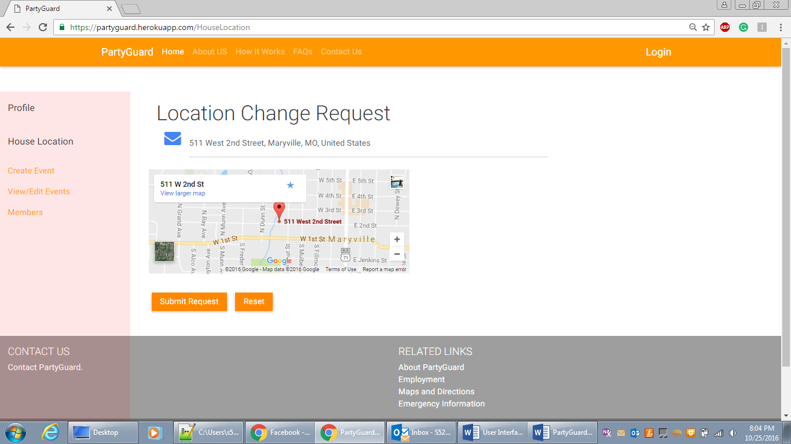

**Screen:** Change Location.

**Purpose:** ThePage allows Host user to change the address of the fraternity

**Navigation and User Interaction:**

1. User can enter new address of the fraternity.
2. User can view google map of the new address.
3. User can save the address by clicking on Submit request.
4. User can navigate to Add Customer page
5. User can navigate to Create event page.
6. User can navigate to View/Edit events page.
7. User can navigate to member page.

**Create Event Page:**

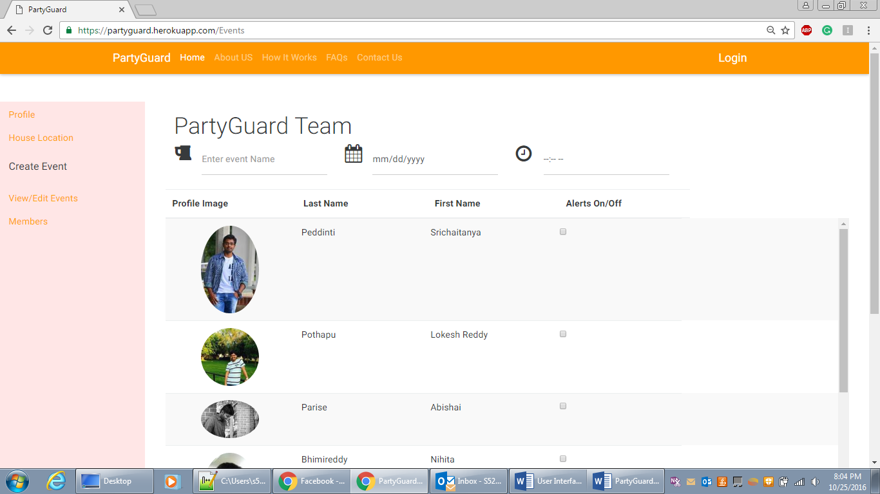

**Screen:** Create events.

**Purpose:** ThePage allows Host user to create a new event and assign guards to that event.

**Navigation and User Interaction:**

1. User can enter details of new event.
2. User can select guards for that event by clicking on check boxes
3. User can save the event by clicking on save.
4. User can navigate to Add Customer page
5. User can navigate to Change location page.
6. User can navigate to View/Edit events page.
7. User can navigate to member page.

**View/Edit Events:**

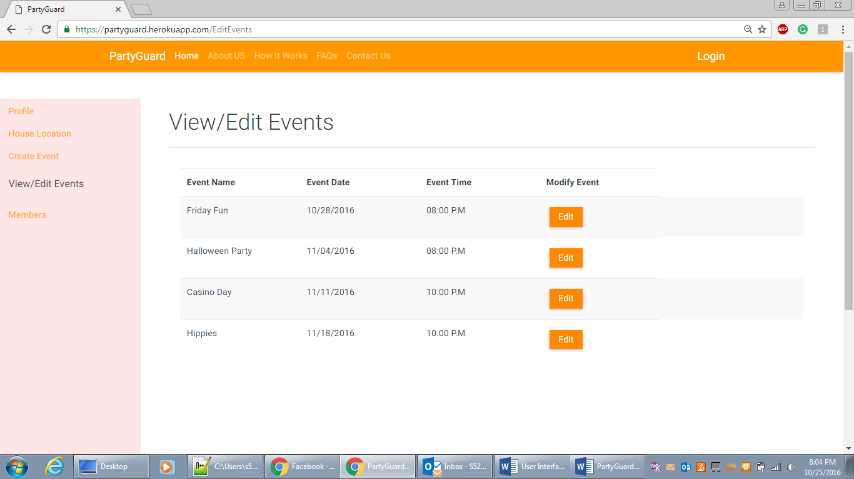

**Screen:** View/Edit events.

**Purpose:** ThePage allows Host user to View or edit the events created.

**Navigation and User Interaction:**

1. User can view all the events and also select a particular event to edit by clicking on Edit button.
2. User can navigate to Add Customer page
3. User can navigate to Change location page.
4. User can navigate to Create event page.
5. User can navigate to member page.

**Members’ page:**

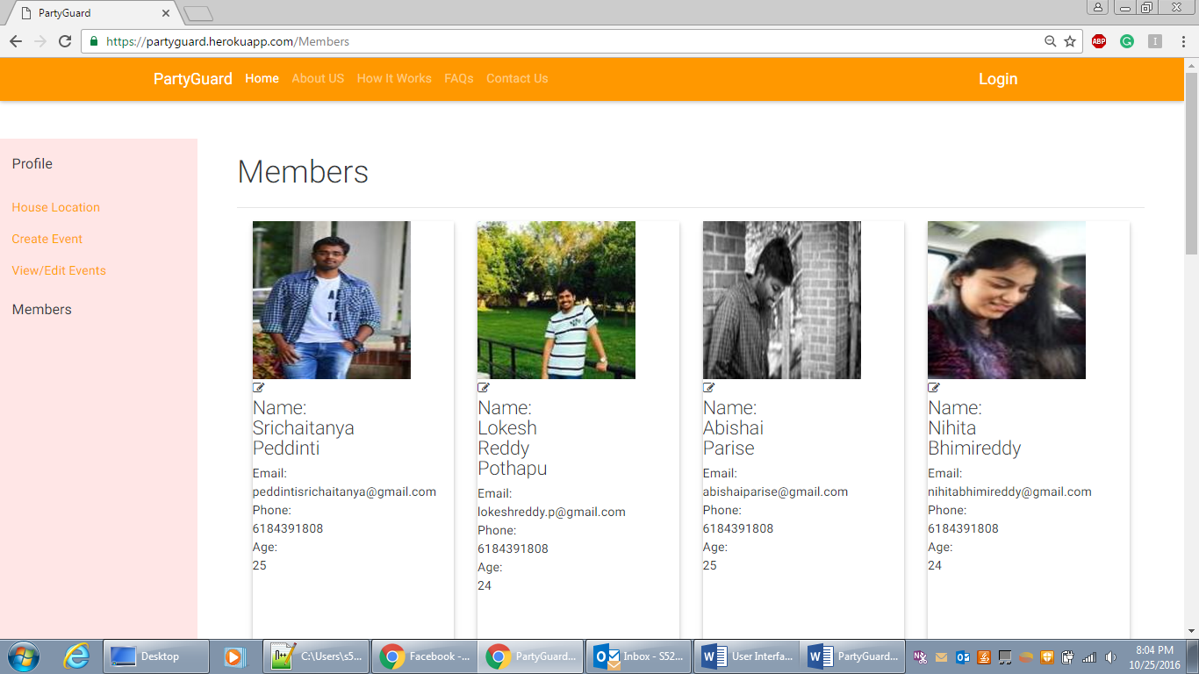

**Screen:** Members.

**Purpose:** ThePage allows Host user to View members in his fraternity.

**Navigation and User Interaction:**

1. User can view all the members registered to that fraternity.
2. User ca delete the member
3. User can navigate to Add Customer page
4. User can navigate to Change location page.
5. User can navigate to Create event page.
6. User can navigate to View Events page.

**Guard User:**

**Profile page:**

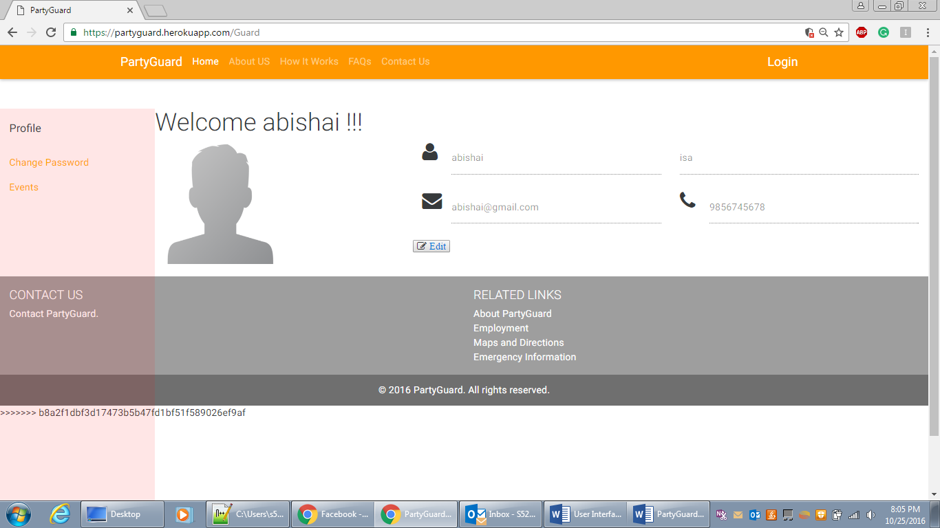

**Screen:** Guard user Profile page.

**Purpose:** ThePage allows Guard user to View his profile.

**Navigation and User Interaction:**

1. User can view his profile.
2. User can navigate to edit his profile on clicking Edit button.
3. User can navigate to Change Password page.
4. User can navigate to Events page.

**Edit Profile page:**

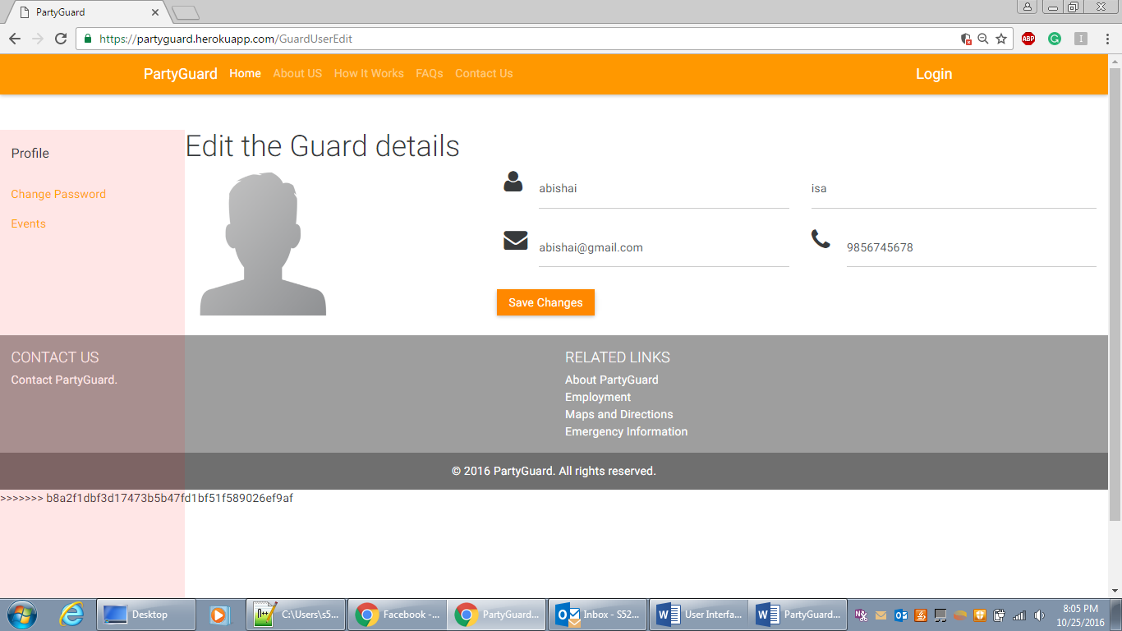

**Screen:** Guard user Edit Profile page.

**Purpose:** ThePage allows Guard user to edit his profile.

**Navigation and User Interaction:**

1. User can edit his profile details.
2. User can save the details by clicking on save button.
3. User can navigate to Change Password page.
4. User can navigate to Events page.

**Change Password:**

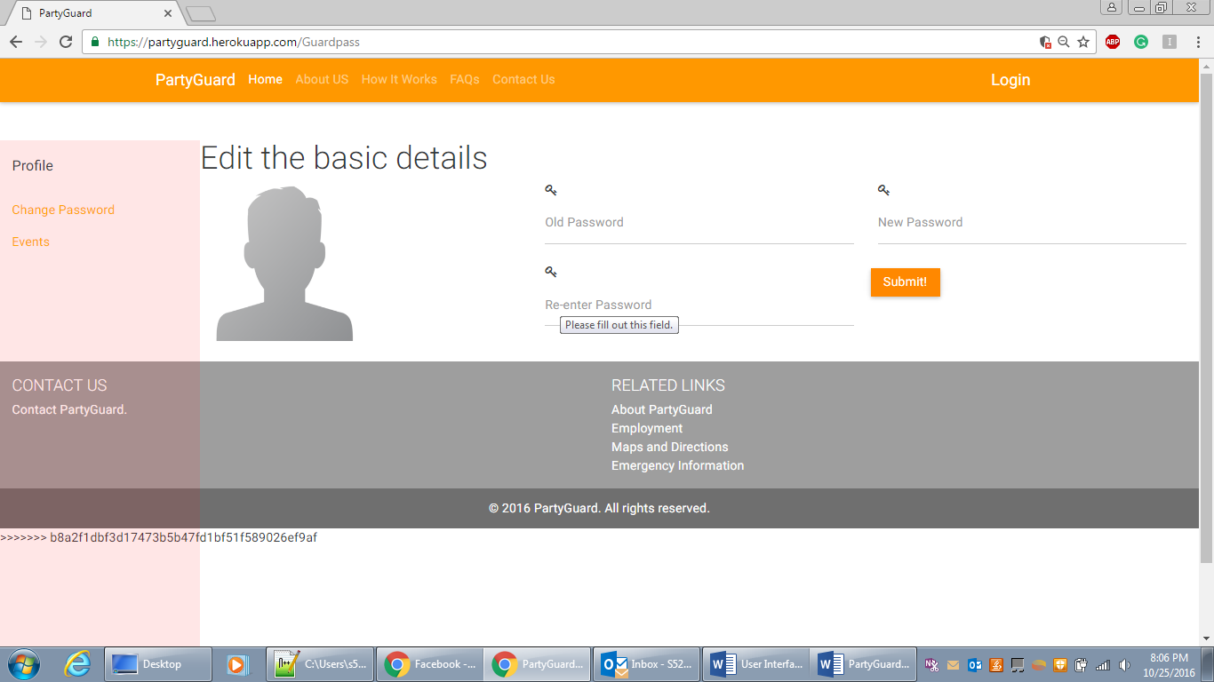

**Screen:** Guard user Change password page.

**Purpose:** ThePage allows Guard user to change his password.

**Navigation and User Interaction:**

1. User can enter his new password details.
2. User can save the changes by clicking on submit button.
3. User can navigate to Profile page.
4. User can navigate to Events page.

**Basic user:**

Basic profile page:

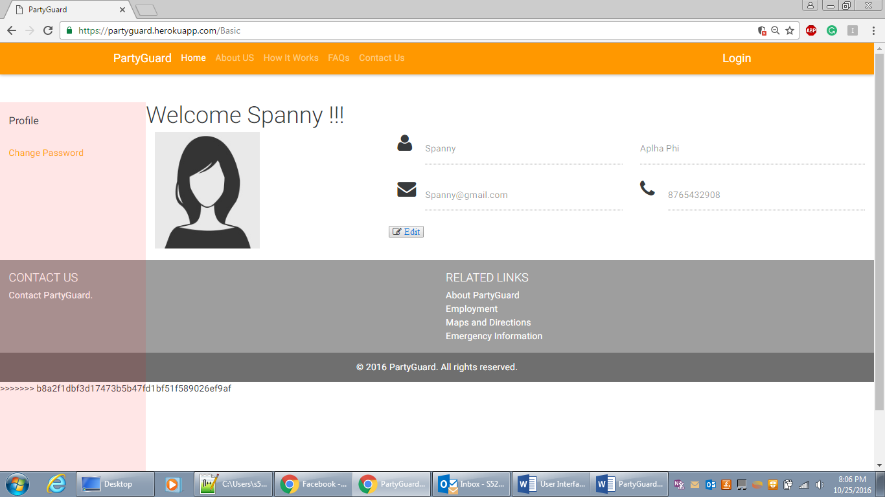

**Screen:** Basic user Profile page.

**Purpose:** ThePage allows Basic user to View her profile.

**Navigation and User Interaction:**

1. User can view her profile.
2. User can navigate to edit her profile on clicking Edit button.
3. User can navigate to Change Password page.

**Change Password page**

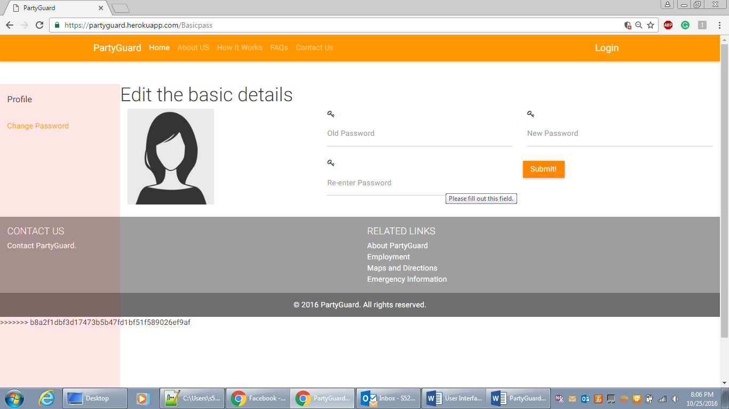

**Screen:** Basic user Change password page.

**Purpose:** ThePage allows Basic user to change his password.

**Navigation and User Interaction:**

1. User can enter her new password details.
2. User can save the changes by clicking on submit button.
3. User can navigate to Profile page.