**PARTYGUARD TEST PLAN**

**Product:** PartyGuard Web Application

**Client:** Jacob C Stansbury

**Team name:** PartyFreaks

**Roles and responsibilities:**

|  |  |
| --- | --- |
| **Team Member** | **Project Roles** |
| Prem Abishai Parise | Primary Contact |
| Nihitha Reddy Bhimireddy | Client Management |
| Lokesh Reddy Pothapu | Requirements Management |
| Srichaitanya Peddinti | Database Management |
| Spandana Velaga | Quality and Testing Management |
| Sindhuja Pannala | Issues Management |
| Gopinadh Cherupally | Communications and Documentation Management |

**VERSION HISTORY**

|  |  |  |  |
| --- | --- | --- | --- |
| **Version No.** | **Date** | **Changed By** | **Changes Made** |
| 1 | **10/07/2016** | **Nihitha Reddy Bhimireddy** | Initial Commit |
| 2 | **10/28/2016** | **Gopinadh Cherupally** | Update test cases of unit testing and integration testing |

**UNIT TESTING**

1. **Home page**

<https://github.com/s525080/PartyGuardWeb/blob/2051aa7d93bd7e08f1432dbaf88f2dec7035b4fa/homepage.xlsx>

|  |  |  |  |  |  |
| --- | --- | --- | --- | --- | --- |
| Test case number | Test case description | Steps | Expected result | Actual Result | Status(Pass/Fail) |
| 1 | Check the text fields | click on the text field | Should be able to type | User can be able to type | Pass |
|  |  | text field should be enabled |  |  |  |
| 2 | Image carousel | Redirect to homepage | Images should be changed automatically | Images are changing automatically | Pass |
|  |  | View the image carousel |  |  |  |
|  |  | Images should change automatically for every 5 seconds |  |  |  |
| 3 | Submit button | Click on Submit button | Details about the application should be sent to the user | Functionality is yet to be done | Fail |
|  |  | Send the quote to the registered user |  |  |  |
| 4 | Home button | Click on the home button | Homepage is displayed | Home page is displayed | Pass |
|  |  | Home page should be displayed |  |  |  |
| 5 | About us button | Go to homepage of partyguard | Redirect to About us page | About us page is displayed | Pass |
|  |  | View the About us button on the top |  |  |  |
|  |  | Press on the button About us |  |  |  |
| 6 | How it works button | Go to homepage of partyguard | Redirects to the how it works page | How it works page is displayed | Pass |
|  |  | View the button How it works |  |  |  |
|  |  | Click on the button How it works |  |  |  |
| 7 | FAQs button | Go to homepage of partyguard | Redirect to FAQs page | FAQs page is displayed | Pass |
|  |  | View the FAQs button on the top |  |  |  |
|  |  | Press on the button FAQs |  |  |  |
| 8 | Contact us button | Go to homepage of partyguard | Redirect to Contact us page | Contact us page is displayed | Pass |
|  |  | View the Contact us button on the top |  |  |  |
|  |  | Press on the button Contact us |  |  |  |
| 9 | Login button | Go to homepage of partyguard | Redirect to login page | login page is displayed | Pass |
|  |  | View the Login button on the top |  |  |  |
|  |  | Press on the button Login |  |  |  |
| 10 | Name text field | Go to homepage | Should be able to type a valid name | Functionality is yet to be done | Fail |
|  |  | View the text field |  |  |  |
|  |  | Type in the text field |  |  |  |
| 11 | Email text field | Go to homepage | Should be able to type a valid email address | Functionality is yet to be done | Fail |
|  |  | View the text field |  |  |  |
|  |  | Should be able to type email address |  |  |  |
| 12 | Download link | Go to home page | Should be able to download the app through the link | Functionality is yet to be done | Fail |
|  |  | View the link download here |  |  |  |
|  |  | Click on the link |  |  |  |
| 13 | Host link | Go to home page | Should be able to redirect to host page | Functionality is yet to be done | Fail |
|  |  | View the link know more |  |  |  |
|  |  | Click on the link |  |  |  |
| 14 | Guard link | Go to home page | Should be able to redirect to guard page | Functionality is yet to be done | Fail |
|  |  | View the link know more |  |  |  |
|  |  | Click on the link |  |  |  |
| 15 | contact partyguard link | Go to homepage of partyguard | redirect to contact page | Functionality is yet to be done | fail |
|  |  | view the contact partyguard link |  |  |  |
|  |  | click on the link |  |  |  |
| 16 | about partyguard link | Go to homepage of partyguard | redirect to about partyguard page | Functionality is yet to be done | fail |
|  |  | view the about partyguard link |  |  |  |
|  |  | click on the link |  |  |  |
| 17 | employment link | Go to homepage of partyguard | redirect to employment page | Functionality is yet to be done | fail |
|  |  | view the about employment link |  |  |  |
|  |  | click on the link |  |  |  |
| 18 | maps and directions link | Go to homepage of partyguard | redirect to maps directions page | Functionality is yet to be done | fail |
|  |  | view the maps and directions link |  |  |  |
|  |  | click on the link |  |  |  |
| 19 | emergency information link | Go to homepage of partyguard | redirect to emergency page | Functionality is yet to be done | fail |
|  |  | view the emergency link |  |  |  |
|  |  | click on the link |  |  |  |

**Screenshot:**

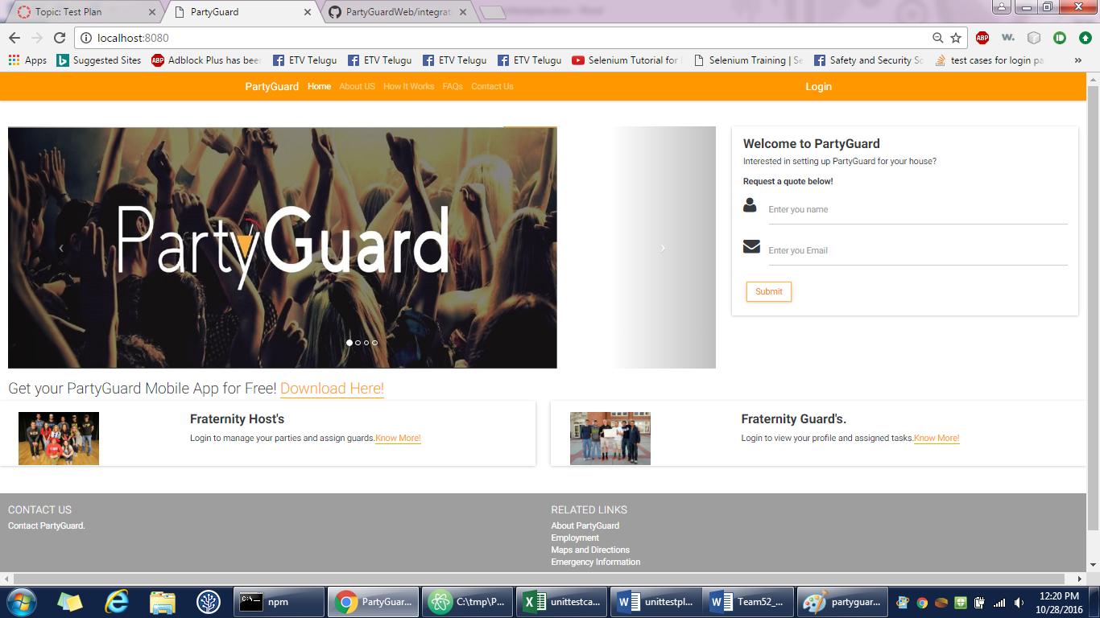

1. **Login page**

Gopinadh Cherupally – 100% contribution

<https://github.com/s525080/PartyGuardWeb/blob/b3c04d4cb9bdad9be56ba5cf242fa960d22cadac/loginpage.xlsx>

|  |  |  |  |  |  |
| --- | --- | --- | --- | --- | --- |
| Test case number | Test case description | Steps | Expected result | Actual Result | Status(Pass/Fail) |
| 1 | login button | Open a web browser and type the url | Redirect to login page | Login page is displayed | Pass |
|  |  | View the login button |  |  |  |
|  |  | Press the login button |  |  |  |
| 2 | forgot password link | View the forgot password link | Details page should be displayed | Functionality is yet to be done | Fail |
|  |  | Click the forgot password link |  |  |  |
| 3 | Check the text fields | click on the text field | Should be able to type | Able to type | Pass |
|  |  | text field should be enabled |  |  |  |
| 4 | Home button | Click on the home button | Homepage is displayed | Homepage is displayed | Pass |
|  |  | Homepage should be displayed |  |  |  |
| 5 | About us button | Go to homepage of partyguard | Redirect to About us page | About us page is displayed | Pass |
|  |  | View the About us button on the top |  |  |  |
|  |  | Press on the button About us |  |  |  |
| 6 | How it works button | Go to homepage of partyguard | Redirects to the how it works page | How it works page is displayed | Pass |
|  |  | View the button How it works |  |  |  |
|  |  | Click on the button How it works |  |  |  |
| 7 | FAQs button | Go to homepage of partyguard | Redirect to FAQs page | FAQs page is displayed | Pass |
|  |  | View the FAQs button on the top |  |  |  |
|  |  | Press on the button FAQs |  |  |  |
| 8 | Contact us button | Go to homepage of partyguard | Redirect to Contact us page | Contact us page is displayed | Pass |
|  |  | View the Contact us button on the top |  |  |  |
|  |  | Press on the button Contact us |  |  |  |
| 9 | Login button | Go to homepage of partyguard | Redirect to login page | Login page is displayed | Pass |
|  |  | View the Login button on the top |  |  |  |
|  |  | Press on the button Login |  |  |  |
| 10 | Sign up link | Go to login page | Redirect to signup page | Sign up page is displayed | Pass |
|  |  | View the sign up link |  |  |  |
|  |  | should be able to view the sign up page |  |  |  |
| 11 | Register as a guard button | Go to login page | Registration page is displayed | Functionality is yet to be done | Fail |
|  |  | View the register as a guard button |  |  |  |
|  |  | Click on the register as a guard button |  |  |  |
| 12 | contact partyguard link | Go to about us page of partyguard | redirect to contact page | Functionality is yet to be done | fail |
|  |  | view the contact partyguard link |  |  |  |
|  |  | click on the link |  |  |  |
| 13 | about partyguard link | go to about us page | redirect to about partyguard page | Functionality is yet to be done | fail |
|  |  | view the about partyguard link |  |  |  |
|  |  | click on the link |  |  |  |
| 14 | employment link | go to about us page | redirect to employment page | Functionality is yet to be done | fail |
|  |  | view the about employment link |  |  |  |
|  |  | click on the link |  |  |  |
| 15 | maps and directions link | go to about us page | redirect to maps directions page | Functionality is yet to be done | fail |
|  |  | view the maps and directions link |  |  |  |
|  |  | click on the link |  |  |  |
| 16 | emergency information link | go to about us page | redirect to emergency page | Functionality is yet to be done | fail |
|  |  | view the emergency link |  |  |  |
|  |  | click on the link |  |  |  |

**Screenshot:**

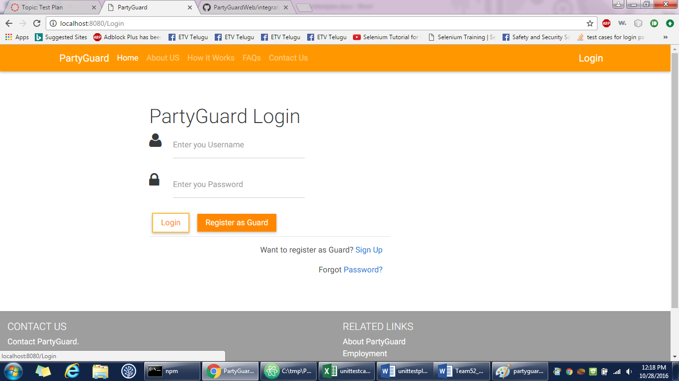

1. **About us page**

Gopinadh Cherupally – 100% contribution

<https://github.com/s525080/PartyGuardWeb/blob/Documents/about%20us%20page.xlsx>

|  |  |  |  |  |  |
| --- | --- | --- | --- | --- | --- |
| Test case number | Test case description | Steps | Expected result | Actual result | Status(Pass/Fail) |
| 1 | About us button | Go to homepage of partyguard | Redirect to About us page | About us page is displayed | pass |
|  |  | View the About us button on the top |  |  |  |
|  |  | Press on the button About us |  |  |  |
| 2 | Home button | Click on the home button | Homepage is displayed | Homepage is displayed | Pass |
|  |  | Homepage should be displayed |  |  |  |
| 3 | About us button | Go to about us of partyguard | Redirect to About us page | About us page is displayed | Pass |
|  |  | View the About us button on the top |  |  |  |
|  |  | Press on the button About us |  |  |  |
| 4 | How it works button | Go to about us page of partyguard | Redirects to the how it works page | How it works page is displayed | Pass |
|  |  | View the button How it works |  |  |  |
|  |  | Click on the button How it works |  |  |  |
| 5 | FAQs button | Go to about us page of partyguard | Redirect to FAQs page | FAQs page is displayed | Pass |
|  |  | View the FAQs button on the top |  |  |  |
|  |  | Press on the button FAQs |  |  |  |
| 6 | Contact us button | Go to about us page of partyguard | Redirect to Contact us page | Contact us page is displayed | Pass |
|  |  | View the Contact us button on the top |  |  |  |
|  |  | Press on the button Contact us |  |  |  |
| 7 | contact partyguard link | Go to about us page of partyguard | redirect to contact page | Functionality is yet to be done | fail |
|  |  | view the contact partyguard link |  |  |  |
|  |  | click on the link |  |  |  |
| 8 | about partyguard link | go to about us page | redirect to about partyguard page | Functionality is yet to be done | fail |
|  |  | view the about partyguard link |  |  |  |
|  |  | click on the link |  |  |  |
| 9 | employment link | go to about us page | redirect to employment page | Functionality is yet to be done | fail |
|  |  | view the about employment link |  |  |  |
|  |  | click on the link |  |  |  |
| 10 | maps and directions link | go to about us page | redirect to maps directions page | Functionality is yet to be done | fail |
|  |  | view the maps and directions link |  |  |  |
|  |  | click on the link |  |  |  |
| 11 | emergency information link | go to about us page | redirect to emergency page | Functionality is yet to be done | fail |
|  |  | view the emergency link |  |  |  |
|  |  | click on the link |  |  |  |

**Screenshot:**

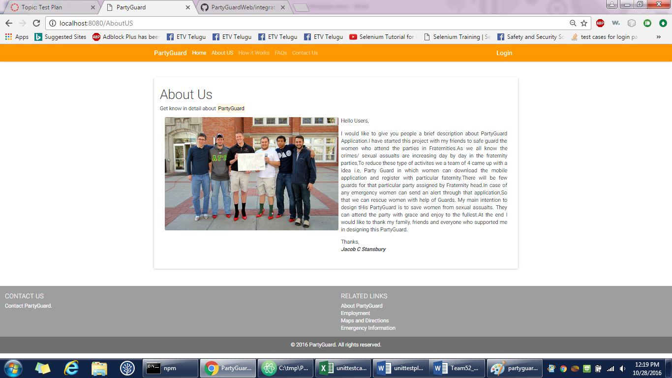

1. **Contact us page**

Gopinadh Cherupally – 100% contribution

<https://github.com/s525080/PartyGuardWeb/blob/0cc023775d30bd1b43e4d477b3b119f7de8d2284/contactus.xlsx>

|  |  |  |  |  |  |
| --- | --- | --- | --- | --- | --- |
| Test case number | Test case description | Steps | Expected result | Actual result | Status(Pass/Fail) |
| 1 | Contact us button | Go to homepage of partyguard | Redirect to Contact us page | contact us page is displayed | pass |
|  |  | View the Contact us button on the top |  |  |  |
|  |  | Press on the button Contact us |  |  |  |
| 2 | Home button | Click on the home button | Homepage is displayed | Homepage is displayed | Pass |
|  |  | Homepage should be displayed |  |  |  |
| 3 | About us button | Go to contact us page of partyguard | Redirect to About us page | About us page is displayed | Pass |
|  |  | View the About us button on the top |  |  |  |
|  |  | Press on the button About us |  |  |  |
| 4 | How it works button | Go to contact us page of partyguard | Redirects to the how it works page | How it works page is displayed | Pass |
|  |  | View the button How it works |  |  |  |
|  |  | Click on the button How it works |  |  |  |
| 5 | FAQs button | Go to contact us page of partyguard | Redirect to FAQs page | FAQs page is displayed | Pass |
|  |  | View the FAQs button on the top |  |  |  |
|  |  | Press on the button FAQs |  |  |  |
| 6 | Contact us button | Go to contact us page of partyguard | Redirect to Contact us page | Contact us page is displayed | Pass |
|  |  | View the Contact us button on the top |  |  |  |
|  |  | Press on the button Contact us |  |  |  |
| 7 | contact partyguard link | Go to contact us page of partyguard | redirect to contact page | Functionality is yet to be done | fail |
|  |  | view the contact partyguard link |  |  |  |
|  |  | click on the link |  |  |  |
| 8 | about partyguard link | Go to contact us page of partyguard | redirect to about partyguard page | Functionality is yet to be done | fail |
|  |  | view the about partyguard link |  |  |  |
|  |  | click on the link |  |  |  |
| 9 | employment link | Go to contact us page of partyguard | redirect to employment page | Functionality is yet to be done | fail |
|  |  | view the about employment link |  |  |  |
|  |  | click on the link |  |  |  |
| 10 | maps and directions link | Go to contact us page of partyguard | redirect to maps directions page | Functionality is yet to be done | fail |
|  |  | view the maps and directions link |  |  |  |
|  |  | click on the link |  |  |  |
| 11 | emergency information link | Go to contact us page of partyguard | redirect to emergency page | Functionality is yet to be done | fail |
|  |  | view the emergency link |  |  |  |
|  |  | click on the link |  |  |  |

**Screenshot:**



1. **FAQs page**

Gopinadh Cherupally – 100% contribution

<https://github.com/s525080/PartyGuardWeb/blob/bce930a3e53861df6288298ef80e9ab528fdf21b/FAQs%20page.xlsx>

|  |  |  |  |  |  |
| --- | --- | --- | --- | --- | --- |
| Test case number | Test case description | Steps | Expected result | Actual Result | Status(Pass/Fail) |
| 1 | FAQs button | Go to homepage of partyguard | Redirect to FAQs page | FAQs page is displayed | Pass |
|  |  | View the FAQs button on the top |  |  |  |
|  |  | Press on the button FAQs |  |  |  |
| 2 | Host user questions | View the How it works page | Should view the answer related to that question | answer is displayed | Pass |
|  |  | Click on the question |  |  |  |
| 3 | Guard user questions | View the How it works page | Should view the answer related to that question | answer is displayed | Pass |
|  |  | Click on the question |  |  |  |
| 4 | Basic user questions | View the How it works page | Should view the answer related to that question | answer is displayed | Pass |
|  |  | Click on the question |  |  |  |
| 5 | Links | Should be able to view the link | should be able to view the data of the link | data is viewed | Pass |
|  |  | Click on the link |  |  |  |
|  |  | View the data of that link |  |  |  |
| 6 | Home button | Click on the home button | Homepage is displayed | Homepage is displayed | Pass |
|  |  | Homepage should be displayed |  |  |  |
| 7 | About us button | Go to FAQs page of partyguard | Redirect to About us page | About us page is displayed | Pass |
|  |  | View the About us button on the top |  |  |  |
|  |  | Press on the button About us |  |  |  |
| 8 | How it works button | Go to FAQs page of partyguard | Redirects to the how it works page | How it works page is displayed | Pass |
|  |  | View the button How it works |  |  |  |
|  |  | Click on the button How it works |  |  |  |
| 9 | FAQs button | Go to FAQs page of partyguard | Redirect to FAQs page | FAQs page is displayed | Pass |
|  |  | View the FAQs button on the top |  |  |  |
|  |  | Press on the button FAQs |  |  |  |
| 10 | Contact us button | Go to FAQs page of partyguard | Redirect to Contact us page | Contact us page is displayed | Pass |
|  |  | View the Contact us button on the top |  |  |  |
|  |  | Press on the button Contact us |  |  |  |
| 11 | contact partyguard link | Go to FAQs page of partyguard | redirect to contact page | Functionality is yet to be done | fail |
|  |  | view the contact partyguard link |  |  |  |
|  |  | click on the link |  |  |  |
| 12 | about partyguard link | Go to FAQs page of partyguard | redirect to about partyguard page | Functionality is yet to be done | fail |
|  |  | view the about partyguard link |  |  |  |
|  |  | click on the link |  |  |  |
| 13 | employment link | Go to FAQs page of partyguard | redirect to employment page | Functionality is yet to be done | fail |
|  |  | view the about employment link |  |  |  |
|  |  | click on the link |  |  |  |
| 14 | maps and directions link | Go to FAQs page of partyguard | redirect to maps directions page | Functionality is yet to be done | fail |
|  |  | view the maps and directions link |  |  |  |
|  |  | click on the link |  |  |  |
| 15 | emergency information link | Go to FAQs page of partyguard | redirect to emergency page | Functionality is yet to be done | fail |
|  |  | view the emergency link |  |  |  |
|  |  | click on the link |  |  |  |

**Screenshot:**

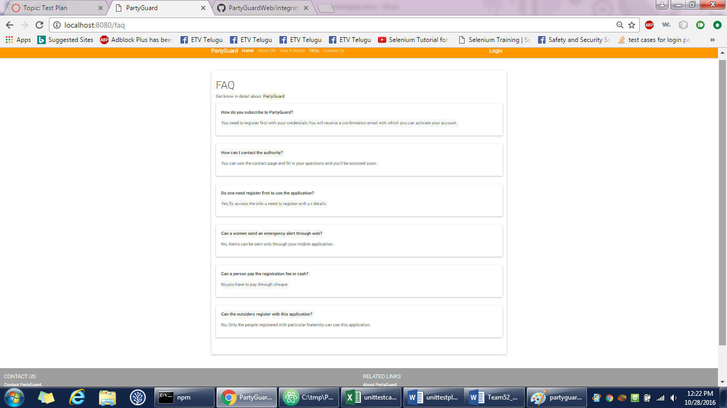

1. **How it works page**

Gopinadh Cherupally – 100% contribution

<https://github.com/s525080/PartyGuardWeb/blob/36eb1022c468be8240e7559e24fbb4241b966182/howitworkspag.xlsx>

|  |  |  |  |  |  |
| --- | --- | --- | --- | --- | --- |
| Test case number | Test case description | Steps | Expected result | Actual Result | Status(Pass/Fail) |
| 1 | How it works button | Go to homepage of partyguard | Redirects to the how it works page | How it works page is displayed | Pass |
|  |  | View the button How it works | |  |  |
|  |  | Click on the button How it works | | |  |
| 2 | Host user questions | View the How it works page | Should view the answer related to that question | answer is dsplayed | pass |
|  |  | Click on the question | |  |  |
| 3 | Guard user questions | View the How it works page | Should view the answer related to that question | answer is dsplayed | pass |
|  |  | Click on the question | |  |  |
| 4 | Basic user questions | View the How it works page | Should view the answer related to that question | answer is dsplayed | pass |
|  |  | Click on the question | |  |  |
| 5 | Links | Should be able to view the link | should be able to view the data of the link | data is displayed | pass |
|  |  | Click on the link | |  |  |
|  |  | View the data of that link | |  |  |
| 6 | Home button | Click on the home button | Homepage is displayed | Homepage is displayed | Pass |
|  |  | Homepage should be displayed | |  |  |
| 7 | About us button | Go to faqs page of partyguard | Redirect to About us page | About us page is displayed | Pass |
|  |  | View the About us button on the top | | |  |
|  |  | Press on the button About us | |  |  |
| 8 | How it works button | Go to faqs page of partyguard | Redirects to the how it works page | How it works page is displayed | Pass |
|  |  | View the button How it works | |  |  |
|  |  | Click on the button How it works | |  |  |
| 9 | FAQs button | Go to faqs page of partyguard | Redirect to FAQs page | FAQs page is displayed | Pass |
|  |  | View the FAQs button on the top | |  |  |
|  |  | Press on the button FAQs | |  |  |
| 10 | Contact us button | Go to faqs page of partyguard | Redirect to Contact us page | Contact us page is displayed | Pass |
|  |  | View the Contact us button on the top | | |  |
|  |  | Press on the button Contact us | |  |  |
| 11 | contact partyguard link | Go to faqs page of partyguard | redirect to contact page | Functionality is yet to be done | fail |
|  |  | view the contact partyguard link | |  |  |
|  |  | click on the link |  |  |  |
| 12 | about partyguard link | Go to faqs page of partyguard | redirect to about partyguard page | Functionality is yet to be done | fail |
|  |  | view the about partyguard link | |  |  |
|  |  | click on the link |  |  |  |
| 13 | employment link | Go to faqs page of partyguard | redirect to employment page | Functionality is yet to be done | fail |
|  |  | view the about employment link | |  |  |
|  |  | click on the link |  |  |  |
| 14 | maps and directions link | Go to faqs page of partyguard | redirect to maps directions page | Functionality is yet to be done | fail |
|  |  | view the maps and directions link | |  |  |
|  |  | click on the link |  |  |  |
| 15 | emergency information link | Go to faqs page of partyguard | redirect to emergency page | Functionality is yet to be done | fail |
|  |  | view the emergency link | |  |  |
|  |  | click on the link |  |  |  |

**Screenshot:**

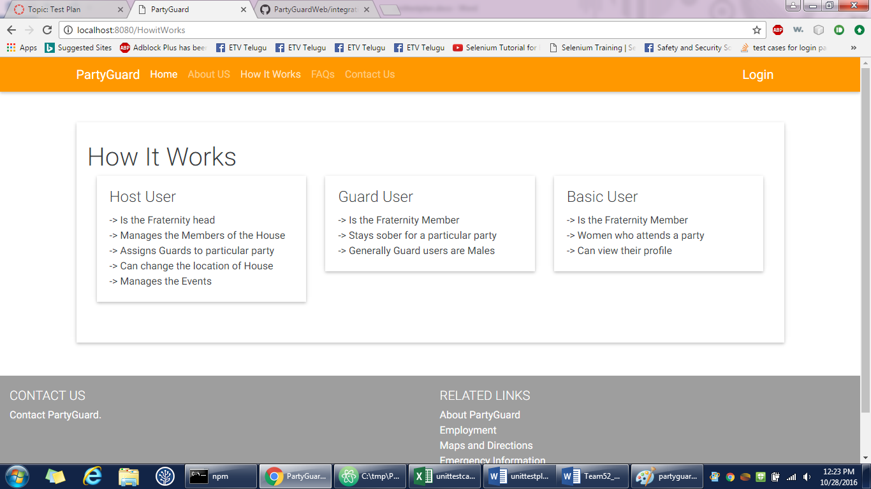

1. **Basic user login page**

Gopinadh Cherupally – 100% contribution

<https://github.com/s525080/PartyGuardWeb/blob/4e22e91dfcc9289aa4a5710a65c95b80e9184bf3/basicuserlogin.xlsx>

|  |  |  |  |  |  |
| --- | --- | --- | --- | --- | --- |
| Test case number | Test case description | Steps | Expected result | Actual result | Status(Pass/Fail) |
| 1 | login button | Open a web browser and type the url | Redirect to login page | Login page is displayed | Pass |
|  |  | View the login button |  |  |  |
|  |  | Press the login button |  |  |  |
| 2 | forgot password link | View the forgot password link | Details page should be displayed | Functionality is yet to be done | Fail |
|  |  | Click the forgot password link |  |  |  |
| 3 | Check the text fields | click on the text field | Should be able to type | Able to type | Pass |
|  |  | text field should be enabled |  |  |  |
| 4 | Home button | Click on the home button | Homepage is displayed | Homepage is displayed | Pass |
|  |  | Homepage should be displayed |  |  |  |
| 5 | About us button | Go to login page of partyguard | Redirect to About us page | About us page is displayed | Pass |
|  |  | View the About us button on the top |  |  |  |
|  |  | Press on the button About us |  |  |  |
| 6 | How it works button | Go to login page of partyguard | Redirects to the how it works page | How it works page is displayed | Pass |
|  |  | View the button How it works |  |  |  |
|  |  | Click on the button How it works |  |  |  |
| 7 | FAQs button | Go to login page of partyguard | Redirect to FAQs page | FAQs page is displayed | Pass |
|  |  | View the FAQs button on the top |  |  |  |
|  |  | Press on the button FAQs |  |  |  |
| 8 | Contact us button | Go to login page of partyguard | Redirect to Contact us page | Contact us page is displayed | Pass |
|  |  | View the Contact us button on the top |  |  |  |
|  |  | Press on the button Contact us |  |  |  |
| 9 | Login button | Go to login page of partyguard | Redirect to login page | Login page is displayed | Pass |
|  |  | View the Login button on the top |  |  |  |
|  |  | Press on the button Login |  |  |  |
| 10 | Sign up link | Go to login page | Redirect to signup page | Sign up page is displayed | Pass |
|  |  | View the sign up link |  |  |  |
|  |  | should be able to view the sign up page |  |  |  |
| 11 | Register as a guard button | Go to login page | Registration page should be displayed | Registration page is displayed | Pass |
|  |  | View the register as a guard button |  |  |  |
|  |  | Click on the register as a guard button |  |  |  |
| 12 | Check for empty validation | Click login button without entering any values in user name and password fields | Validation should be shown as please verify your username and password | validation is shown | Pass |
| 13 | Enter user name | Enter a valid username and leave password field empty | Validation should be shown as please verify your password | validation is shown | Pass |
|  |  | Click login button |  |  |  |
| 14 | Invalid username | Enter invalid username and valid password | Validation should be shown as invalid username or password | validation is shown | Pass |
| 15 | Enter password | Leave username field name blank and enter a valid password | Validation is given to enter username | validation is shown | pass |
|  |  | Click login button |  |  |  |
| 16 | Invalid password | Enter valid username and invalid password | Validation should be shown as please verify your password | validation is shown | Pass |
|  |  | Click login button |  |  |  |
| 17 | Hiding password | Enable the password text field | Password should be visible as dots | password is visible as dots | Pass |
|  |  | Type the password |  |  |  |
| 18 | login successful | Type the username as "basic" | Basic user profile page should be displayed | Basic user page is displayed | Pass |
|  |  | Type the password as "basic" |  |  |  |
|  |  | Press login |  |  |  |
| 19 | contact partyguard link | go to login page | redirect to contact page | Functionality is yet to be done | fail |
|  |  | view the contact partyguard link |  |  |  |
|  |  | click on the link |  |  |  |
| 20 | about partyguard link | go to login page | redirect to about partyguard page | Functionality is yet to be done | fail |
|  |  | view the about partyguard link |  |  |  |
|  |  | click on the link |  |  |  |
| 21 | employment link | go to login page | redirect to employment page | Functionality is yet to be done | fail |
|  |  | view the about employment link |  |  |  |
|  |  | click on the link |  |  |  |
| 22 | maps and directions link | go to login page | redirect to maps directions page | Functionality is yet to be done | fail |
|  |  | view the maps and directions link |  |  |  |
|  |  | click on the link |  |  |  |
| 23 | emergency information link | go to login page | redirect to emergency page | Functionality is yet to be done | fail |
|  |  | view the emergency link |  |  |  |
|  |  | click on the link |  |  |  |

**Screenshot:**

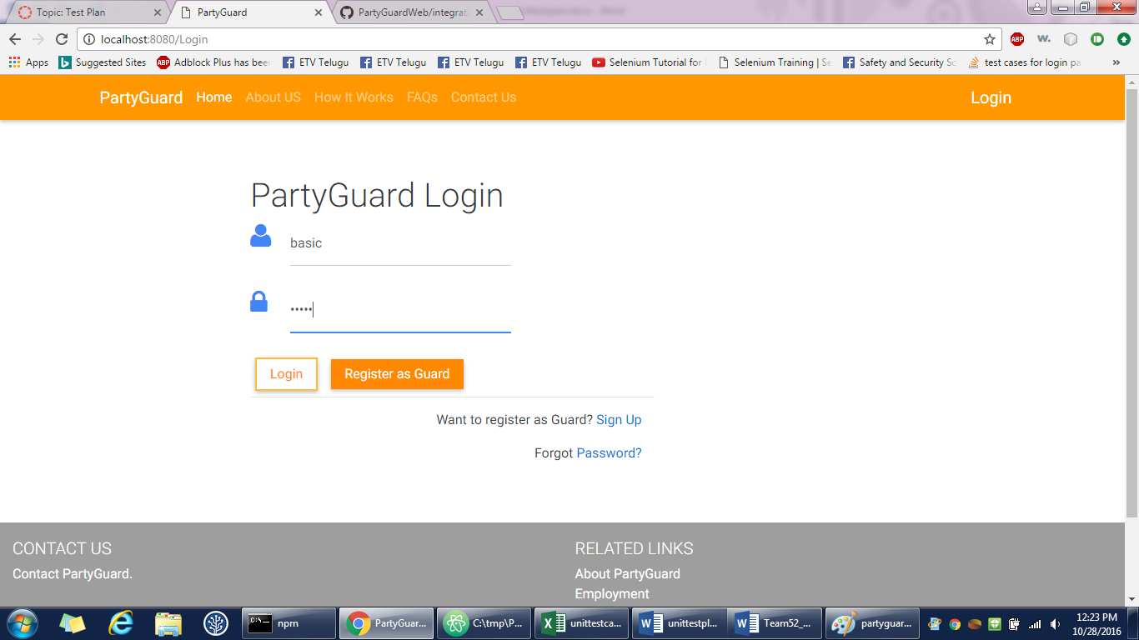

1. **Basic user page**

Gopinadh Cherupally – 100% contribution

<https://github.com/s525080/PartyGuardWeb/blob/8c3cd225325561ccecf2de36877401dc9483debf/basicuserprofile.xlsx>

|  |  |  |  |  |  |  |
| --- | --- | --- | --- | --- | --- | --- |
| Test case number | Test case description | Steps | Expected result | Actual Result | Status(Pass/Fail) | |
| 1 | logout button | Login with the credentials | logout button is displayed on the top right | Functionality is yet to be done | pass | |
|  |  | Go to the basic user page | |  |  | |
| 2 | profile button | login to the basic user page | able to view the personal details | personal details are viewed | pass | |
|  |  | click on the profile button | |  |  | |
| 3 | change password button | Go to the basic user page | able to see the change password page | password change page is displayed | pass | |
|  |  | click on the change password button | | |  | |
| 4 | edit button | go to profile page | edit page should be displayed | edit page is displayed | pass | |
|  |  | click on edit button | |  |  | |
| 5 | Edit full name text field | go to profile page | should be able to edit full name | full name is edited | pass | |
|  |  | click on edit button | |  |  | |
|  |  | click on the text field full name | |  |  | |
| 6 | edit fraternity name text field | go to profile page | should be able to edit fraternity name | fraternity name is edited | pass | |
|  |  | click on edit button | |  |  | |
|  |  | click on the text field fraternity name | | |  | |
| 7 | edit email | go to profile page | should be able to edit email | email is edited | pass | |
|  |  | click on edit button | |  |  | |
|  |  | click on the text field email | |  |  | |
| 8 | "@" validation for email | go to profile page | validation should be displayed | validation is displayed | pass | |
|  |  | click on edit button | |  |  | |
|  |  | click on the text field email | |  |  | |
|  |  | enter email without "@" | |  |  | |
| 9 | edit phone number | go to profile page | should be able to edit with numbers | numbers are edited | pass | |
|  |  | click on edit button | |  |  | |
|  |  | click on the text field phone number | | |  | |
| 10 | save changes button | go to profile page | should be able to view the changes saved | changes are displayed | pass | |
|  |  | click on edit button | |  |  | |
|  |  | edit the changes |  |  |  | |
|  |  | click on the save button | |  |  | |
| 11 | empty text field validations | go to profile page | validation about empty text field should be displayed | validation is displayed | pass | |
|  |  | click on edit button | |  |  | |
|  |  | click the save changes button with empty text fields | | | | |
| 12 | Home button | Click on the home button | Homepage is displayed | Homepage is displayed | | Pass |
|  |  | Homepage should be displayed | | | |  |
| 13 | About us button | Go to login page of partyguard | Redirect to About us page | About us page is displayed | | Pass |
|  |  | View the About us button on the top | | | |  |
|  |  | Press on the button About us | |  | |  |
| 14 | How it works button | Go to login page of partyguard | Redirects to the how it works page | How it works page is displayed | | Pass |
|  |  | View the button How it works | |  | |  |
|  |  | Click on the button How it works | | | |  |
| 15 | FAQs button | Go to login page of partyguard | Redirect to FAQs page | FAQs page is displayed | | Pass |
|  |  | View the FAQs button on the top | | | |  |
|  |  | Press on the button FAQs | |  | |  |
| 16 | Contact us button | Go to login page of partyguard | Redirect to Contact us page | Contact us page is displayed | | Pass |
|  |  | View the Contact us button on the top | | | |  |
|  |  | Press on the button Contact us | |  | |  |
| 17 | contact partyguard link | go to profile page | redirect to contact page | Functionality is yet to be done | | fail |
|  |  | view the contact partyguard link | | | |  |
|  |  | click on the link |  |  | |  |
| 18 | about partyguard link | go to profile page | redirect to about partyguard page | Functionality is yet to be done | | fail |
|  |  | view the about partyguard link | |  | |  |
|  |  | click on the link |  |  | |  |
| 19 | employment link | go to profile page | redirect to employment page | Functionality is yet to be done | | fail |
|  |  | view the about employment link | | | |  |
|  |  | click on the link |  |  | |  |
| 20 | maps and directions link | go to profile page | redirect to maps directions page | Functionality is yet to be done | | fail |
|  |  | view the maps and directions link | | | |  |
|  |  | click on the link |  |  | |  |
| 21 | emergency information link | go to profile page | redirect to emergency page | Functionality is yet to be done | | fail |
|  |  | view the emergency link | |  | |  |
|  |  | click on the link |  |  | |  |

**Screenshot:**

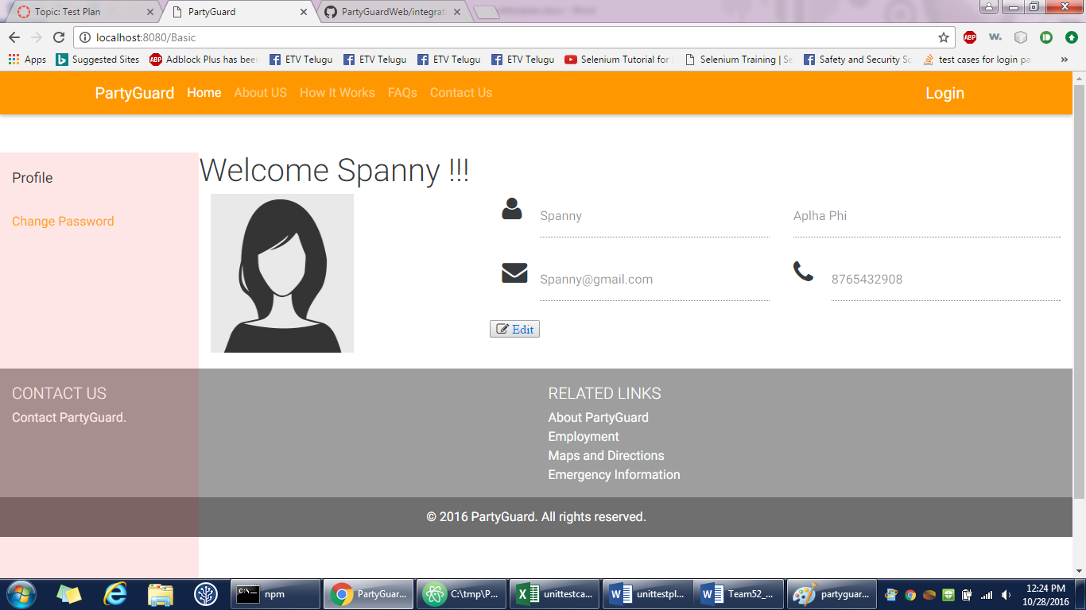

1. **Change password page**

Gopinadh Cherupally – 100% contribution

<https://github.com/s525080/PartyGuardWeb/blob/402429a8de094915449b8679de657308939eb730/basicchangepassword.xlsx>

|  |  |  |  |  |  |
| --- | --- | --- | --- | --- | --- |
| Test case number | Test case description | Steps | Expected result | Actual Result | Status(Pass/Fail) |
| 1 | Check the text fields | click on the text field | Should be able to type | Able to type | Pass |
|  |  | text field should be enabled |  |  |  |
| 2 | Hiding password | Enable the password text field | Password should be visible as dots | password is visible as dots | Pass |
|  |  | Type the password |  |  |  |
| 3 | Old password text field | login to basic user page | Should be able to type the password | Able to type password | Pass |
|  |  | redirect to change password page |  |  |  |
|  |  | click on the text field old password |  |  |  |
| 4 | password text field | login to basic user page | Should be able to type the password | Able to type password | pass |
|  |  | redirect to change password page |  |  |  |
|  |  | click on the text field password |  |  |  |
| 5 | Confirm password text field | login to basic user page | Should be able to type the password | Able to type password | pass |
|  |  | redirect to change password page |  |  |  |
|  |  | click on the text field confirm password |  |  |  |
| 6 | submit button | login to basic user page | password should be updated | functionality is yet to be done | fail |
|  |  | redirect to change password page |  |  |  |
|  |  | click on the submit button |  |  |  |
| 7 | empty text field validation | login to basic user page | validation should be shown | functionality is yet to be done | fail |
|  |  | redirect to change password page |  |  |  |
|  |  | click on submit button directly |  |  |  |
| 8 | Home button | Click on the home button | Homepage is displayed | Homepage is displayed | Pass |
|  |  | Homepage should be displayed |  |  |  |
| 9 | About us button | Go to basic user page of partyguard | Redirect to About us page | About us page is displayed | Pass |
|  |  | View the About us button on the top |  |  |  |
|  |  | Press on the button About us |  |  |  |
| 10 | How it works button | Go to basic user page of partyguard | Redirects to the how it works page | How it works page is displayed | Pass |
|  |  | View the button How it works |  |  |  |
|  |  | Click on the button How it works |  |  |  |
| 11 | FAQs button | Go to basic user page of partyguard | Redirect to FAQs page | FAQs page is displayed | Pass |
|  |  | View the FAQs button on the top |  |  |  |
|  |  | Press on the button FAQs |  |  |  |
| 12 | Contact us button | Go to basic user page of partyguard | Redirect to Contact us page | Contact us page is displayed | Pass |
|  |  | View the Contact us button on the top |  |  |  |
|  |  | Press on the button Contact us |  |  |  |
| 13 | contact partyguard link | go to profile page | redirect to contact page | Functionality is yet to be done | fail |
|  |  | view the contact partyguard link |  |  |  |
|  |  | click on the link |  |  |  |
| 14 | about partyguard link | go to profile page | redirect to about partyguard page | Functionality is yet to be done | fail |
|  |  | view the about partyguard link |  |  |  |
|  |  | click on the link |  |  |  |
| 15 | employment link | go to profile page | redirect to employment page | Functionality is yet to be done | fail |
|  |  | view the about employment link |  |  |  |
|  |  | click on the link |  |  |  |
| 16 | maps and directions link | go to profile page | redirect to maps directions page | Functionality is yet to be done | fail |
|  |  | view the maps and directions link |  |  |  |
|  |  | click on the link |  |  |  |
| 17 | emergency information link | go to profile page | redirect to emergency page | Functionality is yet to be done | fail |

**Screenshot:**

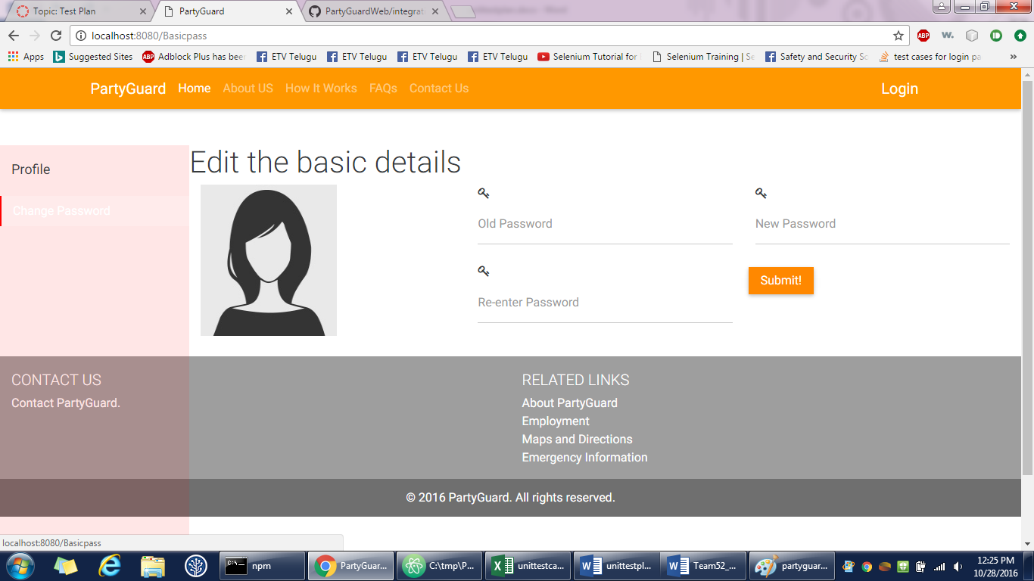

1. **Guard login**

Gopinadh Cherupally – 100% contribution

<https://github.com/s525080/PartyGuardWeb/blob/a97fa45b9757717370c7d11e5ca6b32ed2015741/guardlogin.xlsx>

|  |  |  |  |  |  |
| --- | --- | --- | --- | --- | --- |
| Test case number | Test case description | Steps | Expected result | Actual result | Status(Pass/Fail) |
| 1 | login button | Open a web browser and type the url | Redirect to login page | Login page is displayed | Pass |
|  |  | View the login button | |  |  |
|  |  | Press the login button | |  |  |
| 2 | forgot password link | View the forgot password link | Details page should be displayed | Functionality is yet to be done | Fail |
|  |  | Click the forgot password link | |  |  |
| 3 | Check the text fields | click on the text field | Should be able to type | Able to type | Pass |
|  |  | text field should be enabled | |  |  |
| 4 | Home button | Click on the home button | Homepage is displayed | Homepage is displayed | Pass |
|  |  | Homepage should be displayed | |  |  |
| 5 | About us button | Go to login page of partyguard | Redirect to About us page | About us page is displayed | Pass |
|  |  | View the About us button on the top | | |  |
|  |  | Press on the button About us | |  |  |
| 6 | How it works button | Go to login page of partyguard | Redirects to the how it works page | How it works page is displayed | Pass |
|  |  | View the button How it works | |  |  |
|  |  | Click on the button How it works | |  |  |
| 7 | FAQs button | Go to login page of partyguard | Redirect to FAQs page | FAQs page is displayed | Pass |
|  |  | View the FAQs button on the top | |  |  |
|  |  | Press on the button FAQs | |  |  |
| 8 | Contact us button | Go to login page of partyguard | Redirect to Contact us page | Contact us page is displayed | Pass |
|  |  | View the Contact us button on the top | | |  |
|  |  | Press on the button Contact us | |  |  |
| 9 | Login button | Go to login page of partyguard | Redirect to login page | Login page is displayed | Pass |
|  |  | View the Login button on the top | |  |  |
|  |  | Press on the button Login | |  |  |
| 10 | Sign up link | Go to login page | Redirect to signup page | Sign up page is displayed | Pass |
|  |  | View the sign up link | |  |  |
|  |  | should be able to view the sign up page | | |  |
| 11 | Register as a guard button | Go to login page | Registration page should be displayed | Registraton page is displayed | Pass |
|  |  | View the register as a guard button | |  |  |
|  |  | Click on the register as a guard button | | |  |
| 12 | Check for empty validation | Click login button without entering any values in user name and password fields | Validation should be shown as please verify your username and password | validation is shown | Pass |
| 13 | Enter user name | Enter a valid username and leave password field empty | Validation should be shown as please verify your password | validation is shown | Pass |
|  |  | Click login button | |  |  |
| 14 | Invalid username | Enter invalid username and valid password | Validation should be shown as invalid username or password | validation is shown | Pass |
| 15 | Enter password | Leave username field name blank and enter a valid password | Validation is given to enter username | validation is shown | pass |
|  |  | Click login button | |  |  |
| 16 | Invalid password | Enter valid username and invalid password | Validation should be shown as please verify your password | validation is shown | Pass |
|  |  | Click login button | |  |  |
| 17 | Hiding password | Enable the password text field | Password should be visible as dots | password is visible as dots | Pass |
|  |  | Type the password | |  |  |
| 18 | login successful | Type the username as "basic" | Basic user profile page should be displayed | Basic user page is displayed | Pass |
|  |  | Type the password as "basic" | |  |  |
|  |  | Press login |  |  |  |
| 19 | contact partyguard link | go to login page | redirect to contact page | Functionality is yet to be done | fail |
|  |  | view the contact partyguard link | |  |  |
|  |  | click on the link |  |  |  |
| 20 | about partyguard link | go to login page | redirect to about partyguard page | Functionality is yet to be done | fail |
|  |  | view the about partyguard link | |  |  |
|  |  | click on the link |  |  |  |
| 21 | employment link | go to login page | redirect to employment page | Functionality is yet to be done | fail |
|  |  | view the about employment link | |  |  |
|  |  | click on the link |  |  |  |
| 22 | maps and directions link | go to login page | redirect to maps directions page | Functionality is yet to be done | fail |
|  |  | view the maps and directions link | |  |  |
|  |  | click on the link |  |  |  |
| 23 | emergency information link | go to login page | redirect to emergency page | Functionality is yet to be done | fail |
|  |  | view the emergency link | |  |  |
|  |  | click on the link |  |  |  |

**Screenshot:**

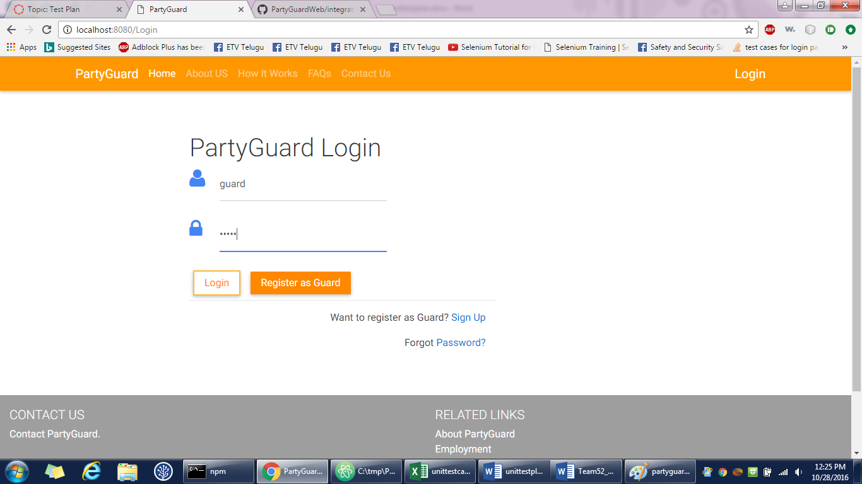

1. **Guard profile**

Gopinadh Cherupally – 100% contribution

<https://github.com/s525080/PartyGuardWeb/blob/d616386a16f30f4300ddaf325ed136a4d1e20588/guardprofile.xlsx>

|  |  |  |  |  |  |
| --- | --- | --- | --- | --- | --- |
| Test case number | Test case description | Steps | Expected result | Actual Result | Status(Pass/Fail) |
| 1 | logout button | Login with the credentials | logout button is displayed on the top right | Functionality is yet to be done | pass |
|  |  | Go to the guard user page | |  |  |
| 2 | profile button | login to the guard user page | able to view the personal details | personal details are viewed | pass |
|  |  | click on the profile button | |  |  |
| 3 | change password button | login to the guard user page | able to see the change password page | password change page is displayed | pass |
|  |  | click on the change password button | | |  |
| 4 | edit button | go to profile page | edit page should be displayed | edit page is displayed | pass |
|  |  | click on edit button | |  |  |
| 5 | Edit full name text field | go to profile page | should be able to edit full name | full name is edited | pass |
|  |  | click on edit button | |  |  |
|  |  | click on the text field full name | |  |  |
| 6 | edit fraternity name text field | go to profile page | should be able to edit fraternity name | fraternity name is edited | pass |
|  |  | click on edit button | |  |  |
|  |  | click on the text field fraternity name | | |  |
| 7 | edit email | go to profile page | should be able to edit email | email is edited | pass |
|  |  | click on edit button | |  |  |
|  |  | click on the text field email | |  |  |
| 8 | "@" validation for email | go to profile page | validation should be displayed | validation is displayed | pass |
|  |  | click on edit button | |  |  |
|  |  | click on the text field email | |  |  |
|  |  | enter email without "@" | |  |  |
| 9 | edit phone number | go to profile page | should be able to edit with numbers | numbers are edited | pass |
|  |  | click on edit button | |  |  |
|  |  | click on the text field phone number | | |  |
| 10 | save changes button | go to profile page | should be able to view the changes saved | changes are displayed | pass |
|  |  | click on edit button | |  |  |
|  |  | edit the changes | |  |  |
|  |  | click on the save button | |  |  |
| 11 | empty text field validations | go to profile page | validation about empty text field should be displayed | validation is displayed | pass |
|  |  | click on edit button | |  |  |
|  |  | click the save changes button with empty textfields | | | |
| 12 | Home button | Click on the home button | Homepage is displayed | Homepage is displayed | Pass |
|  |  | Homepage should be displayed | | |  |
| 13 | About us button | Go to login page of partyguard | Redirect to About us page | About us page is displayed | Pass |
|  |  | View the About us button on the top | | |  |
|  |  | Press on the button About us | |  |  |
| 14 | How it works button | Go to login page of partyguard | Redirects to the how it works page | How it works page is displayed | Pass |
|  |  | View the button How it works | |  |  |
|  |  | Click on the button How it works | |  |  |
| 15 | FAQs button | Go to login page of partyguard | Redirect to FAQs page | FAQs page is displayed | Pass |
|  |  | View the FAQs button on the top | | |  |
|  |  | Press on the button FAQs | |  |  |
| 16 | Contact us button | Go to login page of partyguard | Redirect to Contact us page | Contact us page is displayed | Pass |
|  |  | View the Contact us button on the top | | |  |
|  |  | Press on the button Contact us | |  |  |
| 17 | contact partyguard link | go to profile page | redirect to contact page | Functionality is yet to be done | fail |
|  |  | view the contact partyguard link | |  |  |
|  |  | click on the link |  |  |  |
| 18 | about partyguard link | go to profile page | redirect to about partyguard page | Functionality is yet to be done | fail |
|  |  | view the about partyguard link | |  |  |
|  |  | click on the link |  |  |  |
| 19 | employment link | go to profile page | redirect to employment page | Functionality is yet to be done | fail |
|  |  | view the about employment link | |  |  |
|  |  | click on the link |  |  |  |
| 20 | maps and directions link | go to profile page | redirect to maps directions page | Functionality is yet to be done | fail |
|  |  | view the maps and directions link | | |  |
|  |  | click on the link |  |  |  |
| 21 | emergency information link | go to profile page | redirect to emergency page | Functionality is yet to be done | fail |
|  |  | view the emergency link | |  |  |
|  |  | click on the link |  |  |  |

**Screenshot:**

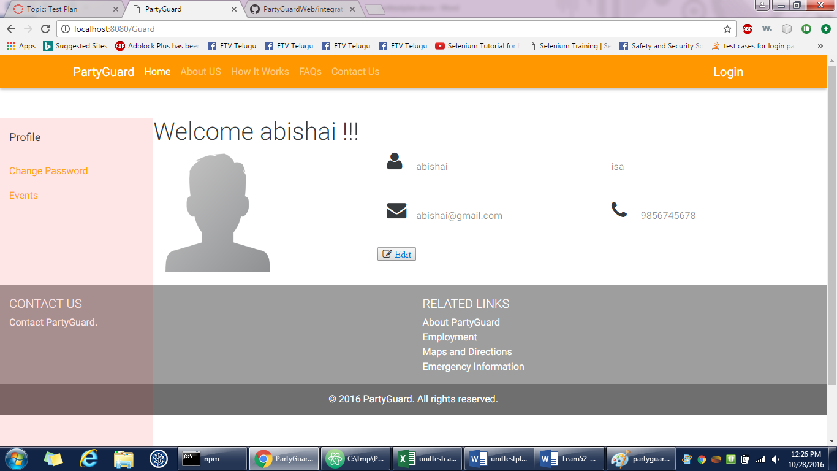

1. **Guard change password**

Gopinadh Cherupally – 100% contribution

<https://github.com/s525080/PartyGuardWeb/blob/36945d1a7df20436e1baec4d8a0b12a1ba8af2d1/guardchangepassword.xlsx>

|  |  |  |  |  |  |
| --- | --- | --- | --- | --- | --- |
| Test case number | Test case description | Steps | Expected result | Actual Result | Status(Pass/Fail) |
| 1 | Check the text fields | click on the text field | Should be able to type | Able to type | Pass |
|  |  | text field should be enabled | | |  |
| 2 | Hiding password | Enable the password text field | Password should be visible as dots | password is visible as dots | Pass |
|  |  | Type the password | |  |  |
| 3 | Old password text field | login to guard user page | Should be able to type the password | Able to type password | Pass |
|  |  | redirect to change password page | | |  |
|  |  | click on the text field old password | | |  |
| 4 | password text field | login to guard user page | Should be able to type the password | Able to type password | pass |
|  |  | redirect to change password page | | |  |
|  |  | click on the text field password | | |  |
| 5 | Confirm password text field | login to guard user page | Should be able to type the password | Able to type password | pass |
|  |  | redirect to change password page | | |  |
|  |  | click on the text field confirm password | | | |
| 6 | submit button | login to guard user page | password should be updated | functionality is yet to be done | fail |
|  |  | redirect to change password page | | |  |
|  |  | click on the submit button | | |  |
| 7 | empty text field validation | login to guard user page | validation should be shown | functionality is yet to be done | fail |
|  |  | redirect to change password page | | |  |
|  |  | click on submit button directly | | |  |
| 8 | Home button | Click on the home button | Homepage is displayed | Homepage is displayed | Pass |
|  |  | Homepage should be displayed | | |  |
| 9 | About us button | login to guard user page | Redirect to About us page | About us page is displayed | Pass |
|  |  | View the About us button on the top | | |  |
|  |  | Press on the button About us | | |  |
| 10 | How it works button | login to guard user page | Redirects to the how it works page | How it works page is displayed | Pass |
|  |  | View the button How it works | | |  |
|  |  | Click on the button How it works | | |  |
| 11 | FAQs button | login to guard user page | Redirect to FAQs page | FAQs page is displayed | Pass |
|  |  | View the FAQs button on the top | | |  |
|  |  | Press on the button FAQs | | |  |
| 12 | Contact us button | login to guard user page | Redirect to Contact us page | Contact us page is displayed | Pass |
|  |  | View the Contact us button on the top | | | |
|  |  | Press on the button Contact us | | |  |
| 13 | contact partyguard link | go to profile page | redirect to contact page | Functionality is yet to be done | fail |
|  |  | view the contact partyguard link | | |  |
|  |  | click on the link | |  |  |
| 14 | about partyguard link | go to profile page | redirect to about partyguard page | Functionality is yet to be done | fail |
|  |  | view the about partyguard link | | |  |
|  |  | click on the link | |  |  |
| 15 | employment link | go to profile page | redirect to employment page | Functionality is yet to be done | fail |
|  |  | view the about employment link | | |  |
|  |  | click on the link | |  |  |
| 16 | maps and directions link | go to profile page | redirect to maps directions page | Functionality is yet to be done | fail |
|  |  | view the maps and directions link | | |  |
|  |  | click on the link | |  |  |
| 17 | emergency information link | go to profile page | redirect to emergency page | Functionality is yet to be done | fail |
|  |  | view the emergency link | | |  |
|  |  | click on the link | |  |  |

**Screenshot:**

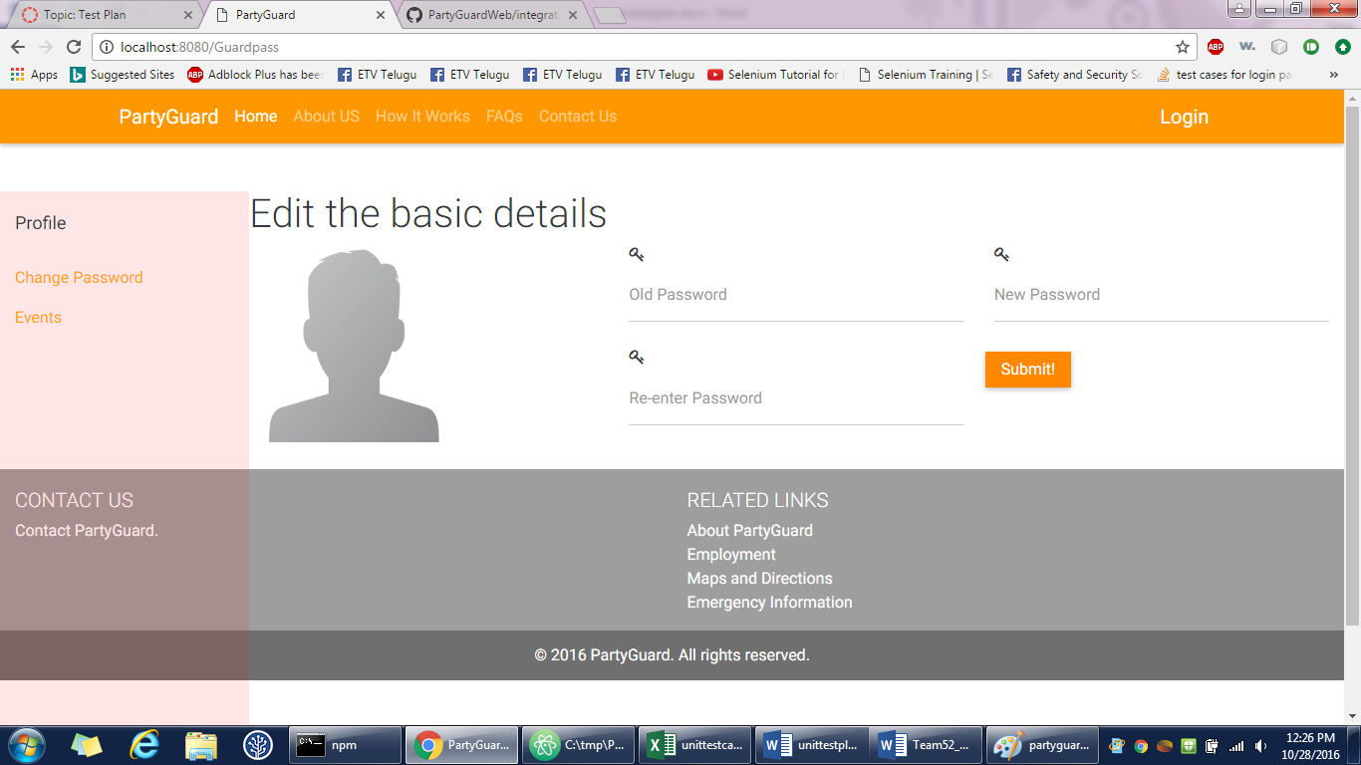

1. **Admin/Master user login**

Nihitha Reddy Bhimireddy – 100% contribution

|  |  |  |  |  |  |
| --- | --- | --- | --- | --- | --- |
| TEST CASE NUMBER | TEST CASE DESCRIPTION | STEPS | ACTUAL RESULT | EXPECTED RESULT | STATUS (PASS/FAIL) |
|  |  | ADMIN LOGIN |  |  |  |
| 1 | Login | a.Open a web browser and type the url | Admin is redirected to the login page | Home page of the website should be displayed | PASS |
|  |  | b.View login button on the right corner of the web page |  |  |  |
|  |  | c.Press the login button |  | Redirect to the user login page |  |
|  |  |  |  |  |  |
| 2 | Check the text fields | a. Click on the text field | Both the username and password fields are enabled | The login page should contain the following text fields | PASS |
|  |  | b. Text field should be enabled |  | a.Username |  |
|  |  | c.Should be able to type the username |  | b.Password |  |
|  |  | d.Should be able to type the password |  |  |  |
|  |  |  |  |  |  |
| 3 | Check for empty validation | a. Click Login button without entering any values in user name and password fields | No alert message is displayed. Yet to implement the alert functionality | An alert message "Please enter username and password" should be displayed in the login page itself | FAIL |
|  |  |  |  |  |  |
| 4 | Enter only user name | a.Enter a valid username and leave password blank | An alert message "Please fill out the field" is displayed | An alert message " Please enter valid password" should be displayed in the login page itself | PASS |
|  |  | b. Click Login button |  |  |  |
|  |  |  |  |  |  |
| 5 | Invalid username | a. Enter invalid username and valid password | No alert message is displayed. Yet to implement the alert functionality | An alert message" Invalid username or password" should be displayed in the login page itself | FAIL |
|  |  | b. Click Login button |  |  |  |
|  |  |  |  |  |  |
| 6 | Enter only password | a. Leave username field name blank and enter a valid password | An alert message "Please fill out the field" is displayed | An alert message " Please enter valid username " should be displayed in the login page itslef | PASS |
|  |  | b. Click Login button |  |  |  |
|  |  |  |  |  |  |
| 7 | Invalid password | a. Enter valid username and invalid password | No alert message is displayed. Yet to implement the alert functionality | An alert message " Invalid username or password" should be displayed in the login page itslef | FAIL |
|  |  | b. Click Login button |  |  |  |
|  |  |  |  |  |  |
| 8 | Invalid login | a. Enter invalid username and invalid password | No alert message is displayed. Yet to implement the alert functionality | An alert message " Please enter valid username and password" should be displayed in the login page itself | FAIL |
|  |  | b. Click Login button |  |  |  |
|  |  |  |  |  |  |
| 9 | Valid login | a. Enter valid username and valid password | For now admin is redirected to the add customer page | Master user dashboard should be displayed | FAIL |
|  |  | b. Click Login button |  |  |  |

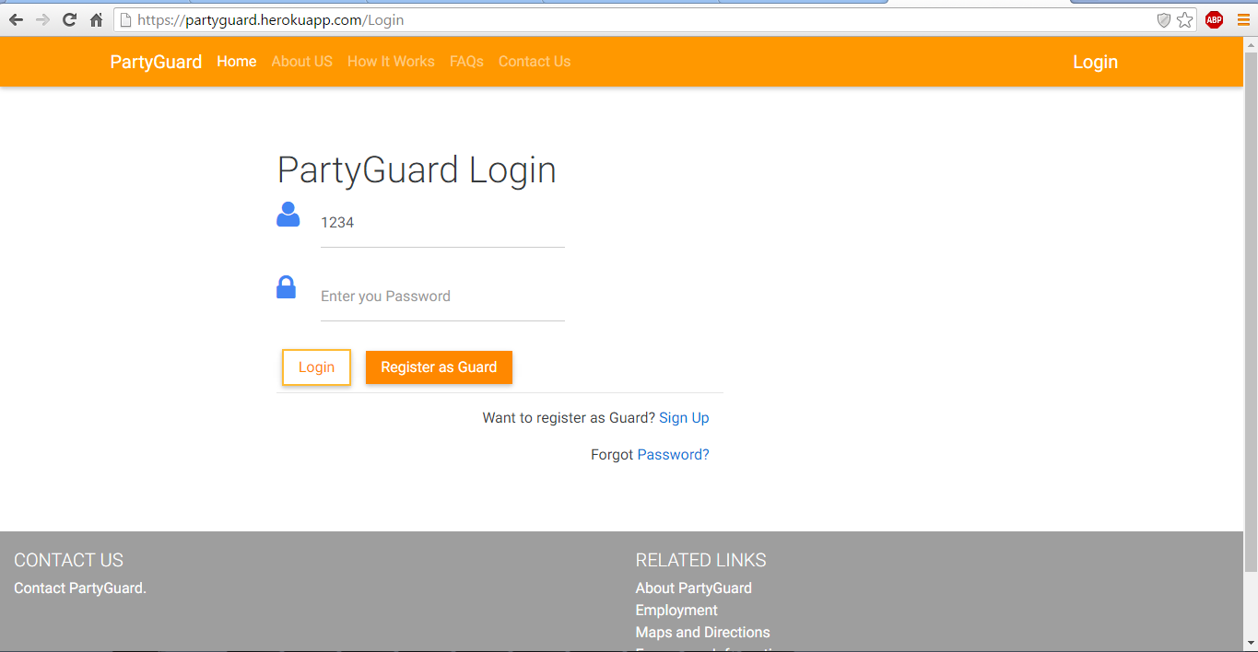

1. **Admin dashboard**

Nihitha Reddy Bhimireddy – 100% contribution

|  |  |  |  |  |  |
| --- | --- | --- | --- | --- | --- |
| TEST CASE NUMBER | TEST CASE DESCRIPTION | STEPS | ACTUAL RESULT | EXPECTED RESULT | STATUS(PASS/FAIL) |
|  |  | ADMIN DASHBOARD |  |  |  |
| 10 | Admin Dashboard | a. View number of customers and users registered | All the details can be viewed. But these are not dynamic. | Admin should be able to view the subscription details (Customer ID, Fraternity, Start Date, End Date, Status) | FAIL |
|  |  | b. Scroll down to view the subscription details |  |  |  |

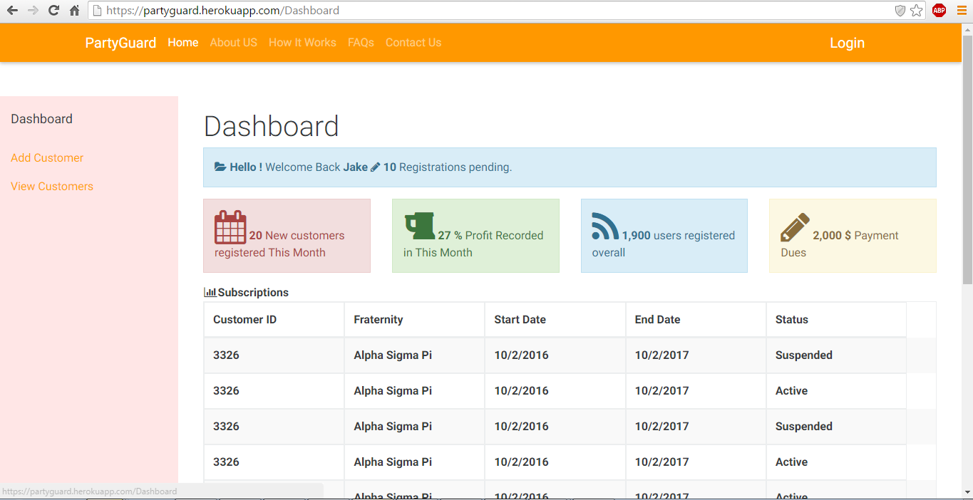

1. **Add Customers/Acknowledge Customers**

Nihitha Reddy Bhimireddy – 100% contribution

|  |  |  |  |  |  |
| --- | --- | --- | --- | --- | --- |
| TEST CASE NUMBER | TEST CASE DESCRIPTION | STEPS | ACTUAL RESULT | EXPECTED RESULT | STATUS(PASS/FAIL) |
|  |  | ADD CUSTOMERS/ACKNOWLEDGE CUSTOMERS |  |  |  |
|  |  |  |  |  |  |
| 11 | Select only university | a.Click on drop down menu and select one university from the list | The selected university is displayed | The required university should be selected. In the acknowledgement page the selected university should be displayed | PASS |
|  |  | b.Click Create Account | The form gets submitted without selecting the uniersity fromthe list and no name is displayed in the acknowledgement page | If not entered " Please select a university" should be displayed | FAIL |
| 12 | Enter only House Name | a.Click on the text field | Any character can be entered in this field | Admin can enter the house name. Only alphabets should be accepted | FAIL |
|  |  | b.The text field should be enabled | If left empty the alert message is being displayed | If not entered "Enter house name" should be displayed | PASS |
|  |  | c. Should be able to enter house name |  |  |  |
|  |  |  |  |  |  |
| 13 | Enter Nickname | a.Click on the text field | It accepts any character | The house nickname can be alphanumeric | PASS |
|  |  | b.The text field should be enabled | If left empty the alert message is being displayed | An alert message " Enter nick name " should be displayed | PASS |
|  |  | c. Should be able to enter nickname |  |  |  |
|  |  |  |  |  |  |
| 14 | Enter Chapter | a.Click on the text field | It accepts any character | The chapter name can be alphanumeric | PASS |
|  |  | b.The text field should be enabled | If left empty the alert message is being displayed | An alert message " Enter chapter name" should be displayed | PASS |
|  |  | c. Should be able to enter chapter |  |  |  |
|  |  |  |  |  |  |
| 15 | Enter Username | a.Click on the text field | The username accepts any character | The username can be alphanumeric | PASS |
|  |  | b.The text field should be enabled | If not entered, appropriate alert message is displayed | An alert message " Enter username" Should be displayed | PASS |
|  |  | c. Should be able to enter username |  |  |  |
|  |  |  |  |  |  |
| 16 | Enter Email | a.Click on the text field | It allows only valid email address which consists of @ and domain name | The email should consists of @ and valid domain name | PASS |
|  |  | b.The text field should be enabled | If not entered, appropriate alert message is displayed | If not "Please enter valid email address" should be displayed | PASS |
|  |  | c. Should be able to enter email |  |  |  |
|  |  |  |  |  |  |
| 17 | Enter phone number | a. Click on the text field | No alphabets or special characters are allowed to enter | Only numbers should be entered as phone number | PASS |
|  |  | b.The text field should be enabled | It allows more than 10 numbers in the phone number field | The phone numer should have only 10 numbers | FAIL |
|  |  | c. Should be able to enter phone number |  |  |  |
|  |  |  |  |  |  |
| 18 | Enter all the details in the fields | a. Click on the text fields | All the entered details are reflected in the acknowledgement page | The acknowledegement page should have all the details same as the entered details | PASS |
|  | (Create Account) | b.The text fields should be enabled |  |  |  |
|  |  | c.Enter all the details |  |  |  |
|  |  | d. Click on Create account button |  |  |  |
|  |  |  |  |  |  |
| 19 | Enter all details in the fields | a. Click on the text fields | All the fields are empty | All the information entered in the fields should be reset | PASS |
|  | (Reset) | b.The text fields should be enabled |  |  |  |
|  |  | c.Enter all the details |  |  |  |
|  |  | d. Click on Reset button |  |  |  |
|  |  |  |  |  |  |
| 20 | Alignment of all fields | Each field in the row should be aligned | Few fields are not aligned. | All the fields should be aligned in their respective row | FAIL |

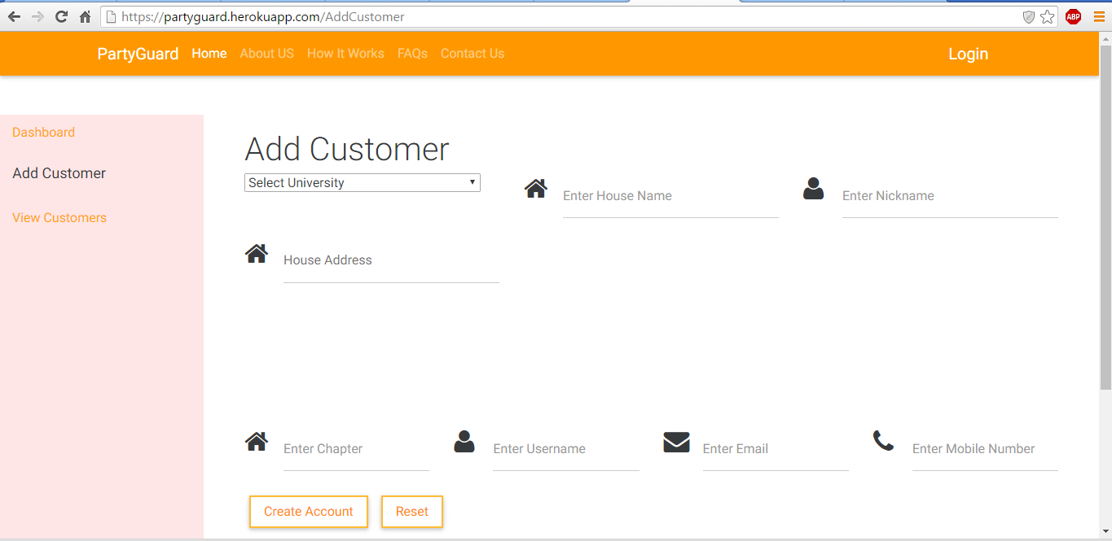

1. **View Customers**

Nihitha Reddy Bhimireddy – 100% contribution

|  |  |  |  |  |  |
| --- | --- | --- | --- | --- | --- |
|  |  | VIEW CUSTOMERS |  |  |  |
|  |  |  |  |  |  |
| 21 | Fraternity Name Description | Short description regarding the fraternity | No description is provided | A short description regarding each fraternity should be given below the name of the fraternity | FAIL |
|  |  |  |  |  |  |
| 22 | Action button | There should be two buttons suspend and activate | Both the buttons are in static mode | As soon as the admin wants to activate the activate button should toggle to suspend and whenever the subscriptions are completed then it should toggle to activate mode | FAIL |

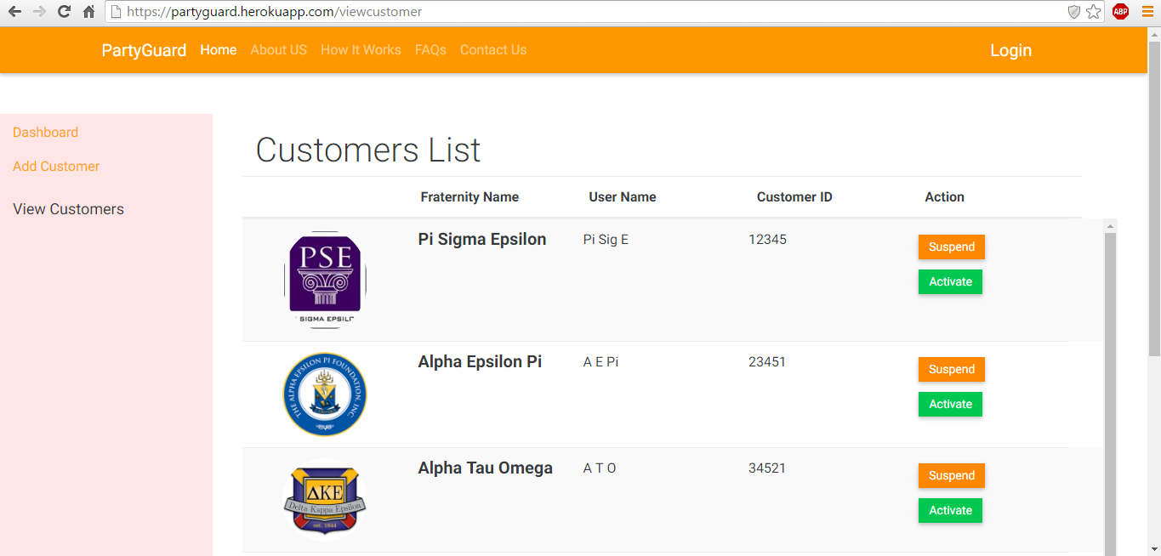

|  |  |  |  |  |
| --- | --- | --- | --- | --- |
| Test case number | Test case description | Steps | Expected result | **Status(Pass/Fail)** |
| 1 | user Login | a.Enter Valid user name and password | Enter Valid user name and password | **Pass** |
| 2 |  | b. Click on Login button | Redirect to home page of guard | **PASS** |
| 3 |  |  |  |  |
| 4 | View after login | After logging in the user must see profile,Create events ,View/edit events, Members tabs in left pane | View all the tabs in the left window pane. | **PASS** |
| 5 |  |  |  |  |
| 6 | Profile | Host must be able edit his profile. | Host must be able edit his profile. | **PASS** |
| 7 |  | The host must see the map with their house current location. | Must see the location of their house. | **PASS** |

|  |  |  |  |  |
| --- | --- | --- | --- | --- |
| Test case number | Test case description | Steps | Expected result | **Status(Pass/Fail)** |
| 1 | user Login | a.Enter Valid user name and password | Enter Valid user name and password | **Pass** |
| 2 |  | b. Click on Login button | Redirect to home page of guard | **PASS** |
| 3 |  |  |  |  |
| 4 | View after login | After logging in the user must see profile,Create events ,View/edit events, Members tabs in left pane | View all the tabs in the left window pane. | **PASS** |
| 5 |  |  |  |  |
| 6 | Profile | Host must be able edit his profile. | Host must be able edit his profile. | **PASS** |
| 7 |  | The host must see the map with their house current location. | Must see the location of their house. | **PASS** |

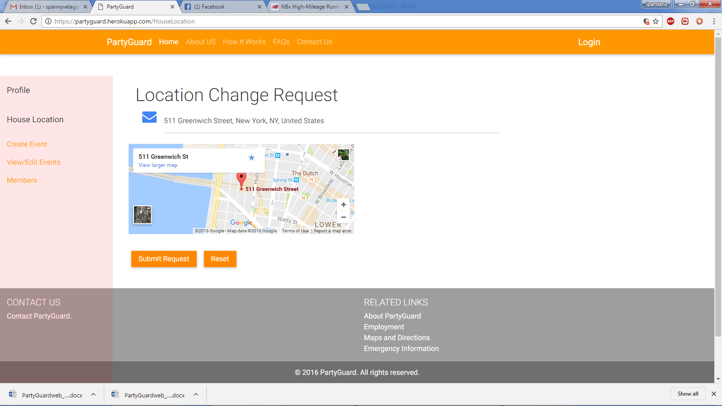

|  |  |  |  |  |
| --- | --- | --- | --- | --- |
|  | Create event | a.Create a new event by adding event name ,Date and time | Create a new event by adding event name ,Date and time | **PASS** |
| 11 |  | b.Host must be able to see the list of guards . | Able to see list of guards | **PASS** |
| 12 |  | c.Host must be able to select the guards to the party | c.Host must be able to select the guards to the party | **PASS** |
| 13 |  | d. Host must be able to save the changes made to the event by clicking save button | d. Host must be able to save the changes made to the event by clicking save button | **PASS** |
| 14 |  | Alignment of the elements in the page | Alignemnt should be proper | **FAIL** |
| 15 |  | Reset button clear all the fields in the create events page. | Reset button clear all the fields in the create events page. | **FAIL** |
| 16 |  | Images of the profiles must be of same size | Images must be consistent in size | **FAIL** |

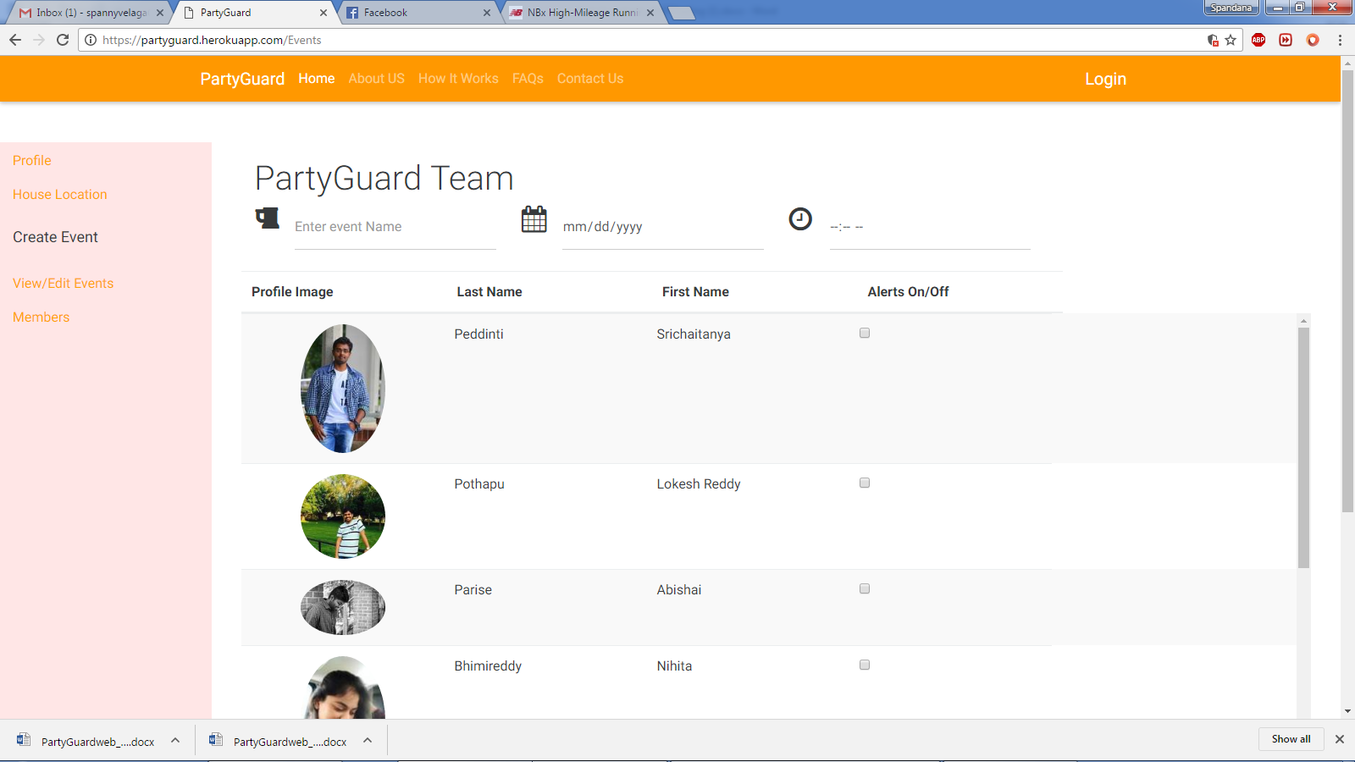

|  |  |  |  |  |
| --- | --- | --- | --- | --- |
| 17 | View/Edit Events | a.Host clicks on View/edit options in left pane |  |  |
| 18 |  | b. Host must be see the list of events(Event name,Date,Time) | Host must be see the list of events(Event name,Date,Time) | **PASS** |
| 19 |  |  |  |  |
| 20 | Members | Display the list of all members | Display the list of all members | **Pass** |
| 21 |  | Edit the the customer | Edit the customer | **FAIL** |
| 22 |  | Delete the particular customer | delete particular customer | **FAIL** |
| 23 |  | Alignment of the elements in the page | Alignment should be proper | **FAIL** |
|  |  |  |  |  |

