Theory of Automata – Home Work 3

Name – Akshay Kumar Singh

R11603620

1. **Draw a state diagram for nondeterministic finite automata that accepts the following languages**

**Sol :** The easiest way to do this is to make a 2 state FSA for aa* and a 4 state one for (ab)*(ba)*, then make a seventh state, the start state, that non-deterministically guesses which class an input string will fall into.

*1.2****.* (ba ∪ b)* ∪ (bb ∪ a)\***

**Sol:** This is the set of strings where either:

(1) every a is preceded by a b, or

(2) all b's occur in pairs. So, we can make a 5 state nondeterministic machine by making separate machines (each with two states) for the two languages and then introducing ε transitions from the start state to both of them.

1. **Give the regular expression for the language accepted by the following finite automaton**

**Sol: a* (ba* ba*)\***

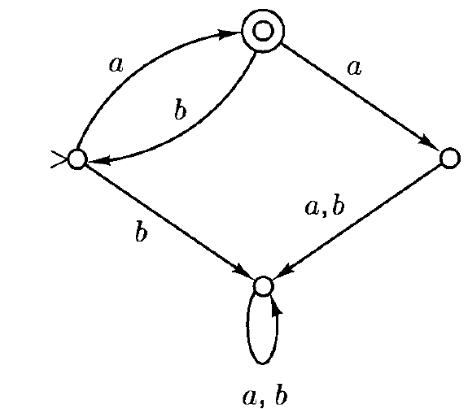

**Sol: abb(ab)\***

1. **Write the regular expression for the following sets**
   1. **All strings over that are odd in length**

**3.2 All strings over that end with**

