**PHOTOSHOP TOOLS**

**Ref:** <https://helpx.adobe.com/in/photoshop-elements/using/tools.html>

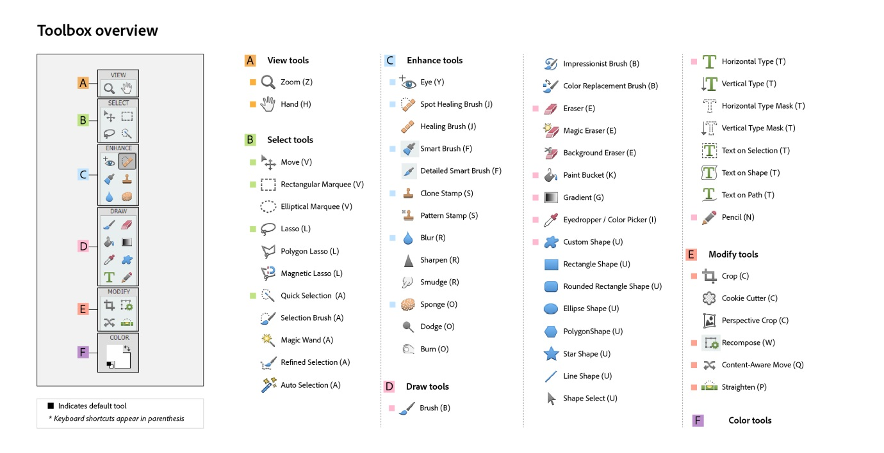

1. View tools **B.** Select tools **C.** Enhance tools **D.** Draw tools **E.** Modify tools **F.** Color

How to Do Theme Banners   
------------------------------------------

CTRL+N: Take new layer with  
-------------------

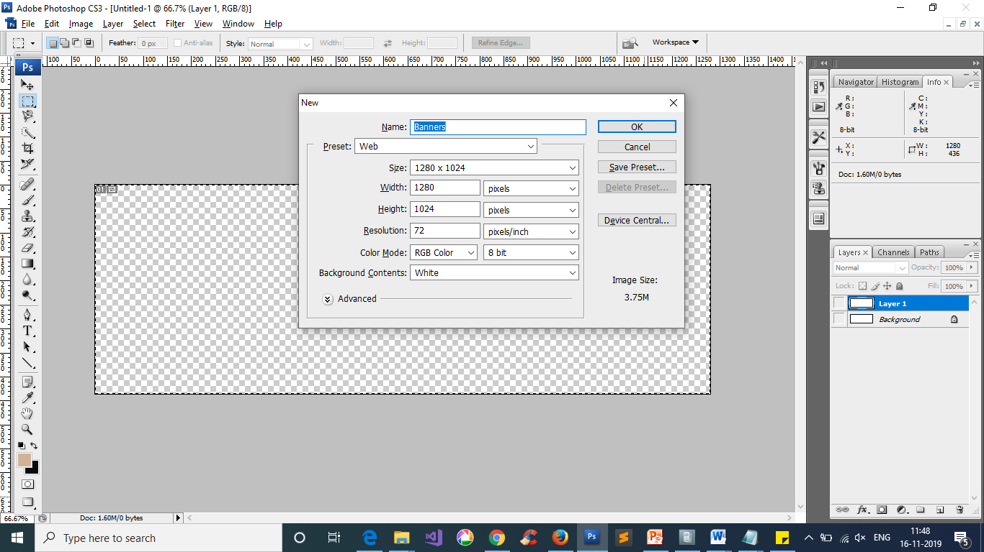

1. Choose Present as **Web**
2. Size :Width*Height =1280*436 pixels click on **OK**

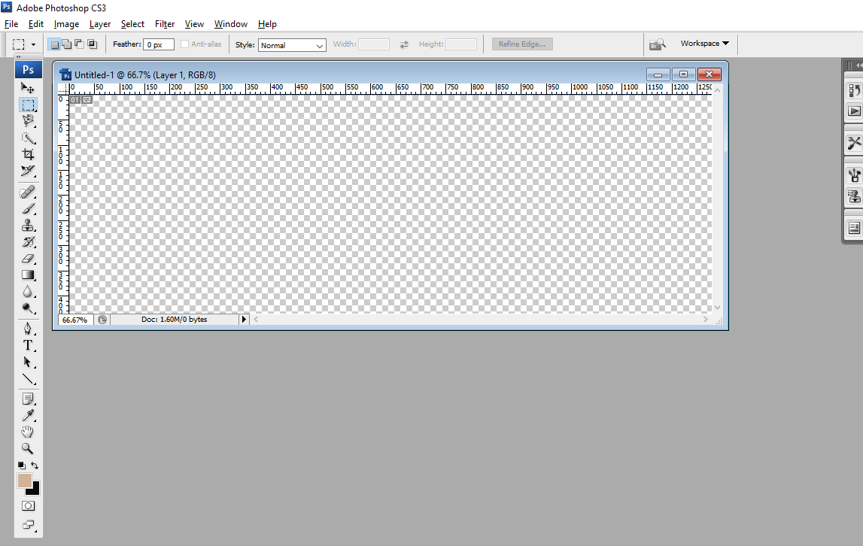

Double Click on Document and load image which you required

1. Minimize the slide by clicking highlighted arrow mark
2. Double click on outside the slide and load an Image which you required
3. Select new image and click ctrl+A (ctrl+A) selection then ctrl+X (Cut) then close that cutted window and past that Image on new Window

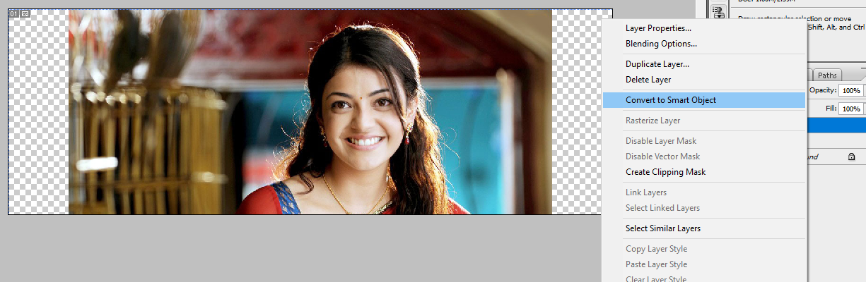

1. Adjust the image by click Convert to Smart object on layer and Try to adjust the image as you required
2. Select Move Tool (V) to adjust the Image and click (Ctrl+T) to select the Image and Drag as per your Requirement by clicking (**SHIFT+ALT)**

Note: if you click ctrl+T It will show only selection as a box but when you choose convert as smartObject we used get Diagonal Edges .. which help to get an image High Quality

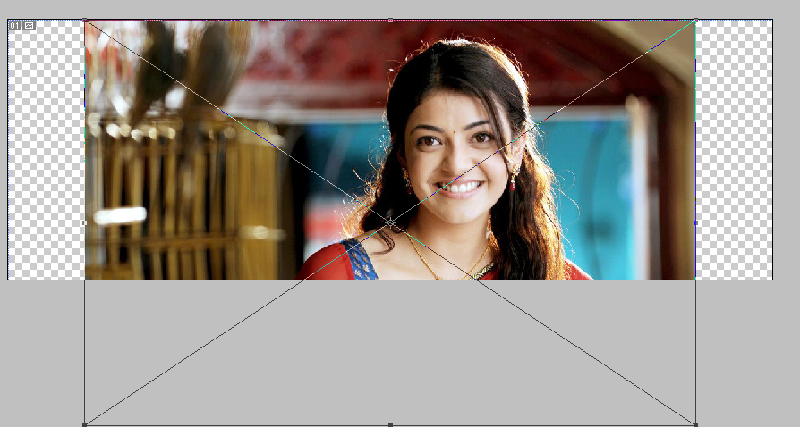

After Adjustment  
------------------------

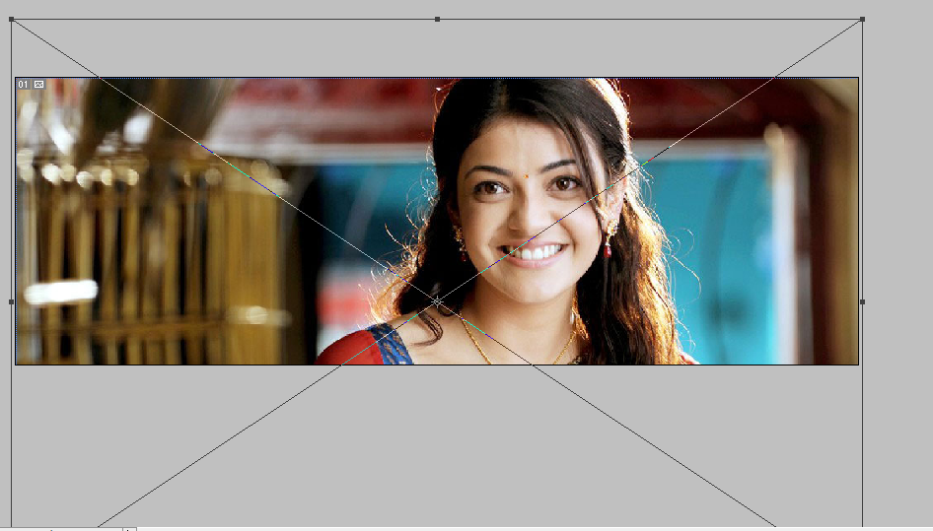

8.After Adjustment click on enter and and save an Image ..Image save is Two types by click shortcut method and choosing from File save

* Ctrl+shift+Alt+S gives the Save Result
* Choose 2-UP for two Images; 4-UP for 4 Images
* Check Quality and choose Image format and click on save
* Direct save ,e ctrl+S which select PSD Format in feature u can rework on PSD

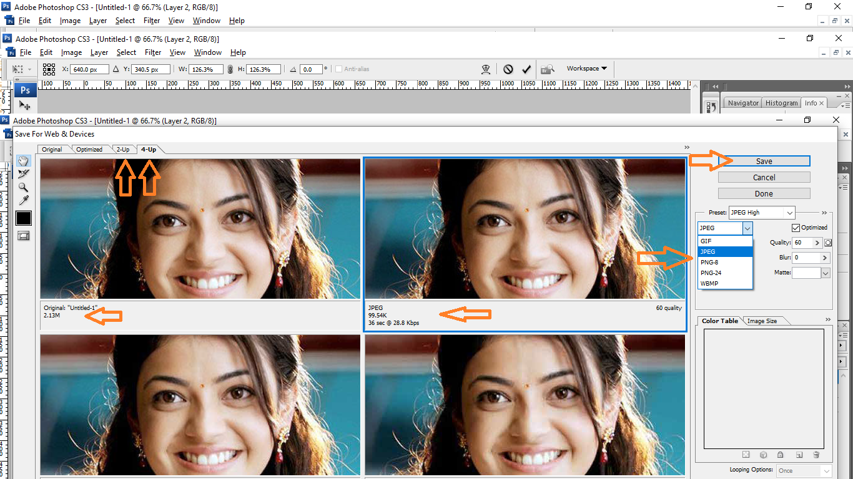

Save on local PC