Game Design Document

Fill up the following document

1. Write the title of your project.

* HASHIRU!

1. What is the goal of the game?

* Playing character needs to overcome the obstacles & difficulties whenever the phase of life changes and to reach the end i.e. when your progress bar will be filled.

1. Write a brief story of your game.

* To make dream come true , one needs to overcome the difficulties in his/her life . You are the player who is going to make a run to make your dream come true by overcoming the obstacles and difficulties. Your phase of life changes from childhood to teenage and finally to adulthood. As the phase changes , you start getting more and more obstacles in your life . Let’s see if you can fight with these difficulties and accomplish your goal.

1. Which are the playing characters of this game?

* Playing characters are the ones who respond to the user based on the input from the user.
* Cars, monkeys, dinos, wizards, etc., are the playing characters in the game.

|  |  |  |
| --- | --- | --- |
| Number | Character Name | What can this character do? |
| 1 | A girl(child,teenage,adult) | she can run and jump. |
| 2 |  |  |
| 3 |  |  |
| 4 |  |  |
| 5 |  |  |
| 6 |  |  |
| 7 |  |  |
| 8 |  |  |

1. Which are the Non-Playing Characters of this game?

* Non-Playing characters are the ones that don't have an action or behavior when the user interacts with the game.
* Hurdles, stones, bananas, coins, etc., are non-playing characters in the game.

|  |  |  |
| --- | --- | --- |
| Number | Character Name | What can this character do? |
| 1 | Spiky bars | It can reduce the life of playing character, once the character touches it. |
| 2 | trophies | These are the achievments of girl that increase points. |
| 3 | Light bulb(acts as a ray of hope) | It can save the life of pc only once in a game. |
| 4 | cactus | Reduces the life of pc. |
| 5 | virus | Reduces the life of pc. |
| 6 | Brick wall | Still character. |
| 7 |  |  |
| 8 |  |  |

Draw your imagination of this game. What does this game look like?

* Draw the game either on your computer or on paper.
* Add images of the game scenes to show each of the playing and non-playing characters at least once

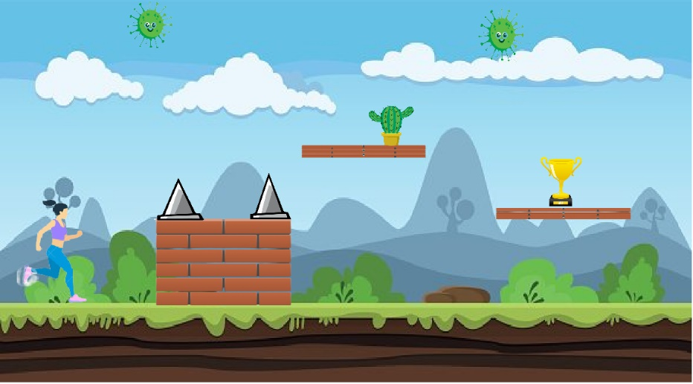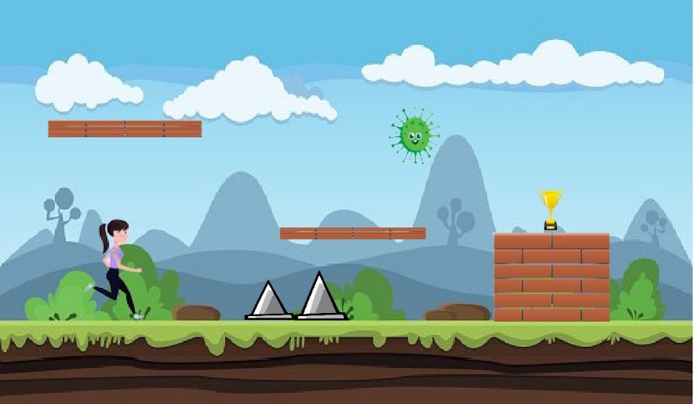.

How do you plan to make your game engaging?

* By rewarding players with trophies to keep them motivated.
* By increasing their scores after collecting trophies.
* making it challenging by increasing velocity and number of obstacles after every phase.
* Feedback through sounds and scores.
* By decreasing brightness(shows the feeling of despair)if pc touches any obstacle.
* By increasing brightness when pc touches a bulb(keep the pc motivated).
* By changing animation of the character whenever the phase of life changes.
* By showing progress bar.
* Sweetalert at the end.