SOFTWARE ENGINEERING
LAB2
NAME: Anvii S Rai
SRN: PES2UG24CS076
SECTION: 5B

Jira Backlog with Epics and User Stories
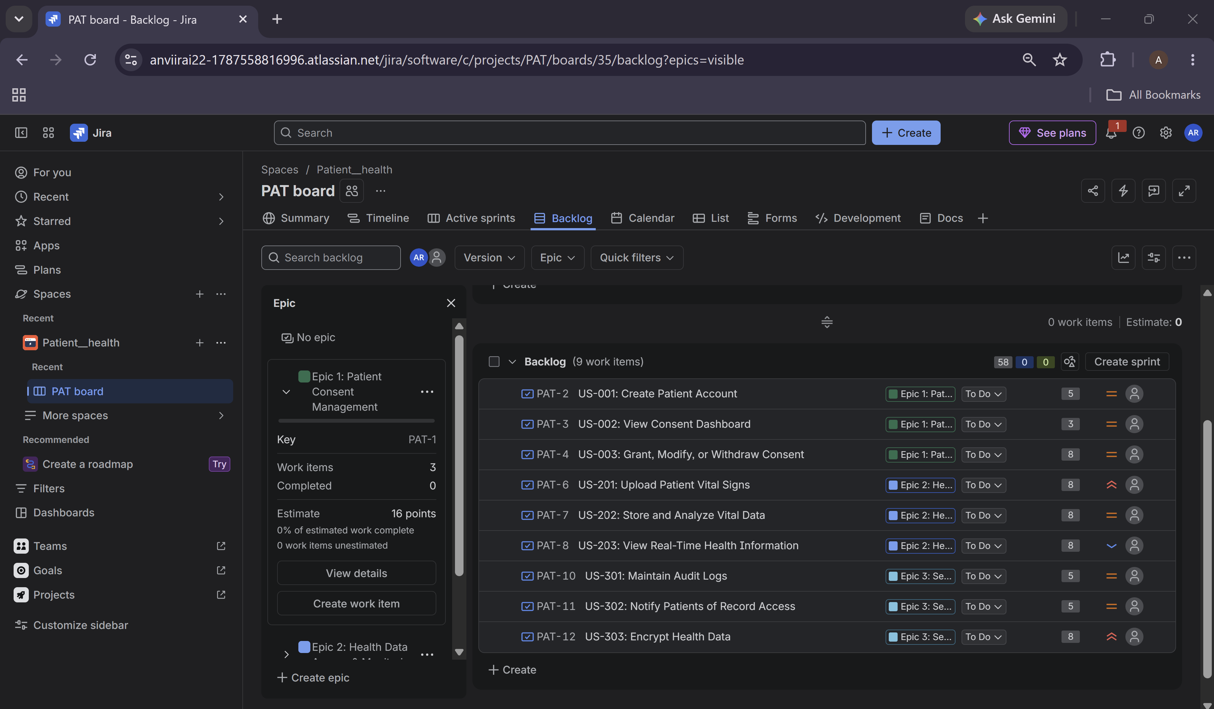
Story Point Assignments

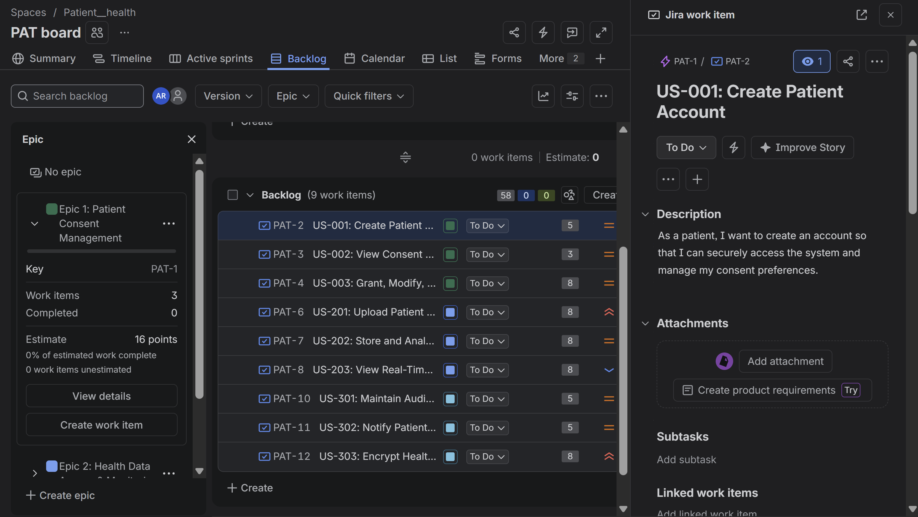
Active Sprint Board
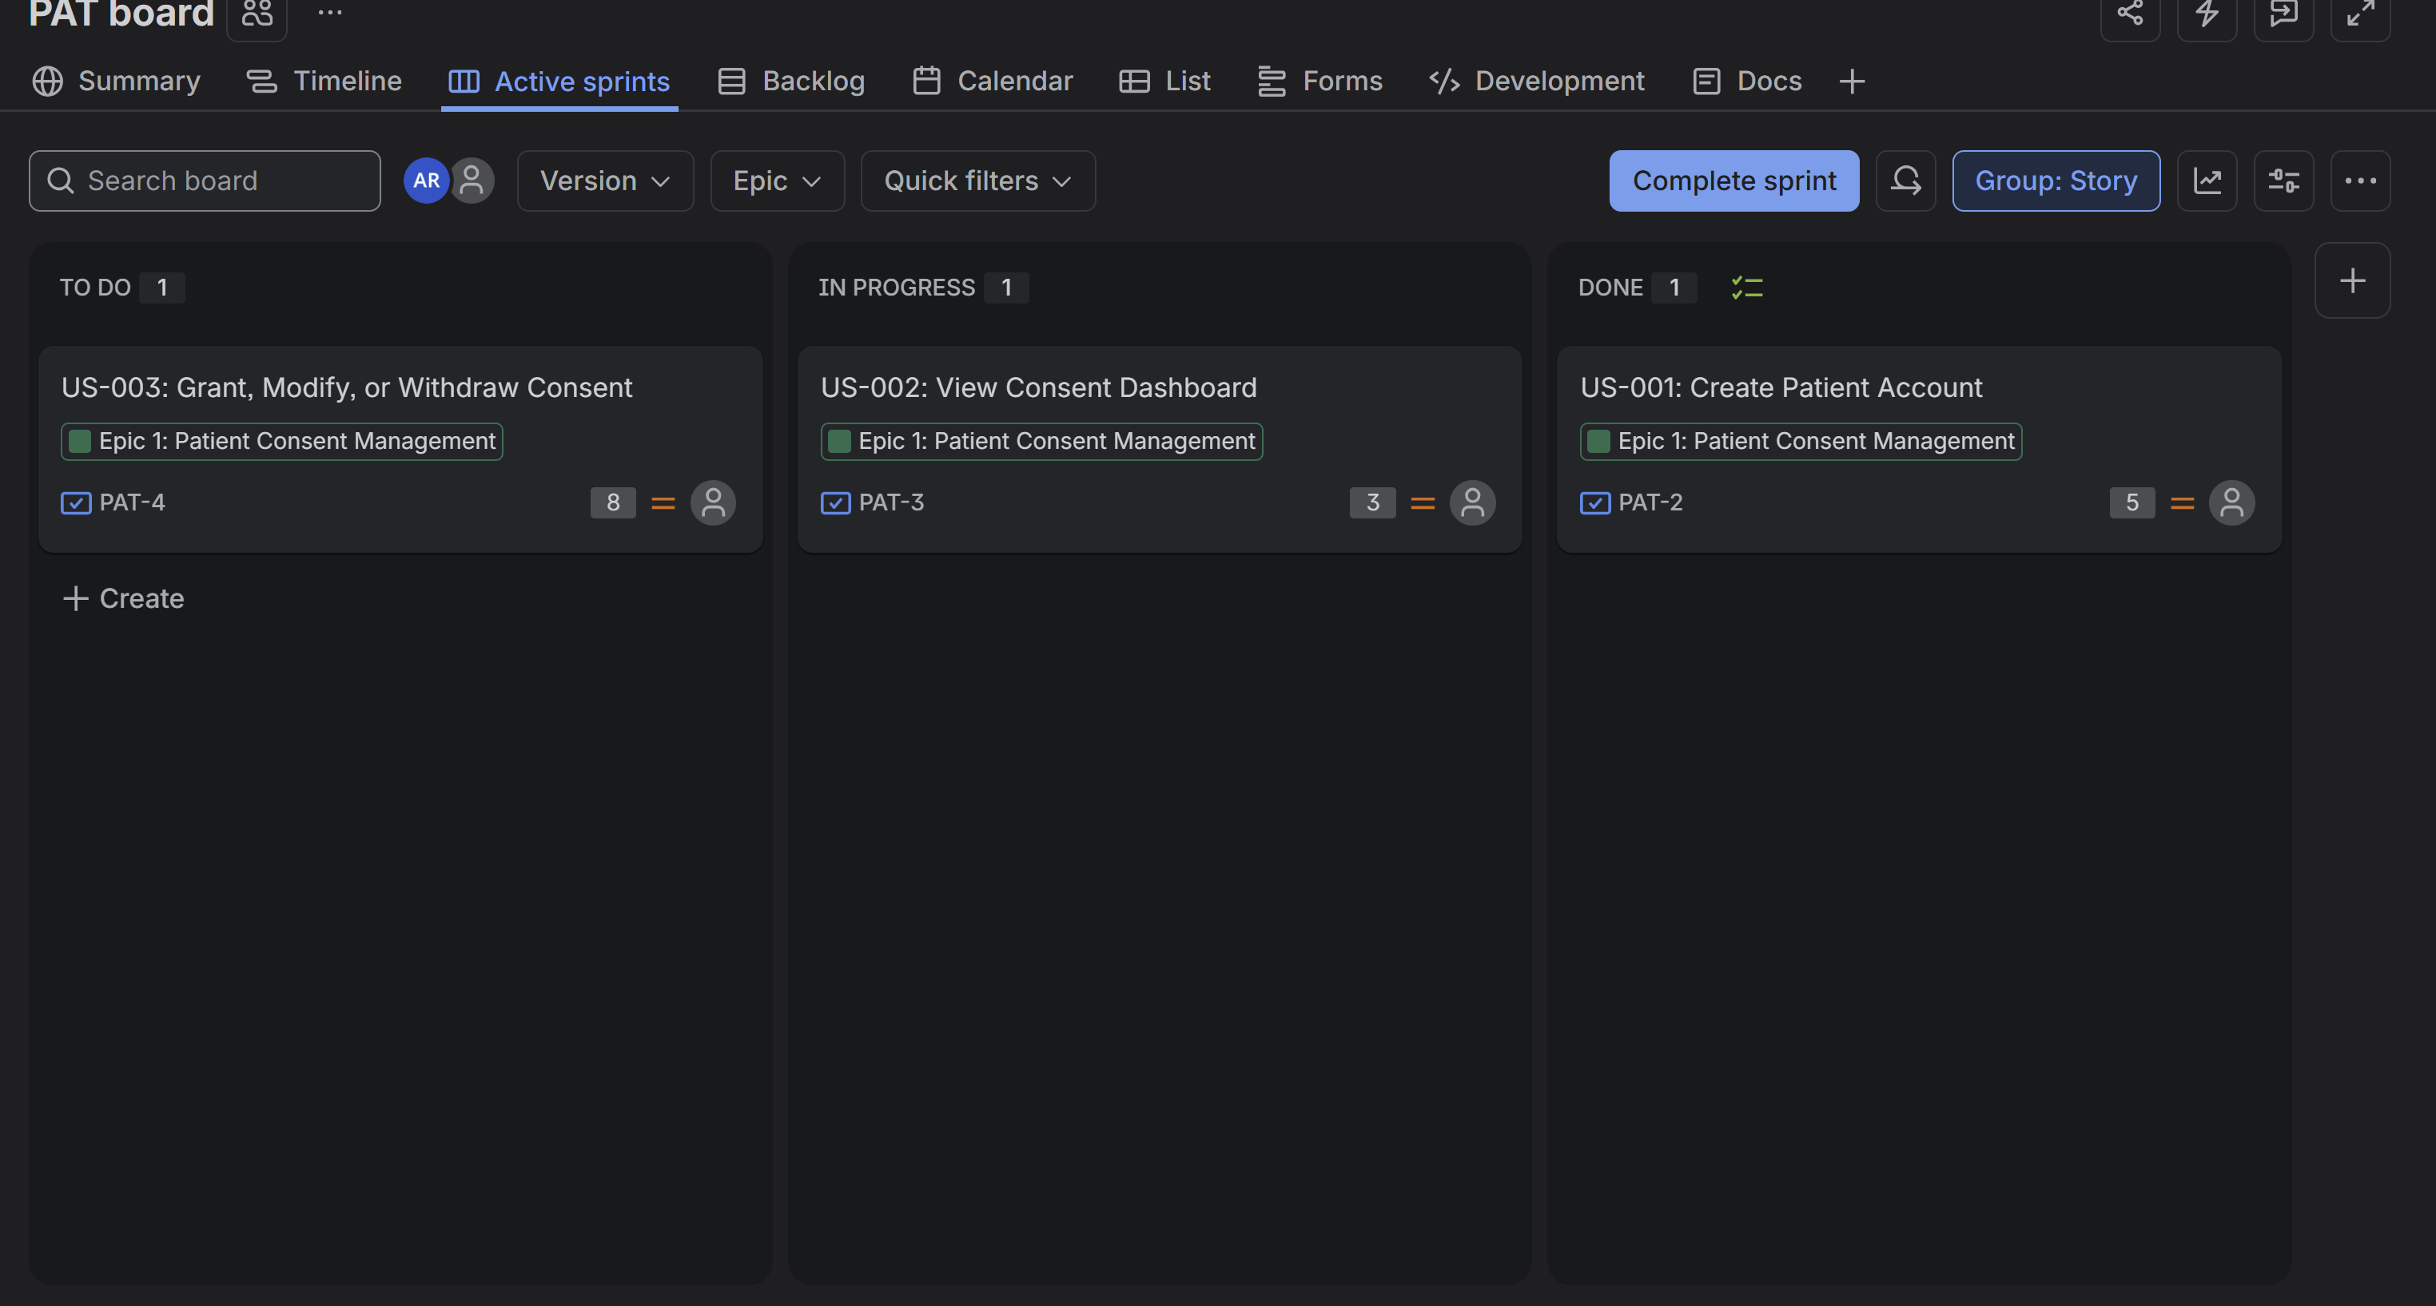
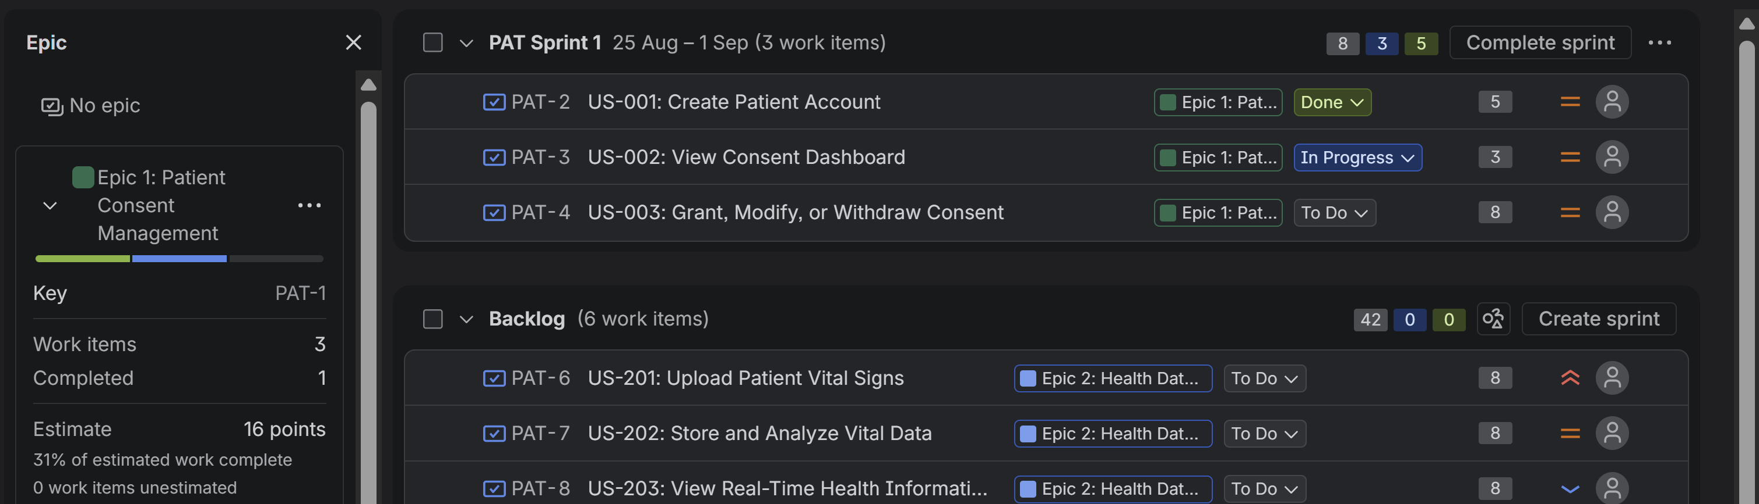

Burndown Chart
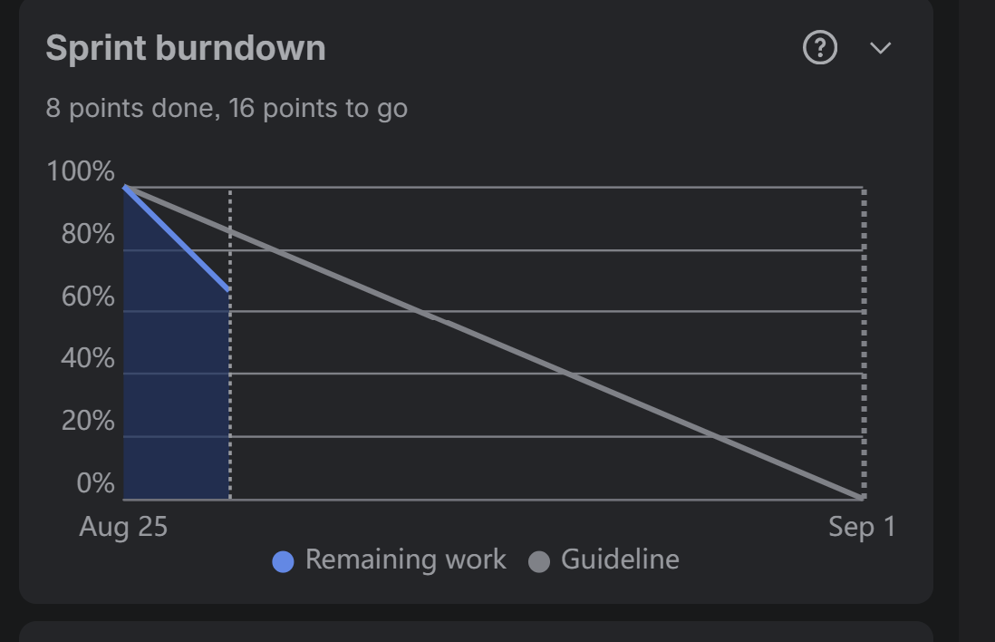

1. Did your estimations reflect the actual effort?

The estimates were mostly accurate. Some tasks took slightly more effort than expected.
Other tasks were easier and quicker to complete.
Overall, the story points were useful for planning.

2. Was your backlog well-prioritized?

Yes, the backlog was well-prioritized. I put the most important stories first.
This helped us focus on the main features.Lower-priority tasks were handled later.

3. How did your simulated sprint align with your plan?

The sprint mostly followed the original plan. We worked on the stories in the planned order.
Most of the planned work was completed during the sprint.
This helped us stay focused on the sprint goal.

4. What insights did the burndown chart give about your team’s capacity?

The burndown chart showed our progress during the sprint. It helped us see how quickly work was being completed.
We could see whether we were on track to finish. It also gave us an idea of our team’s capacity.

