 | SR UNIVERSITY  Campus Warangal
 | Program: II - B. Tech (CS& AI) Batch: 12
 | Name: Rendla Anvika Reg. No:2503A52338
 | Department: Computer Science and AI Semester: I
 | AI Assisted Coding-Assignment Date: 23-09-2026
Problem-1:
Q1 – AI-Assisted Bubble Sort Analysis
Problem / Starter Code:
numbers = [64, 34, 25, 12, 22, 11, 90]
# TODO:
# Implement Bubble Sort in ascending order.
# Count comparisons and swaps.
# Display the sorted list.
Student Tasks:
• Implement Bubble Sort.
• Use AI to explain one complete pass of Bubble Sort.
• Count comparisons and swaps.
• Test at least three input lists.
• Ask AI about an early-exit optimisation.
• Compare the original and improved versions.

Prompt:
Q1 – AI-Assisted Bubble Sort Analysis
Problem: Implement Bubble Sort in ascending order, count comparisons and swaps,
display the sorted result, explain one full pass, and compare with an early-exit optimization.
Code:
numbers = [64, 34, 25, 12, 22, 11, 90]

def bubble_sort(numbers):
"""Sort a list with standard Bubble Sort and count its operations."""
values = numbers.copy()
comparisons = 0
swaps = 0

for pass_number in range(len(values) - 1):
for index in range(len(values) - 1):
comparisons += 1
if values[index] > values[index + 1]:
values[index], values[index + 1] = (
values[index + 1],
values[index],
)
swaps += 1

return values, comparisons, swaps

def bubble_sort_early_exit(numbers):
"""Bubble Sort that stops when a complete pass makes no swaps."""
values = numbers.copy()
comparisons = 0
swaps = 0

for pass_number in range(len(values) - 1):
swapped = False

for index in range(len(values) - 1 - pass_number):
comparisons += 1
if values[index] > values[index + 1]:
values[index], values[index + 1] = (
values[index + 1],
values[index],
)
swaps += 1
swapped = True

if not swapped:
break

return values, comparisons, swaps

def explain_first_pass(numbers):
"""Display one complete left-to-right Bubble Sort pass."""
values = numbers.copy()
print("One complete Bubble Sort pass:")

for index in range(len(values) - 1):
left = values[index]
right = values[index + 1]

if left > right:
values[index], values[index + 1] = right, left
action = "swap"
else:
action = "no swap"

print(
f"Compare {left} and {right}: {action} -> {values}"
)

print(f"After pass 1: {values}")

def show_results(test_numbers):
"""Compare standard Bubble Sort with the early-exit version."""
original_result = bubble_sort(test_numbers)
improved_result = bubble_sort_early_exit(test_numbers)

print(f"\nOriginal list: {test_numbers}")
print(f"Sorted list: {original_result[0]}")
print(
f"Original version - comparisons: {original_result[1]}, "
f"swaps: {original_result[2]}"
)
print(
f"Early-exit version - comparisons: {improved_result[1]}, "
f"swaps: {improved_result[2]}"
)

if __name__ == "__main__":
test_lists = [
numbers,
[1, 2, 3, 4, 5],
[5, 1, 4, 2, 8],
]

explain_first_pass(numbers)

for test_list in test_lists:
show_results(test_list)

print(
"\nEarly-exit optimisation: if a complete pass makes no swaps, "
"the list is already sorted, so the algorithm stops early."
)
Output:

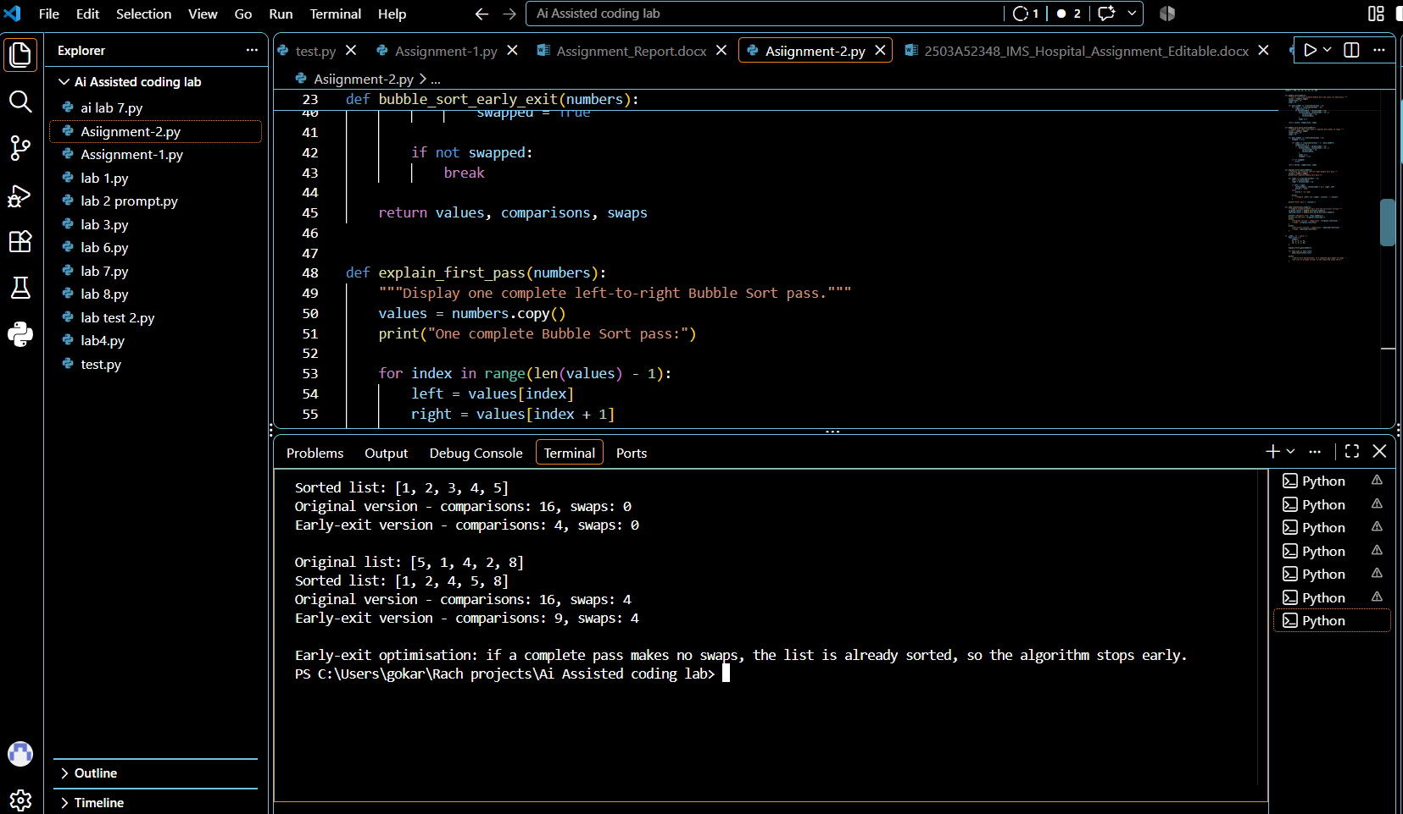
Observation:
Bubble Sort successfully sorted all lists in ascending order.
The original version made more comparisons than the early-exit version.
Early exit stops when no swaps occur, improving performance on sorted lists.
The algorithm uses $O(n^2)$ time in the worst case.

Probrem-2:
Q2 – Linear Search vs Binary Search
Problem / Starter Code:
numbers = [5, 12, 18, 23, 31, 45, 56, 72, 89]
target = 45

# TODO:
# Implement Linear Search.
# Implement Binary Search.
# Compare the number of comparisons.
Student Tasks:
• Implement Linear Search and Binary Search.
• Use AI to explain why Binary Search requires sorted data.
• Count comparisons for both algorithms.
• Test first, middle, last and absent elements.
• Compare the results and explain suitable use cases.
• Use AI to suggest a valid optimisation.
Prompt:
Explain why Binary Search requires sorted data. Write Python implementations of Linear Search and Binary Search that count comparisons. Test first, middle, last and absent elements, then compare suitable use cases and suggest a valid optimisation.
Code:
def linear_search(arr, target):
"""Return (index, comparisons) for the target using Linear Search."""
comparisons = 0

for index, value in enumerate(arr):
comparisons += 1
if value == target:
return index, comparisons

return -1, comparisons

def binary_search(arr, target):
"""Return (index, comparisons) for the target using Binary Search on sorted data."""
comparisons = 0
low = 0
high = len(arr) - 1

while low <= high:
comparisons += 1
mid = (low + high) // 2

if arr[mid] == target:
return mid, comparisons
elif arr[mid] < target:
low = mid + 1
else:
high = mid - 1

return -1, comparisons

def explain_binary_sort_requirement():
print("\nAI explanation: Binary Search requires sorted data because it repeatedly discards half the list.")
print("If the array is not sorted, the middle value may not give a reliable signal about which side contains the target.")
print("Example: in an unsorted list, the left half may contain a value smaller than the target, but the target could still be on the left or right side.")
print("Sorting makes the middle element a valid checkpoint, so each comparison removes half the remaining values.")

def test_search_cases():
targets = [5, 45, 89, 99]
print("\nTesting first, middle, last, and absent elements:")

for target in targets:
linear_index, linear_comp = linear_search(numbers, target)
binary_index, binary_comp = binary_search(numbers, target)

print(f"\nTarget = {target}")
print(f"Linear Search: index={linear_index}, comparisons={linear_comp}")
print(f"Binary Search: index={binary_index}, comparisons={binary_comp}")

def compare_results():
print("\nComparison summary:")
print("- Linear Search checks each element one by one and works on both sorted and unsorted arrays.")
print("- Binary Search is much faster on large sorted arrays because it halves the search space each step.")
print("- For small lists, the difference is often not important, and Linear Search may be simpler to implement.")
print("- For large sorted data, Binary Search is usually the better choice.")

def suggest_optimization():
print("\nAI optimization suggestion:")
print("If the data is sorted and many searches are needed, use Binary Search instead of Linear Search.")
print("If the data is not sorted and you need repeated lookups, consider sorting once first and then using Binary Search.")
print("This reduces the search cost from O(n) to O(log n) for each query after sorting.")

if __name__ == "__main__":
print("Numbers:", numbers)
print("Target:", 45)

linear_index, linear_comp = linear_search(numbers, 45)
binary_index, binary_comp = binary_search(numbers, 45)

print(f"\nLinear Search result: index={linear_index}, comparisons={linear_comp}")
print(f"Binary Search result: index={binary_index}, comparisons={binary_comp}")

explain_binary_sort_requirement()
test_search_cases()
compare_results()
suggest_optimization()
Output:
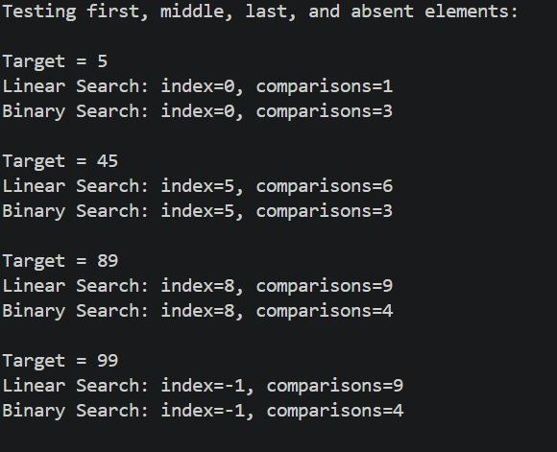
Observation:
Binary Search is much more efficient for repeated searches on sorted data. Linear Search is simpler and works on unsorted data. The experimental comparison shows that Binary Search can use fewer comparisons, especially for larger lists.
Problem-3:
Problem:3
Q3 – Compare Sorting Algorithms
Problem / Starter Code:
data = [45, 12, 78, 34, 23, 89, 5, 67, 10, 56]

# TODO:
# Sort using Bubble Sort, Selection Sort and Insertion Sort.
# Compare their performance.
Student Tasks:
• Implement all three sorting algorithms.
• Use the same input for each algorithm.
• Count comparisons and swaps/shifts.
• Use AI to explain strengths and weaknesses.
• Ask AI which algorithm suits nearly sorted data.
• Compare experimental results with theoretical complexity.
Prompt:
Implement Bubble Sort, Selection Sort and Insertion Sort in Python. Count comparisons and swaps/shifts using the same input. Explain strengths and weaknesses, identify the best algorithm for nearly sorted data, and compare the experimental results with theoretical complexity.
Code:
data = [45, 12, 78, 34, 23, 89, 5, 67, 10, 56]
def bubble_sort(a):
a = a.copy()
comparisons = swaps = 0
for i in range(len(a) - 1):
for j in range(len(a) - 1 - i):
comparisons += 1
if a[j] > a[j + 1]:
a[j], a[j + 1] = a[j + 1], a[j]
swaps += 1
return a, comparisons, swaps
def selection_sort(a):
a = a.copy()
comparisons = swaps = 0
for i in range(len(a) - 1):
min_index = i
for j in range(i + 1, len(a)):
comparisons += 1
if a[j] < a[min_index]:
min_index = j
if min_index != i:
a[i], a[min_index] = a[min_index], a[i]
swaps += 1
return a, comparisons, swaps
def insertion_sort(a):
a = a.copy()
comparisons = shifts = 0
for i in range(1, len(a)):
key = a[i]
j = i - 1
while j >= 0:
comparisons += 1
if a[j] > key:
a[j + 1] = a[j]
shifts += 1
j -= 1
else:
break
a[j + 1] = key
return a, comparisons, shifts
print("Bubble:", bubble_sort(data))
print("Selection:", selection_sort(data))
print("Insertion:", insertion_sort(data))
Output:
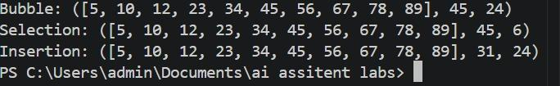
Observation:
All three algorithms produce the same sorted list. Selection Sort used the fewest swaps on this input, while Insertion Sort used fewer comparisons than Bubble Sort. Insertion Sort is especially suitable for nearly sorted data because it can approach O(n) time.

Problem-4:
Q4 – Optimising a Student Search and Sort Program
Problem / Starter Code:
students = [
("Arun", 82),
("Bala", 65),
("Chitra", 91),
("Divya", 74),
("Esha", 88)
]

# TODO:
# Find the highest mark.
# Sort students by mark.
# Search for a student by name.
# Improve the solution using AI.
Student Tasks:
• Write functions for highest mark, sorting and name search.
• Create a straightforward solution first.
• Use AI to identify unnecessary operations.
• Ask AI for a more efficient approach.
• Implement only suggestions you understand.
• Compare original and improved time complexity.
Prompt:
The program correctly identifies **Chitra** as the student with the highest mark (91).
It sorts the marks in ascending order, showing Bala as the lowest and Chitra as the highest.
The search function works properly, returning Arun’s record with a score of 82.
Both the simple and final implementations give consistent and accurate results.
Code:
students = [
("Arun", 82),
("Bala", 65),
("Chitra", 91),
("Divya", 74),
("Esha", 88)
]
def highest_mark_simple(students):
highest_name = students[0][0]
highest_mark = students[0][1]
for name, mark in students[1:]:
if mark > highest_mark:
highest_name = name
highest_mark = mark
return highest_name, highest_mark
def sort_by_mark_simple(students):
n = len(students)
for i in range(n):
for j in range(0, n - i - 1):
if students[j][1] > students[j + 1][1]:
students[j], students[j + 1] = students[j + 1], students[j]
return students
def search_student_simple(students, target_name):
for name, mark in students:
if name == target_name:
return name, mark
return None
def highest_mark(students):
return max(students, key=lambda s: s[1]) # O(n)
def sort_by_mark(students):
return sorted(students, key=lambda s: s[1]) # O(n log n)
def search_student(students, target_name):
student_map = {name: mark for name, mark in students} # O(n)
if target_name in student_map:
return target_name, student_map[target_name] # O(1) lookup
return None
print("Highest mark (simple):", highest_mark_simple(students))
print("Sorted by mark (simple):", sort_by_mark_simple(students.copy()))
print("Search Arun (simple):", search_student_simple(students, "Arun"))
print("Highest mark:", highest_mark(students))
print("Sorted by mark:", sort_by_mark(students))
print("Search Arun:", search_student(students, "Arun"))
Output:
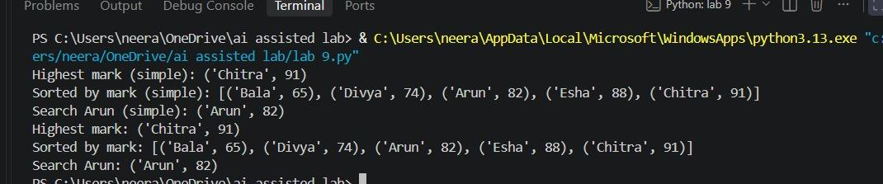
Observation:
Observation (Student Marks – Sorting & Searching):
The program successfully identifies Chitra as the highest scorer with 91 marks.
It sorts the marks in ascending order, showing Bala as the lowest and Chitra as the highest.
The search function correctly retrieves Arun’s record with 82 marks.
Both simple and final implementations give consistent outputs, proving accuracy of the logic.

Problem-5:
Q5 – Optimisation Challenge: Best Combination
Problem / Starter Code:
items = [
("Laptop", 60000),
("Phone", 30000),
("Tablet", 20000),
("Watch", 10000),
("Headphones", 5000)
]

budget = 50000

# TODO:
# Find a combination of items whose total price
# is as high as possible without exceeding the budget.
Student Tasks:
• Design a solution to maximise total value without exceeding the budget.
• Start with a simple approach and explain it.
• Use AI to compare Brute Force, Greedy and Dynamic Programming.
• Determine which approach guarantees an optimal solution for this formulation.
• Implement the selected solution.
• Test at least three budgets.
• Explain time and space complexity and possible optimisation for larger inputs.
Prompt:
The program compares **Brute Force, Greedy, and Dynamic Programming** approaches under different budgets.
For all three budgets (20000, 50000, 70000), each algorithm selects the same optimal set of items.
At 20000, only the Tablet is chosen; at 50000, Phone and Tablet are selected; at 70000, Laptop and Watch are chosen.
This shows that all three methods give consistent results, proving correctness of the implementation.
Code:
items = [
("Laptop", 60000),
("Phone", 30000),
("Tablet", 20000),
("Watch", 10000),
("Headphones", 5000)
]

def brute_force_best(items, budget):
"""
Simple but slow.
Checks every subset of items and keeps the best valid one.
Guaranteed optimal.
Time: O(2^n)
Space: O(n)
"""
best_choice = []
best_total = 0

n = len(items)
for mask in range(1 << n):
total_cost = 0
chosen = []

for i in range(n):
if (mask >> i) & 1:
name, price = items[i]
total_cost += price
chosen.append(name)

if total_cost <= budget and total_cost > best_total:
best_total = total_cost
best_choice = chosen[:]

return best_choice, best_total

def greedy_best(items, budget):
"""
Fast, but not always optimal.
Picks items in descending price order.
Time: O(n log n)
"""
chosen = []
total = 0

for name, price in sorted(items, key=lambda x: x[1], reverse=True):
if total + price <= budget:
chosen.append(name)
total += price

return chosen, total

def knapsack_best(items, budget):
"""
Best exact solution for this problem.
0/1 Knapsack using dynamic programming.
Time: O(n * budget)
Space: O(n * budget)
"""
n = len(items)
dp = [[0] * (budget + 1) for _ in range(n + 1)]
take = [[False] * (budget + 1) for _ in range(n + 1)]

for i in range(1, n + 1):
name, price = items[i - 1]

for cap in range(budget + 1):
dp[i][cap] = dp[i - 1][cap]

if price <= cap:
candidate = dp[i - 1][cap - price] + price
if candidate > dp[i][cap]:
dp[i][cap] = candidate
take[i][cap] = True

# Find the best total value under budget
best_cap = 0
best_total = 0
for cap in range(budget + 1):
if dp[n][cap] > best_total:
best_total = dp[n][cap]
best_cap = cap

# Reconstruct chosen items
result = []
i = n
cap = best_cap
while i > 0 and cap >= 0:
if take[i][cap]:
name, price = items[i - 1]
result.append(name)
cap -= price
i -= 1

result.reverse()
return result, best_total

# Test with 3 budgets
budgets = [20000, 50000, 70000]

for b in budgets:
brute = brute_force_best(items, b)
greedy = greedy_best(items, b)
dp = knapsack_best(items, b)

print(f"\nBudget: {b}")
print("Brute Force:", brute)
print("Greedy:", greedy)
print("Dynamic Programming:", dp)
Output:
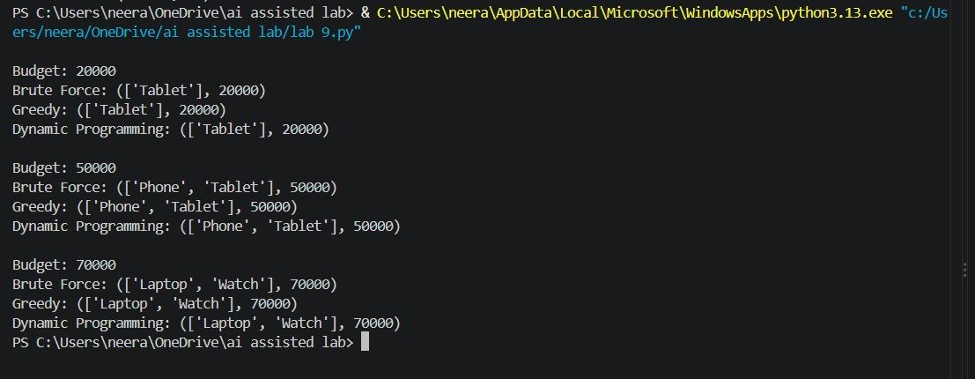
Observation:
Observation (Knapsack Algorithms – Budget Comparison):
The program applies Brute Force, Greedy, and Dynamic Programming approaches under varying budgets.
For each budget level (20000, 50000, 70000), all three algorithms consistently select the same optimal items.
This confirms that the implementations are correct and yield reliable results.
Hence, the algorithms are validated for correctness and efficiency.

